**Project Report**

**ON**

**“Budget Manager”**

**BY**

**Kamlesh Somnath Jadhav**

**MCA 2nd Year Sem III**

**University Seat No: _________**

Under the guidance of

**Prof. Sapna Chavan**

**SAVITRIBAI PHULE PUNE UNIVERSITY**

**MASTER OF COMPUTER APPLICATION**



**Dr. D.Y. Patil School of MCA**

**Charoli (BK), PUNE-** **412105**

**Academic Year 2021-2022**

**ACKNOWLEDGEMENT**

I consider it a privilege to express few words of gratitude and respect to all who guided and inspired me in successful completion of this project. I acknowledge my profound indebtedness and extend my deep sense of gratitude to my Project Guide Prof. /Dr. Sapna Chavan for sharing their knowledge and experience and providing valuable guidance, profound advice and encouragement that has led to successful completion of this project.

I would like to thank, **Dr. E. B. Khedkar**, Director, Dr D Y Patil School of MCA and **Prof. Ashok Deokar,** HOD**,** Dr D Y Patil School of MCA for their guidance and unflinching support throughout the phase of my Project Submission.

**Kamlesh Somnath Jadhav**

**MCA II SEM III**

**Dr D Y Patil School of MCA,**

**Lohegaon, Pune – 412 105**

**INDEX**

|  |  |  |
| --- | --- | --- |
| **Sr.**  **No.** | **Title** | **Page No.** |
| 1. | Introduction | 4 |
| 2. | Problem Definition | 5 |
| 3. | Feasibility Study | 6 |
| 4. | Gathering Data Requirements and Functional Requirement | 7 |
| 5. | Designing the normalized database | 8 |
| 6. | UML diagram | 9-13 |
| 7. | Input/output Screens | 14-24 |
| 8. | Test Case Design | 25 |
| 9. | Conclusion | 26 |
| 10. | References | 26 |

**INTRODUCTION**

* Budget Manager helps you keep track of your spending, and keep your data as your own. After adding some budgets, simply record your data-to-day transactions. You can then view how close your sending is to your budget.
* The application requires very little permission, and never attempts to access the Internet. There is an option to back up your cards to local storage. From there you can send the backup somewhere safe.

**Objective:**

Budget Manager helps manage personal budgets. After adding your budgets, simply record your day-to-day transactions

**Need Of System:**

This system helps us to reach out our budget easily, we can track on daily basis that, how close are we to achieve our budget. And also, in the case if we are having some revenues then we get aware that we are getting away from our budget. So, this is a very efficient way of budget tracking.

**PROBLEM DEFINATION & SCOPE**

**Problem Description:**

It is very difficult to maintain the Transaction records manually, or using the excel sheet, and hard to retrieve the history of transactions if we maintain our transactions in a manual way, hence maintenance is high.

**Existing System:**

There is no existing system therefore we all calculate the budget manually.

**Proposed System:**

This system helps us to reach out our budget easily, we can track on daily basis that, how close are we to achieve our budget. And also, in the case if we are having some revenues then we get aware that we are getting away from our budget. So, this is a very efficient way of budget tracking.

**FEASIBILITY STUDY**

**Technical Feasibility:**

The system ensures accuracy, reliability and case of data retrieval. The platform will be portable enough to work on any of the platforms and operating environment. The system will be efficient in its performance. Performance could be the speed and the memory required for the system is based on an outline design of system requirement in term of input, processes, output, field, program and procedures.

**Economic Feasibility:**

The economic analysis is the most frequency used method for evaluating the effectiveness of a new system. More commonly known as cost analysis, the procedures are to determine the benefits and savings that are expected from a candidate system and compare them with costs. The hardware used for the system will estimate budget of project. The cost incurred to modify the system will be minimized. Manpower to work on the system will be reduced.

**Operational Feasibility:**

Is measures of how well a proposed system solves the problems and takes advantages of the opportunities identified during scope definition and how it satisfies the requirement identifies in the requirement analysis phase of system development. The new online system saves the time and also it is profitable, we can store the data into single register (computer). Users don’t want any register to maintain n that all information.

**DATA DICTIONARY**

* **Data Requirements of System:**

1. **Identify the end users:** The end users of the system the people who want to keep track of their daily Transactions.
2. **Input data to the system:** User’s daily expense details.
3. **Output information from the system:** All transactions history.

* **Functional or Processing Requirements of the system:**

1. User can add his/her daily expense.
2. User can add his/her daily revenue.
3. User can view his/her daily expenditure.

* **Hardware and Software Requirements:**

Operating System: Windows 7/8/10 (32 or 64 bit)

Mac OS X 10.8.5.

GNOME or KDE or Unity desktop on Ubuntu or Fedora or GNU/Linux Debian

Application Software: Eclipse/Android Studio

Language: java

RAM: 4 GB

Hard Disk: 1TB

Key Board: Standard Windows Keyboard

Mouse: Two or Three button mouse

Monitor: SVGA

Java Development Kit (JDK) 7.

1280x800 screen resolution.

A Faster processor (according to you budget).

**DESGINING THE NORMALIZED DATABASE**

1. Table: Budgets

|  |  |  |  |
| --- | --- | --- | --- |
| Sr.no | Field Name | Field Type | Description |
| 1. | ID (PK) | Integer | Budget Id |
| 2. | Name | Varchar(30) | Budget name |
| 3. | Amount | Boolean | Budget Amount |

1. Table: Transactions

|  |  |  |  |
| --- | --- | --- | --- |
| Sr.no | Field name | Field Type | Description |
| 1. | ID (PK) | Integer | Transaction ID |
| 2. | Type | Integer | Transaction Type  (1-Expense & 2-Revenues) |
| 3. | Description | Varchar(50) | Transaction Description |
| 4. | Account | Varchar(20) | Transaction Account |
| 5. | Budget ID (FK) | Integer | Budget ID |
| 6. | Amount | Boolean | Transaction Amount |
| 7. | Note | Varchar(50) | Transaction Note |
| 8. | Date | Integer | Transaction Date |
| 9. | Receipt | Varchar(100) | Transaction receipt path |

1. Table: Receipt Quaity

|  |  |  |  |
| --- | --- | --- | --- |
| Sr.no | Field Name | Field Type | Description |
| 1. | Name (PK) | Varchar(30) | Receipt Name (Transaction) |
| 2. | Quality | Integer | Receipt Quality |

**UML DIAGRAM**

1. **Use Case Diagram**

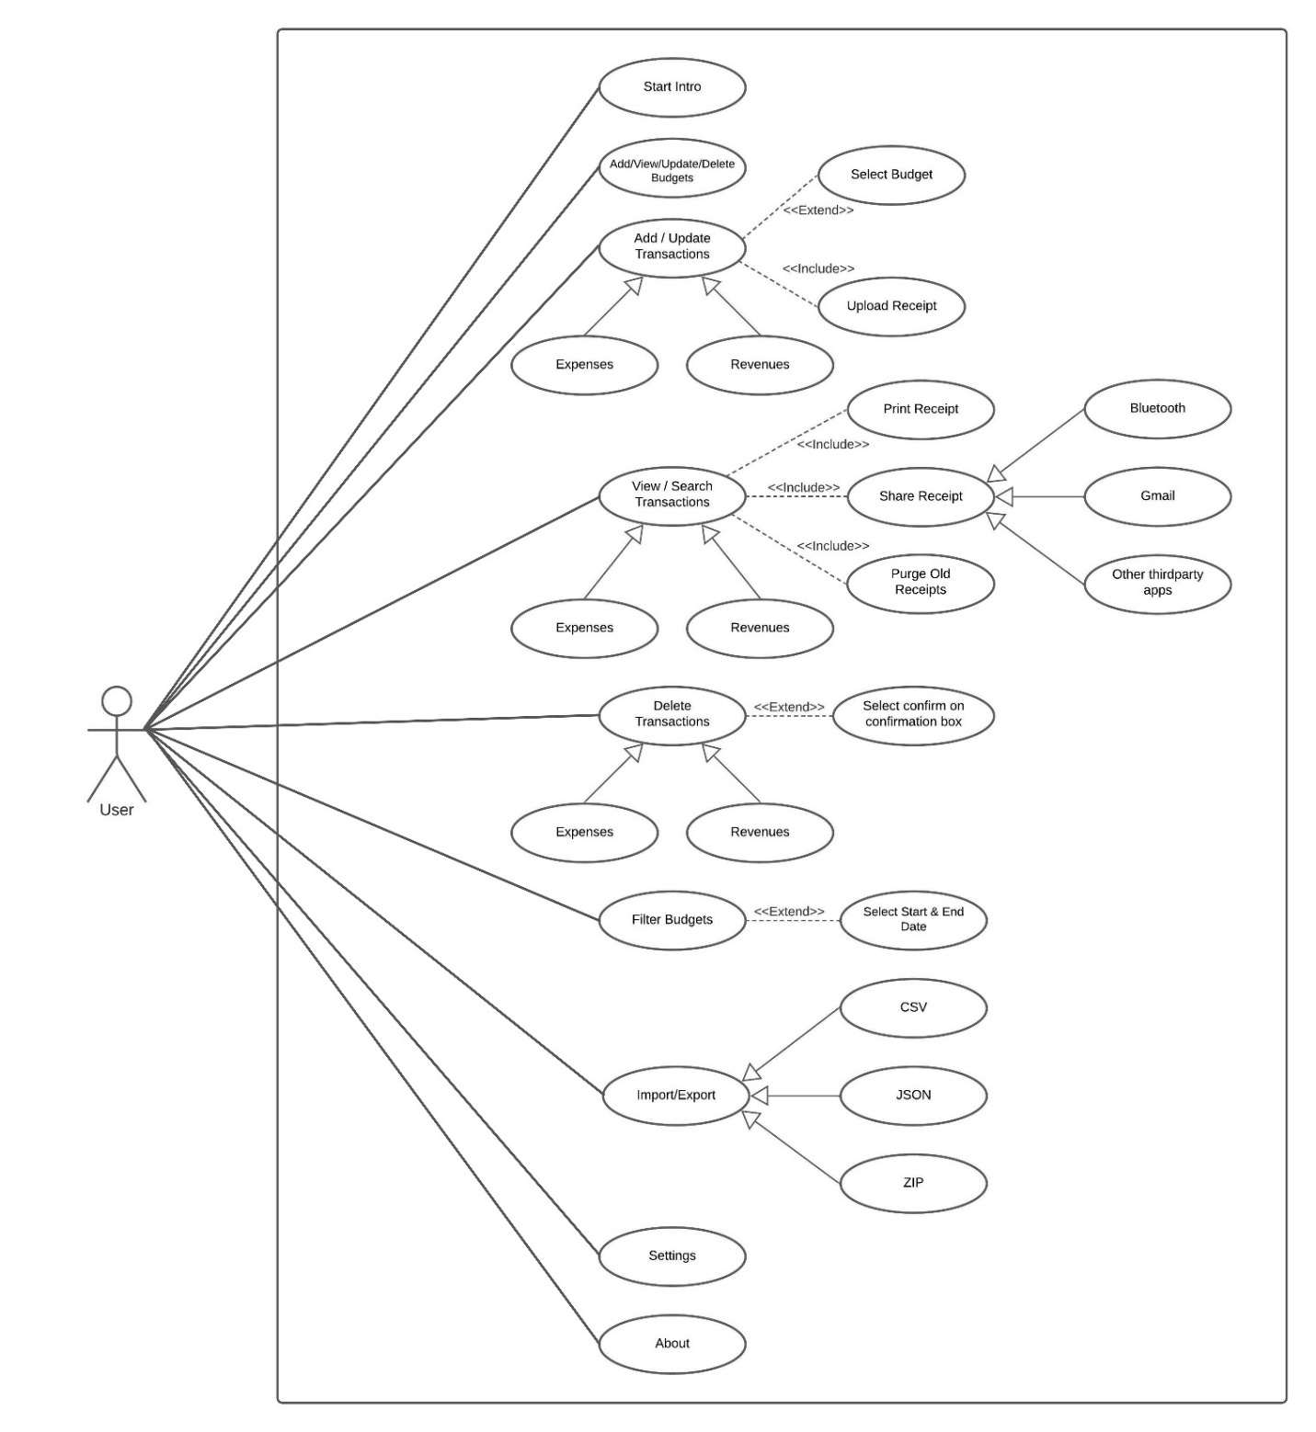

1. **Sequence Diagram**

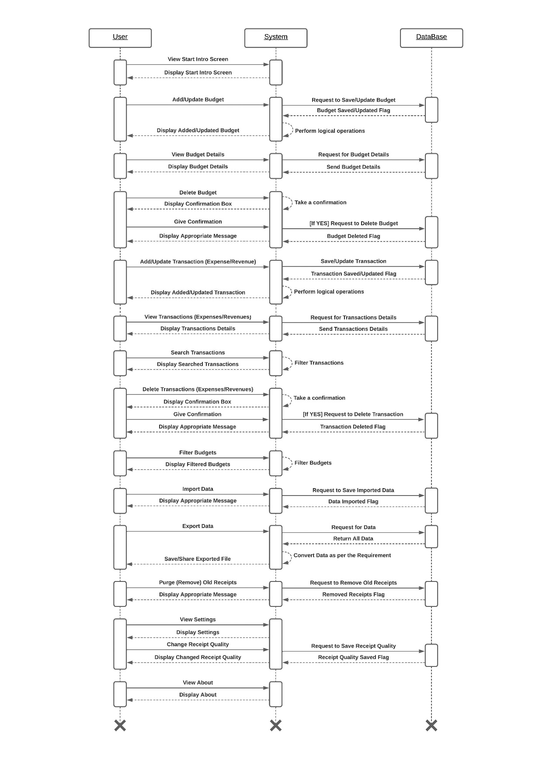

1. **Activity Diagram**

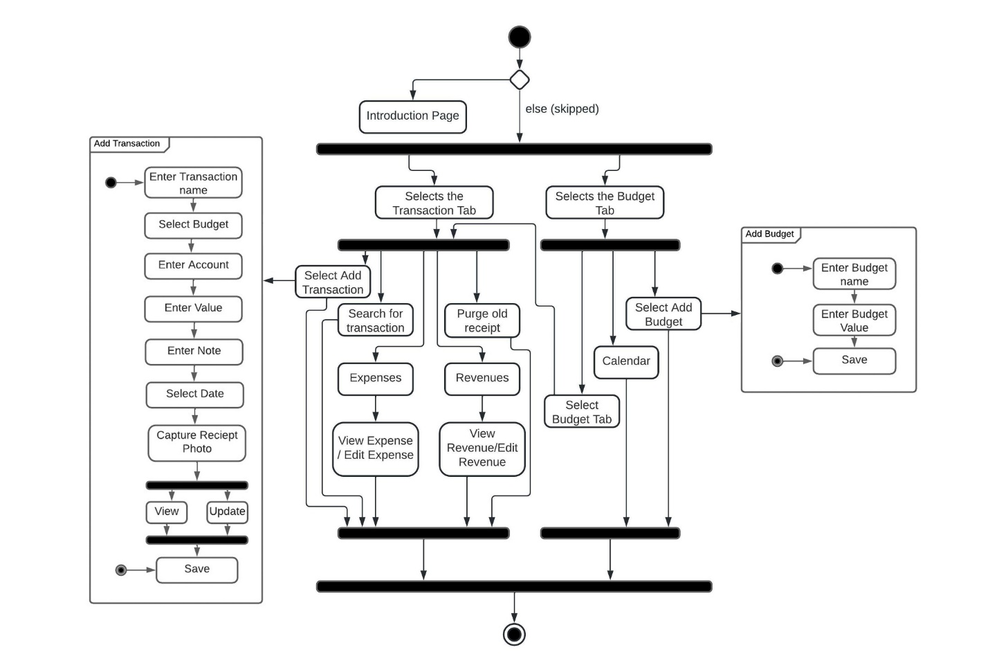

1. **Collaboration Diagram**

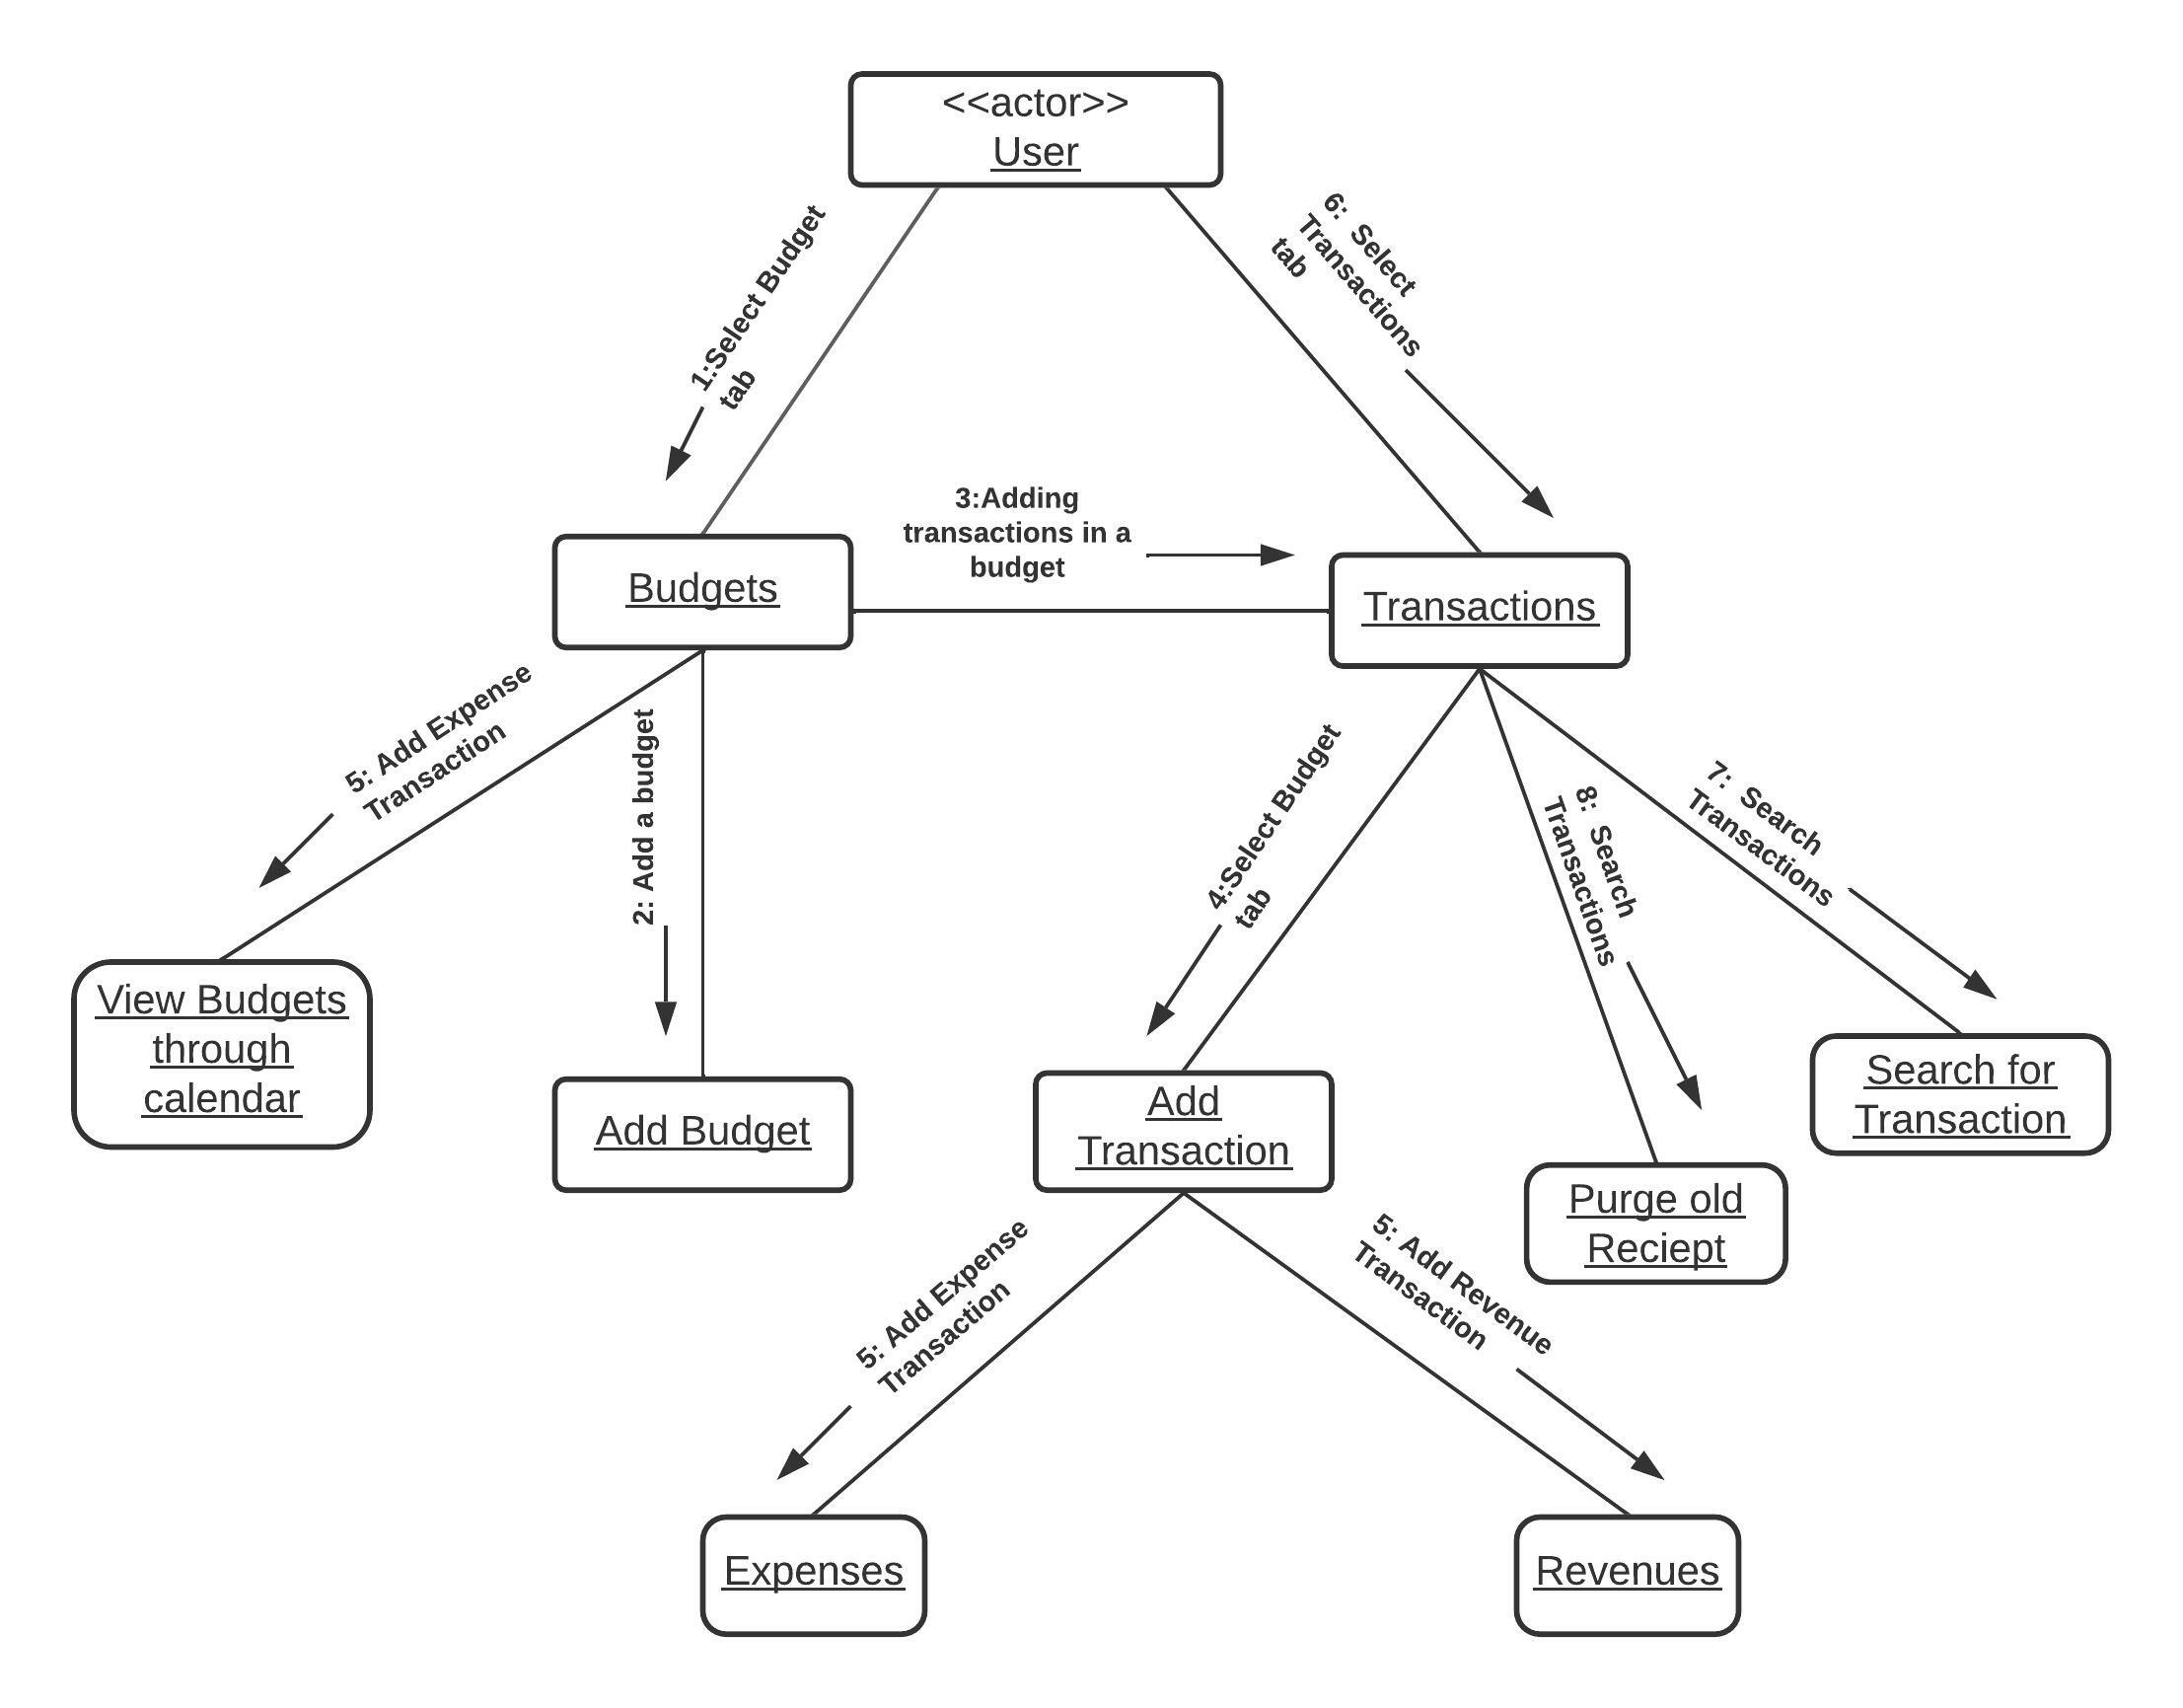

1. **Class Diagram**

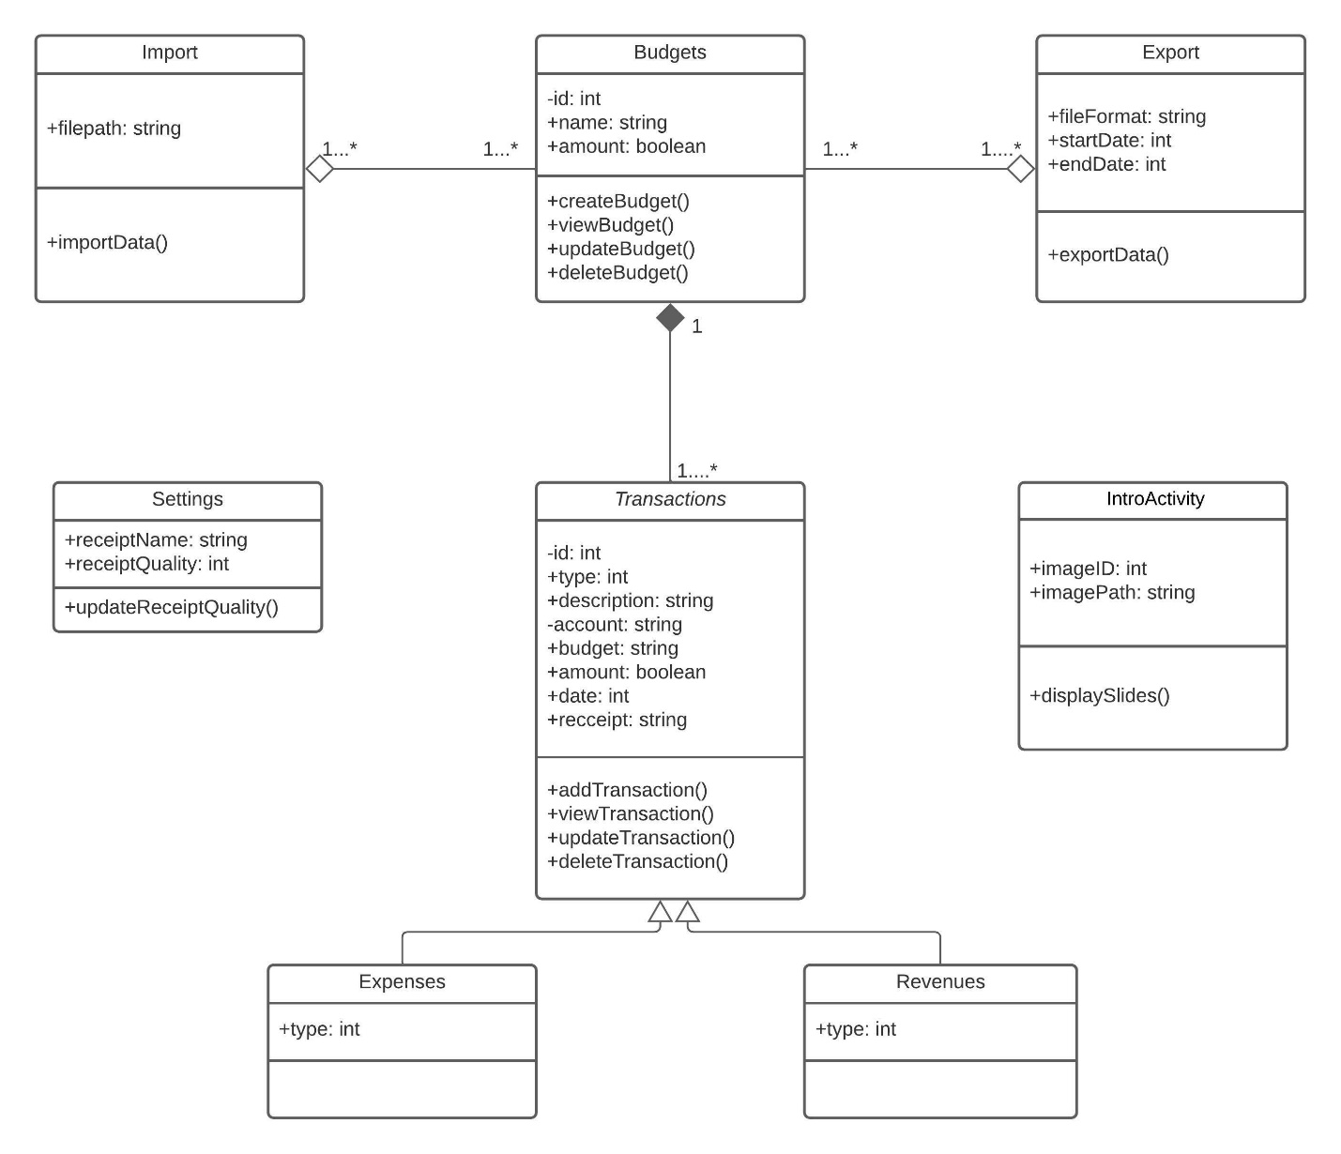

**SCREENSHOTS**

**Intro Page 1 Intro Page 2**

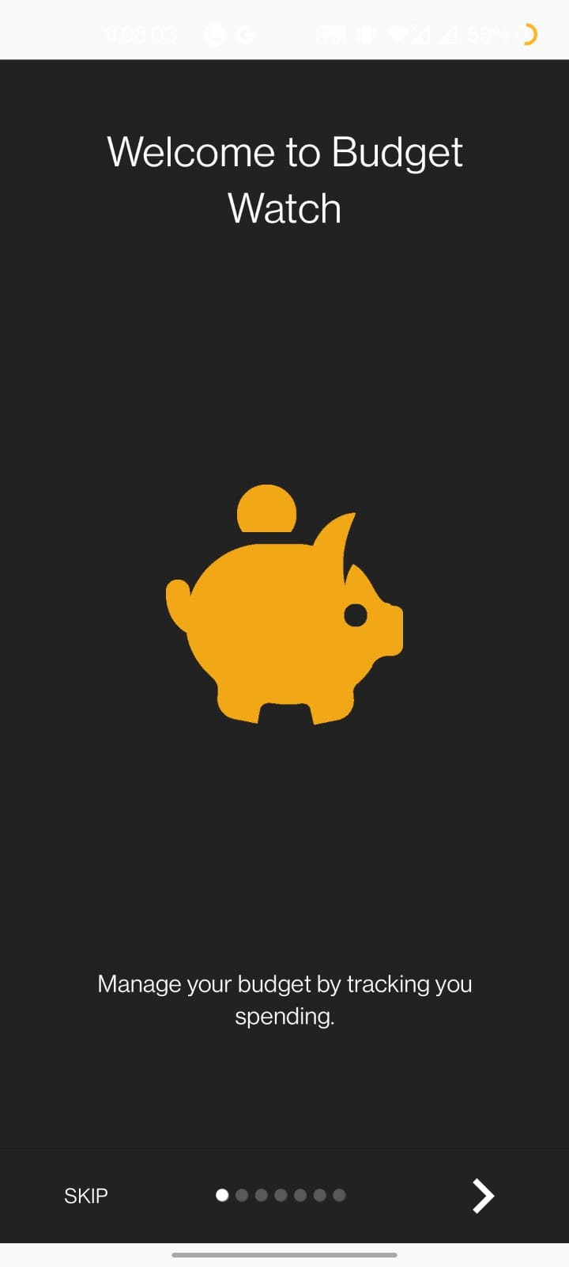 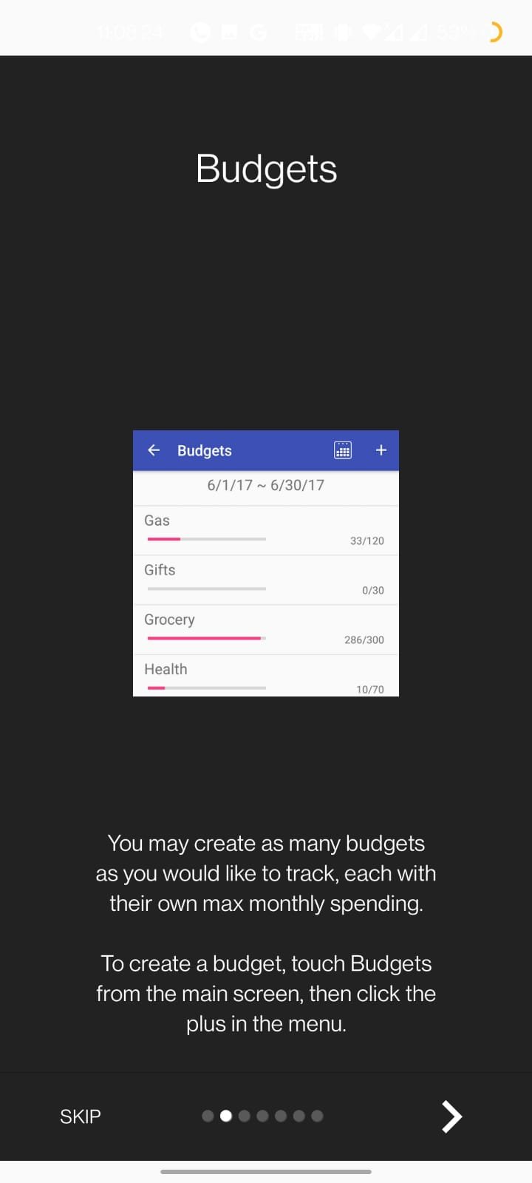

**Intro Page 3 Intro Page 4**

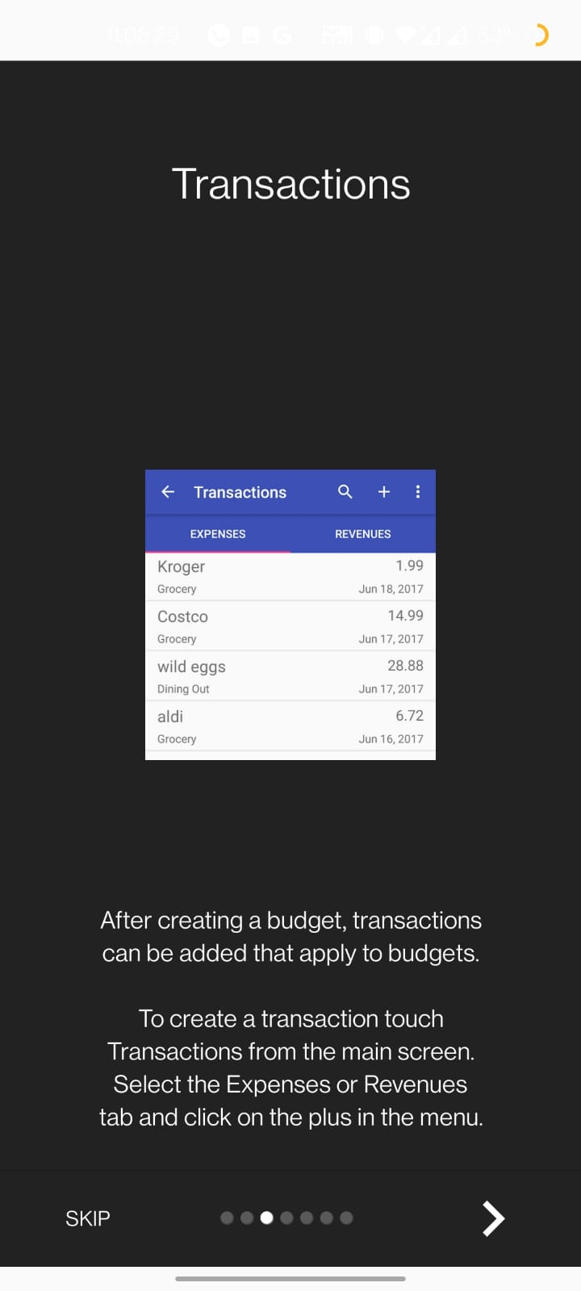 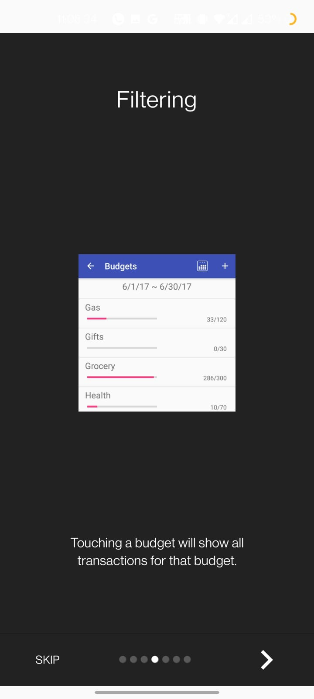

**Intro Page 5 Intro Page 6**

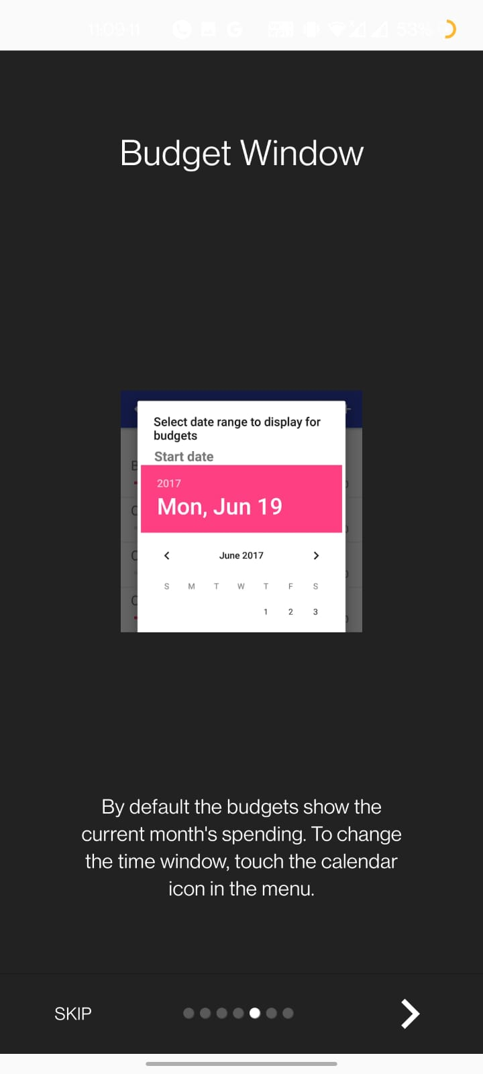 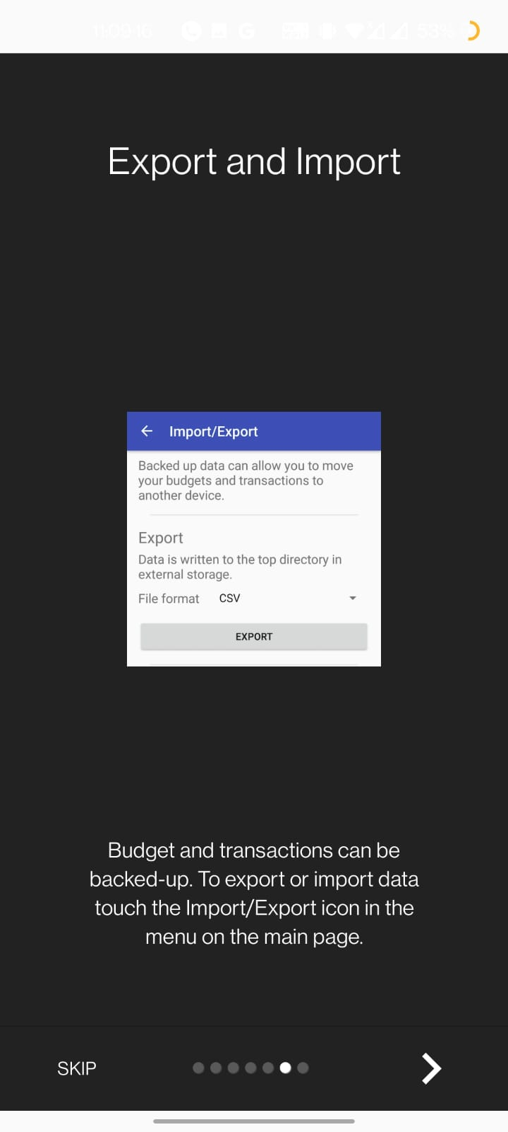

**Intro Page 7 Home Page**

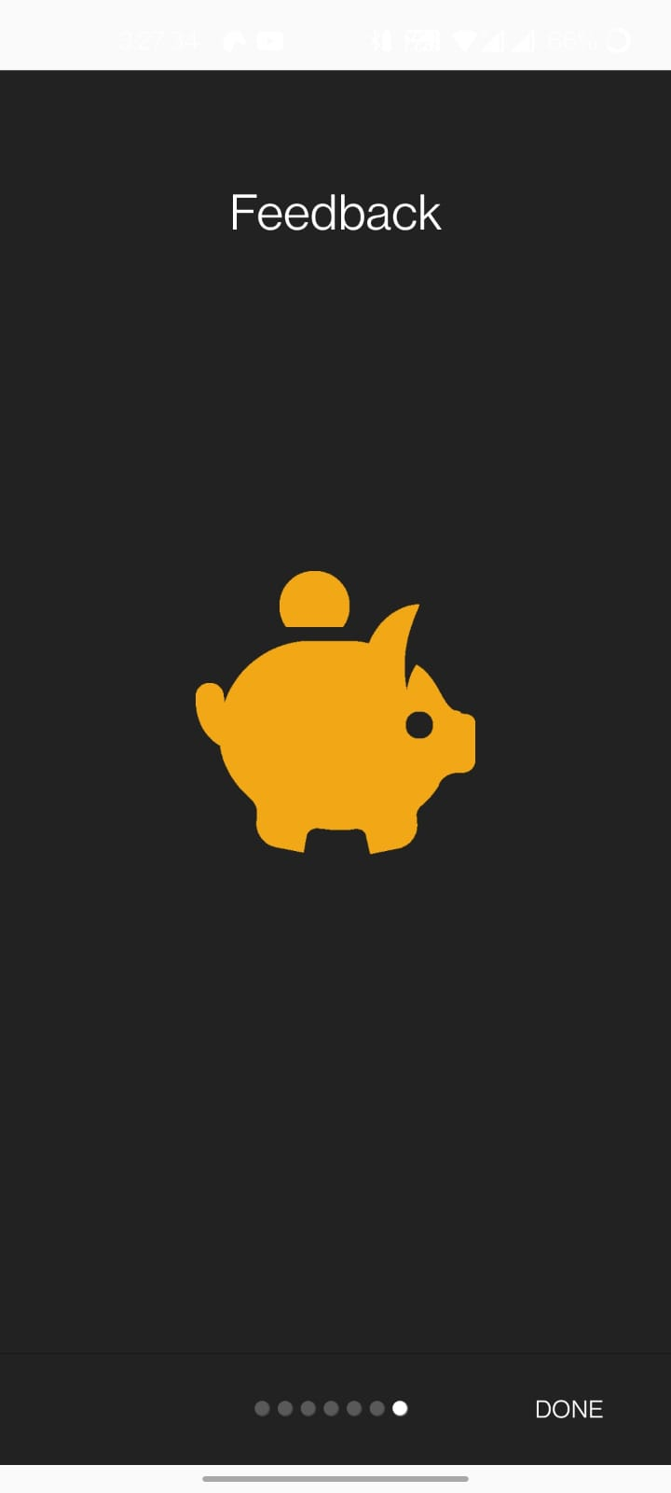 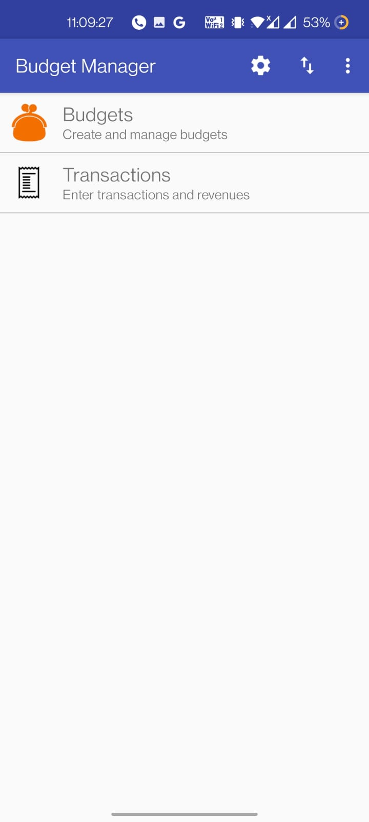

**All Budgets Add Budget**

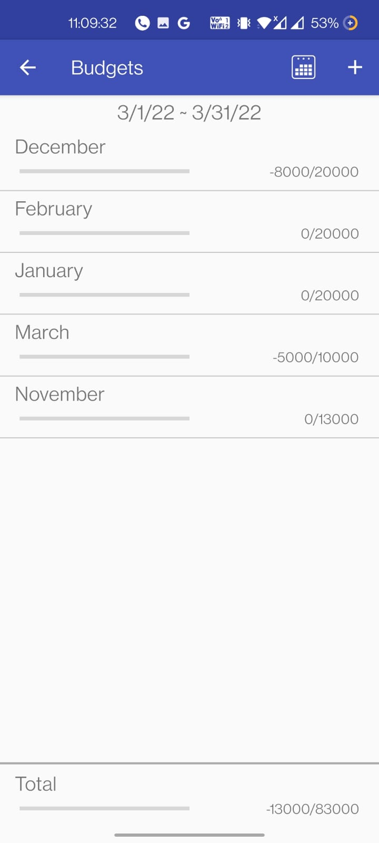 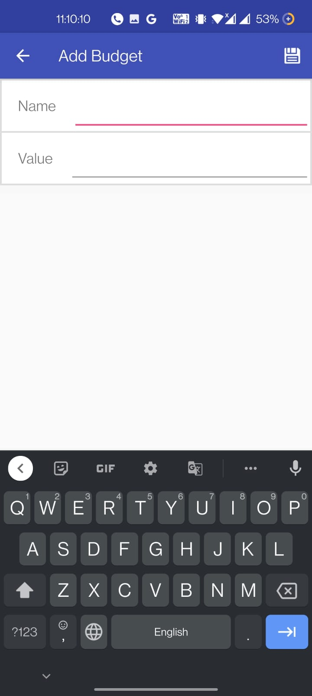

**Display Budget Expense Transaction for a Particular**

**Budget**

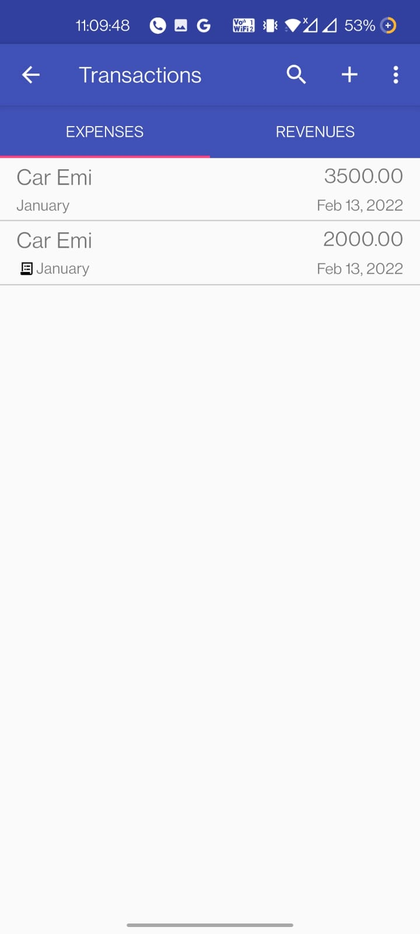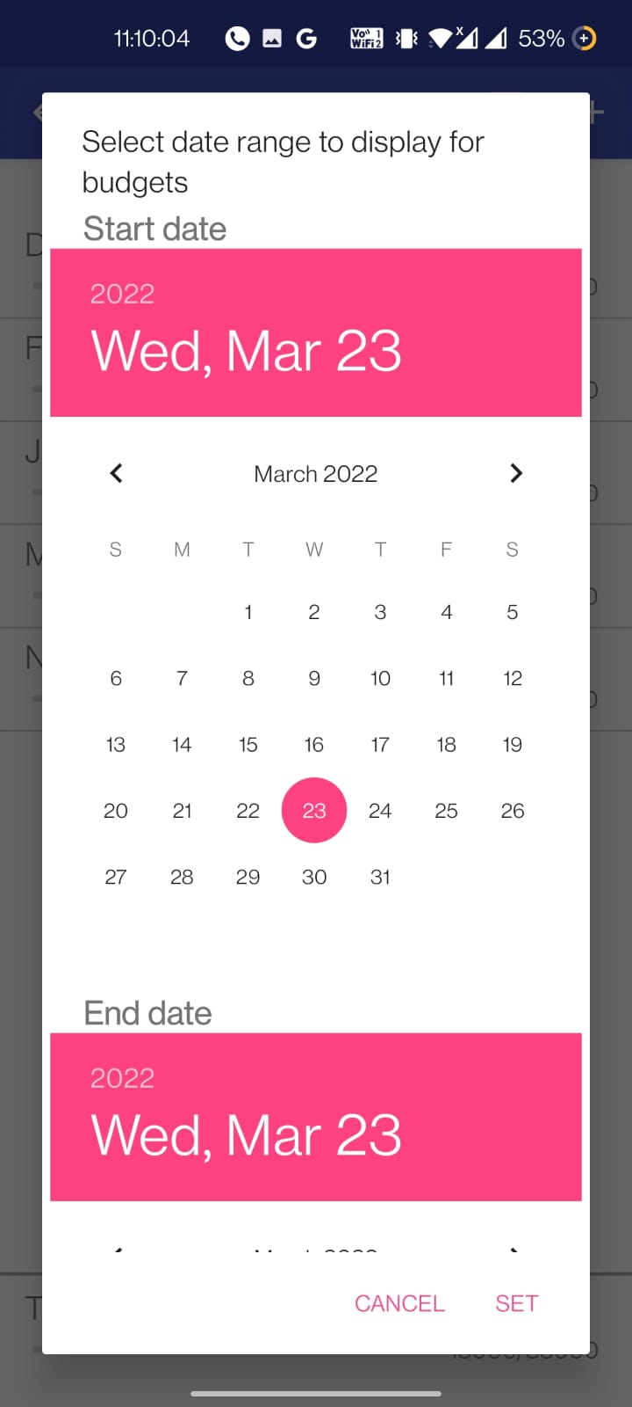

**Revenues Transaction All Expenses Transaction**

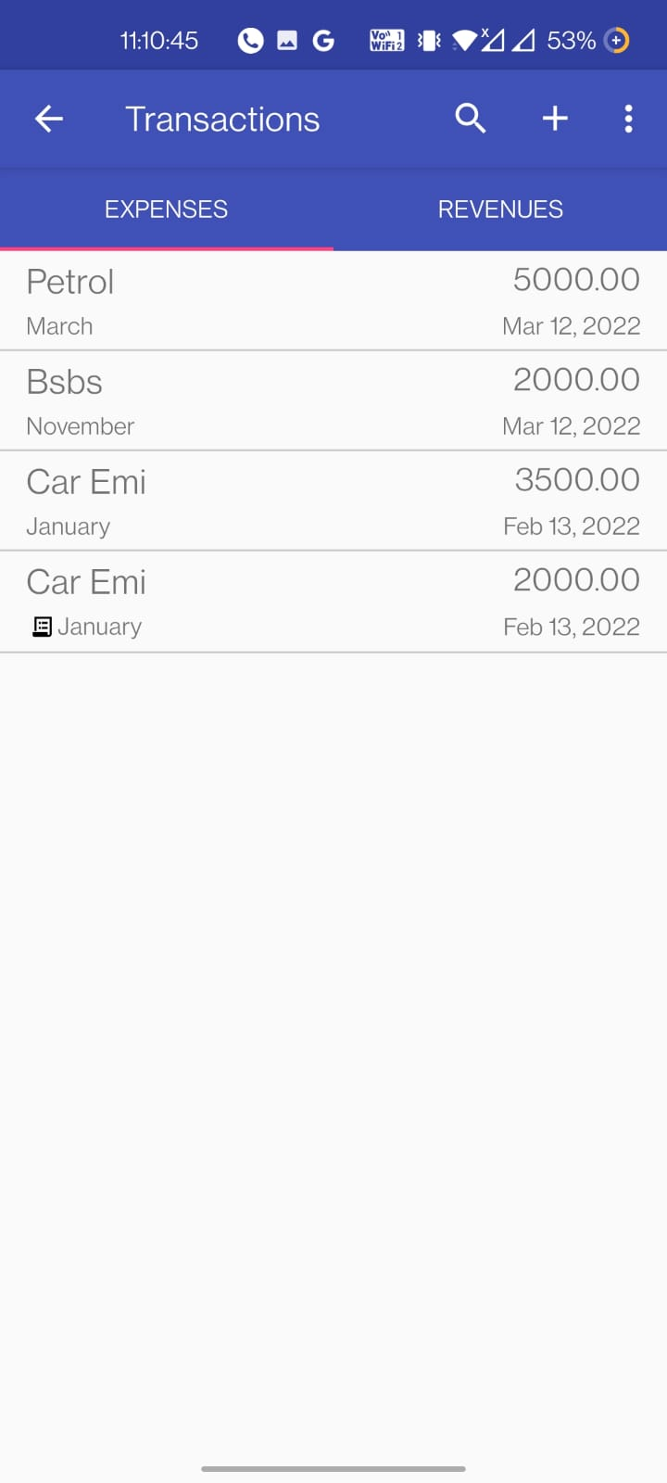 **for a Particular Budget for all Budget**

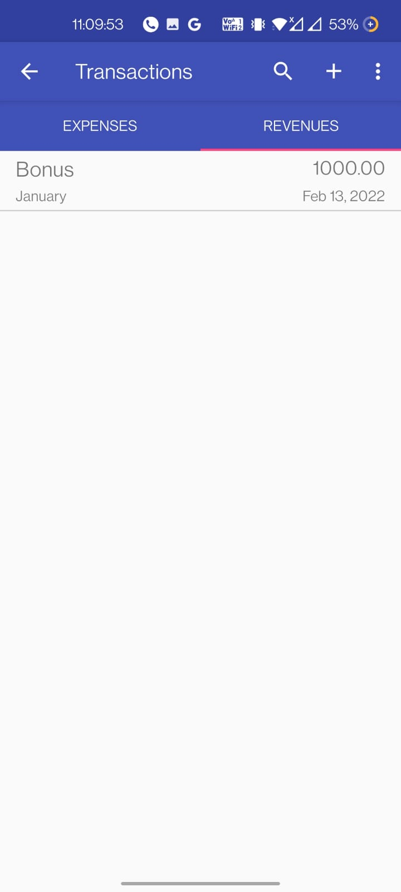

**All Revenues Transaction of all Budget Add Expense**

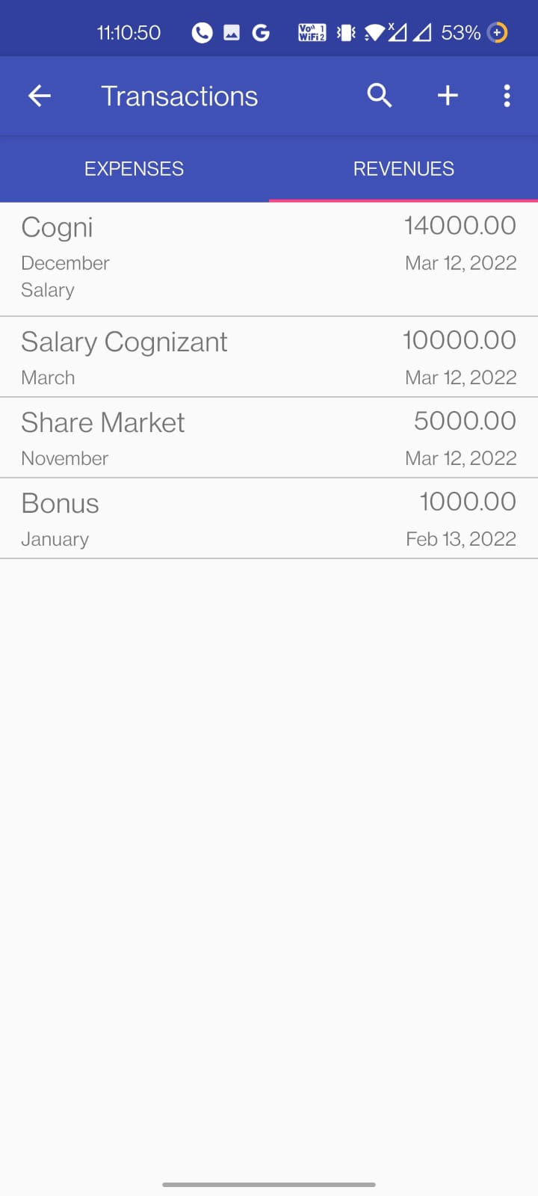 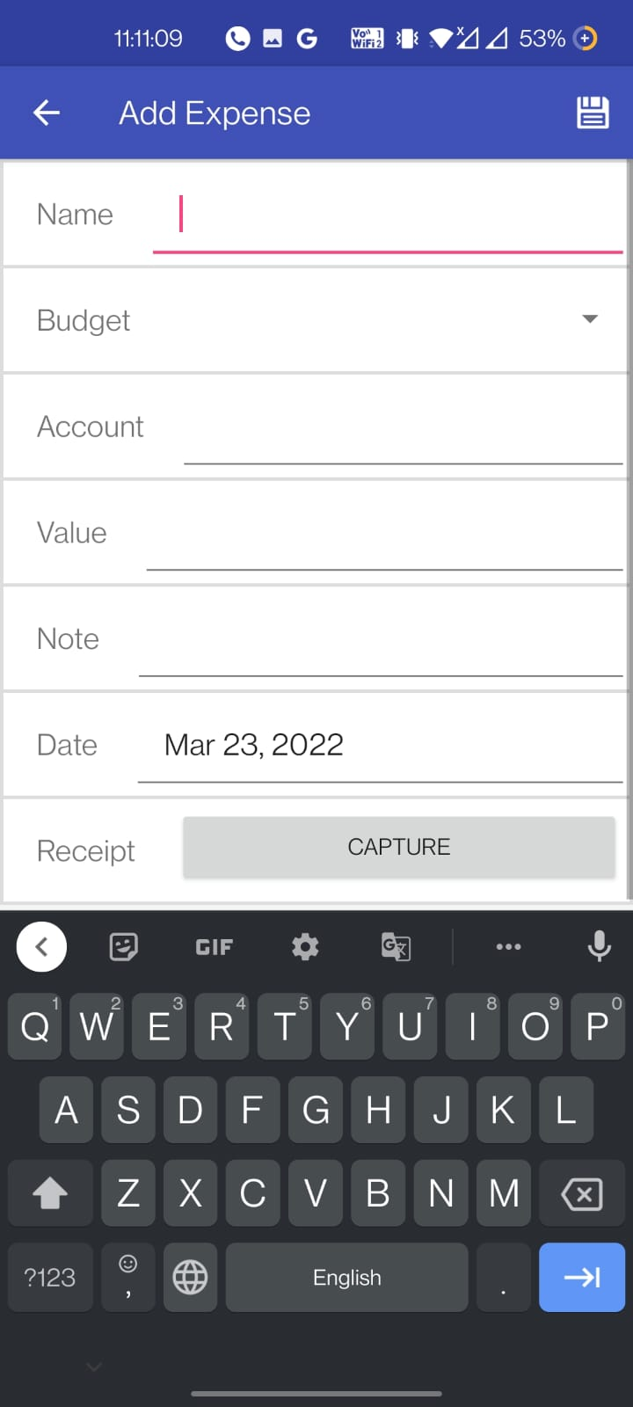

**Add Revenue Search for Transaction**

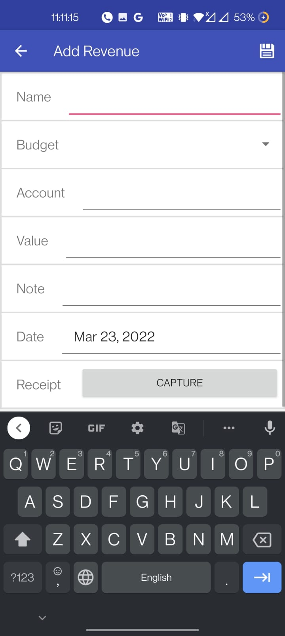 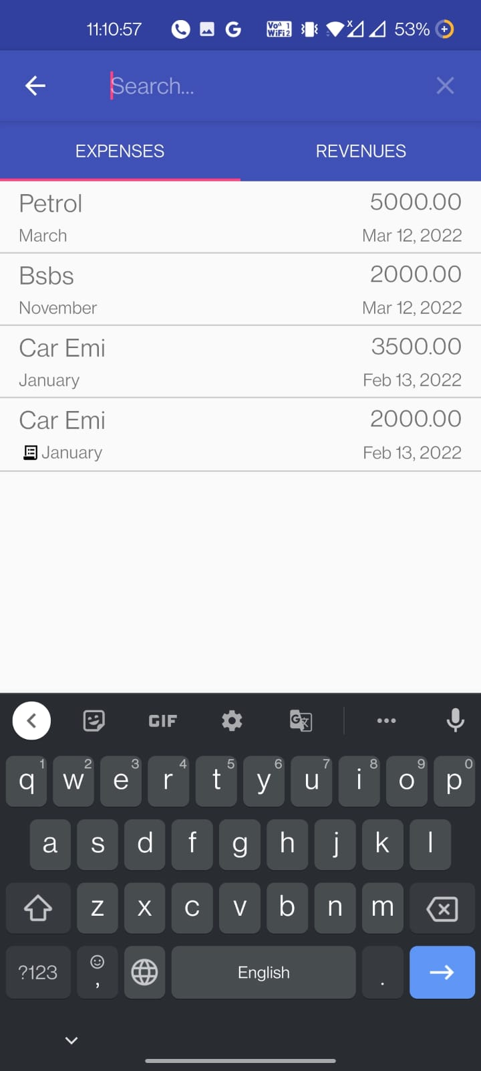

**Import / Export Settings**

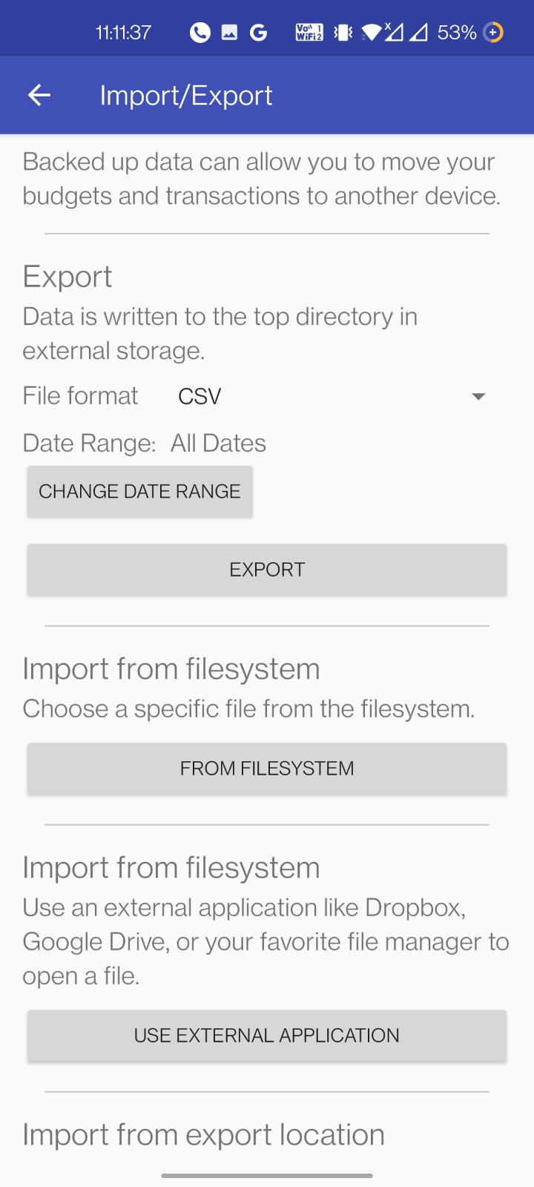 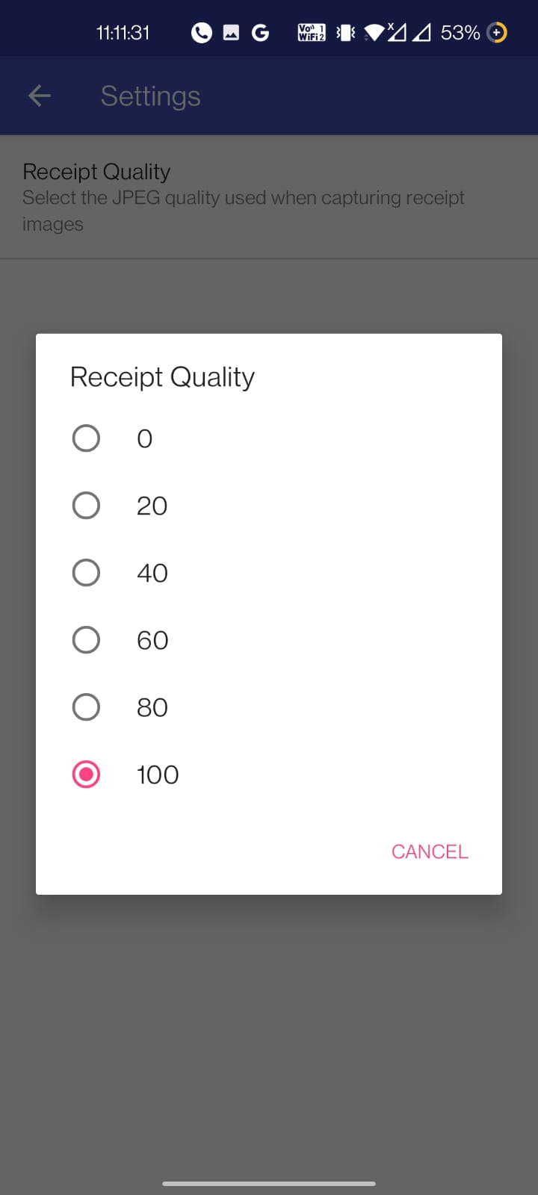

**Purge Old Receipt**

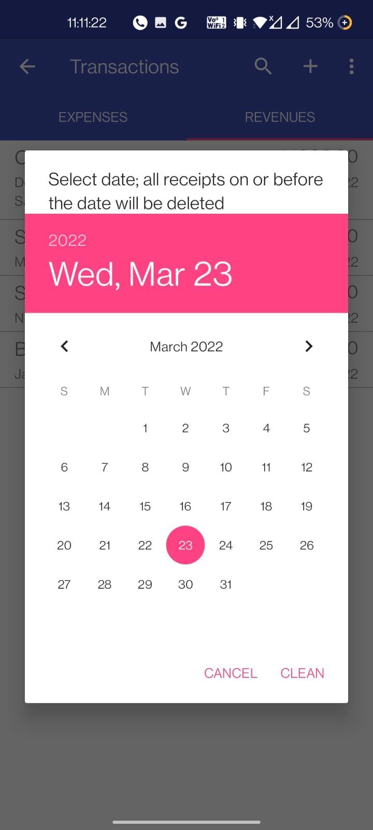

**TEST CASES**

* While adding transactions, Try adding decimal number, it should accept the decimal values.
* While adding a transaction whether it is Expense or revenue check whether while using Add Receipt option camera is opened or not.
* While searching for transactions check for case sensitivity.
* In Settings try to select receipt quality option.
* In Import Export option try to import a file using “Import from filesystem option”.
* In Import / Export option try to Export the file.
* Display Budget using Calendar Range function.
* After using Purge old receipt option check whether receipt files get deleted or not.

**CONCLUSION**

This system helps us to reach out our budget easily, we can track on daily basis that, how close are we to achieve our budget. And also, in the case if we are having some revenues then we get aware that we are getting away from our budget. So, this is a very efficient way of budget tracking.

**REFERENCES**

1. <https://developer.android.com/docs>
2. <https://www.geeksforgeeks.org/android-tutorial/>
3. [www.w3schools.com](http://www.w3schools.com)
4. [www.google.com](http://www.google.com)
5. [www.colorlib.com](http://www.colorlib.com)
6. [www.themes.getbootstrap.com](http://www.themes.getbootstrap.com)

**Thank You!**