DATA PIPELINE DOCUMENTATION
(KAFKA: PRODUCER -> CONSUMER -> S3 -> SNOWFLAKE)
NAME: SAHIL SUMAN; GGID: 30139507

STEP 1: COLLECT DATA SET (IN THIS CASE STUDENTDATA.CSV)
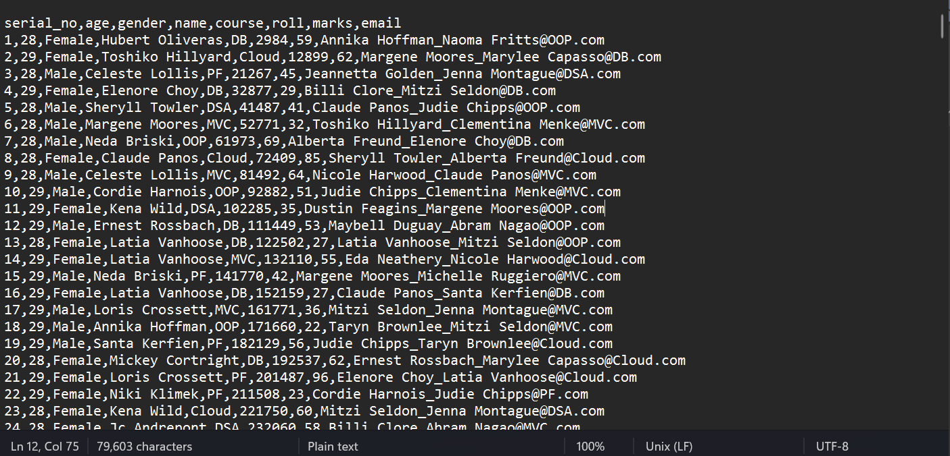

STEP 2: SSH / CONNECT TO EC2 AND ADD THE DATASET CONTENTS TO ITS LOCAL STORAGE
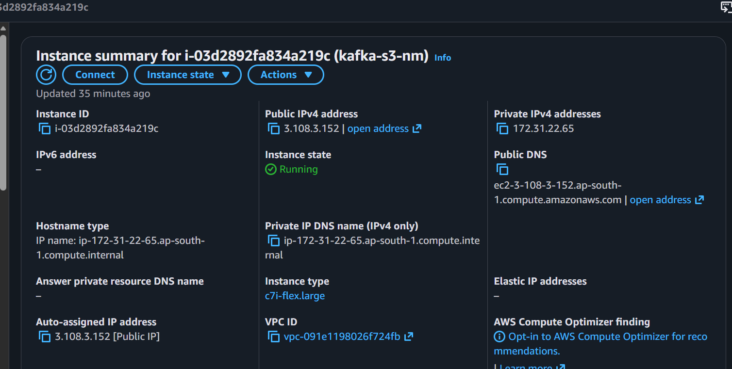

STEP 3: INSTALL KAFKA AND START ZOOKEPER AND SEVER AS -DAEMON
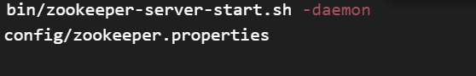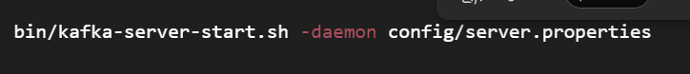
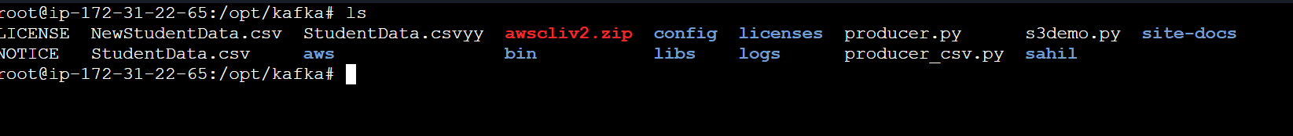

STEP 4: CREATE TOPIC AND WRITE THE NECESSARY FILES (PRODUCER_CSV.PY AND S3DEMO.PY IN THIS CASE):
- CREATING TOPIC (CAPGEMINI IN THIS CASE)

- PRODUCER_CSV.PY
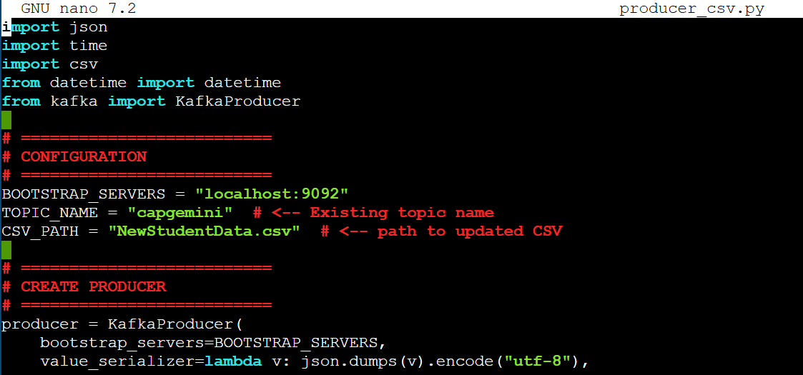
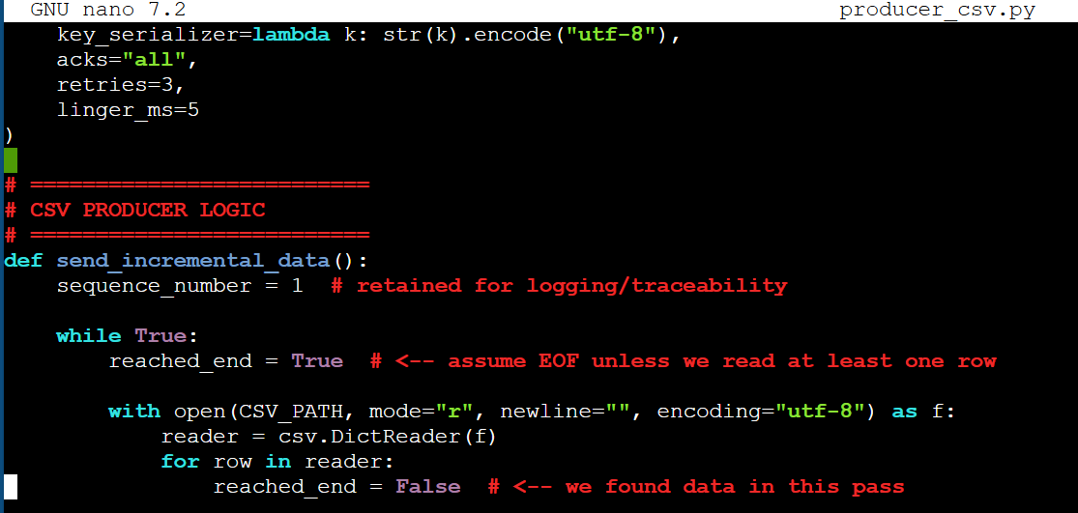
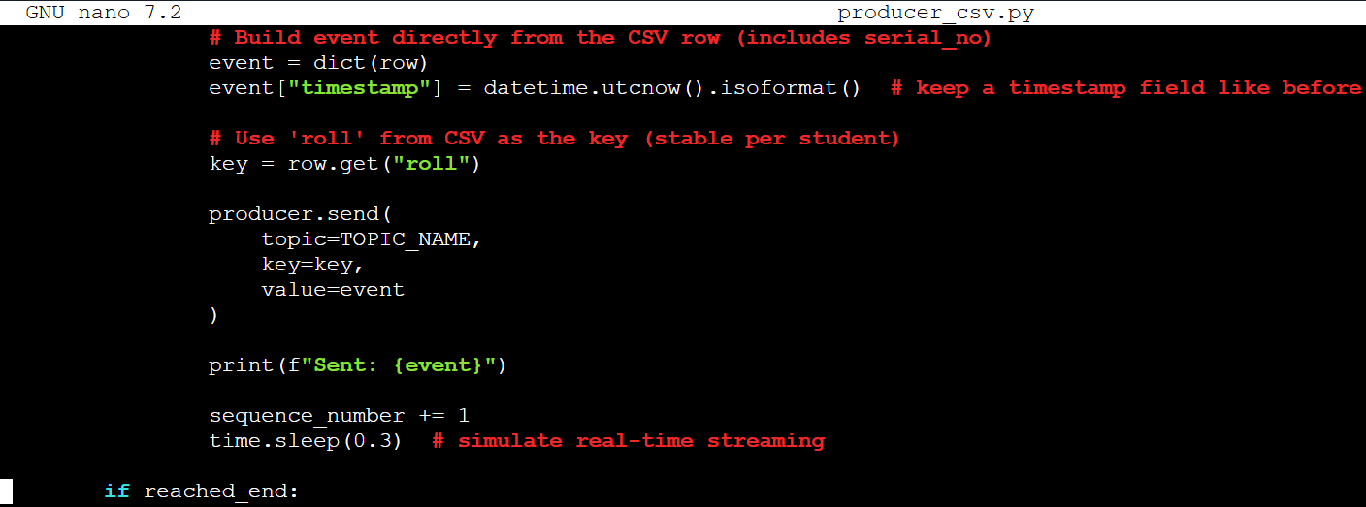
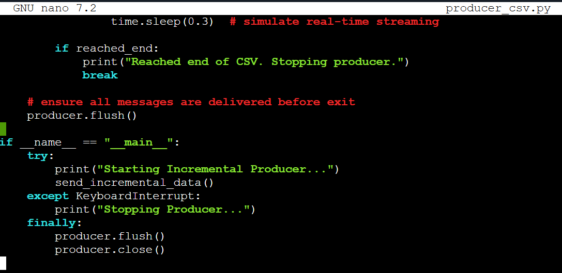

C) S3DEMO.PY (CONSUMER, THAT IS RECEVING AND STREAMING DATA TO S3)
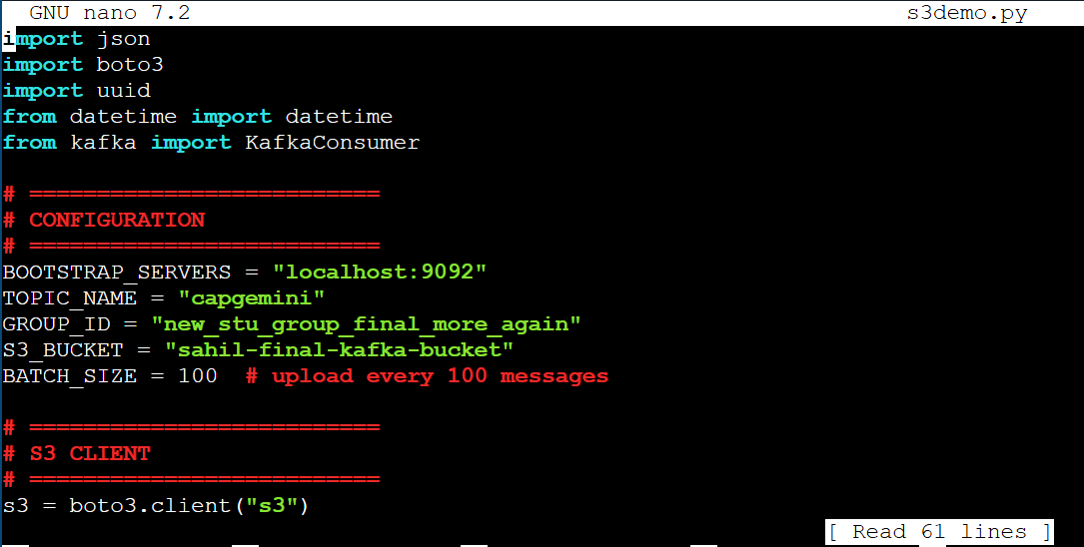

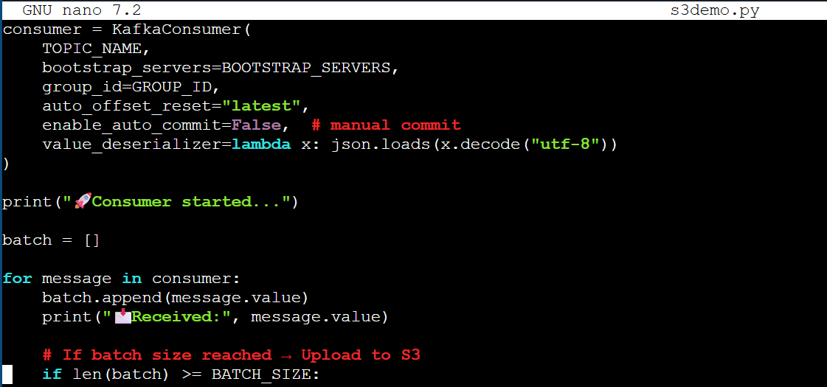
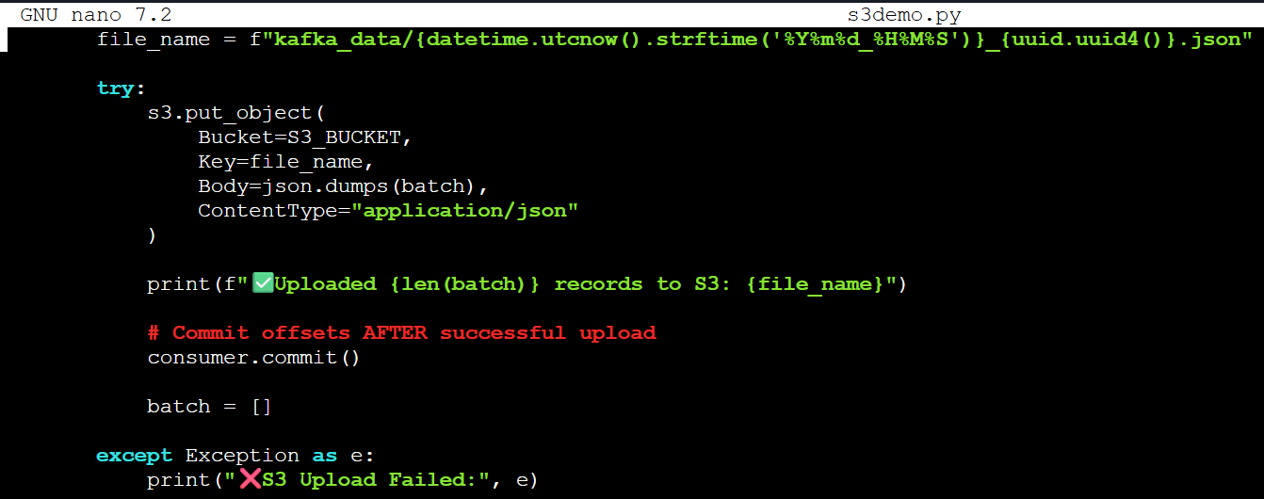

STEP 5: CREATE IAM ROLE FOR S3 ACCESS AND ATTATCH IT WITH YOUR EC2 INSTANCE
(KAFKA-S3-ACCESS HERE)
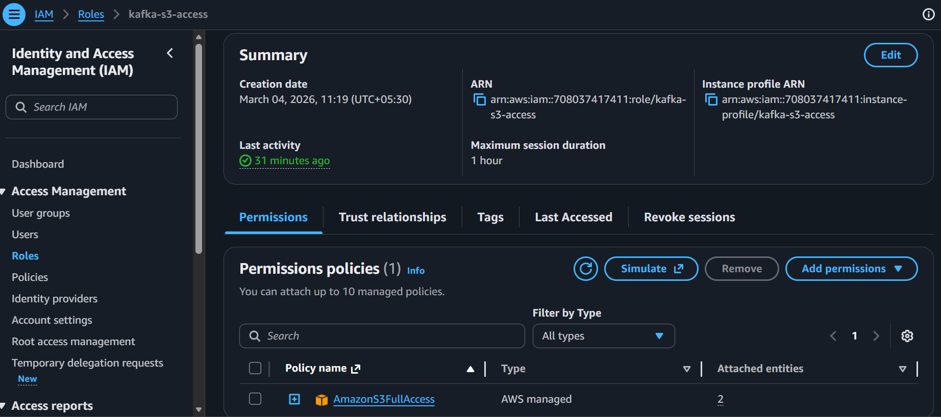
STEP 6: INSTALL AWS CLI AND CHECK ACCESS
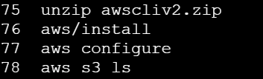
STEP 7: INSTALL PYTHON VENV, MAKE A VIRTUAL ENVIRONMENT AND RUN THE FOLLOWING COMMANDS
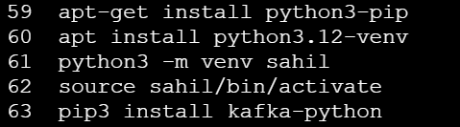
STEP 8: RUN S3DEMO.PY (IT WAITS FOR INCOMING DATA)
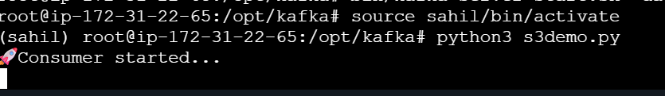

STEP 9: RUN PRODUCER_CSV.PY (IN ANOTHER TERMINAL ON THE SAME MACHINE)
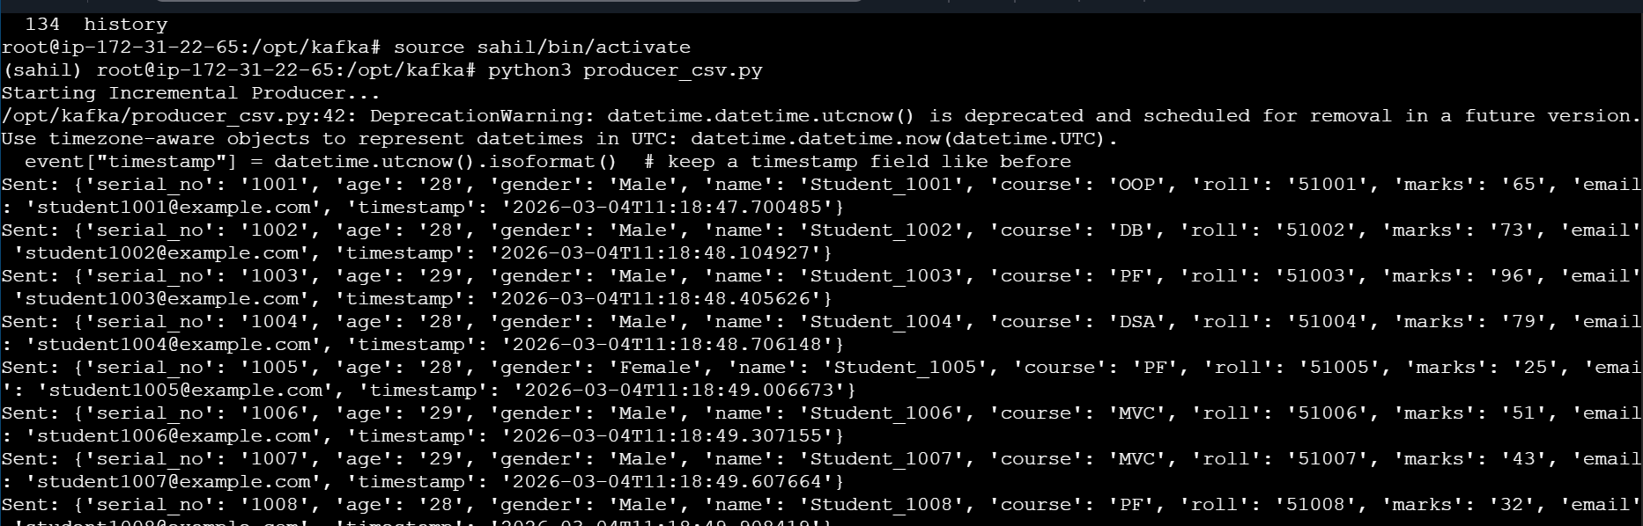
S3DEMO.PY STARTS RECEVING AND UPLOADING TO S3
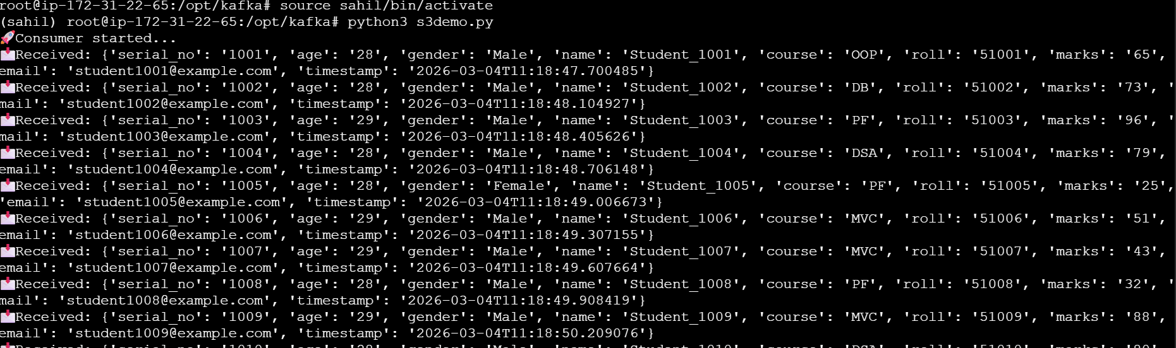
OBJECTS IN S3 (1100 RECORDS SENT IN 11 BATCHES , 100 BATCH_SIZE) :
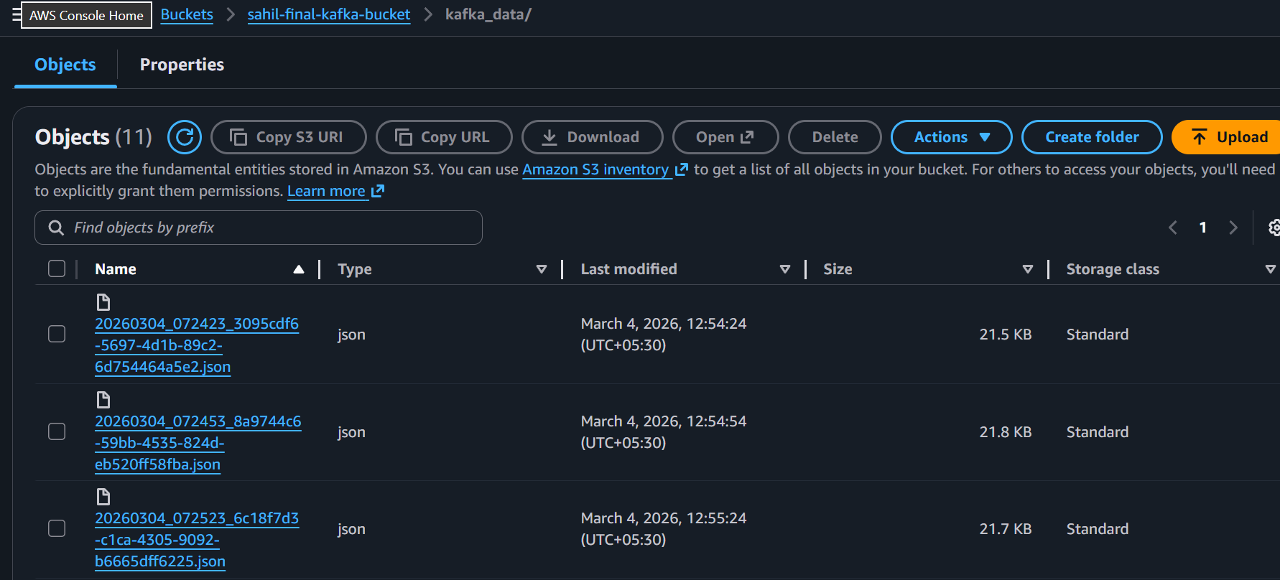

POST THIS STEP, LOGIN TO SNOWFLAKE AS ACCOUNT ADMIN AND CONTINUE…

STEP 10: CREATE AN IAM ROLE WITH THE FOLLOWING
ACCESS POLICY –
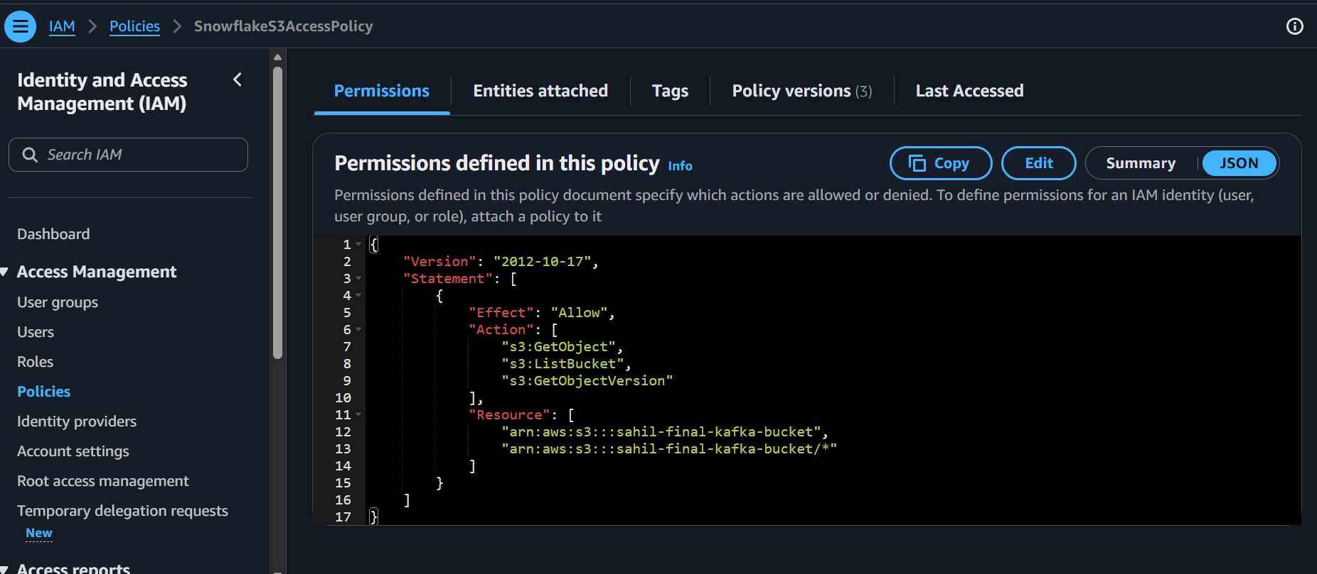
TRUST POLICY: (EXTERNAL ID AND AWS ARN FOUND AFTER RUNNING DESC STORAGE INTEGRATION <NAME> AFTER CREATION)
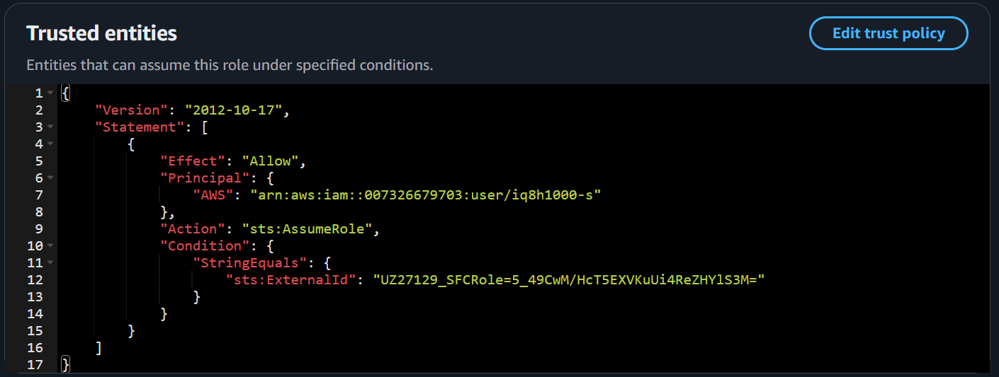

STEP 10: CONFIGURE STORAGE INTEGRATION WITH THE NECESSARY CREDENTIALS
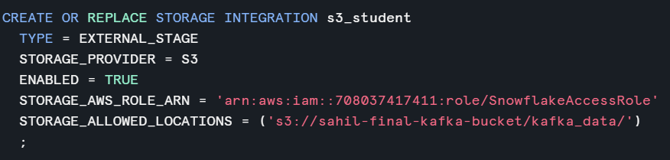

STEP 11: GET IAM ARN AND EXTERNAL ID FROM DESCRIPTION AND PASTE INTO TRUST POLICY
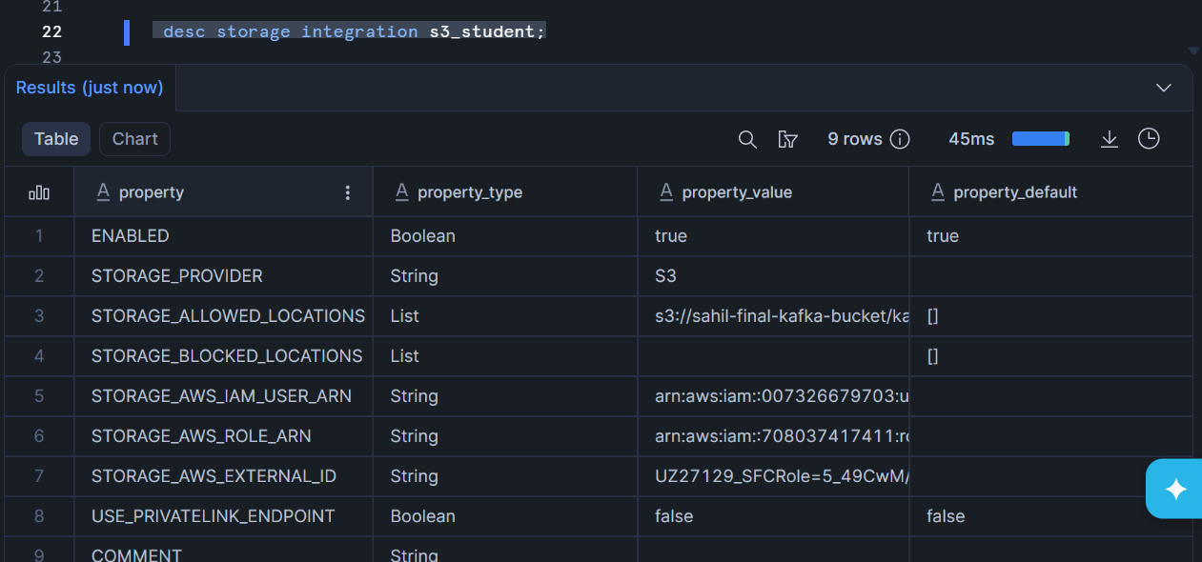

STEP 12: CREATE STAGE
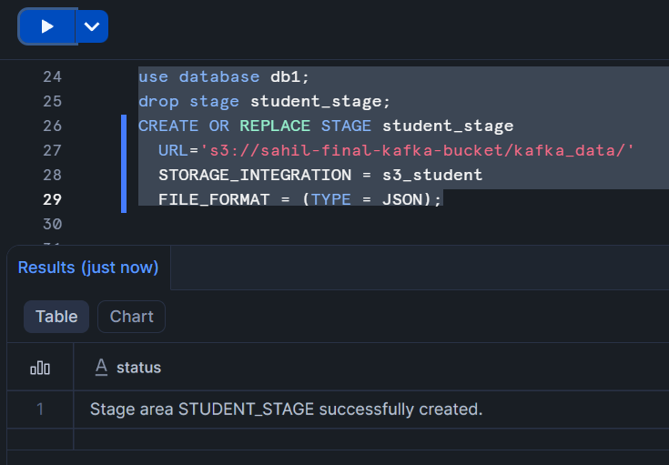

STEP 13: RUN LIST <STAGE NAME> TO VERIFY DATA INGESTION
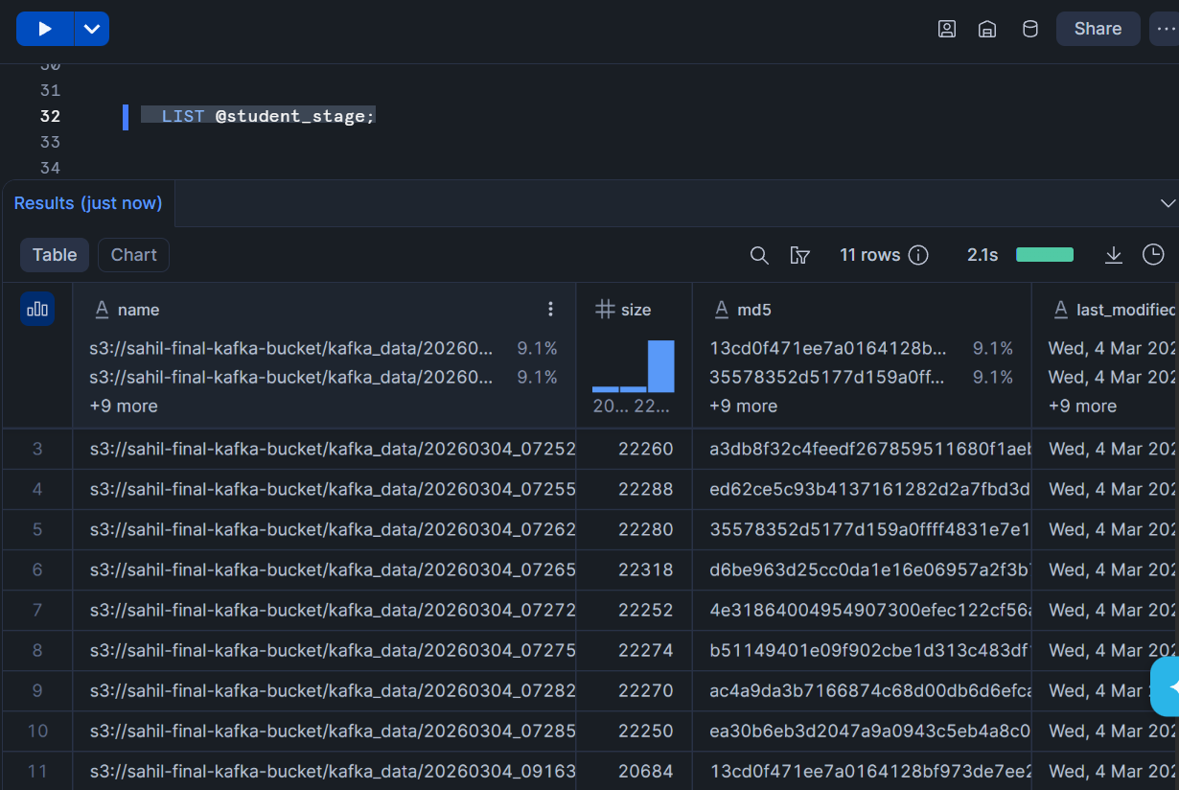
STEP 14: CREATE RAW TABLE
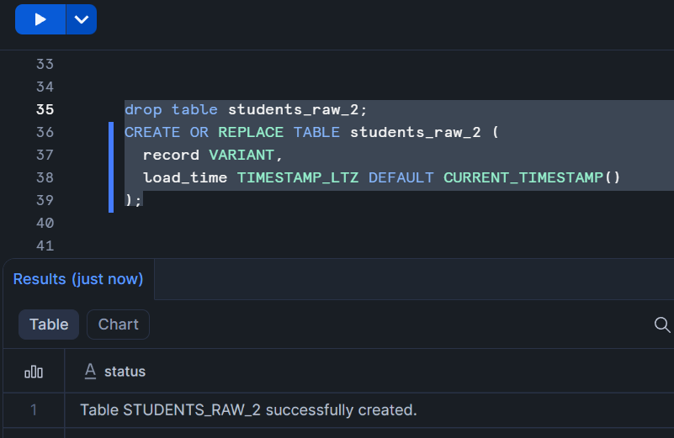

STEP 15:CREATE PIPE AND COPY DATA FROM STAGE TO RAW TABLE
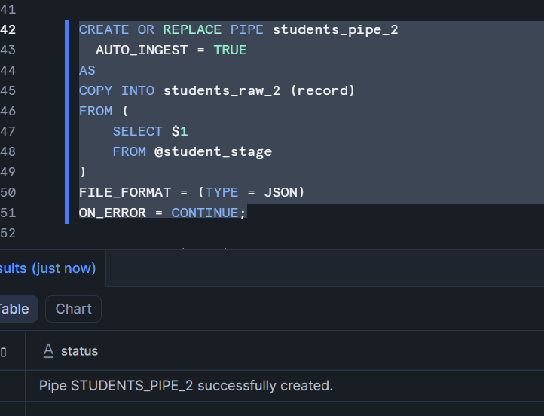

STEP 16: RUN ALTER PIPE <PIP_NAME> REFRESH TO INGEST NEW DATA (IF ANY, SINCE MANUAL INGESTION)
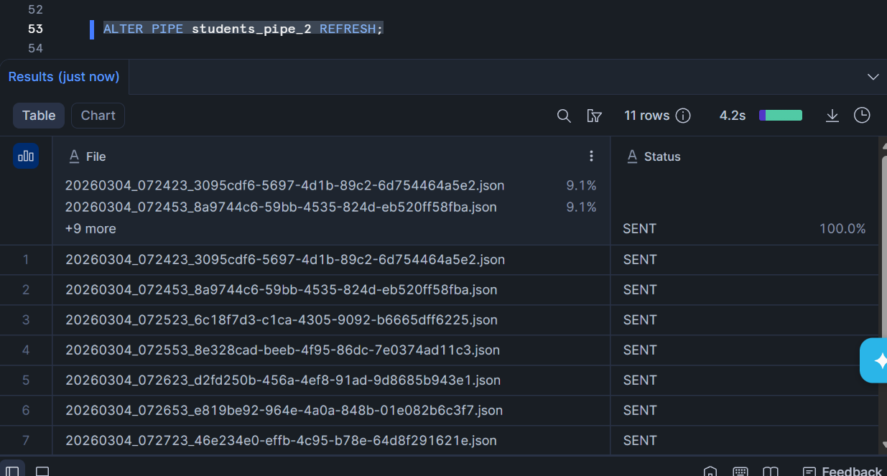

STEP 17: CHECK RAW_TABLE FOR OBJECTS
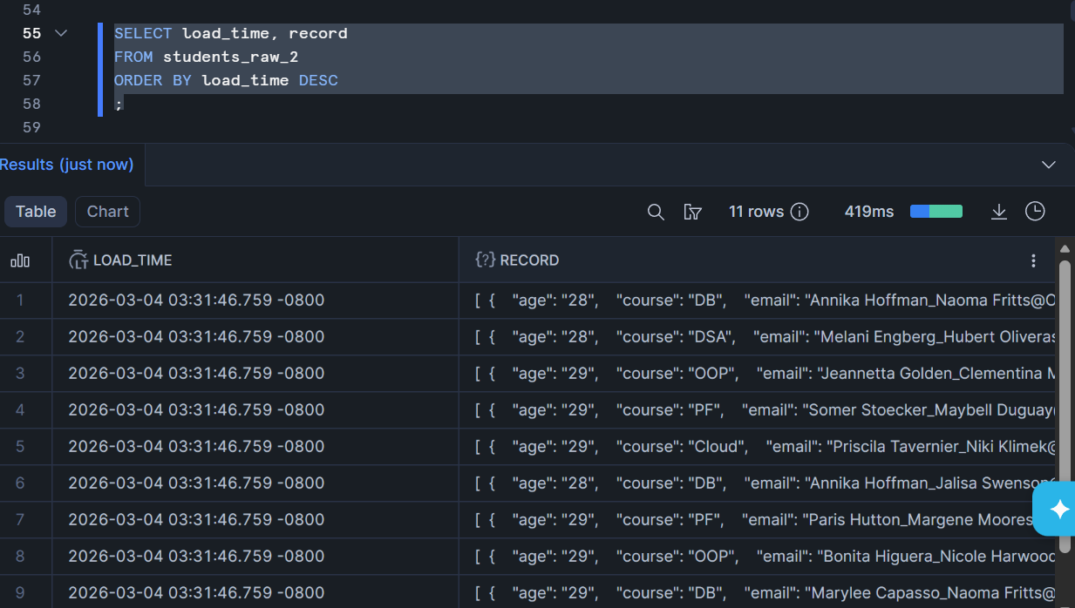

STEP 18: CREATE VIEW AND FLATTEN JSON DATA TO PUSH INTO TABLE
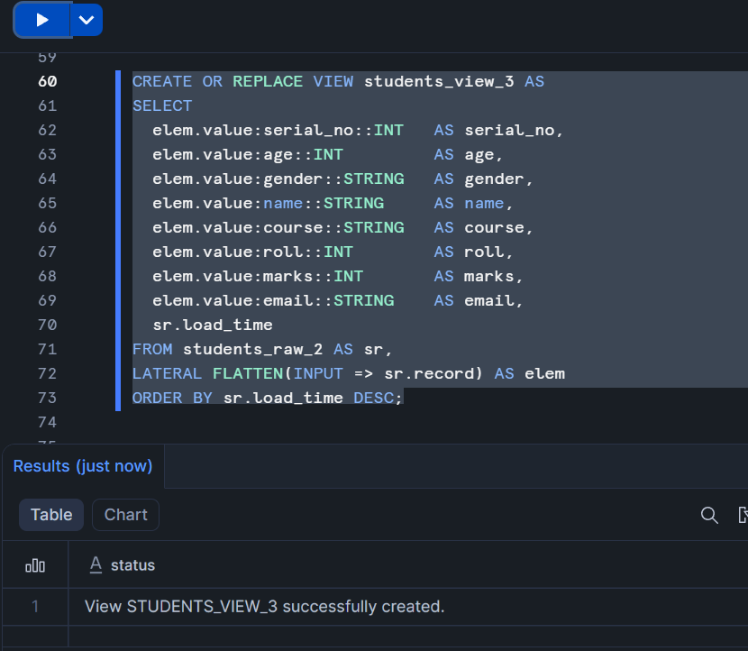

STEP 19: FINALLY, CHECK THE VIEW TO CHECK IF ALL THE RECORDS HAVE BEEN RECEIVED
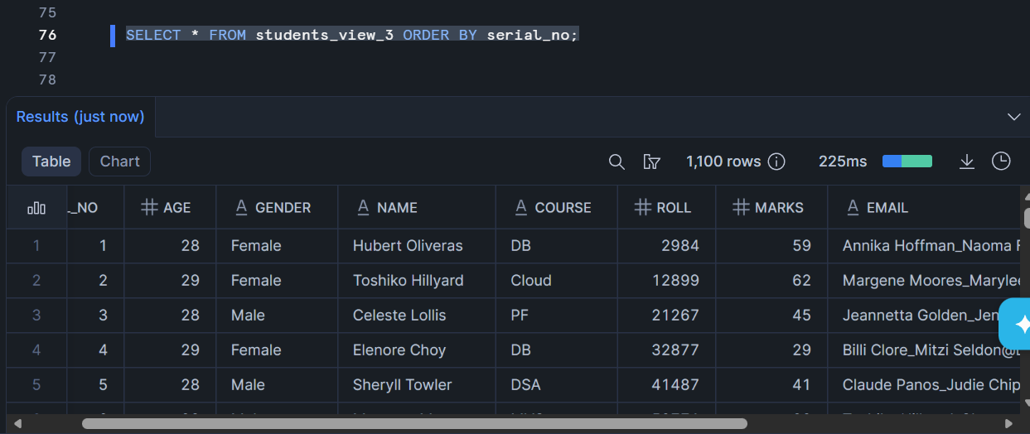

THE END.

