REDSHIFT – HANDS ON
Sahil Suman: 30139507

Step 1: S3 Bucket Creation and allowing Public Access
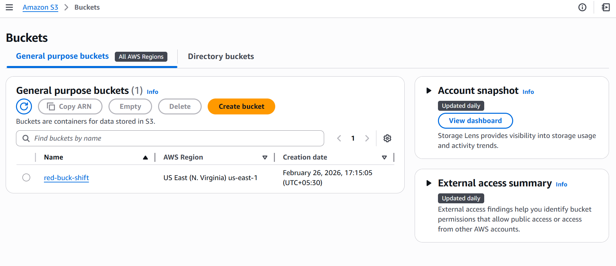

Step 2: Edit Bucket Policy
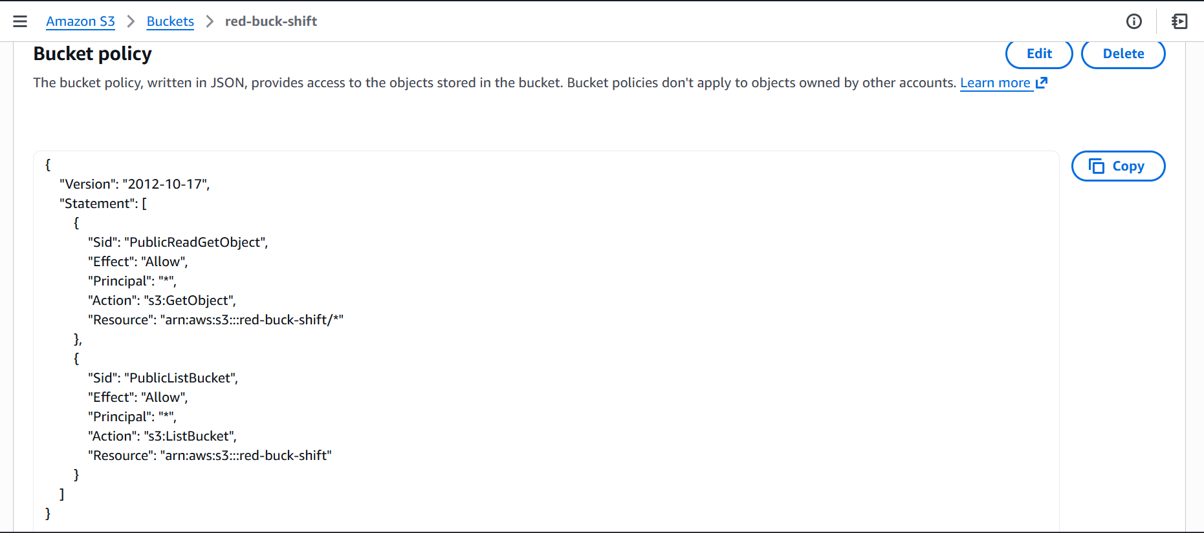

Step 3: Upload required files

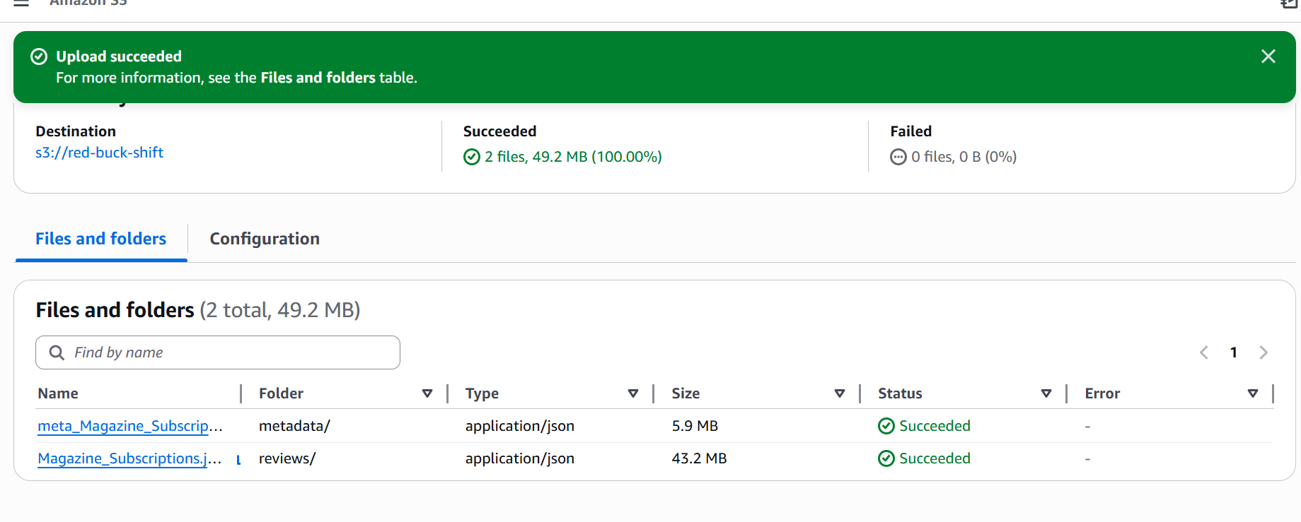

Step 4: Create RedShift Cluster
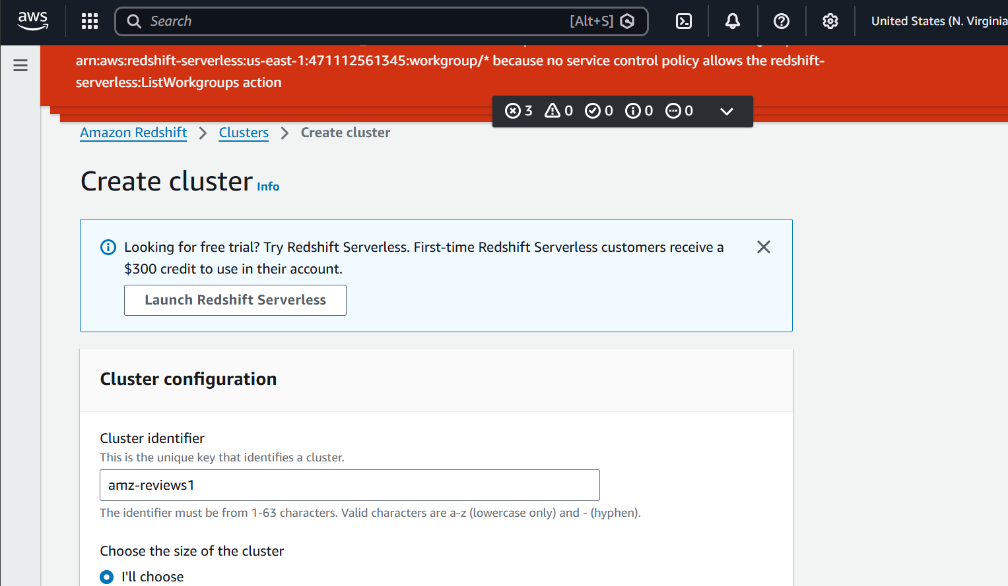

Step 5: Create IAM Role and grant it access to the created bucket, while associating it to redshift cluster
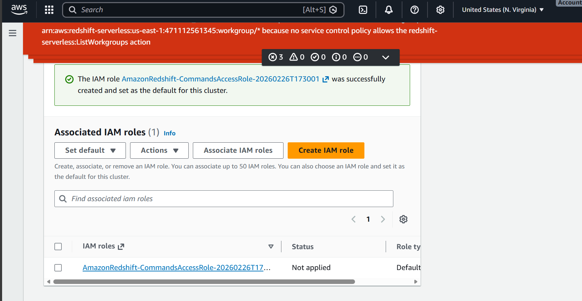

Step 6: Make an EC2 instance and download dependencies.
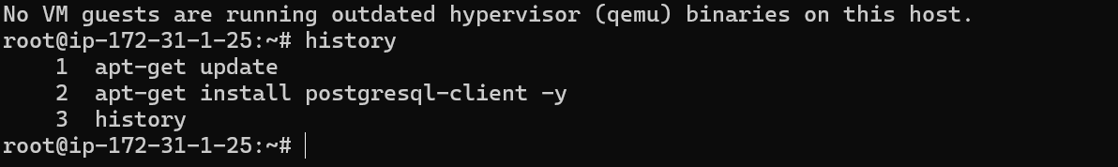

Step 7: Connect REDSHIFT cluster to EC2 instance
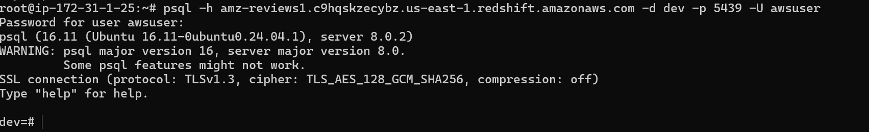

Step 8: Upload required files to S3 Bucket
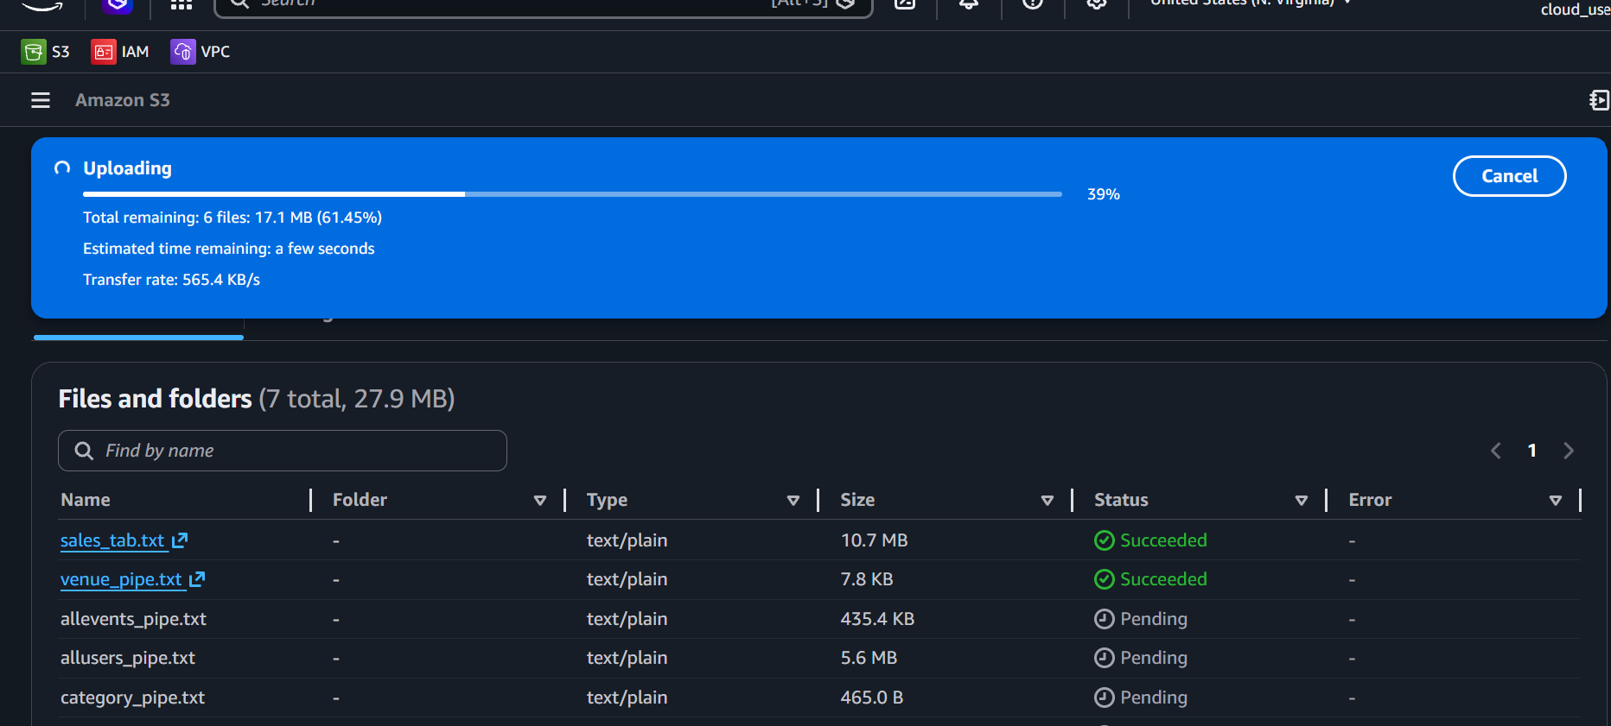

Step 9: LOAD data onto RedShift via S3

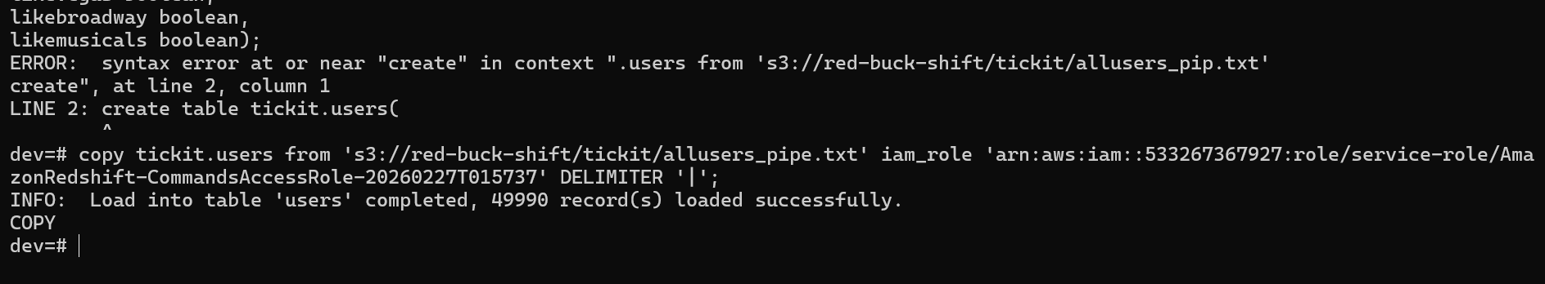

P.T.O

Step 10: Perform BASIC CRUD operations on a separate table
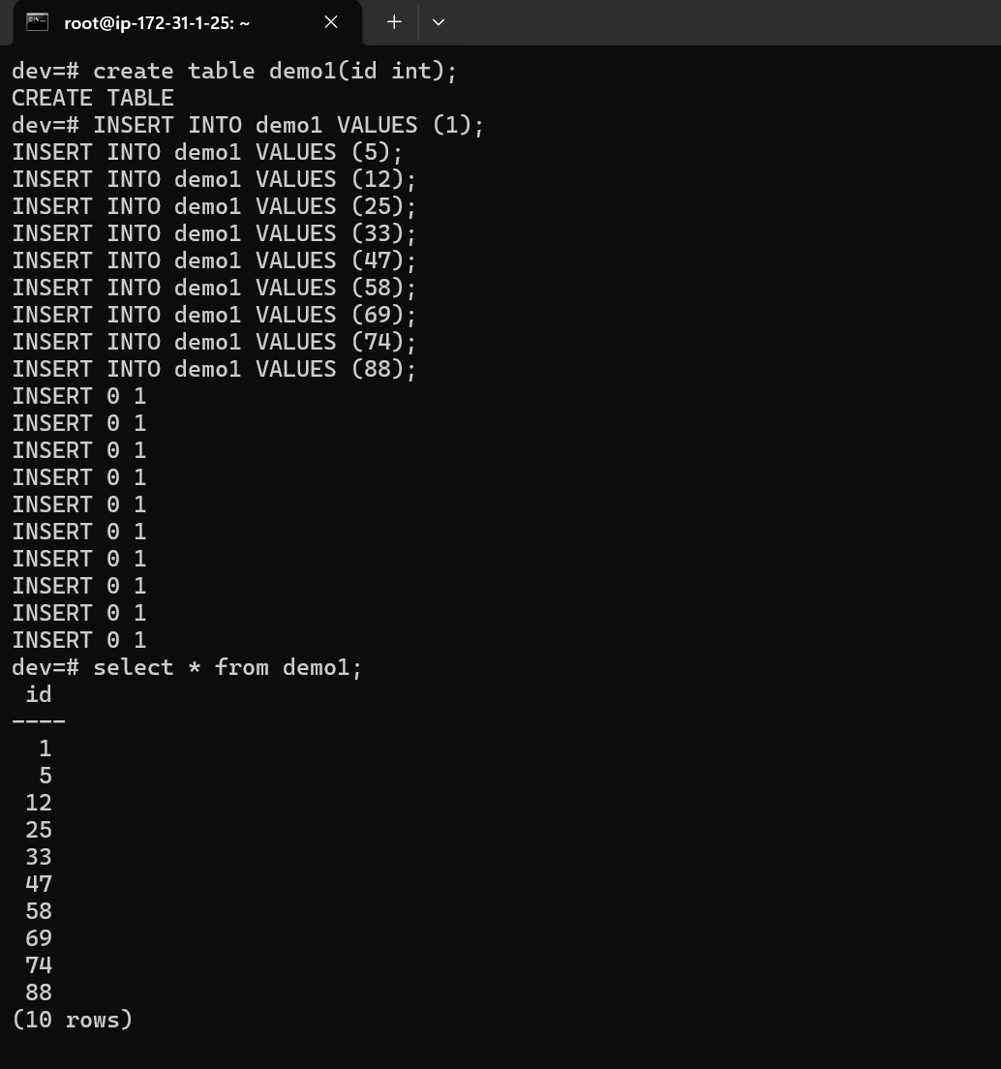

STEP 11: Unload Data from RedShift back to S3
