

DELIVERY ON FOOT



**CAPSTONE PROJECT REPORT**



DEVELOPED BY: MANDEEP KAUR-[C0684262]

SAHIL THAPAR-[C0688032] MOHAMED FAHAD SHAIKH-[C0686094]

TABLE OF CONTENTS

1. Introduction *1*
2. Work Plan *2*
   1. Pre-Execution 2
      1. Requirement gathering 3
      2. Analysis 3
      3. Layout Design 4
      4. Development 4
      5. Testing 5
   2. Post-Execution 6
      1. Requirement gathering 7
      2. ER Diagram 7
      3. Analysis 8
      4. Layout Design 8

2.2.3 Class Diagram 9

* + 1. Use-Case Diagram 10
    2. Development 11
    3. Testing 11

1. Application Walkthrough *15*
   1. Customer UX 15
   2. Runner UX 21
2. Monetisation Methods *24*
   1. Service Fees Incurrment 24
   2. Mobile Advertising 24
3. Conclusion 25

References 25

# INTRODUCTION

## About the App:

The basic idea of the app is to provide same-day delivery service at an affordable price for a city. The regular postal/mail service provided by the local or the federal government is often very slow or not very efﬁcient with their service and delivery timings and can take up to 2 days.

To overcome this problem, we have come up with an app that will provide a platform for people to send and receive items across the city. Customers who wants to get their items delivered across the city will use the app to post a listing which will have item’s name, description, value, pick-up/delivery address & time etc.

The registered users whom we will refer as Runners will see this listing on their phone and bid for it. Once a successful bid is made and both parties have agreed, the item will be picked up and delivered as per decided address

& time.

The targeted users are people form the local area of city who want to send or receive items on the same day.

The app is also very helpful to people who are looking for part-time work opportunity and willing to deliver items across the city and earn some extra cash.

# WORKPLAN (Pre-Execution)

**[What we aim to do]**

The approach we will be following here to execute the Software Development Life Cycle will be a hybrid of Iterative and Agile Development methodology.

Agile software development describes a set of values and principles for software development under which requirements and solutions evolve through the collaborative effort of self-organizing cross-functional teams. It advocates adaptive planning, evolutionary development, early delivery, and continuous improvement, and it encourages rapid and ﬂexible response to change.

The following representation provides an insight of our intended timeline.

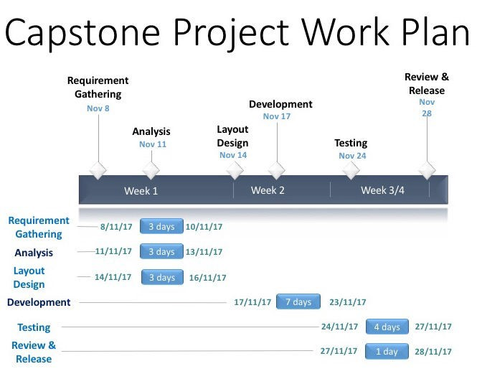

## The following section will explain each we aim to follow as per the work plan:

Requirement gathering:

The Requirements gathering is an essential part of any project and project management. Understanding fully what a project will deliver is critical to its success.

We will be providing three days towards this step as it gives us an overall understanding of the app and will help us in achieving our goal of meeting the requirements of the app.

In this step, we will obtain the primary requirements of the app that we need to achieve. We will also be assessing the basic functionality that has to be developed to get the app running and also the extra features that we will be adding on later.

In the process we will be idealising the the complete walkthrough and steps that a user will be performing in terms of both the customer and the runner. During the whole process we will be brainstorming on various ideas while taking a note of them so they can used during our next phase of Analysis.

## Analysis:

All the information and the requirements that we gathered and all the ideas and fucntionalities that we intend to implement during the previous phase will be analysed and summarized during this phase. We will be analysing on ways to implement the requiremnts into actual code and get it working.

During this step we will also be rectfying the features and functionalities that we deem unnecessary and might hinder with the basic requirements of the app. This phase will be taking upto three days of the work plan.

At the end of this phase, we shall have the necessary data that goes into prodcution of the app.

## Layout Design:

During this phase we will be plotting and designing the layouts for individual screens and interfaces of the application. It includes the deﬁning of elements that are to be used on the interfaces and their relative positioning on the screen.

After designing the layout, we will be incorporating the application ﬂow and the various interfaces will be linked together to obtain and pleasing user experience.

Like the previous phases, we will be alotting three days from our work plan towards this phase. At the end of this phase we will be having a complete navigation ﬂow of the app with each screen completely designed to deliver a smooth and easy-to-use User Experience.

## Development:

This phase will be the most important phase of our work plan and we will be giving upto seven days of time towards this phase. During this phase we plan to incorporate the requirements into production.

We will be using the layouts that we designed in the earlier layout design phase. The ﬂow of the development will follow the application’s navigational ﬂow and we will be coding the back-functionality and also render the XML ﬁles for each interface screen.

Using the as-we go approach, we will be aiming to complete the full navigation of the app which will not only be working as per our requirements but we will be also eliminating and troubleshoot the errors and that come across during the development phase.

## Testing:

This is one of the vital phases of our work plan because this is where all the hardwork we put in during all the earlier phases will go on at test drive. We will be giving no less than 4 days towards this phase. We will be designing several Test cases for various criterias and will be running them all on the app to come across maximum numbers of bugs and misfunctionalities.

With rigourous testing on multiple devices we aim to discover and eliminate maximum if not all the bugs and errors and come up with a reliable application that delivers a great experience and perfomance for the users.

# WORKPLAN (Post-Execution)

**[What we actually did]**

As mentioned earlier the approach we will be following here to execute the Software Development Life Cycle will be a hybrid of Iterative and Agile Development methodology.

We followed the above mentioned methodologies religiously and tried to encorporate all its principals into our work plan. We were able to follow the alloted work days towards each phase on most instances with a minor delay here and there between phases.

Consequently, the great design and principles of the methodologies we followed helped us in achieving our requirements and we came up with an exceptional app that was not only reliable and fast but also implemented the most recent technologies in practice currently.

The below representation demonstrates our post exectuion workplan.

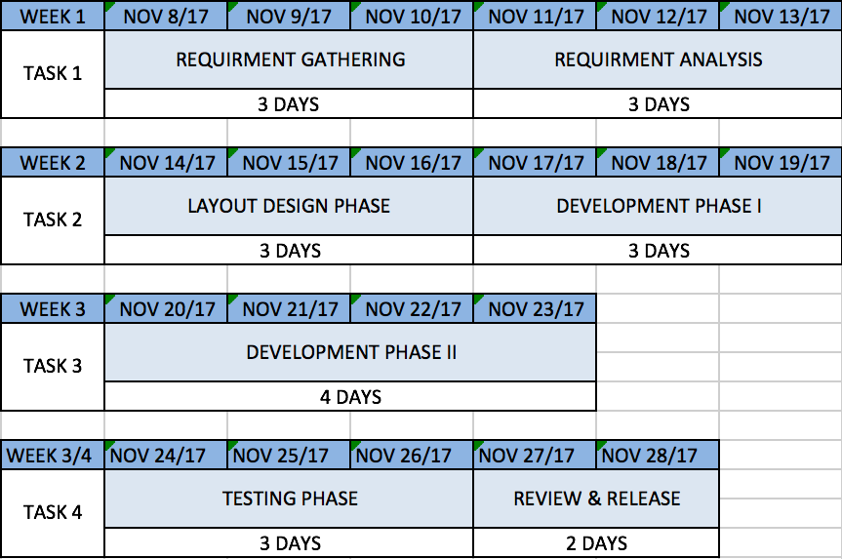

## The following section will explain each step we followed as per the work plan:

Requirement gathering:

This phase was the very beginning of our development cycle and we started with imagining the app from scratch and what it is supposed to do and how it will do it. We brainstormed on ideas in team and came up with the most feasable one’s and extended them further. We carefully noted down the preliminary requirements of the app so that it gives us a kickstart for the development phase and have a basic skeleton of the app.

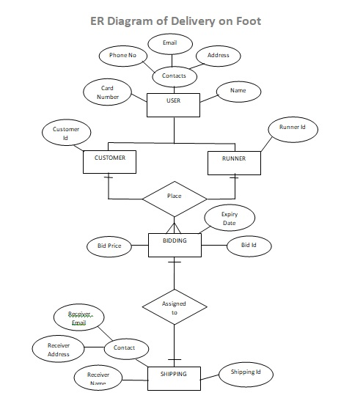

Analysis:

As now we had the initial requirements and functionality of the app that we gathered and intend to implement during the previous phase were analysed and summarized during this phase. We deduced on ways to implement the requirements into the actual application and get it working.

We will also rectfyed the features and functionalities that came across as unnecessary and might hinder with the basic requirements of the app.

By the end of this phase, we had a solid understanding of the app and the requirements and it gave us the conﬁedence to proceed with the development stage.

## Layout Design:

During this phase we actually hand-drew the designs and the layouts for individual screens and interfaces of the application. We deﬁned the elements that are to be used on the interfaces and their relative positioning on the screen.

While designing the layouts, we incorporated the application ﬂow and the various interfaces that were linked together to obtain and pleasing user experience while also maximizing the effectiveness of the production.

This phase in particular proved to be very helpful for the development phase as by the end of this phase we had complete navigation ﬂow of the app with each screen completely designed.

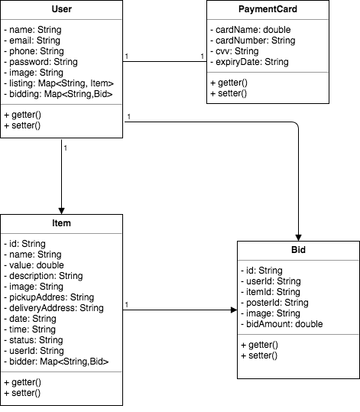

**CLASS DIAGRAM**

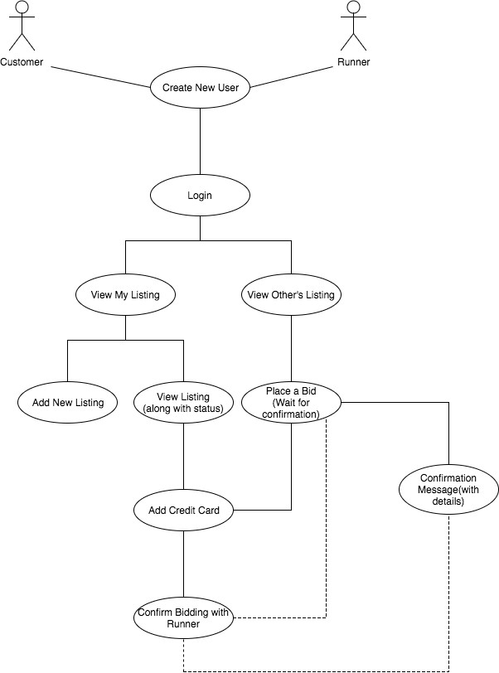

**USE-CASE DIAGRAM**

Development:

This phase was easily the most critical phase of our work plan and the most time consuming as well. During this phase we incorporated the requirements into production.

We used the layouts that we designed in the earlier layout design phase. The ﬂow of the development were implemented with the application’s navigational ﬂow and we will be coded the back-functionality and also optimized the overall look and feel of the app.

However, we faced many instances where the app would crash completely and it gave us the short-comings of our code. We rectiﬁed each of the errors that we came across during such crash instances and eliminated the bad code snippets replacing them with more optimum solutions that would not only solve our issue but also enhance the fucntionality of the app.

## Testing:

As said earlier, this was one of the vital phases of our work plan as all the hardwork we put in during all the earlier phases was actually tested in real life conditions on actual devices. We made sure to give enough time that was 4 days towards this phase in our case.

We designed several Test cases for various criterias and ran them all on the app to come across maximum numbers of bugs and misfunctionalities using actual mobile devices and not just the emulator.

The follwing are some of the test cases we designed and incorporated during the testing phase:

|  |  |
| --- | --- |
| **TS** | **Test Scenarios** |
| TS_01 | User is able to see Login page once he click on icon to launch app |
| TS_02 | User should be able to put valid email |
| TS_03 | User should be able to put valid password |
| TS_04 | User should be able to login with valid credentials of email and password |
| TS_05 | User should be able to go to signup page when he click New User? Register Here! Link. |
| TS_06 | User should be able to enter his name. |
| TS_07 | User should be able to enter his email |
| TS_08 | User should be able to enter is phone number and only number in this ﬁeld no AlphaNumeric characters |
| TS_09 | User should be able to enter his password in password textbox which should not be visible |
| TS_10 | User should be able to enter his password again in Conﬁrm password ﬁeld which should not be visible. |
| TS_11 | User should be registered once he click on sign up button |
| TS_12 | User should be able to login after sign up. |
| TS_13 | "Add new Listing" button on welcome screen after user logged in |
| TS_14 | User should be able to click on "Add new Listing" button |

|  |  |
| --- | --- |
| TS_15 | User should be able to upload a picture through camera for the item he wants to bid in Add new Listing Page. |
| TS_16 | User should be able to ﬁll all the details in "Add new Lisitng" window or page. |
| TS_17 | User is not allowed to skip any information on "Add new Listing" page |
| TS_18 | User should be able to click "Done" button once user ﬁlls all the details of product for delivery. |
| TS_19 | User should be able to view his listing in "My Listing" tab. |
| TS_20 | User should be able to view List of others Listing in "Bid" Tab. |
| TS_21 | User should be able to change his password from ":"icon at upper right corner of screen. |
| TS_22 | User should be able to logout out successfully, once user clicks on Logout Button. |
| TS_23 | User should be able to update his proﬁle from same ":" icon at top. |
| TS_24 | user should be able to view List of items under "BID" section. |
| TS_25 | User should be able to act as a runner as well as a customer in one single account. |
| TS_26 | Runner should be able to place a bid for item to deliver. |
| TS_27 | Customer should ﬁll reciever details before conﬁrming Runner. |
| TS_28 | user should be able to ﬁll his credit card details for the ﬁrst time before accepting bid or listing item. |

|  |  |
| --- | --- |
| TS_29 | if runner is not able to deilver or runs away with item, money should be deduct from runners credit card which is equal to value of item mentioned by customer in listing. |
| TS_30 | Once customer approves runner bid, bid amount alongwith 5% charge should deducted from customer account. |
| TS_31 | Runner will get his payment, once runner successfully deliver the item at given destination before deadline |
| TS_32 | User should be able to delete his listing. |
| TS_33 | Customer should be able to see status of his listing for eg - Active, Inactive, Delivered and Pending. |
| TS_34 | User should ﬁll all the details about his credit card and accept privacy terms and conditions which is required by bussiness |
| TS_35 | User should not logout untill user click logout button. |
| TS_36 | User should be able to ﬁll contact form in case of any problem or feedback at upper right corner of screen under ":" icon. |
| TS_37 | Listing will disappear from BID area if customer conﬁrmed runner before deadline or mentioned time. |
| TS_38 | Runner would get message after conﬁrmed by customer which includes reciever details. |
| TS_39 | Listing will disappear from BID Tab if customer didn't conﬁrmed runner before deadline or mentioned time. |
| TS_40 | Customer should be able to delete inactive listing items from "My Listing" Tab. |

With rigourous testing on multiple devices we not only discovered and eliminated most of the the bugs and errors and ended up with a reliable application that delivers a great experience and perfomance for the users.

# APPLICATION WAKLTHROUGH

## Customer UX:

The following walkthrough demostrates the UX (User experience) from a Customer’s point of view who will be posting the item to be delivered.

1. Login Screen:

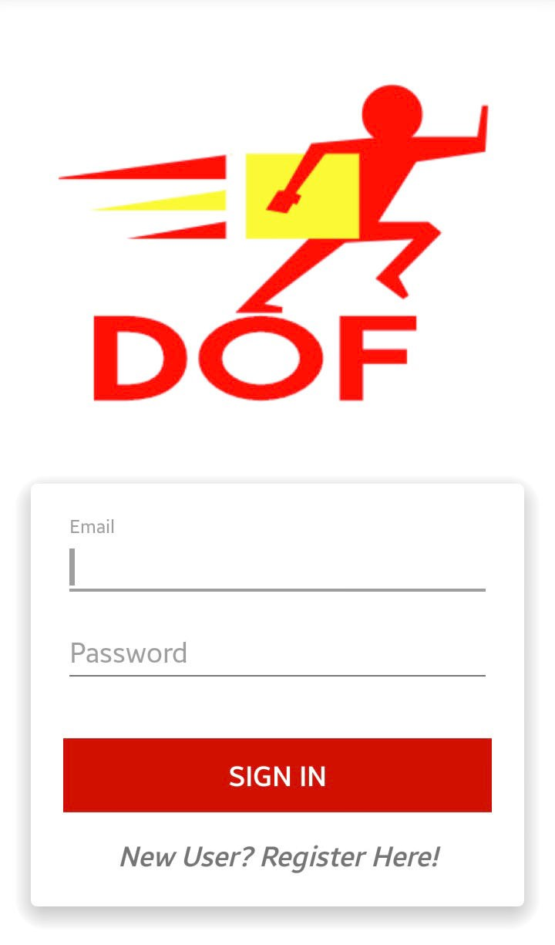

This is the initial screen of the app that is shown when the app is opened. User can login with the Sign-in functionality with valid credentials.

1. Sign-Up screen:

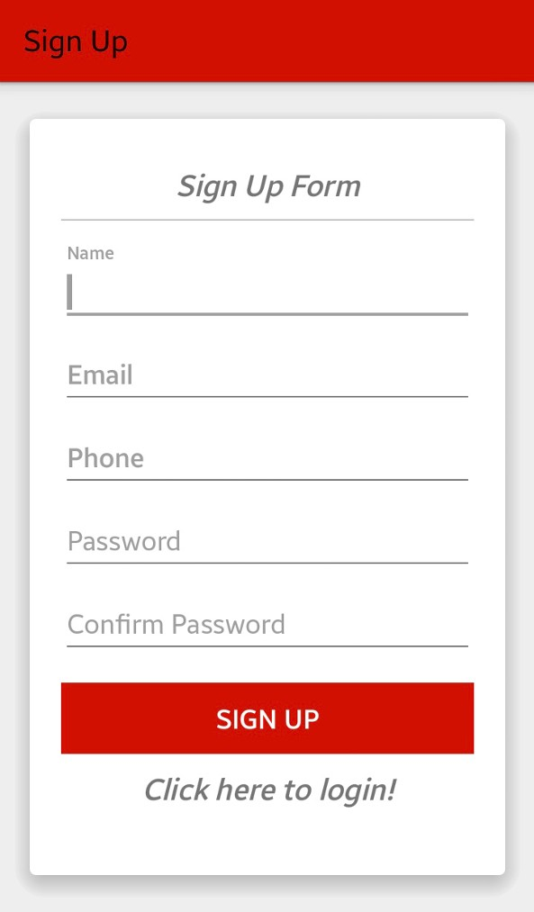

This is the Sign-up screen using which the new User can Sign-up with DOF.

1. My Listing:

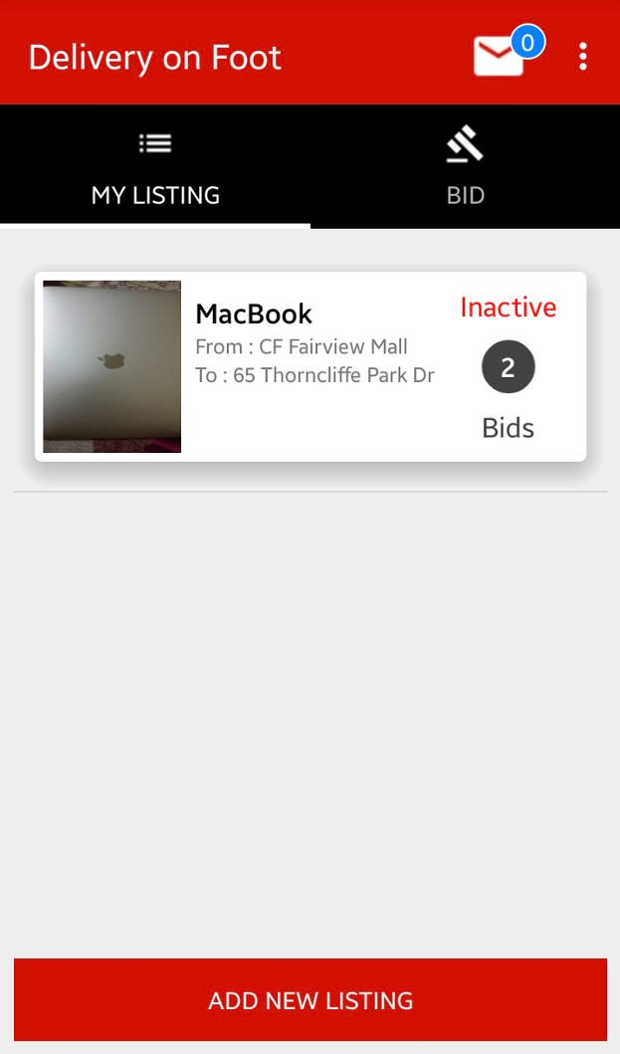

The My Listing screen shows the User all the listings they have posted on the DOF app.

1. Bids:

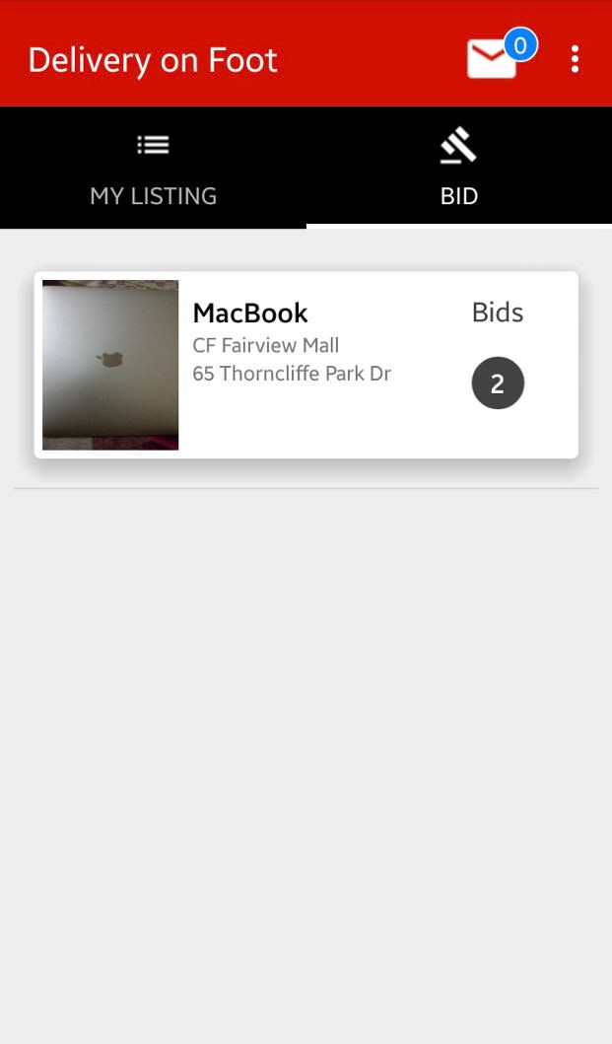

The Bid screen shows the all the other listings posted on the DOF app by others.

1. Add Listing:

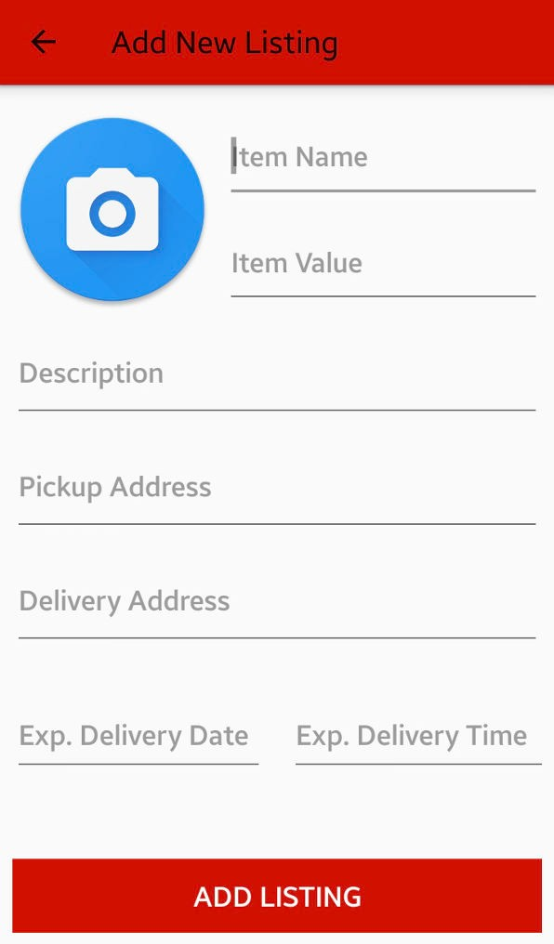

The Add Listing screen lets the user add a new listing by ﬁlling out all the information and adding an image of the item to be delivered.

1. Listing View:

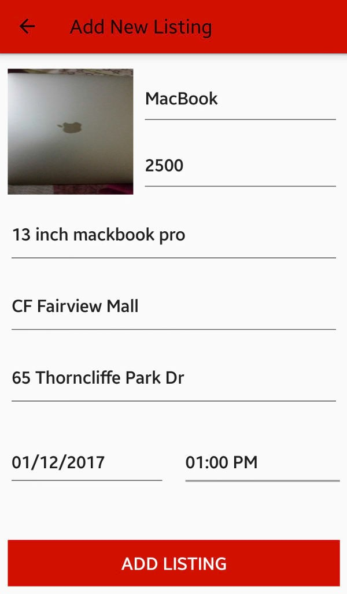

After adding all the required information, this is how the Add listing screen looks.

1. Bid Received:

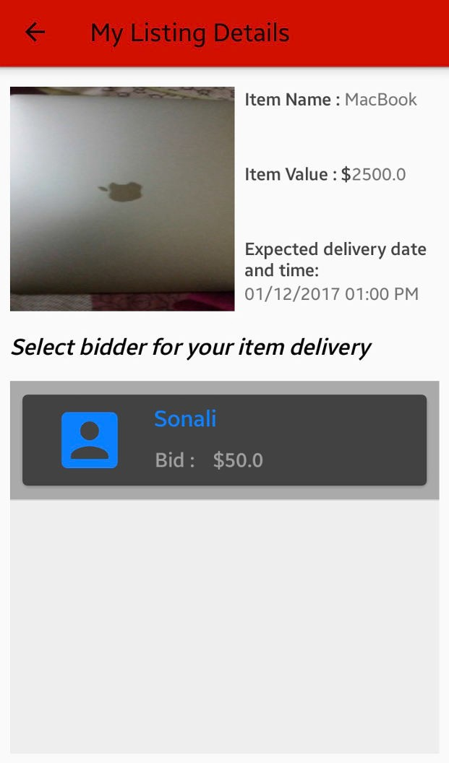

When a runner bids on the customer’s listing, it will displayed as a list.

1. Bid Acceptance:

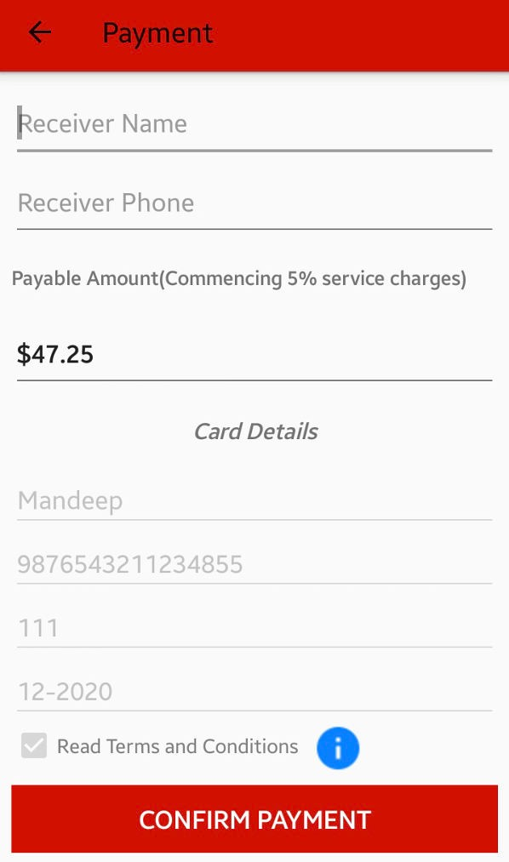

When a customer accepts any runner’s bid, they will be prompted with payment screen with a total amount that will be charged to their card.

1. Settings:

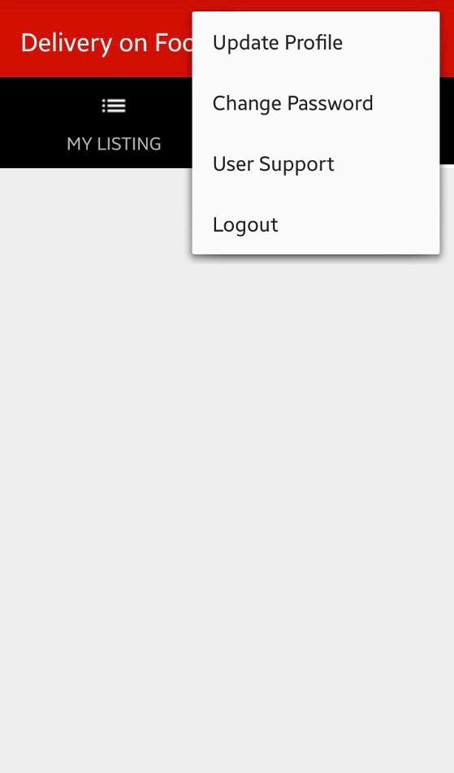

The Settings menu at top-right corner lets the user update their proﬁle alongwith other options.

1. Update PW:

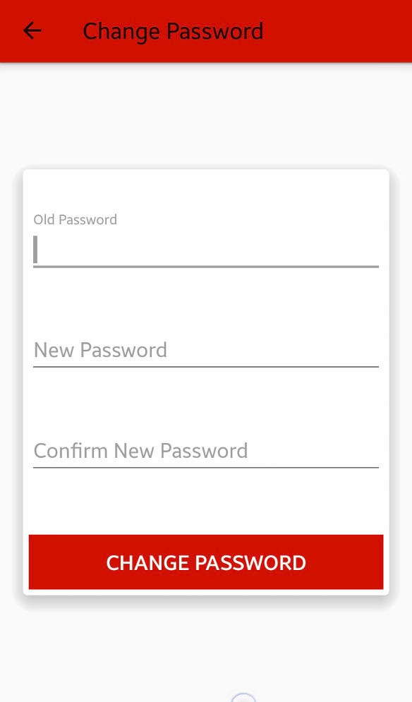

This is the screen where the users can change their password.

1. Support:

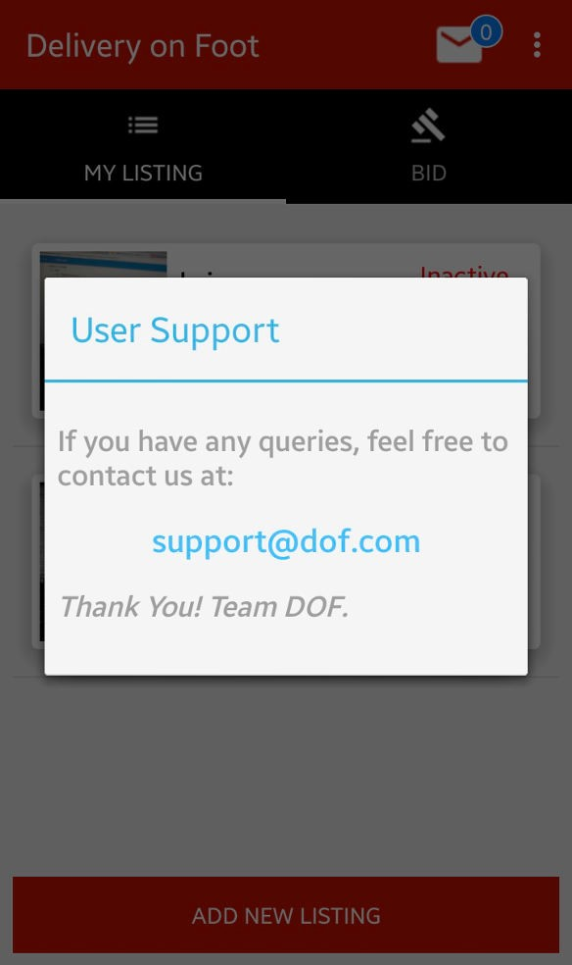

In case where support is required to the user, they will be provided with contact information of the DOF team.

## Runner UX:

The following walkthrough demostrates the UX (User experience) from a Customer’s point of view who will be posting the item to be delivered.

* 1. Bids:

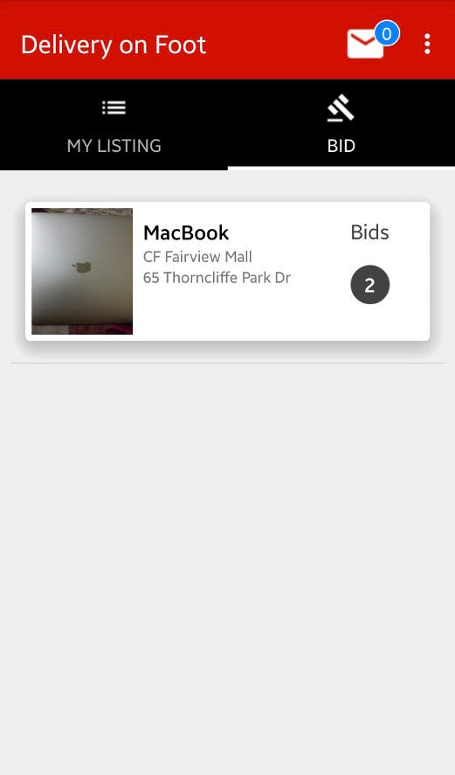

The Bid screen will let the Runner view the all the listings posted on the DOF.

* 1. Bid interface:

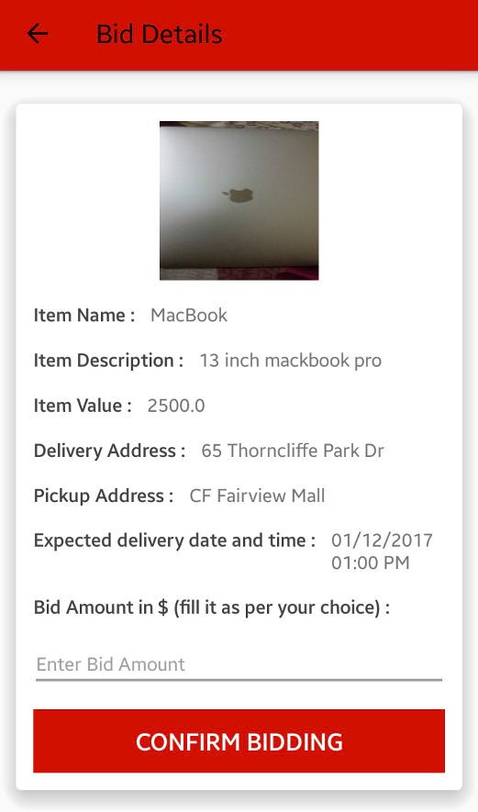

After clicking on the listing, the runner will be presented with Bid screen where they can place their bid by entering the amount and then conﬁrm it.

* 1. Payment information:

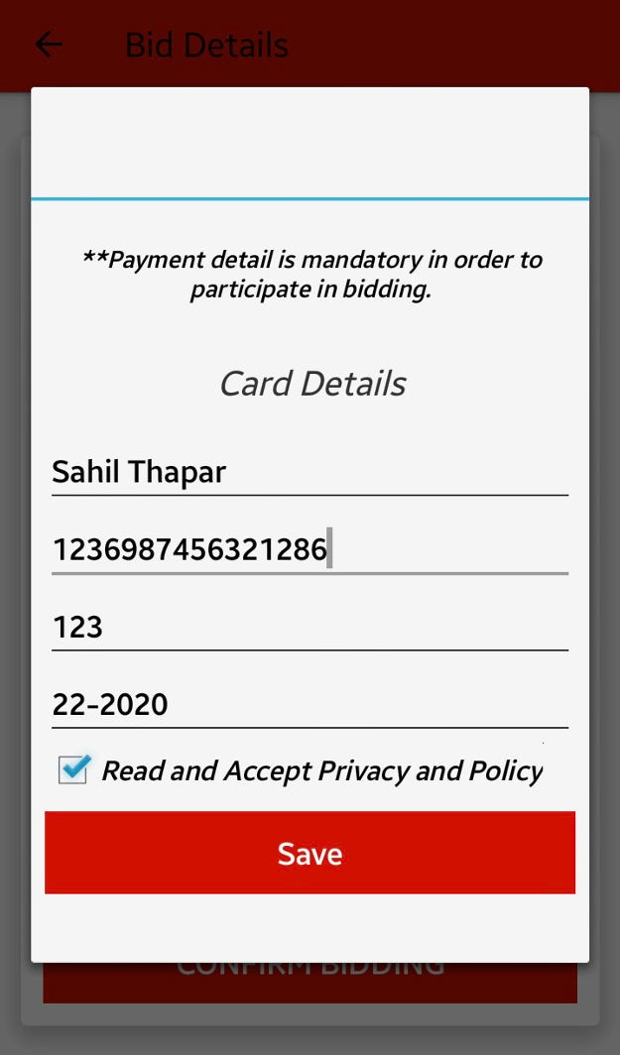

After clicking on the conﬁrm button, the runner will need to provide their credit card details for the safety of the item and can be used for reimbursement.

* 1. Bid added to the listing:

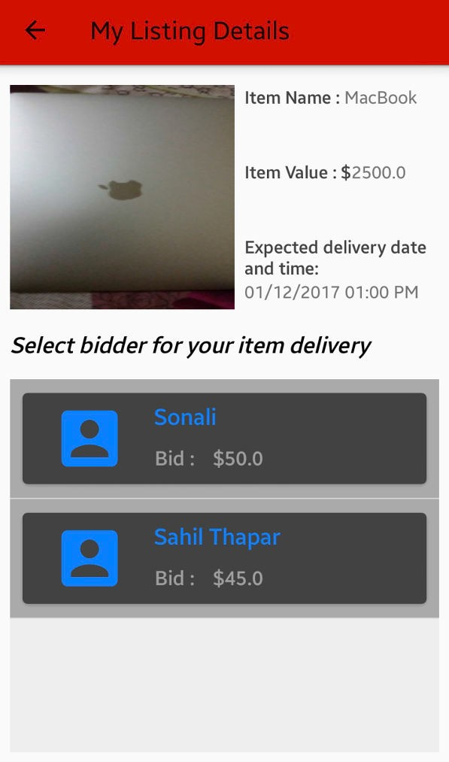

Once the bidding is done, the bid will be added to the lsiting.

* 1. Bid Acceptance:

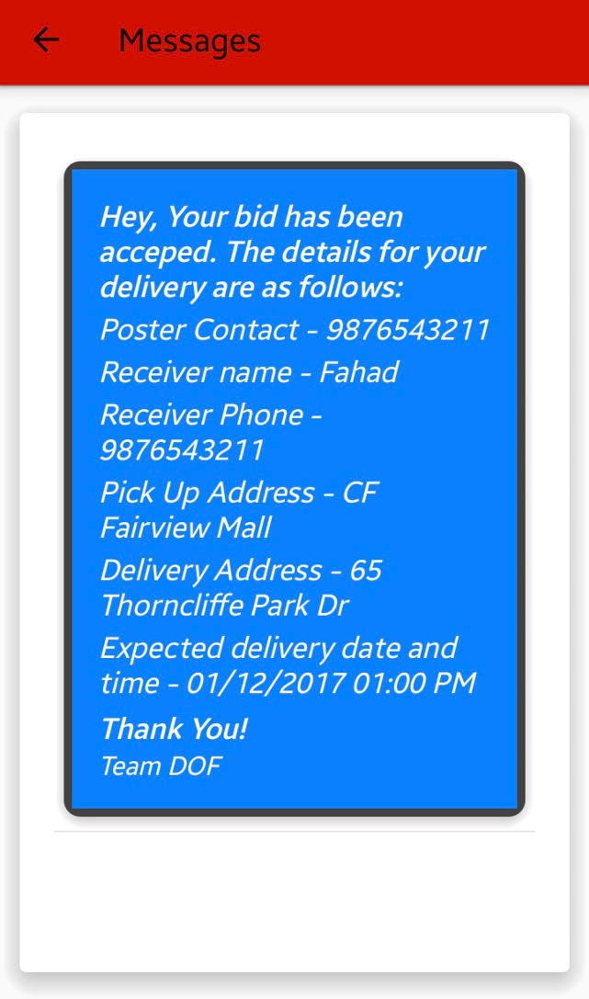

When a bid is accepted by the customer and the payment is received by DOF, the Runner will receive a the message in his inbox with all the details to pick-up and deliver the item.

# Monetisation Methods

For any business, in order to operate, a steady ﬂow of ﬁnance is neccessary. DOF implements a number of ways to genearte income for the company as well provides an employment platform to many local residents of the city who are registered with DOF and actively deliver items using the platform.

## Service Fees Incurrment:

We incur a minor Service fee of 5% on the amount of accepted bid by the customer who added the listing and they are charged with total amount of the accepted bid plus the service fee. The payment is obtained by DOF before the delivery of the item and the proﬁt is shared with Runner once the item is delivered.

Example: Accepted Bid: $50 Service Fee: 5%

Total Amount charged: $50 + 5% (50) = $ 52.5

## Mobile Advertising:

We also plan to introduce mobile advertising using the Google AdMob service where users are shown ads based on their location and search history. The ad will be displayed as a small bar at the bottom of the screen or the can also be shown as pop-up card at various screens of the app.

Mobile adverstising will generate a substantial amount of revenue for the application and hence ensuring continous operations of the the company as well as bringing in proﬁts for the company and its stakeholders.

# CONCLUSION

The overall experience of designing, developing, testing and improving the application while following the Software Development Lifecycle methodologies proved to be a very valuable source of learning and gave us an opportunity to enhance our development skills and gave us conﬁdence to execute much more complex projects.

Not only it helped us to improve our progaramming skills but also taught us to work in a team which gave an insight of real-life work experience.

It was not just a capstone project that we developed, but the overall experience was of like a startup company where rough ideas are executed and delivered into a ﬁnished product.

# REFERENCES

* https://developer.android.com/studio/index.html
* https://material.io/guidelines/
* https://stackoverﬂow.com/
* https://[www.ﬂuidui.com/](http://www.ﬂuidui.com/)
* <http://www.oracle.com/technetwork/java/javase/downloads/index.ht> ml
* https://developers.google.com/apis-explorer/#p/
* https://ﬁrebase.google.com/