Updated Diagram

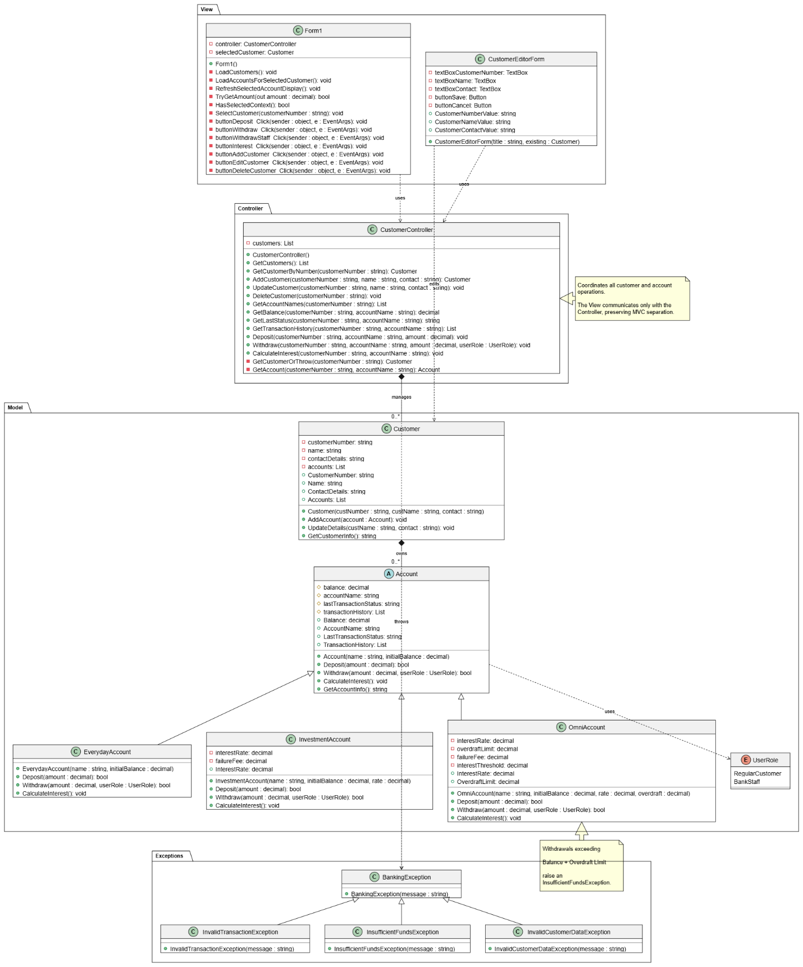
Controller Class Design Analysis
The CustomerController class serves as the core business logic component within the Model–View–Controller (MVC) architecture. Its primary responsibility is to separate application logic from the Windows Forms user interface, ensuring that the view is only responsible for collecting user input and displaying information. This separation follows the principle of separation of concerns, making the system more organised, easier to maintain, and simpler to extend in the future. The controller maintains an internal collection of Customer objects and provides a well-defined interface for all customer-related operations.
For customer management, the controller implements the complete set of CRUD (Create, Read, Update, Delete) functions. The AddCustomer(customerNumber, name, contact) method creates a new Customer object only after validating that the customer number is unique, preventing duplicate records from being added. The GetCustomers() and GetCustomerByNumber(customerNumber) methods retrieve customer information without allowing the user interface to access the internal data structure directly. Similarly, UpdateCustomer(customerNumber, name, contact) locates the required customer and updates its details through the Customer.UpdateDetails(...) method, while DeleteCustomer(customerNumber) removes the selected customer from the collection. By centralising these operations, the controller ensures that all data modifications are handled consistently in a single location.
In addition to customer management, the controller coordinates account-related operations, including GetAccountNames(customerNumber), GetBalance(customerNumber, accountName), Deposit(...), Withdraw(...), and CalculateInterest(...). These methods encapsulate the banking business rules and prevent the presentation layer from performing financial calculations or directly manipulating account data. Instead, the Windows Form communicates with the controller, which processes requests using the model classes and returns the required results for display.
Overall, this design improves modularity, maintainability, and reusability by clearly separating the user interface from the application's business logic. It also increases testability because controller methods can be verified independently of the graphical interface. Furthermore, if the banking application is later migrated to another platform, such as a web application, WPF desktop application, or mobile application, the existing controller and model classes can be reused with minimal changes, reducing development effort while preserving the core functionality of the system.
TASK 02
Flow Diagram
