Cryptography
The resources including the assignments and projects :
https://github.com/CSeCIITB/LS-2024-Intro-to-Crypto
Timeline:
Week 1: 27 June - 7 July
Week 2: 8 July - 14 July
Week 3: 15 July - 21 July
Week 4: 22 July - 28 July
- Week 1-3: Weekly content will be released along with corresponding assignments.
- Project statement will be released in 2 parts:
  - Part 1 will be released along with Week 2
  - Part 2 will be released after Week 3

- Cryptography forms one of the most important fields in the digital age, protecting your privacy, enabling secure communication, underpinning blockchain and cryptocurrencies, safeguarding national security, ensuring data integrity, supporting zero-knowledge proofs, facilitating digital signatures, enabling secure voting systems, and driving secure multi-party computation.

Q) How do I figure out what cipher could be used is there any generalized approach?
→ To identify any general ciphertext, numerous techniques can be applied like frequency analysis (which characters appear most often), coincidence index (what is the "randomness" in the ciphertext), and noticing certain patterns etc.
But for the given challenges in the first week, you can figure out the cipher used by just the description of the challenge and some online tools.

# Section-1 (Classical Cryptography) :
The principle of confidentiality: no one except the authorised parties should be able to make sense of the data. Classical ciphers were used to encrypt a plaintext message (in a particular language, we usually use English in our examples) into unintelligible ciphertext which cannot be decrypted without knowledge of a certain secret key known only to the authorised participants. Classical ciphers, despite trying their best to be hard to decrypt without a key, are vulnerable to all sorts of attacks that would enable an attacker to decrypt a ciphertext without knowledge of the secret key. Analysing cryptographic protocols rigorously is the field of cryptanalysis.
To pass an encrypted message from one person to another, it is first necessary that both parties have the 'key' for the cipher, so that the sender may encrypt it and the receiver may decrypt it.

## Classical Ciphers.
1) Caesar Cipher : (one of the simplest and most popular classical ciphers)
- It is a type of substitution cipher in which each letter in the plaintext is 'shifted' a certain number of places down the alphabet. The Caesar cipher offers essentially no communication security, and it will be shown that it can be easily broken even by hand.
- For the caesar cipher, the key is the number of characters to shift the cipher alphabet.
- Mathematical Description :
First we translate all of our characters to numbers, (a to z) = (0 to 25). We can now represent the caesar cipher encryption function, e(x), where x is the character we are encrypting and k is the key (the shift) :
e(x) = (x+k) mod26
Similarly, decryption function : d(y) = (y-k) mod26
After applying this function the result is a number which must then be translated back into a letter.
- Cryptanalysis : (Cryptanalysis is the art of breaking codes and ciphers )
  - Since the shift has to be a number between 0 and 25, we can simply try each possibility and see which one results in a piece of readable text. This is the easiest method actually used.
This simplistic method of cryptanalysis only works on very simple ciphers such as the Caesar cipher and the rail fence cipher, others have too many keys to check.
  - All strategies that work with the substitution cipher will also work with the Caesar cipher, but not the vice versa.
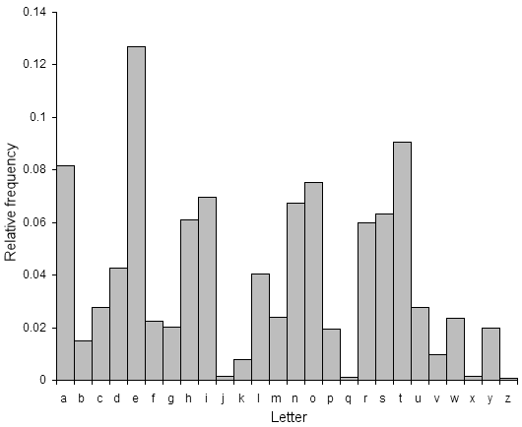
  - If this is not possible, a more systematic approach is to calculate the frequency distribution of the letters in the cipher text. This consists of counting how many times each letter appears. Natural English text has a very distinct distribution that can be used help crack codes.
(ex. of methods = quadgram statistics)
Find the shift that causes the ciphertext frequencies to match up closely with the natural English frequencies, then decrypt the text using that shift. This method can be used to easily break Caesar ciphers.
Of course, the more ciphertext you have, the more likely this is to be true (this is the case for all statistical measures

2) ROT13 Cipher :
- = Mirror cipher = Reciprocal cipher.
- nothing but the Caesar cipher with key=13.
- It’s special because the encryption and decryption functions are the same.
3) Vigenère Cipher (Polyalphabetic Cipher) :
- was once considered the indecipherable cipher, but now very easy to crack using statistical analysis.

