**DBMS Mini Project Report**

**“Online Shopping Cart System”**

**Submitted by**

Poojan Panchal PA13 (S1032180249)

Sahil Mondal PA24 (S1032180389)

Vignesh Charan Raman PA33 (S1032180459)

Pranav Parnerkar PA36 (S1032180563)

**Under the Guidance of**

**Shakti Kinger**

At

**School of Computer Engineering and Technology**

# Abstract

Over the last decade, the ecommerce industry has boomed, taking over physical shopping due to its simplicity and convenience for the consumer. They indulge even more in these websites over the year because of strong discounts on the items. In view of these positive features, we find it an avenue worth putting in our technological expertise. We aim to create a user-friendly e-commerce website in this project. To place orders, the customer must sign up for the website and log in using their credentials. The user can also place several orders at a time, and monitor the website's order status. The system is robust enough for updating and clearing the customer's cart after placing an order. It also incorporates the transaction gateway for payment of the customer’s orders. An admin page is provided for the seller to add new products and update the stocks of current products. The application is powered by MySQL as the backend, is helmed by HTML and CSS in the GUI department and Flask Web Interface (python library) for connectivity. The stakeholders of the website are the customer, the admin and the development team. The website will offer electronics in two categories i.e. mobiles and laptops.

**Contents**

Abstract 2

List of Figures 4

Introduction 5

Problem Statement 5

Tools & Technologies 5

ER Diagram 6

Schema Diagram 7

Database Normalization 8

DDL Commands 9

DML Commands 9

Triggers 10

Functions 10

Frontend GUI screenshots (User-End) 11

Frontend GUI screenshots (Admin-End) 12

Conclusion 13

References 13

# List of Figures

Figure 1: Entity Relationship Diagram 6

Figure 2: Schema Diagram 7

Figure 3: DDL Commands 9

Figure 4: DML Commands 9

Figure 5: Triggers Implementation 10

Figure 6: Functions 10

Figure 7: User-side pages 12

Figure 8: Admin side pages 13

# Introduction

Essentially, ecommerce (or electronic commerce) is buying and selling of goods (or services) on the internet. Because of numerous advantages and benefits, more and more people say they prefer online shopping over conventional shopping these days. The buyer’s decision-making process has changed dramatically in recent years. Buyers are conducting extensive research online before ever speaking to a sales person. Buyers are also making more direct purchases online and via their smartphone, never stepping foot into traditional brick-and-mortar locations.

Since then, ecommerce has evolved to make products easier to discover and purchase through online retailers and marketplaces. Independent freelancers, small businesses, and large corporations have all benefited from ecommerce, which enables them to sell their goods and services at a scale that was not possible with traditional offline retail.

**Motivation & Objective:**

Online buying and selling of goods has been imperative since a decade now and. From mobile shopping to online payment encryption and beyond, ecommerce encompasses a wide variety of data, systems, and tools for both online buyers and sellers. Most businesses with an ecommerce presence use an ecommerce store and/or an ecommerce platform to conduct both online marketing and sales activities and to oversee logistics and fulfilment

# Problem Statement

With increase in public demand for miscellaneous electronics products specifically mobiles and phones, develop a User-interactive E-commerce application for online shopping integrated with a comely database architecture based on MySQL.

# Tools & Technologies

|  |  |
| --- | --- |
| * Python * MySQL Database * HTML | * CSS and Bootstrap * Java Script |

# ER Diagram

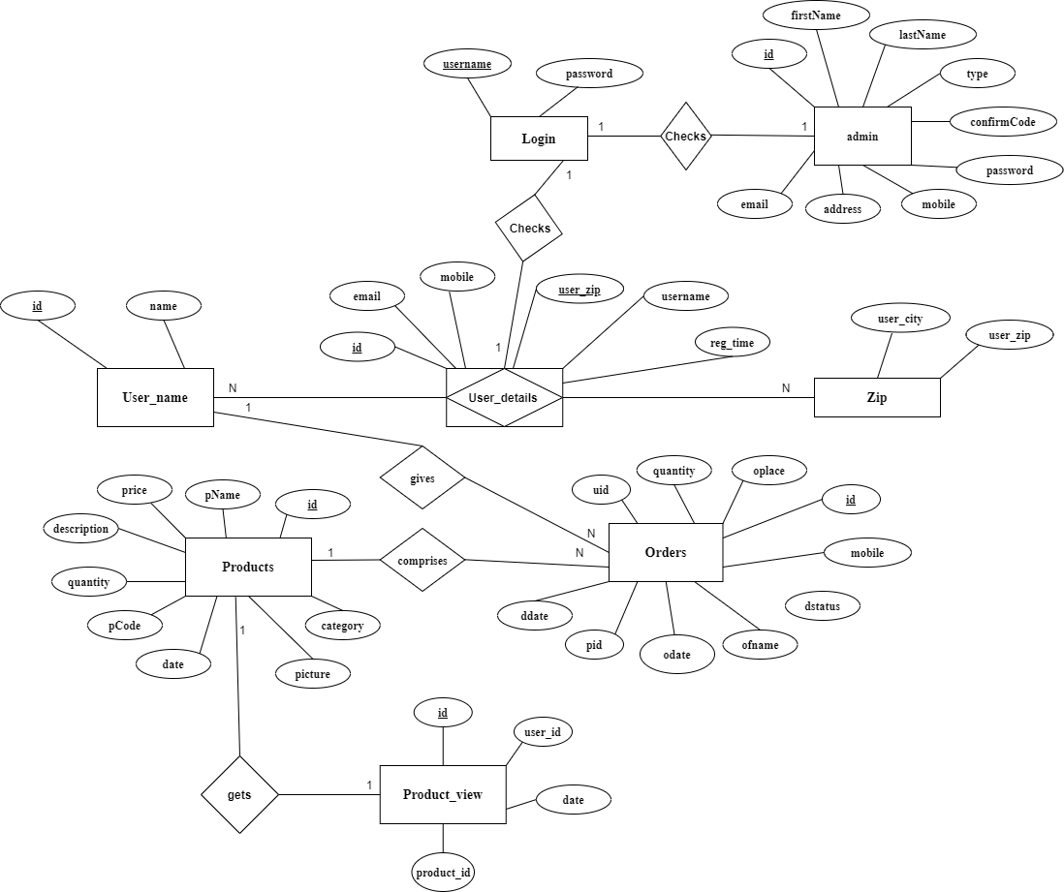

Figure 1: Entity Relationship Diagram

# Schema Diagram

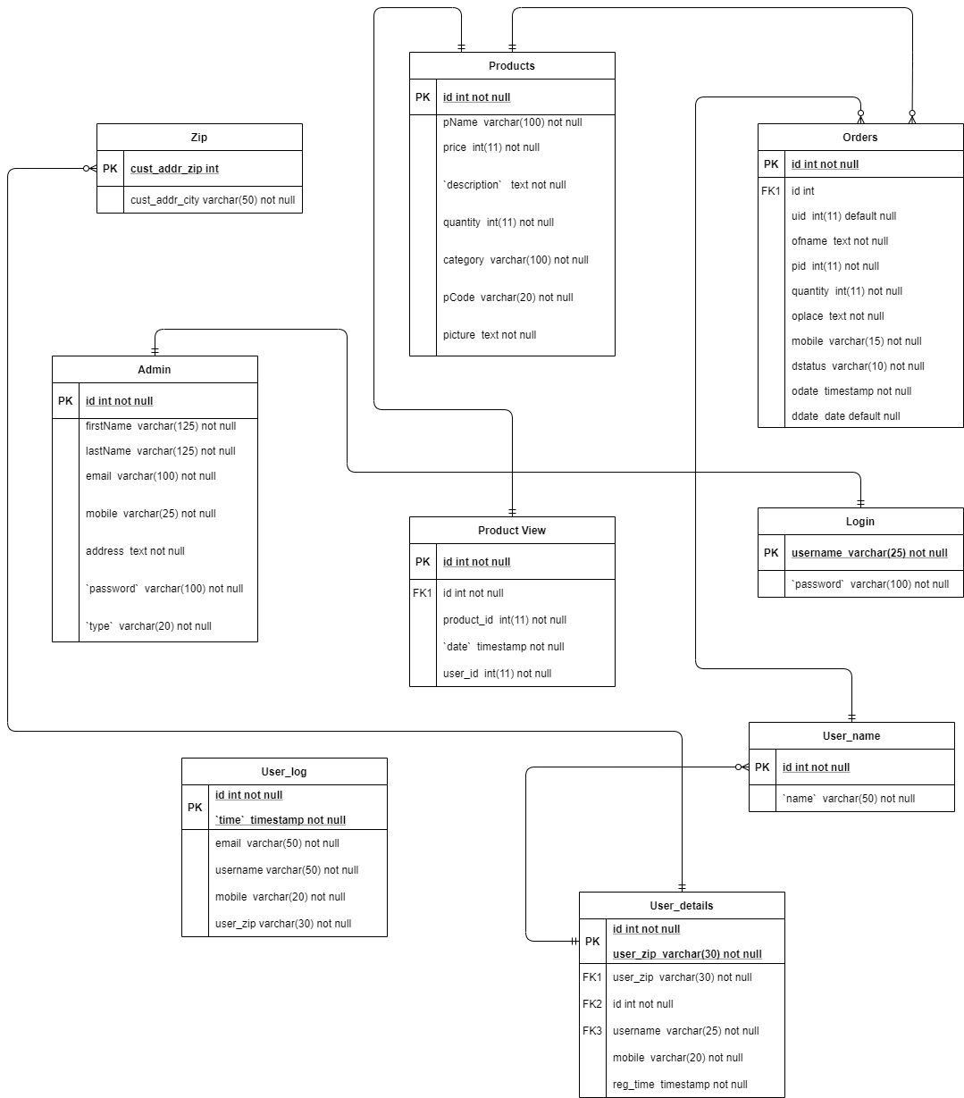

Figure 2: Schema Diagram

# Database Normalization

**Parent Table:**

users (id, name, email, username, password, mobile, user_city, user_zip, reg_time)

**1st NF:**

user_name (id, name)

user_details (id, email, username, password, mobile, user_city, user_zip, reg_time)

**2nd NF:**

Fd1: id, username -> email, mobile, user_city, user_zip, reg_time (Primary Key)

Fd2: username -> password (Partial dependency)

Fd3: user_zip -> user_city (Transitive Dependency)

**Tables:**

user_name (**id**, name)

user_details (**id**, **user_zip**, username, email, mobile, user_city, reg_time)

login (**username**, password)

**3rd NF:**

id -> user_zip, user_zip -> user_city

Hence:

user_details (**id**, username, email, mobile, user_zip, reg_time)

zip (**user_zip**, user_city)

**Final sub-tables of users after normalization :**

user_name (**id**, name)

user_details (**id**, **user_zip** , username, email, mobile, reg_time)

zip (**user_zip**, user_city)

login (**username**, password)

**Final Schema:**

admin(**id**,firstName,lastName,email,mobile,address,’password’,’type’,confirmCode)

products(**id**, pName,price,’description’,quantity, category,pCode,picture,’date’)

orders(**id**,uid,ofname,pid,quantity,oplace,mobile,dstatus,odate,ddate)

product_view(**id**, user_id,product_id,’date’)

login(**username**,’password’)

user_name (**id**, name)

user_details (**id**, **user_zip**, username, email, mobile, reg_time)

zip (**user_zip**, user_city)

user_log(**id**, email, username, mobile, ‘time’, user_zip)

# DDL Commands

|  |  |
| --- | --- |
| I) | II) |

Figure 3: DDL Commands

# DML Commands

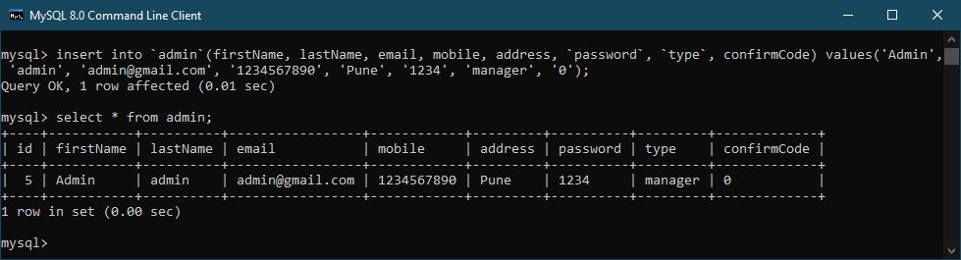

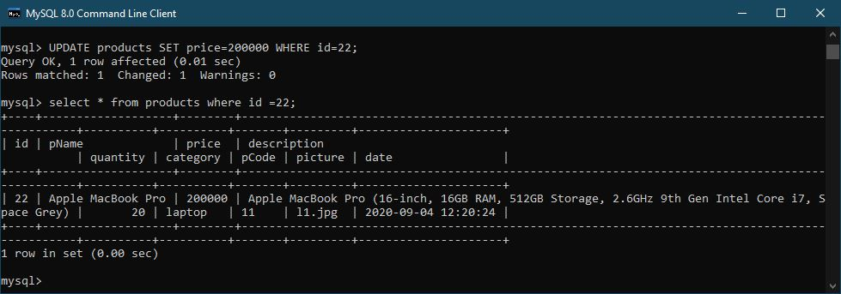

Figure 4: DML Commands

# Triggers

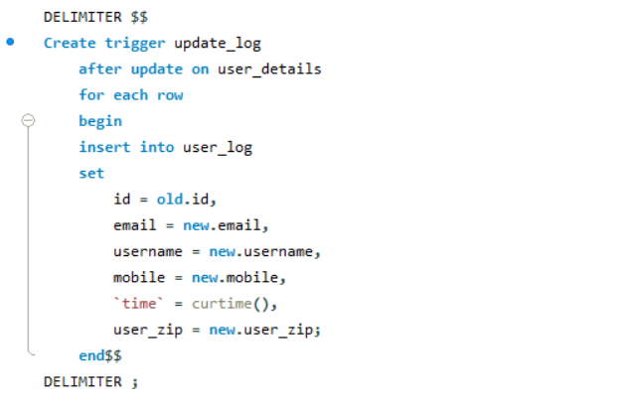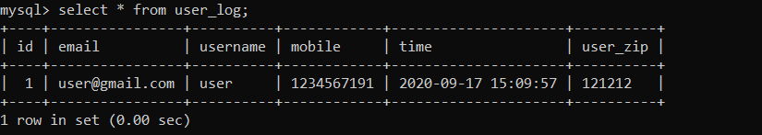

Figure 5: Triggers Implementation

# Functions

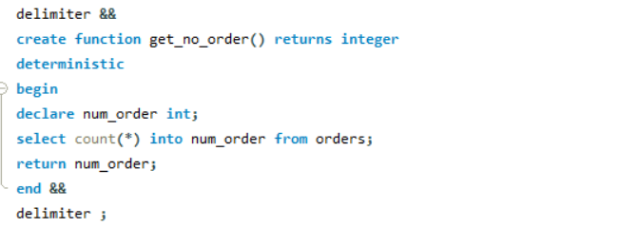

Figure 6: Functions

# Frontend GUI screenshots (User-End)

# 

|  |  |
| --- | --- |
| **I)** | **II)** |
| **III)** | **IV)** |
| **V)** | **VI)** |
| **VII)** | **VIII)** |
| **IX)** | **X)** |
| **XII)** |  |

Figure 7: User-side pages

# Frontend GUI screenshots (Admin-End)

|  |  |
| --- | --- |
| **I)** | **II)** |
| **III)** | **IV)** |
| **V)** | **VI)** |

Figure 8: Admin side pages

# Conclusion

# In conclusion, a database is a far more efficient mechanism to store and organize data than spreadsheets, it allows for a centralized facility that can easily be modified and quickly shared among multiple users. Having a web based front end removes the requirement of users having to understand and use a database directly, and allows users to connect from anywhere with an internet connection and a basic web browser. It also allows the possibility of queries to obtain information for various surveys.

# References

# JavaScript Enlightenment, Cody Lindley-First Edition, based on JavaScript 1.5, ECMA-262, Edition

# Complete CSS Guide, Maxine Sherrin and John Allsopp-O'Reilly Media; September 2012

# Database Systems Models, Languages, Design and Application Programming, Ramez Elmasri and Shamkant B. Navathe, 7th Edition, 2017, Pearson.

# <http://www.w3schools.com/html/defualt.asp,http://www.w3schools.com/css/default.asp,http://www.w3schools.com/js/default.asp>

# Cai Y. Cude B. J. (2008). Online shopping. In Xiao J. J. (Ed.), Handbook of Consumer Finance Research. New York: Springer Publishing. 10.1007/978-0-387-75734-6_9