GIT:

Earlier complete code on central system

-if central system fails whole project would collapse

1)central dependency

2)need live internet connection

3)if changes on project, manager need to track, here it was not possible

4) storage issue for maintaining project history

GIT🡪is VCS (version control system)

GitHub is Remote Repo(Directory)

Developer would clone project code and from here it is possible to recover code also if lost from github repo

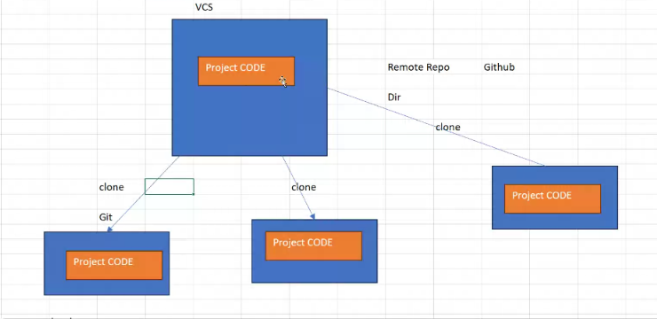

Local repo🡪

Working directory,

staging area,

local repo

working dir🡪any work to be done here

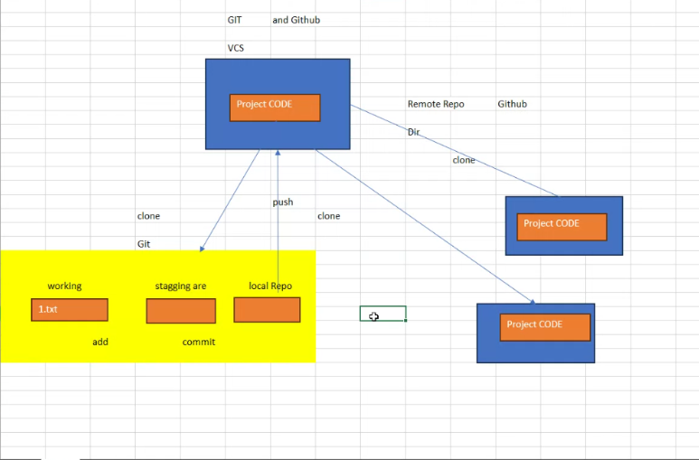

Working to staging🡪add

Staging to local repo🡪commit

Local repo to github🡪push

Remote repo to local repo🡪pull

In Git, "working", "staging", and "local" refer to the three key areas where your code exists within a local repository: the working directory (where you make changes), the staging area (where you prepare changes to be committed), and the local repository (where the committed changes are stored); essentially, you work on files in your working directory, stage the changes you want to commit in the staging area, and then finally commit those staged changes to your local repository

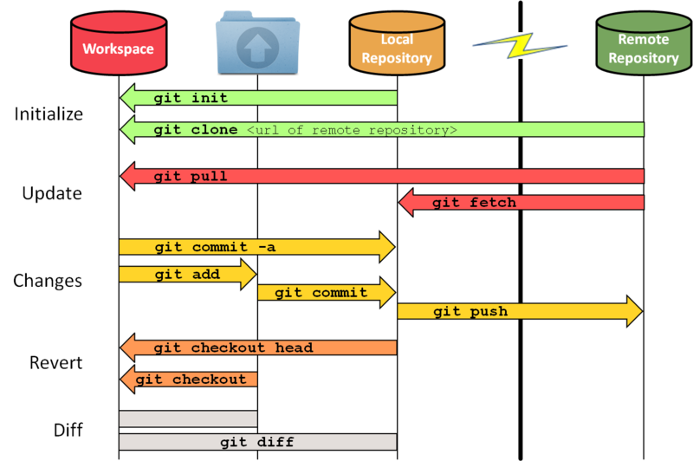

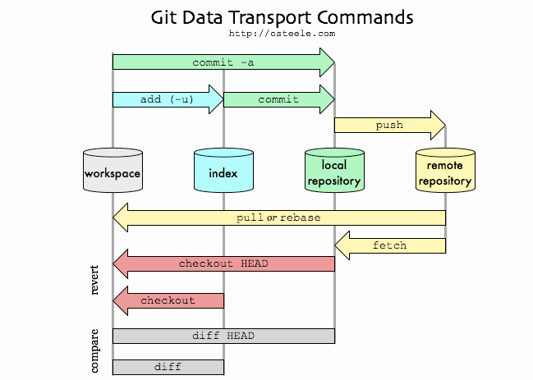

Remote Repo:

1.Public 🡪internet🡪see🡪but we can’t commit

2.private 🡪see🡪can commit changes🡪paid

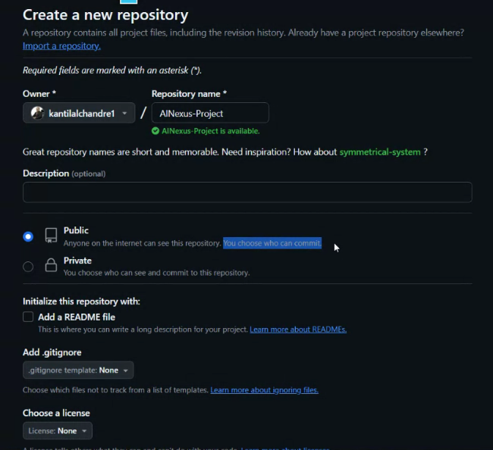

ReadMe🡪project description

Create repo🡪upload file🡪commit changes

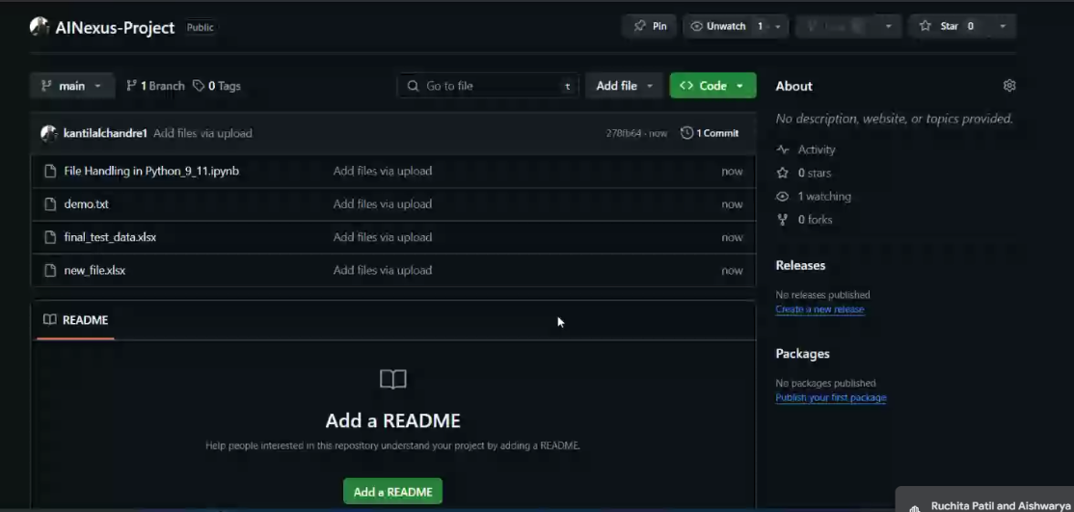

Code🡪copy github Repo URL

Install gitbash🡪download for windows

Where we can write linux commands on windows

**What is Git Bash?**

Git Bash is an application for Microsoft Windows environments which provides an emulation layer for a Git command line experience. Bash is an acronym for Bourne Again Shell. A shell is a terminal application used to interface with an operating system through written commands.

**Is Git Bash and Git the same?**

Git - The collection of command line programs that makes up the Git version control system. (2) Bash - The name of a popular default shell on macOS and Linux. This means that the Git Bash package not only installs Git, but also the Bash shell and some important utilities for Bash.

We need to know who pushed the changes means which user and his email

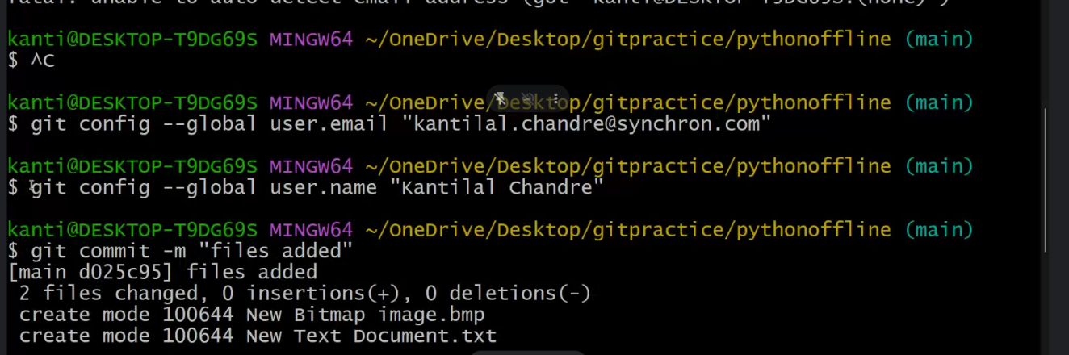

Execute this command in gitbash

git config --global user.email "kantilal.chandre@synchron.com"

git config --global user.name "Kantilal Chandre"

opne folder🡪open gitbash🡪run the above commands🡪

run gitclone <repo_URL>

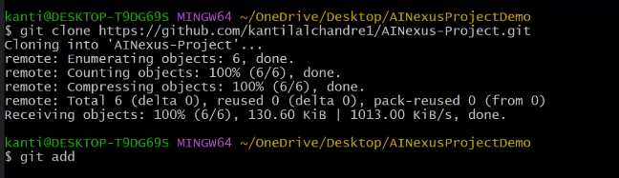

make some changes in file(these changes are made in working

)

Add in staging area from working directory

Git add . 🡪for all files

Git add <file1>

Git add <file1 file2 file3..>

Now add to local

git commit -a -m "The Commit message" 🡪to commit all files

git commit -m "The Commit message" 🡪to commit selected files

if you are in the current directory, add ./ to the front of the path;

git commit -m 'my notes' ./path/to/my/file.ext

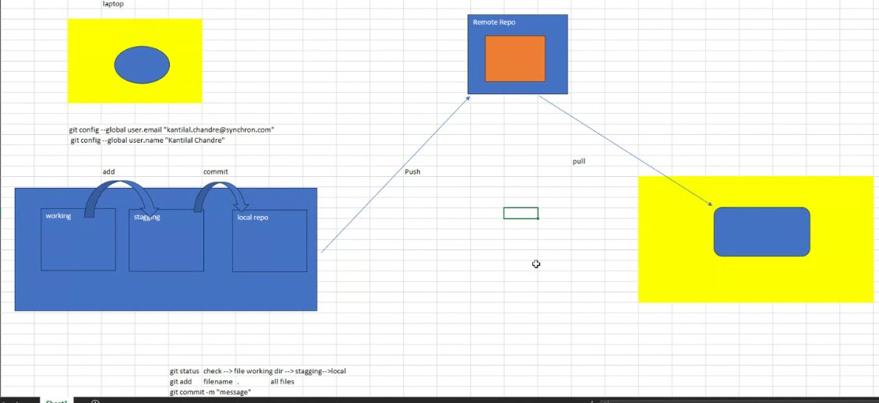

Git push 🡪from local to GitHub repo

Not accessible to other developers so they need to pull for updated changes

If we change company we need to change our user.email and user.name

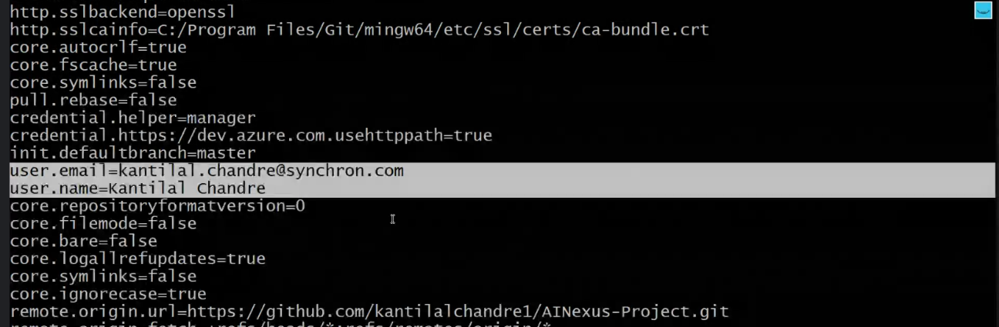

We can track in github what changes were made

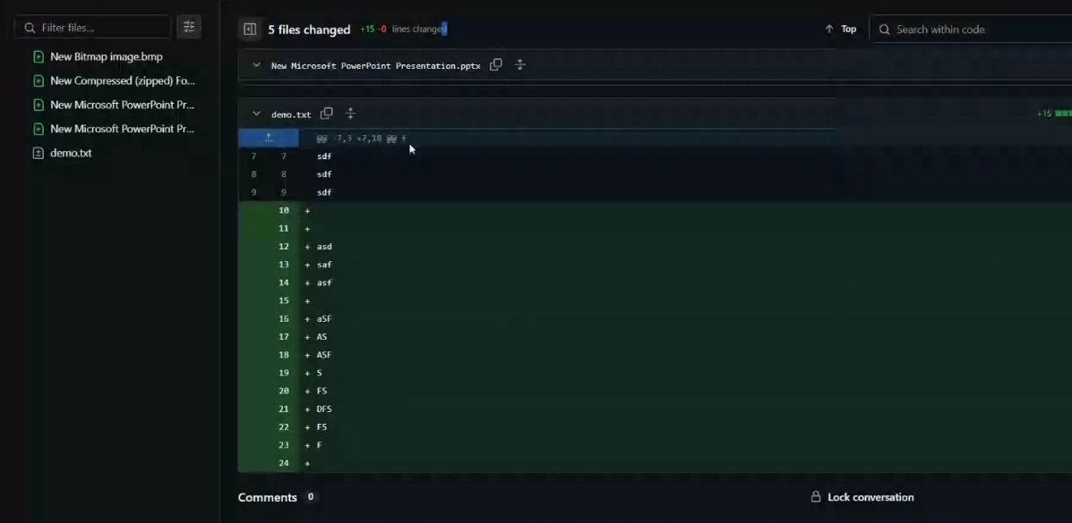

For each changes there is commit id

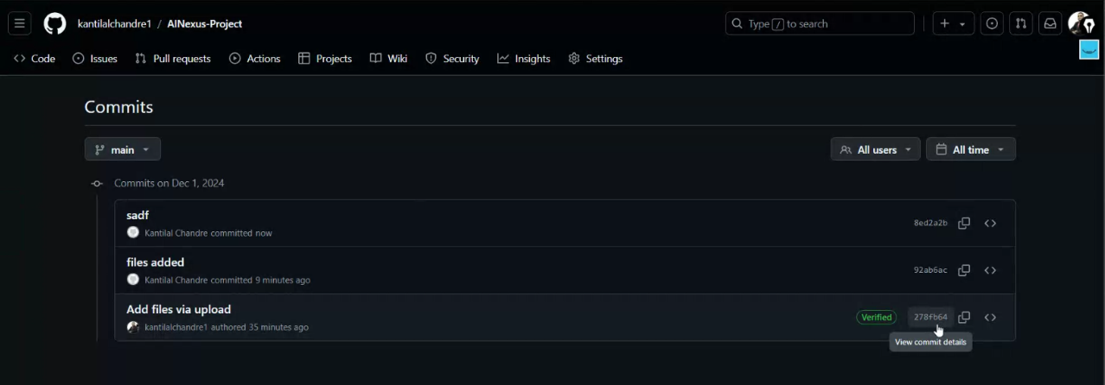

Git status 🡪to see changes made in git