
MAHARASHTRA EDUCATION SOCIETY'S
(SINCE 1860)
INSTITUTE OF MANAGEMENT & CAREER COURSES (IMCC)
(AUTONOMOUS)
Approved by AICTE and Recognized by Savitribai Phule Pune University, Pune
IMCC Campus, 131, Mayur Colony, Kothrud, Pune 411038, Maharashtra, India | Ph.: 020-2546 6271 / 73 | e-mail: info.imcc@mespune.in | https://imcc.mespune.in
NAAC Accredited with Grade A+
Ref. No. MES IMCC / 442/ 2025 – 26/ Date: 06/05/2026

CERTIFICATE

This is to certify that the Project entitled “Waitless_Q” is completed by “Sahil K. Pardeshi” of M.C.A. Semester II for the Academic Year 2025-26 at MES’ Institute of Management & Career Courses (IMCC), Pune - 411038.

To the best of our knowledge, this is an original study done by the said student and important sources used by him/her have been duly acknowledged in this report.

The report is submitted as a part of course ITP21 Mini Project for the Academic Year 2025-26 as per the rules and guidelines prescribed by the institute.

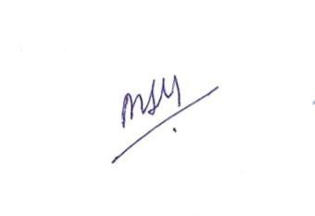
Dr Shilpa Parlikar Ms. Manasi Shirurkar Dr. Ravikant Zirmite
Project Coordinator Program Coordinator Head, Dept. Of MCA

INDEX

 |  | contents | Page no.
1 |  | Introduction | 3-5
 | 1 | Project Scope
2 |  | Analysis and Design | 7-20
 | 2.1 | Entity Relationship Diagram (ERD) | 7
 | 2.2 | Use Case Diagrams | 8-9
 | 2.3 | Table Structure/Data Dictionary | 10-11
 | 2.4 | Sample Input and Output Screens (Screens must have valid data.  All Screens must have at-least 5 valid records.) | 12-20
 |  |  | 21-27
3 |  | User Manual (All screens with proper description/purpose  Details about validations related to data to be entered.)

Introduction :

Serverless Real-Time wait time predictor System is a cloud-based web application developed to manage and automate queue operations. The system allows students to generate queue tokens online and track their position in the queue through a real-time dashboard. It eliminates the need for physical queues and manual token handling, thereby reducing congestion and improving service efficiency.
The application provides real-time visibility of the current token number, student’s token number, and estimated waiting time, ensuring transparency and fairness in queue management. The system continuously updates queue status using cloud-based services, allowing multiple users to access live information simultaneously.

Project Scope :

Functionalities / Modules:

- User Registration & Authentication Module
Allows students and admin users to securely access the system. Manages login, authentication, and session handling.

- Token Generation Module
Enables students to generate a unique queue token online. Automatically assigns token numbers in sequence.

- Queue Management Module
Maintains the current queue status, updates the current serving token, and manages the flow of tokens in real time.

- Live Dashboard Module
Displays real-time information such as current token number, student’s token number, and queue progress.

- Estimated Waiting Time Module
Calculates and displays the estimated waiting time based on the current token and average service time.

- Admin Control Module
Allows administrators to call the next token, pause or reset the queue, and manage daily queue operations.

- Cloud Database Module
Stores token details, queue status, timestamps, and user information securely on the cloud.

Users :

1) Admin(Staff) :-

- Admin Roles & Responsibilities and Interaction with System:
  - Choose Shifts.
  - Reset Queue.
  - Call Next Token and view reports.

2)Users (Students) :-

- Students Roles & Responsibilities and Interaction with The system:
  - Register and log in to the system.
  - Click Generate Tokens.
  - View Token details.

Number of User Interfaces :-

- Home / Landing Interface
Provides an overview of the system and allows users to access the token generation and dashboard features.

- Token Generation Interface
Enables students to generate a new token and view their assigned token number.

- Live Queue Dashboard Interface
Displays the current token being served, student’s token number, and estimated waiting time in real time.

- Admin Dashboard Interface
Allows administrators to manage the queue, call next token, reset the system, and monitor queue status.

- Status / Notification Interface
Displays queue updates, waiting status, and system messages to users.

Analysis and Design

2.1 Entity Relationship Diagram (ERD) :-

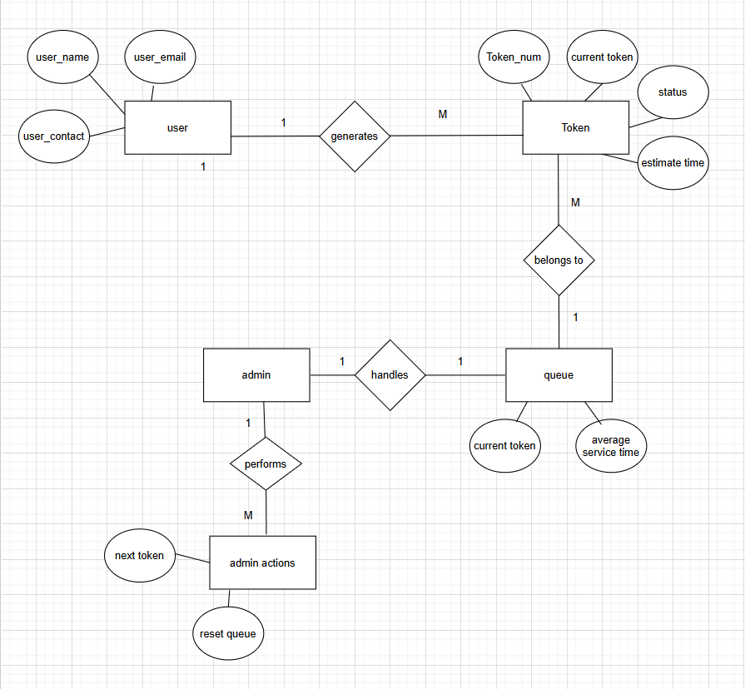

2.2 Use Case Diagram :-
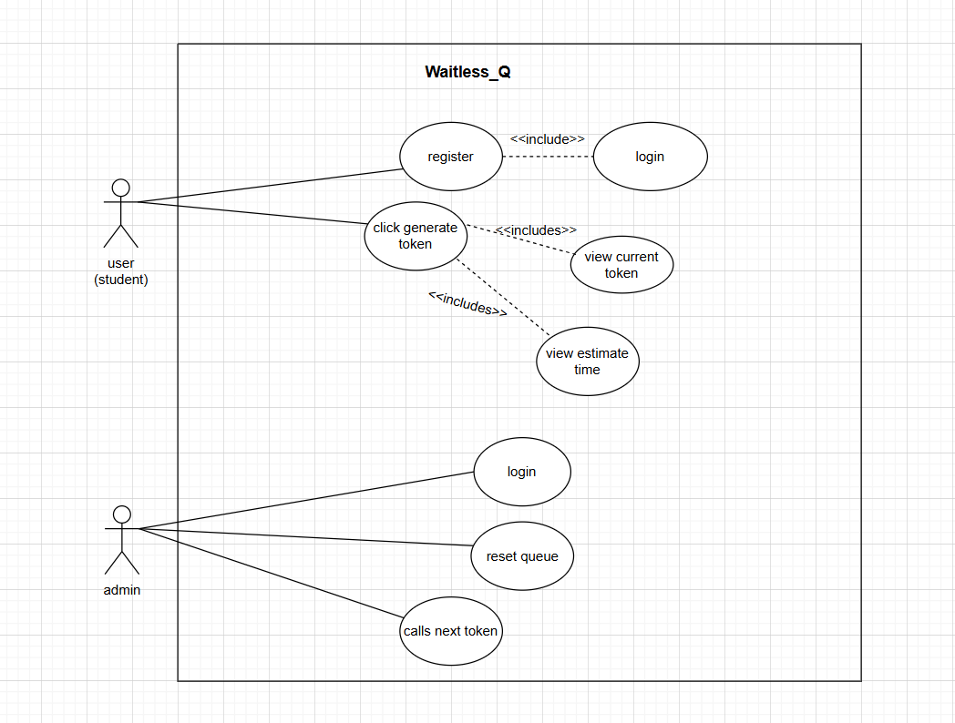

2.3 Table Structure / Data Dictionary:-
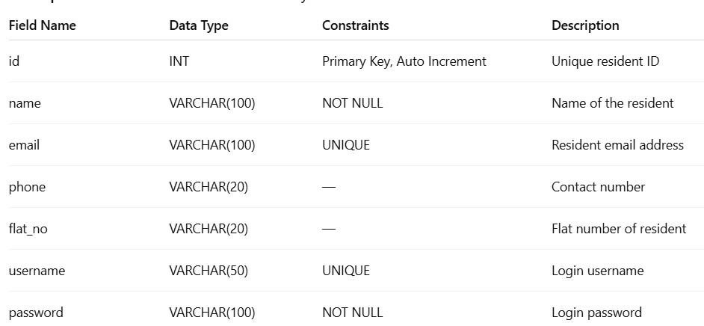

1)

Resident Table:

-

- Admin Table :-

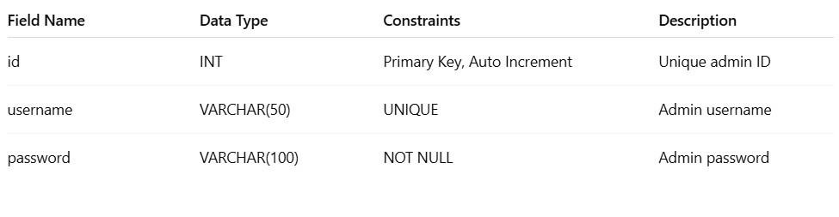
- Payment Table :-

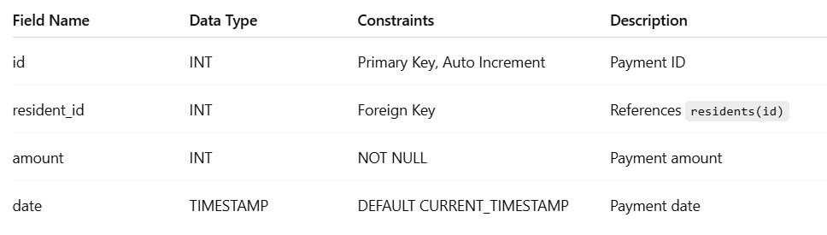

4) Notice Table:-

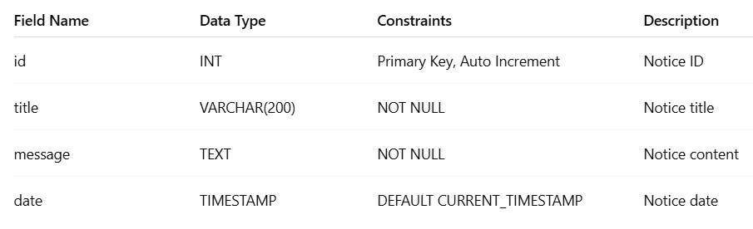

5) Booking Table:-

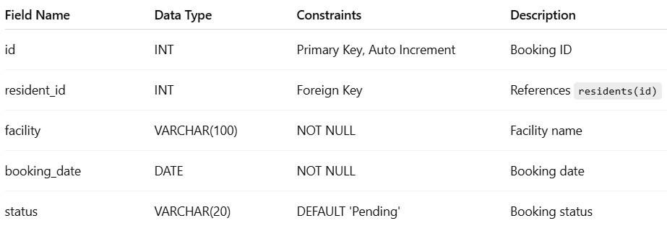

6) Complaint Table:-

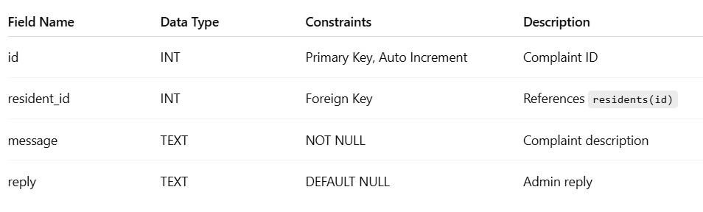

2.4Sample Input Output Screens:-

Student Side :

a) Home Page –

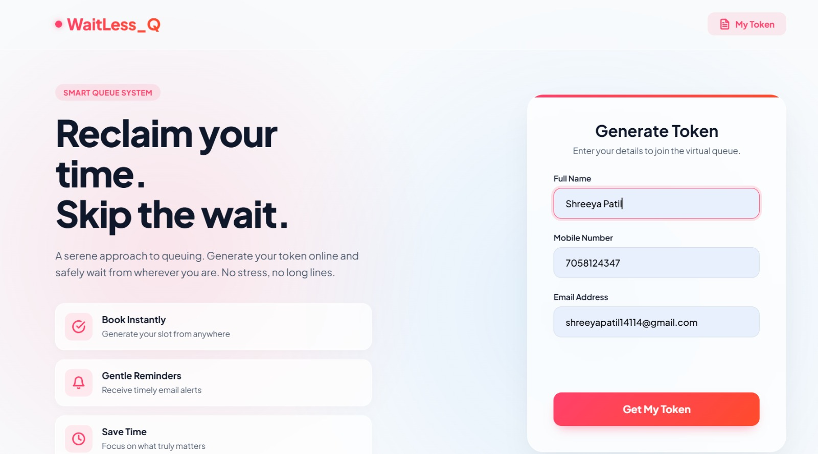

b) Token Page –

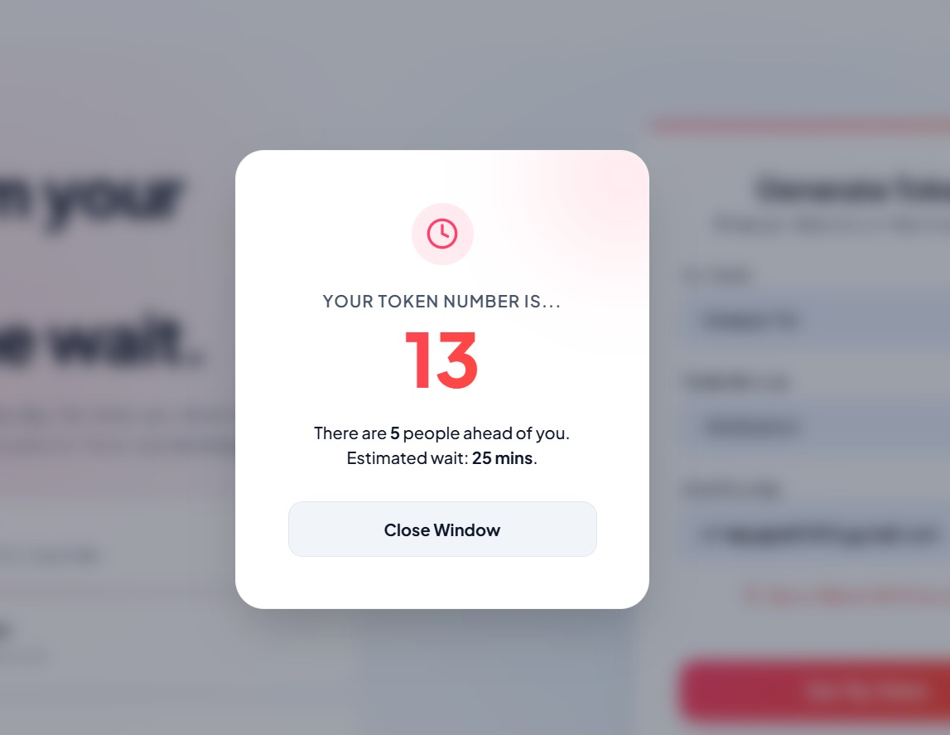

Admin Side

a) Login Page-

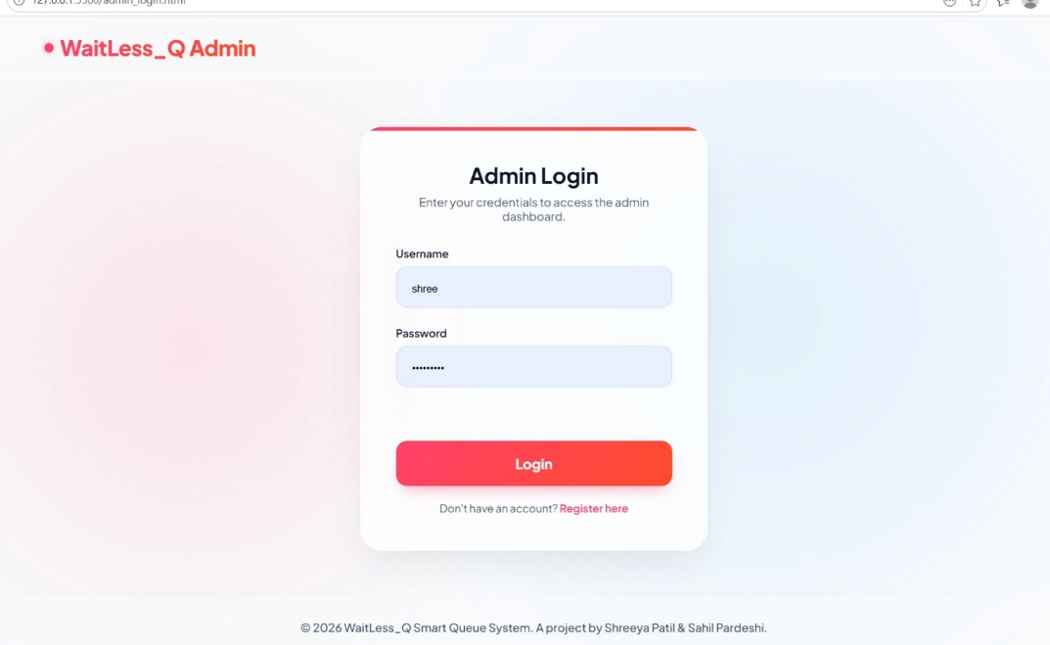

b) Shift Selection Page -

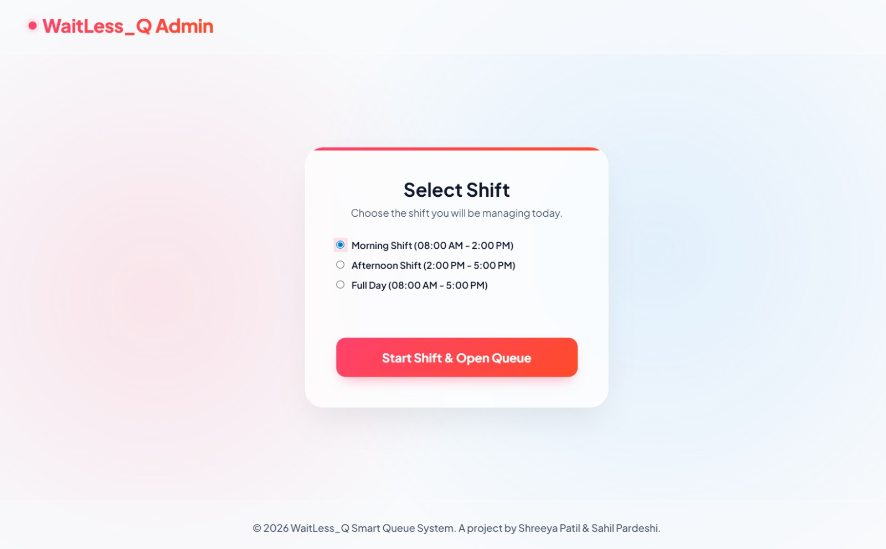

c) Admin Dashboard -

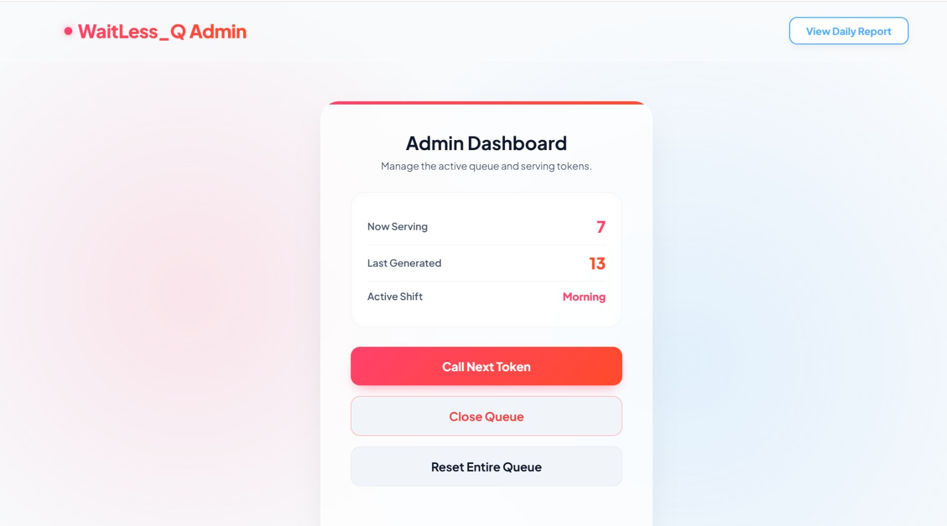

d) Admin Reports Page -

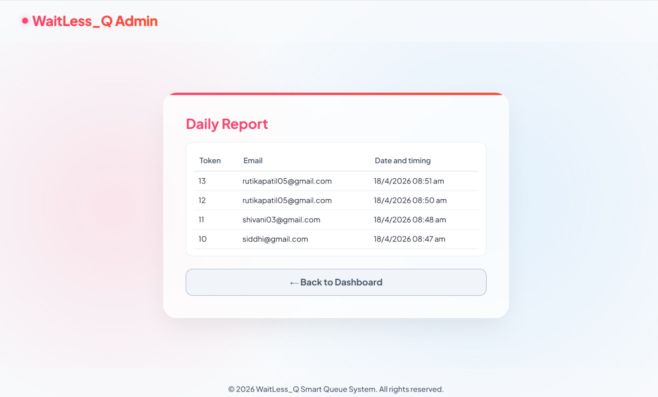

2.4 User Manual:-

Students Side -

a) Home / Token generation Page -

- After visiting the site a small form will be displayed.
- Fill the required details in the form.
- After fill the info click on Get My Token button.
- The system will give the generated token and estimated time details.
- User can click on My Token button to check the token details afterwards.



b) Token Page -

- After clicking on Get My Token or My Token button.
- This page will load with token details.



Admin Side-

a) Booking Page –

1) The admin reviews the booking information.
2)The admin can verify booking availability and payment details.
3) Verified bookings are updated in the system.
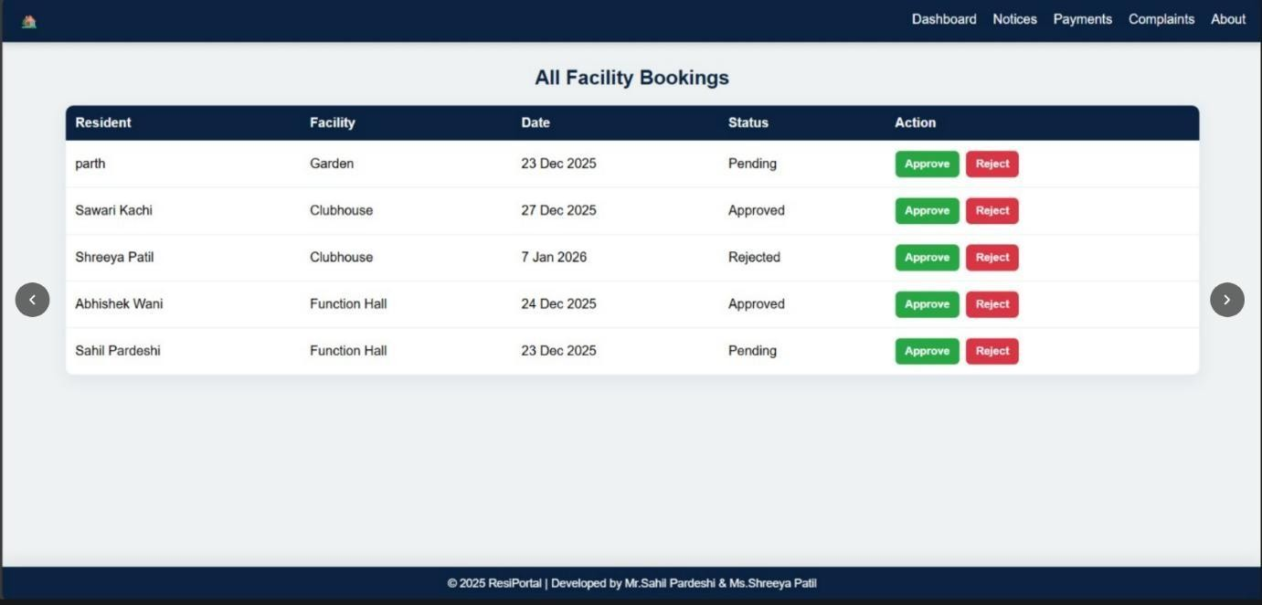

b) Notice -

1)The admin can view all posted notices in a list format.
2)Both active and past notices can be accessed.

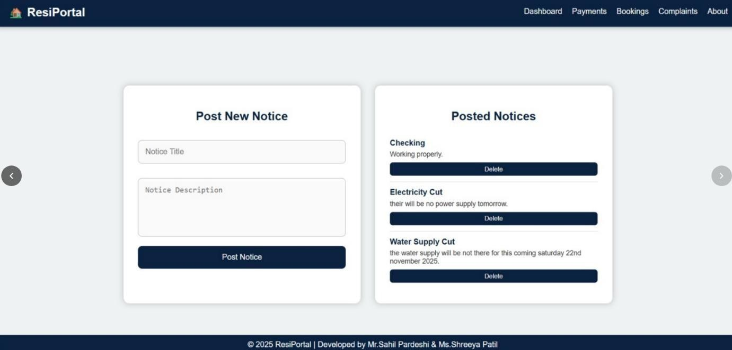

c) Maintenance -

1)The admin checks the payment records
2)Verified payments are marked as Completed in the system.
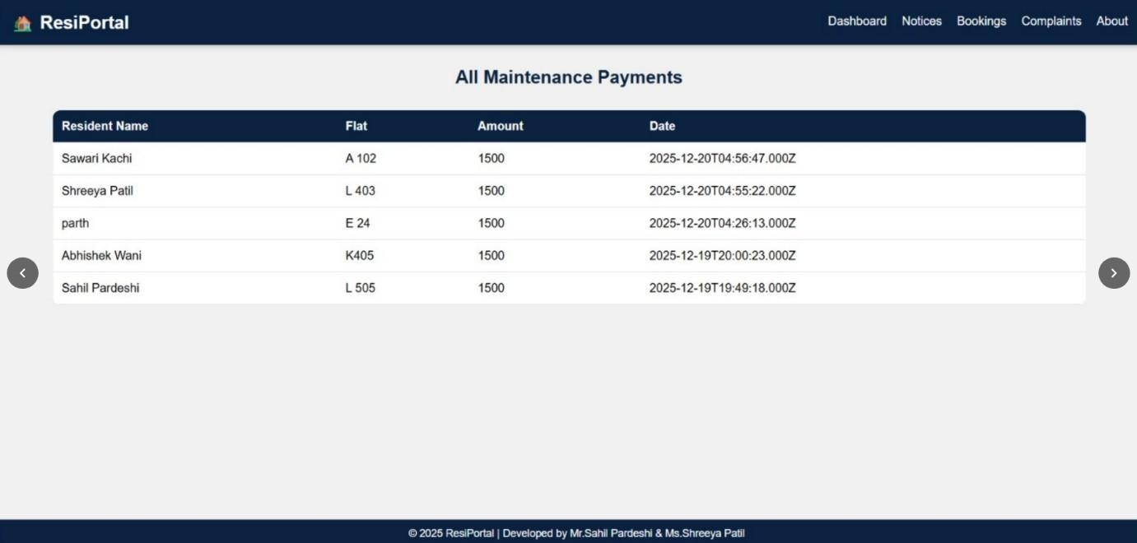

d) Complaint –

1)The admin reviews the complaint details.
2)Takes necessary action to resolve the issue.
3)Updates the complaint status to:
Pending
Reply

