Simulation of Well mixed and stochastic Models for COVID 19
Alexandra Nickel ¹, Sahil Khan ¹, Lily Wagner ¹
¹ School of Biomedical Engineering, Drexel University, USA
Course : Bmes678
Instructor: Ahmet Sacan
Date : 2026-07-07
Original Paper(s): Hou et al.’s The effectiveness of quarantine of Wuhan city against the Corona Virus Disease 2019 (COVID‐19): A well‐mixed SEIR model analysis

abstract
The COVID-19 pandemic led to widespread illness due to the rapid transmission of the highly contagious virus. Modelling the spread of the virus was crucial to predicting future outbreaks and assessing the impact of various methods of mitigating them. This project utilized two different types of models to estimate the spread of COVID-19. The first approach used a well-mixed SEIR model Hou et al.’s Wuhan Quarantine Study [4] and the second approach used a probability-based stochastic contact network model. The SEIR model was developed using a system of differential equations for susceptible (S), exposed (E), infected (I), and recovered (R) populations. The contact network model uses a power law network structure and estimates transmission based on connections between individuals. The stochastic model includes several features to more accurately model probabilities that impact transmission including latent period duration, infectious period duration, varying infectivity, and quarantine duration. Parameter analyses also depict the impact that certain probabilities have on peak infection and rates. The overall results indicate that the well-mixed SEIR model replicated the general trends observed in the previous studies that it reflects. The contact network model demonstrates the importance of network structure and how quarantines may either reduce or increase the rate of disease spread depending on how many and what types of connections exist within the network of individuals. These findings support the idea that network characteristics and different probable elements should be considered when attempting to predict future outcomes of an epidemic where transmission depends on specific interactions between individuals.

introduction
Coronavirus disease 2019 (COVID-19) is an infectious illness affecting the respiratory system that is caused by the virus called SARS-CoV-2. Since its first case was reported in Wuhan, China in late 2019, COVID-19 has illustrated how rapidly a respiratory disease can spread through a population when people engage in daily contact networks. Public health measures like quarantine, isolation and diminished contact rates are often done before the extent of an outbreak is known as the disease can occur before and/or at the same time as symptoms are observed. In such a context, mathematical models come in handy to simulate the dynamics of epidemics, to predict eventual infection waves and determine their size, and to check the effect of modifying epidemic parameters, such as the transmission or recovery rate.

Medical interest in understanding the spread of COVID-19 is growing due to the risk of large outbreaks, resulting in increased hospitalization and preventable deaths. A mathematical model can be developed to estimate the number of people who will be infected at a given point in time to help estimate when medical resources may be needed. This project investigates the spread of COVID-19 with both well-mixed SEIR model and contact-network-based model. The well-mixed SEIR model assumes uniform mixing of the population whereas the network model assumes transmission occurs between particular persons. Using these two approaches, differences in assumptions about population mixing can be contrasted with the resulting differences in predictions for peak infections, time to peak and total infections.

Physiology and Disease Background:
The virus spreads the most through respiratory droplets and aerosols from an infected person's nose, mouth, and lungs when they are breathing, talking, coughing, or sneezing. Once exposed, a person can incubate the virus which replicates in the body and can cause symptoms. In SEIR modeling, this is the exposed compartment of the system (people who are infected but not fully infectious or symptomatically ill). Infectious, can spread the virus to susceptible persons in close contact. Infected people either heal, are isolated or, in more elaborate models, may move to the hospital or death.

In the SEIR model, the population is split into four distinct compartments: Susceptible, Exposed, Infected, Recovered. Susceptible persons have not been infected but can be infected when in contact with an infected person. People who have been exposed but are not yet showing symptoms have the virus but are in the latent/incubation period. Patients with the infection can spread it to others. Recovered individuals will not spread the infection anymore and are assumed to be temporarily immune in the model. Biological and behavioral characteristics of the disease process include parameters like contact rate, transmission probability, rate of incubation, and rate of recovery. For instance, the transmission rate indicates the efficiency of the spread of the virus when contact occurs, and the recovery rate is the speed at which infected people become non-infectious.

Goals
The aim of this project is to replicate and develop the COVID-19 SEIR model that Hou et al. used in their research on the effectiveness of the Wuhan quarantine. The first goal is to use the parameter values presented in the paper to implement the basic well-mixed SEIR model and compare the model results to the original publication. The second goal is to conduct parameter analysis for the contact rate, transmission rate and recovery rate to see how each parameter influences the peak infections and time to peak. The third goal is to create a contact-network simulation where the assumption of well-mixed is relaxed and where transmission takes place via a network of individual contacts. This enables the project to contrast the epidemic predictions with and without population structure and connectivity.

The purpose of these simulations is to explore the ability of public health interventions to shape the outcomes of an epidemic. For instance, a decrease in the contact rate may be quarantine, social distancing or travel restrictions. Modifying the transmission rate can be the wearing of a mask, vaccination, or behavioral changes that reduce the risk of being infected with each other. A change in the recovery rate may indicate a faster diagnosis, treatment or isolation. The model can be used to gain insights into which of these parameters are most important for controlling an outbreak by analyzing their effects on the peak level and timing of infection.

Related Work:
To assess the impact of the Chinese city of Wuhan's quarantine during the early phase of the COVID-19 outbreak, Hou et al. created a well-mixed SEIR model. They analyzed the effect of the quarantine on the epidemic trajectory using transmission dynamics, and assessed the potential for reducing the contact between people to delay and/or decrease the number of infections. The present project extends this study in two ways: first by reproducing the basic SEIR results and second by exploring the model using parameter sweeps and a stochastic simulation using a network.

Other COVID-19 modeling efforts have also relied on SEIR-type models to analyze the impact of quarantine and travel restrictions. Later modelling of travel restrictions in Wuhan showed that they lowered the risk of exports and slowed the spread of the epidemic, lending further support to the concept that early restrictions could change the dynamics of an epidemic. Network-based models are another step closer to reality because they take into account that individuals do not randomly interact with everyone else. Instead, the infection is transmitted through organized contacts like families, schools, places of work, communities, etc. This project examines how the model structure impacts prediction and the need to choose model assumptions that reflect the biological and social characteristics of disease transmission by comparing a well-mixed model with a contact-network model.

methods

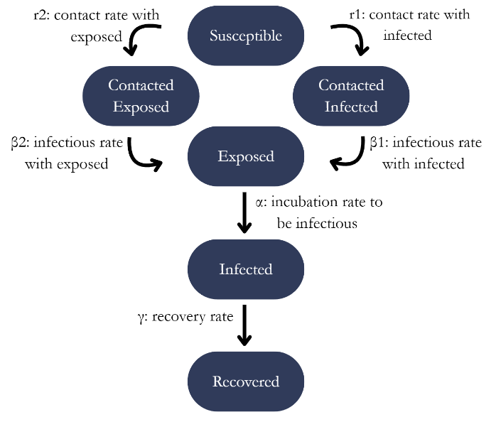
Basic Model: Well Mixed SEIR Model
Figure 1: Basic SEIR Model The figure shows the system and diagram outlining the well-mixed susceptible-exposed-infectious-recovered (SEIR) model. The rates depicted describe the relationship between populations involved in transmission of COVID-19.
The Basic Model is a well-mixed model using a system of differential equations to computationally simulate how the SEIR populations changed from day to day. The model equations in Figure 1 and parameters in table 1 were designed after the ones in “The effectiveness of quarantine of Wuhan city against the Corona Virus Disease 2019 (COVID‐19): A well‐mixed SEIR model analysis” by Can Hou et al. The system of equations used to create the model were:

$$\frac{\text{dS}}{\text{dt}}\text{=-}{\text{r}}_{\text{1}}{\text{β}}_{\text{1}}\frac{\text{IS}}{\text{N}}\text{-}{\text{r}}_{\text{2}}{\text{β}}_{\text{2}}\frac{\text{ES}}{\text{N}}$$
$$\frac{\text{dE}}{\text{dt}}\text{=}{\text{r}}_{\text{1}}{\text{β}}_{\text{1}}\frac{\text{IS}}{\text{N}}\text{-αE+}{\text{r}}_{\text{2}}{\text{β}}_{\text{2}}\frac{\text{ES}}{\text{N}}$$
$$\frac{\text{dI}}{\text{dt}}\text{=αE-γI}$$
$$\frac{\text{dR}}{\text{dt}}\text{=γI}$$

Symbol | Name | Value
 | Populations:
$$S$$ | Susceptible Population | $$S_{0}=11080778$$
$$E$$ | Exposed Population | $$E_{0}=193$$
$$I$$ | Infected Population | $$I_{0}=27$$
$$R$$ | Recovered Population | $$R_{0}=2$$
$$N$$ | Total Population | $$N=S+I+E+R=11081000$$
 | Contact Rates:
$$r_{1}$$ | S and I | $$6$$
$$r_{2}$$ | S and E | $$18$$
 | Infection Rates:
$$β_{1}$$ | From I | $$0.4$$
$$β_{2}$$ | From E | $$0.2$$
$$α$$ | Incubation Rate | 0.14
$$γ$$ | Recovery Rate | 0.048
Table 1. List of populations and parameters used in the Basic Model. Table 1 shows the estimated parameter values for COVID-19 [4]. The name of each parameter describes what the parameter represents in the model.

Parameter Analysis of SEIR Model
A parameter analysis was conducted to examine the effect of altering the contact rate, transmission rate and recovery rate on the outcome of the epidemic. The exposed individuals' contact rate (r₂), transmission rate from exposed individuals (β₂), and recovery rate (gamma) were varied independently. All other parameters were fixed for each sweep of the parameter study. A model simulation time of 200 days was used for solving the model.

The data for the infectious population “I” was obtained from the model output for each simulation. The peak number of infections $I$ was determined as the maximum number of infections and the time to peak infection was determined as the time at which the maximum number of infections I occurred. Parameter-versus-outcome plots were used to summarize these results: r₂ versus peak infections, r₂ versus time to peak,
β₂ versus peak infections, β₂ versus time to peak, gamma versus peak infections, and gamma versus time to peak.

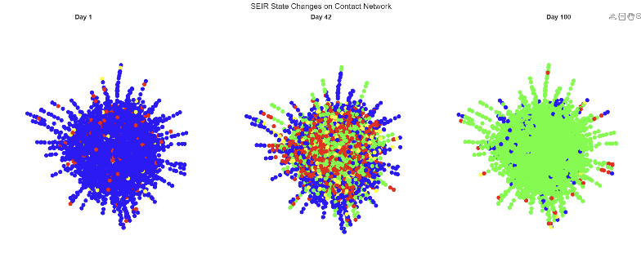
Contact Network Model
Figure 2: Contact-Network Model Contact-network SEIR simulation with 10,000 nodes shown at Day 1, peak infection around Day 42, and Day 100. Nodes are colored by disease state: susceptible individuals are blue, exposed individuals are yellow, infectious individuals are red, and recovered individuals are green. The snapshots show the infection spreading through the network over time

A stochastic contact network model was developed to simulate COVID-19 transmission accounting for different probabilities that would impact the outcomes of the basic SEIR model. In this model, each individual was represented as a node and their interactions with other individuals as edges between nodes. This allows for the observation of transmission based on person-to-person contact rather than only the well-mixed population interactions. The model followed the same general SEIR disease states as the basic SEIR model as well as considered other conditions whose probabilities affect the transmission and recovery rates.

Symbol | Name | Value
$$N$$ | Number of individuals | 10000
$$k_min$$ | Minimum Number of Connections | $$10$$
$$k_max$$ | Maximum Number of Connections | $$500$$
$$γ$$ | Coefficient of Connections | $$2.3$$
$$t$$ | Number of Simulated Days | $$60$$
$$t_e$$ | Latency Period Duration | $$4$$
$$t_i$$ | Infectious Period Duration | $$14$$
$$t_q$$ | Quarantine Period Duration | $$10$$
$$p_i0$$ | Initial Percent Infected | $$0.1$$
$$p_e0$$ | Initial Percent Exposed | $$0.01$$
$$p_q$$ | Probability of an Individual Quarantining | $$0.5$$
$$β_{1}$$ | Probability of Infection from Exposure at Minimum Infection | $$0.02$$
$$β_{2}$$ | Probability of Infection from Exposure from Maximum Infection | 0.6

Table 2. List of populations and parameters used in the Contact Network Model. Table 2 shows the estimated parameter values for COVID-19 [4]. The name of each parameter describes what the parameter represents in the model
.
The contact network was generated for a population of N = 10000 people. The number of contacts each individual would have was determined by a Power Law network generation strategy. Contacts were randomly paired to create a symmetric contact matrix. Each entry in the matrix equaled 1 if there was a contact between the two people listed in the row and column; if not, it would be 0.

In addition to assigning random values to all entries in the contact matrix, the number of contacts assigned to each person was randomly selected. At the beginning of the simulations, 10% of individuals were randomly designated as infected and 1% as exposed. The simulations ran for 100 days and recorded the number of people in each population, S, E, I, and R, per day. A time-varying infectivity based on an infectious period ranging from 10-20 days [7] was used instead of a fixed value in the model. The lowest and highest transmission probabilities were defined at 0.02 and 0.6, respectively.

Disease progression was controlled with an individual time counter. Individuals that were exposed to the virus waited a 4-day latency period before they became infected as per reported durations of incubation [5]. Infected individuals waiting for 14 days before entering the recovered state, based on the infectious period [7].

Quarantine conditions were also added to represent reduced contact post-infection or exposure. When quarantined, an individual’s connections within the contact matrix were temporarily removed for a quarantine period of 10 days, so they could not transmit infection through those connections during that time. This quarantine period is based on the unlikelihood that infected individuals are infectious after a period of 10 days [9]. Once quarantined status was lifted, their original contacts were restored.

The main outputs of the stochastic contact network model were daily SEIR population counts, which were used to estimate when the greatest amount of infection occurred and when that infection would occur under probability-based transmissions.

Parameter Analysis of Contact Network Model
A parameter analysis was executed to observe the impact of the percent of people quarantined and the duration of the latent period on the transmission between individuals. Both parameters were varied within a range of the fixed value used in the contact network model and produced curves to display the outcomes when each of the values within the range was input as the parameter value. The curves plotted were percent of quarantined individuals vs. peak infections, percent of quarantined individuals vs. time to peak infection, latent period duration vs. peak infections, and latent period duration vs. time to peak infection. The peak number of infections I was determined as the maximum number of infections and the time to peak infection was determined as the time at which the maximum number of infections I occurred.

Contact Network Visualization

The simulated contact matrix was converted to a MATLAB graph object using the graph function to see the disease states spread across the contact network. For all visualization time points a force directed layout was created and then reused, so that node positions did not change between snapshots. This enabled the color change of nodes to indicate changes in disease state over time but not changes in network structure or network layout.

Three snapshots of the network were plotted. They were the first day, the day on which the number of infectious people was the highest and the last simulation day. The day of maximum infection was determined by the day on which the infected population output I(t) reached its highest value. The stored disease state for each selected day was used to color the nodes as blue for susceptible, yellow for exposed, red for infectious and green for recovered disease states. The three snapshots were presented side by side to help to make visual comparisons of the infection's propagation across the same contact network during the simulation.
Figure 4: Basic Model (Right) and Figure 2 of Hou et. al. (Left) showing the effects of r₂ on their simulated Well Mixed model Populations

Experiments and REsults

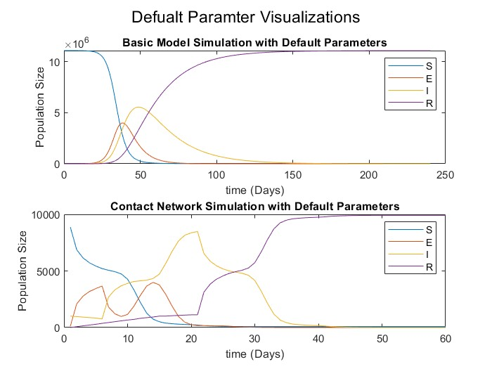
Representative Runs of Basic and Contact Model
Figure 3: Shows a characteristic run for the Basic Model (top) and the Contact Network Model (Bottom) using their default parameters over time.
Figure 5: The effect of parameters r₂ (Top),$β_{2}$ (Middle), and $γ$ (Bottom) on Peak Infections (Left) and Time to Peak (Right)

Basic Model Results

The Basic Model was used to simulate and recreate the results from figure 2 of Hou et. al, and shows the effect of r₂ on the populations in their model (Fig 4).

The effect of model parameters r₂, $β_{2}$, and $γ$ on the model was then analyzed (Fig, 5).

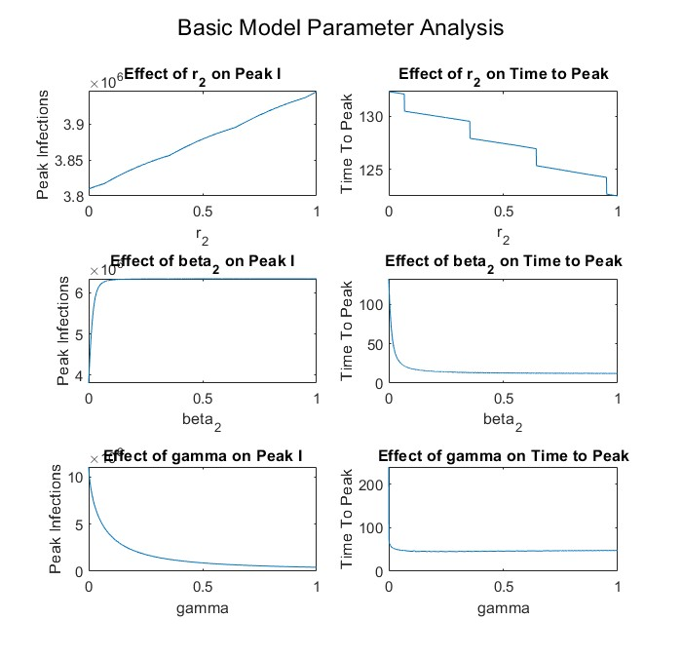

Contact Network Results:

The Contact Network Model was used to analyze the effect of the percent of individuals who quarantine on infections. Figure 6 is a time representation of the effect infection and figure 7 shows the effect of quarantine on max infection peak and time to peak.
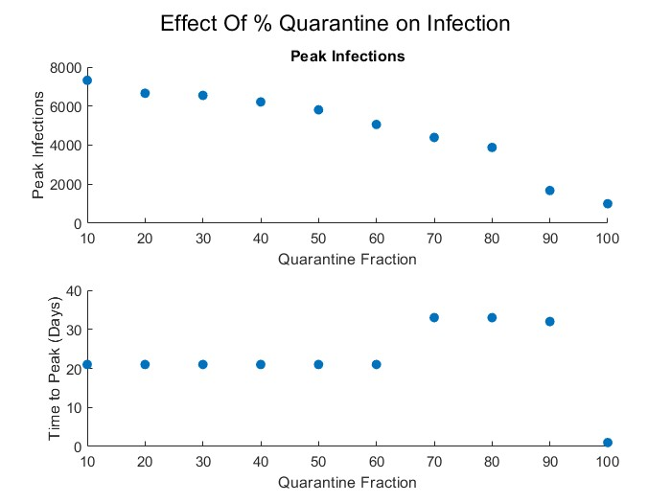
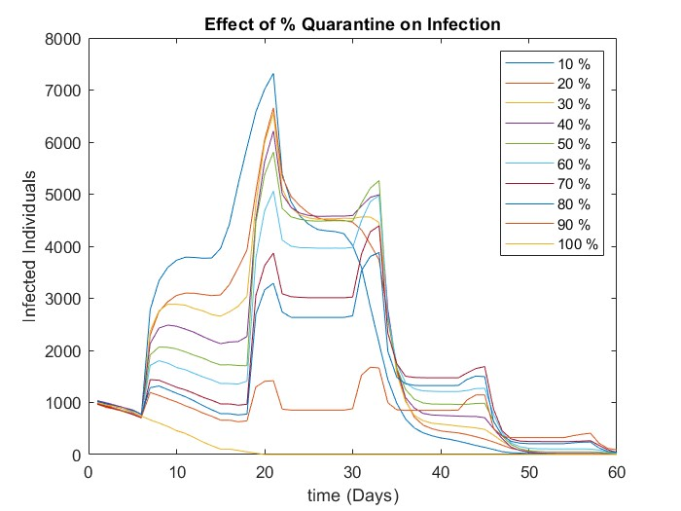
Figure 7: Effect of the percent of individuals who quarantined when infected or exposed on Peak Infections (Top) and Time to Peak (Bottom)
Figure 6: Visual Representation on the percent of individuals who quarantine on the Infected Population

DISCUSSION
The default parameter simulations exhibited the typical SEIR outbreak pattern. It can be seen that the basic deterministic model predicted reduction in the susceptible population as people progressed into the exposed and infected sections and growth in the recovered population with time. Exposed and infected populations reached a maximum and decreased quantity following the natural recovery of more people. The contact-network simulation had the same overall SEIR shape but the curves were not as smooth as in the uniform mixing case since disease transmission was subjected to the randomness of transmission and to the network connections of each individual.

The parameter analysis revealed that the more the exposed contact rate, r2, the more the peak number of contacts and the less the time to the peak would be. This means the more these people come in contact with each other, the quicker the disease can spread through the population. The same trend was observed in the r2 population plots: the susceptible population decreased earlier under higher r2 and the exposed and infected populations peaked earlier. For both the time to peak and the peak infections, increasing exposed transmission rate β2 caused the outbreak to grow more rapidly, with larger transmission probability from exposed individuals leading to faster outbreak growth. Conversely, a higher recovery rate, gamma, lowered the number of infections in the peak due to the fact that the infected people recovered faster, allowing them less time to spread the infection.

The simulations under quarantine demonstrated that increasing the number of quarantined individuals decreases the maximum number of infections in the whole population. This implies that the elimination of exposed and/or infectious individuals from normal contact will reduce the spread of disease within the network. Time to peak was less easily reproducible, possibly due to the stochastic nature of the contact network model; this includes the random infection events for each run of the model, as well as the random structure of the network itself. Additionally, the infection-over-time quarantine plot indicated that the higher the number of quarantined individuals, the lower the infection curve was, though some curves fluctuated due to the fact that individuals are modeled as being either quarantined or reinfected, but not both, and this happens at random. For certain simulations smaller populations were used due to limited computational power and this may have led to more variability in the results. The model could be extended in the future by increasing the number of networks and the number of simulations for each parameter value, which would increase the stability and representativeness of the model's trends.

Overall, the basic SEIR model was well replicated and served as a starting point for comparing the various models for the transmission of COVID-19. The deterministic SEIR model was similar in structure to the model of Hou et al., consisting of susceptible, exposed, infectious and recovered compartments with transitions between each compartment driven by rates of disease progression. This gave a good starting point as it demonstrated how the overall population-level infection curve can be replicated, later introducing a more detailed contact network visualization.

There were some differences between our contact-network visualization and the one presented by Firth et al. that are worth noting. The amount of detail in the intervention included in the graph was different. The researchers in the Nature Medicine paper applied the actual contact network and simulated localized interventions like contact tracing, case isolation, and quarantine, testing and physical distancing. Their figures could be used to demonstrate not only disease distribution, but also the number of people who would be isolated or quarantined in various scenarios of interventions. On the other hand, we aimed to represent the disease-state of each node in the network in terms of SEIR over time. The nodes were colored as susceptible, exposed, infectious, or recovered, but people under quarantine were not separately visible in the final graph in our case.

This difference is important for us to talk about because it affects the interpretation of the disease state and the contact network between people. The Firth et al. model considers only selected individuals and their contacts are removed or limited by the quarantine, which enables the authors to assess the impact of interventions on the size of outbreaks and the number of people removed from normal contact. Our visualization was less complex, as we were only able to provide a view of how the infection spread through the network, however quarantined individuals were not shown, nor was the distribution of quarantined individuals over time. Thus, although our model was able to capture the spread of infection across a contact network, the contact network model referenced in Nature Medicine was more complete in terms of models of public-health interventions and the impact on contact network transmission.

In the future, one way to improve the model would be to include quarantine as a separate visual state in the contact-network graph. This would allow the model to show not only all of our depicted SEIR data, but also which individuals are removed from normal contact due to isolation. Adding this feature would make the visualization more realistic and would help show how public-health interventions reduce transmission through the network.

References
1. ‌Barabási, A.-L., & Albert, R. (1999). Emergence of Scaling in Random Networks. Science, 286(5439), 509–512. https://doi.org/10.1126/science.286.5439.509
2. Firth, J. A., Hellewell, J., Klepac, P., Kissler, S., Kucharski, A. J., & Spurgin, L. G. (2020). Using a real-world network to model localized COVID-19 control strategies. Nature Medicine, 26(10), 1616–1622. https://doi.org/10.1038/s41591-020-1036-8
3. Graph generators — NetworkX 3.3 documentation. (n.d.). Networkx.org. https://networkx.org/documentation/stable/reference/generators.html
4. Hou, C., Chen, J., Zhou, Y., Hua, L., Yuan, J., He, S., Guo, Y., Zhang, S., Jia, Q., Zhao, C., Zhang, J., Xu, G., & Jia, E. (2020). The effectiveness of quarantine of Wuhan city against the Corona Virus Disease 2019 (COVID‐19): A well‐mixed SEIR model analysis. Journal of Medical Virology, 92(7), 841–848. https://doi.org/10.1002/jmv.25827
5. Li, Q., Guan, X., Wu, P., Wang, X., Zhou, L., Tong, Y., Ren, R., Leung, K. S. M., Lau, E. H. Y., Wong, J. Y., Xing, X., Xiang, N., Wu, Y., Li, C., Chen, Q., Li, D., Liu, T., Zhao, J., Li, M., & Tu, W. (2020). Early Transmission Dynamics in Wuhan, China, of Novel Coronavirus-Infected Pneumonia. The New England Journal of Medicine, 382(13), 1199–1207. https://doi.org/10.1056/NEJMoa2001316
6. ‌OSTI, (2026). Synthetic Generators to Simulate Social Network. Osti.gov. https://www.osti.gov/servlets/purl/1242056
7. ‌Rǎdulescu, A., Williams, C., & Cavanagh, K. (2020). Management strategies in a SEIR-type model of COVID 19 community spread. Scientific Reports, 10(1). https://doi.org/10.1038/s41598-020-77628-4
8. skissler. (2025). GitHub - skissler/haslemere: Supplemental information and data for the manuscript “Sparking ‘The BBC Four Pandemic’: Leveraging citizen science and mobile phones to model the spread of disease.” GitHub. https://github.com/skissler/haslemere
9. Walsh, K. A., Spillane, S., Comber, L., Cardwell, K., Harrington, P., Connell, J., Teljeur, C., Broderick, N., de Gascun, C. F., Smith, S. M., Ryan, M., & O’Neill, M. (2020). The duration of infectiousness of individuals infected with SARS-CoV-2. Journal of Infection, 81(6), 847–856. https://doi.org/10.1016/j.jinf.2020.10.009

