MSE-01 Submission
Sahil 202401100100215 CS-5C
Course Code: CS305E (AI Powered CI/CD Containerization –BLENDED-CIE-MSE 1
DevOps Assessment – Continuous Integration with GitHub Actions

Submission Evidences:
1.GitHub Repository link:
https://github.com/Sahil1024-git/github-skills-challenge
2. Pull request URL used to validate the workflows:
Validate Python CI and coverage workflows by Sahil1024-git · Pull Request #2 · Sahil1024-git/github-skills-challenge
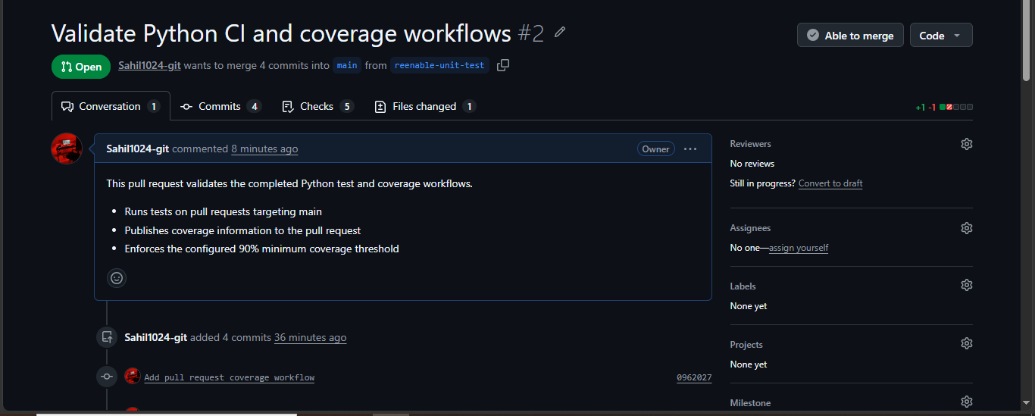

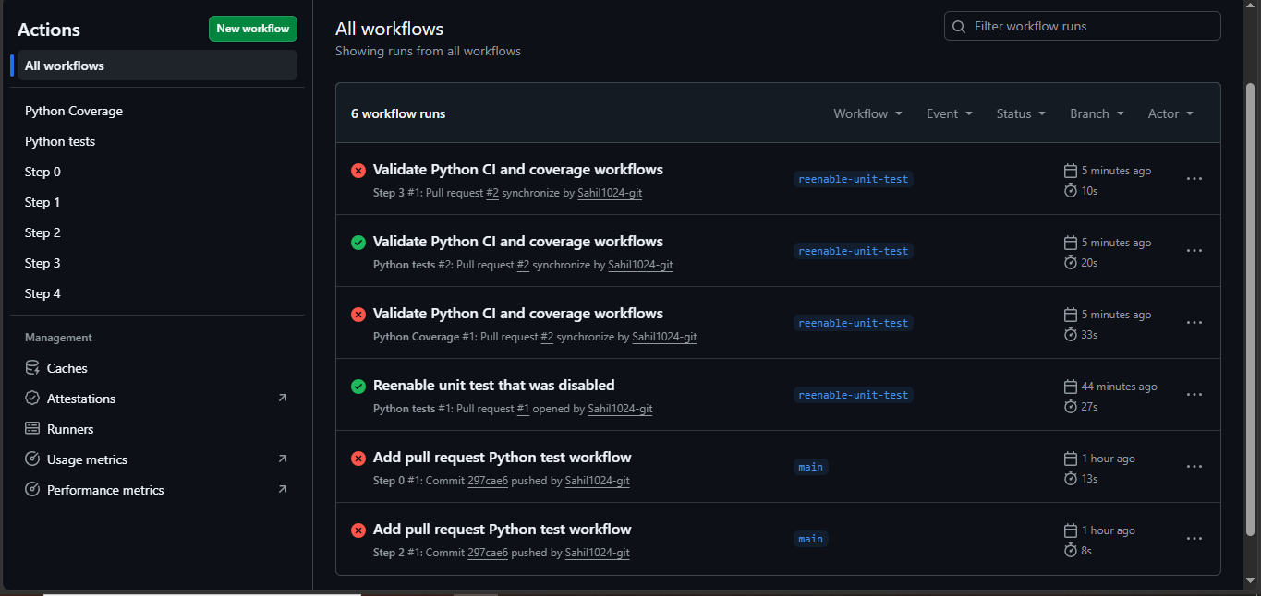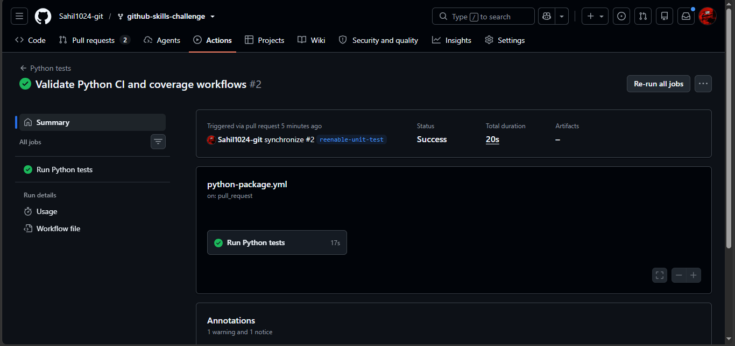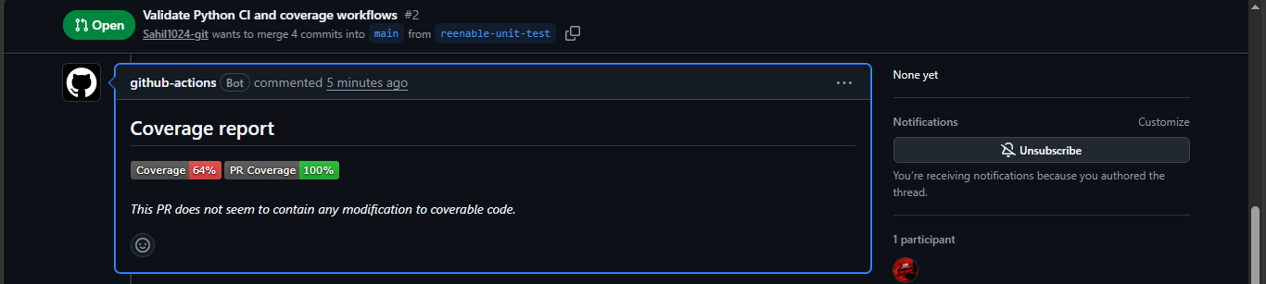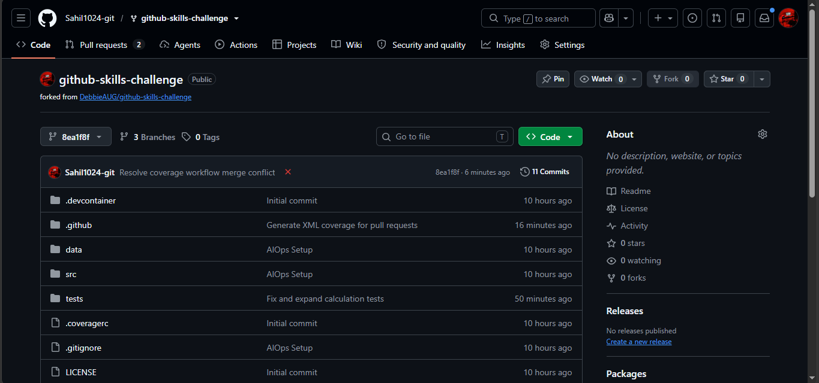

3. Screenshot showing the GitHub Actions workflows 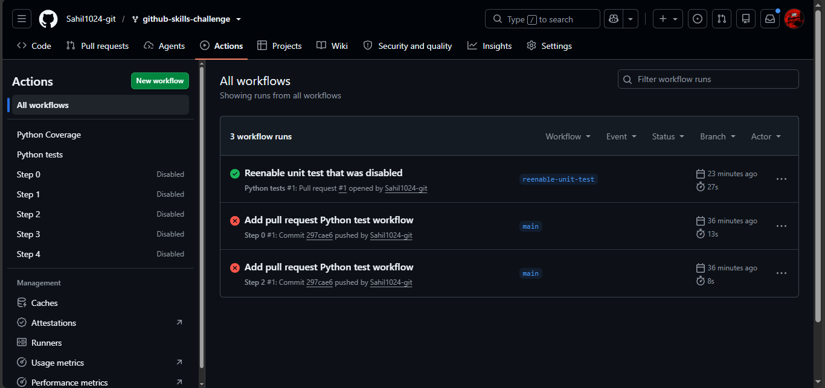

4. Screenshot showing a successful test workflow execution 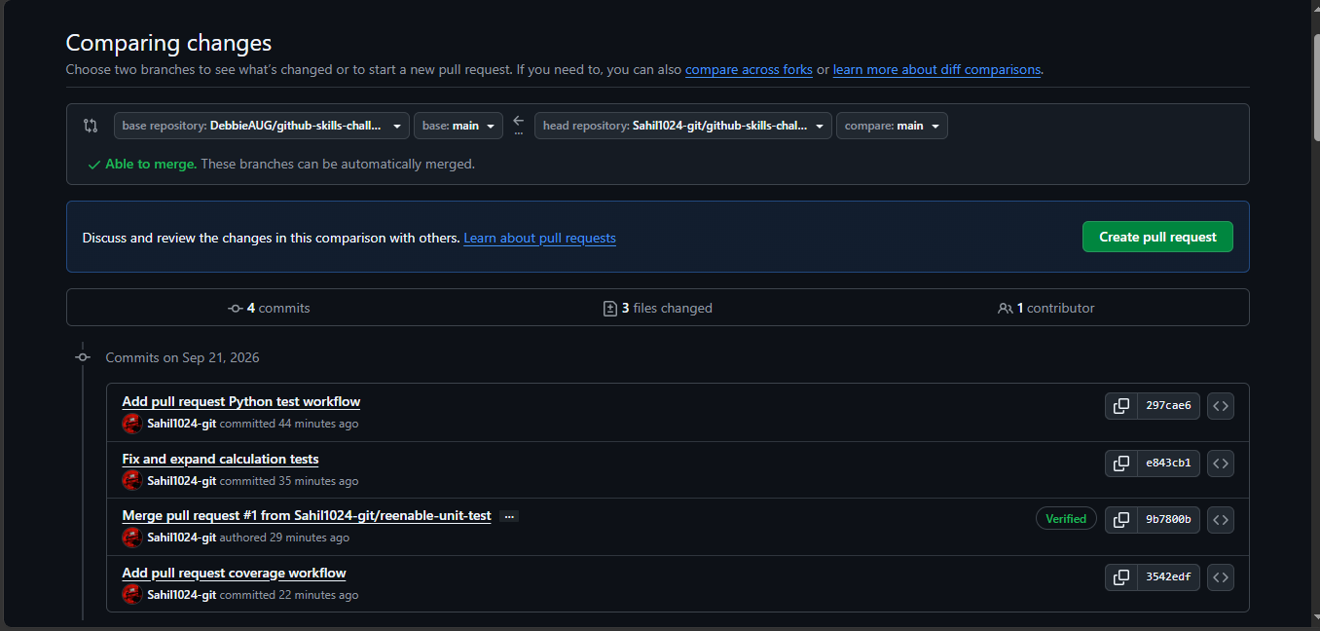
5. Screenshot showing the coverage result/comment on the pull request
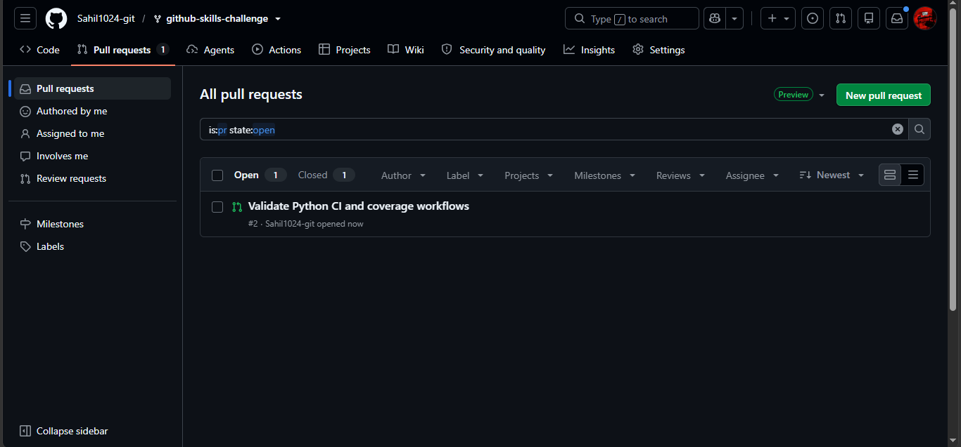

6. Screenshot showing the final repository/workflow files
Direct workflow files:
