LAB 8

Name:Sahil Saini Salaria
Reg. No. 180905048
Roll:11C
Batch 5

//Header file

#include <stdio.h>
#include <stdlib.h>
#include <ctype.h>
#include <string.h>

const char *keywords[] = {
"auto","double","int","struct","break","else","long","switch","case","enum",
"register","typedef","char","extern","return","union","continue","for","signed",
"void","do","if","static","while","default","goto","sizeof","volatile","const","float",
"short","unsigned","printf","scanf","true","false","bool"
};
const char *datypes[]={"int","char","void","float","bool","double"};
int isdtype(char *w)
{
int i;
for(i=0;i<sizeof(datypes)/sizeof(char*);i++)
{
if(strcmp(w,datypes[i])==0)
{
return 1;
}
}
return 0;
}
int isKeyword(char *w)
{

int i;

for(i=0;i<sizeof(keywords)/sizeof(char*);i++)

{

if(strcmp(w,keywords[i])==0)

{

return 1;

}

}

return 0;
}
struct token
{
char lexeme[128];
unsigned int row,col;
char type[64];
};
struct sttable
{
int sno;
char lexeme[128];
char dtype[64];
char type[64];
int size;
};
int findTable(struct sttable *tab,char *nam,int n)
{
int i=0;
for(i=0;i<n;i++)
{
if(strcmp(tab[i].lexeme,nam)==0)
{
return 1;
}
}
return 0;
}
struct sttable fillTable(int sno,char *lexn,char *dt,char *t,int s)
{
struct sttable tab;
tab.sno=sno;
strcpy(tab.lexeme,lexn);
strcpy(tab.dtype,dt);
strcpy(tab.type,t);
tab.size=s;
return tab;
}
void printTable(struct sttable *tab,int n)
{
for(int i=0;i<n;i++)
{
printf("%d %s %s %s %d\n",tab[i].sno,tab[i].lexeme,tab[i].dtype,tab[i].type,tab[i].size);
}
}
static int row=1,col=1;
char buf[2048];
char dbuf[128];
int ind=0;
const char specialsymbols[]={'?',';',':',','};
const char arithmeticsymbols[]={'*'};
int charIs(int c,const char *arr)
{
int len;
if(arr==specialsymbols)
{
len=sizeof(specialsymbols)/sizeof(char);
}
else if(arr==arithmeticsymbols)
{
len=sizeof(arithmeticsymbols)/sizeof(char);
}
for(int i=0;i<len;i++)
{
if(c==arr[i])
{
return 1;
}
}
return 0;
}
void fillToken(struct token *tkn,char c,int row,int col, char *type)
{
tkn->row=row;
tkn->col=col;
strcpy(tkn->type,type);
tkn->lexeme[0]=c;
tkn->lexeme[1]='\0';
}
void newLine()
{
++row;
col=1;
}
int sz(char *w)
{
if(strcmp(w,"int")==0)
return 4;
if(strcmp(w,"char")==0)
return 1;
if(strcmp(w,"void")==0)
return 0;
if(strcmp(w,"float")==0)
return 8;
if(strcmp(w,"bool")==0)
return 1;
}
struct token getNextToken(FILE *fa)
{
int c;
struct token tkn=
{
.row=-1
};
int gotToken=0;
while(!gotToken && (c=fgetc(fa))!=EOF)
{
if(charIs(c,specialsymbols))
{
fillToken(&tkn,c,row,col,"SS");
gotToken=1;
++col;
}
else if(charIs(c,arithmeticsymbols))
{
fseek(fa,-1,SEEK_CUR);
c=getc(fa);
if(isalnum(c)){
fillToken(&tkn,c,row,col,"ARITHMETICOPERATOR");
gotToken=1;
++col;
}
fseek(fa,1,SEEK_CUR);
}
else if(c=='(')
{
fillToken(&tkn,c,row,col,"LB");
gotToken=1;
col++;
}
else if(c==')')
{
fillToken(&tkn,c,row,col,"RB");
gotToken=1;
col++;
}
else if(c=='{')
{
fillToken(&tkn,c,row,col,"LC");
gotToken=1;
col++;
}
else if(c=='}')
{
fillToken(&tkn,c,row,col,"RC");
gotToken=1;
col++;
}
else if(c=='[')
{
fillToken(&tkn,c,row,col,"LS");
gotToken=1;
col++;
}
else if(c==']')
{
fillToken(&tkn,c,row,col,"RS");
gotToken=1;
col++;
}
else if(c=='+')
{
int x=fgetc(fa);
if(x!='+')
{
fillToken(&tkn,c,row,col,"ARITHMETICOPERATOR");
gotToken=1;
col++;
fseek(fa,-1,SEEK_CUR);
}
else
{
fillToken(&tkn,c,row,col,"UNARYOPERATOR");
strcpy(tkn.lexeme,"++");
gotToken=1;
col+=2;
}
}
else if(c=='-')
{
int x=fgetc(fa);
if(x!='-')
{
fillToken(&tkn,c,row,col,"ARITHMETICOPERATOR");
gotToken=1;
col++;
fseek(fa,-1,SEEK_CUR);
}
else
{
fillToken(&tkn,c,row,col,"UNARYOPERATOR");
strcpy(tkn.lexeme,"++");
gotToken=1;
col+=2;
}
}
else if(c=='=')
{
int x=fgetc(fa);
if(x!='=')
{
fillToken(&tkn,c,row,col,"ASSIGNMENTOPERATOR");
gotToken=1;
col++;
fseek(fa,-1,SEEK_CUR);
}
else
{
fillToken(&tkn,c,row,col,"RELATIONALOPERATOR");
strcpy(tkn.lexeme,"++");
gotToken=1;
col+=2;
}
}
else if(isdigit(c))
{
fillToken(&tkn,c,row,col++,"NUMBER");
int j=1;
while((c=fgetc(fa))!=EOF && isdigit(c))
{
tkn.lexeme[j++]=c;
col++;
}
tkn.lexeme[j]='\0';
gotToken=1;
fseek(fa,-1,SEEK_CUR);
}
else if(c == '#')
{
while((c = fgetc(fa))!= EOF && c != '\n');
newLine();
}
else if(c=='\n')
{
newLine();
c = fgetc(fa);
if(c == '#')
{
while((c = fgetc(fa)) != EOF && c != '\n');
newLine();
}
else if(c != EOF)
{
fseek(fa, -1, SEEK_CUR);
}
}
else if(isspace(c))
{
++col;
}
else if(isalpha(c) || c=='_')
{
tkn.row=row;
tkn.col=col++;
tkn.lexeme[0]=c;
int j=1;
while((c=fgetc(fa))!=EOF && isalnum(c))
{
tkn.lexeme[j++]=c;
col++;
}
tkn.lexeme[j]='\0';
if(isKeyword(tkn.lexeme))
{
strcpy(tkn.type,"KEYWORD");
}
else
{
strcpy(tkn.type,"IDENTIFIER");
}
gotToken=1;
fseek(fa,-1,SEEK_CUR);
}
else if(c=='/')
{
int d=fgetc(fa);
++col;
if(d=='/')
{
while((c=fgetc(fa))!= EOF && c!='\n')
{
++col;
}
if(c=='\n')
{
newLine();
}
}
else if(d=='*')
{
do
{
if(d=='\n')
{
newLine();
}
while((c==fgetc(fa))!= EOF && c!='*')
{
++col;
if(c=='\n')
{
newLine();
}
}
++col;
}while((d==fgetc(fa))!= EOF && d!='/' && (++col));
++col;
}
else
{
fillToken(&tkn,c,row,--col,"ARITHMETIC OPERATOR");
gotToken=1;
fseek(fa,-1,SEEK_CUR);
}
}
else if(c=='"')
{
tkn.row=row;
tkn.col=col;
strcpy(tkn.type, "STRING LITERAL");
int k = 1;
tkn.lexeme[0] = '"';
while((c = fgetc(fa)) != EOF && c != '"')
{
tkn.lexeme[k++] = c;
++col;
}
tkn.lexeme[k] = '"';
gotToken = 1;
}
else if(c == '<' || c == '>' || c == '!')
{
fillToken(&tkn, c, row, col, "RELATIONALOPERATOR");
++col;
int d = fgetc(fa);
if(d == '=')
{
++col;
strcat(tkn.lexeme, "=");
}
else
{
if(c == '!')
{
strcpy(tkn.type, "LOGICALOPERATOR");
}
fseek(fa, -1, SEEK_CUR);
}
gotToken = 1;
}
else if(c == '&' || c == '|')
{
int d = fgetc(fa);
if(c == d)
{
tkn.lexeme[0] = tkn.lexeme[1] = c;
tkn.lexeme[2] = '\0';
tkn.row = row;
tkn.col = col;
++col;
gotToken = 1;
strcpy(tkn.type, "LOGICALOPERATOR");
}
else
{
fseek(fa, -1, SEEK_CUR);
}
++col;
}
else
{
++col;
}
}
return tkn;
}

// main

#include <stdio.h>
#include <stdlib.h>
#include <ctype.h>
#include <string.h>
#include "la.h"

void program();
void declarations();
void datatype();
void idlist();
void idlistprime();
void assignstat();
void statementlist();
void statement();
void expn();
void eprime();
void simpleexp();
void seprime();
void term();
void tprime();
void factor();
void relop();
void addop();
void mulop();
struct token tkn;
FILE *f1;
char *rel[]={"==","!=","<=",">=",">","<"};
char *add[]={"+","-"};
char *mul[]={"*","/","%"};
int isrel(char *w)
{
int i;
for(i=0;i<sizeof(rel)/sizeof(char*);i++)
{
if(strcmp(w,rel[i])==0)
{
return 1;
}
}
return 0;
}
int isadd(char *w)
{
int i;
for(i=0;i<sizeof(add)/sizeof(char*);i++)
{
if(strcmp(w,add[i])==0)
{
return 1;
}
}
return 0;
}
int ismul(char *w)
{
int i;
for(i=0;i<sizeof(mul)/sizeof(char*);i++)
{
if(strcmp(w,mul[i])==0)
{
return 1;
}
}
return 0;
}
int main()
{
FILE *fa, *fb;
int ca, cb;
fa = fopen("input.c", "r");
if (fa == NULL){
printf("Cannot open file \n");
exit(0);
}

fb = fopen("output.c", "w+");
ca = getc(fa);
while (ca != EOF){
if(ca==' ')
{
putc(ca,fb);
while(ca==' ')
ca = getc(fa);
}
if (ca=='/')
{
cb = getc(fa);
if (cb == '/')
{
while(ca != '\n')
ca = getc(fa);
}
else if (cb == '*')
{
do
{
while(ca != '*')
ca = getc(fa);
ca = getc(fa);
} while (ca != '/');
}
else{
putc(ca,fb);
putc(cb,fb);
}
}
else putc(ca,fb);
ca = getc(fa);
}
fclose(fa);
fclose(fb);
fa = fopen("output.c", "r");
if(fa == NULL){
printf("Cannot open file");
return 0;
}
fb = fopen("temp.c", "w+");
ca = getc(fa);
while (ca != EOF)
{
if(ca=='"')
{
putc(ca,fb);
ca=getc(fa);
while(ca!='"')
{
putc(ca,fb);
ca=getc(fa);
}
}
else if(ca=='#')
{

while(ca!='\n')
{

ca=getc(fa);

}
ca=getc(fa);
}
putc(ca,fb);
ca = getc(fa);
}
fclose(fa);
fclose(fb);

fa = fopen("temp.c", "r");
fb = fopen("output.c", "w");
ca = getc(fa);
while(ca != EOF){
putc(ca, fb);
ca = getc(fa);
}
fclose(fa);
fclose(fb);
remove("temp.c");
f1=fopen("output.c","r");
if(f1==NULL)
{
printf("Error! File cannot be opened!\n");
return 0;
}

while((tkn=getNextToken(f1)).row!=-1)
{
if(strcmp(tkn.lexeme,"main")==0)
{
program();
break;
}else{
printf("Missing main function\n");
break;
}
}
fclose(f1);
}
void program()
{

if(strcmp(tkn.lexeme,"main")==0)
{
tkn=getNextToken(f1);
if(strcmp(tkn.lexeme,"(")==0)
{
tkn=getNextToken(f1);
if(strcmp(tkn.lexeme,")")==0)
{
tkn=getNextToken(f1);
if(strcmp(tkn.lexeme,"{")==0)
{
tkn=getNextToken(f1);
declarations();
statementlist();
if(strcmp(tkn.lexeme,"}")==0)
{
printf("Compiled successfully");
return;
}
else
{
printf("} missing at row=%d col=%d",tkn.row,tkn.col);
exit(1);
}
}
else
{
printf("{ missing at row=%d col=%d",tkn.row,tkn.col);
exit(1);
}
}
else
{
printf(") missing at row=%d col=%d",tkn.row,tkn.col);
exit(1);
}
}
else
{
printf("( missing at row=%d col=%d",tkn.row,tkn.col);
exit(1);
}
}
}
void declarations()
{
if(isdtype(tkn.lexeme)==0)
{
return;
}
datatype();
idlist();
if(strcmp(tkn.lexeme,";")==0)
{
tkn=getNextToken(f1);
declarations();
}
else
{
printf("; missing at row=%d col=%d",tkn.row,tkn.col);
exit(1);
}
}
void datatype()
{
if(strcmp(tkn.lexeme,"int")==0)
{
tkn=getNextToken(f1);
return;
}
else if(strcmp(tkn.lexeme,"char")==0)
{
tkn=getNextToken(f1);
return;
}
else
{
printf("%s Missing datatype at row=%d col=%d",tkn.lexeme, tkn.row,tkn.col);
exit(1);
}
}
void idlist()
{
if(strcmp(tkn.type,"IDENTIFIER")==0)
{
tkn=getNextToken(f1);
idlistprime();
}
else
{
printf("Missing IDENTIFIER at row=%d col=%d",tkn.row,tkn.col);
}
}
void idlistprime()
{
if(strcmp(tkn.lexeme,",")==0)
{
tkn=getNextToken(f1);
idlist();
}
if(strcmp(tkn.lexeme,"[")==0)
{
tkn=getNextToken(f1);
if(strcmp(tkn.type,"NUMBER")==0)
{
tkn=getNextToken(f1);
if(strcmp(tkn.lexeme,"]")==0)
{
tkn=getNextToken(f1);
if(strcmp(tkn.lexeme,",")==0)
{
tkn=getNextToken(f1);
idlist();
}
else
{
return;
}
}
}
}
else
{
return;
}
}
void statementlist()
{
if(strcmp(tkn.type,"IDENTIFIER")!=0)
{
return;
}
statement();
statementlist();
}
void statement()
{
assignstat();
if(strcmp(tkn.lexeme,";")==0)
{
tkn=getNextToken(f1);
return;
}
}
void assignstat()
{
if(strcmp(tkn.type,"IDENTIFIER")==0)
{
tkn=getNextToken(f1);
if(strcmp(tkn.lexeme,"=")==0)
{
tkn=getNextToken(f1);
expn();
}
else
{
printf("= missing at row=%d col=%d",tkn.row,tkn.col);
exit(1);
}
}
else
{
printf("Missing IDENTIFIER at row=%d col=%d",tkn.row,tkn.col);
exit(1);
}
}
void expn()
{
simpleexp();
eprime();
}
void eprime()
{
if(isrel(tkn.lexeme)==0)
{
return;
}
relop();
simpleexp();
}
void simpleexp()
{
term();
seprime();
}
void seprime()
{
if(isadd(tkn.lexeme)==0)
{
return;
}
addop();
term();
seprime();
}
void term()
{
factor();
tprime();
}
void tprime()
{
if(ismul(tkn.lexeme)==0)
{
return;
}
mulop();
factor();
tprime();
}
void factor()
{
if(strcmp(tkn.type,"IDENTIFIER")==0)
{
tkn=getNextToken(f1);
return;
}
else if(strcmp(tkn.type,"NUMBER")==0)
{
tkn=getNextToken(f1);
return;
}
}
void relop()
{
if(strcmp(tkn.lexeme,"==")==0)
{
tkn=getNextToken(f1);
return;
}
if(strcmp(tkn.lexeme,"!=")==0)
{
tkn=getNextToken(f1);
return;
}
if(strcmp(tkn.lexeme,"<=")==0)
{
tkn=getNextToken(f1);
return;
}
if(strcmp(tkn.lexeme,">=")==0)
{
tkn=getNextToken(f1);
return;
}
if(strcmp(tkn.lexeme,"<")==0)
{
tkn=getNextToken(f1);
return;
}
if(strcmp(tkn.lexeme,">")==0)
{
tkn=getNextToken(f1);
return;
}
}
void addop()
{
if(strcmp(tkn.lexeme,"+")==0)
{
tkn=getNextToken(f1);
return;
}
if(strcmp(tkn.lexeme,"-")==0)
{
tkn=getNextToken(f1);
return;
}
}
void mulop()
{
if(strcmp(tkn.lexeme,"*")==0)
{
tkn=getNextToken(f1);
return;
}
if(strcmp(tkn.lexeme,"/")==0)
{
tkn=getNextToken(f1);
return;
}
if(strcmp(tkn.lexeme,"*")==0)
{
tkn=getNextToken(f1);
return;
}
}

Output:

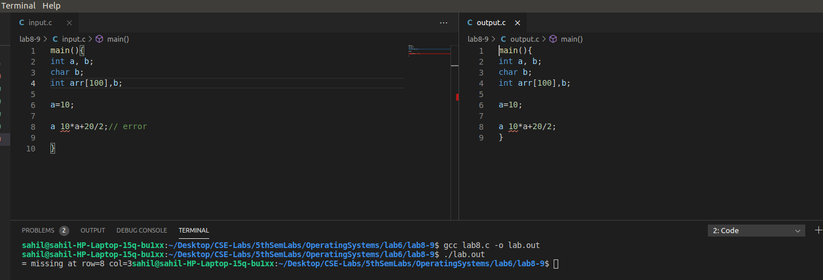
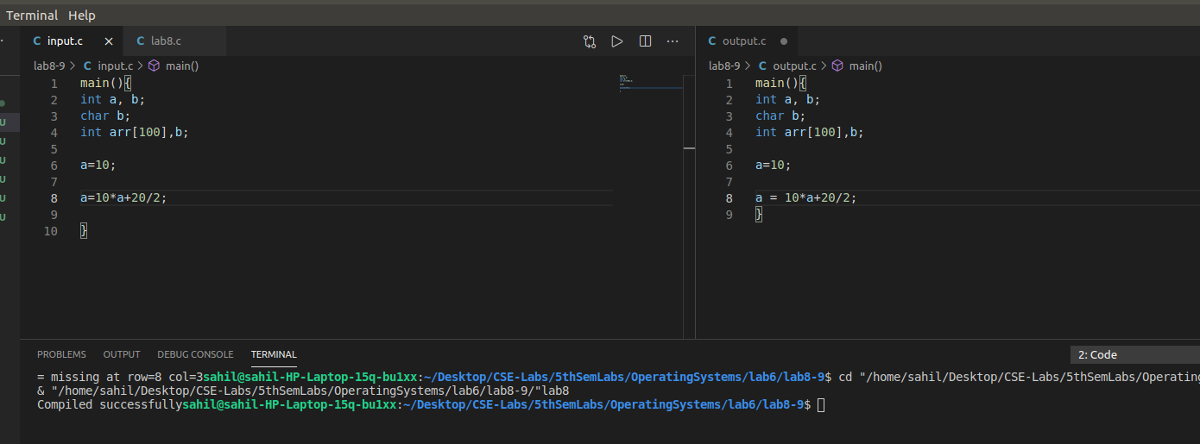

///////////////////////////////////////END///////////////////////////////////

