Lab 8 OS
Sahil Saini Salaria
Reg No. 180905048
Roll No. 11C
Batch 5

Q1

#include<stdio.h>
#include<stdlib.h>
#include<pthread.h>

void* generate_fibonacci(void* param) {
int* arr = (int*)param;
int n = arr[0];
arr[1] = 0;
arr[2] = 1;
for(int i = 3;i <= n;i++) {
arr[i] = arr[i-1] + arr[i-2];
}
return NULL;
}

int main(int argc, char const *argv[])
{
int n;
printf("Enter no of Fibonacci numbers : \n");
scanf("%d",&n);

int* arr = (int*)malloc((n+1)*sizeof(int));
arr[0] = n;

pthread_t thread;
pthread_create(&thread,0,&generate_fibonacci,(void*)arr);
pthread_join(thread,0);

for(int i = 1;i <= n;i++)
printf("%d ",arr[i]);
printf("\n");
return 0;
}
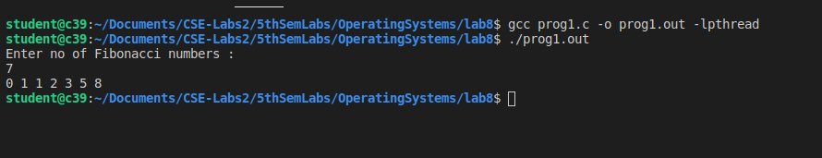

Q2

#include<stdio.h>
#include<stdlib.h>
#include<pthread.h>

void* summation(void* param) {
int* arr = (int*)param;
int sum = 0;
int n = arr[0];
for(int i = 1;i <= n;i++) {
if(arr[i] > 0)
sum += arr[i];
}
return (void*)sum;
}

int main(int argc, char const *argv[])
{
int n;
printf("Enter the no. of numbers : \n");
scanf("%d",&n);

int* arr = (int*)malloc((n+1)*sizeof(int));
arr[0] = n;

printf("Enter the numbers : \n");
for(int i= 1;i <= n;i++) {
scanf("%d",&arr[i]);
}

int answer = 0;
pthread_t thread;
pthread_create(&thread,0,&summation,(void*)arr);
pthread_join(thread,(void**)&answer);

printf("Summation of non-negative numbers = %d\n",answer);
return 0;
}

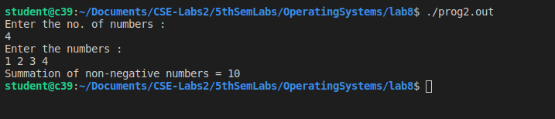

Q3

#include<stdio.h>
#include<pthread.h>

#define N 30
#define MAX_THREADS 4

int prime_arr[N]={0};

void *printprime(void *ptr)
{
int j,flag;
int i=(int)(long long int)ptr;
while(i<N)
{
// printf("Thread id[%d] checking [%d]\n",pthread_self(),i);
flag=0;
for(j=2;j<=i/2;j++)
{
if(i%j==0)
{
flag=1;
break;
}
}

if(flag==0 && (i>1))
{
prime_arr[i]=1;
}
i+=MAX_THREADS;
}
}

int main()
{
pthread_t tid[MAX_THREADS]={{0}};
int count=0;
printf("Enter starting and ending\n");
int st,en;
scanf("%d %d",&st,&en);

for(count=0;count<MAX_THREADS;count++)
{
// printf("\r\n CREATING THREADS %d",count);
pthread_create(&tid[count],NULL,printprime,(void*)count);
}
printf("\n");
for(count=0;count<MAX_THREADS;count++)
{
pthread_join(tid[count],NULL);
}

int c=0;

for(count=st;count<en;count++)
if(prime_arr[count]==1)
printf("%d ",count);
printf("\n");

return 0;
}

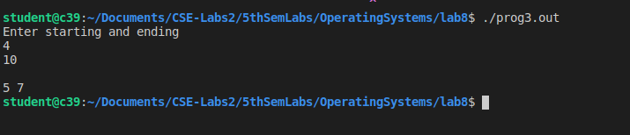

Q4

#include <stdio.h>
#include <stdlib.h>
#include <pthread.h>
#include <errno.h>
#include <ctype.h>
#include <unistd.h>

#define handle_error_en(en, msg) \
do { errno = en; perror(msg); exit(EXIT_FAILURE); } while (0)

volatile int running_threads = 0;
pthread_t thread[1];
int numOfElements;
struct Results{
int sum;
}Results,Results2;
void *findsum(void *array_ptr){

int i; /*counter*/

int *elements = (int*)array_ptr;
for(i = 0; i < numOfElements; i++){
if(elements[i]%2==0)
Results.sum += elements[i];
else
Results2.sum += elements[i];
}

running_threads -= 1;

return NULL;

}

int getArrayInput(int n, int *array_ptr){

int input;

int numberOfElements = 0;

printf("Creating Dynamic Array...\n-\n");

for(;;){

printf("Enter a positive value:\nNegative Number to Stop\n-\n");

if (scanf("%d",&input) != 1){

printf("\nOops that wasn't an Integer\nlets try filling the array again\nRemember INTEGERS only!\n");

exit(EXIT_FAILURE);

}

if (input >= 0){

if (numberOfElements == n){

n += 1;

array_ptr = realloc(array_ptr, n * sizeof(int));

}

array_ptr[numberOfElements++] = input;

} else {

printf("\nNumber of Integers: %d\n", numberOfElements);

break;

}

}

return numberOfElements;

}

void createThreads(int *array_ptr){

int s;

s = pthread_create(&thread[2], NULL, findsum, (void *)array_ptr);

if (s != 0){

handle_error_en(s, "pthread_create");

}

running_threads += 1;

}
int main(){
int n = 1;

int *array_ptr = malloc(n * sizeof(int));

numOfElements = getArrayInput(n, array_ptr);

createThreads(array_ptr);

while(running_threads>0){

sleep(1);

}
printf("\nThe sum of even %d and odd %d\n",Results.sum,Results2.sum);
return(0);
}

