LAB 2

Sahil Saini
Section C
Roll No. 11
Lab OS

Q1

#include<unistd.h>
#include<stdio.h>
#include<sys/stat.h>
#include<stdlib.h>
#include<dirent.h>
#include<string.h>
int main(){
DIR* mydir;
char *c;
int i;
struct dirent *myfile;
struct stat fileStat;
mydir=opendir(".");
stat(".",&fileStat);
while((myfile=readdir(mydir))!=NULL){
stat(myfile->d_name,&fileStat);
if(strcmp(myfile->d_name,".")!=0 && strcmp(myfile->d_name,"..")!=0){
printf("%s\n",myfile->d_name);
printf("File Permission:\n");
printf( (S_ISDIR(fileStat.st_mode)) ? "d" : "-");
printf( (fileStat.st_mode & S_IRUSR) ? "r" : "-");
printf( (fileStat.st_mode & S_IWUSR) ? "w" : "-");
printf( (fileStat.st_mode & S_IXUSR) ? "x" : "-");
printf( (fileStat.st_mode & S_IRGRP) ? "r" : "-");
printf( (fileStat.st_mode & S_IWGRP) ? "w" : "-");
printf( (fileStat.st_mode & S_IXGRP) ? "x" : "-");
printf( (fileStat.st_mode & S_IROTH) ? "r" : "-");
printf( (fileStat.st_mode & S_IWOTH) ? "w" : "-");
printf( (fileStat.st_mode & S_IXOTH) ? "x" : "-");
printf("\n");
}
}
closedir(mydir);
return 0;
}

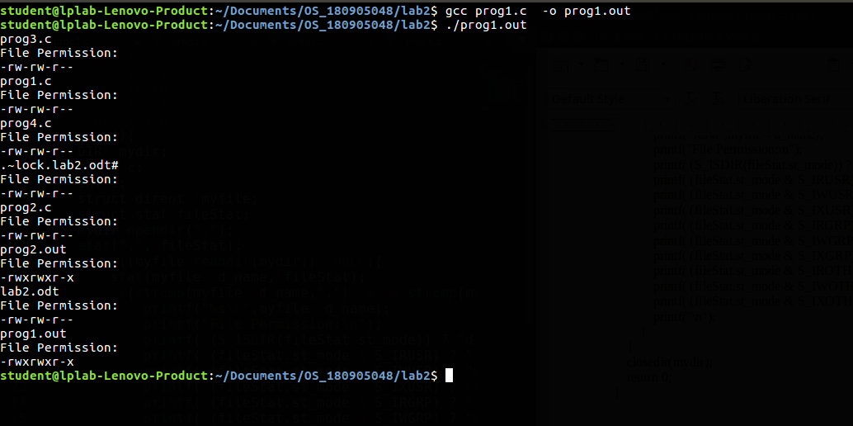

Q2

#include <unistd.h>
#include <sys/stat.h>
#include <stdlib.h>
#include <stdio.h>
#include <string.h>
#include <dirent.h>

void printdir(char * dir, int depth)
{
DIR* dp;
struct dirent* entry;
struct stat statbuf;
if((dp = opendir(dir)) == NULL)
{
fprintf(stderr, "cannot open directory: %s\n", dir);
return;
}
chdir(dir);
while((entry = readdir(dp)) != NULL)
{
lstat(entry->d_name, &statbuf);
if(S_ISDIR(statbuf.st_mode))
{
if(strcmp(".", entry->d_name)==0 || strcmp("..", entry->d_name)==0)
continue;
printf("%*s%s/\n",depth," ",entry->d_name);
printdir(entry->d_name, depth+4);
}
else
printf("%*s%s/\n", depth," ", entry->d_name);
}
chdir("..");
closedir(dp);
}
int main(int argc, char const *argv[])
{
/* code */
printdir(".", 0);
exit(0);
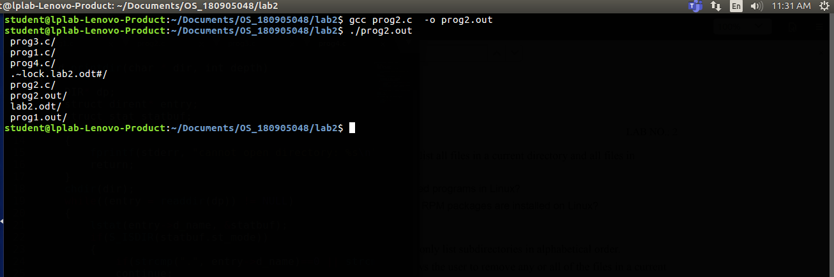
}

Q3

#include <unistd.h>
#include <sys/stat.h>
#include <stdlib.h>
#include <stdio.h>
#include <string.h>
#include <dirent.h>

void printdir(char * dir, int depth)
{
DIR* dp;
struct dirent* entry;
struct stat statbuf;
if((dp = opendir(dir)) == NULL)
{
fprintf(stderr, "cannot open directory: %s\n", dir);
return;
}
chdir(dir);
while((entry = readdir(dp)) != NULL)
{
lstat(entry->d_name, &statbuf);
if(S_ISDIR(statbuf.st_mode))
{
if(strcmp(".", entry->d_name)==0 || strcmp("..", entry->d_name)==0)
continue;
printf("%*s%s/\n",depth," ",entry->d_name);
printdir(entry->d_name, depth+4);
}
else
printf("%*s%s/\n", depth," ", entry->d_name);
}
chdir("..");
closedir(dp);
}
int main(int argc, char const *argv[])
{
/* code */
printdir("/usr/bin", 0);
exit(0);
}

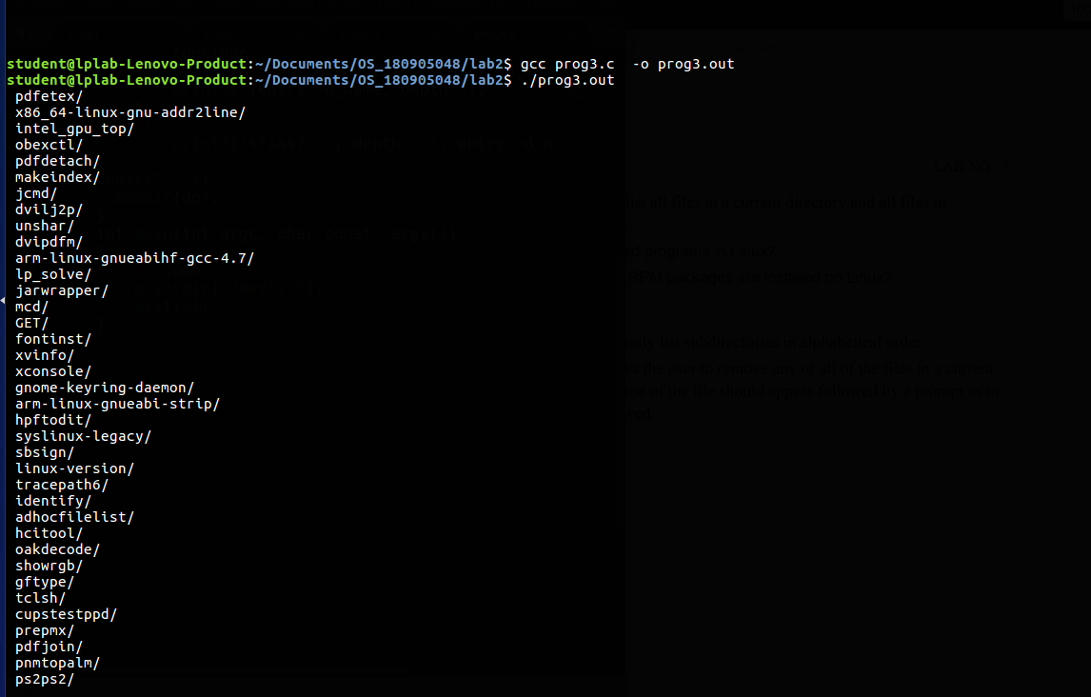

Q4

#include <unistd.h>
#include <sys/stat.h>
#include <stdlib.h>
#include <stdio.h>
#include <string.h>
#include <dirent.h>

void printdir(char * dir, int depth)
{
DIR* dp;
struct dirent* entry;
struct stat statbuf;
if((dp = opendir(dir)) == NULL)
{
fprintf(stderr, "cannot open directory: %s\n", dir);
return;
}
chdir(dir);
while((entry = readdir(dp)) != NULL)
{
lstat(entry->d_name, &statbuf);
if(S_ISDIR(statbuf.st_mode))
{
if(strcmp(".", entry->d_name)==0 || strcmp("..", entry->d_name)==0)
continue;
printf("%*s%s/\n",depth," ",entry->d_name);
printdir(entry->d_name, depth+4);
}
else
printf("%*s%s/\n", depth," ", entry->d_name);
}
chdir("..");
closedir(dp);
}
int main(int argc, char const *argv[])
{
/* code */
printdir("/dev", 0);
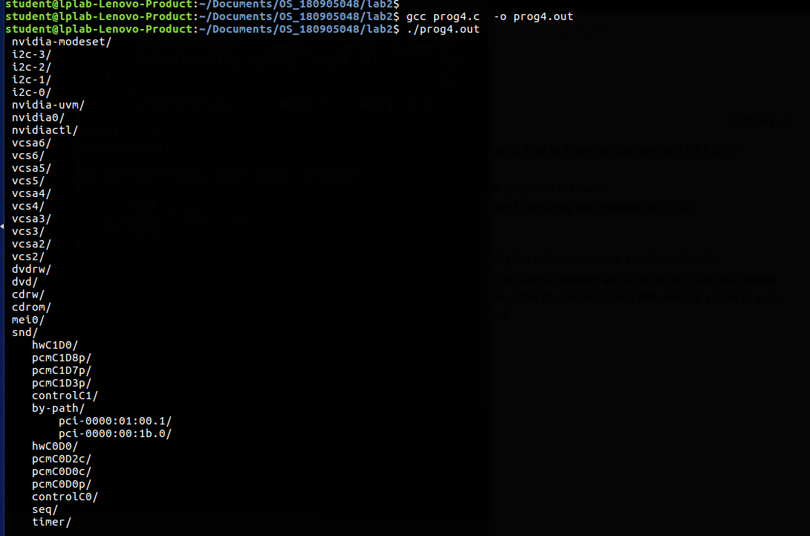
exit(0);
}

