LAB 4

Sahil Saini Salaria
Reg no. 180905048
Roll No. 11C
OS lab

Q1

#include <stdio.h>
#include <stdlib.h>
#include <unistd.h>
#include <sys/types.h>
#include <sys/stat.h>

int main(int argc, char * argv[])
{

struct stat sb;
int ret;

if(argc<2)
{
fprintf(stderr,"usage:%s <file> \n",argv[0]);
return 1;
}

ret=stat(argv[1],&sb);
if(ret)
{
perror("stat");
return 1;
}

printf("%ld\n",sb.st_ino);

}

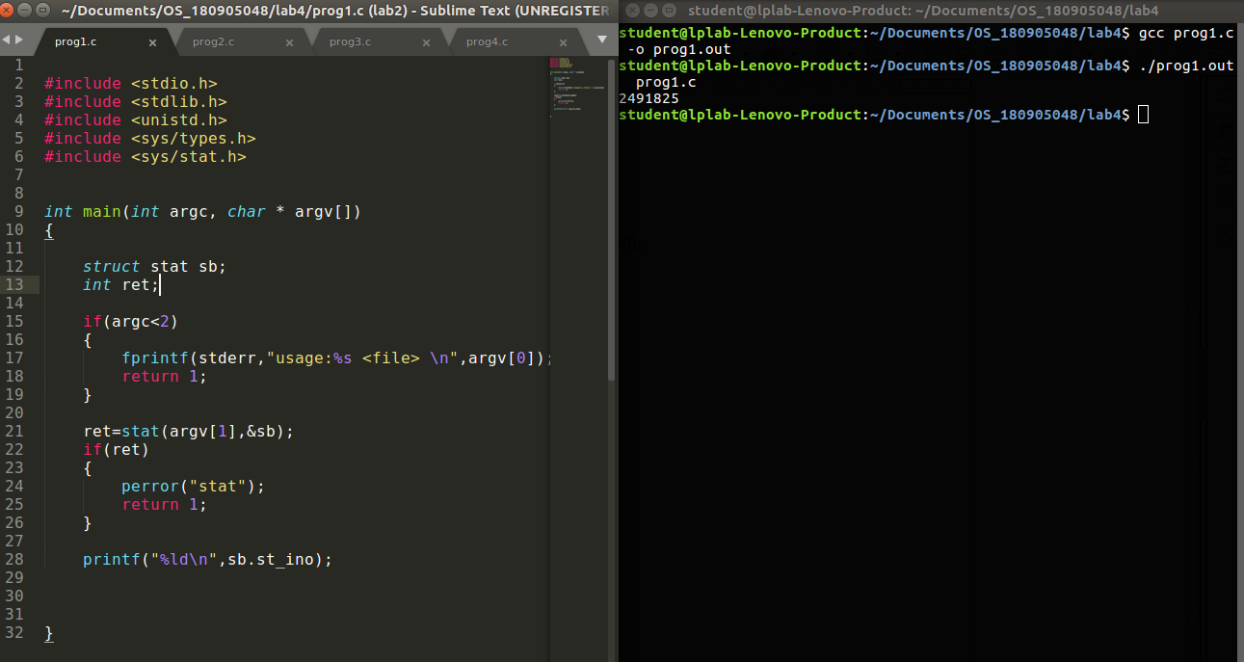

cross-check:
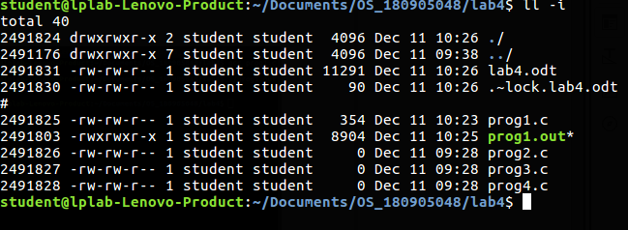

Q2

#include <stdio.h>
#include <stdlib.h>
#include <unistd.h>
#include <sys/types.h>
#include <sys/stat.h>

int main(int argc, char * argv[])
{

struct stat sb;
int ret;

if(argc<2)
{
fprintf(stderr,"usage:%s <file> \n",argv[0]);
return 1;
}

ret=stat(argv[1],&sb);
if(ret)
{
perror("stat");
return 1;
}

printf("Stat structure of %s :\n",argv[1] );
printf("Id of device :%ld\n",sb.st_dev);
printf("Inode number:%ld\n",sb.st_ino);
printf("Permissions :%u\n",sb.st_mode);
printf("Number of hard links :%ld\n",sb.st_nlink);
printf("User id of owner :%u\n",sb.st_uid);
printf("Group id of owner :%u\n",sb.st_gid);
printf("Device id if special file :%ld\n",sb.st_rdev);
printf("Totaol size of the file :%ld\n",sb.st_size);
printf("Block size:%ld\n",sb.st_blksize);
printf("Number of blocks:%ld\n",sb.st_blocks);
printf("Last access time:%ld\n",sb.st_atime);
printf("Last modification time :%ld\n",sb.st_mtime);
printf("Last status change time:%ld\n",sb.st_ctime);
return 0;
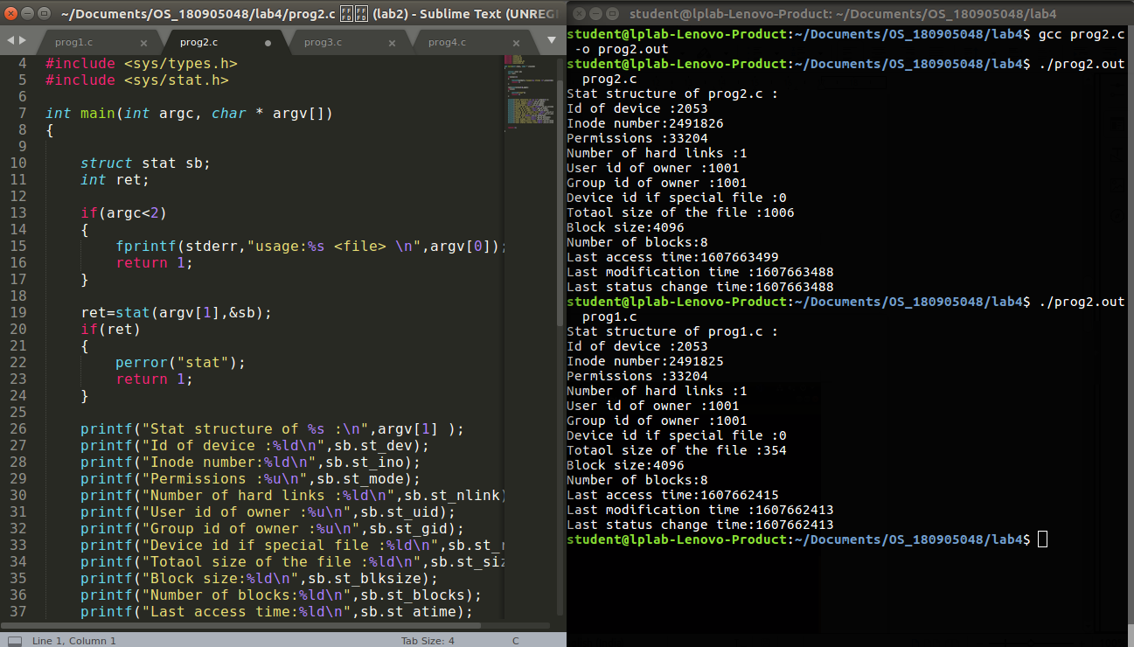
}

Q3

#include <stdio.h>
#include <stdlib.h>
#include <unistd.h>
#include <sys/types.h>
#include <sys/stat.h>

int main(int argc, char * argv[])
{

struct stat sb;
int ret;
char *new_path;

if(argc<3)
{
fprintf(stderr,"usage:%s <old path> \n",argv[0]);
return 1;
}
ret=link(argv[1],argv[2]);
if(ret)
{
perror("link");
return 1;
}
printf("File Linked \n");
printf("New link %s\n",argv[2]);

int ret2=unlink(argv[2]);
if(ret2)
perror("unlink");
else
printf("unlinked successfully\n");

return 0;

}

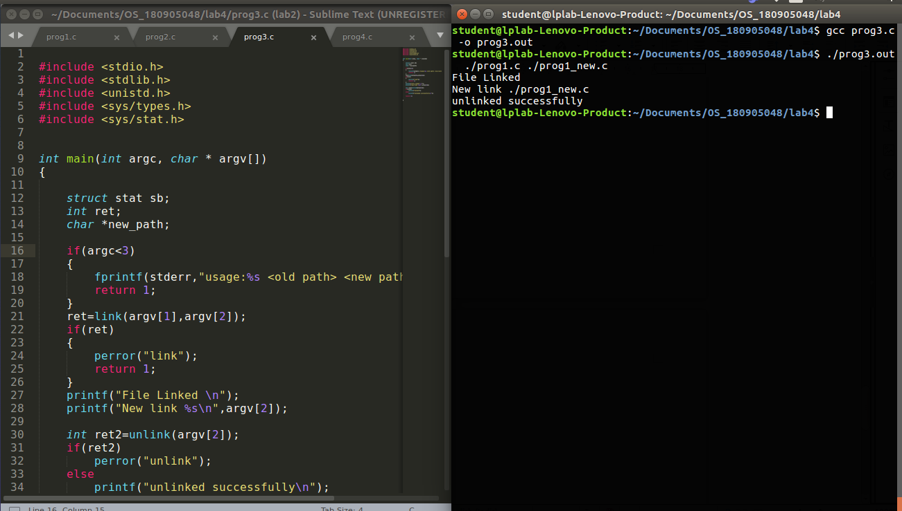

Q4

#include <stdio.h>
#include <stdlib.h>
#include <unistd.h>
#include <sys/types.h>
#include <sys/stat.h>

int main(int argc, char * argv[])
{

struct stat sb;
int ret;
char *new_path;

if(argc<3)
{
fprintf(stderr,"usage:%s <old path> <new path> \n",argv[0]);
return 1;
}
ret=symlink(argv[1],argv[2]);
if(ret)
{
perror("symlink");
return 1;
}
printf("File Linked \n");
printf("New link %s\n",argv[2]);

int ret2=unlink(argv[2]);
if(ret2)
perror("unlink");
else
printf("unlinked successfully\n");

return 0;

}

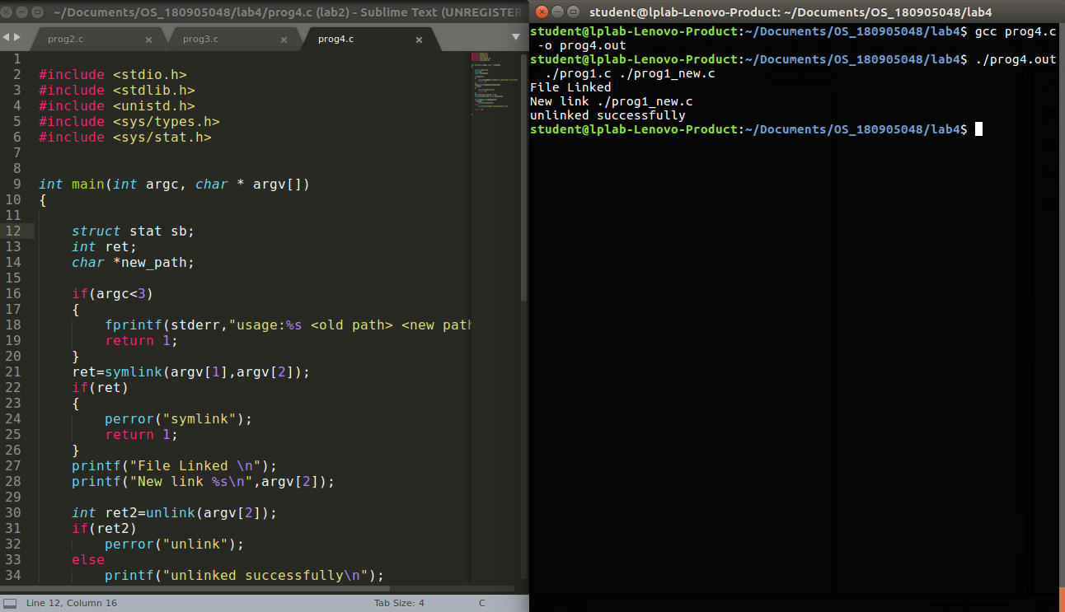

///////////////////////////////////////////////////////////END/////////////////////////////////////////////////////////////////////////////

