OS LAB 5

Sahil Saini Salaria
Reg No 180905048
Roll No 11C
Batch 5th
Lab OS

Producer
// Run Consumer code first then the Producer code
#include <unistd.h>
#include <stdlib.h>
#include <stdio.h>
#include <string.h>
#include <fcntl.h>
#include <limits.h>
#include <sys/types.h>
#include <sys/stat.h>

#define FIFO_NAME "/tmp/my_fifo"
#define BUFFER_SIZE PIPE_BUF
#define TEN_MEG (1024 * 1024 * 10)

int main(int argc, char const *argv[])
{
int pipe_fd;
int res;
int open_mode = O_WRONLY;
int bytes_sent = 0;
int buffer;

if (access(FIFO_NAME, F_OK) == -1)
{
res = mkfifo(FIFO_NAME, 0777);
if (res != 0)
{
fprintf(stderr, "Could not create fifo %s \n", FIFO_NAME);
exit(EXIT_FAILURE);
}
}

printf("Process %d opening FIFO O_WRONLY \n", getpid());
pipe_fd = open(FIFO_NAME, open_mode);
printf("Process %d result %d \n", getpid(), pipe_fd);

if (pipe_fd != -1)
{
int count=0;
while (count < 4)
{
scanf("%d",&buffer);
res = write(pipe_fd, &buffer, sizeof(buffer));
if (res == -1)
{
fprintf(stderr, "Write error on pipe \n");
exit(EXIT_FAILURE);
}
count++;
}
(void)close(pipe_fd);
}
else
exit(EXIT_FAILURE);

printf("Process %d finished \n", getpid());
exit(EXIT_SUCCESS);

return 0;
}

//Consumer

// Run Consumer code first then the Producer code
#include <unistd.h>
#include <stdlib.h>
#include <stdio.h>
#include <string.h>
#include <fcntl.h>
#include <limits.h>

#define FIFO_NAME "/tmp/my_fifo"
#define BUFFER_SIZE PIPE_BUF

int main(int argc, char const *argv[])
{
int pipe_fd;
int res;
int open_mode = O_RDONLY;
int buffer;
int bytes_read = 0;

printf("Process %d opening FIFO O_RDONLY \n", getpid());

pipe_fd = open(FIFO_NAME, open_mode);
printf("Process %d result %d \n", getpid(), pipe_fd);

if (pipe_fd != -1)
{
res = read(pipe_fd, &buffer, sizeof(buffer));
while(res > 0)
{
printf(" Number: %d \n",buffer);
res = read(pipe_fd, &buffer, sizeof(buffer));
bytes_read += res;
}
(void)close(pipe_fd);
}
else
exit(EXIT_FAILURE);

printf("Process %d finished %d bytes read \n", getpid(), bytes_read);
exit(EXIT_FAILURE);
return 0;
}

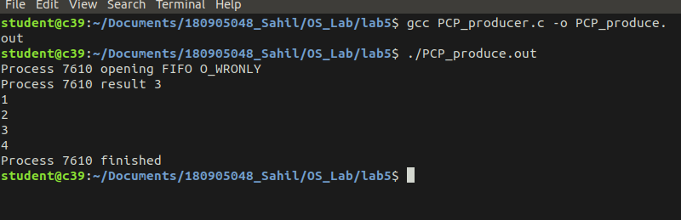
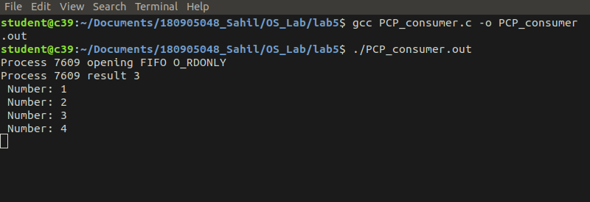

Q2

#include<stdio.h>
#include<stdlib.h>
#include<string.h>
#include<sys/types.h>
#include<fcntl.h>
#include<unistd.h>
#include<error.h>
#include<sys/wait.h>

int main()
{
int arr[2];

// Creating the pipe
int fd=pipe(arr);

if(fd ==-1)
{
printf("Can't create a pipe\n");
exit(1);
}
int f=fork();

if(f==-1)
{
printf("Can't create a child process\n");
exit(2);
}
else if (f==0)
{
printf("Child process\n");
close(arr[1]);
int buffer;
printf("Child reading\n");

// Reading from the pipe
int r= read( arr[0] , &buffer, sizeof(buffer));
buffer=buffer*10;
printf("Buffer after multiplication by 10 :%d \n",buffer);
close(arr[0]);
}
else
{
printf("Parent process\n");
close(arr[0]);
int buffer=30;
printf("Parent writing %d \n", buffer);

// Writing to the pipe
int w=write(arr[1], &buffer, sizeof(buffer));
close(arr[0]);
wait(NULL);
}

printf("Exiting the program\n");
return 0;

}

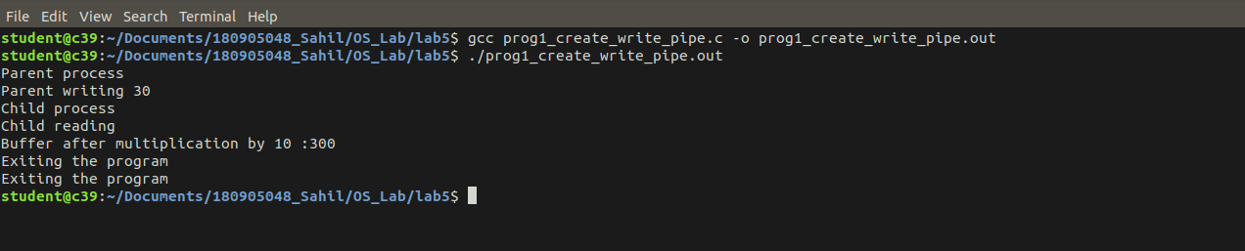

Q3

#include<sys/types.h>
#include<sys/stat.h>
#include<unistd.h>
#include<stdlib.h>
#include<stdio.h>
#include<limits.h>
#include<fcntl.h>
#include<string.h>
#include<sys/types.h>
#include<signal.h>

int main()
{
char * myfifo_file="./myfifo";

int fd;

if(access(myfifo_file, F_OK) == -1){
printf("pipe does not exist\n");
fd = mkfifo(myfifo_file, 0777);
if(fd != 0){
fprintf(stderr, "could not create fifo %s\n", myfifo_file);
exit(EXIT_FAILURE);
}
}

char arr1[100], arr2[100];

while (1)
{

int f1 = open(myfifo_file, O_RDONLY);
read(f1,arr1,sizeof(arr1));
printf("Kaustav: ");
puts(arr1);
close(f1);

int f2 = open(myfifo_file, O_WRONLY);
fgets(arr2,sizeof(arr2),stdin);
write(f2,arr2,sizeof(arr2));
close(f2);;

}

return 0;

}

#include<sys/types.h>
#include<sys/stat.h>
#include<unistd.h>
#include<stdlib.h>
#include<stdio.h>
#include<limits.h>
#include<fcntl.h>
#include<string.h>
#include<sys/types.h>
#include<signal.h>

int main()
{
char * myfifo_file="./myfifo";

int fd;

if(access(myfifo_file, F_OK) == -1){
printf("pipe does not exist\n");
fd = mkfifo(myfifo_file, 0777);
if(fd != 0){
fprintf(stderr, "could not create fifo %s\n", myfifo_file);
exit(EXIT_FAILURE);
}
}

char arr1[100], arr2[100];

while (1)
{

int f1 = open(myfifo_file, O_WRONLY);
fgets(arr2,sizeof(arr2),stdin);
write(f1,arr2,sizeof(arr2));
close(f1);;

int f2 = open(myfifo_file, O_RDONLY);
read(f2,arr1,sizeof(arr1));
printf("Sahil: ");
puts(arr1);
close(fd);

}

return 0;

}

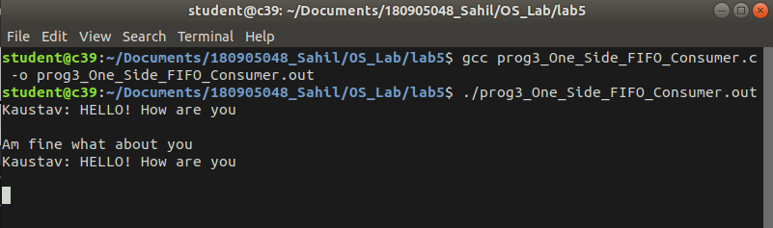

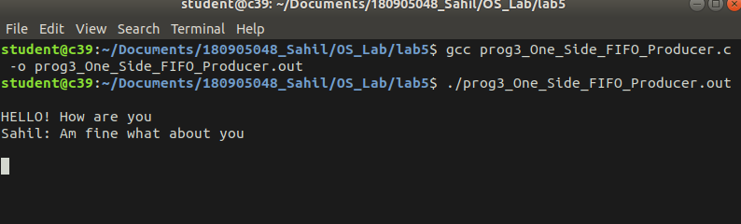

Q4

#include<stdio.h>
#include<stdlib.h>
#include<string.h>
#include<sys/types.h>
#include<fcntl.h>
#include<unistd.h>
#include<error.h>
#include<sys/wait.h>

int main()
{
int arr[2];

// Creating the pipe
int fd=pipe(arr);

if(fd ==-1)
{
printf("Can't create a pipe\n");
exit(1);
}
int f=fork();

if(f==-1)
{
printf("Can't create a child process\n");
exit(2);
}
else if (f==0)
{
printf("Child process\n");
close(arr[1]);
char buffer[4096];
memset(buffer, '\0', sizeof(buffer));
printf("Child reading\n");

// Reading from the pipe
int r= read( arr[0] , buffer, sizeof(buffer));
FILE * fw= fopen("pro3_bin2.bin", "wb+");
int w= fwrite(buffer,sizeof(buffer),100,fw);
for (int i = 0; i < 100; i++)
{
printf("%c ", buffer[i]);
}
close(arr[0]);
return 0;
}
else
{
printf("Parent process\n");
close(arr[0]);
char buffer[4096];
memset(buffer, '\0', sizeof(buffer));
FILE *f1=fopen("pro3_bin.bin","rb");
int r = fread(buffer,sizeof(buffer),100,f1);

// Writing to the pipe
int w=write(arr[1], buffer, sizeof(buffer));
close(arr[0]);
wait(NULL);
}

printf("\nExiting the program\n");
return 0;

}

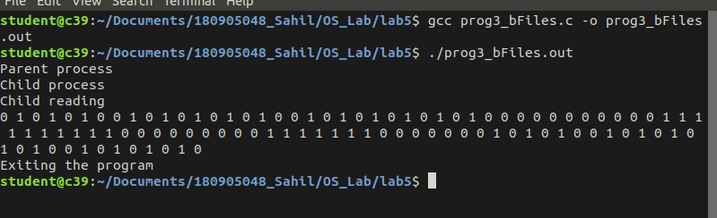

////////////////////////////////////////////////////END/////////////////////////////////////////////////////////////////////

