Lab 7

Sahil Saini Salaria
Reg No. 180905048
Roll no. 11C

//header File getNextToken
#include<stdio.h>
#include<stdlib.h>
#include<string.h>
#include<ctype.h>

struct token{
char lexeme[64];
int row,col;
char type[20];
};

static int row=1,col=1;
char buff[2048];
const char specialsymbols[]={'?',';',':',','};
const char *keywords[]={"const","char","int","return","for","while","do","switch","if","else","unsigned","case","break"};
const char *datatypes[]={"int","char","void","float","bool"};

const char arithmeticsymbols[]={'*'};

int isdatatype(char *w){
int i;
for(i=0;i<sizeof(datatypes)/sizeof(char *);i++){
if(strcmp(w,datatypes[i])==0){
return 1;
}
}
return 0;
}

int iskeyword(char *str){
for(int i=0;i<sizeof(keywords)/sizeof(char *);i++){
if(strcmp(str,keywords[i])==0){
return 1;
}
}
return 0;
}

int charbelongsto(int c, const char *arr){
int len;
if(arr==specialsymbols){
len=sizeof(specialsymbols)/sizeof(char);
}else if(arr==arithmeticsymbols){
len=sizeof(arithmeticsymbols)/sizeof(char);
}
for(int i=0;i<len;i++){
if(c==arr[i]){
return 1;
}
}
return 0;
}

void filltoken(struct token *tkn, char c, int row, int col, char *type){
tkn->row=row;
tkn->col=col;
strcpy(tkn->type,type);
tkn->lexeme[0]=c;
tkn->lexeme[1]='\0';
}

void newline(){
row++;
col=1;

}

struct token getnexttoken(FILE *f1){
int c;
struct token tkn={
row=-1
};
int gottoken=0;

while(!gottoken &&(c=fgetc(f1))!=EOF){
if(charbelongsto(c,specialsymbols)){
filltoken(&tkn,c,row,col,"specialsymbols");
gottoken=1;
col++;
}

else if(charbelongsto(c,arithmeticsymbols)){
filltoken(&tkn,c,row,col,"arithmeticoperator");
gottoken=1;
col++;
}

else if(c=='('){
filltoken(&tkn,c,row,col,"leftbracket");
gottoken=1;
col++;
}
else if(c==')'){
filltoken(&tkn,c,row,col,"rightbracket");
gottoken=1;
col++;
}
else if(c=='{'){
filltoken(&tkn,c,row,col,"left curly");
gottoken=1;
col++;
}
else if(c=='}'){
filltoken(&tkn,c,row,col,"right curly");
gottoken=1;
col++;
}
else if(c=='+'){
int d=fgetc(f1);
if(d!='+'){
filltoken(&tkn,c,row,col,"arithmeticoperator");
gottoken=1;
col++;
fseek(f1,-1,SEEK_CUR);
}else{
filltoken(&tkn,c,row,col,"unary coperator");
strcpy(tkn.lexeme,"++");
gottoken=1;
col+=2;

}
}
else if(c=='+'){
int d=fgetc(f1);
if(d!='-'){
filltoken(&tkn,c,row,col,"arithmeticoperator");
gottoken=1;
col++;
fseek(f1,-1,SEEK_CUR);
}else{
filltoken(&tkn,c,row,col,"unary operator");
strcpy(tkn.lexeme,"--");
gottoken=1;
col+=2;

}
}
else if(c=='='){
int d=fgetc(f1);
if(d!='-'){
filltoken(&tkn,c,row,col,"arithmeticoperator");
gottoken=1;
col++;
fseek(f1,-1,SEEK_CUR);
}else{
filltoken(&tkn,c,row,col,"relational operator");
strcpy(tkn.lexeme,"==");
gottoken=1;
col+=2;

}
}
else if(isdigit(c)){
tkn.row=row;
tkn.col=col;
tkn.lexeme[0]=c;
int k=1;
while((c=fgetc(f1))!=EOF&&isdigit(c)){
tkn.lexeme[k++]=c;
col++;
}
tkn.lexeme[k]='\0';
strcpy(tkn.type,"number");
gottoken=1;
fseek(f1,-1,SEEK_CUR);
}

else if(c=='#'){
while((c=fgetc(f1))!=EOF&&c!='\n');
newline();

}

else if(c=='\n'){
newline();
c=fgetc(f1);
if(c=='#'){
while((c=fgetc(f1))!=EOF&&c!='\n');
newline();

}

else if(c!=EOF){
fseek(f1,-1,SEEK_CUR);
}
}

else if(isspace(c)){
col++;
}

else if(isalpha(c)||c=='_'){
tkn.row=row;
tkn.col=col++;
tkn.lexeme[0]=c;
int k=1;
while((c=fgetc(f1))!=EOF && isalnum(c)){
tkn.lexeme[k++]=c;
col++;
}
tkn.lexeme[k]='\0';
if(iskeyword(tkn.lexeme)){
strcpy(tkn.type,"keyword");
}else{
strcpy(tkn.type,"identifier");
}
gottoken=1;
fseek(f1,-1,SEEK_CUR);
}

else if(c=='/'){
int d=fgetc(f1);
col++;
if(d=='/'){
while((c=fgetc(f1))!=EOF&&c!='\n'){
col++;
}
if(c=='\n'){
newline();
}
}else if(d=='*'){
do{
if(d=='\n'){
newline();
}
while((c=fgetc(f1))!=EOF &&c!='*'){
col++;
if(c=='\n'){
newline();
}
}
col++;
}
while((d=fgetc(f1))!=EOF &&d!='/' &&col++);
col++;

}else{
filltoken(&tkn,c,row,col--,"arithmeticoperator");
gottoken=1;
fseek(f1,-1,SEEK_CUR);
}
}
else if(c=='"'){
tkn.row=row;
tkn.col=col;
strcpy(tkn.type,"String literal");
int k=1;
tkn.lexeme[0]='"';
while((c=fgetc(f1))!=EOF &&c!='"'){
tkn.lexeme[k++]=c;
col++;
}
tkn.lexeme[k]='"';
gottoken=1;
}

else if(c=='<' || c=='>' || c=='!'){
filltoken(&tkn,c,row,col,"relational operator");
col++;
int d=fgetc(f1);
if(d=='='){
col++;
strcat(tkn.lexeme,"=");
}
else{
if(c=='!'){
strcpy(tkn.type,"logical operator");
}
fseek(f1,-1,SEEK_CUR);
}
gottoken=1;

}

else if(c=='&'||c=='|'){
int d=fgetc(f1);
if(c==d){
tkn.lexeme[0]=tkn.lexeme[1]=c;
tkn.lexeme[2]='\0';
tkn.row=row;
tkn.col=col;
col++;
gottoken=1;
strcpy(tkn.type,"logical operator");
}else{
fseek(f1,-1,SEEK_CUR);
}
col++;
}
else{
col++;
}
}
return tkn;

}

#include <stdio.h>
#include <stdlib.h>
#include <string.h>
#include <ctype.h>
#include "nextToken.h"

void program();
void declarations();
void data_type();
void identifier_list();
void assign_stat();

struct token curr;
FILE *f1;
void invalid(){
printf("error");
exit(0);
}
void program()
{

if(strcmp(curr.lexeme,"main")==0)
{
curr=getnexttoken(f1);
if(strcmp(curr.lexeme,"(")==0)
{
curr=getnexttoken(f1);
if(strcmp(curr.lexeme,")")==0)
{
curr=getnexttoken(f1);;
if(strcmp(curr.lexeme,"{")==0)
{
curr=getnexttoken(f1);
declarations();
assign_stat();
if(strcmp(curr.lexeme,"}")==0)
{
return;
}
else
{
printf("\nMissing } at row:%d and col:%d.\n\n",curr.row,curr.col);
exit(0);
}
}
else
{
printf("\nMissing { at row:%d and col:%d.\n\n",curr.row,curr.col);
exit(0);
}
}
else
{
printf("\nMissing ) at row:%d and col:%d.\n\n",curr.row,curr.col);
exit(0);
}
}
else
{
printf("\nMissing ( at row:%d and col:%d.\n\n",curr.row,curr.col);
exit(0);
}
}
else
{
printf("\nMissing main function\n\n");
exit(0);
}
}

void declarations()
{

if(isdatatype(curr.lexeme)==0)
{
return;
}
data_type();
identifier_list();
if(strcmp(curr.lexeme,";")==0)
{
curr=getnexttoken(f1);
declarations();
}
else {printf("\nMissing ; at row:%d and col:%d.\n\n",curr.row,curr.col); exit(0);}

}

void data_type()
{
if(strcmp(curr.lexeme,"int")==0)
{
curr=getnexttoken(f1);
return;
}
else if(strcmp(curr.lexeme,"char")==0)
{
curr=getnexttoken(f1);
return;
}
else
{
printf("\nMissing data type at row:%d and col:%d.\n\n",curr.row,curr.col);
exit(0);
}
}

void identifier_list()
{
if(strcmp(curr.type,"identifier")==0)
{
curr=getnexttoken(f1);
if(strcmp(curr.lexeme,",")==0)
{
curr=getnexttoken(f1);
identifier_list();
}
else return;
}

else
{
printf("\nMissing identifier at row:%d and col:%d.\n\n",curr.row,curr.col);
exit(0);
}
}

void assign_stat()
{
if(strcmp(curr.type,"identifier")==0)
{
curr=getnexttoken(f1);
if(strcmp(curr.lexeme,"=")==0)
{
curr=getnexttoken(f1);
if(strcmp(curr.type,"identifier")==0)
{
curr=getnexttoken(f1);
if(strcmp(curr.lexeme,";")==0)
{
curr=getnexttoken(f1);
return;
}
}

else if(strcmp(curr.type,"number")==0)
{
curr=getnexttoken(f1);
if(strcmp(curr.lexeme,";")==0)
{
curr=getnexttoken(f1);
return;
}
else
{
printf("\nMissing ; at row:%d and col:%d.\n\n",curr.row,curr.col);
exit(0);
}

}
else
{
printf("\nMissing identifier at row:%d and col:%d.\n\n",curr.row,curr.col);
exit(0);
}
}
else
{
printf("\nMissing = at row:%d and col:%d.\n\n",curr.row,curr.col);
exit(0);
}
}
else
{
printf("\nMissing identifier at row:%d and col:%d.\n\n",curr.row,curr.col);
exit(0);
}
}

int main()
{
FILE *fa, *fb;
int ca, cb;
fa = fopen("input.c", "r");
if (fa == NULL){
// printf("hii");
printf("Cannot open file \n");
return 0;
}
fb = fopen("output.c", "w");
ca = getc(fa);
while (ca != EOF){
if(ca==' ')
{
putc(ca,fb);
while(ca==' ')
ca = getc(fa);
}
if (ca=='/')
{
cb = getc(fa);
if (cb == '/')
{
while(ca != '\n')
ca = getc(fa);
}
else if (cb == '*')
{
do
{
while(ca != '*')
ca = getc(fa);
ca = getc(fa);
} while (ca != '/');
}
else{
putc(ca,fb);
putc(cb,fb);
}
}
else putc(ca,fb);
ca = getc(fa);
}
fclose(fa);
fclose(fb);
fa = fopen("output.c", "r");
if(fa == NULL){
printf("Cannot open file");
return 0;
}
fb = fopen("input", "w");
ca = getc(fa);
while(ca != EOF){
if(ca == '#'){
while(ca != '\n'){
ca = getc(fa);
}
}
ca = getc(fa);
if(ca != EOF && ca != '#'){
putc(ca, fb);
}
}
fclose(fa);
fclose(fb);

fa = fopen("input.c", "r");
fb = fopen("output.c", "w");
ca = getc(fa);
int a,b;
while(ca != EOF){
putc(ca, fb);
ca = getc(fa);
}
fclose(fa);
fclose(fb);
// remove("sample1.c");
f1=fopen("output.c","r");
if(f1==NULL)
{
printf("Error! File cannot be opened!\n");
return 0;
}
struct token tkn;
curr=getnexttoken(f1);
program();
printf("\nCompiled\n\n");
fclose(f1);
}

Test Case 1:

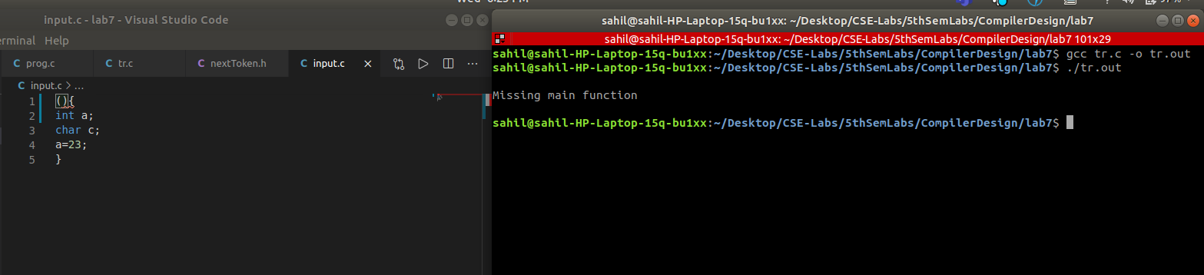
Test Case 2:
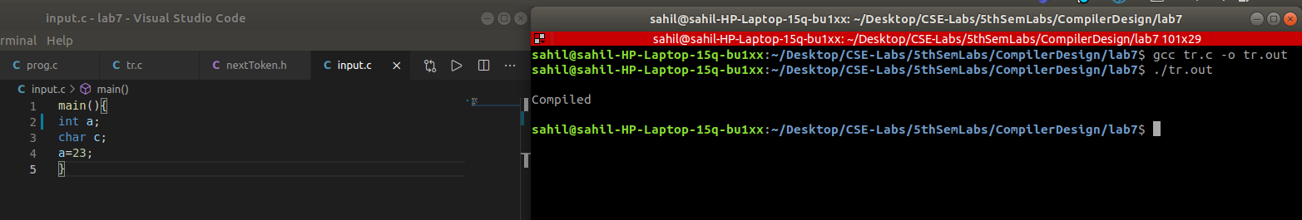
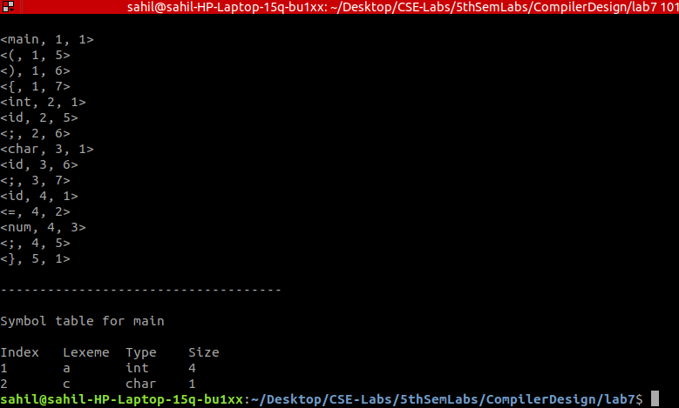

/////////////////////////////////////END//////////////////////////////////////////////

