LAB 1

Name : Sahil Saini Salaria
Section : CSE C
Roll No. : 11
Reg No. : 180905048
Date: 7/12/2020

Q1

//Client

#include <stdio.h>
#include <strings.h>
#include <sys/types.h>
#include <arpa/inet.h>
#include <sys/socket.h>
#include <netinet/in.h>
#include <unistd.h>
#include <stdlib.h>

#define PORT 5000
#define MAXLINE 1000

// Driver code
int main()
{
char buffer[100];
// char *message = "Hello Server";
char *rows[3];
rows[0] = "1 2 3";
rows[1] = "4 5 6";
rows[2] = "7 8 9";

int sockfd, n, len;
struct sockaddr_in servaddr, cliaddr;

// clear servaddr
bzero(&servaddr, sizeof(servaddr));
servaddr.sin_addr.s_addr = htonl(INADDR_ANY);
servaddr.sin_port = htons(PORT);
servaddr.sin_family = AF_INET;

// create datagram socket
sockfd = socket(AF_INET, SOCK_DGRAM, 0);

for (int i = 0; i < 3; i++)
{
sendto(sockfd, rows[i], MAXLINE, 0, (struct sockaddr *)&servaddr, sizeof(servaddr));
len = sizeof(cliaddr);
}

// // waiting for response
// n = recvfrom(sockfd, buffer, sizeof(buffer), 0, (struct sockaddr *)&cliaddr, &len);
// buffer[n] = '\0';
// printf("message fromser is %s \n", buffer);
// getchar();

// close the descriptor
close(sockfd);
}

// server
#include <stdio.h>
#include <strings.h>
#include <sys/types.h>
#include <arpa/inet.h>
#include <sys/socket.h>
#include <netinet/in.h>
#include <unistd.h>

#define PORT 5000
#define MAXLINE 1000

// Server code
int main()
{
char buffer[100];
int servsockfd, len, n;
struct sockaddr_in servaddr, cliaddr;
bzero(&servaddr, sizeof(servaddr));

// Create a UDP Socket
servsockfd = socket(AF_INET, SOCK_DGRAM, 0);
servaddr.sin_addr.s_addr = htonl(INADDR_ANY);
servaddr.sin_port = htons(PORT);
servaddr.sin_family = AF_INET;

// bind server address to socket descriptor
bind(servsockfd, (struct sockaddr *)&servaddr, sizeof(servaddr));

while (1)
{
//receive the datagram
len = sizeof(cliaddr);

n = recvfrom(servsockfd, buffer, sizeof(buffer), 0, (struct sockaddr *)&cliaddr, &len);
buffer[n] = '\0';
puts(buffer);
//Echoing back to the client
sendto(servsockfd, buffer, n, 0, (struct sockaddr *)&cliaddr, sizeof(cliaddr));
}

getchar();
// close the descriptor
close(servsockfd);
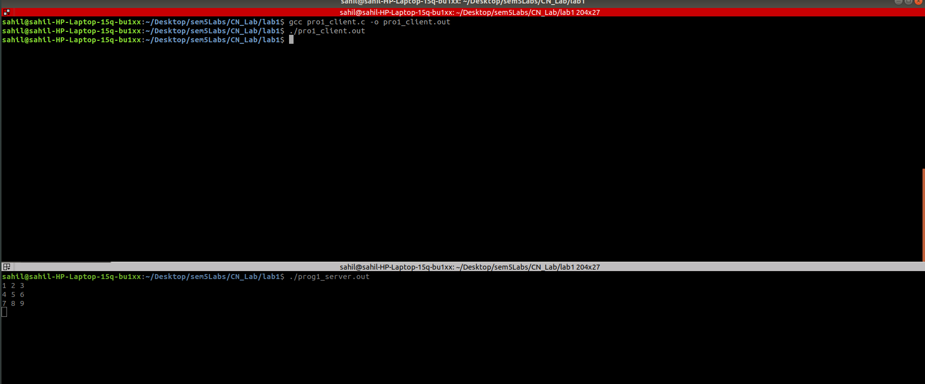
}

Q2

//Client

#include <sys/types.h>
#include <sys/socket.h>
#include <stdio.h>
#include <netinet/in.h>
#include <arpa/inet.h>
#include <unistd.h>
#include <stdlib.h>

int main()
{
int sockfd;
int len;
struct sockaddr_in address;
int result;
char ch[100];

/* Create a socket for the client. */

sockfd = socket(AF_INET, SOCK_STREAM, 0);

/* Name the socket, as agreed with the server. */

address.sin_family = AF_INET;
address.sin_addr.s_addr = inet_addr("127.0.0.1");
address.sin_port = 9735;
len = sizeof(address);

/* Now connect our socket to the server's socket. */

result = connect(sockfd, (struct sockaddr *)&address, len);

if(result == -1) {
perror("oops: client2");
exit(1);
}

/* We can now read/write via sockfd. */
printf(" Please Type the String to send:");
scanf("%s",ch);
write(sockfd, ch, 100);
read(sockfd, ch, 100);
printf("char from server = %s\n", ch);
close(sockfd);
exit(0);
}

//Server

#include <sys/types.h>
#include <sys/socket.h>
#include <stdio.h>
#include <netinet/in.h>
#include <arpa/inet.h>
#include <unistd.h>
#include <stdlib.h>

int main()
{
int server_sockfd, client_sockfd;
int server_len, client_len;
struct sockaddr_in server_address;
struct sockaddr_in client_address;

/* Create an unnamed socket for the server. */

server_sockfd = socket(AF_INET, SOCK_STREAM, 0);

/* Name the socket. */

server_address.sin_family = AF_INET;
server_address.sin_addr.s_addr = inet_addr("127.0.0.1");
server_address.sin_port = 9735;
server_len = sizeof(server_address);
bind(server_sockfd, (struct sockaddr *)&server_address, server_len);

/* Create a connection queue and wait for clients. */

listen(server_sockfd, 5);
while(1) {
char ch[100];

printf("server waiting\n");

/* Accept a connection. */

client_len = sizeof(client_address);
client_sockfd = accept(server_sockfd,
(struct sockaddr *)&client_address, &client_len);

/* We can now read/write to client on client_sockfd. */
//char *inet_ntoa(client_addr.sin_addr);
char * ip_add =inet_ntoa(client_address.sin_addr);
int port=client_address.sin_port;

printf("IP:%s PORT:%d\n", ip_add,port);
read(client_sockfd, ch, 100);
printf("%s\n",ch);

for(int i=0; ch[i]!='\0'; i++)
{
if(ch[i]>='a' && ch[i]<='z')
{
ch[i] = ch[i] - 32;
}
}

// ch.upper();
write(client_sockfd, ch, 100);
close(client_sockfd);
}
}

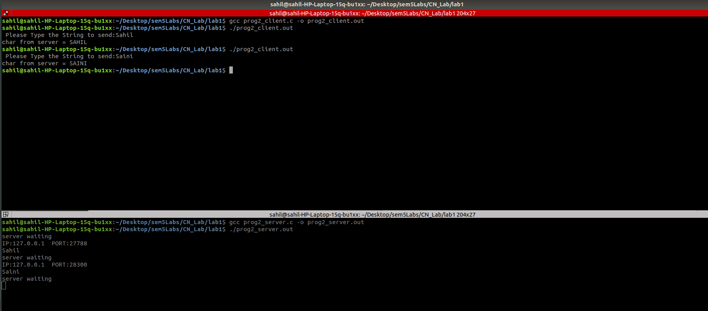

Q3

// Client program:
//TCP Client program:
#include <stdio.h>
#include <stdlib.h>
#include <unistd.h>
#include <errno.h>
#include <string.h>
#include <sys/types.h>
#include <sys/socket.h>
#include <netinet/in.h>
#include <netdb.h>
#include <arpa/inet.h>
#include <sys/wait.h>
#include <signal.h>

int main()
{
int sd,nd,n,len,reult,n1;
struct sockaddr_in seraddress, cliaddr;
sd=socket(AF_INET, SOCK_STREAM,0);
seraddress.sin_family=AF_INET;
seraddress.sin_addr.s_addr=INADDR_ANY;
seraddress.sin_port=htons(10200);
len=sizeof(seraddress);
connect(sd,(struct sockaddr*)&seraddress,len);

char buff[100];
int a , b;
char op;

printf("Enter two integers to \n");

scanf(" %d %d",&a,&b);
printf("Enter the operator:");
scanf(" %c",&op);

buff[0]=a;
buff[1]=b;
buff[2]=op;
buff[3]='\0';

write(sd,&buff,100);

char buf1[100];

n1=read(sd,buf1,100);

printf("%d %c %d : %d\n",a,op,b, *buf1);

}

//Server program
#include <stdio.h>
#include <stdlib.h>
#include <unistd.h>
#include <errno.h>
#include <string.h>
#include <sys/types.h>
#include <sys/socket.h>
#include <netinet/in.h>
#include <netdb.h>
#include <arpa/inet.h>
#include <sys/wait.h>
#include <signal.h>
int main()
{
int sd,nd,n,len,reult;
struct sockaddr_in seraddress, cliaddr;
sd=socket(AF_INET, SOCK_STREAM,0);
seraddress.sin_family=AF_INET;
seraddress.sin_addr.s_addr=INADDR_ANY;
seraddress.sin_port=htons(10200);
bind(sd,(struct sockaddr*)&seraddress,sizeof(seraddress));
listen(sd,5);
len=sizeof(cliaddr);

int s=0;
while(1)
{
s++;
char buff[100];

nd=accept(sd,(struct sockaddr*)&cliaddr,&len);

if (fork()==0){
close(sd);

// printf("Forked\n");
read(nd,buff,100);

char result[100];
// printf("%c\n",buff[2]);
switch(buff[2])
{
case '+': result[0] = (buff[0])+(buff[1]);
break;
case '-': result[0] = (buff[0])-(buff[1]);
break;
case '*': result[0] = (buff[0])*(buff[1]);
break;
case '/': result[0] = (buff[0])/(buff[1]);
break;

}
write(nd, result, 100);
close(nd);

}
if(s>10)
exit(0);

}

}

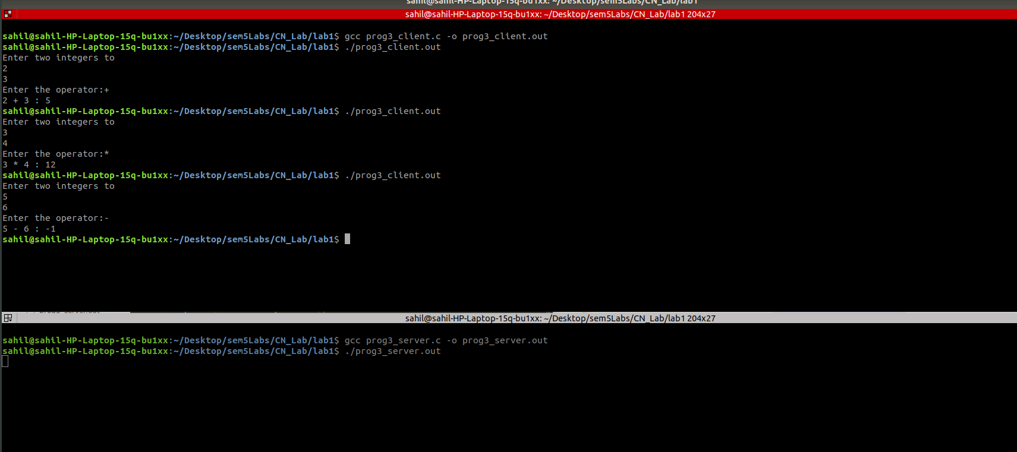

Q4

//Client
#include <stdio.h>
#include <strings.h>
#include <sys/types.h>
#include <arpa/inet.h>
#include <sys/socket.h>
#include<netinet/in.h>
#include<unistd.h>
#include<stdlib.h>

#define PORT 5000
#define MAXLINE 1000

// Driver code
int main()
{
char buffer[100];
char *message = "What is time?";
int sockfd, n,len;
struct sockaddr_in servaddr, cliaddr;

// clear servaddr
bzero(&servaddr, sizeof(servaddr));
servaddr.sin_addr.s_addr = htonl(INADDR_ANY);
servaddr.sin_port = htons(PORT);
servaddr.sin_family = AF_INET;

// create datagram socket
sockfd = socket(AF_INET, SOCK_DGRAM, 0);
sendto(sockfd, message, MAXLINE, 0, (struct sockaddr*)&servaddr, sizeof(servaddr));
len=sizeof(cliaddr);

// waiting for response
n=recvfrom(sockfd, buffer, sizeof(buffer), 0, (struct sockaddr*)&cliaddr,&len );
buffer[n]='\0';
printf("Time is : %s \n",buffer);
getchar();

// close the descriptor
close(sockfd);
}

//Server

#include <stdio.h>
#include <strings.h>
#include <sys/types.h>
#include <arpa/inet.h>
#include <sys/socket.h>
#include <netinet/in.h>
#include <time.h>
#include <unistd.h> // close function
#define PORT 5000
#define MAXLINE 1000

int main()
{
char buffer[100];
int servsockfd, len,n;
struct sockaddr_in servaddr, cliaddr;
bzero(&servaddr, sizeof(servaddr));

// Create a UDP Socket
servsockfd = socket(AF_INET, SOCK_DGRAM, 0);
servaddr.sin_addr.s_addr = htonl(INADDR_ANY);
servaddr.sin_port = htons(PORT);
servaddr.sin_family = AF_INET;

// bind server address to socket descriptor
bind(servsockfd, (struct sockaddr*)&servaddr, sizeof(servaddr));

//receive the datagram
len = sizeof(cliaddr);
n = recvfrom(servsockfd, buffer, sizeof(buffer),0, (struct sockaddr*)&cliaddr,&len);
buffer[n] = '\0';
printf("Request: \n");
puts(buffer);
//Echoing back to the client

time_t t; // not a primitive datatype
time(&t);

sendto(servsockfd, ctime(&t), n, 0, (struct sockaddr*)&cliaddr, sizeof(cliaddr));
getchar();

// close the descriptor
close(servsockfd);
}

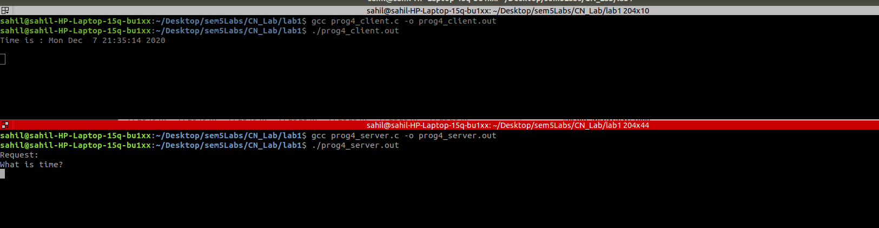

//////////////////////////////////////////////////////////////////END///////////////////////////////////////////////////////////////////////

