LAB 1

Sahil Saini
Roll no. 11
Sec C
180905048
OS lab

Q1

#include<stdio.h>
#include<unistd.h>
#include<stdlib.h>
#include<fcntl.h>
#include<sys/stat.h>
#include<string.h>
int main(int argc, char *argv[])
{

int fd;
int i=0;
int k=0;
char buf[100][100];
char ch;

fd=open("myFile.txt",O_RDONLY);
if(fd==-1)
{
printf("Cant open the file\n");
exit(1);
}
while((read(fd,&ch,1))==1)
{
if(ch!='\n')
{
buf[k][i]=ch;
i++;
}
else
{
buf[k][i]='\0';
if(strstr(buf[k],argv[1])!=NULL)
printf("line:%d %s\n",k+1,buf[k]);
i=0;
k++;
}
printf("Loop");
}
}
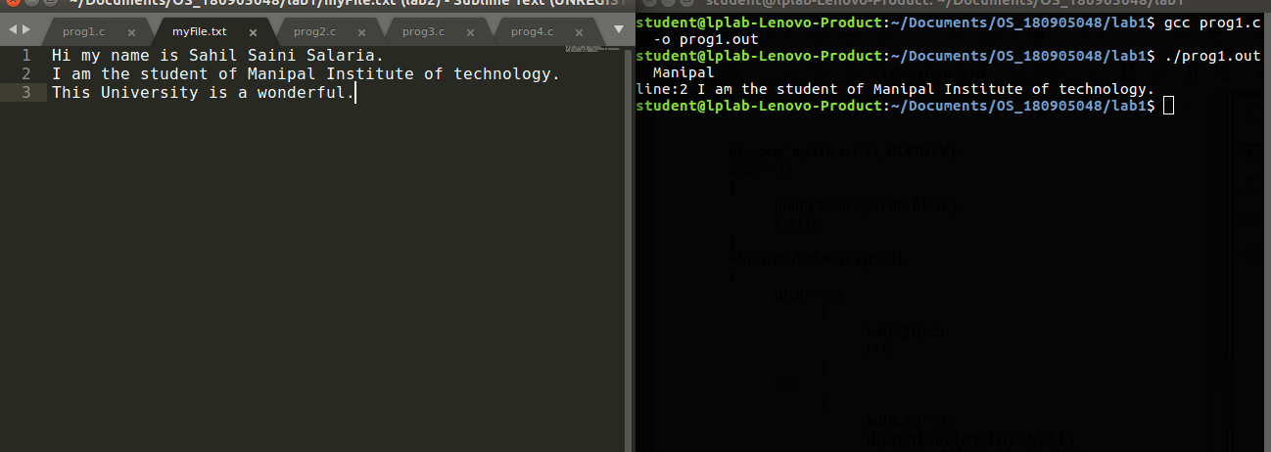

Q2

#include<stdio.h>
#include<unistd.h>
#include<stdlib.h>
#include<fcntl.h>
#include<sys/stat.h>
#include<string.h>
int main(int argc, char const *argv[])
{

int fd;
int k=0;
char buf[100][100];
char ch;
if(argc!=2)
{
printf("error\n");
exit(0);
}
fd=open(argv[1],O_RDONLY);
if(fd==-1)
{
printf("Cant open the file\n");
exit(0);
}
while(read(fd,&ch,1)==1)
{
if(ch=='\n')
{
k++;
}
printf("%c",ch);
if(k==20)
{
while((read(0,&ch,1))!=1);
k=0;
}
}
return 0;

}

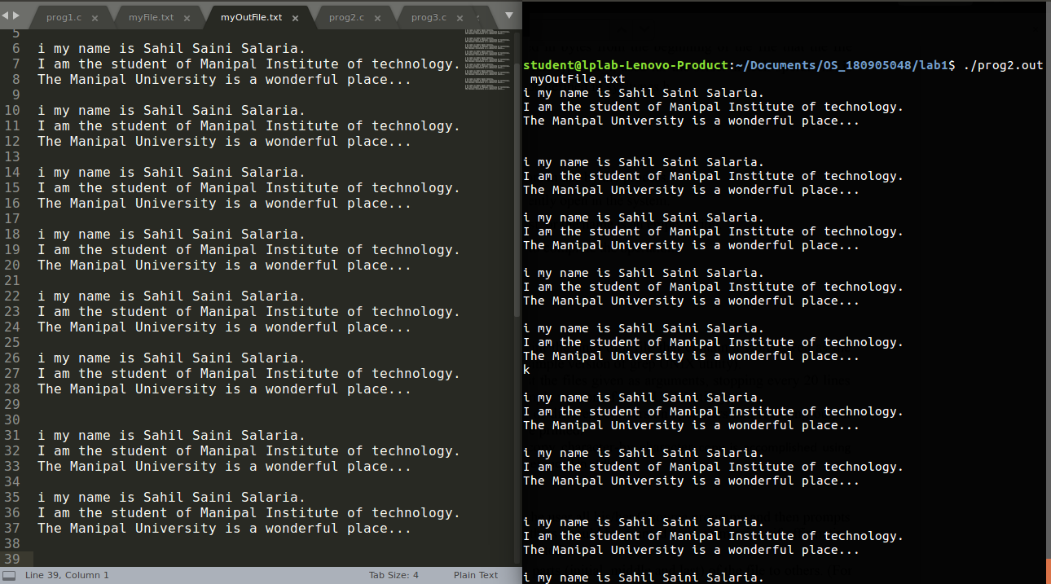

Q3

#include<stdio.h>
#include<string.h>
#include<stdlib.h>
#include<errno.h>

int main()
{
unsigned int a=342;
int b=3453;
char c='c';
char * d ="HI i am sahil";
float e= 2.3;
double f= 3.4323;
errno= EPERM;

printf("Unsigned int %u\n",a);
printf("Integer %d\n",b);
printf("character %c\n",c);
printf("String %s\n",d);
printf("Float %f\n",e);
printf("Double %f\n",f);
printf("Error Number : %m\n");

return 0;

}

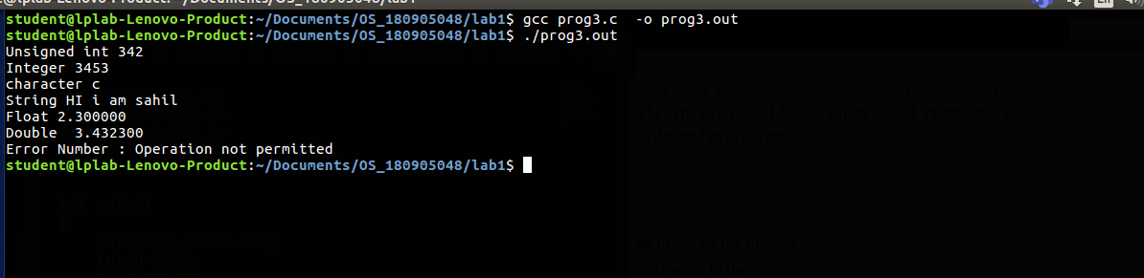

Q4

#include<stdio.h>
#include<stdlib.h>
#include<string.h>
#include<fcntl.h>
#include<unistd.h>

int main()
{
int in =open("myFile.txt",O_RDONLY);
int out=open("myOutFile.txt",O_WRONLY);

char ch[10];
read(in,&ch,1);
while(read(in,&ch,1)==1)
{
write(out,&ch,1);
}

return 0;
}

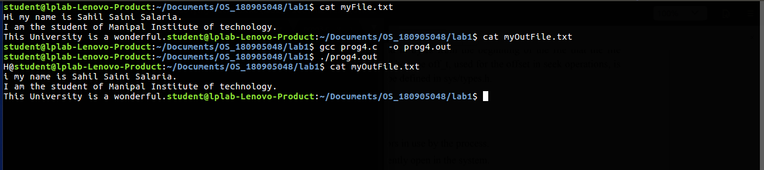

//////////////////////////////////////////////////END///////////////////////////////////////////////////////////////////

