LAB 3

Sahil Saini Salaria
Reg no. 180905048
Roll No. 11C
OS lab

Q1
#include<sys/types.h>
#include<sys/wait.h>
#include <stdio.h>
#include <stdlib.h>
#include <unistd.h>

void main()
{
int status;
pid_t pid;
pid =fork();

if(pid==-1)
{
printf("CHILD NOT CR3EATED\n");
}
else if(pid==0)
{
printf("I AM CHILD\n");
exit(0);
}
else {
wait(&status);
printf("I AM PARENT\n");
printf("CHILD RETURNED :%d \n",status);
}
}

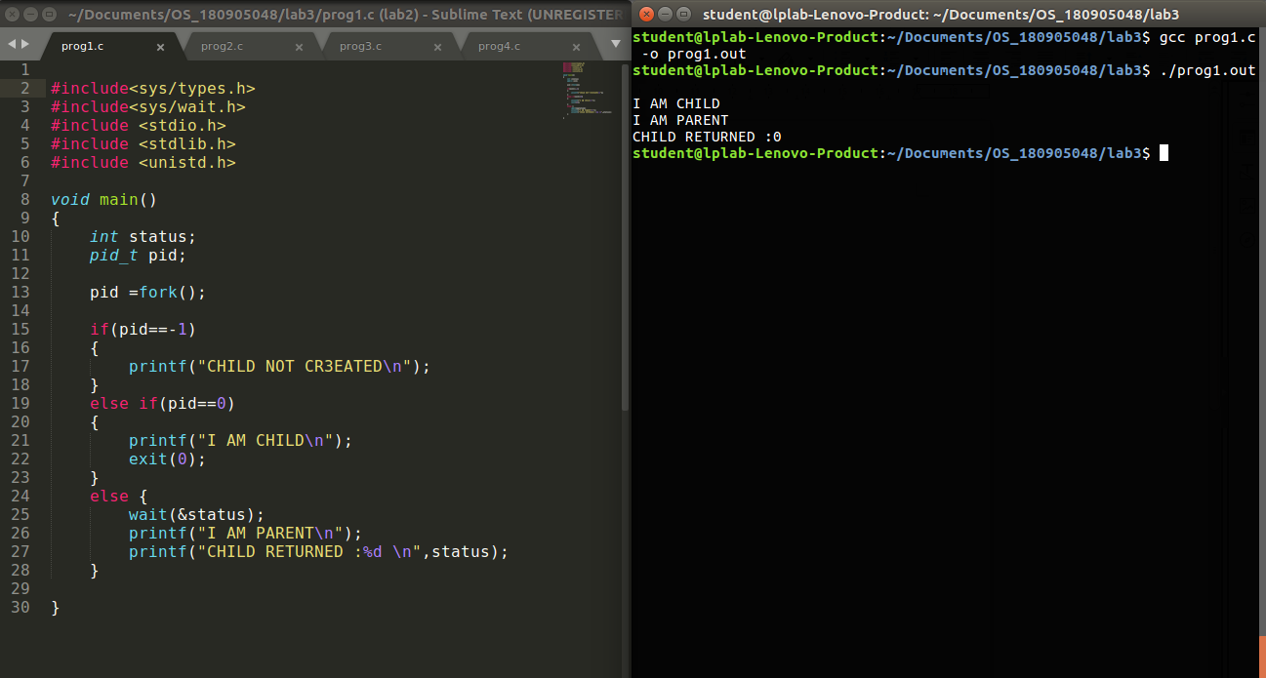

Q2
#include<sys/types.h>
#include<sys/wait.h>
#include <stdio.h>
#include <stdlib.h>
#include <unistd.h>

void main()
{
pid_t pid;
char * arr[]={"./prog1.out",NULL};
pid =fork();

if(pid==-1)
{
printf("Child not created\n");
}
else if(pid==0)
{
printf("I am child going to run the exec\n");
execvp(arr[0],arr);
printf("This will not be executed\n");
exit(0);
}
else {
wait(NULL);
printf("I am parent\n");
}

}

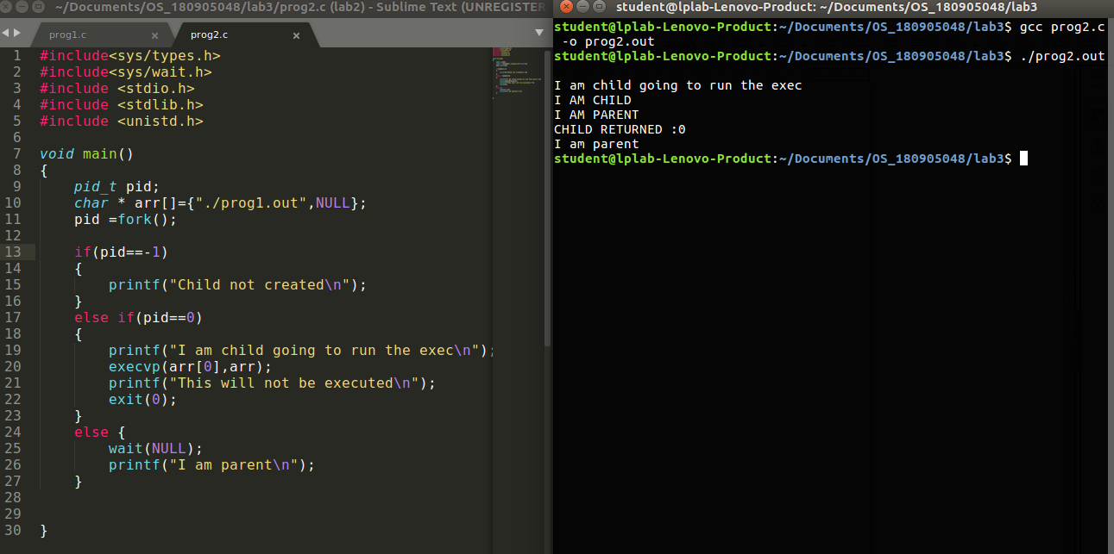

Q3

#include <stdio.h>
#include <stdlib.h>
#include <unistd.h>
#include <sys/types.h>
#include <sys/wait.h>

int main()
{
pid_t pid= fork();
if(pid==-1)
{
printf("Child not created\n");
}
else if(pid==0)
{
printf("Child created\n");
printf("The child process id from child is: %d \n", getpid());
printf("The parent process id from child is: %d \n", getppid());
exit(0);
}
else {
wait(NULL);
printf("I am the parent\n");
printf("The child process id from parent is: %d \n", pid);
printf("The parent process id from parent is: %d \n", getpid());
}

}

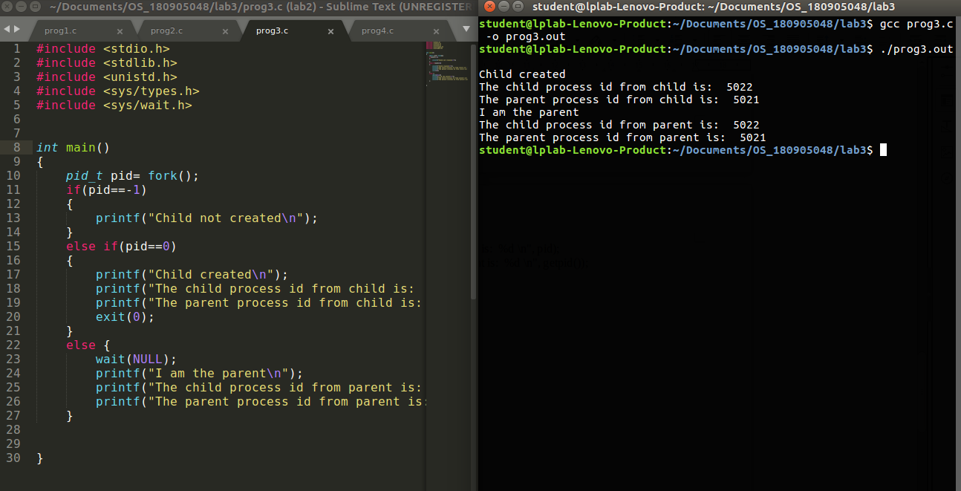

Q4

#include <stdio.h>
#include <stdlib.h>
#include <sys/types.h>
#include <sys/wait.h>
#include <unistd.h>
int main()
{
pid_t pid;
pid=fork();
if(pid==-1){
printf("Fork failed\n");
exit(0);
}
else if(pid==0)
{
printf("In Child:\n");
for(int i=0;i<10;i++)
{
printf("Child process - %d\n",i+1);
}
printf("Parent PID : %d\nChild PID : %d\n",getppid(),getpid());
exit(0);
}
else
{
printf("In Parent:\n");
for(int i=0;i<2;i++)
printf("Parent process - %d\n",i+1);
sleep(10);
int p=fork();
if(p==0){
printf("In child\n");
sleep(1);
printf("Parent pid : %d\n",getppid());
}
else{
printf("Exiting parent\n");
exit(0);
}
return 0;
}
}

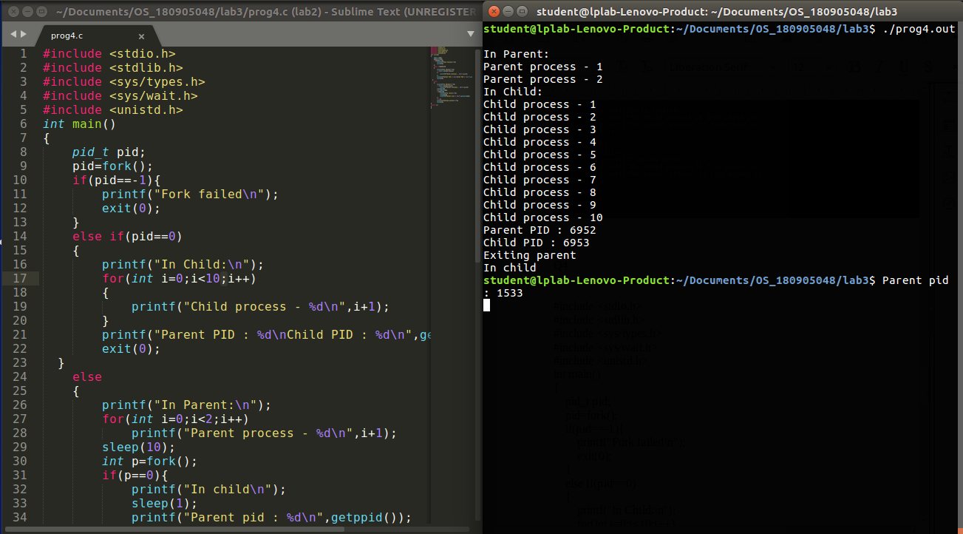

//////////////////////////////////////////////////////////////////////END/////////////////////////////////////////////////////////////////

