OS LAB 6

Sahil Saini Salaria
Reg No 180905048
Roll No 11C
Batch 5th
Lab OS

Q1

//sender

#include <stdlib.h>
#include <stdio.h>
#include <string.h>
#include <errno.h>
#include <unistd.h>
#include <sys/types.h>
#include <sys/ipc.h>
#include <sys/msg.h>

int main()
{
int a=0;
int msgid = msgget((key_t)1234,0666|IPC_CREAT);
if(msgid==-1)
{
fprintf(stderr,"msgget failed!!\n");
exit(EXIT_FAILURE);
}
printf("Enter a number: ");
scanf("%d",&a);

if(msgsnd(msgid, &a, sizeof(int),0)==-1)
{
printf("msgsnd failed!!!\n");
exit(EXIT_FAILURE);
}
exit(EXIT_SUCCESS);
}

//rcv

#include <stdlib.h>
#include <stdio.h>
#include <string.h>
#include <errno.h>
#include <unistd.h>
#include <sys/types.h>
#include <sys/ipc.h>
#include <sys/msg.h>

int main()
{
int a=0;
int msgid = msgget((key_t)1234,0666|IPC_CREAT);
if(msgid==-1)
{
fprintf(stderr,"msgget failed!!\n");
exit(EXIT_FAILURE);
}

if(msgrcv(msgid, &a, sizeof(int),0,0)==-1)
{
printf("msgsnd failed!!!\n");
exit(EXIT_FAILURE);
}
else
{
printf("Recieved Number: %d\n",a);
int p = a;
int r=0,s=0;
while(p!=0)
{
r=p%10;
s=s*10+r;
p=p/10;
}
if(s==a)
printf("Palindrome Number!!\n");
else
printf("NOT Palindrome Number\n");
}
exit(EXIT_SUCCESS);
}

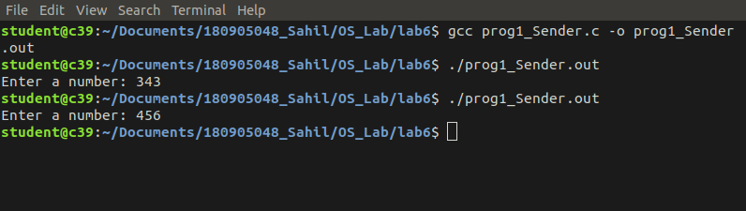

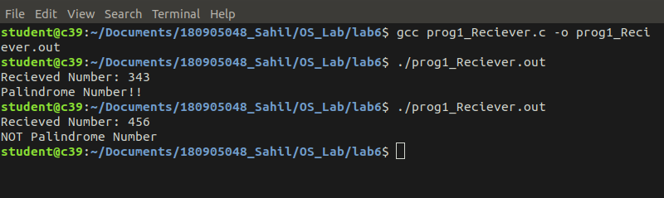

Q2

#include <stdlib.h>
#include <stdio.h>
#include <string.h>
#include <errno.h>
#include <unistd.h>
#include <sys/types.h>
#include <sys/ipc.h>
#include <sys/shm.h>

struct shared_use
{
char c;
char next_char;
};

int main()
{
int running = 1;
pid_t pid;
void *shared_memory = (void *)0;
int shmid;
struct shared_use *st;
srand((unsigned int)getpid());
shmid = shmget((key_t)1234,sizeof(struct shared_use),0666|IPC_CREAT);
if(shmid==-1)
{
fprintf(stderr,"shmget failed\n");
exit(EXIT_FAILURE);
}
shared_memory = shmat(shmid,(void *)0,0);
if(shared_memory == (void *)-1)
{
fprintf(stderr, "shmat failed\n");
exit(EXIT_FAILURE);
}
st = (struct shared_use *)shared_memory;
char ch;
printf("Enter a character: \n");
scanf("%c",&ch);
st->c=ch;
printf("You entered: %c\n",st->c);

pid = fork();
if(pid == -1)
{
fprintf(stderr, "%d\n",errno);
exit(1);
}
else if(pid == 0)
{
printf("Current char: %c\n",st->c);
st->c++;
}
else
{
printf("Waiting for Child process to increment the character\n");
sleep(2);
printf("Updated char: %c\n",st->c);
}
if(shmdt(shared_memory)==-1)
{
fprintf(stderr, "shmdt failed\n");
exit(EXIT_FAILURE);
}
}

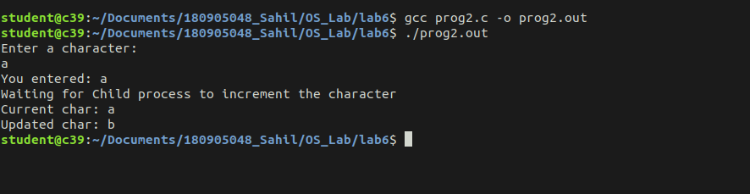

////////////////////////////////////////////////END////////////////////////////////////////////////////////////////

