Lab 7 OS
Sahil Saini Salaria
Reg No. 180905048
Roll No. 11C
Batch 5

Q1

#include <pthread.h>
#include <stdio.h>
#include <stdlib.h>
#include <unistd.h>
#include <semaphore.h>
int buf[10], f, r;
sem_t mutex, full, empty;
void *produce(void *arg)
{
int i;
for (i = 0; i < 20; i++)
{
sem_wait(&empty);
sem_wait(&mutex);
printf("produce item is %d\n", i);
buf[(++r) % 10] = i;
sleep(1);
sem_post(&mutex);
sem_post(&full);
}
}
void *consume(void *arg)
{
int item, i;
for (i = 0; i < 20; i++)
{
sem_wait(&full);
sem_wait(&mutex);
item = buf[(++f) % 10];
printf("consumed item is %d\n", item);
sleep(1);
sem_post(&mutex);
sem_post(&empty);
}
}
int main(int argc, char const *argv[])
{
pthread_t tid1, tid2;
sem_init(&mutex, 0, 1);
sem_init(&full, 0, 0);
sem_init(&empty, 0, 10);
pthread_create(&tid1, NULL, produce, NULL);
pthread_create(&tid2, NULL, consume, NULL);
pthread_join(tid1, NULL);
pthread_join(tid2, NULL);
return 0;
}

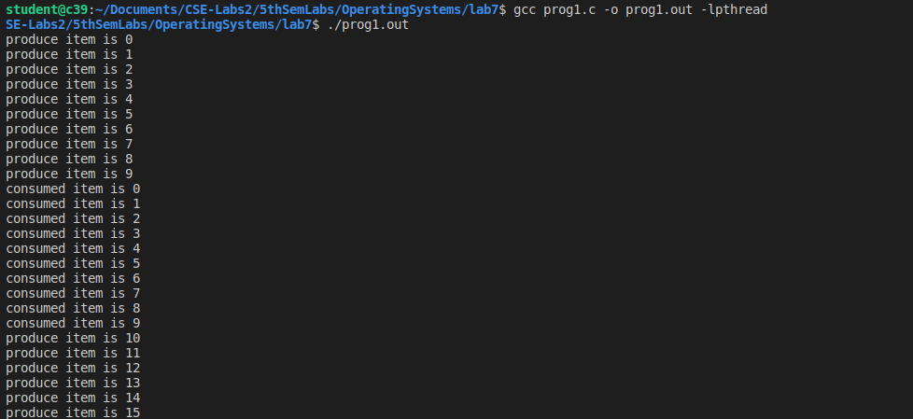

Q2

#include <stdlib.h>
#include <stdio.h>
#include <pthread.h>
#include <semaphore.h>
void *reader(void *rno);
void *writer(void *wno);
sem_t wrt;
pthread_mutex_t mutex;
int cnt = 1;
int numreader = 0;
void *reader(void *rno)
{
pthread_mutex_lock(&mutex);
numreader++;
if (numreader == 1)
{
sem_wait(&wrt);
}
pthread_mutex_unlock(&mutex);
printf("Reader %d: read cnt as %d\n", *((int *)rno), cnt);
pthread_mutex_lock(&mutex);
numreader--;
if (numreader == 0)
{
sem_post(&wrt);
}
pthread_mutex_unlock(&mutex);
}
void *writer(void *wno)
{
sem_wait(&wrt);
cnt = cnt * 2;
printf("Writer %d modified cnt to %d\n", (*((int *)wno)), cnt);
sem_post(&wrt);
}
int main()
{
pthread_t read[10], write[5];
pthread_mutex_init(&mutex, NULL);
sem_init(&wrt, 0, 1);
int a[10] = {1, 2, 3, 4, 5, 6, 7, 8, 9, 10};
for (int i = 0; i < 10; i++)
{
pthread_create(&read[i], NULL, (void *)reader, (void *)&a[i]);
}
for (int i = 0; i < 5; i++)
{
pthread_create(&write[i], NULL, (void *)writer, (void *)&a[i]);
}
for (int i = 0; i < 10; i++)
{
pthread_join(read[i], NULL);
}
for (int i = 0; i < 5; i++)
{
pthread_join(write[i], NULL);
}
pthread_mutex_destroy(&mutex);
sem_destroy(&wrt);
return 0;
}

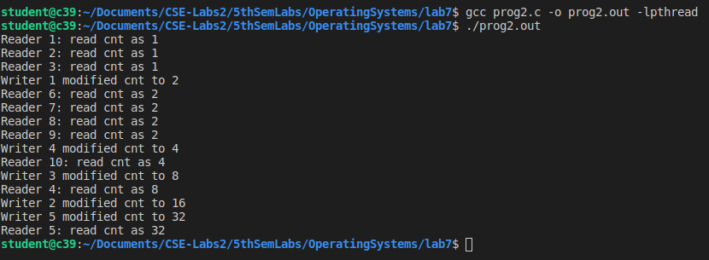

Q3

#include <stdio.h>
#include <pthread.h>
#include <semaphore.h>
#include <stdlib.h>
#include <unistd.h>
int shared;
sem_t sem1, sem2;
void *func1()
{
sem_wait(&sem1);
printf("In function 1\n");
sem_wait(&sem2);
sem_post(&sem2);
sem_post(&sem1);
}
void *func2()
{
sem_wait(&sem2);
printf("In function 2\n");
sem_wait(&sem1);
sem_post(&sem1);
sem_post(&sem2);
}
void main()
{
pthread_t tid1, tid2;
sem_init(&sem1, 0, 1);
sem_init(&sem2, 0, 1);
pthread_create(&tid1, NULL, func1, NULL);
pthread_create(&tid2, NULL, func2, NULL);
pthread_join(tid1, NULL);
pthread_join(tid2, NULL);
}

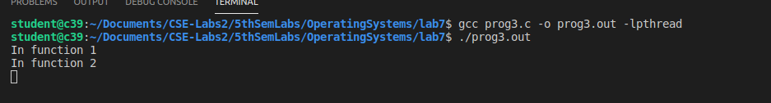

Q4
#include <stdio.h>
#include <pthread.h>
#include <semaphore.h>
#include <stdlib.h>
#include <unistd.h>
int shared;
sem_t sem1, sem2;
void *func1()
{
sem_wait(&sem1);
printf("In function 1\n");
sem_wait(&sem2);
sem_post(&sem2);
sem_post(&sem1);
}
void *func2()
{
sem_wait(&sem2);
printf("In function 2\n");
sem_wait(&sem1);
sem_post(&sem1);
sem_post(&sem2);
}
void main()
{
pthread_t tid1, tid2;
sem_init(&sem1, 0, 1);
sem_init(&sem2, 0, 1);
pthread_create(&tid1, NULL, func1, NULL);
pthread_create(&tid2, NULL, func2, NULL);
pthread_join(tid1, NULL);
pthread_join(tid2, NULL);
}#include <stdio.h>
#include <stdlib.h>
#include <unistd.h>
#include <pthread.h>
#include <errno.h>
#include <sys/ipc.h>
#include <semaphore.h>
#define N 5
time_t end_time;
sem_t mutex, customers, barbers;
int count = 0;
void barber(void *arg);
void customer(void *arg);
int main(int argc, char *argv[])
{
pthread_t id1, id2;
int status = 0;
end_time = time(NULL) + 20;
sem_init(&mutex, 0, 1);
sem_init(&customers, 0, 0);
sem_init(&barbers, 0, 1);
status = pthread_create(&id1, NULL, (void *)barber, NULL);
if (status != 0)
perror("create barbers is failure!\n");
status = pthread_create(&id2, NULL, (void *)customer, NULL);
if (status != 0)
perror("create customers is failure!\n");
pthread_join(id2, NULL);
pthread_join(id1, NULL);
exit(0);
}
void barber(void *arg)
{
while (time(NULL) < end_time || count > 0)
{
sem_wait(&customers);
sem_wait(&mutex);
count--;
printf("Barber:cut hair,count is:%d.\n", count);
sem_post(&mutex);
sem_post(&barbers);
sleep(3);
}
}
void customer(void *arg)
{
while (time(NULL) < end_time)
{
sem_wait(&mutex);
if (count < N)
{
count++;
printf("Customer:add count,count is:%d\n", count);
sem_post(&mutex);
sem_post(&customers);
sem_wait(&barbers);
}
else
sem_post(&mutex);
sleep(1);
}
}
