**SYNOPSIS**

**INDUSTRIAL TRAINING (TR-104)**

[EXCELLENCE TECHNOLOGY]

JAN – MAY 2024

**SUBMITTED BY:**

NIMISH BUDHIRAJA SAHIL SHARMA SANYAM GARG

2004631 2004657 2004659



DEPARTMENT OF COMPUTER SCIENCE AND ENGINEERING

**GURU NANAK DEV ENGINEERING COLLEGE, GILL PARK, GILL ROAD, LUDHIANA**

**INDEX**

1. Artificial Intelligence and Machine Learning 1
2. Confirmation Letter from the Company 2
3. About the Company 5
4. Objective of the training 6
5. Hardware & Software to be used 7
6. What contribution would the project / training make? 8
7. The Schedule of the training 9
8. Your role at the training / site 10
9. **Artificial Intelligence and Machine Learning**

Artificial Intelligence (AI) and Machine Learning (ML) are transformative technologies reshaping numerous industries. AI refers to the simulation of human intelligence in machines programmed to think and learn. It encompasses a broad spectrum of capabilities, including problem-solving, decision-making, language understanding, and perception.

Machine Learning, a subset of AI, involves the development of algorithms that allow computers to learn from and make predictions based on data. Unlike traditional programming, where specific instructions are given, ML models identify patterns and infer rules autonomously from large datasets. This process typically involves training on a portion of data to make accurate predictions on new, unseen data.

AI and ML have diverse applications. In healthcare, they enable early disease detection, personalized treatment plans, and the discovery of new drugs. In finance, they enhance fraud detection, automate trading, and improve risk management. Autonomous vehicles, powered by AI, promise safer and more efficient transportation. Additionally, AI-driven chatbots and virtual assistants are transforming customer service by providing rapid, personalized responses.

The development of AI and ML raises ethical and societal considerations. Issues such as data privacy, security, and the potential for biased decision-making are critical challenges. Moreover, the impact of automation on employment necessitates strategies for workforce adaptation and reskilling.

Overall, AI and ML are pivotal in driving innovation and efficiency across sectors. Their continued evolution promises to address complex global challenges.

1

1. **Confirmation Letter**



**2**

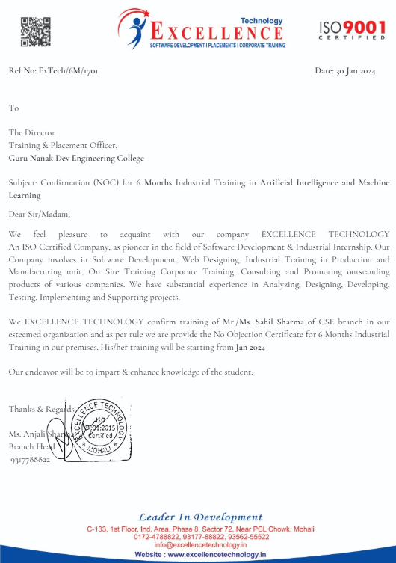

3

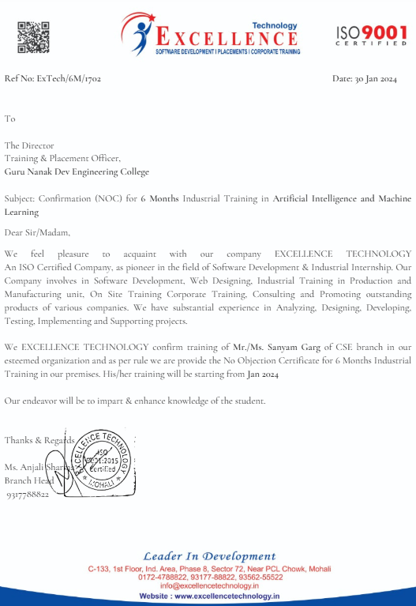

4

1. **About the Company**

Excellence Technology is a software development and industrial training company that offers courses in web development, mobile app development, digital marketing, and more. Their courses are designed to help students get jobs in the IT industry. They also offer 6-month and 6-week industrial training programs.

**What They Do**

Excellence Technology provides a variety of services to help businesses succeed in the digital age. We offer:

**Software development:** We develop custom software applications for businesses of all sizes.

**Web development:** We design and develop websites that are both beautiful and functional.

**Mobile app development:** We develop mobile apps for iOS and Android devices.

**Digital marketing**: We help businesses create and implement effective digital marketing campaigns.

**Industrial training:** We offer 6-month and 6-week industrial training programs that help students develop the skills they need to get jobs in the IT industry.

**Our Team**

Excellence Technology has a team of experienced and qualified professionals who are passionate about helping businesses succeed. Our team includes: Software developers, web developers, Mobile app developers, Digital marketing experts.

5

1. **Objectives**
2. To recognize the hand gestures which includes 26 English alphabets (A-Z) and 10 digits (0-9) using Deep Neural Networks (DNN).
3. To convert sign language into words by an algorithm or a model.
4. To show on the optical viewfinder of the camera module what a particular position of hand means with respect to Sign Language.

6

**5. Hardware and Software Requirements**

**Hardware Required**

* Operating System : Window 10,11
* RAM: Minimum 4GB
* Hard Drive: Minimum 8GB
* Web Cam is must

**Software Required**

* Python
* Tensorflow / Keras
* Open CV
* Artificial Neural Networks (ANN)
* Convolutional Neural Network (CNN)

7

**6. What contribution would the project make?**

The development of a robust Sign Language Recognition (SLR) system can make significant contributions to various fields, particularly in enhancing communication and accessibility. For the hearing impaired, such a system offers an efficient and accurate method to convert sign language into text, thereby facilitating smoother interactions with non-signing individuals. This bridges communication gaps and promotes inclusivity in educational, professional, and social contexts.

For very young children, especially those who are pre-verbal or have speech delays, SLR systems can provide an intuitive means of interacting with computers and other digital devices. This early interaction can support cognitive development, learning, and the ability to communicate needs and thoughts effectively, fostering better developmental outcomes.

From a technological perspective, this project advances the field of computer vision and machine learning by addressing the challenges of feature selection and extraction in gesture recognition. By ensuring viewpoint invariance and user independence, the system becomes more adaptable and user-friendly, capable of recognizing signs accurately regardless of the user’s position or individual differences in signing style.

Furthermore, the insights gained from developing such a system can be applied to other areas of gesture recognition, enhancing human-computer interaction in various applications such as virtual reality, gaming, and remote control interfaces. Overall, the project contributes to the broader goal of creating more accessible, intelligent, and interactive technological solutions.

Overall, the project contributes to creating more accessible, intelligent, and interactive technological solutions, fostering inclusivity and enhancing communication.

8

**7. Schedule of the training**

Session 1: Introduction to Artificial Intelligence and Machine Learning

Session 2: Introduction to Python Programming for AI and ML

Session 3: Control Flow Statements in Python

Session 4: Data Structures in Python and NumPy, Pandas

Session 5: Data Preprocessing and Cleaning

Session 6: Introduction to Machine Learning

Session 7: Linear and Logistic Regression

Session 8: Decision Trees and Random Forests

Session 9: Naive Bayes Classifier

Session 10: Support Vector Machines and Clustering Algorithms

Session 11: Dimensionality Reduction Techniques

Session 12: Introduction to Deep Learning

Session 13: Convolutional Neural Networks (CNNs) and Recurrent Neural Networks (RNNs)

Session 14: Introduction to Natural Language Processing (NLP)

Session 15: Sentiment Analysis and Introduction to Reinforcement Learning

Session 16: Introduction to Computer Vision

Session 17: Emerging Trends in AI and ML

9

**8. My Role at the training**

Throughout the training, my role will evolve to encompass various aspects, reflecting the dynamic nature of the program:

**Trainee and Active Participant:**

* Engage actively with theoretical lessons and coding sessions.
* Ask questions, seek clarification, and actively participate in discussions.

**Collaborator and Team Member:**

* Collaborate with mentors and fellow trainees during coding sessions and project development.
* Participate in collaborative coding practices and code reviews.

**Learner and Adaptor:**

* Adapt to evolving technologies and best practices introduced during the training.
* Embrace a learning mindset to absorb new concepts and techniques.

**Project Contributor:**

* Actively contribute to the development of the Appoint Care Doctor Appointment System.
* Take ownership of specific features or components within the project.

**Reviewer and Refiner:**

* Engage in code review sessions to provide constructive feedback to peers.
* Participate in the refinement of the project codebase based on feedback.

10

**Presenter and Demonstrator:**

* Present the Appoint Care Doctor Appointment System during the final presentation phase.
* Demonstrate features, functionalities, and the overall architecture of the project.

My role is multifaceted, combining active participation, collaboration, and a commitment to continuous learning and improvement. This approach ensures that you derive maximum value from the training, both in terms of skill development and practical project experience.

11