*PR-4: Looping Statements :-*

1. Write C program to print 1 to 10 number.

#include<stdio.h>

int main() {

int i;

for (i=1; i<=10; i++) {

printf("%d\n",i);

}

return 0;

}

Output:-



2. Write C program to print 40 to 31 number.

#include<stdio.h>

int main() {

int i;

for (i=40; i>=31; i--) {

printf("%d\n",i);

}

return 0;

}

Output:-



3. Write C program to print odd number from 80 to 100.

#include<stdio.h>

int main() {

int i;

for (i=80; i<=100; i++) {

if (i % 2 == 1) {

printf("%d\n", i);

}

}

return 0;

}

Output:-



4. Write C program to print number that are divisible by 5 from 25 to 50 number.

#include<stdio.h>

int main() {

int i;

for (i=25; i<=50; i=i+5) {

printf("%d\n",i);

}

return 0;

}

Output:-



5. Write C program to print to print A to Z character.

#include<stdio.h>

int main() {

char i;

for (i='A'; i<='Z'; i++) {

printf("%c\n",i);

}

return 0;

}

Output:-

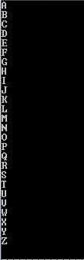

6. Write C program to print multiplication table of any number.

#include<stdio.h>

int main() {

int i, num;

printf("Please enter any number: ");

scanf("%d", &num);

for (i=1; i<=10; i++) {

printf("%d * %d = %d\n",num, i, num * i);

}

return 0;

}

Output:-

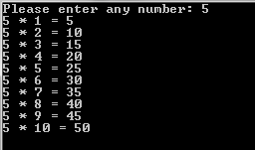

7. Write C program to count number of boys whose weight is less than 50kg and height is greater than 170cm.

#include<stdio.h>

int main() {

int i, count=0;

float weight, heigth;

for (i=1; i<=3; i++) {

printf("Please enter your Weight and Heigth");

scanf("%f %f", &weight, &heigth);

if (weight <= 50 && heigth >= 170) {

count++;

}

}

printf("Boys count is : %d", count);

return 0;

}

Output:-



8. Write C program to find ratio of (a-b) and (c-d) of any three number. If c and d is equal than not to find ratio.

#include<stdio.h>

int main() {

int a, b, c, d, ans, i;

for (i=1; i<=3; i++) {

printf("Please enter any Four number");

scanf("%d %d %d %d", &a, &b, &c, &d);

if (c == d) {

printf("Ratio ti not Possible");

} else {

ans = (a-b)/(c-d);

printf("Ans is: %d\n", ans);

}

}

return 0;

}

Output:-

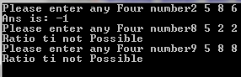

9. Write C program to calculate factorial of a number.

#include<stdio.h>

int main() {

int n, fact=1, i;

printf("PLease enter any number: ");

scanf("%d", &n);

for (i=n; i>=1; i--) {

fact=fact*i;

}

printf("Factrial is: %d", fact);

return 0;

}

Output:-



10. Write C program to give sum of n numbers.

#include<stdio.h>

int main() {

int i, n, sum=0;

printf("PLease enter any number:");

scanf("%d", &n);

for (i=0; i<=n; i++) {

sum = sum + i;

}

printf("Sum is : %d", sum);

return 0;

}

Output:-



11. Write C program to give average of n numbers.

#include<stdio.h>

int main() {

int i,n,avg, sum=0;

printf("enter any number:");

scanf("%d",&n);

for (i=1; i<=n; i++) {

sum = sum + i;

printf("%d\n",i);

}

printf("your sum is:%d\n",sum);

avg = sum / n;

printf("your avg is:%d",avg);

return 0;

}

Output:-

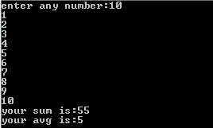

12. Write C program to find a number that is divisible by 7 or 3 from n numbers.

#include<stdio.h>

int main() {

int n, i, num;

printf("Please enter any number: ");

scanf("%d", &n);

i = 1;

do {

printf("\nPlease enter number");

scanf("%d", &num);

if (num %7 == 0 || num %3 == 0) {

printf("%d number is divisibele\n", num);

} else {

printf("%d number is not divisibele\n", num);

}

i++;

} while (i<=n);

return 0;

}

Output:-

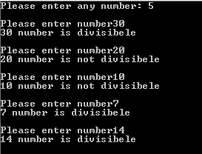

13. Write C program to count number of digits in a number.

#include <stdio.h>

int main(){

int n, Reminder, Counter=0;

printf("Please Enter any number:");

scanf("%d", &n);

while(n > 0){

n = n / 10;

Counter = Counter + 1;

}

printf("Ans is: %d", Counter);

return 0;

}

Output:-



14. Write C program to enter a number and print its reverse & check weather num is palindrome or not?

#include <stdio.h>

int main() {

int num, rev = 0, rem, temp;

printf("Enter a number: ");

scanf("%d", &num);

temp = num;

while (temp != 0) {

rem = temp % 10;

rev = rev * 10 + rem;

temp /= 10;

}

printf("The reverse of %d is: %d\n", num, rev);

if (num == rev) {

printf("%d is a palindrome number", num);

} else {

printf("%d is not a palindrome number", num);

}

return 0;

}

Output:-



15. Write C program to check number is prime or not.

#include<stdio.h>

int main() {

int n, i, flag = 0;

printf("Please enter any number: ");

scanf("%d", &n);

if (n > 1) {

if (n == 2) {

printf("%d is prime number", n);

} else {

for (i=2; i<n; i++) {

if (n %i == 0) {

flag = 1;

break;

}

}

if (flag == 0) {

printf("%d is prime number", n);

} else {

printf("%d is Not prime number", n);

}

}

} else {

printf("Not decidable");

}

return 0;

}

Output:-



16. Write C program to find class of the n students from their m marks.  
   Note: 1. You have to take student's roll number and 5 subject marks out of 100.   
              2. If total marks greater than 450 then grade will be A.  
                  If total marks greater than 350 then grade will be B.  
                  If total marks less than 350 then grade will be C.

#include<stdio.h>

int main() {

int n, i, j, m, Roll_Number, sub, total;

printf("Please enter No Of Student and Subject: \n");

scanf("%d %d", &n, &m);

for (i=1; i<=n; i++) {

printf("PLease enter any Roll Number:- ");

scanf("%d", &Roll_Number);

total=0;

for (j=1; j<=m; j++) {

printf("PLease enter Subject:- ", j);

scanf("%d", &sub);

total = total + sub;

}

printf("PLease enter Total: %d\n", total);

printf("PLease enter Roll Number: %d\n", Roll_Number);

if(total > 450) {

printf("Grade:A\n\n");

} else if (total > 350) {

printf("Grade:B\n\n");

} else {

printf("Grade:c\n\n");

}

}

return 0;

}

Output:-

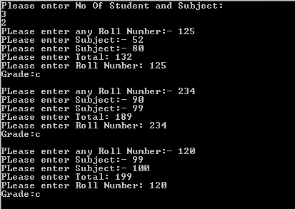

17. Write C program to find expenses of an organization from n month.  
Note:   
 1. You have to ask expense of electricity, salary and marketing of each month.  
 2. You have to print Month number and total expense of each month.

#include<stdio.h>

int main() {

int i,electricity, month_Number,Res,salary, marketing,n;

printf("Please enter any number:");

scanf("%d", &n);

for (i=0; i<=n; i++) {

printf("\nEnter of The Month number:");

scanf("%d", &month_Number);

printf("Electricity is:");

scanf("%d", &electricity);

printf("Salary is:");

scanf("%d", &salary);

printf("Marketing is:");

scanf("%d", &marketing);

Res =electricity+salary+marketing;

printf("Ans is:%d\n",Res);

printf("Marketing is:%d\n",month_Number);

}

return 0;

}

Output:-

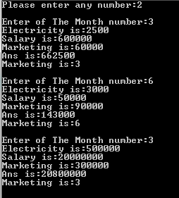  
  
18. Write a program to calculate x power y.(when user input x is 2 and y is 3 then the result will be 8)

#include<stdio.h>

int main() {

int x, y, p = 1, i;

printf("PLease enter X value = ");

scanf("%d", &x);

printf("PLease enter Y value = ");

scanf("%d", &y);

for (i=1; i<=y; i++) {

p = p * x;

}

printf("Ans is = %d", p);

return 0;

}

Output:-



19. Write a program to calculate sum of the digits of a given number.

#include <stdio.h>

int main() {

int sum = 0, x, i, rem;

printf("Please enter any number of X");

scanf("%d", &x);

while (x > 0) {

rem = x % 10;

sum = sum + rem;

x = x / 10;

}

printf("Sum is: %d", sum);

return 0;

}

Output:-



20. Write a program to print all Armstrong numbers under 1000.

#include<stdio.h>

int main (){

int n, rem=0, res=0;

printf("enter any number:");

scanf("%d", &n);

while (n > 0) {

rem = n % 10;

res = res + (rem * rem * rem);

n = n / 10;

}

printf("your number is:%d",res);

return 0;

}

Output:-

