*PR-5: Array:-*

1. Write a C program to print all negative element from static array.

#include<stdio.h>

int main() {

int roll[5] = {-52, 32, -62, 97, 12} , i;

for (i=0; i<=4; i++) {

if (roll[i] < 0) {

printf("%d\n", roll[i]);

}

}

return 0;

}

Output:-



2. Write a C program to print all negative element from dynamic array.

#include<stdio.h>

int main() {

int arr[100], n, i;

printf("Please enter size of an Array: ");

scanf("%d", &n);

for (i=0; i<n; i++) {

printf("Please enter element of array %d: ",i);

scanf("%d", &arr[i]);

}

printf("Ans element of array: ");

for (i=0; i<n; i++) {

if (arr[i] < 0) {

printf("%d ", arr[i]);

}

}

return 0;

}

Output:-

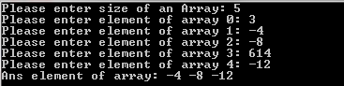

3. Write a C program to print all even element from static array.

#include<stdio.h>

int main() {

int roll[5] = {51 , 42, 86, 31, 321}, i;

for (i=0; i<=4; i++) {

if (roll[i] %2 == 0) {

printf("%d\n", roll[i]);

}

}

return 0;

}

Output:-



4. Write a C program to print all odd element from dynamic array.

#include<stdio.h>

int main() {

int arr[100], n, i;

printf("Please enter size of an Array: ");

scanf("%d", &n);

for (i=0; i<n; i++) {

printf("Please enter element of array %d: ",i);

scanf("%d", &arr[i]);

}

printf("Ans element of array: ");

for (i=0; i<n; i++) {

if (arr[i] %2 == 1) {

printf("%d ", arr[i]);

}

}

return 0;

}

Output:-

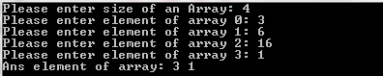

5. Write a C program to print all element that are divisible by 3 from dynamic array.

#include<stdio.h>

int main() {

int arr[100], n, i;

printf("Please enter size of an Array: ");

scanf("%d", &n);

for (i=0; i<n; i++) {

printf("Please enter element of array %d: ",i);

scanf("%d", &arr[i]);

}

printf("Ans element of array: ");

for (i=0; i<n; i++) {

if (arr[i] %3 == 0) {

printf("%d ", arr[i]);

}

}

return 0;

}

Output:-

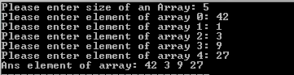

6. Write a C program to find max element from an dynamic array.

#include<stdio.h>

int main() {

int arr[100], n, i, max = 0;

printf("Please enter size of an Array: ");

scanf("%d", &n);

for (i=0; i<n; i++) {

printf("Please enter element of array %d: ",i);

scanf("%d", &arr[i]);

}

for (i=0; i<n; i++) {

if (arr[i] > max) {

max = arr[i];

}

}

printf("Maximum Number is: %d", max);

return 0;

}

Output:-

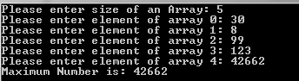

1. Write C program to find second largest number in array.

#include<stdio.h>

int main() {

int arr[100], n, i, m1 = 0, m2 = 0;

printf("Please enter size of an array: ");

scanf("%d", &n);

for (i=0; i<n; i++) {

printf("Please enter value of array: ");

scanf("%d", &arr[i]);

}

for (i=0; i<n; i++) {

if (arr[i] > m1) {

m2 = m1;

m1 = arr[i];

} else if (arr[i] > m2 && arr[i] != m1) {

m2 = arr[i];

}

}

printf("2nd Maximum is: %d", m2);

return 0;

}

Output:-

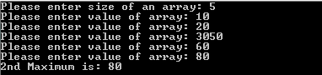

8. Write C program to Update the element into array.

#include<stdio.h>

int main() {

int arr[100], n, i, m1 = 0, m2 = 0, newElement, i1;

printf("Please enter size of an array: ");

scanf("%d", &n);

for (i=0; i<n; i++) {

printf("Please enter value of array: ");

scanf("%d", &arr[i]);

}

printf("Which element so yo need to change?");

scanf("%d", &i1);

printf("Enter The New Element");

scanf("%d", &newElement);

arr[i1 - 1] = newElement;

for (i=0; i<n; i++) {

printf("%d ", arr[i]);

}

return 0;

}

Output:-

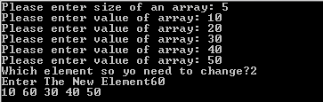

9. Write C program to Insert the element into array.

#include<stdio.h>

int main() {

int arr[100], n, i, m1 = 0, m2 = 0, newElement, i1;

printf("Please enter size of an array: ");

scanf("%d", &n);

for (i=0; i<n; i++) {

printf("Please enter value of array: ");

scanf("%d", &arr[i]);

}

printf("Which element so yo need to change?");

scanf("%d", &i1);

printf("Enter The New Element?");

scanf("%d", &newElement);

n++;

for (i=n-1; i>=i1; i--) {

arr[i] = arr[i-1];

}

arr[i1 - 1] = newElement;

for (i=0; i<n; i++) {

printf("%d ", arr[i]);

}

return 0;

}

Output:-

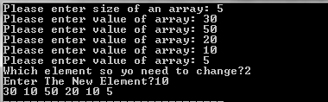

10. Write C program to Delete the element into array.

#include<stdio.h>

int main() {

int arr[100], n, i, m1 = 0, m2 = 0, i1;

printf("Please enter size of an array: ");

scanf("%d", &n);

for (i=0; i<n; i++) {

printf("Please enter value of array: ");

scanf("%d", &arr[i]);

}

printf("Which element so yo need to change?");

scanf("%d", &i1);

n--;

for (i=i1-1; i<=n; i++) {

arr[i] = arr[i+1];

}

for (i=0; i<n; i++) {

printf("%d ", arr[i]);

}

return 0;

}

Output:-

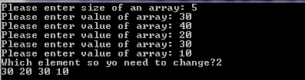

11. Write C program to left rotate an array element.

#include<stdio.h>

int main() {

int arr[100], i, n, first = 0;

printf("PLease enter size of an array");

scanf("%d", &n);

for (i=0; i<n; i++) {

printf("Please enter an Element");

scanf("%d", &arr[i]);

}

first = arr[0];

for (i=0; i<n; i++) {

arr[i] = arr[i+1];

}

arr[n-1] = first;

for (i=0; i<n; i++) {

printf("%d ", arr[i]);

}

return 0;

}

Output:-

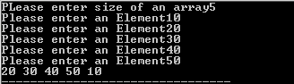

12. Write C program to right rotate an array element.

#include<stdio.h>

int main() {

int arr[100], i, n, last = 0;

printf("PLease enter size of an array");

scanf("%d", &n);

for (i=0; i<n; i++) {

printf("Please enter an Element");

scanf("%d", &arr[i]);

}

last = arr[n-1];

for (i=n-1; i>=0; i--) {

arr[i] = arr[i-1];

}

arr[0] = last;

for (i=0; i<n; i++) {

printf("%d ", arr[i]);

}

return 0;

}

Output:-

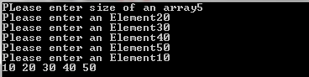

13. Write C program to addition of two matrices.

#include<stdio.h>

int main() {

int arr1[3][3] = {

{1, 25, 86},

{2, 32, 71},

{3, 84, 99}

};

int arr2[3][3] = {

{11, 25, 86},

{22, 32, 71},

{33, 88, 99}

};

int res[3][3] = {0};

int i, j;

for (i=0; i<3; i++) {

for (j=0; j<3; j++) {

res[i][j] = arr1[i][j] + arr2[i][j];

}

}

for (i=0; i<3; i++) {

for (j=0; j<3; j++) {

printf("%d ", res[i][j]);

}

printf("\n");

}

return 0;

}

Output:-



14. Write C program matrix convert into transpose matrix.

#include<stdio.h>

int main() {

int arr[3][3] = {

{1, 25, 86},

{2, 32, 71},

{3, 84, 99}

};

int res[3][3] = {0};

int i, j;

for (i=0; i<3; i++) {

for (j=0; j<3; j++) {

res[j][i] = arr[i][j];

}

}

for (i=0; i<3; i++) {

for (j=0; j<3; j++) {

printf("%d ", res[i][j]);

}

printf("\n");

}

return 0;

}

Output:-



15. Write C program to find sum of diagonal elements of a matrix.

#include<stdio.h>

int main() {

int arr[3][3] = {

{1, 25, 86},

{2, 32, 71},

{3, 84, 99}

};

int i, j, sum = 0;

for (i=0; i<3; i++) {

for (j=0; j<3; j++) {

if (i == j) {

sum = sum + arr[i][j];

}

}

}

printf("Sum is: %d", sum);

return 0;

}

Output:-



16. Write a C program to sum of all even element from an array.

#include<stdio.h>

int main() {

int arr[100], n, i, sum = 0;

printf("Please enter size of an Array: ");

scanf("%d", &n);

for (i=0; i<n; i++) {

printf("Please enter element of array %d: ",i);

scanf("%d", &arr[i]);

}

for (i=0; i<n; i++) {

if (arr[i] %2 == 0) {

sum = sum + arr[i];

}

}

printf("Sum of Even Number is: %d", sum);

return 0;

}

Output:-

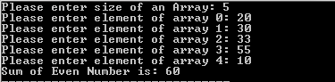

17. Write a C program to find average of an element from an array.

#include<stdio.h>

int main() {

int arr[100], n, i;

float average, sum = 0;

printf("Please enter size of an Array: ");

scanf("%d", &n);

for (i=0; i<n; i++) {

printf("Please enter element of array %d: ",i);

scanf("%d", &arr[i]);

}

for (i=0; i<n; i++) {

sum = sum + arr[i];

average = sum/n;

}

printf("Sum of Average Number is: %.2f", average);

return 0;

}

Output:-

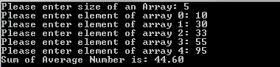

18. Write a C program to count number of students in each group (0-9, 10- 19, 20-29 .... 90-99, 100-100) for the given students marks.  
Marks: 85, 66, 37, 45, 68, 23, 99, 100, 81, 70, 42, 55, 68, 77, 96, 18

#include<stdio.h>

int main() {

int arr[16] = {85, 66, 37, 45, 68, 23, 99, 100, 81, 70, 42, 55, 68, 77, 96, 18};

int n, i;

int count[]={0,0,0,0,0,0,0,0,0,0,0};

for (i=0; i<n; i++) {

if (arr[i] > 0 && arr[i] < 9) {

count[0]++;

} else if (arr[i] > 10 && arr[i] < 19) {

count[1]++;

} else if (arr[i] > 20 && arr[i] < 29) {

count[2]++;

} else if (arr[i] > 30 && arr[i] < 39) {

count[3]++;

} else if (arr[i] > 40 && arr[i] < 49) {

count[4]++;

} else if (arr[i] > 50 && arr[i] < 59) {

count[5]++;

} else if (arr[i] > 60 && arr[i] < 69) {

count[6]++;

} else if (arr[i] > 70 && arr[i] < 79) {

count[7]++;

} else if (arr[i] > 80 && arr[i] < 89) {

count[8]++;

} else if (arr[i] > 90 && arr[i] < 99) {

count[9]++;

} else if (arr[i] > 100) {

count[10]++;

}

}

printf("0 to 9: %d\n", count[0]);

printf("10 to 19: %d\n", count[1]);

printf("20 to 29: %d\n", count[2]);

printf("30 to 39: %d\n", count[3]);

printf("40 to 49: %d\n", count[4]);

printf("50 to 59: %d\n", count[5]);

printf("60 to 69: %d\n", count[6]);

printf("70 to 79: %d\n", count[7]);

printf("80 to 89: %d\n", count[8]);

printf("90 to 99: %d\n", count[9]);

printf("100: %d", count[10]);

return 0;

}

Output:-

