*PR-6: UDF:-*

1. Write a C program to print your introduction using type-1 function.

#include<stdio.h>

void intro() {

printf("Amit Patel\n");

printf("Surat\n");

printf("1465655353\n");

}

int main() {

printf("\*\*\*\*\*\*\*\*\*\*\*\*\*\*\*\*\*\*\*\*\n");

intro();

printf("\*\*\*\*\*\*\*\*\*\*\*\*\*\*\*\*\*\*\*\*\n");

intro();

printf("\*\*\*\*\*\*\*\*\*\*\*\*\*\*\*\*\*\*\*\*\n");

intro();

printf("\*\*\*\*\*\*\*\*\*\*\*\*\*\*\*\*\*\*\*\*\n");

return 0;

}

Output:-

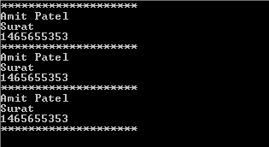

2. Write a C program to find area of circle using type-2 function.

#include<stdio.h>

float areaofcircel(float r) {

float area;

area = 3.14 \* r \* r;

printf("Area of circle: %f\n", area);

}

int main() {

areaofcircel(5);

areaofcircel(20);

return 0;

}

Output:-



3. Write a C program to find area of rectangle using type-3 function.

#include<stdio.h>

float areaofrectangle() {

float l, h, area;

printf("Please enter the lenght and height of rectangle: ");

scanf("%f %f", &l, &h);

area = l \* h;

return area;

}

int main() {

float res, res1;

res = areaofrectangle();

printf("Area of rectangle: %.2f\n", res);

res1 = areaofrectangle();

printf("Area of rectangle: %.2f\n", res1);

return 0;

}

Output:-

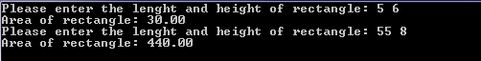  
  
4. Write a C program to create a calculator using type-4 function.

#include<stdio.h>

int add(int a,int b) {

int ans;

ans = a + b;

return ans;

}

int sub(int a,int b) {

int ans;

ans = a - b;

return ans;

}

int mul(int a,int b) {

int ans;

ans = a \* b;

return ans;

}

int div(int a,int b) {

int ans;

ans = a / b;

return ans;

}

int main() {

int a, b, res;

char op;

printf("Please enter any two Values: ");

scanf("%d %d", &a, &b);

printf("Please enter Operaters: ");

scanf(" %c", &op);

switch (op) {

case '+':

res = add(a, b);

break;

case '-':

res = sub(a, b);

break;

case '\*':

res = mul(a, b);

break;

case '/':

res = div(a, b);

break;

default:

printf("Invalid input");

break;

}

printf("Ans is: %d", res);

return 0;

}

Output:-

  
  
5. Write a C program to find number is even or odd using type-1 function.

#include<stdio.h>

void oddandeven() {

int num;

printf("Please enter of Number");

scanf("%d", &num);

if (num % 2 == 0) {

printf("%d is Even number\n",num);

} else {

printf("%d is Odd number\n",num);

}

}

int main() {

oddandeven();

return 0;

}

Output:-

  
  
6. Write a C program to find average of 4 numbers using type-2 function.

#include<stdio.h>

float Average(float n) {

float i, avg,sum=0,value;

for (i=1; i<=n; i++) {

printf("Please enter any Value:");

scanf("%f", &value);

sum = sum + value;

avg = sum / 4;

}

printf("your avg is:%f",avg);

}

int main() {

float n;

printf("enter any number:");

scanf("%f",&n);

Average(n);

return 0;

}

Output:-

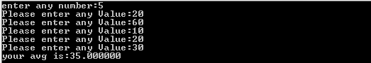  
  
7. Write a C program to find given number is prime or not using type-3 function.

#include<stdio.h>

int prime() {

int n, i, flag = 0;

printf("Please enter any number: ");

scanf("%d", &n);

if (n > 1) {

if (n == 2) {

printf("%d is prime number", n);

} else {

for (i=2; i<n; i++) {

if (n %i == 0) {

flag = 1;

break;

}

}

if (flag == 0) {

printf("%d is prime number", n);

} else {

printf("%d is Not prime number", n);

}

}

} else {

printf("Not decidable");

}

return n;

}

int main() {

int res, res1;

res = prime();

printf("\nResult is: %d", res);

return 0;

}

Output:-

  
  
8. Write a C program to find given number is Armstrong or not using type-4 function.

#include<stdio.h>

int armstrong(int n) {

int i, temp, rem = 1, res = 0;

for (i=1; i<=n; i++) {

temp = i;

while (temp > 0) {

rem = temp % 10;

res = res + (rem \* rem \* rem);

temp = temp / 10;

}

if (res == i) {

printf("%d is Aremstrong\n", i);

}

res = 0;

}

return res;

}

int main() {

int ans, n;

printf("Please enter any number:");

scanf("%d", &n);

ans = armstrong(n);

return 0;

}

Output:-

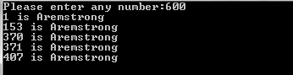  
  
9.Write a C program to find Sum of all Array Elements by passing array as an argument using User Define Functions.

#include<stdio.h>

int Average(int n, int arr[], int i) {

float average, sum = 0;

for (i=0; i<n; i++) {

sum = sum + arr[i];

average = sum/n;

}

printf("Sum of Average Number is: %.2f", average);

return average;

}

int main () {

int arr[100], n, i, ans;

printf("Please enter size of an Array: ");

scanf("%d", &n);

for (i=0; i<n; i++) {

printf("Please enter element of array %d: ",i);

scanf("%d", &arr[i]);

}

ans = Average(n, arr, i);

return 0;

}

Output:-

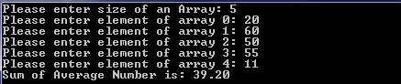  
  
10.Write a C program to find Length of the String by passing String/ Character Array as an Argument using User Define Functions.

#include<stdio.h>

int FindStringLength(char str[]) {

int length = 0;

while (str[length] != '\0') {

length++;

}

return length;

}

int main() {

char str[100], length = 0;

printf("Enter a string: ");

gets(str);

length = FindStringLength(str);

printf("Length is:- %d\n", length);

return 0;

}

Output:-

  
  
11. Write a C program to find factorial of number using recursion.

#include<stdio.h>

int findfact(int n) {

if (n > 1) {

return n \* findfact(n - 1);

} else {

return 1;

}

}

int main() {

int n, ans;

printf("Please enter of value: ");

scanf("%d", &n);

ans = findfact(n);

printf("Find the fact is: %d", ans);

return 0;

}

Output:-

  
  
12-15. Write any four C program that use array and UDF.

12.

#include<stdio.h>

void insert(int n, int i1, int newElement, int arr[]) {

int i;

n++;

for (i=n-1; i>=i1; i--) {

arr[i] = arr[i-1];

}

arr[i1 - 1] = newElement;

for (i=0; i<n; i++) {

printf("%d ", arr[i]);

}

}

int main () {

int n, i, i1, newElement, arr[100];

printf("Please enter size of an array: ");

scanf("%d", &n);

for (i=0; i<n; i++) {

printf("Please enter value of array: ");

scanf("%d", &arr[i]);

}

printf("Which element so yo need to change?");

scanf("%d", &i1);

printf("Enter The New Element?");

scanf("%d", &newElement);

insert(n, i1, newElement, arr);

return 0;

}

Output:-

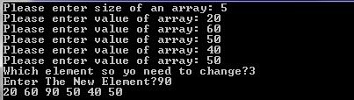

13.

#include<stdio.h>

void nagetive(int arr[], int n, int i) {

printf("Ans element of array: ");

for (i=0; i<n; i++) {

if (arr[i] < 0) {

printf("%d ", arr[i]);

}

}

}

int main () {

int arr[100], n, i, ans;

printf("Please enter size of an Array: ");

scanf("%d", &n);

for (i=0; i<n; i++) {

printf("Please enter element of array %d: ",i);

scanf("%d", &arr[i]);

}

nagetive(arr, n, i);

return 0;

}

Output:-

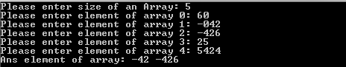

14.

#include<stdio.h>

int secondmax(int n, int arr[], int i) {

int m1 = 0, m2 = 0;

for (i=0; i<n; i++) {

if (arr[i] > m1) {

m2 = m1;

m1 = arr[i];

} else if (arr[i] > m2 && arr[i] != m1) {

m2 = arr[i];

}

}

printf("2nd Maximum is: %d", m2);

return m2;

}

int main () {

int n, i, arr[100], ans;

printf("Please enter size of an array: ");

scanf("%d", &n);

for (i=0; i<n; i++) {

printf("Please enter value of array: ");

scanf("%d", &arr[i]);

}

ans = secondmax(n, arr, i);

return 0;

}

Output:-

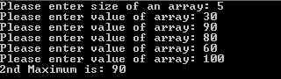

15.

#include<stdio.h>

int sumischeck(int arr[], int n) {

int sum = 0, i;

for (i=0; i<=n; i++) {

sum = sum + arr[i];

}

printf("Ans is: %d", sum);

return sum;

}

int main() {

int arr[100], n, i, ans;

printf("Please enter size of an array: ");

scanf("%d", &n);

for (i=0; i<=n; i++) {

printf("Please enter any value %d :-", i);

scanf("%d", &arr[i]);

}

ans = sumischeck(arr, n);

return 0;

}

Output:-

