Name: SAHIL

Course: B.Sc. (H) Computer Science

Roll No.: 20221474

Submitted to: Kamlesh Kumar Raghuvanshi

Practical : Database Management System

**Creating Database and Tables**

Creating database:

**Query**: create database sahil;

use sahil;

**Output:**

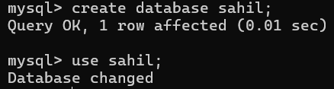

Create table student:

**Query**:

create table STUDENT (

RollNo Char(6) primary key,

StudentName Varchar(20),

Course Varchar(10),

DOB date

);

**Output:**

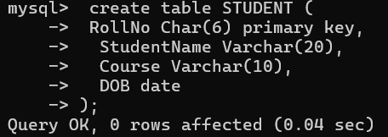

Create table Society:

**Query**:

create table SOCIETY (

SocID Char(6) primary key,

SocName Varchar(20),

MentorName Varchar(15),

TotalSeats int unsigned

);

**Output:**

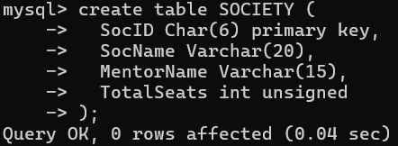

Create table Enrollment:

**Query:**

create table ENROLLMENT (

RollNo Char(6),

SID Char(6),

DateOfEnrollment date,

foreign key (RollNo) references STUDENT(RollNo),

foreign key (SID) references SOCIETY(SocID),

primary key (RollNo, SID)

);

**Output:**

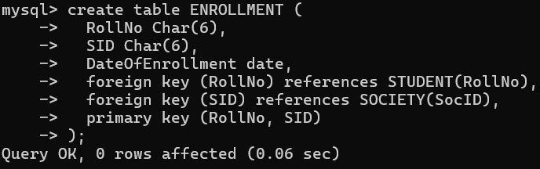

*Q1. Retrieve names of students enrolled in any society.*

**Query:**

select studentname

from student

inner join enrollment on STUDENT.RollNo = ENROLLMENT.RollNo;

**Output:**

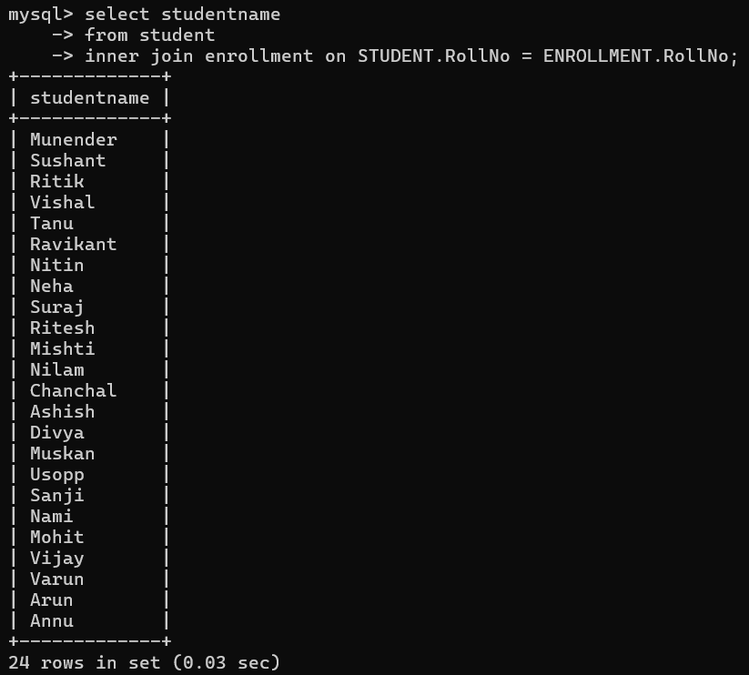

Q2. Retrieve all society names.

**Query:**

select socname from society;

**Output:**

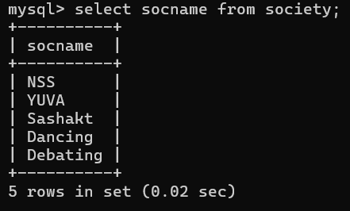

Q3. Retrieve students' names starting with letter ‘A’.

**Query:**

select studentname from student where studentname like 'A%';

**Output:**

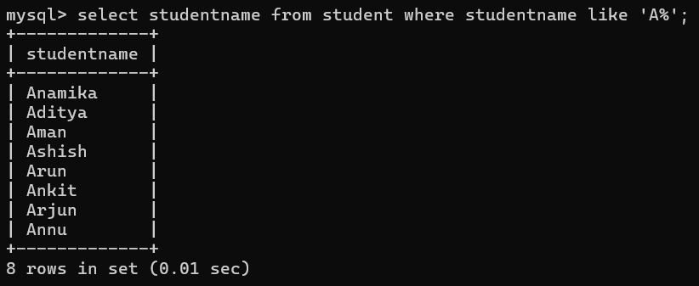

Q4. Retrieve students' details studying in courses ‘computer science’ or ‘chemistry’.

**Query:**

select * from student where course in ('BSC(H)CHEM', 'BSC(H)CS');

**Output:**

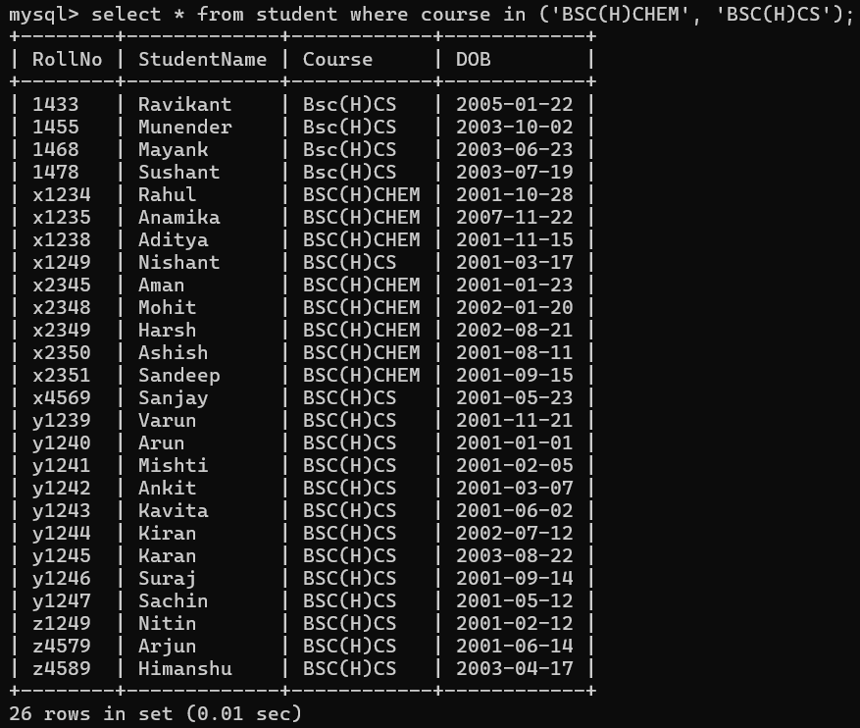

Q5. Retrieve students’ names whose roll no either starts with ‘X’ or ‘Z’ and ends with ‘9’

**Query:**

select studentname from student where rollno like 'X%9' or rollno like 'Z%9';

**Output:**

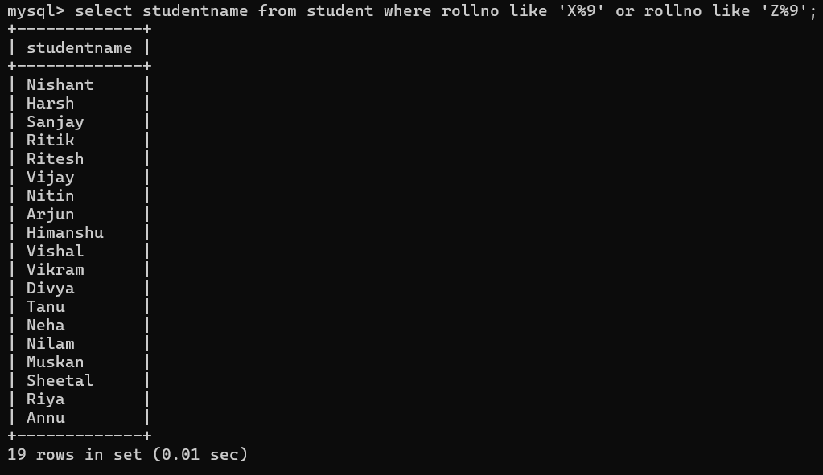

Q6. Find society details with more than N TotalSeats where N is to be input by the user

**Query:**

select * from society TotalSeats > 19;

**Output:**

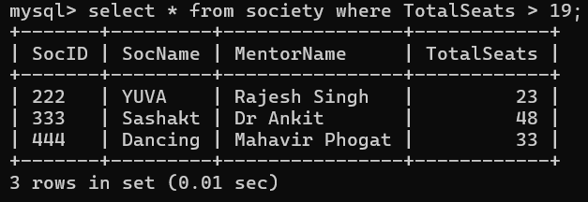

Q7. Update society table for mentor name of a specific society

**Query:**

update society

set MentorName = 'Rohit Sharma'

where SocName = 'Dancing';

**Output:**

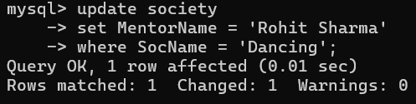

Q8. Find society names in which more than five students have enrolled.

**Query:**

select SocName

from SOCIETY s

inner join ENROLLMENT e on s.SocID = e.SID

group by SocName

having count(*) > 5;

**Output:**

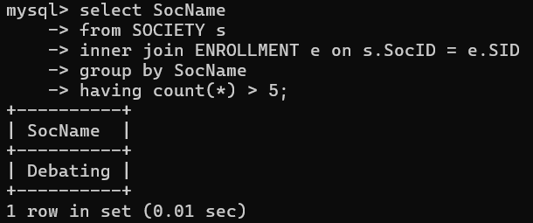

Q9. Find the name of the youngest student enrolled in society 'NSS'.

**Query:**

select StudentName, DOB

from student s

inner join ENROLLMENT e on s.RollNo = e.RollNo

where e.SID = '111'

order by DOB DESC

limit 1;

**Output:**

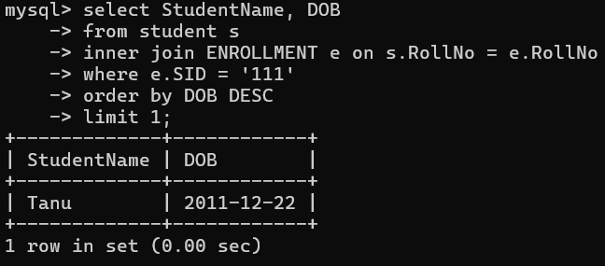

Q10. Find the name of most popular society (on the basis of enrolled students)

**Query:**

select SocName

from society s

inner join ENROLLMENT e on s.SocID = e.SID

group by SocName

order by count(*) DESC

limit 1;

**Output:**

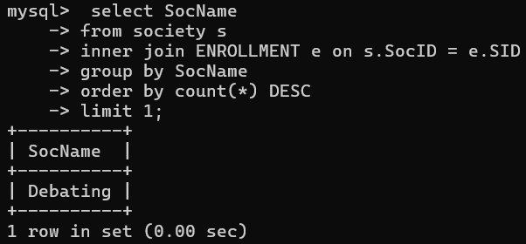

Q11. Find the name of two least popular societies (on the basis of enrolled students)

**Query:**

select SocName

from society s

inner join ENROLLMENT e on s.SocID = e.SID

group by SocName

order by count(*) ASC

limit 2;

**Output:**

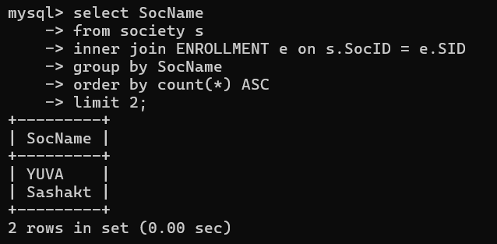

Q12. Find the student names who are not enrolled in any society

**Query:**

select StudentName

from STUDENT s

left join ENROLLMENT e on s.RollNo = e.RollNo

where e.SID is null;

**Output:  
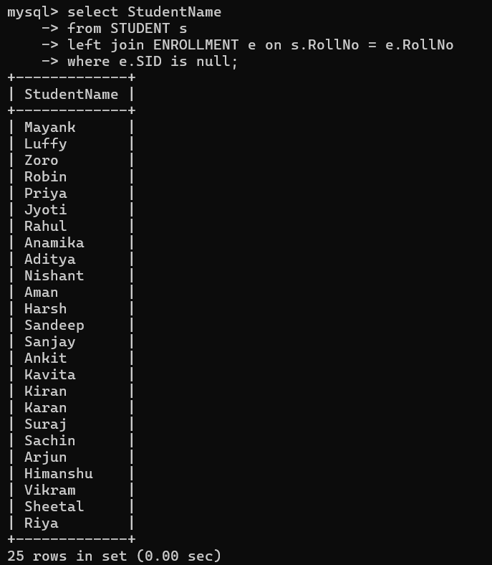**

Q13. Find the student names enrolled in at least two societies

**Query:**

SELECT StudentName

FROM STUDENT s

INNER JOIN ENROLLMENT e1 ON s.RollNo = e1.RollNo

INNER JOIN ENROLLMENT e2 ON s.RollNo = e2.RollNo

WHERE e1.SID <> e2.SID

GROUP BY StudentName

HAVING COUNT(*) >= 2;

**Output:**

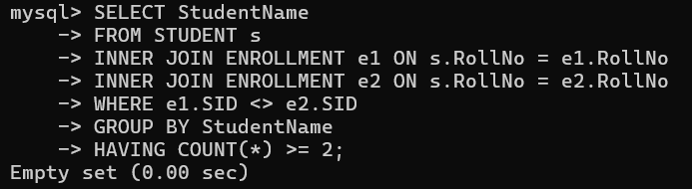

Q14. Find society names in which maximum students are enrolled

**Query:**

SELECT SocName, COUNT(*) AS TotalEnrolledStudents

FROM SOCIETY s

INNER JOIN ENROLLMENT e ON s.SocID = e.SID

GROUP BY SocName

ORDER BY TotalEnrolledStudents DESC

LIMIT 1;

**Output:**

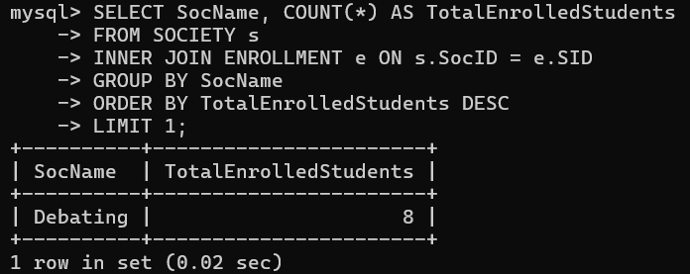

Q15. Find names of all students who have enrolled in any society and society names in which at least one student has enrolled

**Query:**

SELECT StudentName, SocName

FROM STUDENT s

INNER JOIN ENROLLMENT e ON s.RollNo = e.RollNo

INNER JOIN SOCIETY soc ON e.SID = soc.SocID;

**Output:**

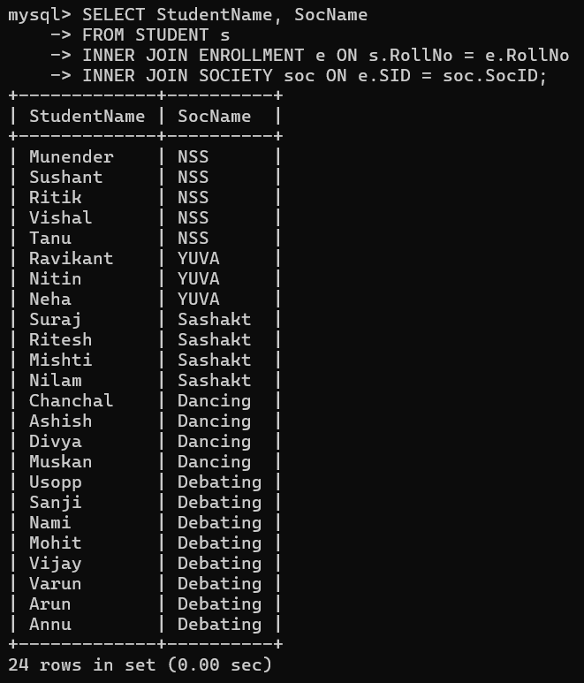

Q16. Find names of students who are enrolled in any of the three societies ‘Debating’, ‘Dancing’and ‘Sashakt’

**Query:**

SELECT StudentName

FROM student s

JOIN ENROLLMENT e ON s.RollNo = e.RollNo

WHERE e.SID IN ('333', '444', '555');

**Output:**

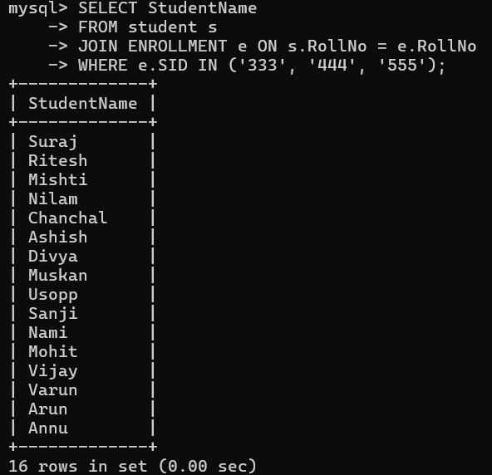

Q17. Find society names such that its mentor has a name with ‘Gupta’ in it.

**Query:**

SELECT SocName, MentorName

FROM SOCIETY

WHERE MentorName LIKE '%Gupta%';

**Output:**

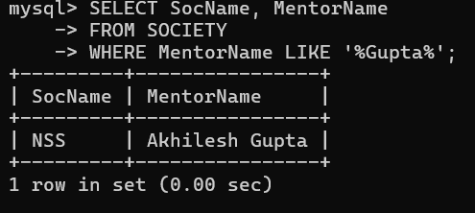

Q18. Find the society names in which the number of enrolled students is only 10% of its capacity.

**Query:**

SELECT SocName, MAX(TotalSeats) AS TotalSeats, COUNT(*) AS EnrolledStudents

FROM SOCIETY s

INNER JOIN ENROLLMENT e ON s.SocID = e.SID

GROUP BY SocName

HAVING COUNT(*) = 0.1 * MAX(TotalSeats);

**Output:**

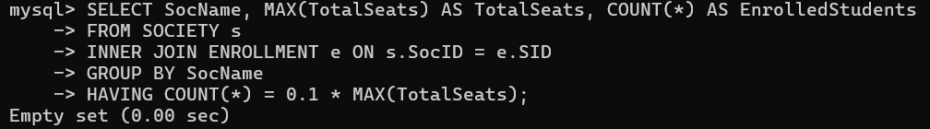

Q19. Display the vacant seats for each society.

**Query:**

SELECT SocName, MAX(TotalSeats) AS TotalSeats, COUNT(*) AS EnrolledStudents, MAX(TotalSeats) - COUNT(*) AS VacantSeats

FROM SOCIETY s

LEFT JOIN ENROLLMENT e ON s.SocID = e.SID

GROUP BY SocName;

**Output:**

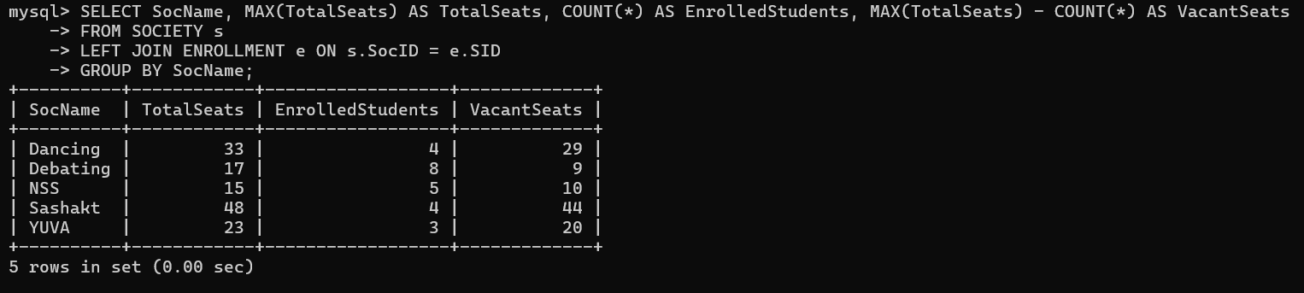

Q20. Increment Total Seats of each society by 10%

**Query:**

UPDATE SOCIETY

SET TotalSeats = TotalSeats * 1.1;

**Output:**

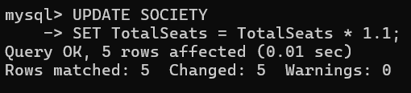

Q21. Add the enrollment fees paid (‘yes’/’No’) field in the enrollment table

**Query:**

ALTER TABLE ENROLLMENT

ADD EnrollmentFee VARCHAR(3) CHECK(EnrollmentFee IN ('yes', 'no'));

**Output:**

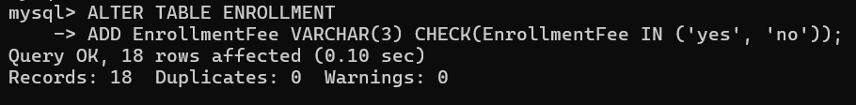

Q22. Update date of enrollment of society id ‘s1’ to ‘2018-01-15’, ‘s2’ to current date and ‘s3’ to ‘2018-01-02’.

**Query:**

UPDATE ENROLLMENT

SET DateOfEnrollment = '2018-01-15'

WHERE SID = 's1';

UPDATE ENROLLMENT

SET DateOfEnrollment = CURDATE()

WHERE SID = 's2';

UPDATE ENROLLMENT

SET DateOfEnrollment = '2018-01-02'

WHERE SID = 's3';

**Output:**

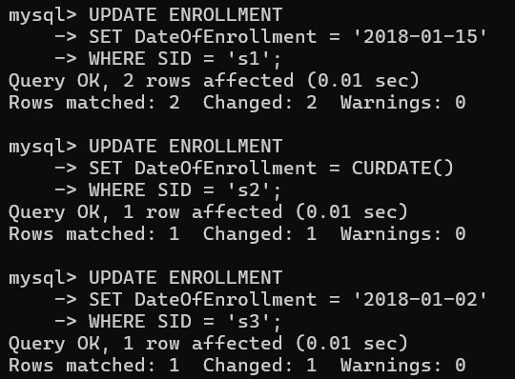

Q23. Create a view to keep track of society names with the total number of students enrolled in it.

**Query:**

CREATE VIEW SocietyEnrollmentView

AS

SELECT SocName, COUNT(*) AS TotalEnrolledStudents

FROM SOCIETY s

INNER JOIN ENROLLMENT e ON s.SocID = e.SID

GROUP BY SocName;

**Output:**

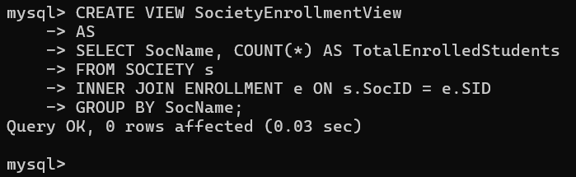

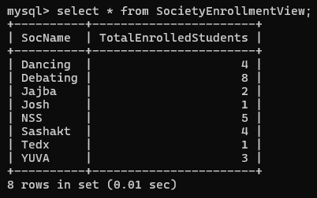

Q24. Find student names enrolled in all the societies.

**Query:**

SELECT StudentName

FROM STUDENT

WHERE RollNo IN (

SELECT RollNo

FROM ENROLLMENT

GROUP BY RollNo

HAVING COUNT(DISTINCT SID) = (SELECT COUNT(DISTINCT SID) FROM ENROLLMENT)

);

**Output:**

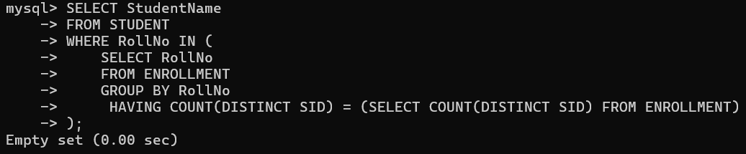

Q25. Count the number of societies with more than 5 students enrolled in it

**Query:**

SELECT COUNT(*) AS TotalSocieties

FROM (

SELECT s.SocID

FROM SOCIETY s

INNER JOIN ENROLLMENT e ON s.SocID = e.SID

GROUP BY s.SocID

HAVING COUNT(*) > 5

) AS SocietyCounts;

**Output:**

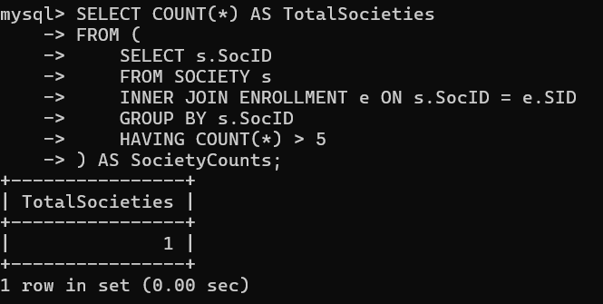

Q26. Add column Mobile number in student table with default value ‘9999999999

**Query:**

ALTER TABLE STUDENT

ADD MobileNumber VARCHAR(10) DEFAULT '9999999999';

**Output:**

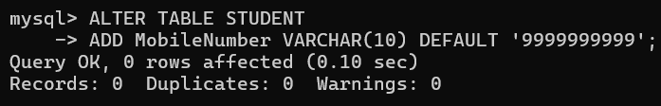

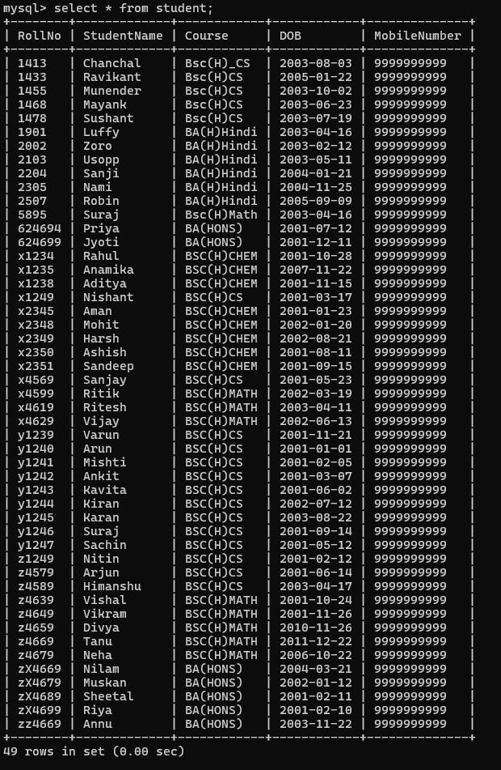

Q27. Find the total number of students whose age is > 20 years.

**Query:**  
SELECT COUNT(*) AS TotalStudentsGreater20

FROM STUDENT

WHERE YEAR(CURDATE()) - YEAR(DOB) > 20;

**Output:**

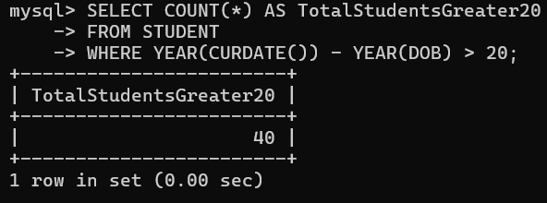

Q28. Find names of students who are born in 2001 and are enrolled in at least one society

**Query:**

SELECT StudentName

FROM STUDENT s

INNER JOIN ENROLLMENT e ON s.RollNo = e.RollNo

WHERE YEAR(DOB) = 2001;

**Output:**

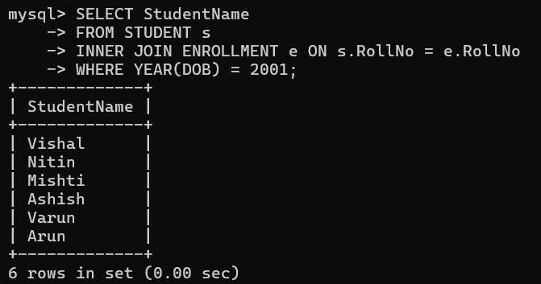

Q29. Count all societies whose name starts with ‘S’ and ends with ‘t’ and at least 5 students are enrolled in the society.

**Query:**

SELECT COUNT(*) AS TotalMatchingSocieties

FROM SOCIETY s

INNER JOIN ENROLLMENT e ON s.SocID = e.SID

WHERE SocName LIKE 'S%' AND SocName LIKE '%t'

GROUP BY SocName

HAVING COUNT(*) >= 5;

**Output:**

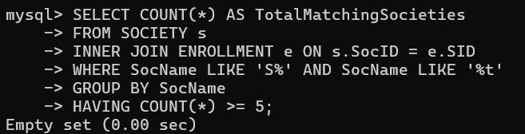

Q30. Display the following information:

Society name, Mentor name, Total Capacity, Total Enrolled ,Unfilled Seats

**Query:**

SELECT SocName, MentorName, MAX(TotalSeats) AS TotalSeats, COUNT(*) AS EnrolledStudents, MAX(TotalSeats) - COUNT(*) AS VacantSeats

FROM SOCIETY s

LEFT JOIN ENROLLMENT e ON s.SocID = e.SID

GROUP BY SocName, MentorName;

**Output:**

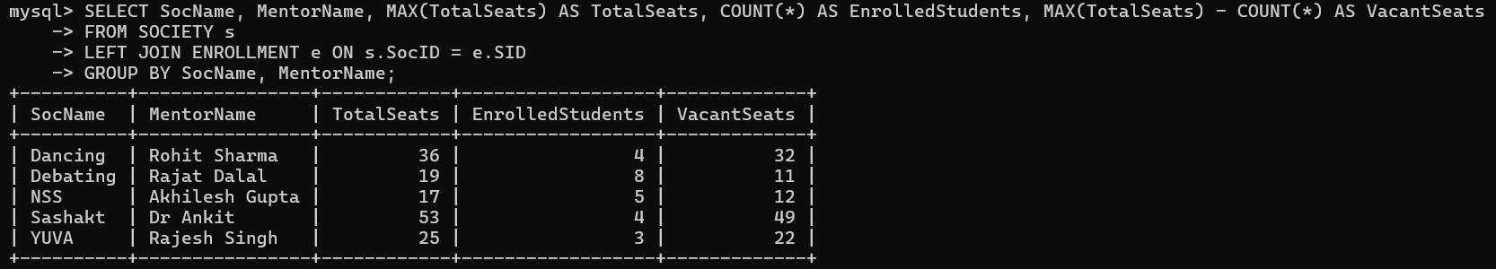

**II. Do the following database administration commands: create user, create role, grant privileges to a role, revoke privileges from a role, create index**

***Output:***



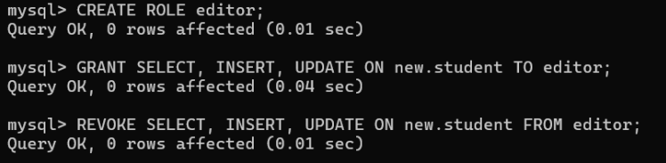



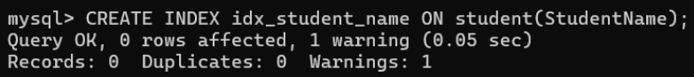

**III.** Execute queries given in part I through a high-level language using ODBC connection.

**CODE:**

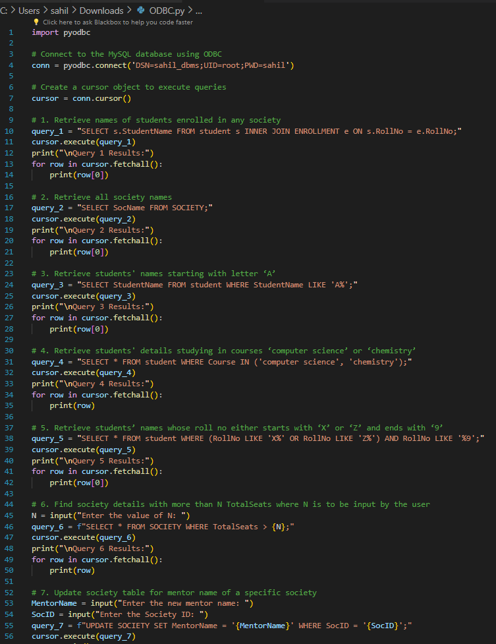

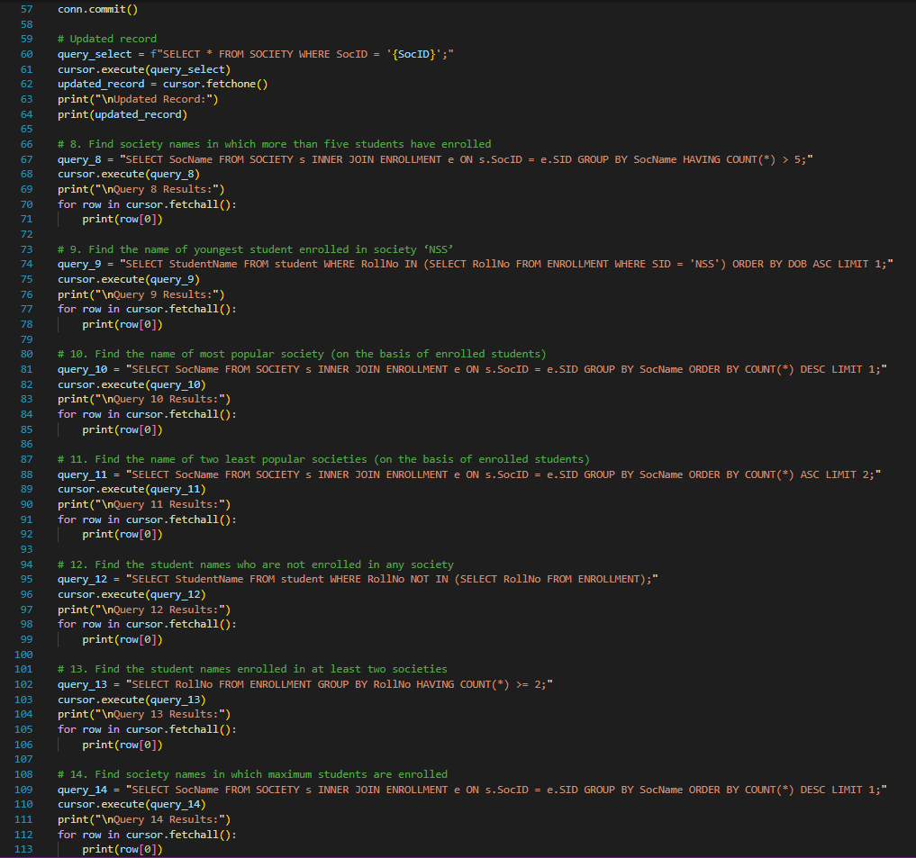

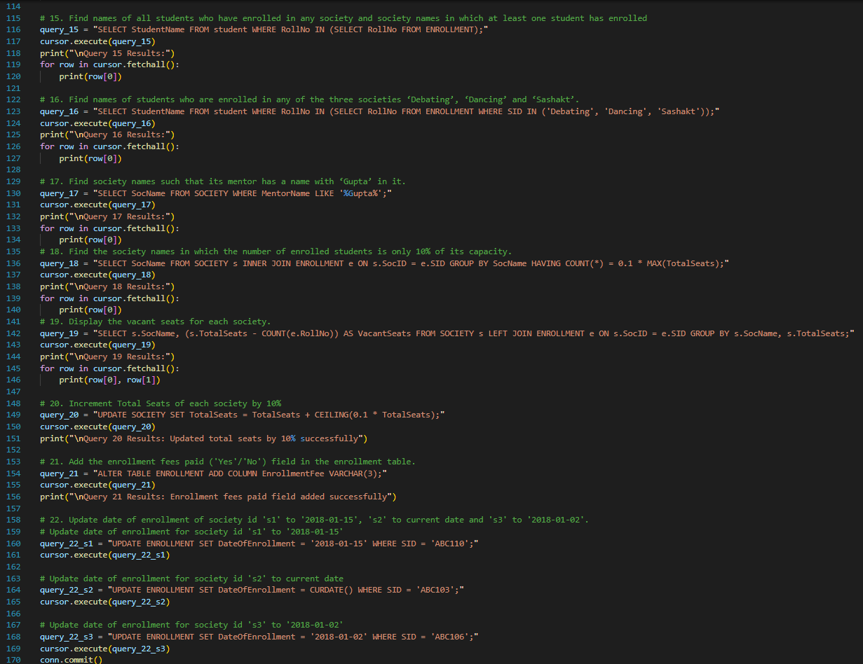

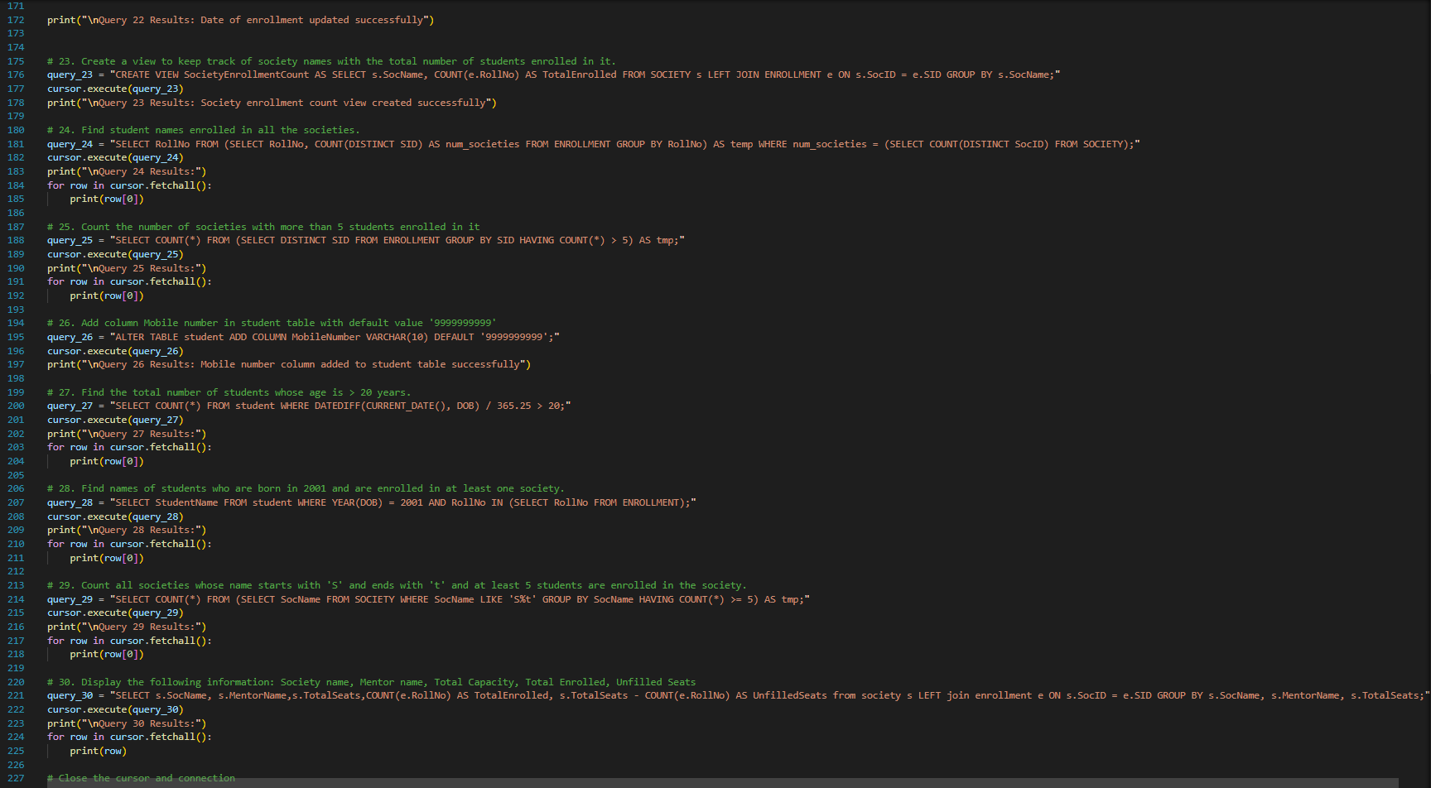



**Output:**

