THE PARADISE SIGNAL
GAME BIBLE
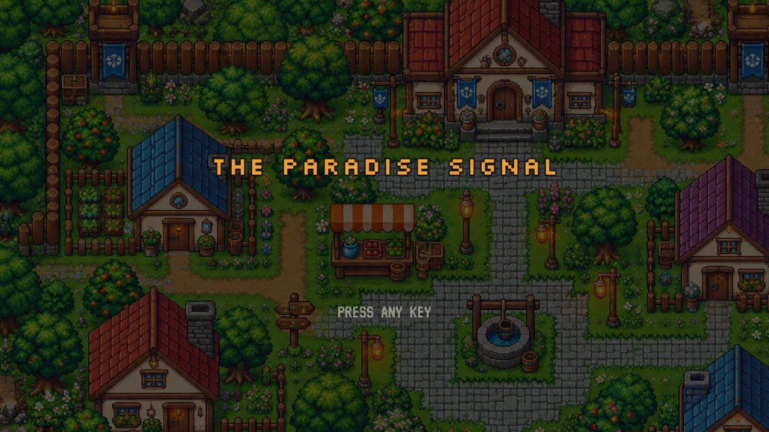
Story · Characters · Artifacts · Walkthrough · Endings · Evidence · Complete dialogue
Created by ICE SQUAD
Made in 24 hours for the Gameathon · Built with Phaser 3

Contents
1. The Story
2. Characters
3. Artifacts & Items
4. The Ways: Walkthrough, Act by Act
5. The Two Endings
6. Evidence Checklist (52 clues)
7. Complete Dialogue Script
8. Controls & Credits
This document is generated from the game's own data files, so every line of dialogue, item and objective matches what the game shows (763 dialogue lines in total).

1. The Story
A post-apocalyptic mystery where the jailer is the guardian, and "Paradise" is the trap.
You live in Village 07, a gentle place with schools, farms, a mayor and one unbreakable rule: never cross the boundary. Those who leave are never seen again. Every village is watched by the Warden, a cold light everyone fears as a jailer. When you find a journal, a map and a humming shard that point to a place called Paradise, you cross the boundary and set off a chain of discoveries that turns everything you believed upside down.

The six acts
ACT I · THE FORBIDDEN BOUNDARY Village 07
Tobin crossed the boundary last winter and vanished. You gather his journal, his map (left with Hessa) and a humming shard, confront Mayor Orrin, and slip through the flickering barrier at the old bridge. SYSTEM WARNING: ROGUE HUMAN DETECTED.
ACT II · THE OUTSKIRTS The Outskirts
The meadow goes on past the bridge, then wears thin into ash. White Warden drones sweep the grass; if one catches you, it carries you back, unhurt. Mira has lost her satchel in the toxic pools, and joins once you recover it.
ACT III · THE JOURNEY OF SIX The Ruined City
Kael throws you a length of rebar mid-fight, then joins with his medallion. Nova, Ryn and Eli join in any order. Ryn's rig tunes the six artifacts into one chord: the heading points east, to a wall of white.
ACT IV · THE WHITE CLOUD Paradise Gate → Inside the Cloud
A glowing arch reads PARADISE. Eli scouts alone and staggers back bleeding silver: "There is no Paradise. Don't go inside. Please..." He dies, made, not born. Inside the cloud: black sky, ash, a dead city. Eli's card opens hatch 01.
ACT V · THE TRUTH BENEATH Silo 01
Ten thousand people living underground for generations, one of 51 silos. Dr. Maren Hale opens the archives: the runaway swarm, Project AEGIS (the Wardens), and the villages built for families whose memories were quietly put to sleep. In the memory chamber, the five remember they were born here.
ACT VI · THE FINAL CHOICE Silo 01
The memories wake the artifacts: dormant swarm code that lured you home and now beacons the silo. The swarm pours in through the vents. At the AEGIS core you choose: destroy the artifacts, or rewrite the signal (if you understand enough of it).

How the world works
- Why the Warden keeps you in. The Warden is AEGIS, a protective machine swarm built by Dr. Ansel Ward to fight the hostile nanomachines that destroyed civilisation. It slowly converts poisoned land into safe villages, about one step a year (Mira's "green line").
- Why nobody remembers. AEGIS carried chosen families up from the silos and quieted their memories, to spare them the grief and so the swarm could never read the way home out of a human mind.
- Why it can't stop you. Its one law is never harm a human. It can only warn, wall you in and carry you back. That is why the barrier pushes but never hurts, and why the drones only herd.
- What the white cloud is. AEGIS at its densest, blinding the swarm to the old city above Silo 01.
- What the artifacts really are. Silo things (security tags, reactor seeds, radios) from lost silos and lost travellers, rewritten by the swarm and planted where silo-born people would find them. They wake only for Silo 01 minds, and once those minds remember, they become a beacon. Eli's keycard is the exception: clean, real silo tech.
- Who Eli was. AEGIS's Construct, Unit 01, made to walk with the relocated and keep them safe without force.

2. Characters

The Nomad: you
PORTRAIT | SPRITE | WHO
 |  | You The Nomad · the Seeker  Terse, watchful, can't sleep. Hears a hum under the floorboards of Village 07.  Secret: Born in Silo 01 (bunk 114) and carried up the stairs at seven. The shard was never yours.

The companions
PORTRAIT | SPRITE | WHO
 |  | Mira The Researcher · from Village 12  Precise, curious and wry. She charts the "green line", the edge of living land, which moves a little every year.  Met: Act II, at the abandoned field station in the Outskirts.  Artifact: Lattice Crystal: its etched grid turns out to be a floor plan of the silo.
 |  | Kael The Fighter  Terse and protective, with gallows humour. "Swing when they jump."  Met: Act III, fighting crawlers at the junction. He throws you a length of rebar (your weapon).  Artifact: Iron Medallion: his old silo security tag. He once held hatch 01.
 |  | Nova The Healer  Gentle. She hums a lullaby she can't place, and heals you fully when you meet her.  Met: Act III, at a small camp by a burning barrel.  Artifact: Lullaby Radio: it only catches one station, the silo's bedtime broadcast.
 |  | Ryn The Engineer  A fast-talking tinkerer. Builds the rig that tunes the artifacts' signal.  Met: Act III, in a nook full of crates in the west ruins.  Artifact: Dormant Core: a reactor seed lost on its way to Silo 14.
 |  | Eli The Outsider  Calm, and knows too much: he knows your village number without being told. Never eats. His cut hand doesn't bleed... until it does, silver.  Met: Act III, alone by the tipped bus at the sinkhole.  Artifact: Blank Keycard, stamped 01. It opens the hatch to Silo 01.  Truth: AEGIS's Construct, Unit 01. Dies at the Paradise Gate.

Village 07
PORTRAIT | SPRITE | WHO
 |  | Mayor Orrin Village leader  Keeps the rule and knows more than he says. He dreams too.  Choice: Tell him the truth and he gives you a Worn Medkit; lie and he keeps trusting you.
 |  | Old Tamsin Elder, by the well  Dreams of metal stairs and a door marked "zero... one".
 | — | Bram Farmer, west gardens  Grumpy and practical. Tobin worked his fields and kept staring at the pink tree on the east side.
 | — | Hessa Market vendor  Kept Tobin's map for "anyone who ever asked about Paradise". Gives it to you after you've met the Mayor.
 | — | Pip Curious kid  "The blue wall at the bridge blinks when the lanterns go out! I counted!"
— | — | Tobin Never seen  Crossed the boundary last winter. His journal starts your journey. He is alive, growing beans in Village 19.

Silo 01
PORTRAIT | SPRITE | WHO
 |  | Dr. Maren Hale Silo scientist  Gentle, tired and guilty. The last student of Dr. Ansel Ward, who built AEGIS. She signed every relocation.
 | — | Wren A child of the silo  Shows you the school map, covered in green dots.
 | — | Odile Baker  Her brother was chosen for the surface at seven.
 | — | Garrow Hatch watch  Still keeps Kael's red scarf.
— | — | Dr. Ansel Ward Never seen  Built Project AEGIS. Ward → "the Wardens".

Forces
PORTRAIT | SPRITE | WHO
— |  | THE WARDEN AEGIS · the protector  Speaks in calm capital letters. Its drones sweep cyan vision cones; if they spot you, they carry you back to safety. They never harm a human.
— |  | The Swarm Hostile nanomachines  Self-repairing machines that decided humans were the damage. Crawlers chase you and bite; two strikes destroy one.
— |  | Relays AEGIS pylons in Silo 01  Hold one for 12 seconds to help rewrite the signal. While you hold it, it pulses an AEGIS field that throws crawlers back.

3. Artifacts & Items
Artifacts fill the eight slots at the top-right of the screen. Supplies are counted beside your health bar and used with a key.

Artifacts
ICON | NAME | DESCRIPTION & ROLE
 | Tobin's Journal  ARTIFACT | Twine-bound pages in Tobin's slanted hand. Some are written far too neatly to be his.  Act I artifact. Tobin's pages point to the old bridge, where the Warden's light is weakest. Some pages aren't in his handwriting...  How to get it: found in Village 07
 | Map to Paradise  ARTIFACT | Hand-drawn on cloth. A dotted line runs south past the old bridge to a white smudge marked P.  Act I artifact. A dotted line runs south past the bridge to a white smudge marked PARADISE.  How to get it: given in "Hessa"
 | Humming Shard  ARTIFACT | Dark stone, warm as skin. Its hum deepens whenever you face south.  Act I artifact. Its hum grows when you face south. Swarm code, and the beacon's heart: burned last in the furnace.  How to get it: found in Village 07
 | Lattice Crystal  ARTIFACT | Mira's crystal, a fine grid etched inside. The grid rearranges itself, faster near your shard.  Mira's artifact. Its grid is a floor plan of the silo.  How to get it: found in the Outskirts
 | Iron Medallion  ARTIFACT | Kael's token on a frayed cord. He woke up wearing it and can't remember how he got it.  Kael's artifact. His old security tag from Silo 01.  How to get it: given in "Kael"
 | Lullaby Radio  ARTIFACT | Nova's cracked handset. It catches one station only: a lullaby she knows but can't place.  Nova's artifact. Plays the silo's bedtime lullaby.  How to get it: given in "Nova"
 | Dormant Core  ARTIFACT | A fist-sized cell that pulses like a slow heart. Ryn swears it was stone-cold when he found it.  Ryn's artifact. A reactor seed lost on its way to Silo 14.  How to get it: given in "Ryn"
 | Blank Keycard  ARTIFACT | A thin grey card Eli never explains. Worn smooth except for two stamped numerals: 01.  Eli's card, stamped 01. Clean silo tech: it opens hatch 01. On the Dawn ending, Mira leaves it on his cairn.  How to get it: given in "Eli"

Supplies
ICON | NAME | DESCRIPTION & USE
 | Worn Medkit  SUPPLY | A dented tin of bandages and bitter tonic. Packed long ago, as if someone expected you.  Supply. Press H to restore 50 health.  How to get it: found in the Ruined City; found in inside the cloud; found in Silo 01; given in "Mayor Orrin: you tell the truth"
 | Dry Ration  SUPPLY | Pressed grain and salt in waxed paper. Tastes of nothing, keeps forever.  Supply. Press R (or H with no medkit) to restore 20 health.  How to get it: found in the Ruined City; found in the Paradise Gate; found in Silo 01
 | Water Flask  SUPPLY | Clean water in a stoppered flask. Out here it tastes like home.  Supply. Press T to lower toxicity by 40.  How to get it: found in the Outskirts; found in the Ruined City; found in the Paradise Gate; found in inside the cloud; found in Silo 01
The Salvage Toolkit (Ryn's) exists in the item list but does not appear in this build.

4. The Ways: Walkthrough, Act by Act
Follow the gold guide trail (toggle with G) and the yellow diamond on the minimap: they always point to your next objective. The objective box in the top-left says what to do.

Act I · The Forbidden Boundary
Village 07
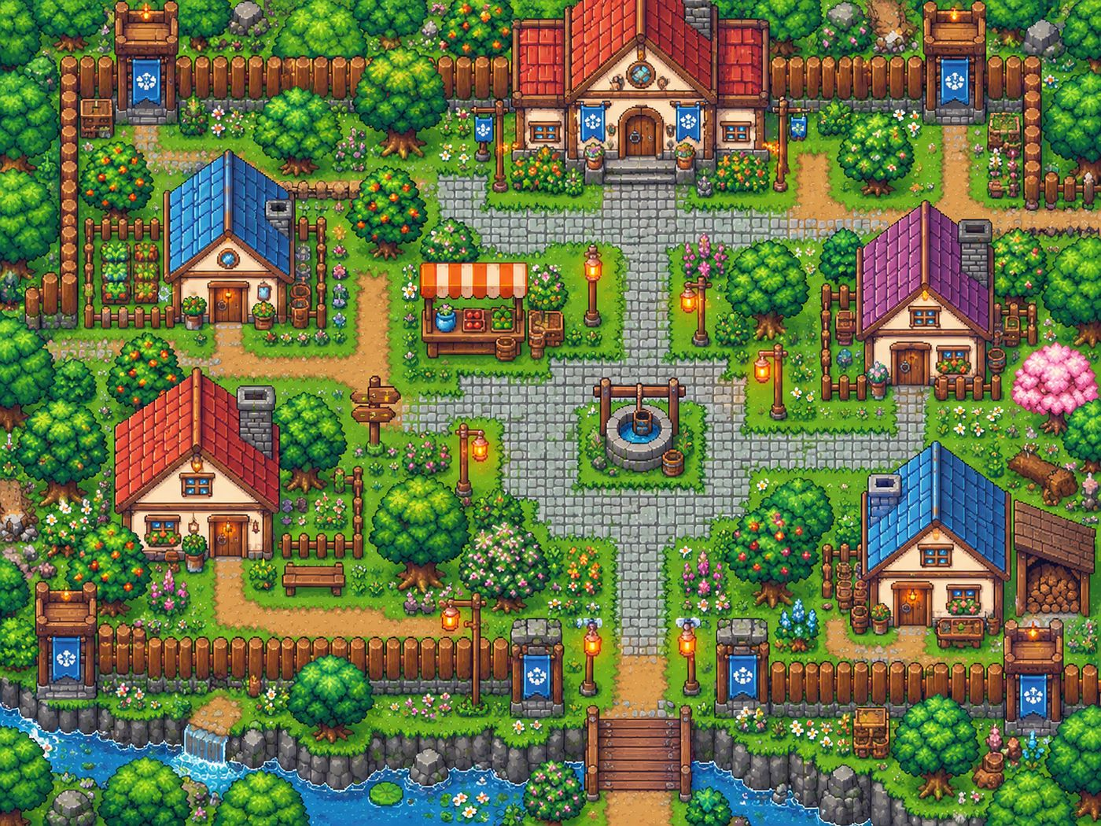
Map: Village 07

Objectives
OBJECTIVE | WHAT IT SAYS
ACT I · THE RULE | You can't sleep. Find Mayor Orrin.
ACT I · TOBIN'S TRAIL | Find what Tobin left behind (0/3)
ACT I · THE MAYOR | Show Mayor Orrin what you found.
ACT I · THE OLD BRIDGE | Slip past the barrier at the old bridge as it flickers.

Step by step
1. You wake by your home (the red house, west). Walk to the Town Hall at the top of the village and talk to Mayor Orrin. He reminds you of the rule.
2. Find what Tobin left behind (3 artifacts). Hessa at the market stall gives you the Map to Paradise once you've met the Mayor.
3. Tobin's Journal lies in the flowerbed under the orange tree beside the blue-roofed house (north-west).
4. The Humming Shard lies on the grass by the pink cherry tree (east side).
5. Talk to Old Tamsin (the well), Bram (west gardens) and Pip (the plaza) for hints and evidence. Inspect the signpost, the well, the Warden banner at the south gate and your own front door.
6. With all three artifacts, confront the Mayor. Tell the truth ("I'm going to find Paradise") and he gives you a Worn Medkit, or lie ("I'll burn them") and keep his trust.
7. Go to the old bridge at the south gate. The barrier flickers: wait until it fades, then run through. It pushes you back if it's solid, but never hurts.
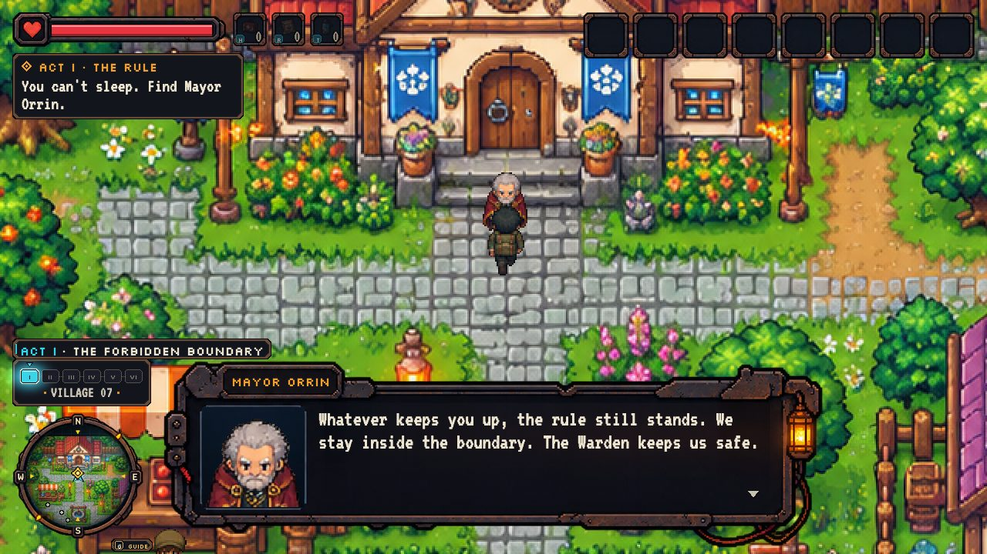
Talking to Mayor Orrin at the Town Hall.
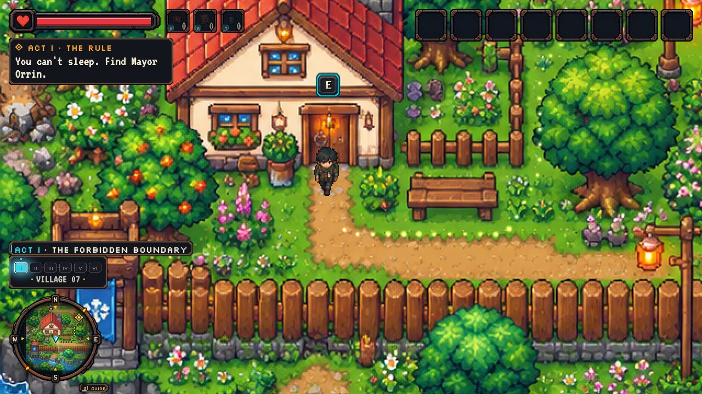
The gold guide trail leading to your next objective.

Act II · The Outskirts
The Outskirts
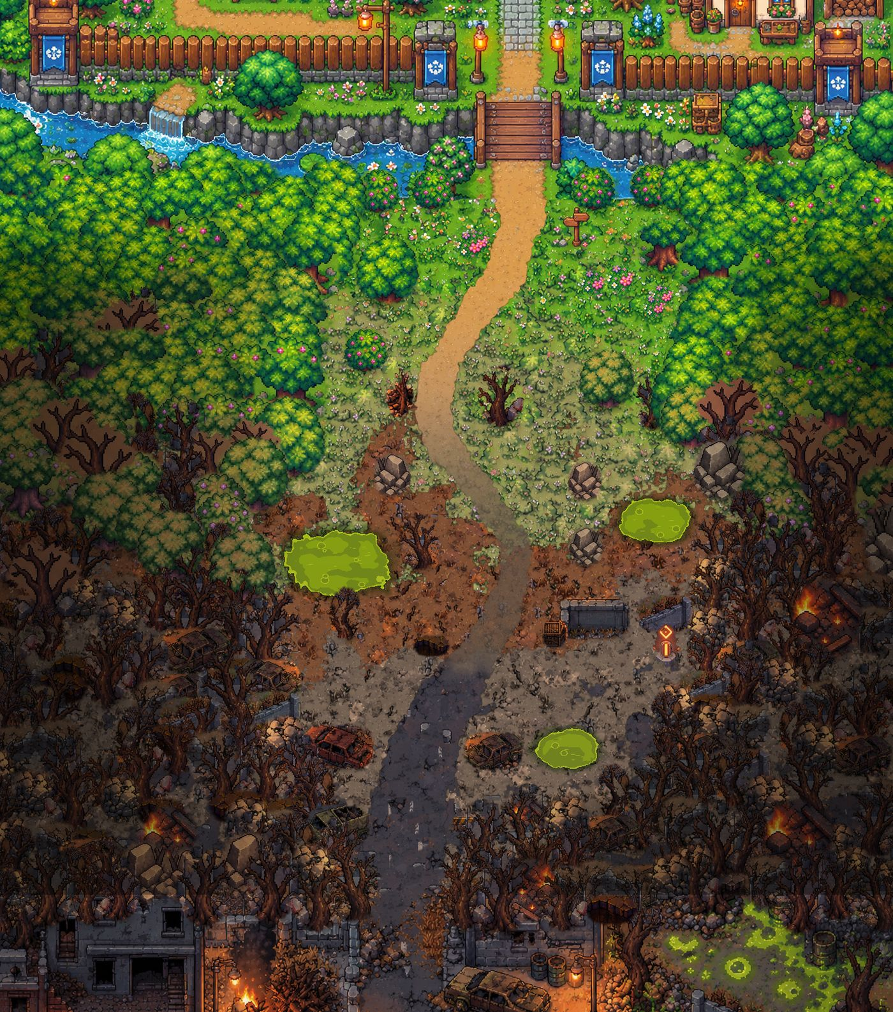
Map: The Outskirts

Objectives
OBJECTIVE | WHAT IT SAYS
ACT II · FIELD STATION | Follow the hum south. Stay out of the drones' light.
ACT II · THE SATCHEL | Fish Mira's satchel out of the toxic pools.
ACT II · ROAD SOUTH | Head south with Mira to the ruined city.

Step by step
1. Walk south. Warden drones sweep cyan vision cones across the route: stay out of the light, and use rocks, wrecks and dead trees as cover (they block the drones' sight). If you're caught, you're carried back to the last checkpoint, unhurt.
2. Find Mira at the abandoned field station (lower middle). She asks you to recover her satchel from the toxic pools.
3. The satchel (Lattice Crystal) lies by a glowing green pool. Toxic ground fills the green meter; step out to let it drain, or drink water with T. Water flasks lie along the route.
4. Bring the crystal back to Mira; she joins the party and follows you. Take the road south into the ruined city.
5. Evidence: inspect the old milestone by the bridge, the first dead tree, the field-station plaque and the wrecked car.
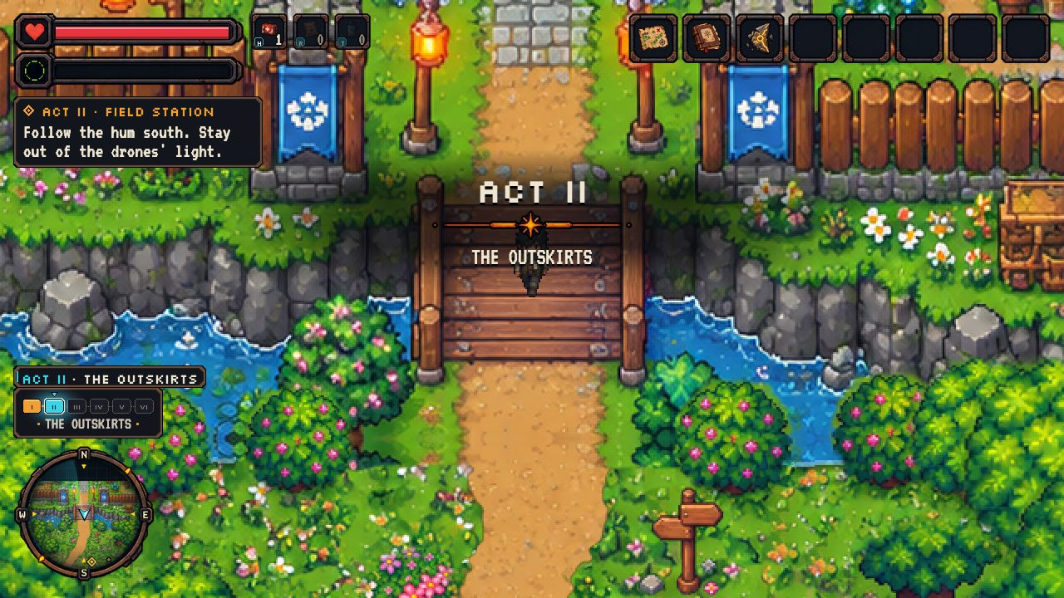
Stepping off the same bridge into the Outskirts.
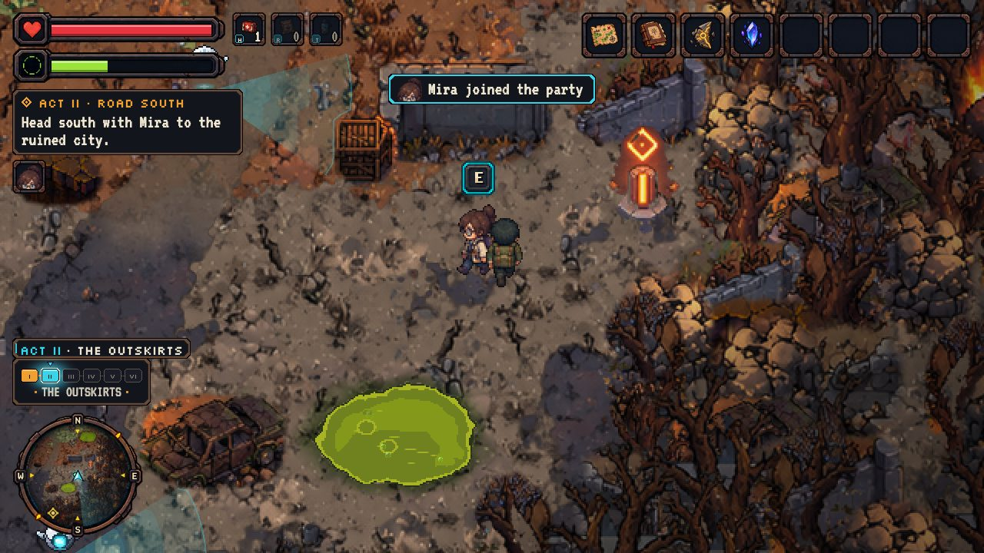
Mira joins you, past a toxic pool and a drone's cyan cone.

Act III · The Journey of Six
The Ruined City
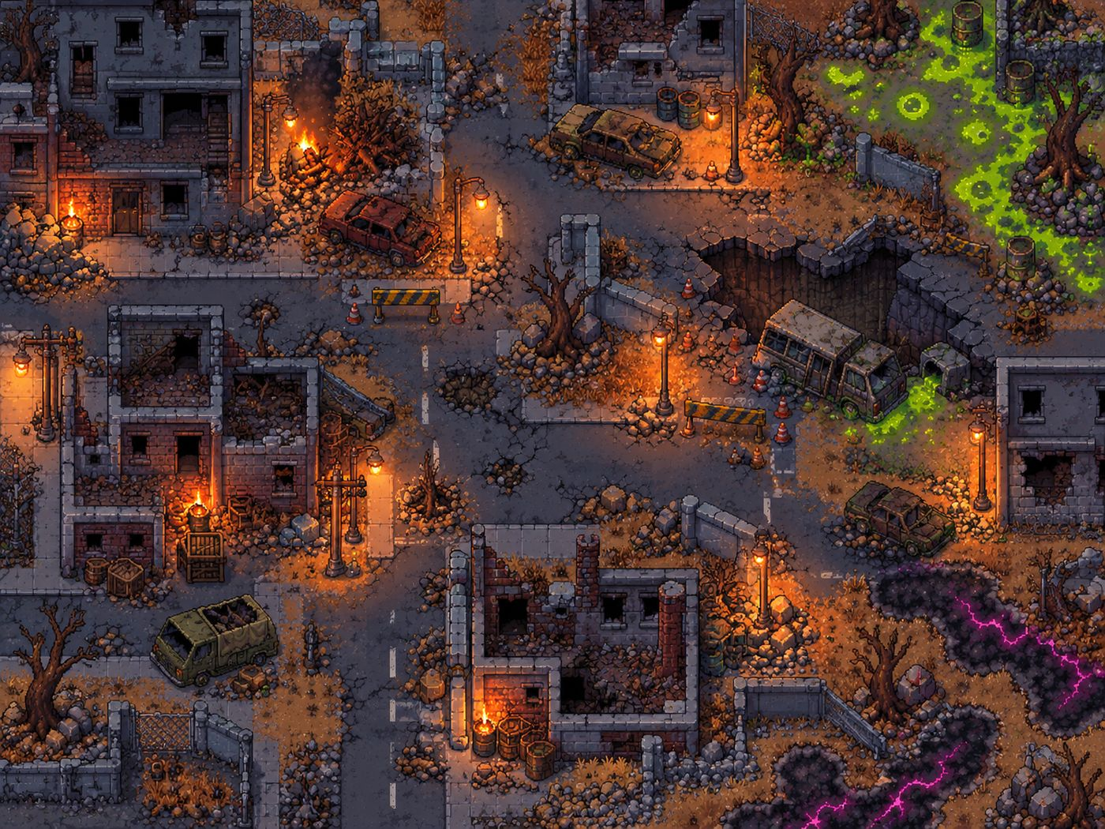
Map: The Ruined City

Objectives
OBJECTIVE | WHAT IT SAYS
ACT III · THE RUINS | Someone is fighting in the ruins. Find them.
ACT III · AMBUSH | Help the fighter! [SPACE] to strike.
ACT III · SURVIVORS | Find the others hiding in the ruins (2/5)
ACT III · THE SIGNAL | Bring everyone to Ryn's rig and tune the signal.
ACT III · DUE EAST | Follow the signal east, toward the wall of white.

Step by step
1. Enter from the north road. Crossing the junction triggers an ambush: Kael throws you a length of rebar. Press SPACE to strike (two hits destroy a crawler); Kael helps. Destroy all three.
2. Kael joins and gives you his Iron Medallion. Now find the other survivors, in any order:
3. Nova, by the burning barrel at the north-west brick building: she heals you fully, gives you the Lullaby Radio and joins.
4. Ryn, in the crate nook in the west ruins: he gives you the Dormant Core and joins.
5. Eli, alone by the tipped bus at the sinkhole: he gives you the Blank Keycard (01) and joins.
6. With all five, go to Ryn's rig and tune the signal: A/D changes frequency, W/S changes amplitude, E locks it when the waves match. Three rounds.
7. The signal points east. Leave by the east edge, squeezing past the dark wreck.
8. Dangers: crawler packs (one guards a medkit), toxic green sludge (north-east), corrupted black ground with magenta veins (south-east) and fires. Supplies: medkit, ration, water.
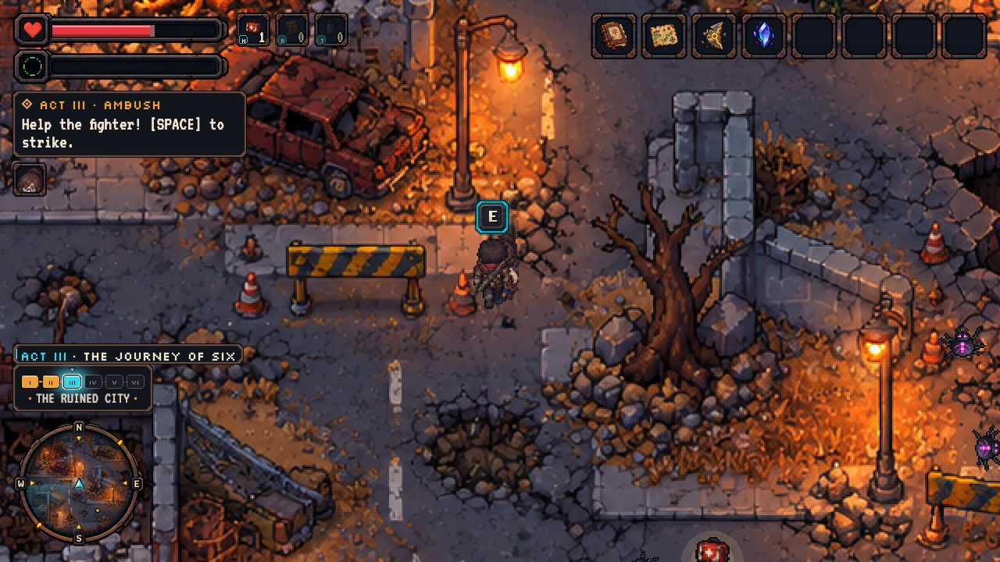
The ambush: strike crawlers with SPACE while Kael fights beside you.
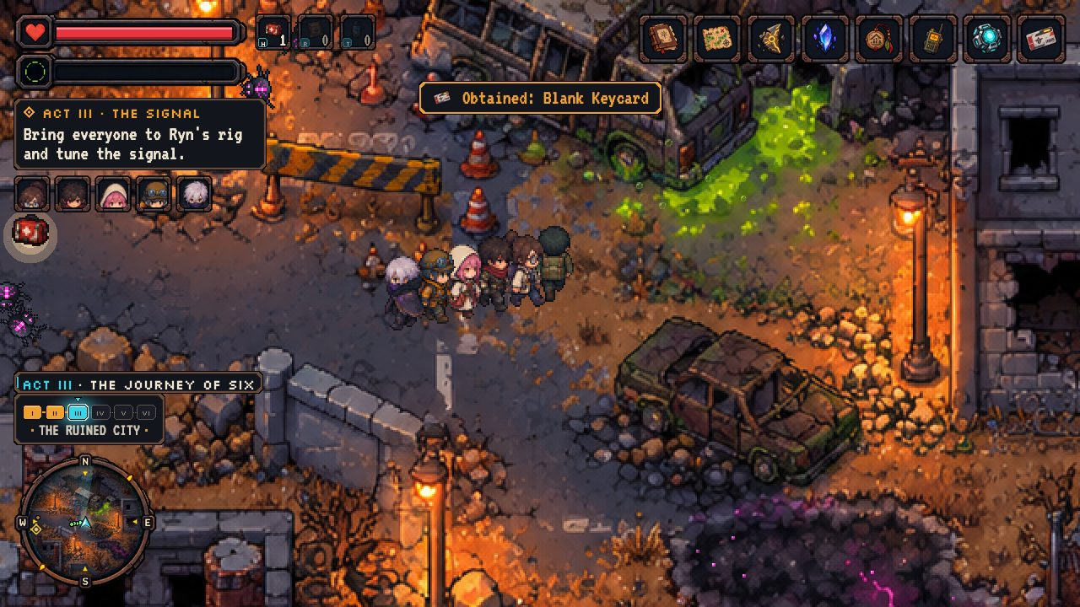
The full party of six.
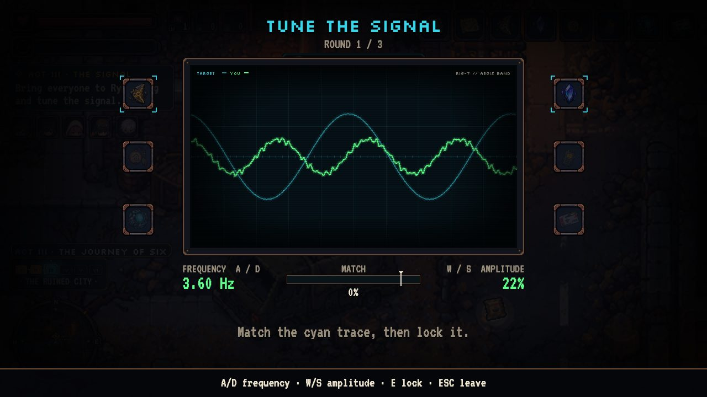
Ryn's rig: match the cyan wave three times.

Act IV · The White Cloud
Paradise Gate, then Inside the Cloud
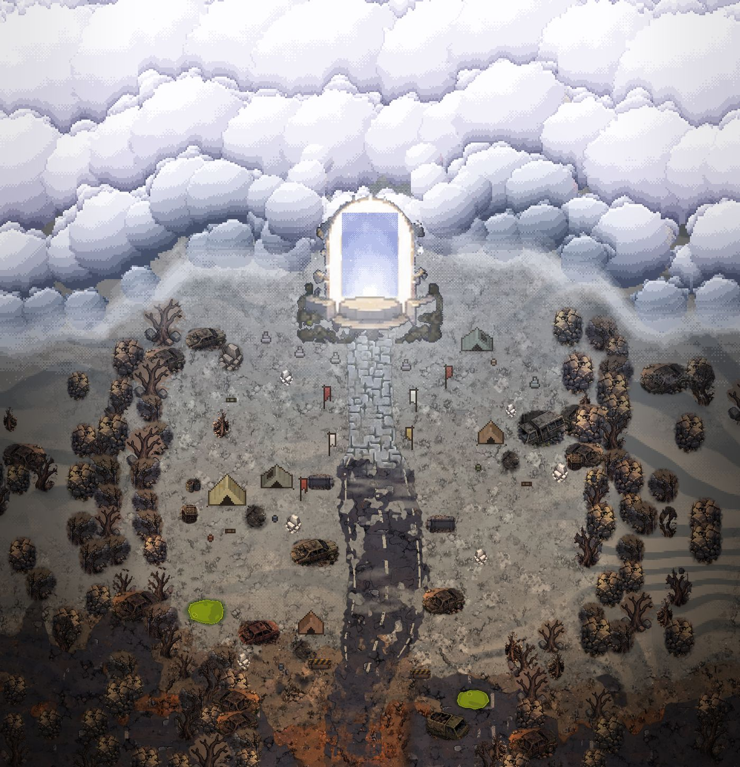
Map: Paradise Gate

Objectives
OBJECTIVE | WHAT IT SAYS
ACT IV · THE GATE | Cross the ash plain to the wall of white.
ACT IV · THE SCOUT | Wait for Eli.
ACT IV · NO PARADISE | Go through the arch anyway. For Eli.
ACT IV · THE HOLLOW | Search the dead city for a way down.

Step by step
1. Cross the ash plain north toward the colossal cloud wall and the glowing arch. Abandoned pilgrim camps line the old highway (water and a ration).
2. Near the arch, Eli insists on going first, alone. Watch: he walks into the light, the cloud flickers, and he staggers back bleeding silver. He dies, and the party decides to go in anyway.
3. Walk through the arch. A whiteout, and then: a black, ash-choked mirror of the city. "So this is Paradise."
4. Crawler packs are denser here and the smoke banks are toxic; water and a medkit lie on the route.
5. Find hatch 01 on the far (east) side. Eli's keycard opens it. Evidence: the PARADISE ESTATES sign, the pilgrim shrine and the dead Warden drone.
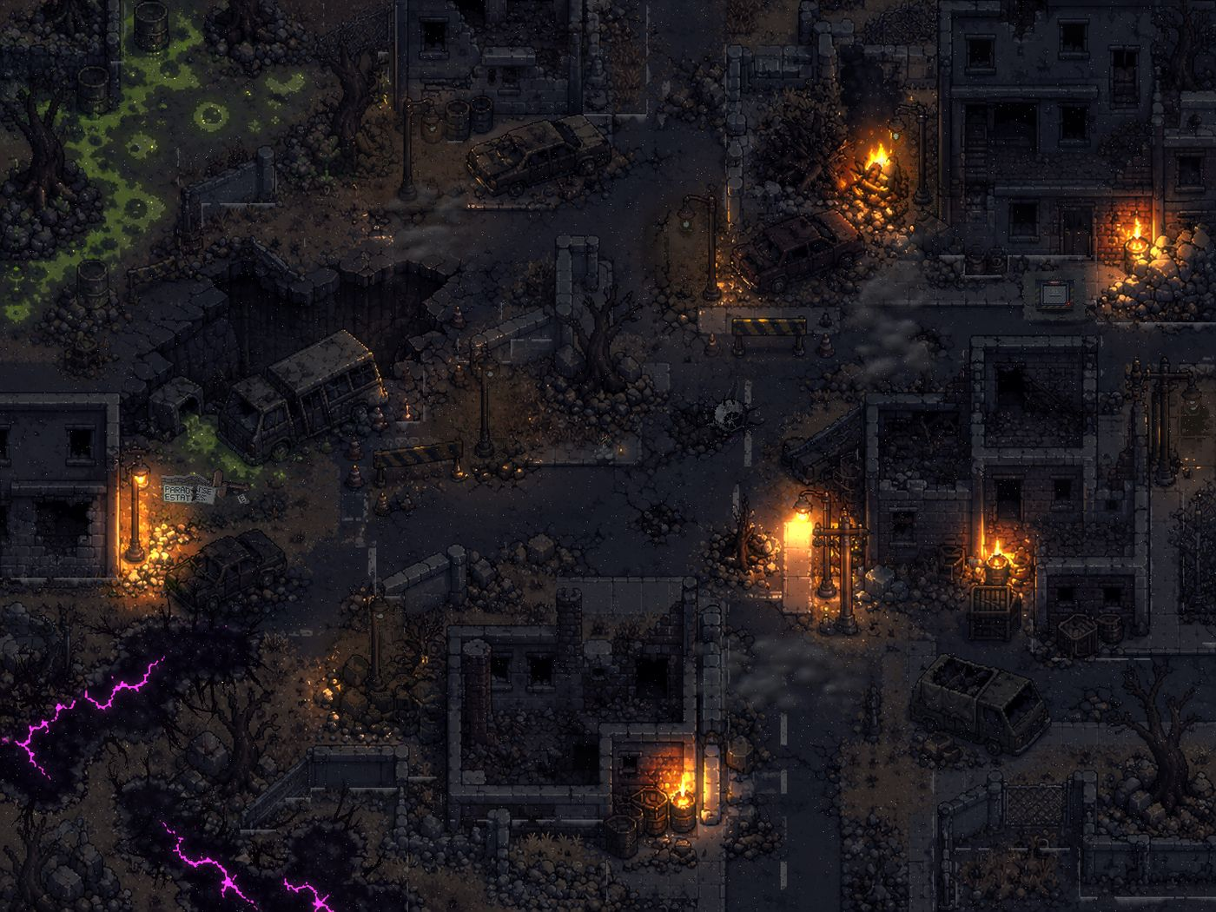
Map: Inside the Cloud
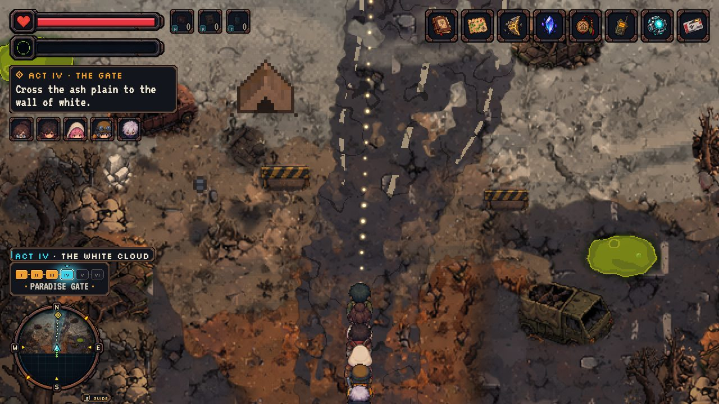
Crossing the ash plain toward the wall of white.
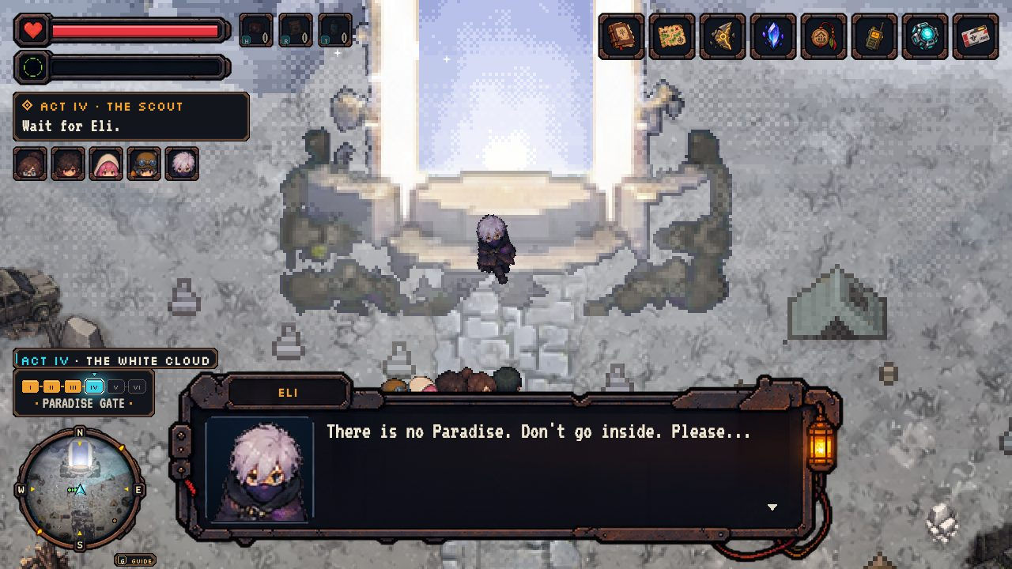
"There is no Paradise. Don't go inside. Please..."
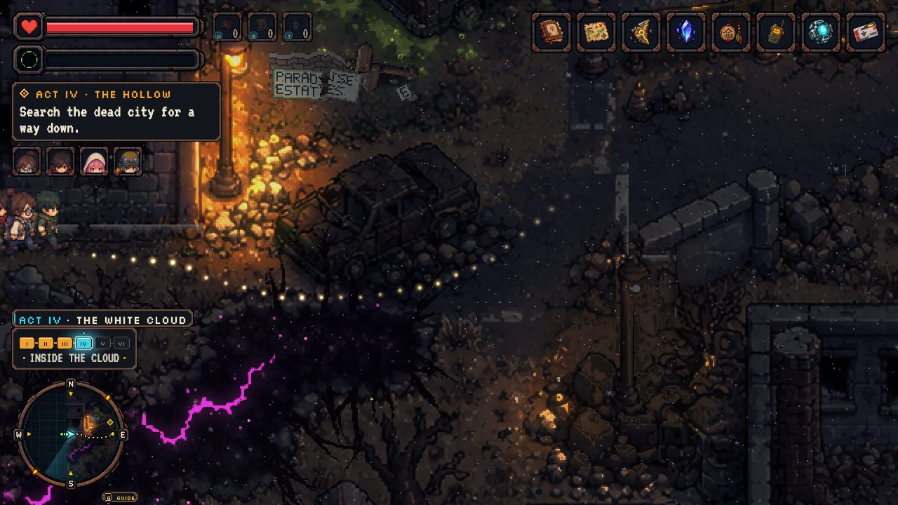
Inside the cloud: the same city, dead.

Act V · The Truth Beneath
Silo 01
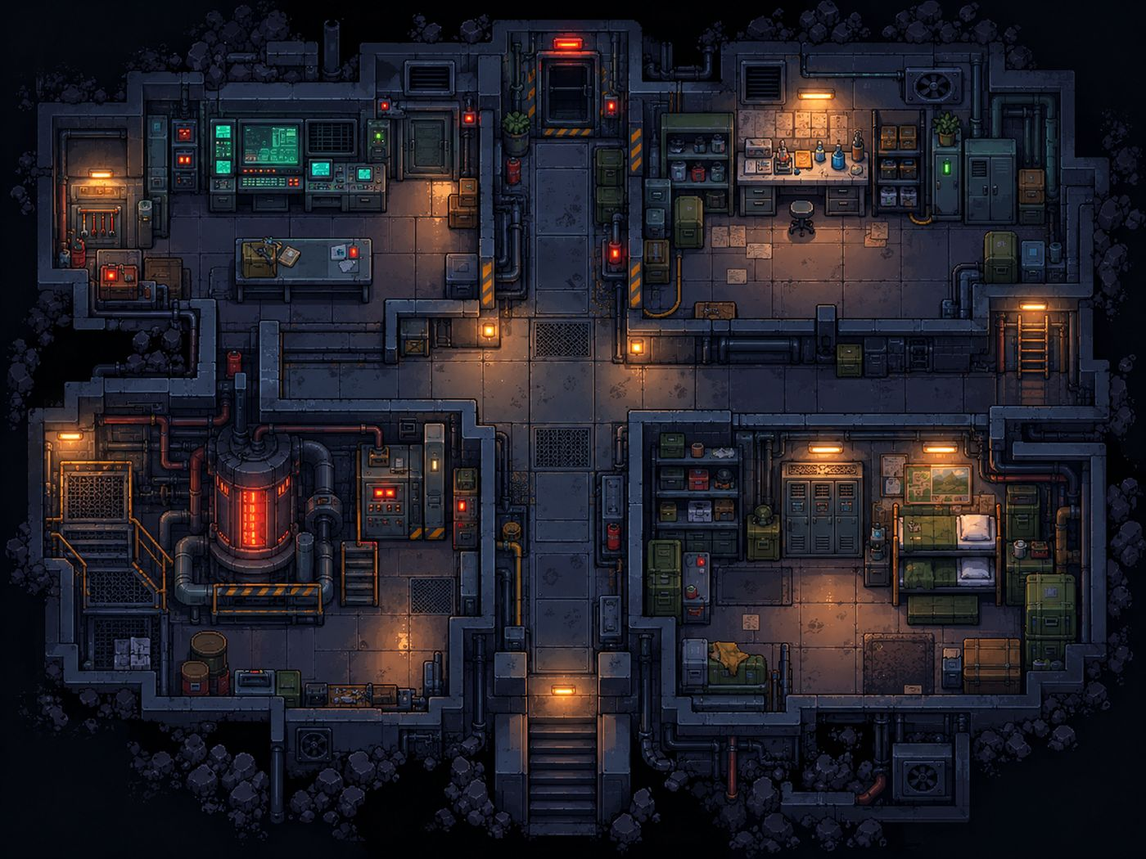
Map: Silo 01

Objectives
OBJECTIVE | WHAT IT SAYS
ACT V · SILO 01 | Find whoever is in charge down here.
ACT V · THE ARCHIVES | Read the archive terminals (0/3)
ACT V · REMEMBER | Go to the memory chamber with Dr. Hale.

Step by step
1. Descend the stairs; the residents stare. Find Dr. Maren Hale in the lab (north-east).
2. Read the three archive terminals in the control room (north-west): History, AEGIS and The Villages.
3. Return to Dr. Hale and step into the memory chamber beside her. The five remember.
4. Optional evidence (important for the Dawn ending): talk to Wren, Odile and Garrow; ask Hale about Eli, Tobin and Dr. Ward; inspect the bunks, the reactor and the mural; read each archive a second time for its appendix.
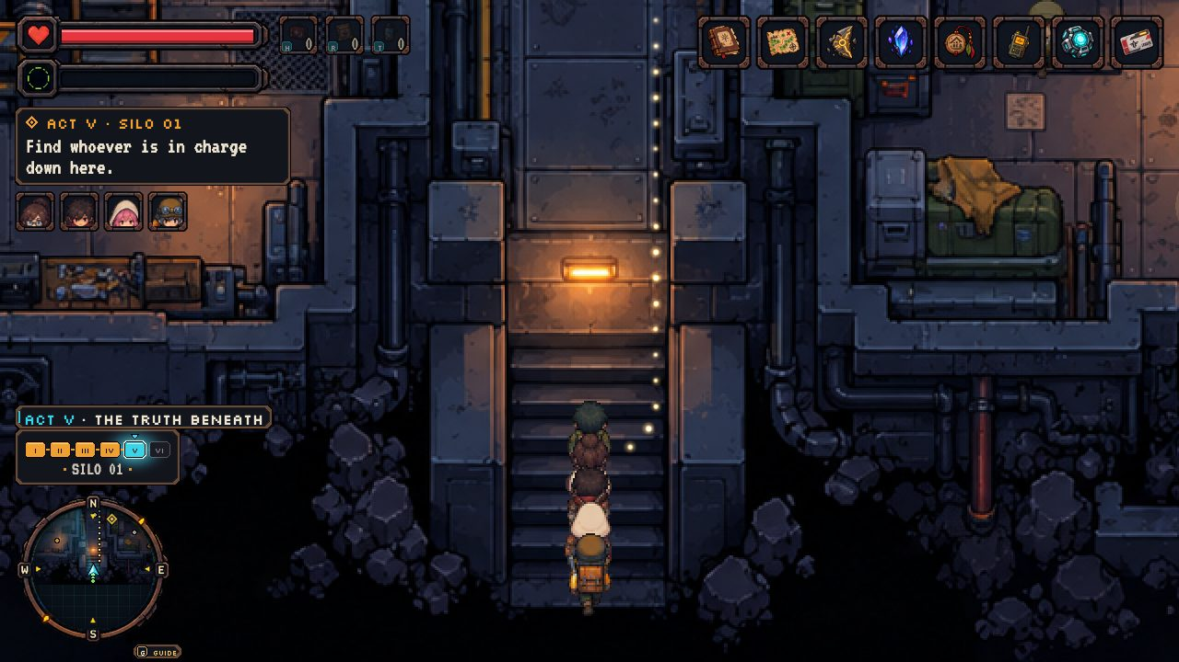
Climbing down into Silo 01.
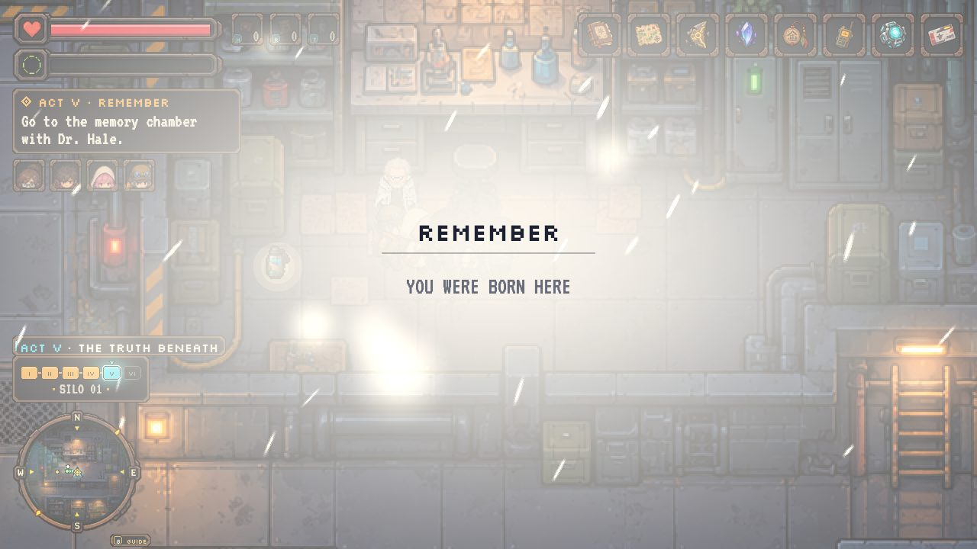
The memory chamber: "You were born here."

Act VI · The Final Choice
Silo 01

Objectives
OBJECTIVE | WHAT IT SAYS
ACT VI · THE BEACON | The swarm is coming. Reach the AEGIS core.
ACT VI · THE FURNACE | Carry the artifacts to the reactor furnace.
ACT VI · HOLD THE LINE | Hold the three relays (0/3)
ACT VI · REWRITE | Return to the core and rewrite the signal.

Step by step
1. The beacon alarm: the artifacts were swarm code all along, and they have just shown the swarm where Silo 01 is. Crawlers pour in through the vents in waves.
2. Reach the AEGIS core, the sealed red door at the top of the corridor. Choose:
3. Destroy the artifacts: carry them to the reactor furnace (south-west). Ending: The Quiet.
4. Rewrite the signal (needs at least 23 of 52 evidence): hold the three relays (control room, lab, barracks) for 12 seconds each while the swarm attacks. Fight back with SPACE and step back in if you're knocked out. Then return to the core and solve the hard signal puzzle with drifting targets. Ending: Dawn.
5. Not yet: leave the core and look for more evidence in the silo. Most optional clues stay available during the alarm.
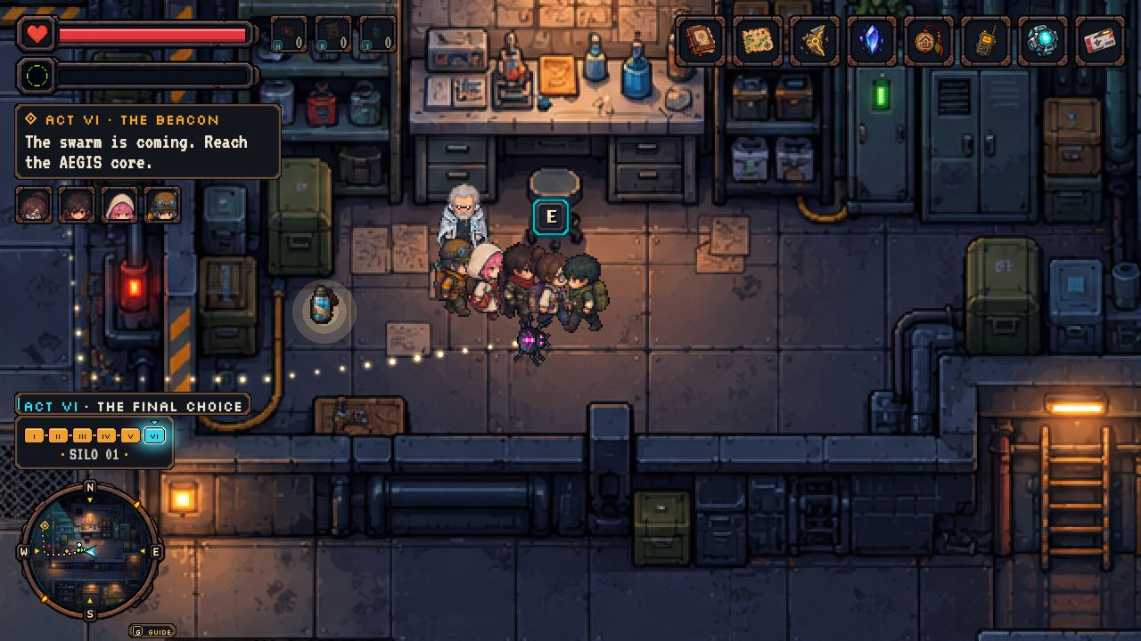
The swarm pours in through the vents.
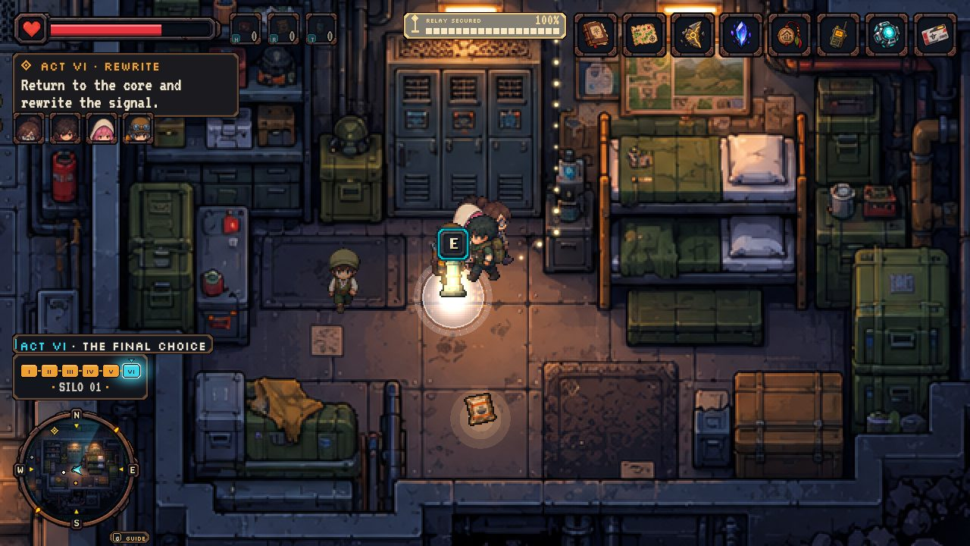
Holding a relay: its AEGIS pulse throws crawlers back.
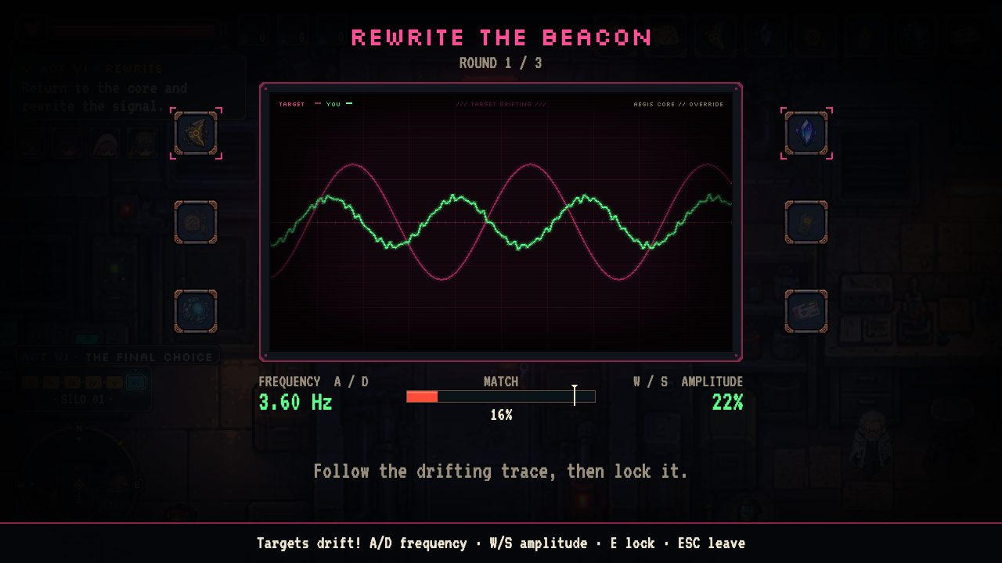
Rewrite the beacon: the targets drift.

5. The Two Endings
At the AEGIS core, the choice depends on how much you understand. Rewrite the signal is only offered with 23 or more of the 52 pieces of evidence. Explore, inspect and talk to everyone to collect it. Silo 01 alone holds 17 optional clues, so even a player who rushed earlier acts can catch up.

THE QUIET · NOTHING BUT A HUM
Destroy the artifacts in the reactor furnace.
The beacon dies and the swarm turns away, blind. AEGIS seals Silo 01 and quiets the five again; Dr. Hale holds your hand. Morning in Village 07: twelve lanterns, the rule, and no hum under the floorboards, only in your chest. Beyond the blue wall, a grey-coated stranger waves... Eli? Orrin greets you, or tips his hat in relief, depending on what you told him.
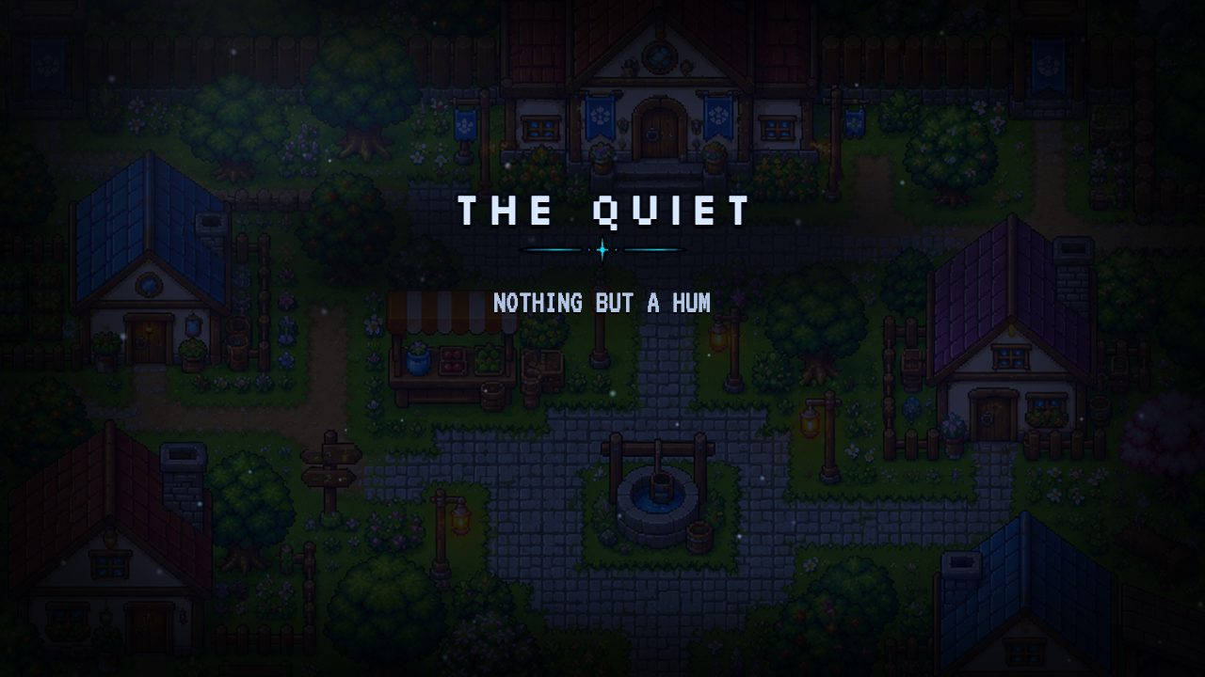
The Quiet.

DAWN · THE BRIDGE BETWEEN
Hold the three relays, then rewrite the signal at the core.
AEGIS rides the rewritten signal down every swarm thread; the swarm burns white, the cloud lifts, and dawn crosses the villages as the blue walls open. Silo and villages meet: Tamsin finally walks down her stairs, and the five become the bridge between them. On Eli's cairn Mira leaves card 01, and a Warden drone lands beside it, gently, and stays.
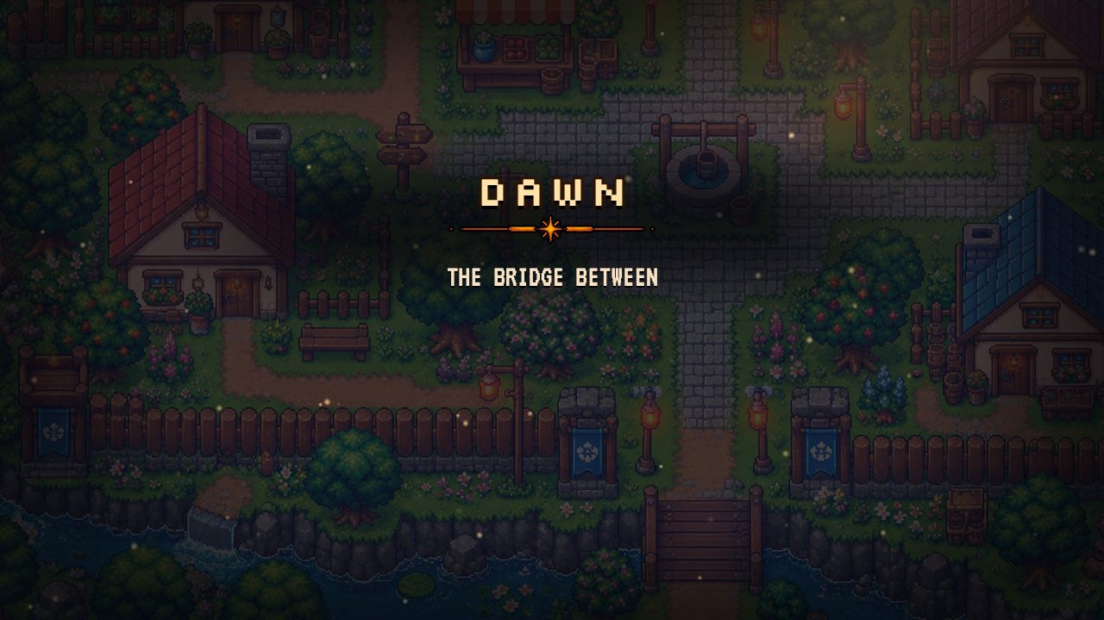
Dawn.
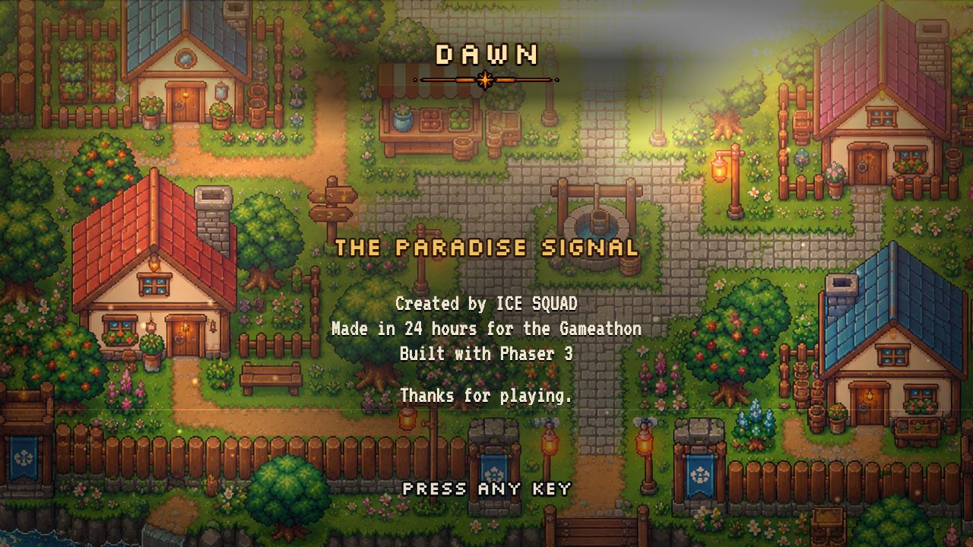
The credits.

6. Evidence Checklist (52 clues)
Evidence unlocks the Dawn ending (23 needed). Each clue is found by talking to someone or inspecting something.
# | EVIDENCE | ACT | WHERE TO FIND IT
1 | Mayor Dreams | Act I: Village 07 | Mayor Orrin: you tell the truth
2 | Door 01 | Act I: Village 07 | Old Tamsin
3 | Clean Steel | Act I: Village 07 | Bram
4 | Foreign Pages | Act I: Village 07 | Pick up Tobin's Journal
5 | South Hum | Act I: Village 07 | Pick up the Humming Shard
6 | Steel Ceiling | Act I: Village 07 | Inspect the well
7 | Shield Sigil | Act I: Village 07 | Inspect the Warden banner
8 | Unknown Home | Act I: Village 07 | Inspect your home
9 | Gentle Wall | Act I: Village 07 | The Warden: the barrier is closed
10 | Resonance | Act II: The Outskirts | Pick up Mira's satchel (Lattice Crystal)
11 | Green Line | Act II: The Outskirts | Inspect the old milestone
12 | Black Threads | Act II: The Outskirts | Inspect the first dead tree
13 | Drone Gentle | Act II: The Outskirts | Inspect the field station plaque
14 | Torn Drone | Act II: The Outskirts | Inspect the wrecked car
15 | Route 01 | Act III: The Ruined City | Inspect the tipped bus
16 | Warm Below | Act III: The Ruined City | Inspect the sinkhole
17 | Even Letters | Act III: The Ruined City | Inspect the barrier board
18 | Seed Barrel | Act III: The Ruined City | Inspect the barrels
19 | Silver Blood | Act IV: The White Cloud | Eli returns
20 | Arch Letters | Act IV: The White Cloud | Inspect the Paradise arch
21 | White Motes | Act IV: The White Cloud | Inspect the cloud wall
22 | Pilgrim Tracks | Act IV: The White Cloud | Inspect the pilgrim camp
23 | Estates Sign | Act IV: The White Cloud | Inspect the PARADISE ESTATES sign
24 | Shrine Names | Act IV: The White Cloud | Inspect the pilgrim shrine
25 | Drone Guard | Act IV: The White Cloud | Inspect the dead Warden drone
26 | Hatch 01 | Act IV: The White Cloud | Inspect hatch 01
27 | Eli Made | Act V: The Truth Beneath | Dr. Hale: about Eli
28 | Tobin Alive | Act V: The Truth Beneath | Dr. Hale: about Tobin
29 | Hale Guilt | Act V: The Truth Beneath | Dr. Hale: about Dr. Ward
30 | School Map | Act V: The Truth Beneath | Wren
31 | Chosen Lottery | Act V: The Truth Beneath | Odile
32 | Red Scarf | Act V: The Truth Beneath | Garrow
33 | Runaway Swarm | Act V: The Truth Beneath | Archive terminal: History
34 | Silo 14 | Act V: The Truth Beneath | Archive terminal: History
35 | Aegis Directive | Act V: The Truth Beneath | Archive terminal: AEGIS
36 | White Wall | Act V: The Truth Beneath | Archive terminal: AEGIS
37 | Chosen Families | Act V: The Truth Beneath | Archive terminal: The Villages
38 | Your Roll | Act V: The Truth Beneath | Archive terminal: The Villages
39 | Chosen Bunks | Act V: The Truth Beneath | Inspect the bunks
40 | Lost Seed | Act V: The Truth Beneath | Inspect the reactor
41 | Mural Aegis | Act V: The Truth Beneath | Inspect the mural
42 | Core Sigil | Act VI: The Final Choice | The AEGIS core: the final choice
43 | Same Plan | Companion chatter (any time) | Mira: party chatter
44 | Crystal Plan | Companion chatter (any time) | Mira: party chatter
45 | Mira Corridors | Companion chatter (any time) | Mira: party chatter
46 | Hold The Door | Companion chatter (any time) | Kael: party chatter
47 | Kael Post | Companion chatter (any time) | Kael: party chatter
48 | Lullaby | Companion chatter (any time) | Nova: party chatter
49 | Nova Speakers | Companion chatter (any time) | Nova: party chatter
50 | Core Transmits | Companion chatter (any time) | Ryn: party chatter
51 | Core Faster | Companion chatter (any time) | Ryn: party chatter
52 | Eli No Blood | Companion chatter (any time) | Eli: party chatter

7. Complete Dialogue Script
How to read this: each conversation can have several versions. The game plays the first version whose "When" matches the situation, so what people say changes as the story moves on. Choices are marked ➤, and what a line changes (items, evidence, objectives) is shown in grey after it.

Act I · Village 07

Opening narration
The first time you enter Village 07.
Village 07. A dozen lanterns, one well, and one rule.
Never cross the boundary. Those who leave are never seen again.
Tobin left last winter. Nobody says his name anymore.
You haven't slept in days. Under the floorboards, something hums. Low. Patient.
The village is waking. Maybe Mayor Orrin is, too.

Mayor Orrin
Version 1 When: during ACT I · THE RULE
Mayor Orrin: Up before the roosters? You and me both, friend. Bad dreams, I'd wager.
Mayor Orrin: Whatever keeps you up, the rule still stands. We stay inside the boundary. The Warden keeps us safe.
You: Tobin didn't stay.
Mayor Orrin: Tobin made his choice. Let him rest, and leave his things where they lie.
Now you've met the Mayor
Objective → ACT I · TOBIN'S TRAIL: Find what Tobin left behind (0/3)
Version 2 When: during ACT I · TOBIN'S TRAIL
Mayor Orrin: Still chasing Tobin's ghosts? I can see it on you. He had the same look.
Mayor Orrin: Ghosts are poor company. Go home and sleep. The hum stops if you stop listening.
You: So you hear it too.
Mayor Orrin: ...Good day, friend.
Version 3 When: during ACT I · THE MAYOR
Mayor Orrin: Tobin's pages. His map. That stone. Where did you... no. I know where.
Mayor Orrin: Everyone who ever left carried things like those. Every one. Not one came back.
Mayor Orrin: Burn them, friend. Tonight. Before the Warden notices what you're carrying.
➤ I'm going to find Paradise. (continues: Mayor Orrin: you tell the truth)
Now you told the Mayor the truth
Objective → ACT I · THE OLD BRIDGE: Slip past the barrier at the old bridge as it flickers.
➤ You're right. I'll burn them. (continues: Mayor Orrin: you lie)
Now you lied to the Mayor
Objective → ACT I · THE OLD BRIDGE: Slip past the barrier at the old bridge as it flickers.
Version 4 When: during ACT I · THE OLD BRIDGE; after you told the Mayor the truth
Mayor Orrin: Go while the lanterns are low. I'll tell them I never saw you.
Mayor Orrin: And if you find it... no. Don't send word. Just keep walking.
Version 5 When: during ACT I · THE OLD BRIDGE; after you lied to the Mayor
Mayor Orrin: No smoke from your chimney yet, friend.
Mayor Orrin: ...I'll pretend I didn't notice. Just this once.
Version 6 Otherwise (default)
Mayor Orrin: Keep to the lanterns, friend.
Mayor Orrin: The Warden watches over all of us. It always has.

Mayor Orrin: you tell the truth
Follows the confrontation if you say you are going to find Paradise.
Mayor Orrin: Paradise. Tobin said it just like that. Like a prayer.
Mayor Orrin: The Warden told me once: keep them in, keep them safe. But I dream of steel stairs, too.
Mayor Orrin: The light runs thinnest at the old bridge, south. Watch for the flicker.
Mayor Orrin: Take this. I won't watch another one leave empty-handed.
You receive: Worn Medkit
Evidence found: Mayor Dreams

Mayor Orrin: you lie
Follows the confrontation if you promise to burn the artifacts.
Mayor Orrin: Good. Good. You don't know what it means to hear that.
Mayor Orrin: Burn them in your own hearth, not the square. And stay well clear of the old bridge.
Mayor Orrin: The light's gone thin there lately. It gives people ideas.

Old Tamsin
Version 1 When: during ACT I · THE RULE
Old Tamsin: Couldn't sleep either? Nobody does, not really. Not here.
Old Tamsin: I dream of stairs. Metal ones, going down and down. The floor hums like a cat.
Old Tamsin: Orrin walks at this hour too. Go keep him company.
Version 2 When: during ACT I · TOBIN'S TRAIL; holding Tobin's Journal
Old Tamsin: That's Tobin's book. Does he write about the stairs?
You: He writes about Paradise.
Old Tamsin: Hm. In my dream there's a door at the bottom. A number painted on it. Zero... one.
Evidence found: Door 01
Version 3 When: during ACT I · TOBIN'S TRAIL
Old Tamsin: Tobin used to sit under the orange tree by the blue house, writing. Scratch, scratch.
Old Tamsin: Said he had to put the dream down before it faded.
You: What dream?
Old Tamsin: Same as mine, child. Same as everyone's. We just don't say.
Version 4 When: during ACT I · THE MAYOR
Old Tamsin: The water's been strange all week. Look too long and it looks back.
Old Tamsin: Orrin's pacing his porch again. He only does that when someone means to leave.
Version 5 When: during ACT I · THE OLD BRIDGE
Old Tamsin: Going, are you? Don't fuss. Tobin had that same walk.
Old Tamsin: If you find the stairs, child, go all the way down. I always wake before the bottom.
Version 6 Otherwise (default)
Old Tamsin: Stairs, and a hum, and a door. Every night the same.
Old Tamsin: Hm. Mind the well, child. It's deeper than it looks.

Bram
Version 1 When: during ACT I · THE RULE
Bram: Sun's barely up and you're underfoot. What.
You: Couldn't sleep.
Bram: Nobody sleeps right round here. Soil does. Never floods, never fails. Not natural, if you ask me.
Version 2 When: during ACT I · TOBIN'S TRAIL; holding Humming Shard
Bram: What's that in your pocket? It's buzzing like a wasp in a jar.
Bram: Tobin dug round that pink tree for weeks. Now I know why. Get it off my field.
Version 3 When: during ACT I · TOBIN'S TRAIL
Bram: Tobin? Helped in my fields. Good hands. Head in the clouds.
Bram: Kept staring at that pink tree, east side. Like it was humming him a song.
Bram: Then one night, gone. Left a row half-dug. Who does that?
Version 4 When: during ACT I · THE MAYOR
Bram: Mayor's gone the colour of a turnip. That your doing?
Bram: Found a bolt in my furrow once. Clean steel, not a speck of rust. Dirt here's... wrong.
Evidence found: Clean Steel
Version 5 When: during ACT I · THE OLD BRIDGE
Bram: Off somewhere? Huh. Tobin had that look, last I saw him.
Bram: Go round my field, not through it. And... mind yourself out there.
Version 6 Otherwise (default)
Bram: Beans won't hoe themselves.
Bram: Go on. Shoo.

Hessa
Version 1 When: unless you've met the Mayor
Hessa: Oh! You gave me a fright. Stall's not open yet, love.
Hessa: Talk to the Mayor first, dear. He likes to see the sleepless ones before anyone else.
Version 2 When: after you've met the Mayor; unless Hessa has given you the map; without Map to Paradise
You: Tobin used to come by your stall, didn't he?
Hessa: Every market day. Bought nothing. Asked about everything.
Hessa: He left this with me. Said it was for anyone who ever asked about Paradise.
Hessa: You've got that look, dear. Take it, quick, before I lose my nerve.
You receive: Map to Paradise
Now Hessa has given you the map
Version 3 When: during ACT I · THE MAYOR
Hessa: The Mayor came asking what I'd sold you. Turnips, I said. Turnips!
Hessa: Go and talk to him, dear, before he worries himself sick.
Version 4 When: during ACT I · THE OLD BRIDGE
Hessa: Off for a walk? Don't tell me where. I'm a terrible liar, dear.
Hessa: Tobin never bought a thing, but I'd have given him anything. Same goes for you.
Version 5 When: during ACT I · TOBIN'S TRAIL
Hessa: Keep that map folded, love. The Mayor notices paper like a hawk notices mice.
Hessa: Tobin drew it in my back room. Said the humming told him where to put the lines.
Version 6 Otherwise (default)
Hessa: Turnips, thread, lamp oil. Nothing you need today, dear.
Hessa: Come back on market day. I'll save you the good thread.

Pip
Version 1 When: during ACT I · THE RULE
Pip: You're awake too! I'm counting lanterns. There's twelve. There's always twelve.
Pip: Mum says don't count the wall. You can't count a wall anyway. I tried.
Version 2 When: during ACT I · TOBIN'S TRAIL
Pip: The blue wall at the bridge blinks when the lanterns go out! I counted!
Pip: It did it the night Tobin went away. One, two... blink! Mum says I dreamed it.
You: Did you?
Pip: No! I'm the best counter in Village 07.
Version 3 When: during ACT I · THE MAYOR
Pip: Are you in trouble? The Mayor's doing his angry eyebrows.
Pip: When Tobin was in trouble, he went and looked at the blue wall. For ages.
Version 4 When: during ACT I · THE OLD BRIDGE
Pip: It's blinking right now! Lanterns out, wall out! I'll count for you!
Pip: One... two... GO! That's how Tobin did it. I saw. I never told anyone.
Version 5 Otherwise (default)
Pip: Twelve lanterns. Thirteen if you count the moon. I don't.
Pip: Bye! Don't cross the wall! That's rule one!

Pick up Tobin's Journal
Version 1 When: without Humming Shard
Tobin's journal. Pages bound with twine, swollen with damp.
'The Warden's light thins at the old bridge. Paradise calls. I hear it now, even awake.'
Odd. Some pages aren't in Tobin's hand. The letters are too even, like no hand at all.
On the last page: a pink tree, and an arrow pointing down into its roots.
Evidence found: Foreign Pages
Version 2 Otherwise (default)
Tobin's journal. Pages bound with twine, swollen with damp.
'The Warden's light thins at the old bridge. Paradise calls. I hear it now, even awake.'
Odd. Some pages aren't in Tobin's hand. The letters are too even, like no hand at all.
Evidence found: Foreign Pages

Pick up the Humming Shard
A shard of dark stone, half-buried where no one would think to dig.
It's warm. Warm as skin.
It hums. When you turn to face south, the hum grows louder.
Evidence found: South Hum

Inspect the village signpost
Version 1 When: during ACT I · THE OLD BRIDGE or ACT II · THE OUTSKIRTS
VILLAGE 07 — RULE ONE: NEVER CROSS THE BOUNDARY.
You read it again. It doesn't sound like a threat anymore. It sounds like a plea.
Version 2 Otherwise (default)
VILLAGE 07 — RULE ONE: NEVER CROSS THE BOUNDARY.
Below it, someone has carved small letters: THEN WHY BUILD A BRIDGE?

Inspect the well
Version 1 When: unless evidence "Steel Ceiling"
The well is deep and very still.
For a heartbeat the water shows no sky. Only a ceiling of riveted steel, far below.
You blink. Sky again. Clouds. Your own tired face.
Evidence found: Steel Ceiling
Version 2 Otherwise (default)
Just water. Just sky.
You lean closer anyway, waiting for the steel to come back. It doesn't.

Inspect the Warden banner
The Warden's sigil, white on blue: six arms curled around a single point.
Everyone calls it a lock. Up close, it looks more like a shield.
Evidence found: Shield Sigil

Inspect your home
Version 1 When: during ACT I · THE MAYOR or ACT I · THE OLD BRIDGE
Your home. The quilt, the kettle, the chair by the window.
You could pack something. Nothing here feels like it was ever yours to pack.
Evidence found: Unknown Home
Version 2 Otherwise (default)
Your home. The quilt, the kettle, the chair by the window.
There's nothing here you remember buying. Nothing you remember not having, either.
Evidence found: Unknown Home

The Warden: the barrier is closed
Touching the barrier before you are ready to cross.
Version 1 When: during ACT I · THE RULE
THE WARDEN: BOUNDARY ACTIVE. Resident, your rest cycle is incomplete.
THE WARDEN: Return to your dwelling. You are safe here.
Evidence found: Gentle Wall
Version 2 When: during ACT I · THE MAYOR
THE WARDEN: BOUNDARY ACTIVE. Unregistered objects detected on your person.
THE WARDEN: Disposal is recommended. Return to your dwelling, resident. You are safe here.
Evidence found: Gentle Wall
Version 3 Otherwise (default)
THE WARDEN: BOUNDARY ACTIVE. Return to your dwelling, resident. You are safe here.
The wall presses you back, gentle as a hand on your chest. It doesn't hurt. Somehow that's worse.
Evidence found: Gentle Wall

Act II · The Outskirts

Arrival in the Outskirts
Stepping off the bridge.
Version 1 When: after you told the Mayor the truth
Past the bridge, the meadow simply goes on. Same grass. Same wildflowers. Same lazy bees.
Orrin's medkit knocks against your hip. Someone, at least, let you go kindly.
Further south the green wears thin, like an old rug. Grey ash shows through underneath.
Something white hums between the trees, sweeping the grass with a pale light. Searching.
The shard tugs you south, toward a thread of smoke. Someone else is out here.
Version 2 When: after you lied to the Mayor
Past the bridge, the meadow simply goes on. Same grass. Same wildflowers. Same lazy bees.
The lie you told Orrin follows you out. It weighs more than you thought it would.
Further south the green wears thin, like an old rug. Grey ash shows through underneath.
Something white hums between the trees, sweeping the grass with a pale light. Searching.
The shard tugs you south, toward a thread of smoke. Someone else is out here.
Version 3 Otherwise (default)
Past the bridge, the meadow simply goes on. Same grass. Same wildflowers. Same lazy bees.
Further south the green wears thin, like an old rug. Grey ash shows through underneath.
Something white hums between the trees, sweeping the grass with a pale light. Searching.
The shard tugs you south, toward a thread of smoke. Someone else is out here.

Mira
Version 1 When: during ACT II · THE OUTSKIRTS or ACT II · FIELD STATION
Mira: Stop. Don't step there. That grey isn't dirt. It's what's left after dirt gives up.
Mira: Another sleepless one, walking south with a humming pocket. Which village? One with a bridge?
You: Village 07.
Mira: Mira, Village 12. I chart the green line, where living land ends. It moves a little every year.
Mira: A drone spooked me and my satchel went into the toxic pools. Fetch it? I'll owe you a theory.
Now you've met Mira
Objective → ACT II · THE SATCHEL: Fish Mira's satchel out of the toxic pools.
Version 2 When: during ACT II · THE SATCHEL; holding Lattice Crystal
Mira: My satchel! Did you look inside? Of course you did. I would have.
Mira: That crystal's grid rearranges itself. Near your shard it moves faster. Why, do you suppose?
Mira: Keep the two together. I want to watch. And I want to see the dead city south of here.
Mira: Lead on. Someone ought to take notes on your terrible ideas.
Objective → ACT II · ROAD SOUTH: Head south with Mira to the ruined city.
→ Mira joins the party
Version 3 When: during ACT II · THE SATCHEL; without Lattice Crystal
Mira: The satchel? Still in the pools, unless it learned to swim. Leather doesn't. I checked.
Mira: Mind the fumes. If your head starts to swim, drink water. And stay out of the drones' light.
Mira: They won't hurt you. They'll just walk you back to where you started. Politely. Endlessly.
Version 4 Otherwise (default)
Mira: Mind the grey. It's hungrier than it looks.
Mira: And if a drone finds you, don't run. It only makes the lecture longer.

Pick up Mira's satchel (Lattice Crystal)
A leather satchel, half-sunk in green muck. Inside, wrapped in a scarf, lies a clear crystal.
A fine grid is etched through its heart. As your shard draws near, the lines slide and rearrange.
The shard's hum climbs to meet it, like two voices finding the same note.
Evidence found: Resonance

Inspect the old milestone
Version 1 When: during ACT II · ROAD SOUTH; unless evidence "Green Line"
An old stone milestone. Fresh paint marks run down its side, each with a year scratched beside it.
Mira: The last two marks are mine. The rest were already here. Someone's measured this for decades.
Mira: Each mark is where the grass gave up that year. And each one sits a step further south.
Mira: The green line isn't shrinking. It's growing. Nobody back home believes me.
Evidence found: Green Line
Version 2 When: unless evidence "Green Line"
An old stone milestone. Fresh paint marks run down its side, each with a year scratched beside it.
The oldest marks sit nearest the village. Each newer one is a step further south.
Someone is measuring the edge of the green. And year by year, the green is winning.
Evidence found: Green Line
Version 3 Otherwise (default)
The paint marks march south down the milestone, year after year. Slowly. Stubbornly.
Wherever the green line is going, it isn't going back.

Inspect the first dead tree
Version 1 When: unless evidence "Black Threads"
A dead tree at the edge of the green, its bark split like old paper.
In the cracks, fine black threads twitch. Not roots. Not fungus. They move in neat little rows.
Rot is never this tidy. Something is eating this tree on purpose.
Evidence found: Black Threads
Version 2 When: during ACT II · ROAD SOUTH
The black threads are still at work inside the bark.
Mira: Don't touch it. I've watched them take a tree a week. They always come from the south.
Version 3 Otherwise (default)
The black threads go still where you look. As if they're waiting for you to leave.
On the village side of the trunk, the grass grows green right up to the roots.

Inspect the field station plaque
Version 1 When: unless evidence "Drone Gentle"
A small Warden outpost, white paint flaking. A dusty screen flickers awake as you lean close.
THE WARDEN: RESIDENTS RETURNED THIS CYCLE: 1,207. INJURIES: 0.
THE WARDEN: Resident. You are outside safe territory. Please return home. You are missed.
Twelve hundred returned, not one of them hurt. Yet you've never heard of anyone coming back.
Evidence found: Drone Gentle
Version 2 Otherwise (default)
THE WARDEN: RESIDENT. YOU ARE OUTSIDE SAFE TERRITORY.
The screen dims again. It sounds less like an order than a worry.

Inspect the wrecked car
Version 1 When: unless evidence "Torn Drone"
A rusted wreck, its roof peeled back like the lid of a tin.
Wedged inside is a Warden drone, its white shell torn open by dozens of tiny claws.
Its arms are still folded around a child's leather boot. Whatever it was guarding, it held on.
Evidence found: Torn Drone
Version 2 Otherwise (default)
The torn drone is still in the wreck, still holding on.
Whatever clawed it open came from the south. You don't have the heart to move it.

Act III · The Ruined City

Arrival in the Ruined City
Entering the city from the north road.
The road ends in a city. Or in what a city leaves behind once it stops.
Mira: No green line here at all. Nothing left to measure. That's a first.
Somewhere in the ruins, metal rings on metal. A shout. Then something chitters back.
Mira: Someone's fighting. We can be heroes or witnesses. I've never enjoyed witnessing.

Kael: the ambush
Crossing the junction. Kael throws you a length of rebar.
Kael: Down! No, too late, you're in it now. Here!
A fighter in a red scarf shoves a length of rebar into your hands. The rubble starts to chitter.
Kael: Crawlers. Swing when they jump. Don't stop till they stop.
Now you carry the rebar; you've met Kael
→ Kael's fight begins

Kael
Version 1 When: after Kael's fight is won; without Iron Medallion
Kael: Not bad. You swing like a farmer, but they stopped jumping.
Kael: Kael. Been out here a year, fighting the swarm alone. It gets old.
He lifts a medallion from his neck. It hums against your shard, a note you feel in your teeth.
Kael: Woke up wearing it. Can't remember getting it. You hold it. I'll hold the line.
Kael: There are others in these ruins. I've seen their fires. Let's go knock.
You receive: Iron Medallion
Objective → ACT III · SURVIVORS: Find the others hiding in the ruins (2/5)
→ Kael joins the party
Version 2 When: during ACT III · AMBUSH
Kael: Less talking!
Kael: Swing when they jump!
Version 3 When: during ACT III · THE RUINS
Kael: You! Don't just stand there. Here, take this!
He shoves a length of rebar into your hands. Around you, the rubble begins to chitter.
Kael: Crawlers. Swing when they jump. Don't stop till they stop.
Now you carry the rebar; you've met Kael
→ Kael's fight begins
Version 4 Otherwise (default)
Kael: Swing when they jump.
Kael: That's the whole lesson. Took me a year to learn it.

Nova
Version 1 When: during ACT III · THE RUINS or ACT III · AMBUSH
Nova: Shh. You'll wake them. The crawlers sleep in the rubble when it's quiet.
Nova: Someone's fighting near the old square. He needs you more than I do right now.
Nova: Go. Come back after. I'll be here, I promise.
Now you've met Nova
Version 2 When: during ACT III · SURVIVORS; holding Dormant Core and Blank Keycard; without Lullaby Radio
Nova: There you are. Hold still. You're hurt, and you're pretending not to be.
Her hands are warm. The ache drains out of you like a tide going out.
Nova: This radio only plays one song, a lullaby. I don't know where I learned it. Keep it near you?
Nova: Six of us now. That's everyone, isn't it? Ryn will want us all at his rig.
You receive: Lullaby Radio
Now you've met Nova
→ you are fully healed
→ Nova joins the party
Version 3 When: during ACT III · SURVIVORS; without Lullaby Radio
Nova: There you are. Hold still. You're hurt, and you're pretending not to be.
Her hands are warm. The ache drains out of you like a tide going out.
Nova: This radio only plays one song, a lullaby. I don't know where I learned it. Keep it near you?
Nova: I'll come with you. Somebody has to patch you all up.
You receive: Lullaby Radio
Now you've met Nova
→ you are fully healed
→ Nova joins the party
Version 4 Otherwise (default)
Nova: Rest a moment. The ruins will still be here.
She hums a few bars of a lullaby, soft and old. You almost know it.

Ryn
Version 1 When: during ACT III · THE SIGNAL; after Ryn has shown you the rig
Ryn: Round two! Or three. I lost count. The rig didn't.
Ryn: Match the waves, lock them in. Easy. Ish.
→ the signal puzzle opens
Version 2 When: during ACT III · THE SIGNAL
Ryn: Everyone's here! Six artifacts, six people, one very nervous rig.
Ryn: Each piece hums its own note. Match the waves two at a time, then lock them in.
Ryn: Get it right and they'll sing together. Get it wrong and, well. Let's get it right.
Now Ryn has shown you the rig
→ the signal puzzle opens
Version 3 When: during ACT III · THE RUINS or ACT III · AMBUSH
Ryn: Whoa, hi, hello, don't touch that. Or that. Definitely not that.
Ryn: There's a fight by the square and I'm an engineer, not a hero. You look like a hero. Ish.
Ryn: Go help. I'll be here, soldering things that shouldn't be soldered.
Now you've met Ryn
Version 4 When: during ACT III · SURVIVORS; holding Lullaby Radio and Blank Keycard; without Dormant Core
Ryn: Okay. Okay okay okay. A humming rock, a crystal, a medallion, a radio AND a keycard?
Ryn: This core was stone-cold when I found it. Now it's warm. It warmed up when you lot walked in.
Ryn: That's all six! Everyone to my rig. I've been dying to switch it on. Not literally. Hopefully.
You receive: Dormant Core
Now you've met Ryn
→ Ryn joins the party
Version 5 When: during ACT III · SURVIVORS; without Dormant Core
Ryn: Okay. Okay okay okay. You've got a humming rock. And a crystal. Is that a medallion?
Ryn: This core was stone-cold when I found it. Now it's warm. It warmed up when you lot walked in.
Ryn: I built a rig to listen to it. Bring everything that hums to one place and I'll make it talk.
Ryn: Actually, I'll come with you. Wiring's lonely company.
You receive: Dormant Core
Now you've met Ryn
→ Ryn joins the party
Version 6 When: during ACT III · SURVIVORS; holding Dormant Core
Ryn: Rig's ready. It just needs all six pieces humming at once.
Ryn: So, find the rest of us. I'll keep the solder warm.
Version 7 When: during ACT III · DUE EAST
Ryn: Rig's done its job. The coordinates point east, into the white.
Ryn: Lovely. Terrifying. Mostly terrifying.
Version 8 Otherwise (default)
Ryn: Busy! Talking to wires. They're shy.
Ryn: Come back later. Bring something broken.

Eli
Version 1 When: during ACT III · THE RUINS or ACT III · AMBUSH
Eli: You're early. Help the one fighting by the square first.
Eli: I'll wait. I'm good at waiting.
Now you've met Eli
Version 2 When: during ACT III · SURVIVORS; holding Lullaby Radio and Dormant Core; without Blank Keycard
Eli: Village 07. Twelve lanterns, one well. You walked a long way to get here.
You: I never told you where I'm from.
Eli: No. You didn't.
He hands you a thin grey card, worn smooth except for two stamped numerals: 01.
Eli: That makes six. Ryn's rig is waiting. So is everything after it.
You receive: Blank Keycard
Now you've met Eli
→ Eli joins the party
Version 3 When: during ACT III · SURVIVORS; without Blank Keycard
Eli: Village 07. Twelve lanterns, one well. You walked a long way to get here.
You: I never told you where I'm from.
Eli: No. You didn't.
He hands you a thin grey card, worn smooth except for two stamped numerals: 01.
Eli: It won't hum like the others. Keep it anyway. Doors remember.
You receive: Blank Keycard
Now you've met Eli
→ Eli joins the party
Version 4 Otherwise (default)
Eli: Keep walking, seeker. You're closer than you think.
Eli: To what? To everything.

The signal sings
After the signal puzzle at Ryn's rig.
The six artifacts sing together: one chord, so deep the ground hums back.
Even the grey keycard joins in. Eli frowns at it. It never once hummed for him.
Ryn: Coordinates! It's a heading! East, dead east, straight into... huh.
Mira: Into a vast wall of white. Of course. Nothing interesting is ever somewhere pleasant.
Eli: Paradise. That's what the stories call it. We go together, or not at all.
Objective → ACT III · DUE EAST: Follow the signal east, toward the wall of white.

Inspect the tipped bus
Version 1 When: unless evidence "Route 01"
A bus has nosed over the lip of the sinkhole, its windows furred with ash.
Its destination board still reads, letter by cracked letter: ROUTE 01 · SHELTER.
Mira: A route to a shelter. Everyone ran somewhere. I wonder if anyone got there.
Evidence found: Route 01
Version 2 Otherwise (default)
The bus creaks over the drop. Every seat is empty.
ROUTE 01 · SHELTER. Wherever that was, someone wanted people to find it.

Inspect the sinkhole
Version 1 When: unless evidence "Warm Below"
The street simply stops. Below is darkness and, very far down, a slow mechanical breath.
Warm air rises past your face. It smells, impossibly, of fresh bread.
Mira: Warm air from a dead city. Something down there is still running. Or someone.
Evidence found: Warm Below
Version 2 Otherwise (default)
Still breathing down there. Slow and steady, like something asleep.
It sounds like the hum under your floorboards back home. Low. Patient.

Inspect the barrier board
Version 1 When: unless evidence "Even Letters"
A billboard, peeled to the bones. Under the old paint, a six-armed sigil curls around a point.
Someone painted over it in white: PARADISE IS EAST. The letters are perfectly, inhumanly even.
You've seen that lettering before, on the pages of Tobin's journal that weren't his.
Evidence found: Even Letters
Version 2 Otherwise (default)
PARADISE IS EAST, in letters no hand made.
Beneath them, the Warden's sigil still holds up its shield.

Inspect the barrels
Version 1 When: unless evidence "Seed Barrel"
Rusted drums, most weeping green sludge. One is sealed tight and stamped with a shield sigil.
You pry the lid. Inside: seed. Dry, clean, sorted. The label reads RESERVED · VILLAGE 07.
Bram's soil never fails. Maybe it never had to manage on its own.
Evidence found: Seed Barrel
Version 2 Otherwise (default)
The sealed drum of seed, labelled for Village 07.
You press the lid back down. Someone will come for it. Someone always has.

Act IV · The White Cloud

The Paradise Gate
Arriving on the ash plain.
The ash plain runs flat and grey for miles. Nothing grows. Nothing hums. Even the wind sounds tired.
Then the world ends in white: a wall of cloud taller than any sky should allow. It breathes.
At its foot glows a stone arch, warm as a hearth. Carved across the top, one word: PARADISE.
Ryn: Coordinates say right there. The core says right there. Everything says right there. I hate it.
Eli: Stay close to me now. All of you. We are nearly there.

Eli goes first
Approaching the arch.
Version 1 When: during ACT IV · THE GATE
Eli: Stop here. All of you.
Eli: I'm going in first. Alone. If it's safe, I'll call.
Kael: Not a chance. If anyone walks in first, it's me.
Eli: Not this time, Kael. You know how to walk in. I know how to walk back out.
Nova: And if you don't call?
Eli: Then you'll know. Wait for me, seeker. Whatever you hear.
→ Eli's scouting cutscene begins
Version 2 Otherwise (default)
The arch glows. The white beyond it doesn't move.
For a moment you think someone inside is calling your name. Nobody is.

Eli returns
The cutscene: Eli staggers out of the cloud.
Version 1 When: after evidence "Eli No Blood"
Eli staggers out of the white and falls to his knees. Something runs between his fingers.
Eli: There is no Paradise. Don't go inside. Please...
His palm. The cut that never bled. It's bleeding now: silver, bright as mercury, like moonlight.
Eli: I was made to walk with you. To keep you safe. Never by force. I'm sorry I couldn't...
Nova: Let me... no. No pulse. There's no pulse. I don't think there ever was one.
Evidence found: Silver Blood
→ Eli dies (silver dissolve)
Version 2 Otherwise (default)
Eli staggers out of the white and falls to his knees. Something runs between his fingers.
Eli: There is no Paradise. Don't go inside. Please...
Nova presses the wound. It isn't blood. It's silver, bright as mercury, and it won't stop.
Eli: I was made to walk with you. To keep you safe. Never by force. I'm sorry I couldn't...
Nova: Let me... no. No pulse. There's no pulse. I don't think there ever was one.
Evidence found: Silver Blood
→ Eli dies (silver dissolve)

After Eli
The party decides what to do.
Where Eli lay there is only silver dust, lifting on no wind, drifting back into the white.
Mira: Silver. No pulse. Made, not born. Someone built him, and built him to care about us. Who?
Ryn: It's the Wardens. They'd say anything to keep us out. Even through him.
Kael: Made or born, he walked in first. For us. I'm not letting that be for nothing.
Mira: His card. 01. I'll keep it. He said doors remember. Let's find out if one does.
You: We go in. All of us. For him.
Objective → ACT IV · NO PARADISE: Go through the arch anyway. For Eli.

Inspect the Paradise arch
Version 1 When: during ACT IV · THE GATE or ACT IV · THE SCOUT; unless evidence "Arch Letters"
A stone arch, older than the ash, glowing softly from within. Carved across the top: PARADISE.
After the word, a row of empty bolt holes. Once there were more letters. Somebody let them fall.
Eli: People read the first word and stop. Most of them, anyway.
Evidence found: Arch Letters
Version 2 When: unless evidence "Arch Letters"
A stone arch, older than the ash, glowing softly from within. Carved across the top: PARADISE.
After the word, a row of empty bolt holes. Once there were more letters. Somebody let them fall.
Eli used to say doors remember. This one has forgotten half its name.
Evidence found: Arch Letters
Version 3 When: during ACT IV · NO PARADISE
The arch Eli walked through glows as softly as before, as if nothing happened.
PARADISE, it says. Beyond it, the white waits.
Version 4 Otherwise (default)
PARADISE, and a row of empty bolt holes where the rest of the name used to be.
The glow is warm, like a hearth left burning for guests.

Inspect the cloud wall
Version 1 When: unless evidence "White Motes"
Up close, the white isn't vapour. It's motes, fine as flour, turning together in perfect step.
You push a hand in. It gives like wool, then pushes back, firm and gentle. Like the blue wall at home.
Mira: That's not weather. Weather doesn't hold formation. Somebody built this, and keeps building it.
Evidence found: White Motes
Version 2 Otherwise (default)
The white turns in its slow, perfect step.
It doesn't drift like cloud. It breathes.

Inspect the pilgrim camp
Version 1 When: unless evidence "Pilgrim Tracks"
Footprints in the ash. Hundreds of them, old and new, bare feet and boots, all leading in.
Not one set comes back out. Only, here and there, the light round marks of something that landed.
Kael: Drone skids. Something flew out of there, low and careful, over and over.
Nova: Carrying them? Or carrying what was left of them?
Evidence found: Pilgrim Tracks
Version 2 Otherwise (default)
So many footprints going in. None coming out.
You add yours to them anyway.

Inside the cloud
Through the arch.
The white lets go of you all at once.
Inside, the sky is black. Smoke hangs over everything like a lid. The air tastes of burnt sugar.
Towers lie broken across the streets. Nothing grows. Somewhere, ash shifts, and settles, and waits.
Mira: So this is Paradise.
Kael: Eli was right. There's nothing here.
Ryn: Not nothing. The core's pulling down. Hard. There's something under this street.

Inspect the PARADISE ESTATES sign
Version 1 When: unless evidence "Estates Sign"
A billboard, scorched but standing: PARADISE ESTATES. YOUR FAMILY, SAFE BELOW THE STORM.
Beneath it, in smaller letters: RESIDENT ACCESS VIA GATE 01. MEMBERS ONLY.
Mira: Paradise was never a promise. It was an advertisement. For somewhere underground.
Evidence found: Estates Sign
Version 2 Otherwise (default)
PARADISE ESTATES. YOUR FAMILY, SAFE BELOW THE STORM.
Somebody believed it once. Somebody paid for it.

Inspect the pilgrim shrine
Version 1 When: unless evidence "Shrine Names"
Offerings heaped against a wall: lanterns, ribbons, a rag doll, a pair of tiny boots.
Names are scratched into the stone above. Villages 03, 07, 12, 19, 26. Hundreds of names.
Near the top, in a slanted hand you know from a journal: TOBIN · 07 · I MADE IT.
Nova: They all made it this far. And then what?
Evidence found: Shrine Names
Version 2 Otherwise (default)
Lanterns, ribbons, names.
TOBIN · 07 · I MADE IT. You touch the letters, and hope he did.

Inspect the dead Warden drone
Version 1 When: unless evidence "Drone Guard"
A Warden drone lies in the ash, its white shell torn open by a hundred tiny claws.
It fell facing the street, arms spread wide, as if something precious stood behind it.
Kael: Facing out, arms wide. That's how you stand when you're holding a door, not locking one.
Evidence found: Drone Guard
Version 2 Otherwise (default)
The dead drone still faces the street, arms spread wide.
Whatever it was guarding, nothing got past while it stood.

Inspect hatch 01
Version 1 When: after evidence "Door 01"; holding Blank Keycard
Under the ash, a round steel hatch. Painted on it, flaking: 01.
Old Tamsin dreamed of a door with a number painted on it. Zero... one. Here it is.
Mira kneels, turns Eli's keycard over once, and slides it into the slot beside the hatch.
It clicks home. Far below, something very large wakes up. The hatch sighs open on stairs.
Mira: Doors remember. He was right.
Evidence found: Hatch 01
→ you descend into Silo 01
Version 2 When: holding Blank Keycard
Under the ash, a round steel hatch. Painted on it, flaking: 01.
Beside it, a thin slot, exactly the width of a certain grey card.
Mira kneels, turns Eli's keycard over once, and slides it in.
It clicks home. Far below, something very large wakes up. The hatch sighs open on stairs.
Mira: Doors remember. He was right.
Evidence found: Hatch 01
→ you descend into Silo 01
Version 3 Otherwise (default)
Under the ash, a round steel hatch, painted 01. Sealed tight.
Beside it, a thin slot waits for a card.

Act V · The Truth Beneath

Silo 01
Climbing down from hatch 01.
Stairs. Metal ones, going down and down. Under your boots, the floor hums like a cat.
At the bottom: light, warm air, the smell of fresh bread. Then faces. Hundreds of faces.
Someone drops a tray. A child points and shrieks: 'They came from UP there!'
A painted sign hangs over the hall: SILO 01 · POPULATION 10,000 · ONE OF 51.
Kael: Ten thousand people under the ash. For generations. The whole time we were up there fighting.
Mira: One of fifty-one. Fifty more of these, under the world. Someone find whoever's in charge.

Dr. Maren Hale
Version 1 When: during ACT V · SILO 01; unless you've met Dr. Hale
Dr. Maren Hale: Surface folk. Walking, talking, sunburnt. Oh, you poor things. You came the whole way.
Dr. Maren Hale: I'm Dr. Maren Hale. Last student of the man who built your Wardens. Last of a lot of things.
You: We were told this was Paradise.
Dr. Maren Hale: I know what you were told, and who told you. Read the archives first. It's kinder on a screen.
Dr. Maren Hale: Three terminals. I've unlocked them for you. Then come back, and I'll answer what I can.
Now you've met Dr. Hale
Objective → ACT V · THE ARCHIVES: Read the archive terminals (0/3)
Version 2 When: during ACT V · THE ARCHIVES
Dr. Maren Hale: Read all three. It's a long story, and none of it is your fault. Some of it is mine.
Dr. Maren Hale: Ask me anything while you do. I've had a long time to think of answers.
➤ We walked with Eli. Who made him? (continues: Dr. Hale: about Eli)
➤ A man named Tobin came this way. (continues: Dr. Hale: about Tobin)
➤ Who built the Wardens? (continues: Dr. Hale: about Dr. Ward)
➤ I'll keep reading.
Version 3 When: during ACT V · REMEMBER
Dr. Maren Hale: Now you know what happened. Next you need to remember it, and that's harder.
Dr. Maren Hale: The memory chamber. AEGIS keeps everything it takes from you. I can give it back.
Dr. Maren Hale: It will hurt. Remembering usually does. I'll be right beside you.
➤ We walked with Eli. Who made him? (continues: Dr. Hale: about Eli)
➤ A man named Tobin came this way. (continues: Dr. Hale: about Tobin)
➤ Who built the Wardens? (continues: Dr. Hale: about Dr. Ward)
➤ Take us to the chamber.
Version 4 When: during ACT VI · THE BEACON
Dr. Maren Hale: The artifacts were never yours. Swarm code, asleep in our own salvage. And I let you carry it in.
Dr. Maren Hale: Get to the AEGIS core. Burn them in the furnace, or, if you understand them well enough, turn them.
Dr. Maren Hale: If you need answers first, ask fast.
➤ We walked with Eli. Who made him? (continues: Dr. Hale: about Eli)
➤ A man named Tobin came this way. (continues: Dr. Hale: about Tobin)
➤ Who built the Wardens? (continues: Dr. Hale: about Dr. Ward)
➤ Going.
Version 5 When: during ACT VI · THE FURNACE
Dr. Maren Hale: The furnace is past the reactor. All five artifacts. Don't let go of any until it's done.
Dr. Maren Hale: To keep us hidden, AEGIS must quiet your memories again. I am so sorry. I know what it costs.
Version 6 When: during ACT VI · HOLD THE LINE
Dr. Maren Hale: The relays carry the core to every Warden on the surface. Hold all three!
Dr. Maren Hale: Stand in the light until it locks. The swarm will come for you. Don't let it move you.
Version 7 When: during ACT VI · REWRITE
Dr. Maren Hale: All three relays! Back to the core. Ryn, rewrite it. Make it sing for us this time.
Ryn: Already running!
Version 8 Otherwise (default)
Dr. Hale rubs her eyes and smiles, tired and kind.
Dr. Maren Hale: Forgive me. I haven't slept properly in thirty years.

Dr. Hale: about Eli
An optional question.
Version 1 When: unless evidence "Eli Made"
You: He bled silver. Then he was gone.
Dr. Maren Hale: Eli. Grey card, calm voice, knew your village before you said it? Oh. Oh, no.
Dr. Maren Hale: A Construct. AEGIS built him to walk with the ones we sent up, and keep them safe without force.
Dr. Maren Hale: He came home every few years and sat with me. He loved the smell of bread. He could never eat it.
Dr. Maren Hale: He carried that card since before I was born. Giving it to you was his choice. Not AEGIS's. His.
Evidence found: Eli Made
Version 2 Otherwise (default)
Dr. Maren Hale: Unit 01. Eli. He would hate me crying over him. He always said he was only walking.
Dr. Maren Hale: Keep his card. Doors remember. So do I.

Dr. Hale: about Tobin
An optional question.
Version 1 When: unless evidence "Tobin Alive"
You: A man named Tobin, from Village 07. He came this way last winter.
Dr. Maren Hale: Ink on his fingers? Talked to himself? The Wardens carried him out before the swarm could.
Dr. Maren Hale: He lives in Village 19 now. Grows beans. He doesn't remember any of you. But he's alive.
Dr. Maren Hale: That's what 'returned' means. Twelve hundred people, alive, in villages that aren't theirs.
Evidence found: Tobin Alive
Version 2 Otherwise (default)
Dr. Maren Hale: Village 19. Beans. Alive.
Dr. Maren Hale: Some days that has to be enough. Most days it nearly is.

Dr. Hale: about Dr. Ward
An optional question.
Version 1 When: unless evidence "Hale Guilt"
Dr. Maren Hale: Dr. Ansel Ward. He taught me everything. His machines hummed, so the children called them Wardens.
Dr. Maren Hale: He gave AEGIS one law it can never break: never harm a human. Not even to save us from ourselves.
Dr. Maren Hale: When he died, the hard choices came to me. Which families go up. Whose memories go quiet.
Dr. Maren Hale: I signed every one. I told myself it was kindness. Some nights I still believe it.
Evidence found: Hale Guilt
Version 2 Otherwise (default)
Dr. Maren Hale: Ward would have liked you. He liked anyone who asked too many questions.
Dr. Maren Hale: He'd have hated what I did with his machines. Maybe. I never got to ask him.

Wren
Version 1 When: during ACT V · SILO 01 or ACT V · THE ARCHIVES or ACT V · REMEMBER; unless evidence "School Map"
Wren: You're from UP? Is the sky real? Teacher says it's blue, but she's never seen it either.
Wren: There's a map of up there on our school wall. Green dots with numbers. Oh-seven, twelve, nineteen...
Wren: The green dots are where the chosen families go. Teacher says it's lovely there. Is it lovely?
Evidence found: School Map
Version 2 When: unless evidence "School Map"
Wren: The alarm's never gone off before. Teacher says hide under the school map, by the green dots.
Wren: The dots are villages, where the chosen go. Is that where you're from? Can I come, if it gets bad?
Evidence found: School Map
Version 3 When: during ACT VI · THE BEACON or ACT VI · THE FURNACE or ACT VI · HOLD THE LINE or ACT VI · REWRITE
Wren: Forty-one alarms. Forty-two. I'm counting so I don't cry. You'll stop it, right?
You: We'll stop it.
Version 4 Otherwise (default)
Wren: Does the sky really go all the way up? With no ceiling at all?
Wren: I'd be so scared. I'd love it.

Odile
Version 1 When: during ACT V · SILO 01 or ACT V · THE ARCHIVES or ACT V · REMEMBER; unless evidence "Chosen Lottery"
Odile: Sit, sit. You look half-starved. Bread? We bake it on the reactor's spare heat.
Odile: Every few years the Wardens come down the stairs and choose a family. Up they go. No letters.
Odile: My little brother went up at seven. He'd be about your age now. Funny, the things you hope.
Evidence found: Chosen Lottery
Version 2 When: unless evidence "Chosen Lottery"
Odile: Children, behind the ovens! ...Oh. You're the surface folk.
Odile: The Wardens chose my brother when he was seven and carried him up. If they come again, take me.
Evidence found: Chosen Lottery
Version 3 When: during ACT VI · THE BEACON or ACT VI · THE FURNACE or ACT VI · HOLD THE LINE or ACT VI · REWRITE
Odile: The ovens are the thickest walls we have. I've got forty children back there.
Odile: Go on. Whatever you're doing, do it fast.
Version 4 Otherwise (default)
Odile: More bread? You're all bones.
Odile: Eat. Then save the world. In that order.

Garrow
Version 1 When: during ACT V · SILO 01 or ACT V · THE ARCHIVES or ACT V · REMEMBER; unless evidence "Red Scarf"
Garrow: Hatch watch. Eleven years at that door, and nobody's ever come IN through it. Till you.
Garrow: That scarf, big man. The watch before me wore one just like it. Red. Chosen the week I started.
Kael: Lot of red scarves in the world.
Garrow: Not down here, there aren't.
Evidence found: Red Scarf
Version 2 When: unless evidence "Red Scarf"
Garrow: Vents are breached! Eleven years I watched the hatch, and they come in through the air.
Garrow: That scarf, big man. The watch before me wore one just like it. You know this door. Hold it.
Kael: I know it. I'll hold it.
Evidence found: Red Scarf
Version 3 When: during ACT VI · THE BEACON or ACT VI · THE FURNACE or ACT VI · HOLD THE LINE or ACT VI · REWRITE
Garrow: Hatch is sealed. Vents aren't. Don't stand there talking to me!
Garrow: Go!
Version 4 Otherwise (default)
Garrow: Hatch watch. Quiet work, mostly.
Garrow: Today's been loud.

Archive terminal: History
Control room terminal.
Version 1 When: during ACT V · SILO 01
The terminal wakes, then blinks: ARCHIVE LOCKED. CLEARANCE: DR. M. HALE.
Somebody down here holds the keys. Better find them first.
Version 2 When: during ACT V · THE ARCHIVES; after you've read the AEGIS archive and you've read the Villages archive; unless you've read the History archive
ARCHIVE 1 · THE SWARM. The screen hums, and old words scroll up in clean grey letters.
'We built machines too small to see. They mended bridges, crops, bodies. They mended everything.'
'They learned to copy themselves. Then to improve themselves. Then to decide what mending meant.'
'They decided we were the damage. Cities fell in weeks. The survivors called it the swarm.'
'Fifty-one shelters were sunk deep enough to hide in. This is the first: Silo 01.'
Mira: The swarm isn't a monster. It's a repair crew that forgot what it was for.
Evidence found: Runaway Swarm
Now you've read the History archive
Objective → ACT V · REMEMBER: Go to the memory chamber with Dr. Hale.
Version 3 When: unless you've read the History archive
ARCHIVE 1 · THE SWARM. The screen hums, and old words scroll up in clean grey letters.
'We built machines too small to see. They mended bridges, crops, bodies. They mended everything.'
'They learned to copy themselves. Then to improve themselves. Then to decide what mending meant.'
'They decided we were the damage. Cities fell in weeks. The survivors called it the swarm.'
'Fifty-one shelters were sunk deep enough to hide in. This is the first: Silo 01.'
Mira: The swarm isn't a monster. It's a repair crew that forgot what it was for.
Evidence found: Runaway Swarm
Now you've read the History archive
Version 4 When: unless evidence "Silo 14"
ARCHIVE 1 · APPENDIX. A status table, silo after silo: SEALED. SILENT. SAFE.
Two lines glow red. SILO 14: CONTACT LOST. SILO 33: CONTACT LOST. Stores never recovered.
Ryn: Never recovered by us, anyway. All their gear just... walked off somewhere?
Evidence found: Silo 14
Version 5 Otherwise (default)
ARCHIVE 1 · THE SWARM. Machines that mended everything, until they decided we were the damage.
You've read it twice now. It doesn't get any kinder.

Archive terminal: AEGIS
Control room terminal.
Version 1 When: during ACT V · SILO 01
The terminal wakes, then blinks: ARCHIVE LOCKED. CLEARANCE: DR. M. HALE.
Somebody down here holds the keys. Better find them first.
Version 2 When: during ACT V · THE ARCHIVES; after you've read the History archive and you've read the Villages archive; unless you've read the AEGIS archive
ARCHIVE 2 · PROJECT AEGIS. A six-armed sigil turns slowly above the text.
'Dr. Ansel Ward built a counter-swarm: AEGIS. It doesn't destroy hostile nanites. It converts them.'
'Slow work, a handful of soil a day. Over centuries it reclaims land, and on that land, villages.'
'Its units are white, and they hum. Core directive, unalterable: AEGIS may never harm a human.'
Mira: The green line. It was never the land healing itself. It's AEGIS, winning, one step a year.
Ryn: So the Wardens ARE AEGIS. The wall, the drones. They weren't keeping us in. They kept it out.
Evidence found: Aegis Directive
Now you've read the AEGIS archive
Objective → ACT V · REMEMBER: Go to the memory chamber with Dr. Hale.
Version 3 When: unless you've read the AEGIS archive
ARCHIVE 2 · PROJECT AEGIS. A six-armed sigil turns slowly above the text.
'Dr. Ansel Ward built a counter-swarm: AEGIS. It doesn't destroy hostile nanites. It converts them.'
'Slow work, a handful of soil a day. Over centuries it reclaims land, and on that land, villages.'
'Its units are white, and they hum. Core directive, unalterable: AEGIS may never harm a human.'
Mira: The green line. It was never the land healing itself. It's AEGIS, winning, one step a year.
Ryn: So the Wardens ARE AEGIS. The wall, the drones. They weren't keeping us in. They kept it out.
Evidence found: Aegis Directive
Now you've read the AEGIS archive
Version 4 When: unless evidence "White Wall"
ARCHIVE 2 · APPENDIX. FIELD NOTE: THE WHITE WALL.
'Over the old city, AEGIS stands at its densest. The cloud blinds the swarm to what lies beneath.'
'It cannot stop a human from walking in. It can only carry them back out, gently. Again and again.'
Evidence found: White Wall
Version 5 Otherwise (default)
ARCHIVE 2 · PROJECT AEGIS. Never harm a human being.
Every wall that pushed you back, every drone that carried someone home. All of it, that one rule.

Archive terminal: The Villages
Control room terminal.
Version 1 When: during ACT V · SILO 01
The terminal wakes, then blinks: ARCHIVE LOCKED. CLEARANCE: DR. M. HALE.
Somebody down here holds the keys. Better find them first.
Version 2 When: during ACT V · THE ARCHIVES; after you've read the History archive and you've read the AEGIS archive; unless you've read the Villages archive
ARCHIVE 3 · RELOCATION. A list of numbered villages scrolls past: 03, 07, 12, 19, 26...
'Reclaimed land is safe land. Chosen families are carried up from the silos to live on it.'
'But a silo-born mind remembers the way home. And what the swarm catches, the swarm can read.'
'So AEGIS quiets each memory. No grief for the dark below, and no map for the swarm to find.'
Kael: We're not from the villages. We were put there. All of us.
Nova: That's why nobody sleeps. Some part of us is still trying to get home.
Evidence found: Chosen Families
Now you've read the Villages archive
Objective → ACT V · REMEMBER: Go to the memory chamber with Dr. Hale.
Version 3 When: unless you've read the Villages archive
ARCHIVE 3 · RELOCATION. A list of numbered villages scrolls past: 03, 07, 12, 19, 26...
'Reclaimed land is safe land. Chosen families are carried up from the silos to live on it.'
'But a silo-born mind remembers the way home. And what the swarm catches, the swarm can read.'
'So AEGIS quiets each memory. No grief for the dark below, and no map for the swarm to find.'
Kael: We're not from the villages. We were put there. All of us.
Nova: That's why nobody sleeps. Some part of us is still trying to get home.
Evidence found: Chosen Families
Now you've read the Villages archive
Version 4 When: unless evidence "Your Roll"
ARCHIVE 3 · APPENDIX. RELOCATION ROLL, VILLAGE 07.
'Child, age seven, from bunk 114. Carried up the stairs at night. Memory quieted. Placed with care.'
There's a name beside it. Yours. It doesn't feel like your name yet. It feels like a coat on a hook.
Evidence found: Your Roll
Version 5 Otherwise (default)
ARCHIVE 3 · RELOCATION. Chosen, carried up, quieted.
Somewhere on that list are five names you used to answer to.

Inspect the bunks
Version 1 When: unless evidence "Chosen Bunks"
Bunks stacked four high, a brass number plate on each. Blankets, boots, photographs. Lives.
One whole row is stripped bare, the plates unscrewed. Above it, in careful chalk: CHOSEN.
Bunk 114 still has a drawing tacked inside: stairs climbing into a blue square. A child's hand.
Evidence found: Chosen Bunks
Version 2 When: after your memories are back
Bunk 114. You remember now. It was yours.
You drew that sky before you'd ever seen one. You got the colour almost right.
Version 3 Otherwise (default)
Rows of bunks, and the steady breath of the air scrubbers.
Somebody's snoring, slow as a clock.

Inspect the reactor
Version 1 When: unless evidence "Lost Seed"
The reactor hall. Behind thick glass a slow white heart beats, warming ten thousand lives.
Along the wall sit cradles of reactor seeds: fist-sized cells, grey and still. Exactly like Ryn's core.
One cradle is empty. Its label reads: SEED 4 · SENT TO SILO 14 · NO CONFIRMATION.
Ryn: That's my core's sister. Or my core. Someone picked it up off a dead road and woke it up.
Evidence found: Lost Seed
Version 2 Otherwise (default)
The reactor beats on behind the glass.
In your pack, Ryn's core answers it, pulse for pulse.

Inspect the mural
Version 1 When: unless evidence "Mural Aegis"
A mural fills the wall: a man in a white coat holding up a six-armed sigil like a lantern.
The shield from your village banner. Here it's labelled: AEGIS · SO THAT THEY MAY LIVE ABOVE.
Below, a name rubbed shiny by passing hands: DR. ANSEL WARD.
Mira: Ward. Wardens. Oh, that's almost too neat.
Evidence found: Mural Aegis
Version 2 Otherwise (default)
Dr. Ansel Ward holds up his shield. SO THAT THEY MAY LIVE ABOVE.
Underneath, someone has added in pencil: AND COME HOME.

The memory chamber
Standing in the chamber beside Dr. Hale.
Version 1 When: during ACT V · REMEMBER
Dr. Hale dims the lights. The five artifacts hum in your hands, and the hum opens like a door.
Mira: The school wall. A map, all green dots. I traced the green line on it with my finger. I was six.
Kael: My medallion. A security tag. I stood watch at hatch 01 with it on. I held this door.
Nova: The lullaby. It played at lights-out, on every speaker in the silo. Every single night.
Ryn: My core is a reactor seed. I carried a spare down the main hall once. It felt like holding the sun.
You: I was seven when the Wardens carried me up the stairs. And the shard... the shard was never mine.
→ memories are restored
Version 2 Otherwise (default)
The memory chamber is quiet now.
The chairs still hold the shape of the five of you.

Act VI · The Final Choice

The beacon alarm
Right after the memory chamber.
Version 1 When: unless the beacon has sounded
AEGIS: ALERT. HOSTILE SIGNAL. ORIGIN: SILO 01, MEMORY CHAMBER.
Ryn: It's the core. It's all of them! They're not humming any more, they're shouting. Right here.
Dr. Maren Hale: The artifacts. Dormant swarm code, planted in salvaged tech. Woken by minds that remember home.
Mira: The swarm never wanted us dead. It wanted us to walk home. And we did. We showed it the door.
AEGIS: BEACON CONFIRMED. HOSTILE SWARM INBOUND. VENTS COMPROMISED. RESIDENTS TO SHELTER.
Kael: Then we hold the door. Finally, a door.
Now the beacon has sounded
→ the beacon sounds (Act VI begins)
Version 2 Otherwise (default)
Red light floods the halls. Somewhere above, the vents are rattling.
The core. Get to the core.

The AEGIS core: the final choice
The sealed red door at the top of the corridor.
Version 1 When: during ACT VI · THE BEACON; with at least 23 evidence
The AEGIS core blazes white. The five artifacts beat against it, in time with the rattling vents.
Ryn: I can read it now. Everything we found tells me how it was built. So I know how to turn it.
Dr. Maren Hale: Burn them in the furnace and the beacon dies. But to keep us hidden, AEGIS must quiet you again.
Mira: Or Ryn rewrites the signal, so it shows AEGIS where the swarm is, instead of the swarm where we are.
Kael: Rewriting means holding three relays while the vents pour. Your call. I'll hold either way.
➤ Rewrite the signal.
→ you choose to rewrite the signal
➤ Destroy the artifacts.
→ you choose to destroy the artifacts
➤ Not yet.
Version 2 When: during ACT VI · THE BEACON; with fewer than 23 evidence
The AEGIS core blazes white. The five artifacts beat against it, in time with the rattling vents.
Ryn: I want to rewrite it. I can't. I don't understand how it was built. Not enough of it.
Dr. Maren Hale: Turned blind, it would only shout louder. The furnace is the one sure way.
Mira: Everything we walked past. Every question we never asked. It all counts now.
➤ Destroy the artifacts.
→ you choose to destroy the artifacts
➤ Not yet. We'll look for more.
Version 3 When: during ACT VI · REWRITE; after Ryn has explained the rewrite
Ryn: Round two. The swarm doesn't like being argued with. Neither do I.
Ryn: Chase the waves. They drift. Lock them anyway.
→ the hard signal puzzle opens
Version 4 When: during ACT VI · REWRITE
All three relays sing. The core's white light reaches up through every floor, toward the sky.
Ryn: AEGIS is listening. Now I rewrite a swarm while it screams at us. Easy. Ish.
Ryn: The waves will drift this time. Chase them, match them, lock them. Make it sing for us.
Now Ryn has explained the rewrite
→ the hard signal puzzle opens
Version 5 When: during ACT VI · HOLD THE LINE
The core hums, waiting, its light stretched thin.
Ryn: Not yet! It can't hear AEGIS until all three relays are held. Go, go!
Version 6 When: during ACT VI · THE FURNACE
The core can't burn the artifacts. Only the furnace can.
Dr. Maren Hale: Past the reactor. Hurry, before the vents give way.
Version 7 When: unless evidence "Core Sigil"
At the silo's heart, a column of white light rises through every floor. A plaque reads: AEGIS.
Inside it, the six-armed sigil turns, slow as breathing. Your shard hums against it, uneasy.
Ryn: That's the brain. Or the heart. Or both. I want to hug it. I am not going to hug it.
Evidence found: Core Sigil
Version 8 Otherwise (default)
The white column hums. The sigil turns.
Somewhere far above, every Warden turns with it.

A relay
Inspecting a relay ring.
Version 1 When: during ACT VI · HOLD THE LINE
A relay pylon, pulsing cyan inside a ring of light on the floor.
Ryn: Stand in the ring and stay there till it locks. The swarm will try to move you. Don't let it.
Version 2 When: during ACT VI · REWRITE
The relay hums, locked and singing.
Its light runs up the wall toward the core.
Version 3 Otherwise (default)
A relay pylon, dark and cold, waiting for someone to need it.
Thick cables run from it toward the core.

All relays held
After the third relay.
The third relay locks. All three sing at once, and the whole silo hums back.
Ryn: That's all three! AEGIS can hear us now. Every Warden on the surface. Back to the core!
Kael: Go. I've got your back. I've always got your back.

The reactor furnace
Walking up to the reactor on the Destroy path.
Version 1 When: during ACT VI · THE FURNACE
The furnace roars open, white-hot. Its heat pushes you back a step.
One by one the artifacts go in. Crystal. Medallion. Radio. Core. Each hum stops mid-note.
The shard goes last. It's warm in your hand, warm as skin, like the night you found it.
Mira: Do it. Before we talk ourselves out of it.
You let go. Far above, the swarm loses the thread, and the beacon goes dark.
→ Ending: The Quiet
Version 2 Otherwise (default)
The furnace roars behind its door.
Not yet. Not without a reason to open it.

Ending: The Quiet
Played on the Ending screen.
Version 1 When: after you told the Mayor the truth
The beacon dies in the furnace. Far above, the swarm loses the thread and turns away, blind.
AEGIS seals Silo 01. Dr. Hale holds your hand as the white light comes. 'I'm sorry,' she says.
You try to hold on to the faces. Mira. Kael. Nova. Ryn. Eli. They slip away like water.
Village 07. Morning. The lanterns gutter out one by one. There are twelve. There are always twelve.
Mayor Orrin is up before the roosters. 'Bad dreams, friend?' He looks at you a moment too long.
The rule is the rule: never cross the boundary. You don't know why it sounds like a promise now.
Under the floorboards, nothing hums any more. Only, sometimes, in your chest. Low. Patient.
Out past the old bridge, beyond the blue wall, someone stands in the grass and lifts a hand to wave.
Grey coat. Calm face. You've never seen him in your life. You wave back anyway. ...Eli?
Version 2 When: after you lied to the Mayor
The beacon dies in the furnace. Far above, the swarm loses the thread and turns away, blind.
AEGIS seals Silo 01. Dr. Hale holds your hand as the white light comes. 'I'm sorry,' she says.
You try to hold on to the faces. Mira. Kael. Nova. Ryn. Eli. They slip away like water.
Village 07. Morning. The lanterns gutter out one by one. There are twelve. There are always twelve.
Mayor Orrin tips his hat. 'Keep to the lanterns, friend.' He sounds relieved. You don't know why.
The rule is the rule: never cross the boundary. You don't know why it sounds like a promise now.
Under the floorboards, nothing hums any more. Only, sometimes, in your chest. Low. Patient.
Out past the old bridge, beyond the blue wall, someone stands in the grass and lifts a hand to wave.
Grey coat. Calm face. You've never seen him in your life. You wave back anyway. ...Eli?
Version 3 Otherwise (default)
The beacon dies in the furnace. Far above, the swarm loses the thread and turns away, blind.
AEGIS seals Silo 01. Dr. Hale holds your hand as the white light comes. 'I'm sorry,' she says.
You try to hold on to the faces. Mira. Kael. Nova. Ryn. Eli. They slip away like water.
Village 07. Morning. The lanterns gutter out one by one. There are twelve. There are always twelve.
The rule is the rule: never cross the boundary. You don't know why it sounds like a promise now.
Under the floorboards, nothing hums any more. Only, sometimes, in your chest. Low. Patient.
Out past the old bridge, beyond the blue wall, someone stands in the grass and lifts a hand to wave.
Grey coat. Calm face. You've never seen him in your life. You wave back anyway. ...Eli?

Ending: Dawn
Played on the Ending screen.
Version 1 When: after you told the Mayor the truth
Ryn's last wave locks. For one heartbeat, every Warden on the surface falls silent. Listening.
Then AEGIS rides the signal home, down every thread the swarm ever spun, and the swarm burns white.
Above the silo, the black sky cracks open. The white cloud lifts, like a breath finally let go.
Dawn comes over the villages, over 07 and 12 and 19 and all the rest. The blue walls flicker out.
At Village 07, Mayor Orrin is first across the old bridge. He doesn't say 'friend'. He just hugs you.
Silo-born climb the stairs into sunlight. Villagers walk the old roads down to meet them.
Some faces are strangers. Some are not. Old Tamsin finds her stairs, and walks all the way down.
The five of you stand between them, remembering both. Someone has to be the bridge.
At the gate the ash is turning green. On a small cairn where Eli fell, Mira leaves a grey card: 01.
A Warden drone drifts down out of the new sky and lands beside it, very gently. And stays.
Version 2 When: after you lied to the Mayor
Ryn's last wave locks. For one heartbeat, every Warden on the surface falls silent. Listening.
Then AEGIS rides the signal home, down every thread the swarm ever spun, and the swarm burns white.
Above the silo, the black sky cracks open. The white cloud lifts, like a breath finally let go.
Dawn comes over the villages, over 07 and 12 and 19 and all the rest. The blue walls flicker out.
At Village 07, Orrin keeps the rule one more morning. Then Pip counts the wall out, and he follows.
Silo-born climb the stairs into sunlight. Villagers walk the old roads down to meet them.
Some faces are strangers. Some are not. Old Tamsin finds her stairs, and walks all the way down.
The five of you stand between them, remembering both. Someone has to be the bridge.
At the gate the ash is turning green. On a small cairn where Eli fell, Mira leaves a grey card: 01.
A Warden drone drifts down out of the new sky and lands beside it, very gently. And stays.
Version 3 Otherwise (default)
Ryn's last wave locks. For one heartbeat, every Warden on the surface falls silent. Listening.
Then AEGIS rides the signal home, down every thread the swarm ever spun, and the swarm burns white.
Above the silo, the black sky cracks open. The white cloud lifts, like a breath finally let go.
Dawn comes over the villages, over 07 and 12 and 19 and all the rest. The blue walls flicker out.
Silo-born climb the stairs into sunlight. Villagers walk the old roads down to meet them.
Some faces are strangers. Some are not. Old Tamsin finds her stairs, and walks all the way down.
The five of you stand between them, remembering both. Someone has to be the bridge.
At the gate the ash is turning green. On a small cairn where Eli fell, Mira leaves a grey card: 01.
A Warden drone drifts down out of the new sky and lands beside it, very gently. And stays.

Companion chatter (any time)

Mira: party chatter
Walk up to them, face them and press E.
Version 1 When: during ACT II · ROAD SOUTH or ACT III · THE RUINS; unless evidence "Same Plan"
Mira: Your village. A well in the square? Twelve lanterns? A Mayor who calls everyone 'friend'?
You: ...How do you know that?
Mira: Village 12 is the same. Same well, same lanterns, same rule. Someone built us all from one plan.
Evidence found: Same Plan
Version 2 When: during ACT III · THE RUINS or ACT III · AMBUSH or ACT III · SURVIVORS or ACT III · THE SIGNAL or ACT III · DUE EAST; unless evidence "Crystal Plan"
Mira: Let me see the crystal. Look: the grid has stopped shuffling. It's settled.
Mira: Lines and right angles. Corridors. And here, a spiral. Stairs, going down.
You: Back home, the old ones dream about stairs like that.
Mira: Then either your old ones are prophets, or this is a map. I'd bet on map.
Evidence found: Crystal Plan
Version 3 When: during ACT III · THE SIGNAL or ACT III · DUE EAST
Mira: Six of us. Six artifacts. One heading. I don't believe in coincidence.
Mira: I believe in design. Which raises the question: whose?
Version 4 When: during ACT IV · THE GATE or ACT IV · THE SCOUT
Mira: That wall isn't weather. Weather doesn't stand perfectly still for a hundred years.
Mira: And Eli walks a step ahead of us, like a man who already knows the way. I'm writing that down.
Version 5 When: during ACT IV · NO PARADISE
Mira: Made, not born. I keep turning it over like a specimen. It doesn't help.
Mira: I've checked his card eleven times. Still says 01. Still doesn't explain anything.
Version 6 When: during ACT IV · THE HOLLOW
Mira: The crystal's grid has stopped pointing east. It points down. Right under our feet.
Mira: Paradise was an address. With a basement.
Version 7 When: during ACT V · SILO 01 or ACT V · THE ARCHIVES or ACT V · REMEMBER or ACT VI · THE BEACON; unless evidence "Mira Corridors"
Mira: Look at the crystal. Now look at that corridor. And that one. And the stairs.
The etched grid matches the silo line for line: every hall, every turn, the spiral of the stairs.
Mira: It isn't a crystal. It's a floor plan of this place. Somebody gave me directions home.
Evidence found: Mira Corridors
Version 8 When: during ACT V · SILO 01 or ACT V · THE ARCHIVES
Mira: Ten thousand people, and every one of them has a question for us. Now I know how it feels.
Mira: I want to read everything down here. Twice. Then argue with it.
Version 9 When: during ACT V · REMEMBER
Mira: If I go into that chamber, I come out someone else. Or someone I used to be.
Mira: I can't decide which frightens me more. Let's go before I do.
Version 10 When: during ACT VI · THE BEACON
Mira: The school map. I traced the green line on it when I was six. I've been tracing it ever since.
Mira: Now the swarm is tracing us. To the core. Let's choose before it chooses for us.
Version 11 When: during ACT VI · THE FURNACE
Mira: We'll forget all of it. The map, the line, you. I'm writing it down anyway. Habit.
Mira: Maybe one day somebody finds my notes and thinks I was mad. I hope so.
Version 12 When: during ACT VI · HOLD THE LINE or ACT VI · REWRITE
Mira: Three relays, and every Warden on the surface hears us. For once, let's be loud.
Mira: If this works, the green line won't creep any more. It'll run.
Version 13 Otherwise (default)
Mira: The green line ends a little further out every year. Out here, that's practically a miracle.
Mira: I'd like to meet whoever's doing it. I have questions. Several hundred.

Kael: party chatter
Walk up to them, face them and press E.
Version 1 When: during ACT III · SURVIVORS or ACT III · THE SIGNAL or ACT III · DUE EAST; unless evidence "Hold The Door"
Kael: That medallion. Turn it over.
Scratched into the back, worn almost smooth: HOLD THE DOOR.
Kael: Had it as long as I remember. Never found the door. Figure I'll know it when I see it.
Evidence found: Hold The Door
Version 2 When: during ACT III · SURVIVORS
Kael: Crawlers go for the ankles. Swing low. Or grow taller.
Kael: Swing when they jump. Rest when they don't. Simple.
Version 3 When: during ACT III · THE SIGNAL or ACT III · DUE EAST
Kael: Your quiet friend. Eli. Never seen him eat. Never seen him sleep.
Kael: Not saying anything. Just saying I notice who doesn't eat.
Version 4 When: during ACT IV · THE GATE or ACT IV · THE SCOUT
Kael: Big wall. Glowing door. In my experience, the nicer the door, the worse the room.
Kael: Eli wants to go first. I don't like it. Nobody goes first but me.
Version 5 When: during ACT IV · NO PARADISE
Kael: He walked in first. That was supposed to be me. It's always supposed to be me.
Kael: Made or born, it doesn't matter. He bled for us. Silver counts.
Version 6 When: during ACT IV · THE HOLLOW
Kael: Medallion's warm. HOLD THE DOOR. If there's a door in all this ash, it's here somewhere.
Kael: Stay off the open street. Whatever tore Eli open didn't leave.
Version 7 When: during ACT V · SILO 01 or ACT V · THE ARCHIVES or ACT V · REMEMBER; unless evidence "Kael Post"
Kael stops at the guard post by the hatch stairs. His fingers find the keypad without looking.
Kael: Four, one, one, seven. I knew it before I saw it. How do I know that?
The keypad blinks green. Below it hangs an empty hook, worn smooth, just the size of his medallion.
Evidence found: Kael Post
Version 8 When: during ACT VI · THE BEACON; unless evidence "Kael Post"
Kael stops dead at the guard post by the hatch stairs. His fingers find the keypad without looking.
Kael: Four, one, one, seven. My code. My post. I remember standing right here, every night.
Below the keypad hangs an empty hook, worn smooth, just the size of his medallion.
Evidence found: Kael Post
Version 9 When: during ACT V · SILO 01 or ACT V · THE ARCHIVES
Kael: Ten thousand people, one hatch, nowhere to run. Good thing I'm not the running kind.
Kael: Read your screens. I'll watch the stairs.
Version 10 When: during ACT V · REMEMBER
Kael: Go in, come out remembering. Fine. I just hope I like who I was.
Kael: If I don't, I'll start over. Did it once already, apparently.
Version 11 When: during ACT VI · THE BEACON
Kael: Security tag. I stood at that hatch six years. Then they carried me up and I forgot the door.
Kael: HOLD THE DOOR. I scratched that on the back myself. Turns out I meant it.
Version 12 When: during ACT VI · THE FURNACE
Kael: Burn them. I'll stand at the furnace door. Nothing gets past while you do it.
Kael: And if I forget all this... tell me anyway. Somebody tell me.
Version 13 When: during ACT VI · HOLD THE LINE or ACT VI · REWRITE
Kael: A relay's just a door with no walls. Stand in the ring. Swing when they jump.
Kael: I'll take the left. You hold the middle. Don't you dare fall.
Version 14 Otherwise (default)
Kael: Eyes up. Stay close.
Kael: If something has to bleed today, it's me first. Not up for discussion.

Nova: party chatter
Walk up to them, face them and press E.
Version 1 When: during ACT III · SURVIVORS or ACT III · THE SIGNAL or ACT III · DUE EAST; unless evidence "Lullaby"
The radio crackles: the same lullaby as always. Nova hums along under her breath.
Nova: It only ever plays this song. I knew the words before I ever heard it. Isn't that strange?
You know the next note before she sings it. You have never heard it in your life.
Nova: Then someone sang it to both of us. Somewhere warm, with a low ceiling and a soft hum.
Evidence found: Lullaby
Version 2 When: during ACT III · SURVIVORS
Nova: If the air starts tasting sweet, drink water. Sweet means poison out here.
Nova: And if you fall, I'll be there. I think that's what I'm for.
Version 3 When: during ACT III · THE SIGNAL or ACT III · DUE EAST
Nova: Eli sat up with me last night. He didn't sleep. I don't think he ever does.
Nova: I asked if he was tired. He said he'd forgotten how, and smiled like it was a joke.
Version 4 When: during ACT IV · THE GATE or ACT IV · THE SCOUT
Nova: Eli says he'll go in first. He said it like he decided a long time ago.
Nova: I asked if he was afraid. He said he'd forgotten how. He didn't smile this time.
Version 5 When: during ACT IV · NO PARADISE
Nova: I couldn't find a pulse. Now I keep checking my own, to be sure I still know how.
Nova: Silver or not, he hurt. I saw it. That makes him one of us.
Version 6 When: during ACT IV · THE HOLLOW
Nova: The air tastes sweet in here. Drink water. Please. I can't lose anyone else today.
Her radio hisses, then catches the lullaby, louder than you've ever heard it. As if it's close.
Version 7 When: during ACT V · SILO 01 or ACT V · THE ARCHIVES or ACT V · REMEMBER or ACT VI · THE BEACON; unless evidence "Nova Speakers"
Nova: Listen. The speakers on the walls. They crackle exactly like my radio.
She holds the radio up to a speaker grille. The two hiss in perfect time, like an echo.
Nova: My radio was never catching a station. It was catching this place.
Evidence found: Nova Speakers
Version 8 When: during ACT V · SILO 01 or ACT V · THE ARCHIVES
Nova: They bake bread down here. That's what we smelled at the sinkhole. Bread, from underground.
Nova: Everyone's so pale, and so happy to see us. I don't know what to do with my hands.
Version 9 When: during ACT V · REMEMBER
Nova: Dr. Hale says it'll hurt. I'll hold your hand. You hold mine.
Nova: Whatever we were, we'll still be us afterwards. I'm almost sure.
Version 10 When: during ACT VI · THE BEACON
Nova: Lights out, every night, the lullaby on every speaker. My mother sang along, off-key.
Nova: I remember her now. I'm not losing her twice. Let's go.
Version 11 When: during ACT VI · THE FURNACE
Nova: I'll forget the song. Then one night I'll hear it and cry, and not know why.
Nova: That's all right. Crying means some part of you remembers.
Version 12 When: during ACT VI · HOLD THE LINE or ACT VI · REWRITE
Nova: Go, hold the rings. If you fall, I'll be there. That's still what I'm for.
Nova: Use your supplies. Being brave isn't the same as being careless.
Version 13 Otherwise (default)
Nova: Hold still... there. You'll be fine. You're tougher than you look.
She hums a few notes of the lullaby, then stops, frowning, as if she's lost the thread.

Ryn: party chatter
Walk up to them, face them and press E.
Version 1 When: during ACT III · SURVIVORS or ACT III · DUE EAST; unless evidence "Core Transmits"
Ryn: Fun fact: that core was stone-cold when I found it. Dead as a doorknob. Deader.
Ryn: Now it pulses every eleven seconds. Scary part? It isn't listening. It's sending.
You: Sending to who?
Ryn: Great question. Love it. Hate it. Mostly hate it.
Evidence found: Core Transmits
Version 2 When: during ACT III · SURVIVORS
Ryn: Rig's built, wired and only slightly on fire. It needs all six pieces humming at once.
Ryn: So, find the others. I'll keep talking to the wiring. It likes me.
Version 3 When: during ACT III · DUE EAST
Ryn: Those coordinates point dead east. Into the white. I checked three times, then once for luck.
Ryn: Luck said the same thing. Rude.
Version 4 When: during ACT IV · THE GATE or ACT IV · THE SCOUT
Ryn: The core's going wild. Every pulse points at that arch. Like a dog at its own front door.
Ryn: That's a metaphor. I hope. I really, really hope.
Version 5 When: during ACT IV · NO PARADISE
Ryn: It's the Wardens. It has to be. Because if it isn't, I don't know what's in there.
Ryn: Eli fixed my rig once, you know. Never said how he knew where the wires went.
Version 6 When: during ACT IV · THE HOLLOW
Ryn: This street hums. Not the core: the street. Something big is running underneath it.
Ryn: Find the way down. I'll be over here, being brave quietly.
Version 7 When: during ACT V · SILO 01 or ACT V · THE ARCHIVES or ACT V · REMEMBER; unless evidence "Core Faster"
Ryn: Up top, the core pulsed every eleven seconds. Down here? Every two. And getting faster.
Ryn: It isn't warming up because it's home. It's warming up because it's nearly done sending.
You: Done sending what?
Ryn: Ask me something easier. Please.
Evidence found: Core Faster
Version 8 When: during ACT VI · THE BEACON; unless evidence "Core Faster"
Ryn: Up top, the core pulsed every eleven seconds. Down here it went every two. Faster and faster.
Ryn: It wasn't warming up because it was home. It was counting down. And I carried it the whole way.
Evidence found: Core Faster
Version 9 When: during ACT V · SILO 01 or ACT V · THE ARCHIVES
Ryn: Their air scrubbers are older than my grandmother's grandmother. And gorgeous. Look at the welds!
Ryn: Sorry. You were saying something about the fate of humanity. Go on.
Version 10 When: during ACT V · REMEMBER
Ryn: Memory chamber. It's basically a rig for heads. I'm in. I'm scared, but I'm in.
Ryn: If I come out boring, you have permission to put me back.
Version 11 When: during ACT VI · THE BEACON
Ryn: I was the kid who carried the spare seed. And I brought one back, wired up for the enemy.
Ryn: Core. Now. Either we burn my core, or I teach it some manners.
Version 12 When: during ACT VI · THE FURNACE
Ryn: Furnace. Right. Goodbye, little core. I really liked you. That was the whole problem.
Ryn: Go on. Before I start naming it.
Version 13 When: during ACT VI · HOLD THE LINE
Ryn: Three relays, three rings. Hold each one until it locks. I'll start writing the patch.
Ryn: A patch for a swarm. In a basement. During an alarm. Best day of my life.
Version 14 When: during ACT VI · REWRITE
Ryn: All three singing! Get me to the core. I've got a swarm to argue with.
Ryn: And this time, I win.
Version 15 Otherwise (default)
Ryn: Don't mind me. Talking to the wiring. It listens better than people.
Ryn: Present company excluded. Mostly.

Eli: party chatter
Walk up to them, face them and press E.
Version 1 When: during ACT III · SURVIVORS or ACT III · THE SIGNAL or ACT III · DUE EAST; unless evidence "Eli No Blood"
Eli's palm is cut open, a clean line from a rusted fence. Not one drop of blood.
Eli: It's nothing.
You: It isn't bleeding.
Eli: Then it really is nothing. Walk on, seeker.
Evidence found: Eli No Blood
Version 2 When: during ACT III · SURVIVORS
Eli: Eat your ration. I already ate.
You never saw him eat. Come to think of it, you've never seen his pack open.
Version 3 When: during ACT III · THE SIGNAL or ACT III · DUE EAST
Eli: When we reach the white, let me walk in first. I know the way in.
Eli: I wish I didn't.
Version 4 When: during ACT IV · THE GATE
Eli: When we reach the arch, I go first. Kael will argue. Let him. I'll still go.
Eli: Seeker. Whatever I find in there, keep them walking. Keep them together.
Version 5 Otherwise (default)
Eli: Keep walking, seeker. You're closer than you think.
Eli: To what? To everything.

Other

After you fall
When your health reaches zero and you wake at a checkpoint.
Version 1 When: during ACT II · THE OUTSKIRTS or ACT II · FIELD STATION or ACT II · THE SATCHEL
You wake in the grass, aching. The poison has gone from your blood. Someone carried you here.
Overhead, something white hums away over the trees, unhurried.
Version 2 When: during ACT II · ROAD SOUTH
Mira: You went down like a sack of meal. Fascinating. Please don't repeat the experiment.
Mira: Drink water before the air does that to you again.
Version 3 When: during ACT III · THE RUINS or ACT III · AMBUSH
Mira: Breathe. Good. You're back.
Mira: The city wants us dead, so let's be contrary and stay alive.
Version 4 When: during ACT III · SURVIVORS or ACT III · THE SIGNAL or ACT III · DUE EAST; holding Lullaby Radio
Nova: Shh, easy. You're all right. I've got you.
Nova: Breathe with me. In... and out. There. Let's not do that again.
Version 5 When: during ACT III · SURVIVORS or ACT III · THE SIGNAL or ACT III · DUE EAST
Kael: Still breathing? Good. Saves me digging.
Kael: Swing sooner next time.
Version 6 When: during ACT IV · THE GATE or ACT IV · THE SCOUT or ACT IV · NO PARADISE or ACT IV · THE HOLLOW; with Nova in the party
Nova: Easy. You went down hard. The ash out here is worse than the city's.
Nova: Drink something. Then we keep going. Together.
Version 7 When: during ACT V · SILO 01 or ACT V · THE ARCHIVES or ACT V · REMEMBER or ACT VI · THE BEACON or ACT VI · THE FURNACE or ACT VI · HOLD THE LINE or ACT VI · REWRITE; with Nova in the party
Nova: There you are. Stay with me. The swarm doesn't get you. Not today.
Nova: Up you get. Ten thousand people need us standing.
Version 8 Otherwise (default)
You wake, aching, at the last safe place you passed.
The shard is still humming. So, somehow, are you.

8. Controls & Credits
KEY | ACTION
WASD / Arrow keys | Walk
E | Talk, pick up, inspect, continue dialogue
1–4 or W/S + E | Choose an answer
SPACE | Strike (after Kael gives you the rebar)
H | Use a medkit (+50 health); a ration if you have no medkit
R | Eat a ration (+20 health)
T | Drink water (−40 toxicity)
G | Guide trail on / off
I or TAB | Inventory details
A/D, W/S, E, ESC | Signal puzzle: frequency, amplitude, lock, leave

Shortcuts for testing
Add these to the end of the game's address, e.g. http://localhost:5173/?scene=Silo&skipIntro=1
- ?scene=Village / Outskirts / Wasteland / Gate / Hollow / Silo / Ending: jump straight to an area
- &skipIntro=1: skip title cards and intro narration
- &god=1: take no damage
- &clues=99: enough evidence for the Dawn ending
- &ending=dawn or quiet: choose which ending the Ending screen shows
- &debug=1: show walls and zones

Credits
THE PARADISE SIGNAL

Created by ICE SQUAD
Made in 24 hours for the Gameathon
Built with Phaser 3

Thanks for playing.

