

**PROJECT TITLE: E-Commerce Website**

Guided by: Prof. Pradnya Mehta

|  |  |  |
| --- | --- | --- |
| **NAME** | **ROLL NO** | **PRN** |
| Sahil Bhagwat | 282037 | 22311046 |
| Shivam Wangikar | 282040 | 22311287 |
| Gaurav Yadav | 282042 | 22311296 |
| Apurva Jangle | 282047 | 22311433 |

**INDEX**

1. Abstract
2. Introduction
3. Conceptual Design
4. Relational Model
5. Graphical User Interface
6. Conclusion
7. Future Scope

**Abstract**

This project presents an eco-conscious e-commerce platform tailored for users who prioritize sustainable living. The platform connects customers with merchants selling eco-friendly clothing products. It offers essential e-commerce functionalities such as product browsing, cart management, checkout, and order tracking. An integrated admin panel facilitates product and order management. The application supports multiple payment methods and includes secure user authentication. Built with the MERN stack, the platform promotes sustainable consumer habits and simplifies access to eco-friendly products.

**Introduction**

With growing global concern for the environment, consumers are shifting toward more sustainable lifestyles. This project aims to encourage that behavior by offering a centralized platform that showcases eco-friendly clothing. While currently functioning as a typical single-admin e-commerce system, the long-term vision includes evolving into a multi-vendor marketplace. The platform allows users to seamlessly shop eco-conscious products while administrators can manage listings and process orders. Secure authentication, responsive UI, and robust backend APIs ensure a smooth experience.

**Conceptual Design**

User Roles:  
- Customers can register, browse eco-friendly products, add them to a cart, and place orders.  
- Admin (currently single-user): Can add/edit/delete products, manage order statuses, and view all order details.  
  
Core Features:  
- Product browsing and detailed view pages  
- Add to cart and checkout with shipping information  
- Payment methods: Cash on Delivery, Razorpay, Stripe (in progress)  
- Secure JWT-based authentication and route protection  
- Admin panel for full control of product and order data

Technology Stack:  
- Frontend: React.js, Axios, Toastify  
- Backend: Node.js, Express.js, MongoDB  
- Libraries: Bcrypt, JWT, CORS, Dotenv and more….

-Cloud: Cloudinary

**Relational Model**

Even though MongoDB is used, the following abstract model represents how collections relate logically:  
  
Users:  
- _id (Primary Key)  
- name  
- email (Unique)  
- password (Hashed)  
- cartData (Object)  
  
Products:  
- _id (Primary Key)  
- name, description, price  
- image (Array)  
- category, subCategory  
- sizes (Array)  
- bestseller (Boolean)  
- date (Timestamp)  
  
Orders:  
- _id (Primary Key)  
- userId (Foreign Key → Users)  
- items (Array of product info)  
- amount, address, status, paymentMethod, payment, date

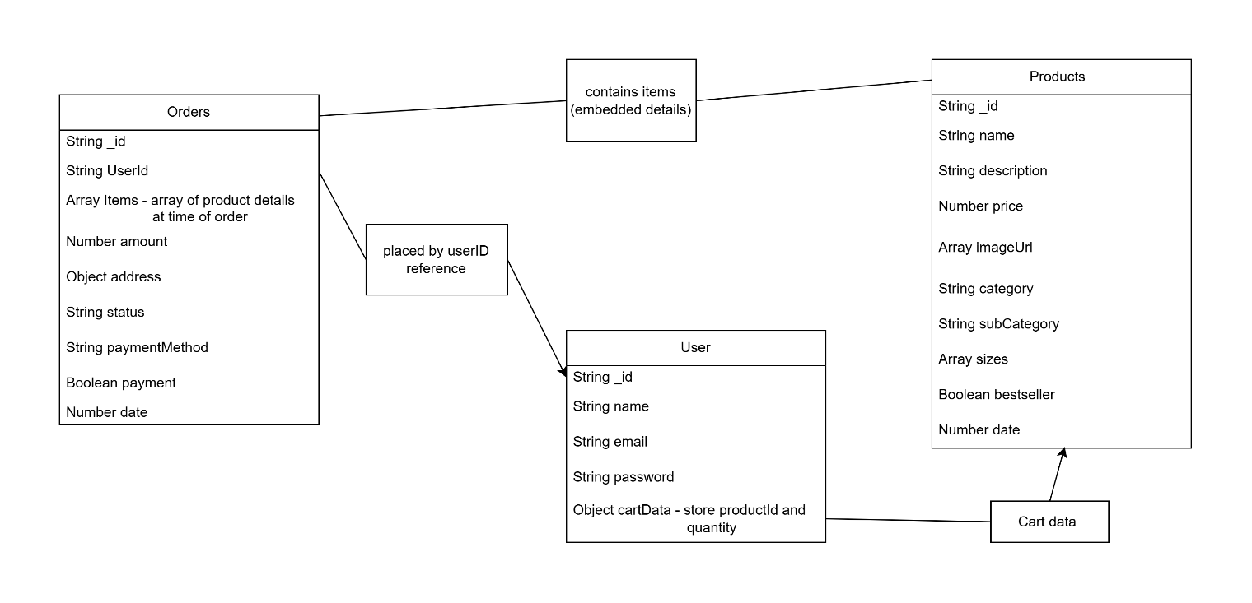

**Graphical User Interface**

- Home Page: Lists all eco-friendly clothing products.  
- Product Page: Offers details, size selection, and add-to-cart options.  
- Cart Page: Lets users review and modify selected products.  
- Checkout Page: Collects address info and shows payment options.  
- Admin Panel:  
 - Add, update, delete products  
 - View orders and update their status  
 - View inventory and order trends

**Conclusion**

This project presents an eco-friendly e-commerce platform designed to empower consumers who are committed to sustainable living. The platform successfully connects eco-conscious customers with merchants offering eco-friendly products, focusing primarily on clothing. By offering an easy-to-use interface with product browsing, detailed information, cart management, and secure checkout, the platform ensures a smooth shopping experience.

The admin panel allows for efficient management of product listings and order tracking, providing the necessary tools for business scalability. Although the platform is currently managed by a single admin, future versions will support multiple vendors, enabling greater diversity and more options for consumers.

The current technology stack—React, Express, MongoDB, and Node.js—ensures scalability, flexibility, and responsiveness. The integration of payment gateways like Razorpay and Cash on Delivery enhances the platform's accessibility for different user preferences.

In terms of future development, the project holds significant potential. Expanding to a multi-vendor marketplace, integrating full Stripe payment functionality, and implementing AI-based recommendation systems will further enhance the user experience. Additionally, incorporating a review and rating system would increase consumer trust and promote more informed purchase decisions.

In summary, the platform lays a solid foundation for eco-friendly e-commerce while aligning with the growing trend of sustainable consumerism. As it evolves, it has the potential to become a key player in the eco-friendly retail space, contributing to a more sustainable future.

**Future scope**

- Multi-Vendor Support: Future updates will allow individual eco-friendly merchants to register, list products, and manage their own stores.  
- Stripe Integration: Full implementation of Stripe for global payments.  
- Merchant Dashboards: Each merchant will get a personalized admin panel to manage products and orders.  
- User Reviews and Ratings: Adds trust and social proof for listed products.  
- AI-based Recommendation Engine: Suggest products based on user preferences and activity.

