INTRODUCTION:

Hospitals and healthcare professionals throughout the world are struggling to keep up with the increase in cases as a result of the COVID-19 epidemic. Making sure hospitals have an acceptable personnel level is a crucial component of providing good patient care. The care of patients may be degraded, death rates may rise, and healthcare institutions may become overburdened due to a lack of staff. In this research, we examine a dataset that offers information on severe staffing shortages and COVID-19-related mortality in hospitals across several states.

OBJECTIVE:

The goal is to examine and draw conclusions from a collection of health data, concentrating on details about COVID-19. We will start with exploring the data set with finding the important columns and understand them. we will starting with exploring the data and draw some visulisation to understand some patterns in this dataset.

* We will understand the distribution and trends of covid19 cases across different states.

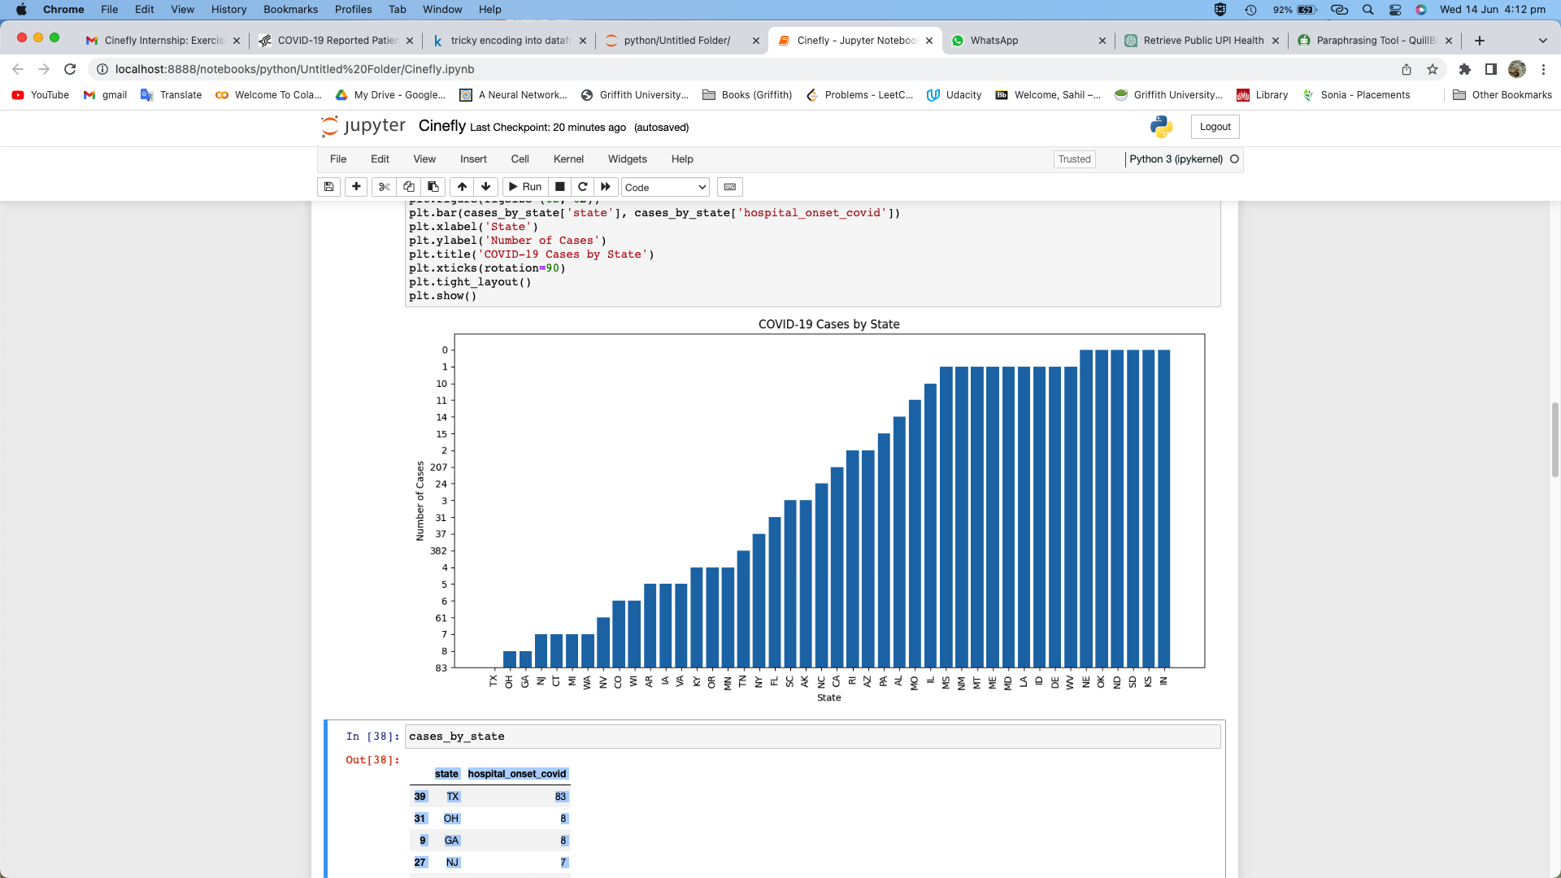

Find the number of covid cases with each state and visualize it.

Texas (TX) has the highest number of hospital-onset COVID-19 cases, with 83 reported cases and also Other states with a significant number of hospital-onset cases include Ohio (OH), Georgia (GA), New Jersey (NJ), Connecticut (CT), and Michigan (MI).

Some states have reported relatively low numbers of hospital-onset cases, such as Nebraska (NE), Oklahoma (OK), North Dakota (ND), South Dakota (SD), Kansas (KS), and Indiana (IN), all reporting 0 cases.

* We'll look for patterns between hospitals with a high death rate and a staffing shortage.

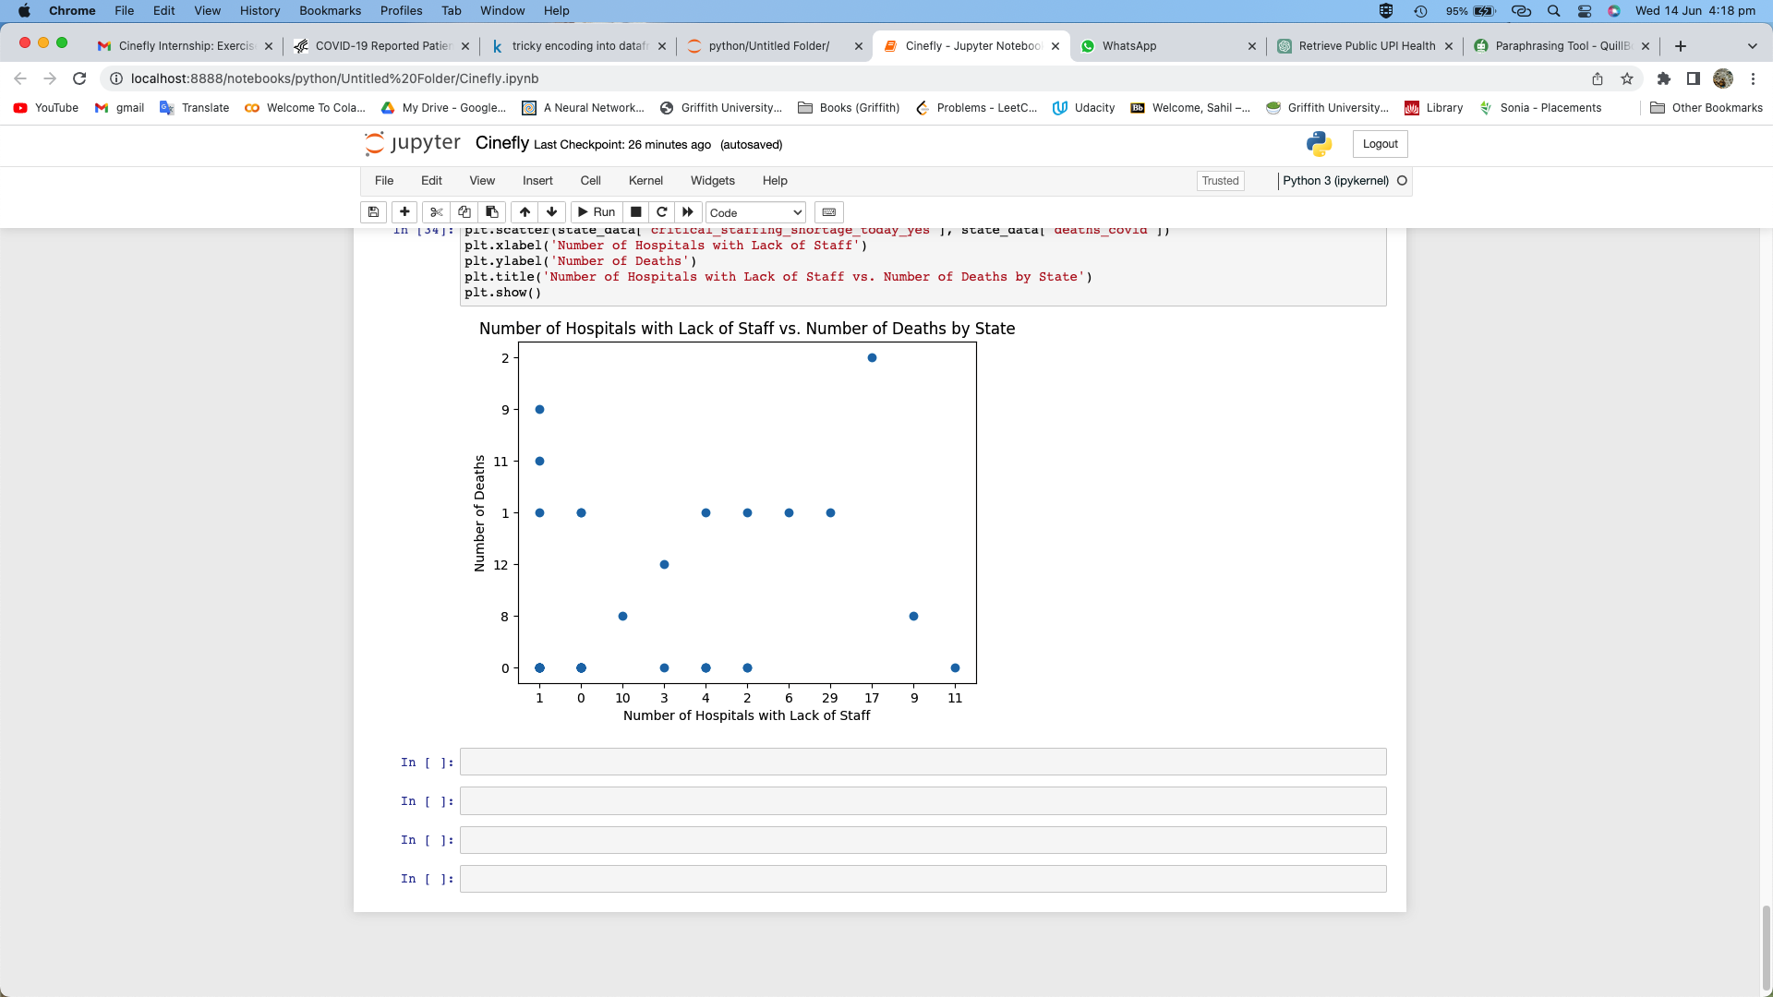

Some states, such as CA, FL, and SC, have a higher number of hospitals with critical staffing shortages (ranging from 3 to 29) compared to other states.

The number of deaths due to COVID-19 varies across states, with some states reporting higher numbers of deaths, like FL, NC, and NY.

Some states have no reported critical staffing shortages today (e.g., AZ, CO, CT, IA, ID, MN, MS, ND, NE, OH, OK, PA, SD, WV).

On the other hand, several states have reported critical staffing shortages, ranging from 1 to 29 hospitals (e.g., CA, FL, MI, SC, VA, WI).

CONCLUSION:

* The knowledge gathered from this study can assist stakeholders in the healthcare industry, governments, and researchers in making well-informed choices to enhance patient care, stop the spread of the disease within healthcare facilities, and efficiently allocate resources during public health emergencies like the COVID-19 pandemic.