AIM-

Design a system for car stereo systems such that whenever the increase volume button is pressed, a red background given by red LED blinks the number of times the button is pressed.

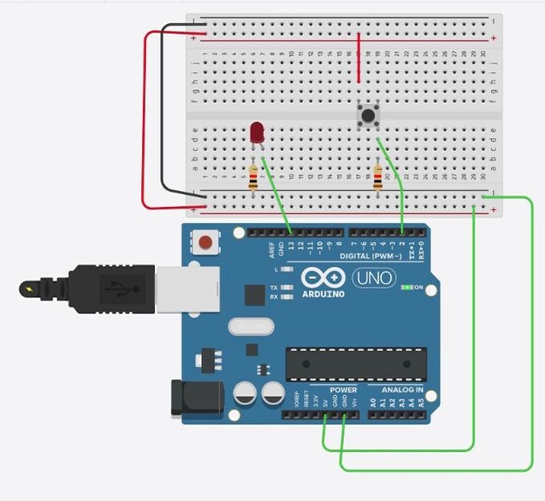

THEORY-

CONCEPT-

AURDINO

The Arduino Uno is an open-source microcontroller board based on the Microchip ATmega328P microcontroller and developed by Arduino.cc.The board is equipped with sets of digital and analog input/output (I/O) pins that may be interfaced to various expansion boards (shields) and other circuits.The board has 14 Digital pins, 6 Analog pins, and programmable with the Arduino IDE (Integrated Development Environment) via a type B USB cable. It can be powered by the USB cable or by an external 9-volt battery, though it accepts voltages between 7 and 20 volts.

LED

A light-emitting diode (LED) is a semiconductor light source that emits light when current flows through it. Electrons in the semiconductor recombine with electron holes, releasing energy in the form of photons. The color of the light (corresponding to the energy of the photons) is determined by the energy required for electrons to cross the band gap of the semiconductor.White light is obtained by using multiple semiconductors or a layer of light-emitting phosphor on the semiconductor device.

PUSH BUTTON

A **push-button** or simply **button** is a simple switch mechanism for controlling some aspect of a machine or a process. Buttons are typically made out of hard material, usually plastic or metal. The surface is usually flat or shaped to accommodate the human finger or hand, so as to be easily depressed or pushed. Buttons are most often biased switches, although many un-biased buttons (due to their physical nature) still require a spring to return to their un-pushed state. Terms for the "pushing" of a button include **pressing**, **depressing**, **mashing**, **slapping**, **hitting**, and **punching**.

LEARNING AND OBSERVATION -

If we press button once the LED glows once as we increase the volume of the car stereo the back led of red colour glows every time when one point is increased.

PROBLEMS AND TROUBLE SHOOTING-

Did not find any problem and did not need any troubleshooting

PRECAUTION-

Connection should be made to aurdiono before connecting power

Connection should be double checked

Positive and negative terminal should be placed correctly

Usb port of aurdino should be checked

LEARNING OUTCOMES

LEARN TO CODE ON AURDIONO

LEARNED HOW TO CONNECT PUSH BUTTON TO LED