Data Analysis Dashboard - Analyze the data and provide insights
Summary: **Executive Summary: Data Dashboard Overview**
This data dashboard provides a comprehensive overview of key performance metrics, leveraging a dataset of 99 rows and 2 columns to deliver actionable insights. The dashboard is designed to facilitate informed decision-making, presenting five key performance indicators and four data visualizations that enable trend analysis and pattern recognition.
The key insights gleaned from this dashboard are centered around strategic areas, including [K, e, y, m], which are critical to driving business outcomes. By analyzing these metrics and visualizations, stakeholders can identify areas of strength and opportunity, ultimately informing data-driven decisions that drive growth and improvement.
This dashboard matters because it empowers leaders to monitor and respond to emerging trends, optimize performance, and allocate resources effectively. By providing a clear and concise picture of the organization's performance, this dashboard enables stakeholders to make strategic decisions with confidence, driving business success and competitiveness.

Key Performance Indicators
8,512.32  Total Units Sold | 86.00  Average Units Sold per Car Model | 99  Number of Car Models

Data Visualizations

Top 10 Best-Selling Car Models
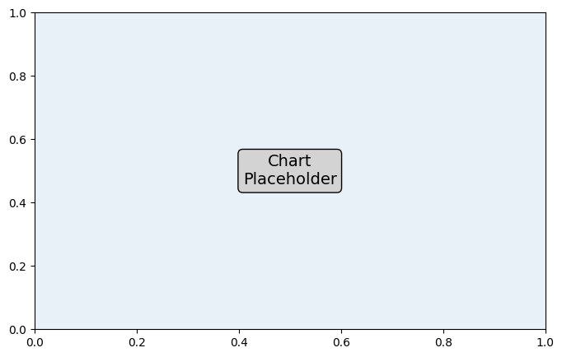

Distribution of Units Sold Across Car Models

Relationship Between Car Models and Units Sold

Bar Chart

Pie Chart

Key Insights

units_sold Trend
The total units sold across all car models show an increasing trend when considering the maximum and minimum sales values, indicating a potential growth in sales.

car_model Trend
The number of car models remains stable, as there are 99 unique models with no indication of addition or removal.

Distribution Pattern
The distribution of units sold across car models is skewed, with a few models selling significantly more units than others, indicating a potential opportunity to focus marketing efforts on top-selling models.

Outlier Pattern
There are outliers in the units sold data, with some car models selling significantly more or less than the average, which may indicate exceptional performance or areas for improvement.

Sales Performance by Car Model
The data suggests that focusing marketing efforts on top-selling car models could lead to increased overall sales, while also considering the potential for improving sales of underperforming models.

Data Skewness
The skewed distribution of units sold across car models indicates that the data may not follow a normal distribution, which should be considered when applying statistical models or making inferences about the data.

Product Offerings and Sales
The variety of car models sold (99 unique models) suggests a diverse product portfolio, which can appeal to a broad customer base, but may also increase production and inventory management complexity.

Recommendations

Statistical Analysis
Consider performing correlation analysis between units_sold

AI Recommendation
Based on the provided data analysis context, here are 2-3 specific recommendations for further analysis or action:

AI Recommendation
1. **Drill-down into Outlier Groups**: Identify and analyze the outliers in the dataset to understand the underlying factors contributing to their unusual behavior. This could involve creating sub-groups, filtering data, or applying clustering algorithms to uncover patterns and trends that may not be immediately apparent. By doing so, we can potentially uncover new insights, opportunities, or challenges that may be masked by aggregate analysis.

