Managing Configuration in Microservices with Spring Cloud
1) Reading Configuration From Classpath
Step 1: Create a Spring Boot Project for Config Server
- Start by creating a new Spring Boot project and name it “ConfigServer.” This project will serve as a dedicated configuration server to manage the configurations of all microservices.
Step 2: Add Dependencies
- In the pom.xml file, include dependencies for Spring Cloud and Spring Boot Actuator.
Step 3: Enable Config Server
- In the ConfigServer application, add the @EnableConfigServer annotation. This annotation designates the application as a configuration server responsible for managing the configurations of other microservices.
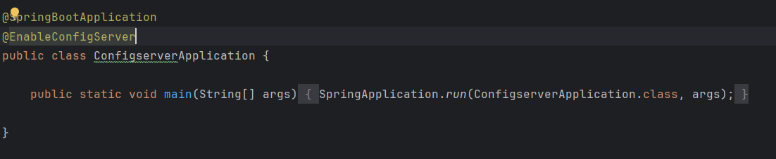
Step 4: Configure application.yml
- Set the application.yml file with a port number (e.g., 8071) and an application name (configserver). This name will help other microservices identify which server to connect to for configuration.
- Add profile configurations by setting the active profile to native. This informs Spring Boot to use the native profile for local property management.
- Create a config folder and add environment-specific application.yml files for each microservice. Name each file according to the microservice and environment. For instance, if the microservice is named accounts, the configuration file for the production environment should be named accounts-prod.yml, while the file for the QA environment should be accounts-qa.yml.
- Specify the file path where the properties are stored. For example, if the YAML configuration files for different environments (production/QA) are stored under classpath, add this location in the search-locations variable. This setup enables the configuration server to locate and serve the necessary properties to each microservice.
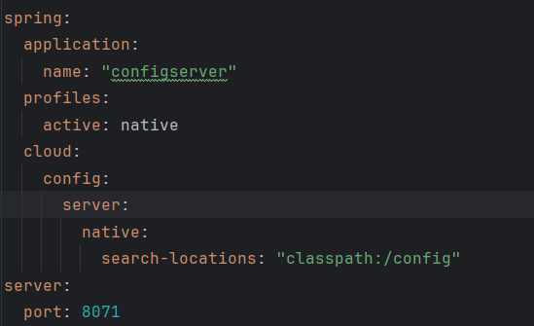
Step 5: Remove Unnecessary Configuration from Microservices
- In this step, remove any redundant configuration settings from all microservices, such as spring.config.activate.on-profile: “qa”. Since we are now using Spring Cloud Config to centralize and manage configurations, these individual settings within each microservice are no longer needed.
- By removing these configurations, we ensure that each microservice relies solely on the configuration provided by the central Config Server, streamlining the configuration process across all services.
- Keep environment-specific properties like build version and contact information, as these will vary based on the environment and should remain unique to each service.
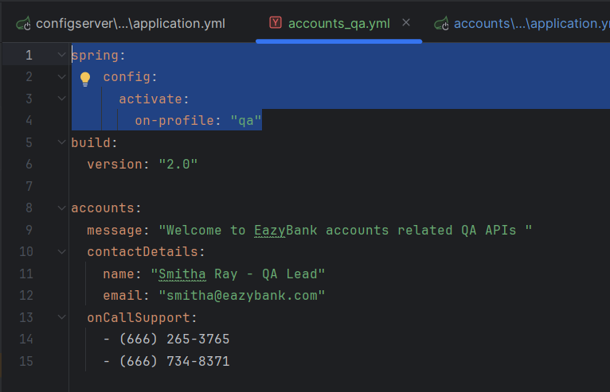
Step 6: Run the Config Server
- Start the Config Server on port 8071.
- To verify the setup, navigate to http://localhost:8071/accounts/prod in your browser. This URL requests the configuration details (such as contact-info) for the accounts microservice in the prod environment.
- If configured correctly, this endpoint should return the configuration details specific to the requested microservice and environment.
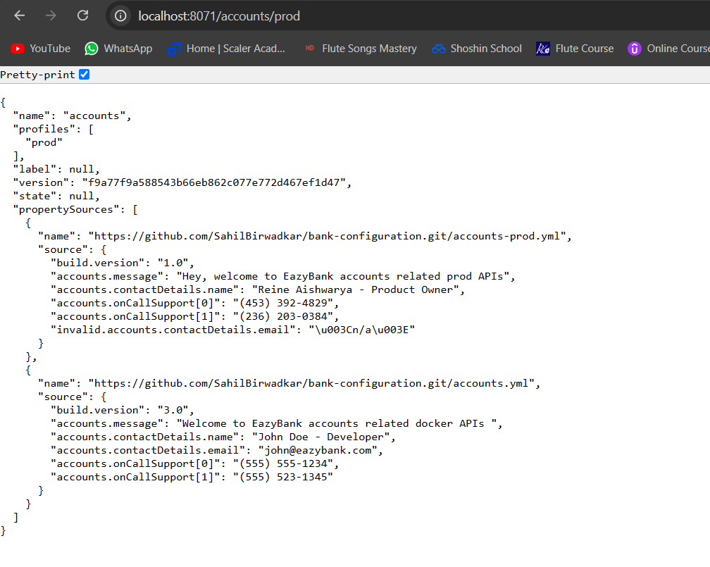
Step 7: Add Config Server Details to Other Microservices
- In the application.yml file of each microservice, add the configuration details of the Config Server. This setup ensures that each microservice connects to the Config Server to fetch its configuration upon startup.
- To control startup dependencies, ensure the Config Server starts before other microservices by specifying it in the configuration. You can make this connection optional by adding optional: true to the spring.config.import statement, allowing microservices to start even if the Config Server is temporarily unavailable.
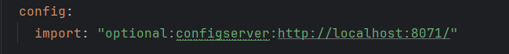
- Specify a unique application name for each microservice in the application.yml file, matching the file name format used in the config folder of the Config Server. For example, for the accounts microservice, set application.name: accounts so the Config Server can correctly identify and serve the matching configuration file (like accounts-prod.yml or accounts-qa.yml) based on the environment.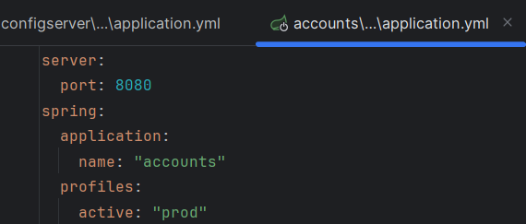
2) Reading Configuration From Git
Step 8: Push All Configuration to GitHub
- Push all configuration files to a private GitHub repository to centralize and secure access to configuration files. This setup prevents developers from accessing configuration files locally, keeping sensitive information safe.
- In the application.yml file of the Config Server application, configure the following properties:
  - Activate Git Profile: Set the spring.profiles.active property to git to enable Git-based configuration.
  - Git Configuration: In the spring.cloud.config.server section, specify git as a child property. Define the uri as the URL of the GitHub repository where the configuration files are stored. Also, set the branch property to the branch containing the configuration files, such as main or prod.

Managing Dynamic Configuration Refresh in Spring Cloud
After successfully centralizing and securing configuration management using GitHub and Spring Cloud, a new challenge arises: applying configuration updates without repeatedly restarting the Config Server. To address this, we can use Spring Boot Actuator for runtime configuration refresh. Here are three effective methods:
1) Refresh Configuration at Runtime Using the /refresh Actuator Endpoint
- Enable the /refresh Endpoint: Include spring-boot-starter-actuator and management.endpoints.web.exposure.include=refresh in the Config Server’s application.yml file to expose the /refresh endpoint.
- Trigger Configuration Refresh: After making changes to the configuration files in GitHub, send a POST request to the /refresh endpoint (e.g., http://localhost:8071/actuator/refresh) to refresh the configuration without restarting the Config Server. This action updates configurations for any changes detected in the Config Server.
2) Refresh Configurations at Runtime Using Spring Cloud Bus
- Spring Cloud Bus Integration: Spring Cloud Bus allows microservices to broadcast state changes (such as configuration updates) across distributed systems using a message broker like RabbitMQ or Kafka.
- Automatic Refresh: When a configuration file is updated in GitHub, triggering a refresh in the Config Server automatically propagates these changes to all subscribed microservices. This method eliminates the need to manually call the /refresh endpoint on each microservice.
- Configuration Setup: Add Spring Cloud Bus dependencies in the pom.xml file for both the Config Server and all microservices. Also, configure the message broker (RabbitMQ/Kafka) in application.yml.
3) Refresh Configuration at Runtime Using Spring Cloud Bus & Spring Cloud Config Monitor
- Config Monitor Integration: The Spring Cloud Config Monitor listens for webhook events from GitHub (or other version control systems). When a configuration file is updated in the repository, the monitor automatically triggers a refresh.
- Automatic Trigger on Changes: Set up a webhook in your GitHub repository to notify the Config Server of changes. When a commit modifies configuration files, this webhook triggers the Spring Cloud Config Monitor to push updates to all microservices via Spring Cloud Bus, ensuring configurations stay up-to-date without manual intervention.
- Configuration Requirements: Add Spring Cloud Bus and Spring Cloud Config Monitor dependencies to the Config Server’s pom.xml. Then configure the webhook in GitHub to point to your Config Server (e.g., http://your-config-server-url/monitor).

