What is Container?
A container is a lightweight, standalone, executable package that includes everything required to run a piece of software, such as code, libraries, and plugins.
Containers are isolated from one another, meaning each container operates independently with its own libraries, dependencies, and configurations. This isolation allows containers to run securely and reliably, without interference from other containers on the same system.
Because containers package all necessary components (like binaries and libraries), they can operate consistently across different environments—whether on a developer’s laptop, in testing, or in production. This portability helps eliminate the common "it works on my machine" problem seen in traditional software deployment.
What is Containerization?
Containerization is the process of packaging software and its dependencies into a container. This approach ensures consistency across different environments, whether in development, testing, or production, by isolating applications and their configurations.
What is Docker?
Docker is a popular open-source platform for developing, shipping, and running applications in containers. Docker provides tools and a runtime environment for creating and managing containers, along with a registry to store and share container images.
Docker Architecture
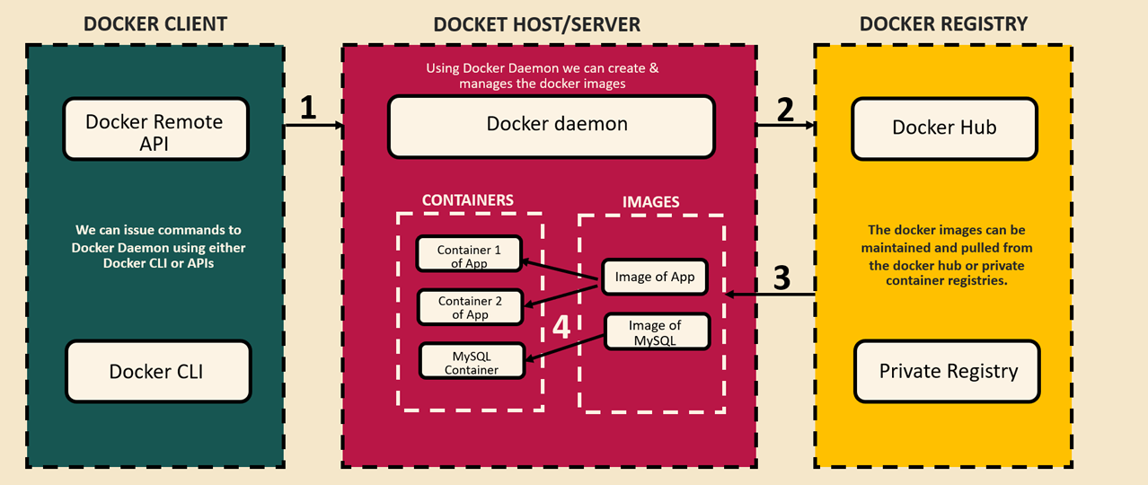
Docker architecture is composed of three primary components:
- Docker Client: The Docker Client allows users to interact with the Docker Host (or Server) to issue instructions on containerizing applications. It includes two main parts:
  - Docker CLI: The command-line interface used to execute Docker commands.
  - Docker Remote API: An API that facilitates communication between the Docker Client and Docker Daemon on the host.
- Docker Server/Host: The Docker Server, or Host, houses a Docker Daemon process that runs continuously in the background, accepting commands from the Docker CLI. For example, when instructed, it can create Docker images by packaging applications (such as Spring Boot, Maven, or microservices) along with their dependencies. This resulting package, known as a Docker image, can then be used to create Docker containers. The Docker Server manages the full lifecycle of these images and containers, handling tasks like creation, deployment, and deletion.
- Docker Registry: Once a Docker image is finalized and ready for deployment, it can be pushed to a Docker Registry—a remote repository where images are stored and managed. Docker Hub, for instance, is a widely used registry where images can be stored securely and retrieved for deployment across various environments (e.g., development, testing, production). The Docker Registry functions similarly to code repositories like GitHub, providing centralized storage and accessibility for Docker images.

There are three main methods to create Docker images.
- Dockerfile
Here, we’ll cover the first method using a Dockerfile, which requires manually specifying all configurations.
- Build the Application
Run the command “mvn clean install“ from the directory containing the pom.xml file. This command will build the project and create a fat JAR file in the target folder.
- Write Dockerfile Instructions
Define the necessary instructions in the Dockerfile to configure the Docker image. 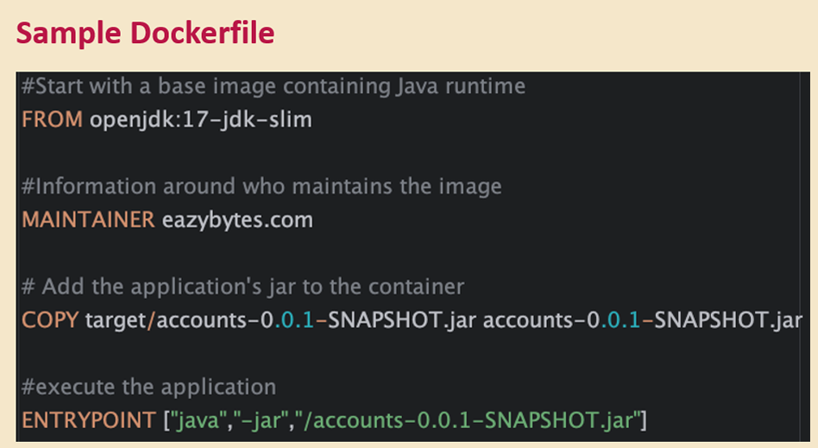
- Build the Docker Image
Navigate to the directory where the Dockerfile is located and execute:
“docker build -t eazybytes/accounts:s4 .”
This command will create a Docker image with the name eazybytes/accounts:s4.
- Run the Docker Container
To start a container based on the newly created image, run:
“docker run -p 8080:8080 eazybytes/accounts:s4”
This command launches the container with port mapping, making the application accessible on port 8080.
- Buildpacks

- Google Jib

Configuration Management in Microservices
In microservices, managing configurations across multiple environments can be challenging. Each environment—such as development, staging, and production—requires different configurations. If we bundle all configurations together, it would necessitate creating separate Docker images for each environment, which is not ideal. A best practice is to use the same Docker image across all environments, including production.
Additionally, some properties, like database credentials, need to be injected into the microservice at startup, as they should not be hard-coded in configuration files or embedded in business logic. Maintaining a single configuration file for each environment can quickly become complex and unmanageable.
To address these challenges, there are three effective methods for configuration management in microservices:
- Configuring Spring Boot with Environment-Specific Profiles: Use profiles to load environment-specific properties directly within Spring Boot.
- External Configuration with Spring Boot: Externalize configurations outside the application, allowing them to be customized per environment without modifying the code.
- Using a Centralized Configuration Server with Spring Cloud Config: Implement a dedicated configuration server to manage all microservice configurations centrally, simplifying maintenance and ensuring consistency across environments.
To read properties from configuration files in a Spring Boot application, we have the following options:
- Using the @Value Annotation
The @Value annotation allows us to inject property values directly from the application.yml or application.properties file. Specify the property’s path in the annotation.
Example:
If the build version is defined in application.yml as build.version: 1.0, you can access this value by annotating a variable with @Value("${build.version}").
Application.yml
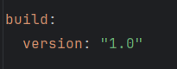
AccountsController.java
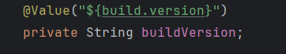
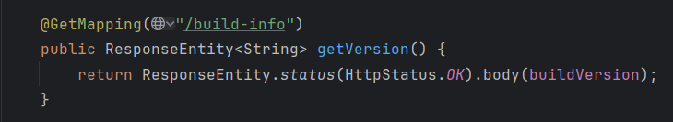
- Using the Environment Interface
The Environment interface provides a programmatic way to access property values in Spring Boot applications. This approach is helpful when you need dynamic access to properties, allowing you to retrieve them at runtime without hardcoding property paths.
Example:
Suppose we want to retrieve the Java version installed on the system. We can achieve this by using the Environment interface as follows:
  - Declare an Environment Variable
Inject the Environment object as a dependency in your component or service.
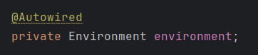
  - Retrieve the Property Value
Use the getProperty() method to fetch the property by its name.
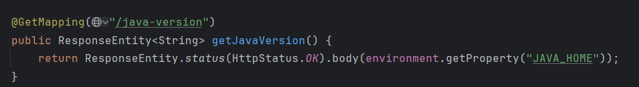
In this example, the java.version property provides the Java version. This approach makes configuration management more flexible and enables dynamic property retrieval based on application logic.

- Using the @ConfigurationProperties Annotation
Unlike the @Value annotation and Environment interface, which are suitable for retrieving single properties, the @ConfigurationProperties annotation allows us to bind multiple related properties into a single class (DTO). This approach is particularly useful when you have a group of properties that you want to manage together, making your configuration code cleaner and more organized.
To use @ConfigurationProperties, follow these steps:
- Define Properties in application.yml
Organize related properties under a common prefix. For instance, if we want to configure account-related settings, we could define them like this:
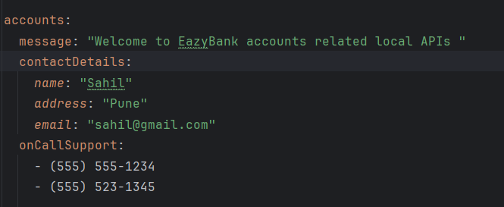
- Create a DTO Class
Create a class that will hold the properties. Annotate it with @ConfigurationProperties and specify the common prefix (e.g., "accounts") that you used in application.yml.
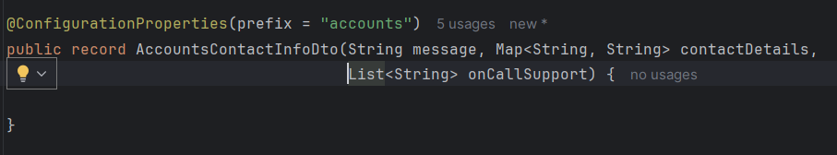
- Enable Configuration Properties in the Application
Make sure @EnableConfigurationProperties is added in your main application class or that @ConfigurationProperties classes are annotated with @Component, so Spring Boot can detect and bind them automatically.
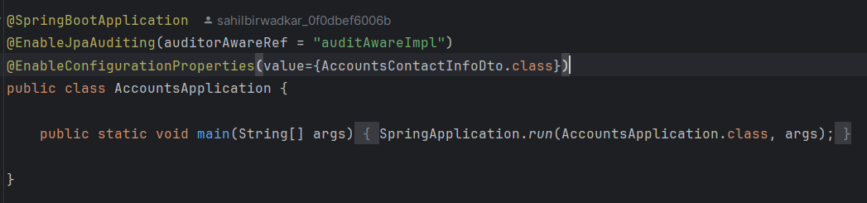
So far, we've defined properties that are common across all environments, without any environment-specific configuration. To handle environment-specific settings, Spring Boot introduces the concept of profiles.
Spring Profiles allow us to group configurations and properties based on different environments, such as development, testing, and production. By creating distinct profiles (e.g., dev, QA, and prod), we can specify unique values for each environment. Spring Boot will activate the appropriate profile based on the current execution context, ensuring the right configuration is loaded for the environment in use.
With profiles, we can configure our application to run seamlessly across multiple environments with the same code base but different settings. Additionally, profiles allow us to control bean creation, enabling beans to be instantiated only when a specific profile is active.
This powerful feature in Spring Boot ensures that both application properties and bean lifecycles can be customized based on the active profile, making it easier to manage environment-specific configurations in a clean, flexible way.
To demonstrate how profiles work, we'll create two additional configuration files: application_qa.yml and application_prod.yml, alongside our default application.yml file.
In this setup:
- Common properties like the port number and database configuration will remain in the main application.yml file, as they are shared across environments.
- Environment-specific properties, such as build version and account-related settings, will be defined in application_qa.yml and application_prod.yml.
application_qa.yml
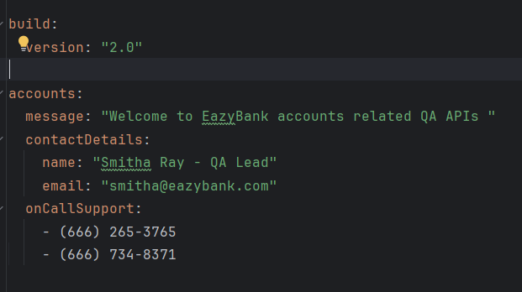
application_prod.yml
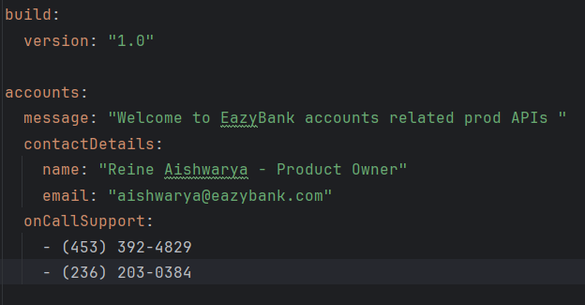
To determine which YAML file is loaded based on the active profile, we can specify the profile activation condition within each configuration file. This setup allows Spring Boot to activate the appropriate configuration automatically based on the profile.
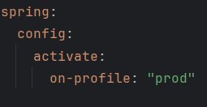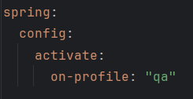
application_prod.yml application_qa.yml
By default, Spring Boot loads the properties from application.yml. To activate a specific profile (for instance, to test with the QA configuration), we need to specify the active profile in our local application.yml file as shown below: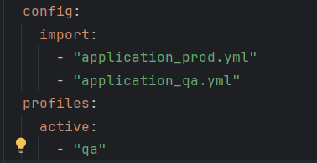
Here:
- config.import specifies a list of configuration files that can be loaded.
- profiles.active determines which profile (and corresponding configuration file) Spring should use.
This setup allows Spring Boot to dynamically load the appropriate configuration file based on the active profile, making it easier to switch between environments during development and testing.

