Sahil Chelaramani
20162051
Assignment 0:Report

a.

The following code opens a set of images, and using the OpenCV video writer creates a video by merging them together. Notice, that the VideoWriter also takes the fourcc code that will be used by the video codec to encode the video. Also, notice that the code takes the FPS as a command line argument, and passes that to the videoWriter(If left unspecified, we use a pre-determined value of 30 ).

#include <iostream>
#include <opencv2/opencv.hpp>

using namespace std;
using namespace cv;

int main(int argc, char** argv) {
Mat frame;
VideoCapture cap("webframe%06d.jpg");
int fps;
if(argc > 1) {
cout << argv[1]<<endl;
fps = atoi(argv[1]);
} else {
fps = 30;
}
VideoWriter writer("webcam_created.avi", CV_FOURCC('M','J','P','G'), fps, Size(640, 480));
int i = 0;
while(1) {
cout << i << endl;
i++;
cap >> frame;
if (frame.empty())
break;
writer.write(frame);
}
return 0;
}

b.

Each frame captured by webcam is saved as an image and displayed on the screen side by side.The code runs for 100 frames and terminates. Highgui functions in OpenCV (for example, imshow() here) takes some time to process its event loop and hence need a call of waitKey() function. Hence the output displayed on the screen is a bit slow.

#include<iostream>
#include<opencv2/opencv.hpp>
#include<opencv2/highgui/highgui.hpp>
#include<stdio.h>

using namespace cv;
using namespace std;

int main() {
VideoCapture cap(0);
Mat edges;
int framecount=0;
for(;framecount<=100;) {
Mat frame;
cap>>frame;
imshow("Webcam",frame);
char filename[128];
sprintf(filename,"webframe%06d.jpg",framecount);
imwrite(filename,frame);
framecount++;
cout<<framecount<<endl;
if(waitKey(30) == 27)
break;
}
return 0;
}

Chroma-Keying

For each video:
• Each frame is processed one by one.
• Each image frame is converted to YCbCr color space.
• Green background is segmented by selecting color within appropriate range and we get segmented image that has binary values corresponding to foreground and background.
• For each pixel in the image, we replace the pixel with one from the background frame if the value of the mask is 0, else we use the pixel from the foreground video.

#include <opencv2/core.hpp>
#include <opencv2/imgproc.hpp>
#include <opencv2/highgui.hpp>

#include <cassert>
#include <cmath>
#include <iostream>
#include <string>

using namespace std;
using namespace cv;

Scalar bgr2ycrcb( Scalar bgr ) {
double R = bgr[ 2 ];
double G = bgr[ 1 ];
double B = bgr[ 0 ];
double delta = 128; // Note: change this value if image type isn't CV_8U.

double Y = 0.299 * R + 0.587 * G + 0.114 * B;
double Cr = ( R - Y ) * 0.713 + delta;
double Cb = ( B - Y ) * 0.564 + delta;

return Scalar( Y, Cr, Cb, 0 /* ignored */ );
}

Mat1b chromaKey( const Mat3b & imageBGR, Scalar chromaBGR, double tInner, double tOuter ) {

assert( tInner <= tOuter );

assert( ! imageBGR.empty() );
Size imageSize = imageBGR.size();
Mat3b imageYCrCb;
cvtColor( imageBGR, imageYCrCb, COLOR_BGR2YCrCb );
Scalar chromaYCrCb = bgr2ycrcb( chromaBGR ); // Convert a single BGR value to YCrCb.

Mat1b mask = Mat1b::zeros( imageSize );
const Vec3d key( chromaYCrCb[ 0 ], chromaYCrCb[ 1 ], chromaYCrCb[ 2 ] );

for ( int y = 0; y < imageSize.height; ++y ) {
for ( int x = 0; x < imageSize.width; ++x ) {
const Vec3d color( imageYCrCb( y, x )[ 0 ], imageYCrCb( y, x )[ 1 ], imageYCrCb( y, x )[ 2 ] );
double distance = norm( key - color );

if ( distance < tInner ) {
// Current pixel is fully part of the background.
mask( y, x ) = 0;
} else if ( distance > tOuter ) {
mask( y, x ) = 255;
} else {
double d1 = distance - tInner;
double d2 = tOuter - tInner;
uint8_t alpha = static_cast< uint8_t >( 255. * ( d1 / d2 ) );

mask( y, x ) = alpha;
}
}
}

return mask;
}

Mat3b replaceBackground( const Mat3b & image, const Mat1b & mask, const Mat3b & image_bkgrd ) {
Size imageSize = image.size();
// const Vec3b bgColorVec( bgColor[ 0 ], bgColor[ 1 ], bgColor[ 2 ] );
Mat3b newImage( image.size() );

for ( int y = 0; y < imageSize.height; ++y ) {
for ( int x = 0; x < imageSize.width; ++x ) {
uint8_t maskValue = mask( y, x );

if ( maskValue >= 255 ) {
newImage( y, x ) = image( y, x );
} else if ( maskValue <= 0 ) {
newImage( y, x ) = image_bkgrd(y,x);
} else {
double alpha = 1. / static_cast< double >( maskValue );
newImage( y, x ) = alpha * image( y, x ) + ( 1. - alpha ) * image_bkgrd(y,x);
}
}
}

return newImage;
}

int mixVideos() {
VideoCapture cap("/home/sahil/Code/ComputerVision/Assignment0/videos/dino.mp4");

VideoCapture cap2("/home/sahil/Code/ComputerVision/Assignment0/videos/2d.mp4");
if( !cap.isOpened() && !cap2.isOpened()){
cout << "Cannot open the video file" << endl;
return -1;
}

double count = cap.get(CV_CAP_PROP_FRAME_COUNT); //get the frame count
namedWindow("MyVideo",CV_WINDOW_AUTOSIZE);

while(1) {
Mat frame , background;
cap.read(frame);
cap2.read(background);
if(background.empty()) {
cap2.set(CV_CAP_PROP_POS_MSEC, 0);
cap2.read(background);
}
if(frame.empty())
break;

// resize(input_bck, input_bck, frame.size());
resize(background, background, frame.size());
Scalar chroma( 0, 255, 0, 0 );
double tInner = 100.;
double tOuter = 120.;
Mat1b mask = chromaKey( frame, chroma, tInner, tOuter );

Mat3b newBackground = replaceBackground( frame, mask, background);
imshow("MyVideo", newBackground);
if(waitKey(10) == 27) {
break;
}
}
return 0;
}

int main() {
mixVideos();
return 0;
}

Output
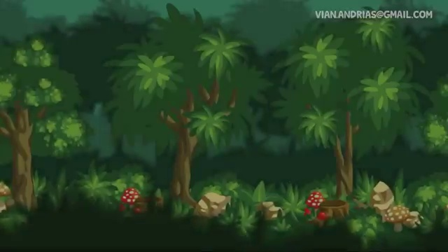

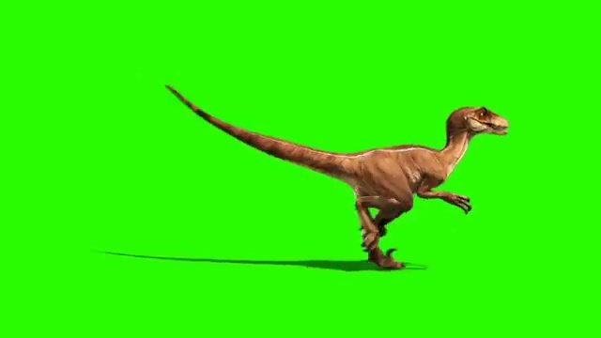

Background Foreground
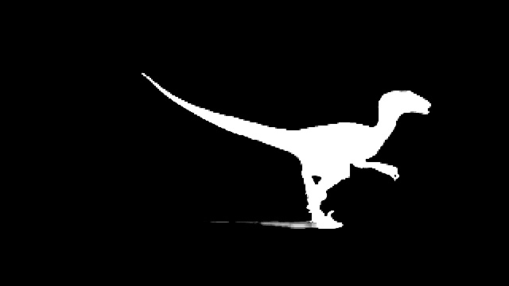
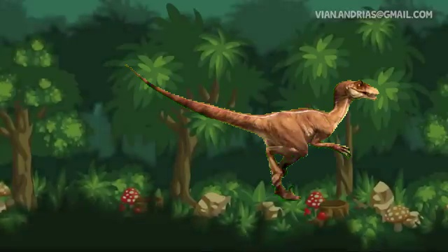

Mask Merged Image

