Practical 1
Code:
from cryptography.hazmat.primitives.asymmetric import rsa, padding
from cryptography.hazmat.primitives import hashes, serialization
from cryptography.exceptions import InvalidSignature
private_key = rsa.generate_private_key(public_exponent=65537, key_size=2048)
public_key = private_key.public_key()
message = b"Karan is a bad boy and he is from london."
signature = private_key.sign(
message,
padding.PSS(
mgf=padding.MGF1(hashes.SHA256()),
salt_length=padding.PSS.MAX_LENGTH
),
hashes.SHA256()
)
print("Signature created successfully.")
def verify_signature(public_key, message, signature):
try:
public_key.verify(
signature,
message,
padding.PSS(
mgf=padding.MGF1(hashes.SHA256()),
salt_length=padding.PSS.MAX_LENGTH
),
hashes.SHA256()
)
return True
except InvalidSignature:
return False
if verify_signature(public_key, message, signature):
print("Signature Verified Successfully.")
else:
print("Signature verification Failed.")
pem_public = public_key.public_bytes(
encoding=serialization.Encoding.PEM,
format=serialization.PublicFormat.SubjectPublicKeyInfo)
print("\nPublic key:\n", pem_public.decode())

Output:
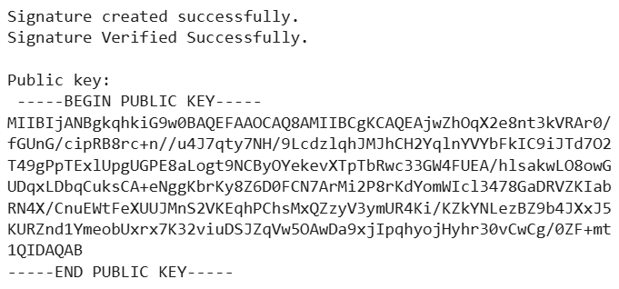
Practical 2
Code:
!pip install cryptography
!pip install bcrypt
import bcrypt
import os
PEPPER = b"MySecretPepperKey"
def hash_password(password: str) -> tuple:
salt = bcrypt.gensalt()
password_peppered = password.encode() + PEPPER
hashed = bcrypt.hashpw(password_peppered, salt)
return hashed, salt
def verify_password(stored_hash: bytes, salt: bytes, password_attempt: str) -> bool:
attempt_peppered = password_attempt.encode() + PEPPER
return bcrypt.checkpw(attempt_peppered, stored_hash)
user_password = "my_secure_password123"
stored_hash, salt = hash_password(user_password)
print("Stored Hash:", stored_hash)
login_attempt= "my_secure_password123"
if verify_password(stored_hash, salt, login_attempt):
print("Password Verified")
else:
print("Invalid Password")

Output:

Practical 3
Code:
import hashlib
input = "What a great day"
result = hashlib.sha256(input.encode())
print("The hexadecimal equivalent of SHA256 is: ")
print(result.hexdigest())

Output:

Code:
import hashlib
input = "what a great day"
result = hashlib.sha256(input.encode())
print("The hexadecimal equivalent of SHA256 is: ")
print(result.hexdigest())

Output:

Code:
import hashlib
input= "Punit 1234S"
result = hashlib.sha512(input.encode())
print("The hexadecimal equivalent of SHA512 IS :")
print(result.hexdigest())

Output:

Code:
import hashlib
input = "$abcdef"
result = hashlib.sha384(input.encode())
print("The hexadecimal equivalent of SHA384 is: ")
print(result.hexdigest())
print("The hexadecimal equivalent of SHA512 is: ")
print(result.hexdigest())

Output:
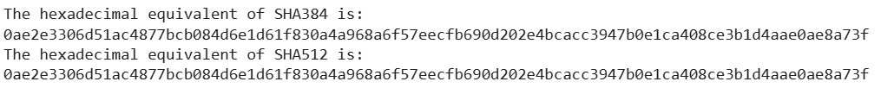

Code:
import hashlib
input = "$abcdef"
result = hashlib.sha384(input.encode())
print("The hexadecimal equivalent of SHA384 is: ")
print(result.hexdigest())

Output:

Code:
import hashlib
input = "$abcdef"
result = hashlib.sha224(input.encode())
print("The hexadecimal equivalent of SHA224 is: ")
print(result.hexdigest())

Output:

Code:
import hashlib
input = "this is great"
result = hashlib.sha1 (input.encode())
print("The hexadecimal equivalent of SHA1 is: ")
print(result.hexdigest())

Output:
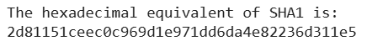
Practical 4
Code:
import hashlib
import time
class Blockchain:
def __init__(self):
self.chain = []
self.current_transactions = []
self.create_block(previous_hash='1', data='Genesis Block')
def create_block(self, previous_hash, data):
block = {
'index': len(self.chain) + 1,
'timestamp': time.time(),
'data': data,
'previous_hash': previous_hash,}
block['hash'] = self.hash_block(block)
self.chain.append(block)
self.current_transactions = []
return block
def hash_block(self, block):
block_string = str(block).encode()
return hashlib.sha256(block_string).hexdigest()
def add_transaction(self, sender, recipient, amount):
self.current_transactions.append({
'sender': sender,
'recipient': recipient,
'amount': amount,})
class Client:
def __init__(self, name):
self.name = name
def send_transaction(self, blockchain, recipient, amount):
blockchain.add_transaction(self.name, recipient, amount)
return f"{self.name} sent {amount} toys to {recipient}"
blockchain = Blockchain()
client1 = Client("Alice")
client2 = Client("Bob")
client3 = Client("Charlie")
print(client1.send_transaction(blockchain, "Bob", 10))
print(client2.send_transaction(blockchain, "Charlie", 5))
print(client3.send_transaction(blockchain, "Alice", 7))
blockchain.create_block(
blockchain.chain[-1]['hash'],
"Block data goes here")
for block in blockchain.chain:
print(f"Block #{block['index']}: {block['data']}")
print(f"Hash: {block['hash']}")
print(f"Previous Hash: {block['previous_hash']}")
print("---")

Output:
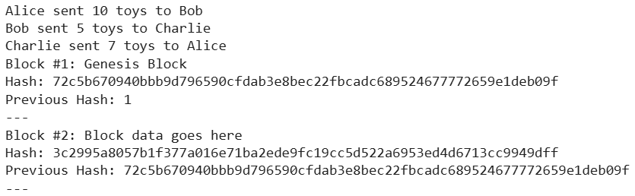

Practical 5
Code:
def derive_utxo(blockchain):
utxo = {}
for block in blockchain:
for tx in block:
for inp in tx['inputs']:
utxo.pop(inp, None)
utxo.update({
(tx['tx_id'], i): v
for i, v in tx['outputs']})
return utxo
blockchain = [
[{'tx_id': 'tx1', 'inputs': [], 'outputs': [(0, 10), (1, 5)]},
{'tx_id': 'tx2', 'inputs': [('tx1', 0)], 'outputs': [(2, 8)]}],
[{'tx_id': 'tx3', 'inputs': [('tx1', 1)], 'outputs': [(3, 4)]},
{'tx_id': 'tx4', 'inputs': [('tx2', 0)], 'outputs': [(4, 7), (5, 3)]}]
]
for (tx_id, idx), value in derive_utxo(blockchain).items():
print(f"TX: {tx_id}, Output: {idx}, Value: {value}")

Output:
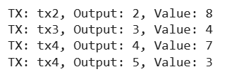
Practical 6
Code:
import requests
import pandas as pd
import numpy as np
import matplotlib.pyplot as plt
import seaborn as sns
from sklearn.preprocessing import MinMaxScaler
from tensorflow.keras.layers import Dense, Dropout, LSTM
from tensorflow.keras.models import Sequential
sns.set_style("darkgrid") # Set a dark grid style for better visualization
api_key = '9868b3d065ca4448baaf699d7fb35fd4'
symbol = 'BTC/USD'
interval = '5min'
order = 'asc'
start_date = '2021-11-03 00:00:00'
end_date = '2021-11-20 00:00:00'
api_url = f'https://api.twelvedata.com/time_series?symbol={symbol}&start_date={start_date}&end_date={end_date}&interval={interval}&order={order}&apikey={api_key}'
data = requests.get(api_url).json()
data_final = pd.DataFrame(data['values'])
scaler = MinMaxScaler(feature_range=(0, 1))
scaled_data = scaler.fit_transform(data_final['close'].values.reshape(-1, 1))
time_intervals_to_train = 24
prediction_interval = 12
x_train, y_train = [], []
for i in range(time_intervals_to_train, len(scaled_data) - prediction_interval):
x_train.append(scaled_data[i - time_intervals_to_train:i, 0])
y_train.append(scaled_data[i + prediction_interval, 0])
x_train, y_train = np.array(x_train), np.array(y_train)
x_train = np.reshape(x_train, (x_train.shape[0], x_train.shape[1], 1))
model = Sequential()
model.add(LSTM(128, return_sequences=True, input_shape=(x_train.shape[1], 1), activation='relu'))
model.add(Dropout(0.4))
model.add(LSTM(64, return_sequences=True, activation='relu'))
model.add(Dropout(0.3))
model.add(LSTM(32, activation='relu'))
model.add(Dropout(0.2))
model.add(Dense(1, activation='sigmoid'))
model.compile(loss='mean_squared_error', optimizer='adam', metrics=['accuracy'])
model.fit(x_train, y_train, epochs=10, batch_size=64)
test_start = '2021-11-20 00:00:00'
test_end = '2021-11-24 00:00:00'
test_api_url = f'https://api.twelvedata.com/time_series?symbol={symbol}&start_date={test_start}&end_date={test_end}&interval={interval}&order={order}&apikey={api_key}'
test_data = requests.get(test_api_url).json()
test_data_final = pd.DataFrame(test_data['values'])
bitcoin_prices = pd.to_numeric(test_data_final['close'], errors='coerce').values.reshape(-1, 1)
model_inputs = scaler.transform(bitcoin_prices)
x_test = []
for i in range(time_intervals_to_train, len(model_inputs)):
x_test.append(model_inputs[i - time_intervals_to_train:i, 0])
x_test = np.array(x_test)
x_test = np.reshape(x_test, (x_test.shape[0], x_test.shape[1], 1))
prediction_prices = model.predict(x_test)
prediction_prices = scaler.inverse_transform(prediction_prices)
plt.figure(figsize=(12, 6))
plt.plot(bitcoin_prices[time_intervals_to_train:], color='green', label='Actual Bitcoin Prices')
plt.plot(prediction_prices, color='red', label='Predicted Prices')
plt.title('Bitcoin Price Prediction', fontsize=18)
plt.xlabel('Time Interval', fontsize=16)
plt.ylabel('Price', fontsize=16)
plt.legend()
plt.show()

Output:
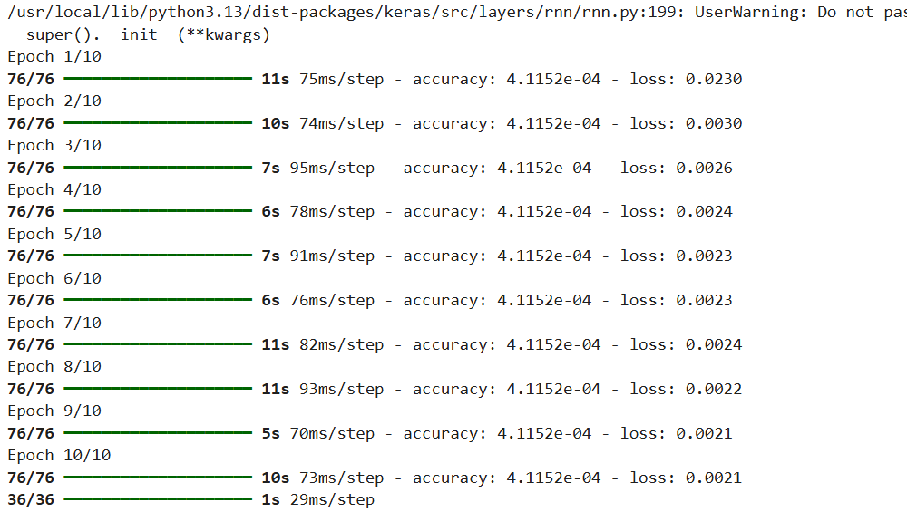
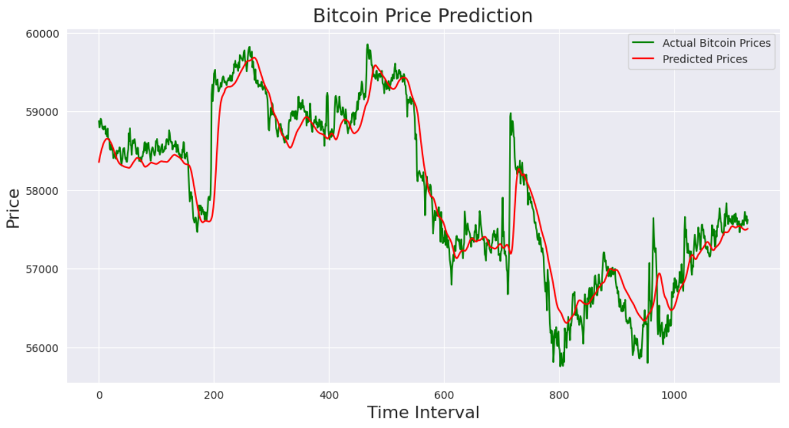

Practical 7
Code:
import numpy as np
import pandas as pd
import yfinance as yf # Keep import but will not use yf.download
import matplotlib.pyplot as plt
from sklearn.preprocessing import MinMaxScaler
from tensorflow.keras.models import Sequential
from tensorflow.keras.layers import LSTM, Dense
try:
crypto_data = pd.read_csv('/content/crypto_500_records.csv')
crypto_data['Date'] = pd.to_datetime(crypto_data['Date'])
crypto_data = crypto_data.set_index('Date')
btc_start_date = crypto_data.index[0].strftime('%Y-%m-%d')
btc_end_date = crypto_data.index[-1].strftime('%Y-%m-%d')
print('Starting Date (from CSV):', btc_start_date)
print('Ending Date (from CSV):', btc_end_date)
crypto_symbols = [col for col in crypto_data.columns if col in ['BTC-USD', 'ETH-USD']]
if not crypto_symbols:
raise ValueError("CSV data does not contain 'BTC-USD' or 'ETH-USD' columns.")
print(f"\nUsing data from CSV for symbols: {crypto_symbols}")
except FileNotFoundError:
print("'/content/crypto_500_records.csv' not found. Please upload the file or adjust the path.")
crypto_data = pd.DataFrame() # Ensure crypto_data is empty if file not found
except Exception as e:
print(f"Error loading or processing /content/crypto_500_records.csv: {e}")
crypto_data = pd.DataFrame() # Ensure crypto_data is empty if error occurs
if not crypto_data.empty:
scalers = {}
scaled_data = pd.DataFrame()
for symbol in crypto_symbols:
if symbol in crypto_data.columns and not crypto_data[symbol].empty:
scaler = MinMaxScaler(feature_range=(0, 1))
scaled_price = scaler.fit_transform(crypto_data[symbol].values.reshape(-1, 1))
scaled_data[symbol] = scaled_price.ravel()
scalers[symbol] = scaler
else:
print(f"Warning: Skipping scaling for {symbol} as column is empty or missing.")
sequence_length = 30
def create_sequences(data, seq_length, target_index):
X, y = [], []
if len(data) > seq_length:
for i in range(len(data) - seq_length):
X.append(data.iloc[i : (i + seq_length)].values)
y.append(data.iloc[i + seq_length, target_index])
return np.array(X), np.array(y)
if 'BTC-USD' in scalers and 'BTC-USD' in scaled_data.columns and not scaled_data['BTC-USD'].empty:
print("\n--- Training Model for BTC-USD ---")
btc_target_index = crypto_symbols.index('BTC-USD')
X_btc, y_btc = create_sequences(scaled_data, sequence_length, btc_target_index)
if len(X_btc) > 0:
split_ratio = 0.8
split_index_btc = int(split_ratio * len(X_btc))
X_train_btc, X_test_btc = X_btc[:split_index_btc], X_btc[split_index_btc:]
y_train_btc, y_test_btc = y_btc[:split_index_btc], y_btc[split_index_btc:]
model_btc = Sequential()
model_btc.add(LSTM(50, return_sequences=True, input_shape=(sequence_length, len(crypto_symbols))))
model_btc.add(LSTM(50))
model_btc.add(Dense(1))
model_btc.compile(optimizer='adam', loss='mean_squared_error')
print("Training BTC-USD model...")
model_btc.fit(X_train_btc, y_train_btc, epochs=10, batch_size=32, verbose=0)
print("BTC-USD model training complete.")
btc_test_predictions = model_btc.predict(X_test_btc)
btc_test_predictions_inverse = scalers["BTC-USD"].inverse_transform(btc_test_predictions)
y_test_btc_inverse = scalers['BTC-USD'].inverse_transform(y_test_btc.reshape(-1, 1))
plt.figure(figsize=(14, 7))
plt.plot(crypto_data.index[split_index_btc + sequence_length:], y_test_btc_inverse, label='Actual (Bitcoin)')
plt.plot(crypto_data.index[split_index_btc + sequence_length:], btc_test_predictions_inverse, label='Predicted (Bitcoin)')
plt.xlabel('Date')
plt.ylabel('Price')
plt.title('Bitcoin Prices - Actual vs Predicted')
plt.legend()
plt.xticks(rotation=45)
plt.grid(True)
plt.tight_layout()
plt.show()
else:
print("Not enough data for BTC-USD to create sequences and train model.")
else:
print("Skipping BTC-USD model training and plotting due to missing data or scaler.")
target_crypto = 'ETH-USD'
if target_crypto in scalers and target_crypto in scaled_data.columns and not scaled_data[target_crypto].empty:
print(f"\n--- Training Model for {target_crypto} ---")
target_index = crypto_symbols.index(target_crypto)
X_target, y_target = create_sequences(scaled_data, sequence_length, target_index)
if len(X_target) > 0:
split_ratio = 0.8
split_index_target = int(split_ratio * len(X_target))
X_train_target, X_test_target = X_target[:split_index_target], X_target[split_index_target:]
y_train_target, y_test_target = y_target[:split_index_target], y_target[split_index_target:]
model_target = Sequential()
model_target.add(LSTM(50, return_sequences=True, input_shape=(sequence_length, len(crypto_symbols))))
model_target.add(LSTM(50))
model_target.add(Dense(1))
model_target.compile(optimizer='adam', loss='mean_squared_error')
print(f"Training {target_crypto} model...")
model_target.fit(X_train_target, y_train_target, epochs=10, batch_size=32, verbose=0)
print(f"{target_crypto} model training complete.")
test_predictions_target = model_target.predict(X_test_target)
test_predictions_target_inverse = scalers[target_crypto].inverse_transform(test_predictions_target)
y_test_target_inverse = scalers[target_crypto].inverse_transform(y_test_target.reshape(-1, 1))
plt.figure(figsize=(14, 7))
plt.plot(crypto_data.index[split_index_target + sequence_length:], y_test_target_inverse, label=f'Actual ({target_crypto})')
plt.plot(crypto_data.index[split_index_target + sequence_length:], test_predictions_target_inverse, label=f'Predicted ({target_crypto})')
plt.xlabel('Date')
plt.ylabel('Price')
plt.title(f'{target_crypto} Prices - Actual vs Predicted')
plt.legend()
plt.xticks(rotation=45)
plt.grid(True)
plt.tight_layout()
plt.show()
else: print(f"Not enough data for {target_crypto} to create sequences and train model.")
else: print(f"Skipping {target_crypto} model training and plotting due to missing data or scaler.")
else: print("Cannot proceed with data preprocessing and model training as crypto_data is empty.")

Output:
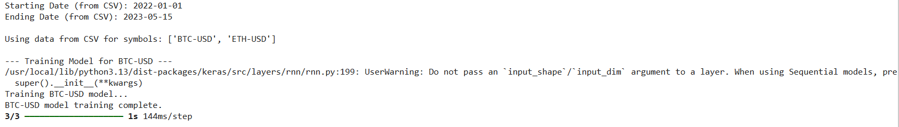
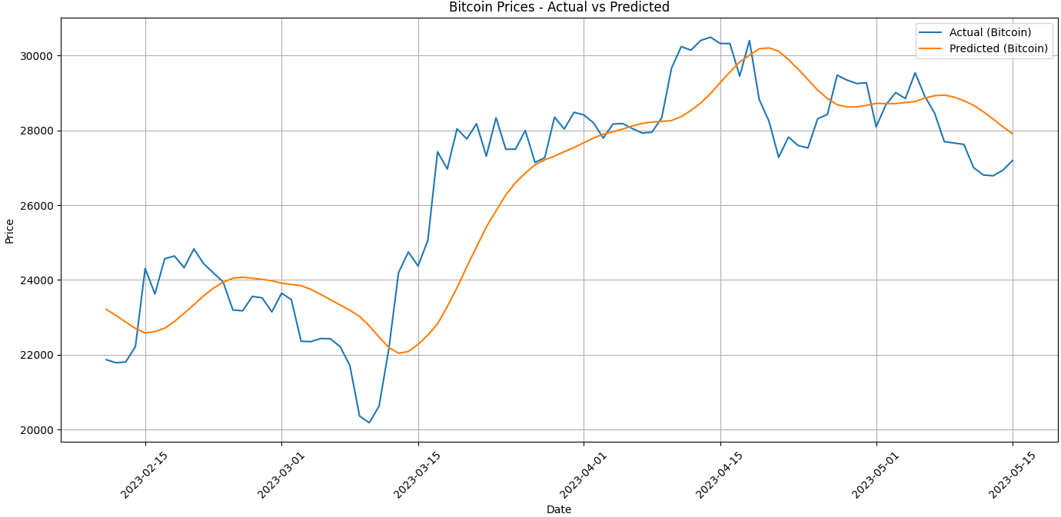
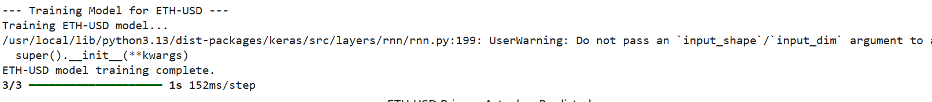
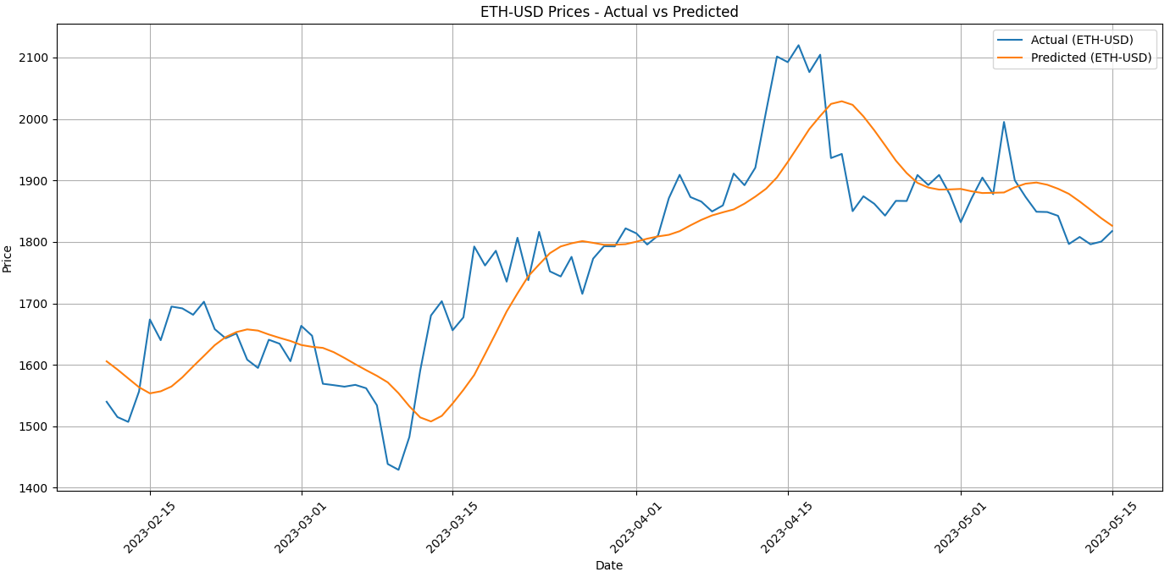
Practical 8
Code:
import hashlib
import time # Import the time module
class Block:
def __init__(self, index, previous_hash, timestamp, data, nonce=0):
self.index = index
self.previous_hash = previous_hash
self.timestamp = timestamp
self.data = data # Assign data to self.data
self.nonce = nonce
self.hash = self.calculate_hash()
def calculate_hash(self):
block_string = str(self.index) + self.previous_hash + str(self.timestamp) + \
str(self.data) + str(self.nonce)
return hashlib.sha256(block_string.encode()).hexdigest()
class Blockchain:
def __init__(self): self.chain = [self.create_genesis_block()]
self.difficulty = 2 # Adjust the difficulty level as needed
def create_genesis_block(self):
return Block(0, "0", int(time.time()), "Genesis Block")
def get_latest_block(self): return self.chain[-1]
def mine_block(self, data): index = len(self.chain)
previous_hash = self.get_latest_block().hash
timestamp = int(time.time())
nonce = 0
new_block = Block(index, previous_hash, timestamp, data, nonce)
while not self.is_valid_proof(new_block):
nonce += 1
new_block.nonce = nonce
new_block.hash = new_block.calculate_hash()
self.chain.append(new_block)
def is_valid_proof(self, block):
target = "0" * self.difficulty
return block.hash[:self.difficulty] == target
def is_chain_valid(self):
for i in range(1, len(self.chain)):
current_block = self.chain[i]
previous_block = self.chain[i-1]
if current_block.hash != current_block.calculate_hash():
return False
if current_block.previous_hash != previous_block.hash:
return False
if not self.is_valid_proof(current_block): return False
return True
my_blockchain = Blockchain()
print("Mining Block 1...")
my_blockchain.mine_block("Block 1 Data")
print("Mining Block 2...")
my_blockchain.mine_block("Block 2 Data")
print("\nBlockchain:")
for block in my_blockchain.chain: print(f"Block #{block.index} - Hash: {block.hash} - Data: {block.data} - Nonce: {block.nonce}")
print(f"\nIs blockchain valid? {my_blockchain.is_chain_valid()}")

Output:
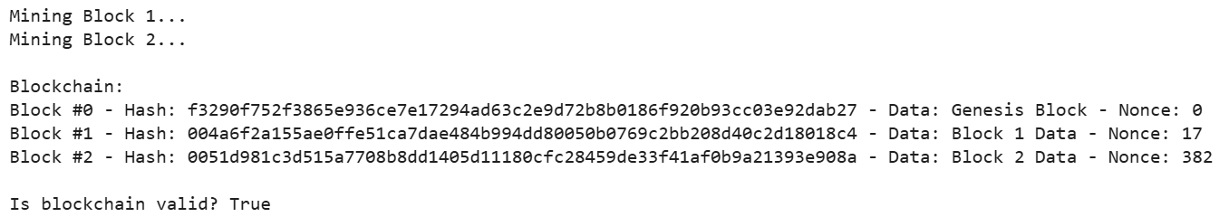

Practical 9
Code:
import hashlib
import time
class Block:
def __init__(self, index, prev_hash, data, nonce=0):
self.index = index
self.prev_hash = prev_hash
self.timestamp = int(time.time())
self.data = data
self.nonce = nonce
self.hash = self.calculate_hash()
def calculate_hash(self):
block_string = f"{self.index}{self.prev_hash}{self.timestamp}{self.data}{self.nonce}"
return hashlib.sha256(block_string.encode()).hexdigest()
class Blockchain:
def __init__(self):
self.chain = [self._create_genesis_block()]
self.difficulty = 2
def _create_genesis_block(self):
return Block(0, "0", "Genesis Block", 0)
def get_latest_block(self):
return self.chain[-1]
def mine_block(self, data):
block = Block(len(self.chain), self.get_latest_block().hash, data)
while not block.hash.startswith("0" * self.difficulty):
block.nonce += 1
block.hash = block.calculate_hash() # Recalculate hash with new nonce
self.chain.append(block)
def is_valid_proof(self, block):
target = "0" * self.difficulty
return block.hash.startswith(target)
def is_chain_valid(self, chain):
for i in range(1, len(chain)):
current_block = chain[i]
previous_block = chain[i-1]
if current_block.hash != current_block.calculate_hash():
return False
if current_block.prev_hash != previous_block.hash:
return False
if not self.is_valid_proof(current_block):
return False
return True
def resolve_conflicts(node1, node2):
if len(node1.chain) >= len(node2.chain):
if not node1.is_chain_valid(node1.chain):
print("Node 1's chain is invalid!")
return False
print("Node 1's chain is chosen (longer or equal).")
return True
else:
if not node2.is_chain_valid(node2.chain):
print("Node 2's chain is invalid!")
return False
node1.chain = list(node2.chain) # Node1 adopts node2's chain
print("Node 2's chain is chosen (longer) and adopted by Node 1.")
return True
node1 = Blockchain() # Define node1
node2 = Blockchain()
print("Node 1 Mining Block 1...")
node1.mine_block("Node 1 - Block 1")
print("Node 2 Mining Block 1...")
node2.mine_block("Node 2 - Block 1")
print("Node 1 Mining Block 2...")
node1.mine_block("Node 1 - Block 2")
print("Node 2 Mining Block 2...")
node2.mine_block("Node 2 - Block 2")
print("\nResolving conflicts...")
resolve_conflicts(node1, node2)
for name, node in [("Node 1", node1), ("Node 2", node2)]:
print(f"\n{name} Blockchain:")
for blk in node.chain:
print(f"Block #{blk.index} - Hash: {blk.hash} - Data: {blk.data} - Nonce: {blk.nonce}")
print(f"\nIs Node 1's blockchain valid? {node1.is_chain_valid(node1.chain)}")
print(f"Is Node 2's blockchain valid? {node2.is_chain_valid(node2.chain)}")

Output:
