Student Name: Sahil Hans UID: 25MCI10088
Branch: M.C.A(A.l & M.L) Section/Group: MAM-1 A
Semester: Second Sem Date of Performance:12/01/2026
Subject Name: TECHINCAL SKILLS Subject Code:

WORKSHEET 1.1
AIM: To design and implement a sample database system using DDL, DML, and DCL commands, including database creation, data manipulation, schema modification, and role-based access control to ensure data integrity and secure, read-only access for authorized users.
S/W Requirement: Oracle Database Express Edition and pgAdmin
OBJECTIVES:
To gain practical experience in implementing Data Definition Language (DDL), Data Manipulation Language (DML), and Data Control Language (DCL) operations in a real database environment. This will also include implementing role-based privileges to secure data.
Given:
An organization wants to design a sample database system to manage Departments, Employees, and Projects. The database must ensure data integrity, controlled access, and proper privilege management for different users.

- Database Design
Create multiple tables such as Department, Employee, and Project.
Define appropriate PRIMARY KEY and FOREIGN KEY constraints.
Enforce NOT NULL, UNIQUE, and CHECK constraints where necessary.

Querry:
CREATE TABLE Departments (
dept_id INT PRIMARY KEY,
dept_name VARCHAR(100) NOT NULL UNIQUE,
location VARCHAR(100) NOT NULL
);

CREATE TABLE Employees (
emp_id INT PRIMARY KEY,
fullname VARCHAR(100) NOT NULL,
salary DECIMAL(10,2) NOT NULL,
dept_id INT NOT NULL
REFERENCES Departments(dept_id)
ON DELETE RESTRICT
ON UPDATE CASCADE,
role VARCHAR(50) NOT NULL
);
CREATE TABLE Projects (
project_id INT PRIMARY KEY,
proj_name VARCHAR(150) NOT NULL,
start_date DATE NOT NULL,
end_date DATE,
dept_id INT NOT NULL
REFERENCES Departments(dept_id)
ON DELETE RESTRICT
ON UPDATE CASCADE
);
- Data Manipulation
Insert sample records into all tables.
Querry:

INSERT INTO Projects (project_id, proj_name, start_date, end_date, dept_id) VALUES
(201, 'Payroll System', '2025-01-10', '2025-06-30', 1),
(202, 'E-Commerce App', '2025-02-01', '2025-12-31', 2),
(203, 'Budget Analysis', '2025-03-15', NULL, 3);
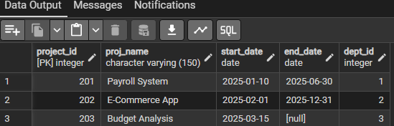

INSERT INTO Employees (emp_id, fullname, salary, dept_id, role) VALUES
(101, 'Amit Sharma', 50000, 1, 'HR Executive'),
(102, 'Neha Verma', 70000, 2, 'Software Engineer'),
(103, 'Rohit Mehta', 90000, 2, 'Project Manager'),
(104, 'Priya Singh', 60000, 3, 'Accountant');
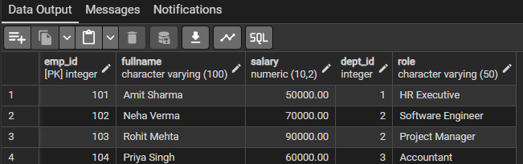

INSERT INTO Departments (dept_id, dept_name, location) VALUES
(1, 'HR', 'Mumbai'),
(2, 'IT', 'Bangalore'),
(3, 'Finance', 'Delhi');
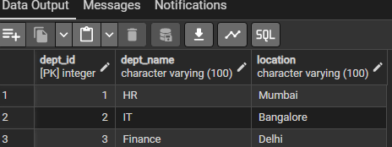
Perform UPDATE operations to modify existing records.
Querry:

Change an employee’s department
UPDATE Employees
SET dept_id = 3
WHERE emp_id = 101;
Extend a project deadline
UPDATE Projects
SET end_date = '2026-03-31'
WHERE project_id = 202;
Perform DELETE operations while maintaining referential integrity.
Querry:
DELETE FROM Employees
WHERE dept_id = 2;
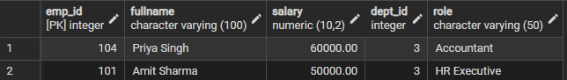

DELETE FROM Projects
WHERE dept_id = 2;
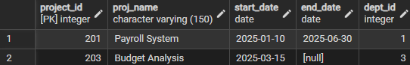
DELETE FROM Departments
WHERE dept_id = 2;
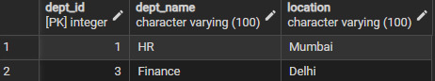

- Access Control & Security
Create a role/user for a reporting staff member.
Querry:
CREATE ROLE reporting_user LOGIN PASSWORD 'report123';


Grant ONLY SELECT privilege on required tables to this role/user.
Querry:
GRANT SELECT ON Departments TO reporting_user;
GRANT SELECT ON Employees TO reporting_user;
GRANT SELECT ON Projects TO reporting_user;

Explicitly REVOKE CREATE privilege so that the user cannot create any database objects.
Querry:
REVOKE CREATE ON SCHEMA public FROM reporting_user;

Ensure the user has read-only access to the database.
Querry:
REVOKE INSERT, UPDATE, DELETE ON ALL TABLES IN SCHEMA public FROM reporting_user;

- Schema Modification
Use ALTER TABLE to add or modify a column.
Querry:
ALTER TABLE Employees
ADD COLUMN email VARCHAR(100);
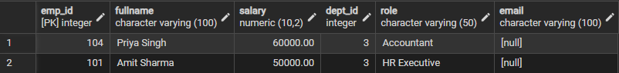
Drop a table that is no longer required using DROP TABLE.
Querry:
DROP TABLE Projects;

Learning Outcomes:
- Understood the basics of relational database design using tables, keys, and relationships.
- Learned to apply primary key and foreign key constraints to maintain data integrity.
- Gained hands-on experience with INSERT, UPDATE, and DELETE operations safely.
- Understood how roles and privileges control access to database objects.
- Learned to use GRANT and REVOKE for implementing read-only users.
- Practiced ALTER TABLE and DROP TABLE for managing database changes.

