

**Project Report**

**By**

SAHIL ALI

**Student1259656**

**SUPERVISOR**

Respected: Sir Muhammad Faizan

**CERTIFICATE**

*This is to certify that*

SAHIL ALI

*Has successfully Designed & Developed*

Air Line

Submitted by:

***Centre Academic Branch***

***Society phase 1 near hik 2 adhai***

|  |  |  |
| --- | --- | --- |
| **S.No** | **Contents** | **Page No** |
| **1** | **Problem Statement/Customer Requirements** | **4** |
| **2** | **Hardware/ Software Requirements** | **5** |
| **3** | **Project Plan** | **6** |
| **4** | **Entity Relationship Diagram** | **7** |
| **5** | **Algorithms(AdminSide+UserSide)** | **8-9** |
| **6** | **Admin Side Screenshots(GUI/Interface)** | **10-13** |
| **7** | **User Side Screenshots (GUI/Interface)** | **14-20** |

**Problem Statement**

**Introduction:**

The problem statement is attached separately in a file “AirlineReservationSystem.doc”

**Standards plan:**

Every code block must have comments. The logic of the program needs to be explained. Proper documentation should be maintained. Complete Project Report along with synopsis, code and documentation should be prepared.

**Documentation:**

No project is complete without documentation. In fact, it is one of the most important activities during the development of a project. The documentation of an ideal project will be in the form of a project report comprising of the following documents:

* Certificate of Completion.
* Table of Contents.
* Problem Definition.
* Customer Requirement Specification.
* Project Plan.
* E-R Diagrams.
* Algorithms.
* GUI Standards Document.
* Interface Design Document.
* Task Sheet.
* Project Review and Monitoring Report.
* Unit Testing Check List.
* Final Check List.

# **Hardware/ Software Requirements**

**Hardware/ Software Requirements**

**Hardware**

* A minimum computer system that will help you access all the tools in the courses is a Pentium 166 or better
* 128 Megabytes of RAM or better

**Software**

* Visual Studio .Net / ASP
* IIS server
* .Net Framework
* Java Virtual Machine/ J2EE server
* Notepad/Java editor
* j2sdk1.4.1_02 (or later).
* EJB Dev Kit
* Java enabled web server
* JSP / Servlets Dev. Kit

**Project Plan**

**Airline**

There will be 2 sides of project, defined as Admin side and user side

**Admin Side :**

It will have login and register of admins and employees which can only access inside it if admin allow them, Flights will be added and listed from admin side ,Bookings , Users ,Queries can be seen from admin side .

**User Side:**

It will have Home which has login and trip details and after loging in user will be taken to Booking page and after registering his Booking, User will be taken to Confirmation Page where he have to confirm his Bookings with certain conditions on it and all these pages have links on from anywhere user can go to other pages.

**ERD(Entity Relationship Diagram)**

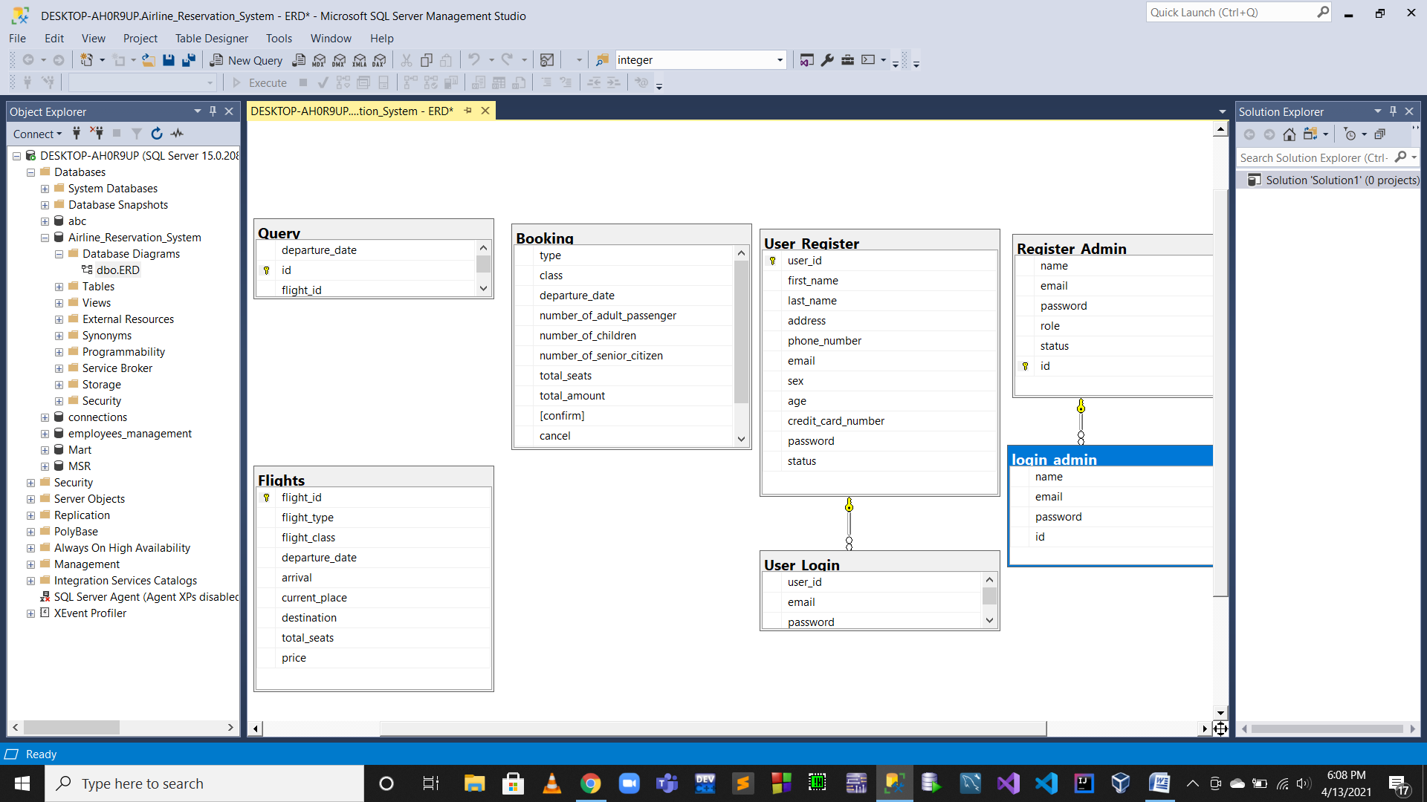

**Algorithms**

Addflight

Listflight

Admin Side

AdminRegister

AdminLogin

Users

Queries

Bookings

User Side

UserLogin

Query

UserRegister

Query

Update User Profile

Booking

Confirmation Of Flight Booking

**Admin Side Screenshots**

**Admin Index**

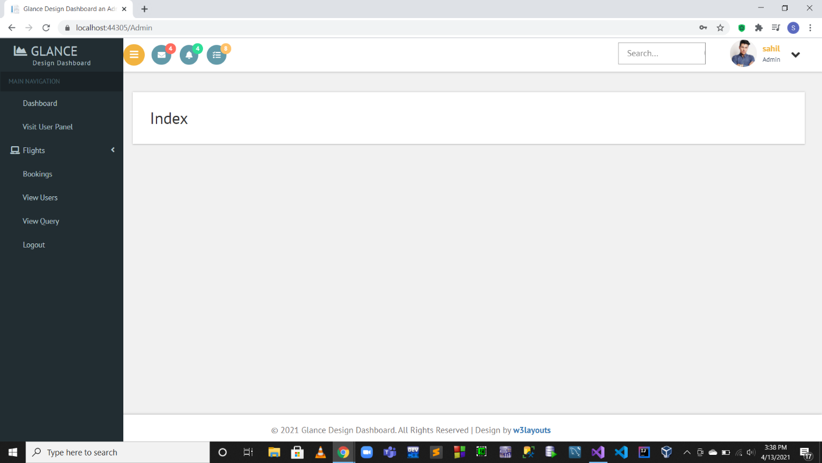

**Admin Register**

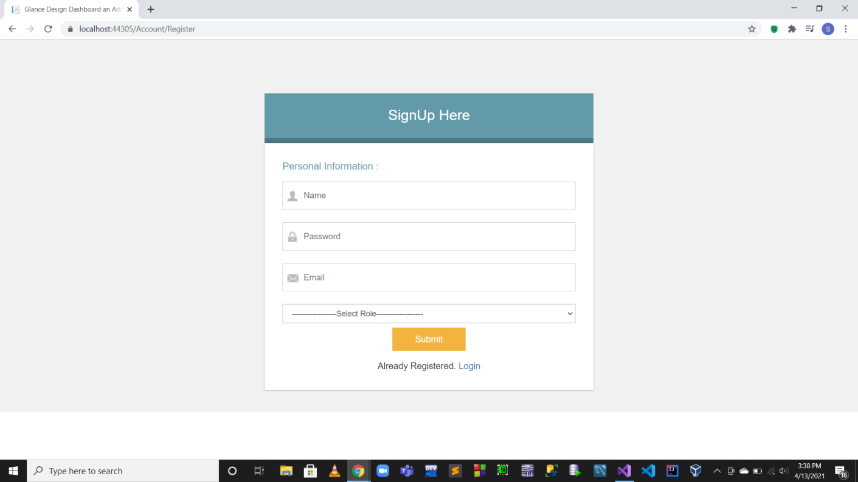

**Admin Login**

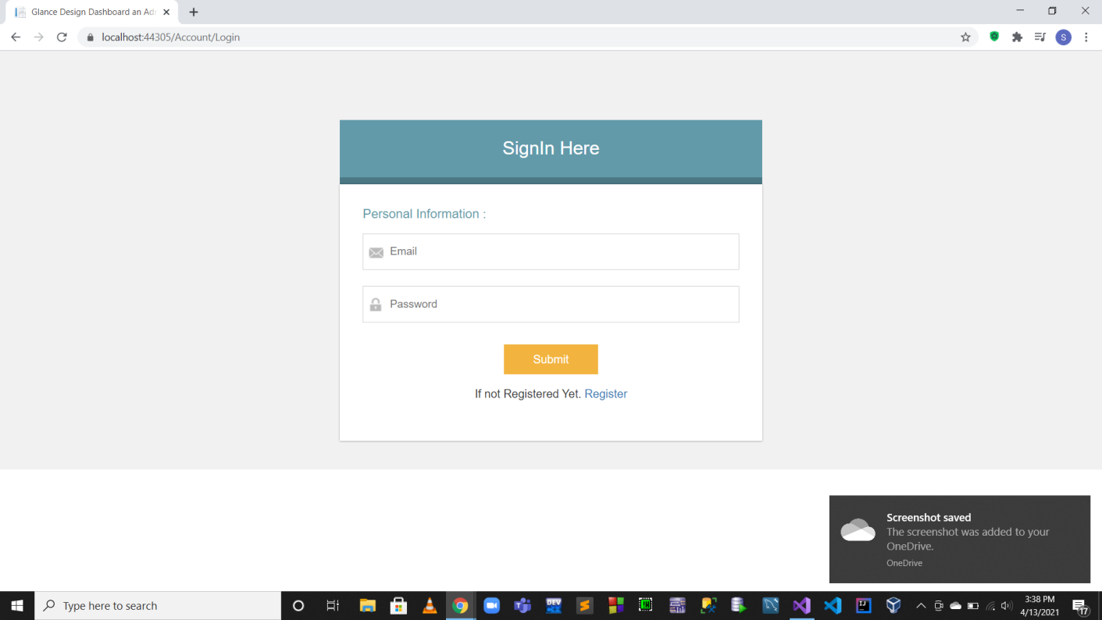

**Admin List Flights**

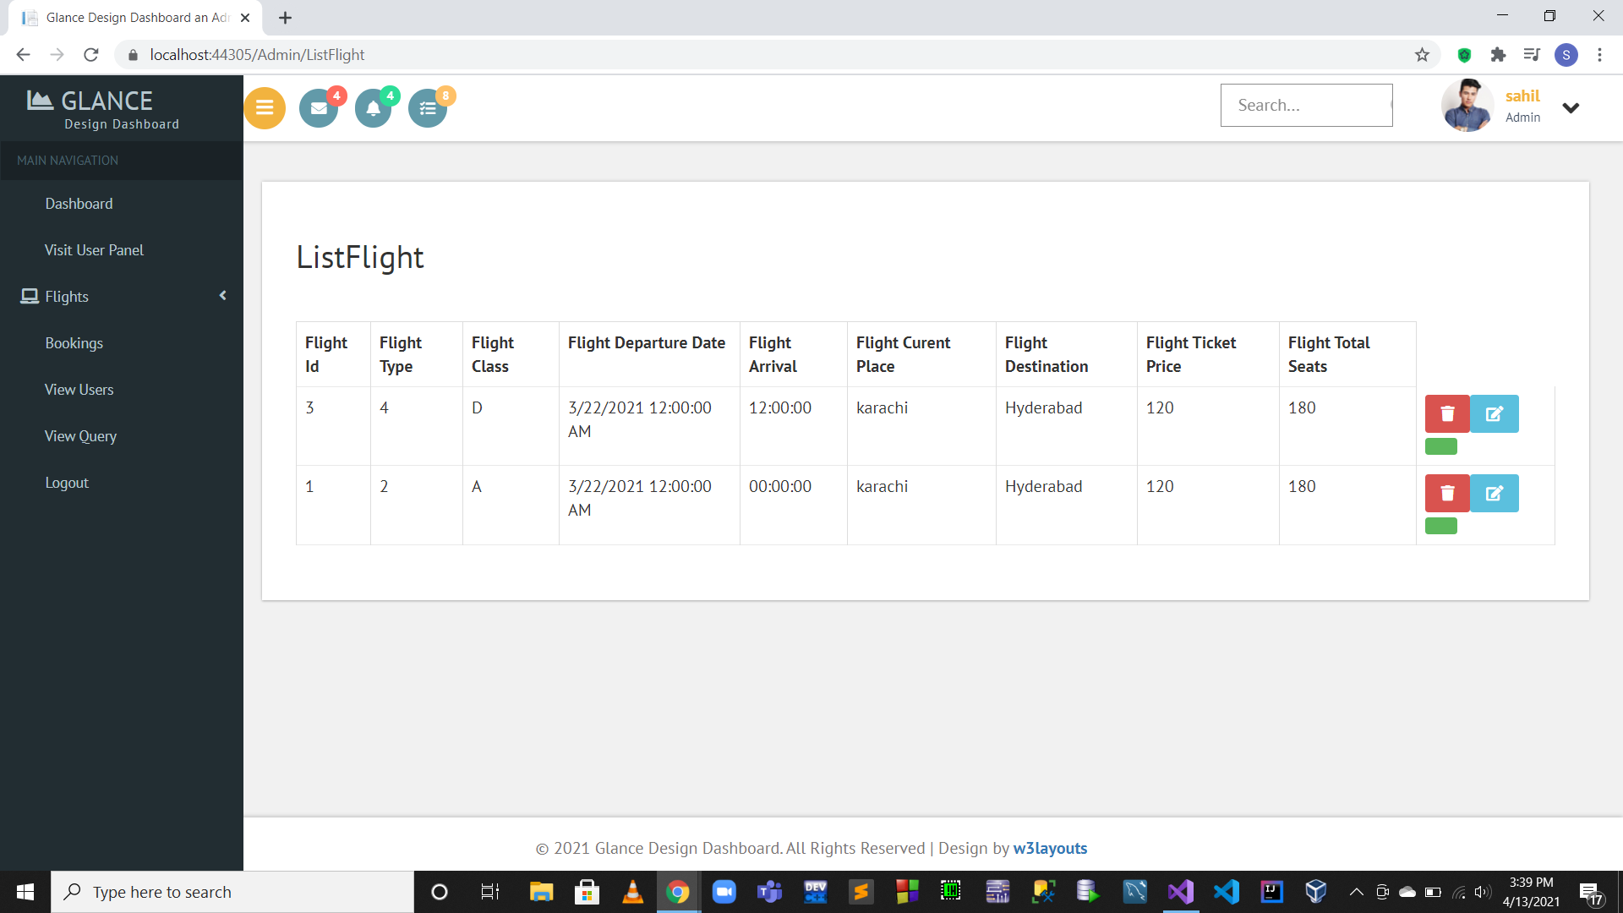

**Admin List User Bookings**

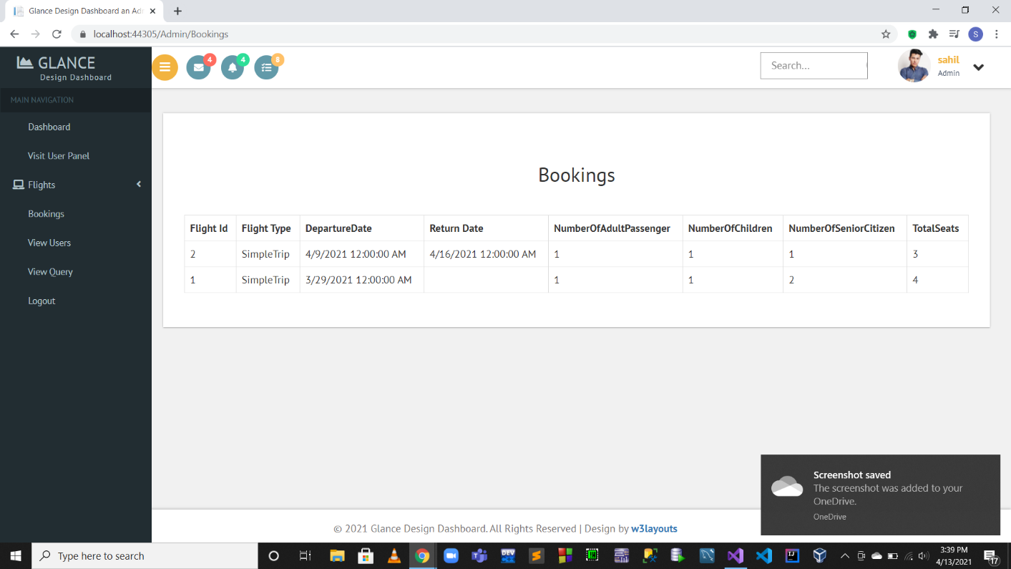

**Admin List User Queries**

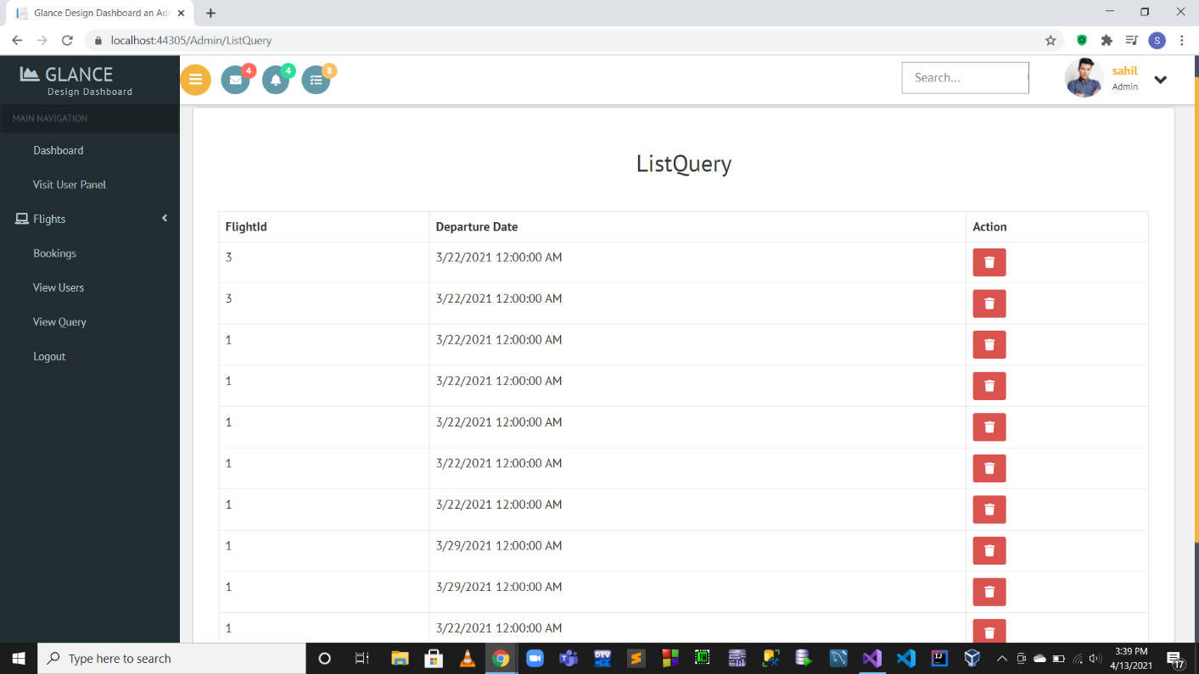

**Admin List Logins**

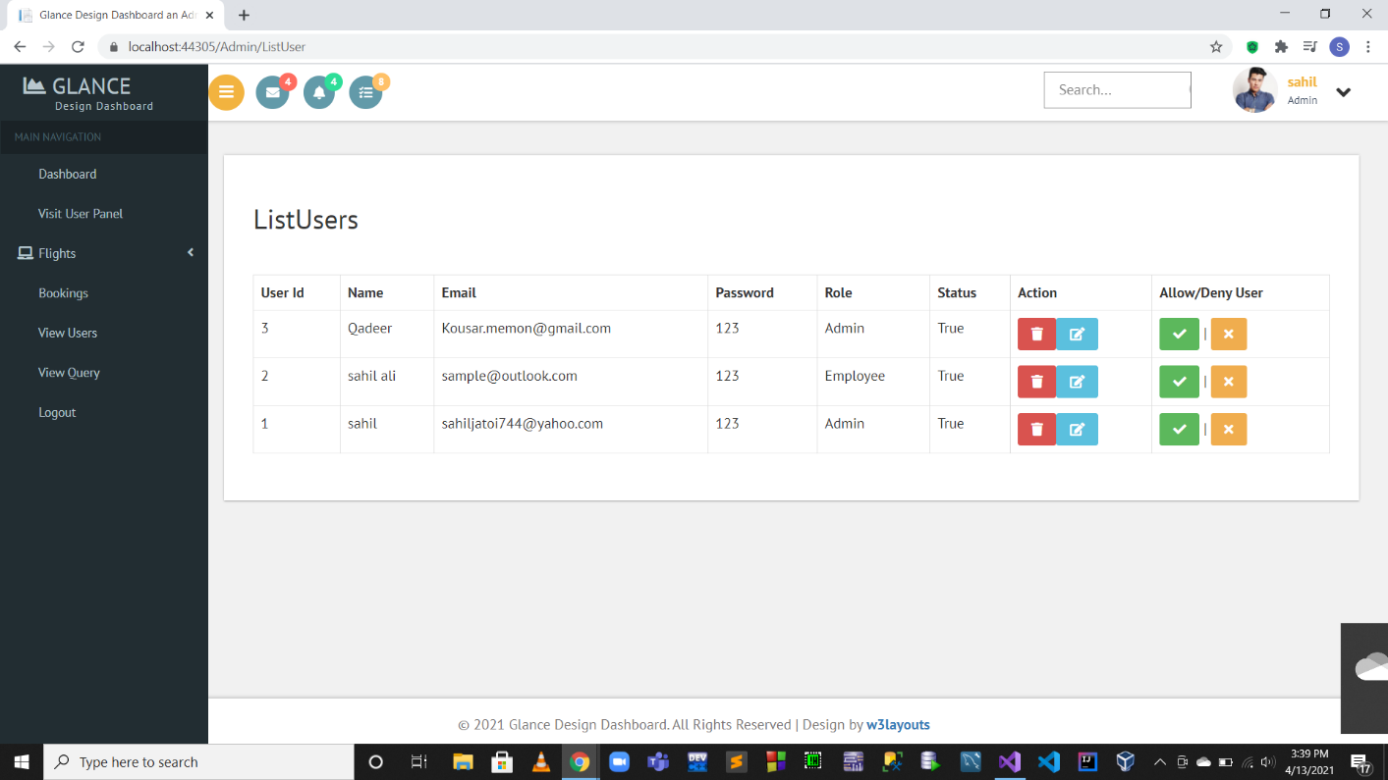

­­

**User Side Screenshots**

**User Index and Login**

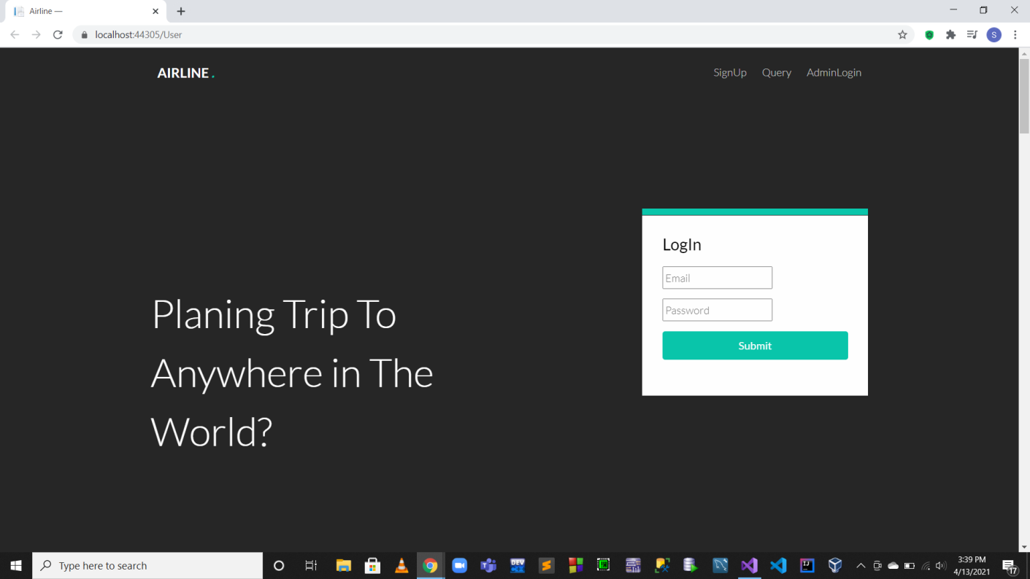

**User Gallery**

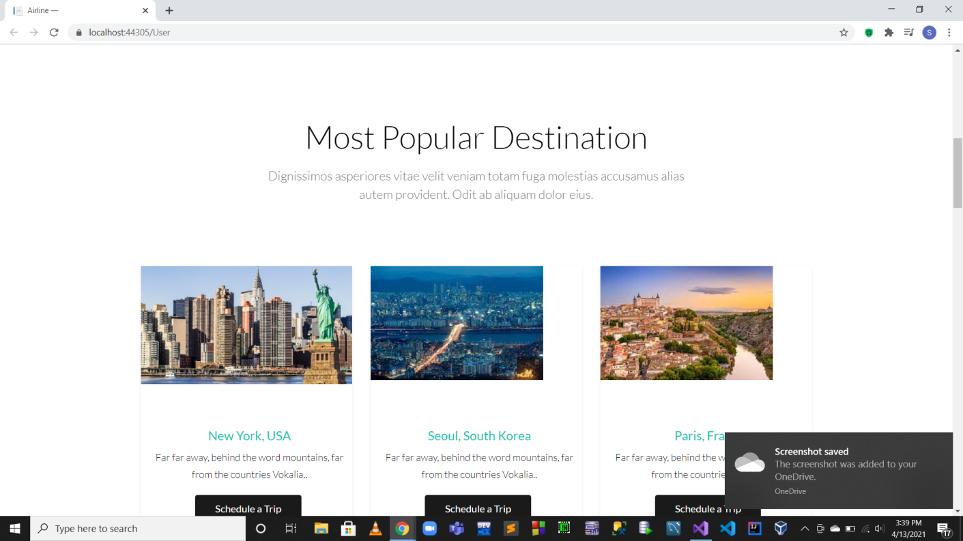

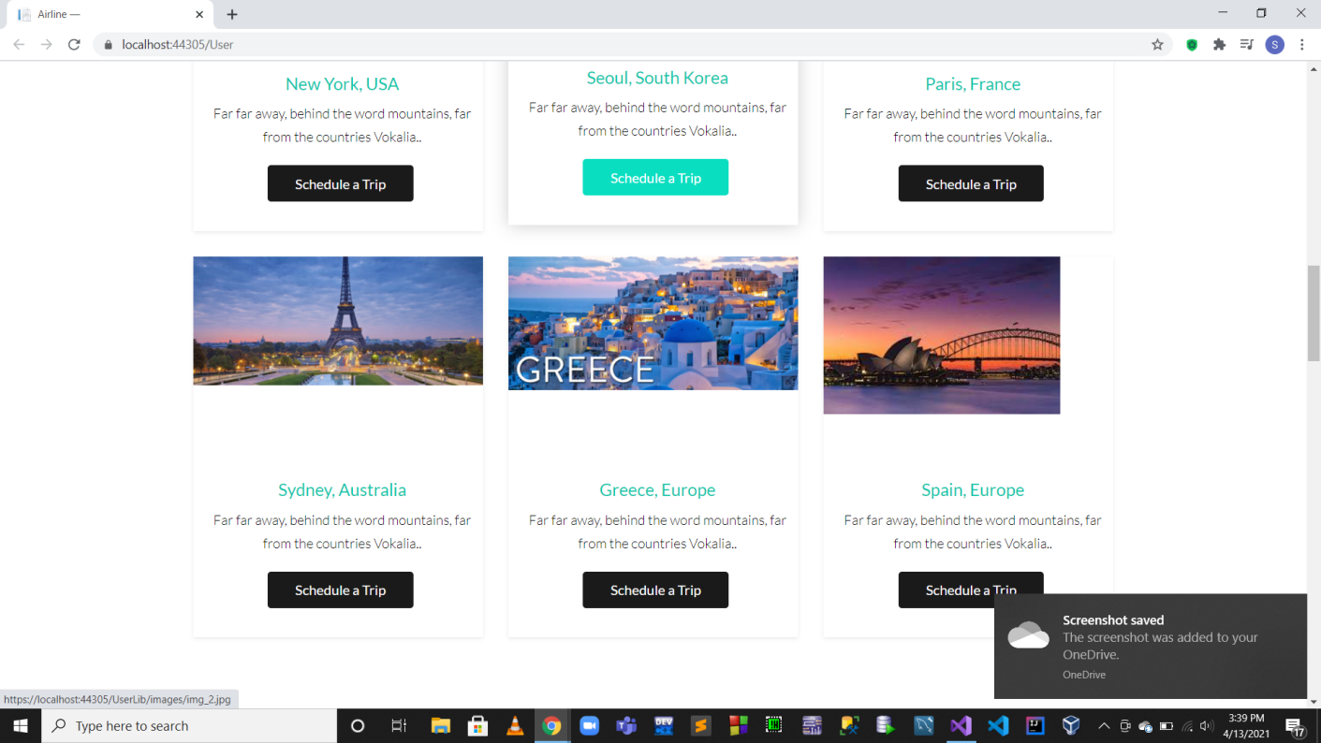

**User Booking Steps**

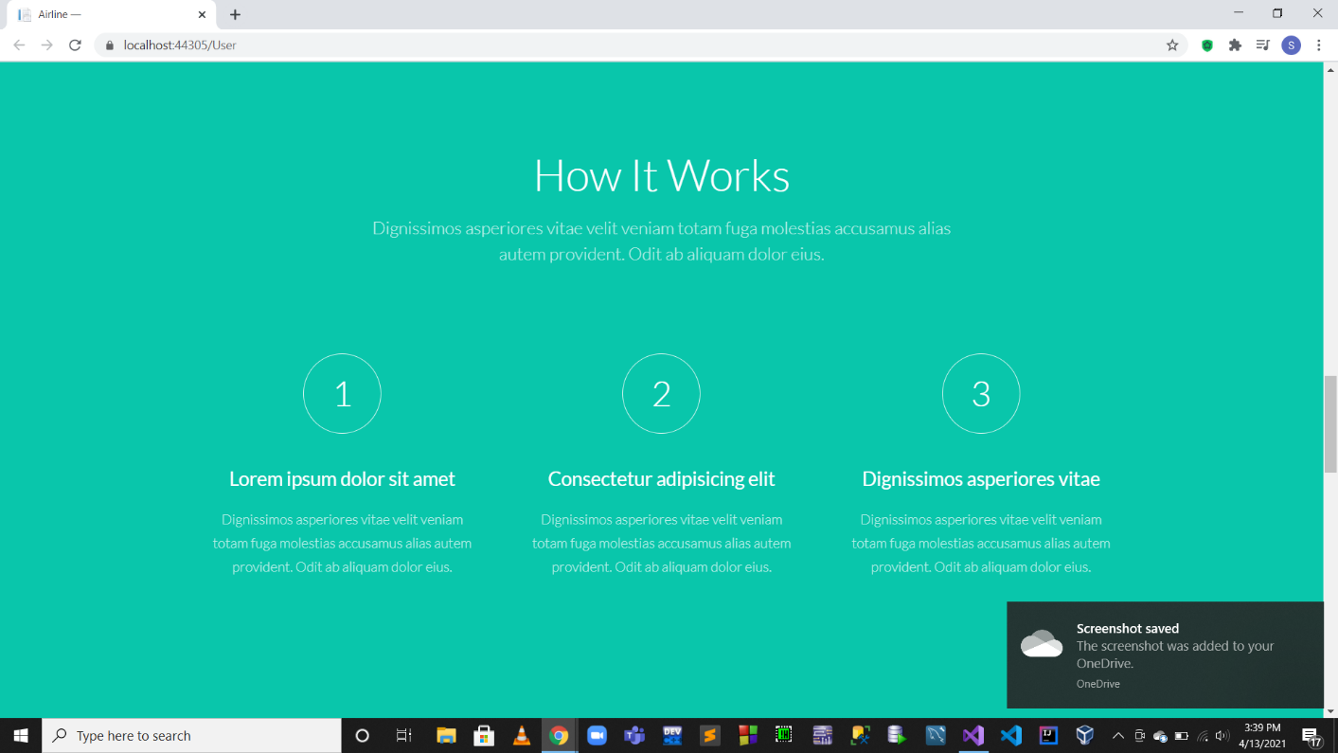

**Airline Success Rate**

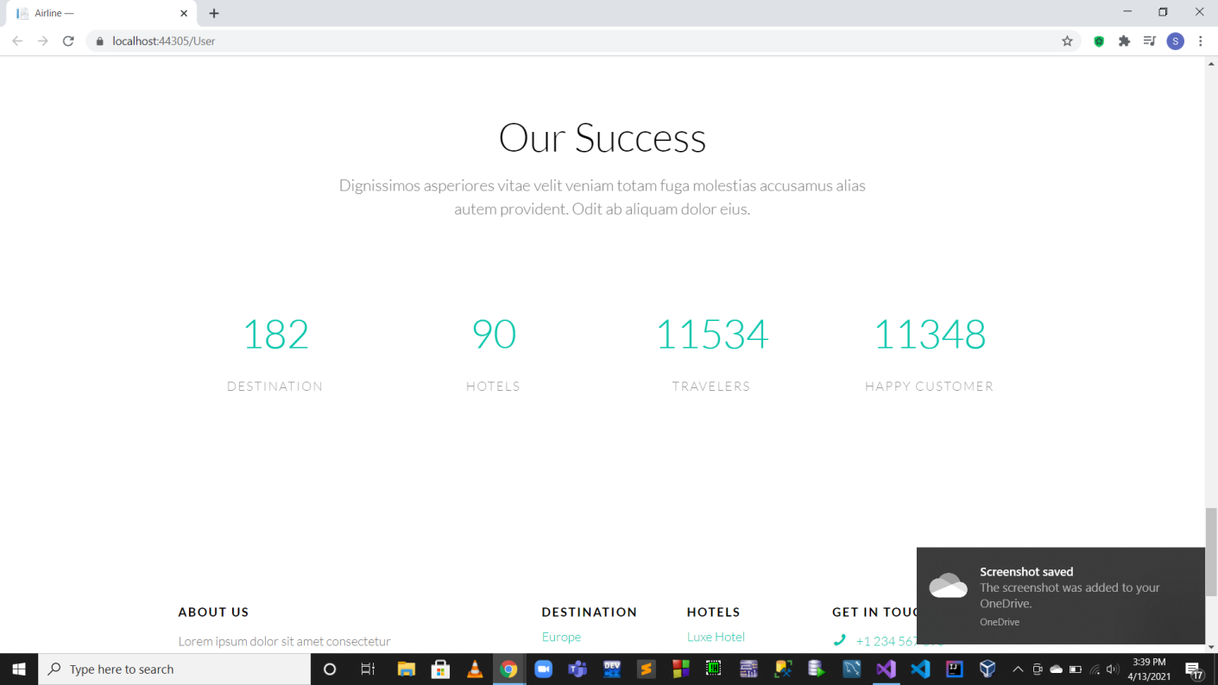

**User Footer**

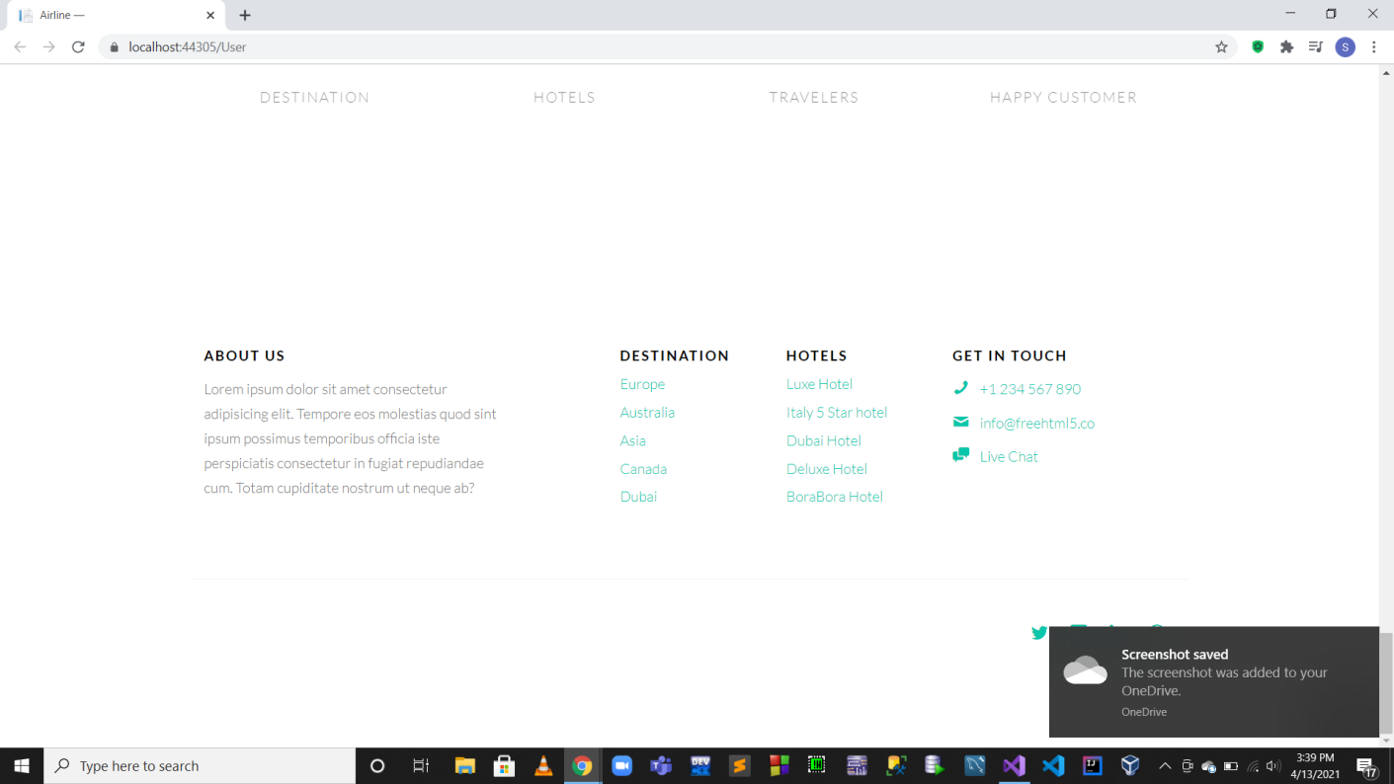

**User Signup**

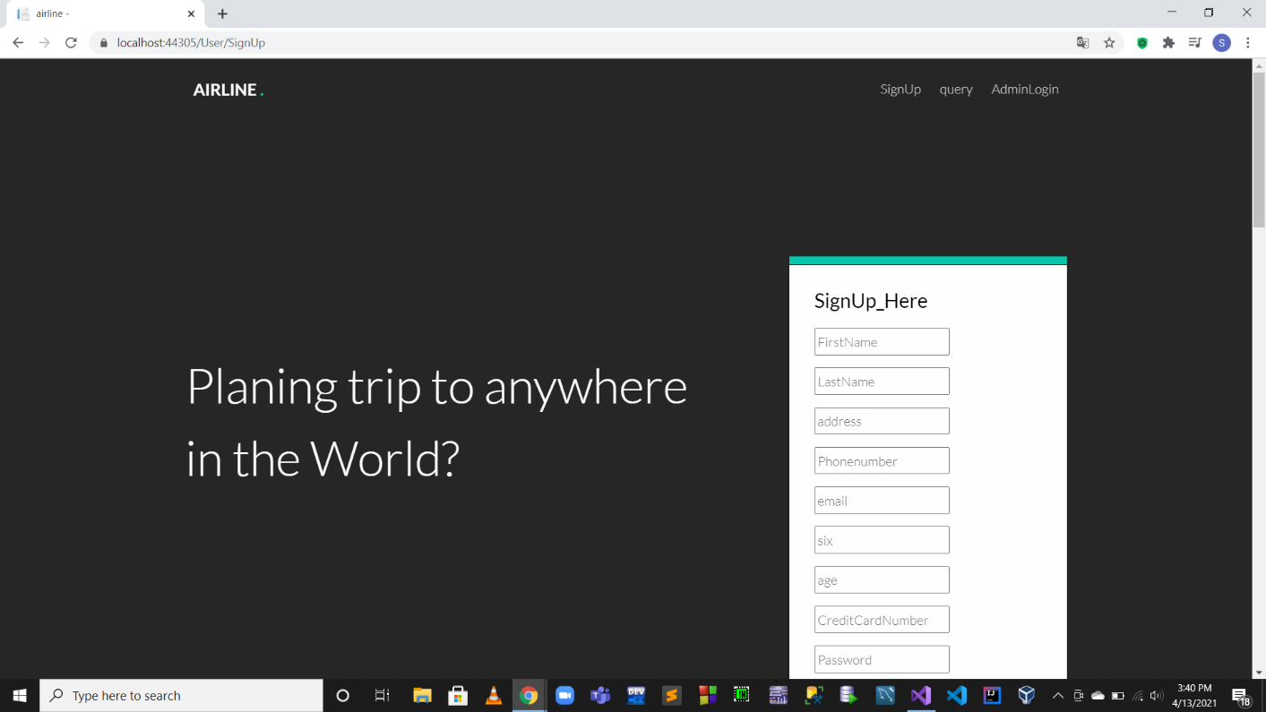

**User Booking**

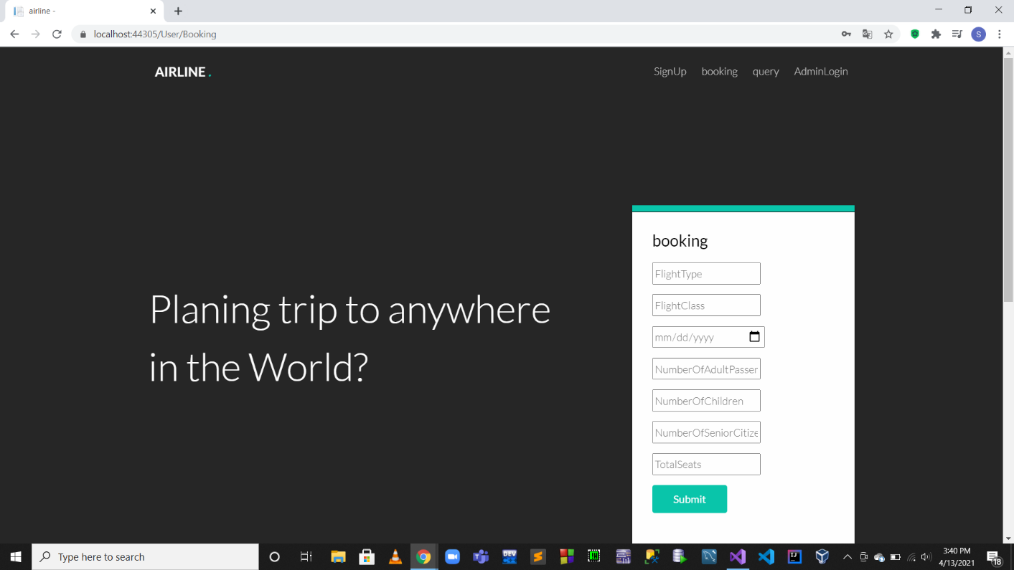

**User Confirmation**

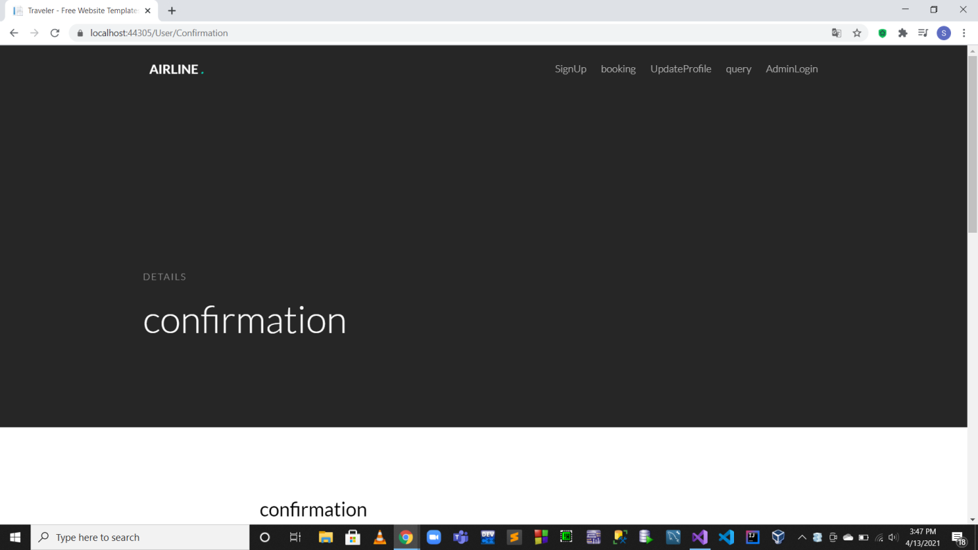

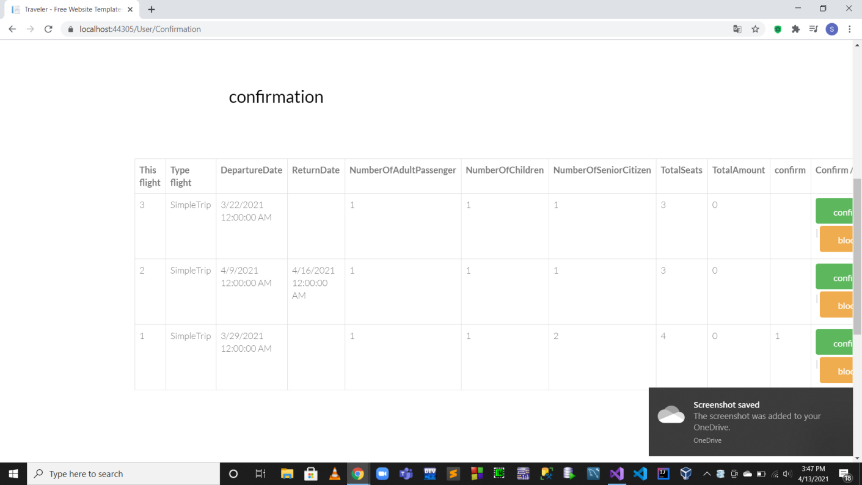

**UserUpdateProfile**

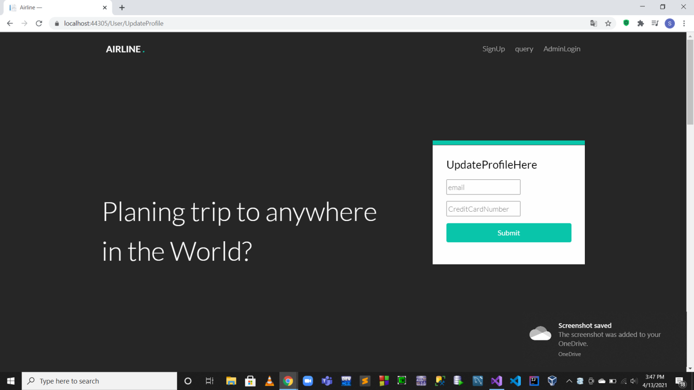

**User Query**

