Road Damage Detection from UAV Images
Using DAL-YOLO
Submitted by:
Sahil Kumar Singh 20233239
Sashwat Barthwal 20233558
Sakaray Varsha 20233241
Sathammai Sathappan 20233559
Under the guidance of
Dr. Abhimanyu Sahu

COMPUTER SCIENCE AND ENGINEERING DEPARTMENT
MOTILAL NEHRU NATIONAL INSTITUTE OF TECHNOLOGY
ALLAHABAD, PRAYAGRAJ-211004, INDIA
October 30, 2026

Road Damage Detection from UAV Images Using DAL-YOLO

1) Abstract
This project tries to find road damage in drone (UAV) images. We use the UAVROAD dataset and an object detection model called DAL-YOLO, which is built on top of YOLO11n. The model must find 14 types of objects, for example cracks, potholes, damaged curbs, trash and water on the road. The notebook converts the dataset labels to YOLO format, makes an 8:1:1 train-validation-test split (4,001 / 500 / 501 images), adds custom modules to YOLO11n and trains for 300 epochs. On the held-out test split the model gets precision 0.684, recall 0.573, F1 0.623, mAP@50 0.593 and mAP@50-95 0.354, compared with 0.635, 0.542, 0.585, 0.556 and 0.340 for the baseline YOLO11n.

2) Introduction

2.1 Background and problem statement
Roads need regular checking for cracks, potholes and other damage. Checking by people on foot is slow. Drones can take many pictures in short time, but someone still has to look at every image. In this project we treat the task as object detection: for each UAV image, the model must draw a box around each damage and give its class name. Many damages are thin and long (like cracks) or very small, so this is harder than normal object detection. [3, 4]

2.2 Objectives and scope
The main goals are: prepare the UAVROAD data for YOLO, build a DAL-YOLO style model by changing YOLO11n, train it, and compare it with a normal YOLO11n model on the held-out test split using precision, recall, F1 (derived from mean precision and recall) and mAP. The scope is only box detection on still images.

2.3 Notebook structure and evidence
IPCV_cleaned_outputs_preserved_map50_90.ipynb
|
|-- Sec 1-2 # Environment and seed (Colab, Tesla T4), Kaggle download
|-- Sec 3 # VOC XML -> YOLO, class audit, 8:1:1 split (seed 56)
|-- Sec 4 # C3k2_DAttention model, architecture checks
|-- Sec 5 # Baseline backup, custom checkpoint load check
|-- Sec 6 # Held-out TEST evaluation of both models, metrics tables
|-- Sec 7-9 # Metric plots, confusion matrices, qualitative examples
|
Colab files (/content/):
|-- baseline_weights_backup/best.pt, last.pt # baseline checkpoints
|-- dal_best.pt # custom model checkpoint
|-- uavroad_experiment/test_metrics_summary.csv, per_class_test_ap.csv

3) Methodology and Implementation

3.1 Dataset organization and preparation
The UAVROAD dataset is downloaded from Kaggle (sweetodd/uavroad). It has JPEG images and Pascal VOC XML label files. The notebook keeps only images that have a matching XML file, which gives 5,002 image-label pairs (no image was missing its XML). The pairs are shuffled with random seed 56 and split 8:1:1.

Each XML box is changed to YOLO format (class, x-centre, y-centre, width, height), divided by image size and scaled to the range 0-1.
A mapping table joins similar raw names into 14 classes, for example "marking" and "damaged marking" both become class 6. The notebook stops with an error if an XML class name is not in the table, so no class is dropped silently; 136 malformed or invalid boxes were skipped. The class "damaged sign" has no boxes in this data, so 13 of the 14 classes have examples. The test split contains 9 background images with no box.
Table 1: Data split used in the notebook. [1]
Split | Images | Used for
Train | 4,001 | Model training
Validation | 500 | Checkpoint selection
Test | 501 (945 boxes) | Final held-out evaluation
Total | 5,002

3.2 Model architecture
The base model is YOLO11n (about 2.6 million parameters). The notebook writes four custom modules in PyTorch, following the DAL-YOLO idea [3]:
C3k2_DAttention: a C3k2 block where the bottleneck uses deformable convolution (torchvision deform_conv2d) with learned offsets and a sigmoid mask. This lets the filter follow the shape of thin and bent cracks. It replaces layer 8 of the backbone.
LSCBNHead: a lighter detection head. Each scale first goes through a 1x1 conv to 256 channels, then one shared 3x3 conv is used for all scales, with a separate BatchNorm for each scale. It replaces the Detect layer (layer 23).
DASI: a fusion block that mixes low-level, high-level and upsampled features with a learned sigmoid weight.

3.3 Training configuration
Training uses the Ultralytics trainer on a Tesla T4 GPU in Google Colab. Main settings: 300 epochs, image size 640, batch 16, SGD with learning rate 0.01, momentum 0.937 and weight decay 0.0005, 3 warm-up epochs and mixed precision (AMP). The default YOLO augmentation is used: mosaic (switched off for the last 10 epochs), horizontal flip 0.5, HSV colour change, translate 0.1, scale 0.5, random erasing 0.4 and RandAugment. Early stopping patience is 100. [1]

3.4 Evaluation
Section 6 loads the baseline (baseline_weights_backup/best.pt) and the custom checkpoint (dal_best.pt) and evaluates both on the held-out test split (501 images, 945 boxes) at image size 640 and batch 16, without any further training. We report precision, recall, mAP@50, mAP@50-95 and per-class AP@50-95 (F1 in this report is derived from mean P and R). Confusion matrices and bar charts are plotted, and 4 random test images are shown with ground truth, baseline and custom boxes side by side. [1]

4) Results and Discussion

Metric | Baseline YOLO11n | Custom DA-YOLO11n | Difference
Precision | 0.6353 | 0.6841 | +0.0488
Recall | 0.5419 | 0.5726 | +0.0307
F1-score | 0.5849 | 0.6234 | +0.0385
mAP@50 | 0.5559 | 0.5931 | +0.0372
mAP@50-95 | 0.3395 | 0.3537 | +0.0142

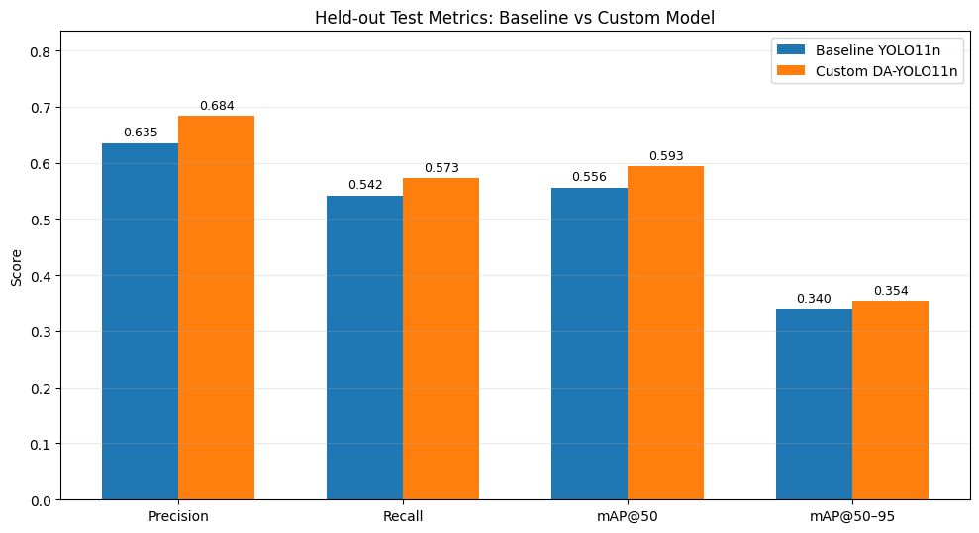
Figure 1: Held-out test metrics of baseline YOLO11n and Custom DA-YOLO11n (F1 not plotted; derived from mean P and R). [1, Sec. 7]

4.1 Class-wise behaviour
Class | Boxes | Precision | Recall | mAP@50 | mAP@50-95
Transverse crack | 129 | 0.728 | 0.713 | 0.730 | 0.418
Longitudinal crack | 139 | 0.652 | 0.683 | 0.695 | 0.354
Alligator crack | 51 | 0.616 | 0.608 | 0.604 | 0.378
Oblique crack | 20 | 0.586 | 0.550 | 0.481 | 0.320
Repair | 92 | 0.711 | 0.859 | 0.825 | 0.632
Pothole | 20 | 0.732 | 0.800 | 0.826 | 0.454
Damaged marking | 28 | 0.710 | 0.500 | 0.522 | 0.209
Greenbelt encroachment | 32 | 0.615 | 0.250 | 0.250 | 0.096
Damaged guardrail | 62 | 0.759 | 0.694 | 0.733 | 0.411
Damaged drainage | 35 | 0.836 | 0.872 | 0.928 | 0.748
Damaged curb | 227 | 0.683 | 0.237 | 0.272 | 0.144
Trash | 86 | 0.584 | 0.302 | 0.332 | 0.160
Water | 24 | 0.683 | 0.375 | 0.512 | 0.274
All | 945 | 0.684 | 0.573 | 0.593 | 0.354

Damaged drainage, repair, pothole, damaged guardrail and the two main crack types are found well (mAP@50 0.69 to 0.93). Damaged curb is the biggest problem: it has the most boxes (227) but recall is only 0.237, so most curbs are missed. Greenbelt encroachment (recall 0.250), trash (0.302) and water (0.375) also have low recall. Compared with the baseline, the custom model gives its largest AP@50-95 gains for water (+0.098), damaged guardrail (+0.082) and pothole (+0.078), but is lower for repair (-0.060), damaged drainage (-0.030) and oblique crack (-0.022). Many classes have 35 or fewer boxes in the test split (for example oblique crack 20, pothole 20, water 24), so their numbers can change a lot with a different split.
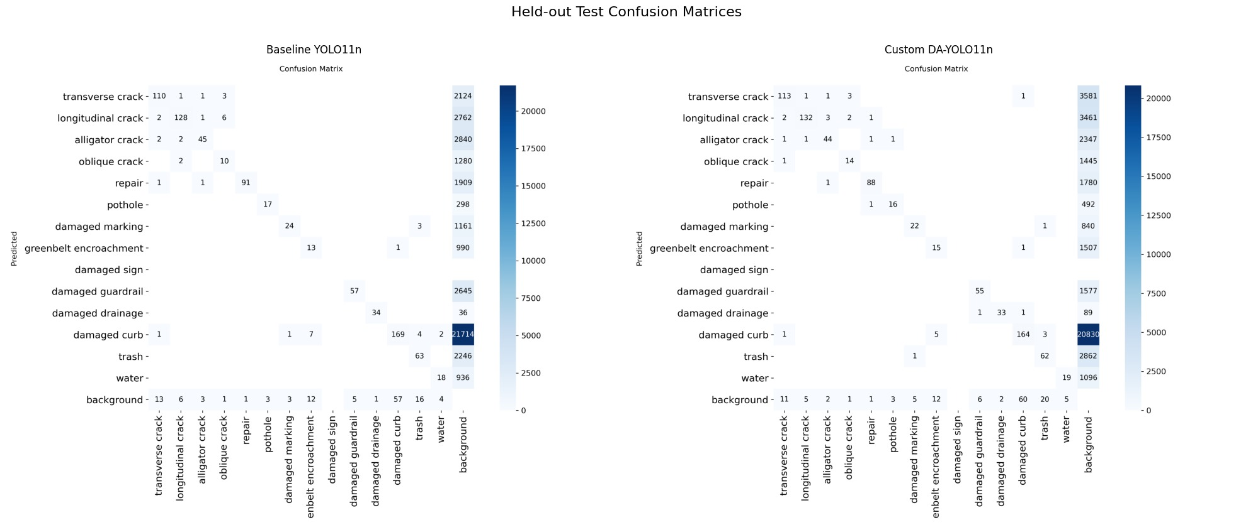
Figure 2: Held-out test confusion matrices. Left: baseline YOLO11n. Right: Custom DA-YOLO11n. [1, Sec. 7]
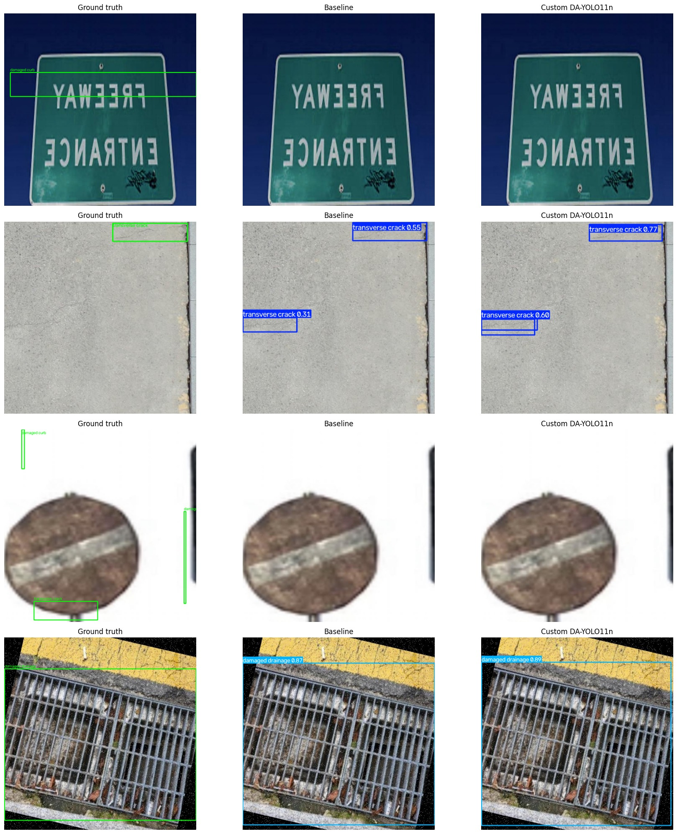
Figure 3: Four random test images. Left: ground truth. Middle: baseline YOLO11n. Right: Custom DA-YOLO11n. [1, Sec. 8]
In Figure 3, both models detect the transverse crack in the second row and the drain in the fourth row; the custom model gives higher confidence for the cracks (0.77 and 0.60 against 0.55 and 0.31) and a similar score for the drain (0.89 against 0.87). In the first and third rows neither model finds the ground-truth damaged curb boxes, which matches the low curb recall in Section 4.1.

5) Conclusion
We have implemented a full pipeline: download UAVROAD, change labels to YOLO format, split the data, add custom modules to YOLO11n, train, and evaluate the baseline and the custom model on the held-out test split with metrics, confusion matrices and example images. The best model gets mAP@50 0.593 and mAP@50-95 0.354, against 0.556 and 0.340 for the baseline. Cracks, repair, pothole, guardrail and drainage are detected well, but curbs, greenbelt, trash and water are often missed.

References
[1] Project artifact: IPCV_cleaned_outputs_preserved_map50_90.ipynb, Sections 1 to 9, source code and saved outputs.
[2] UAVROAD dataset, Kaggle: https://www.kaggle.com/datasets/sweetodd/uavroad
[3] DAL-YOLO paper on UAV road damage detection (C3k2-DAttention, ASPN/DASI, LSCBN head), on which the custom modules are based.
[4] Jocher, G. and Qiu, J. (2024). Ultralytics YOLO11. https://github.com/ultralytics/ultralytics
[5] Dai, J. et al. (2017). Deformable Convolutional Networks. ICCV, 764-773. https://arxiv.org/abs/1703.06211

