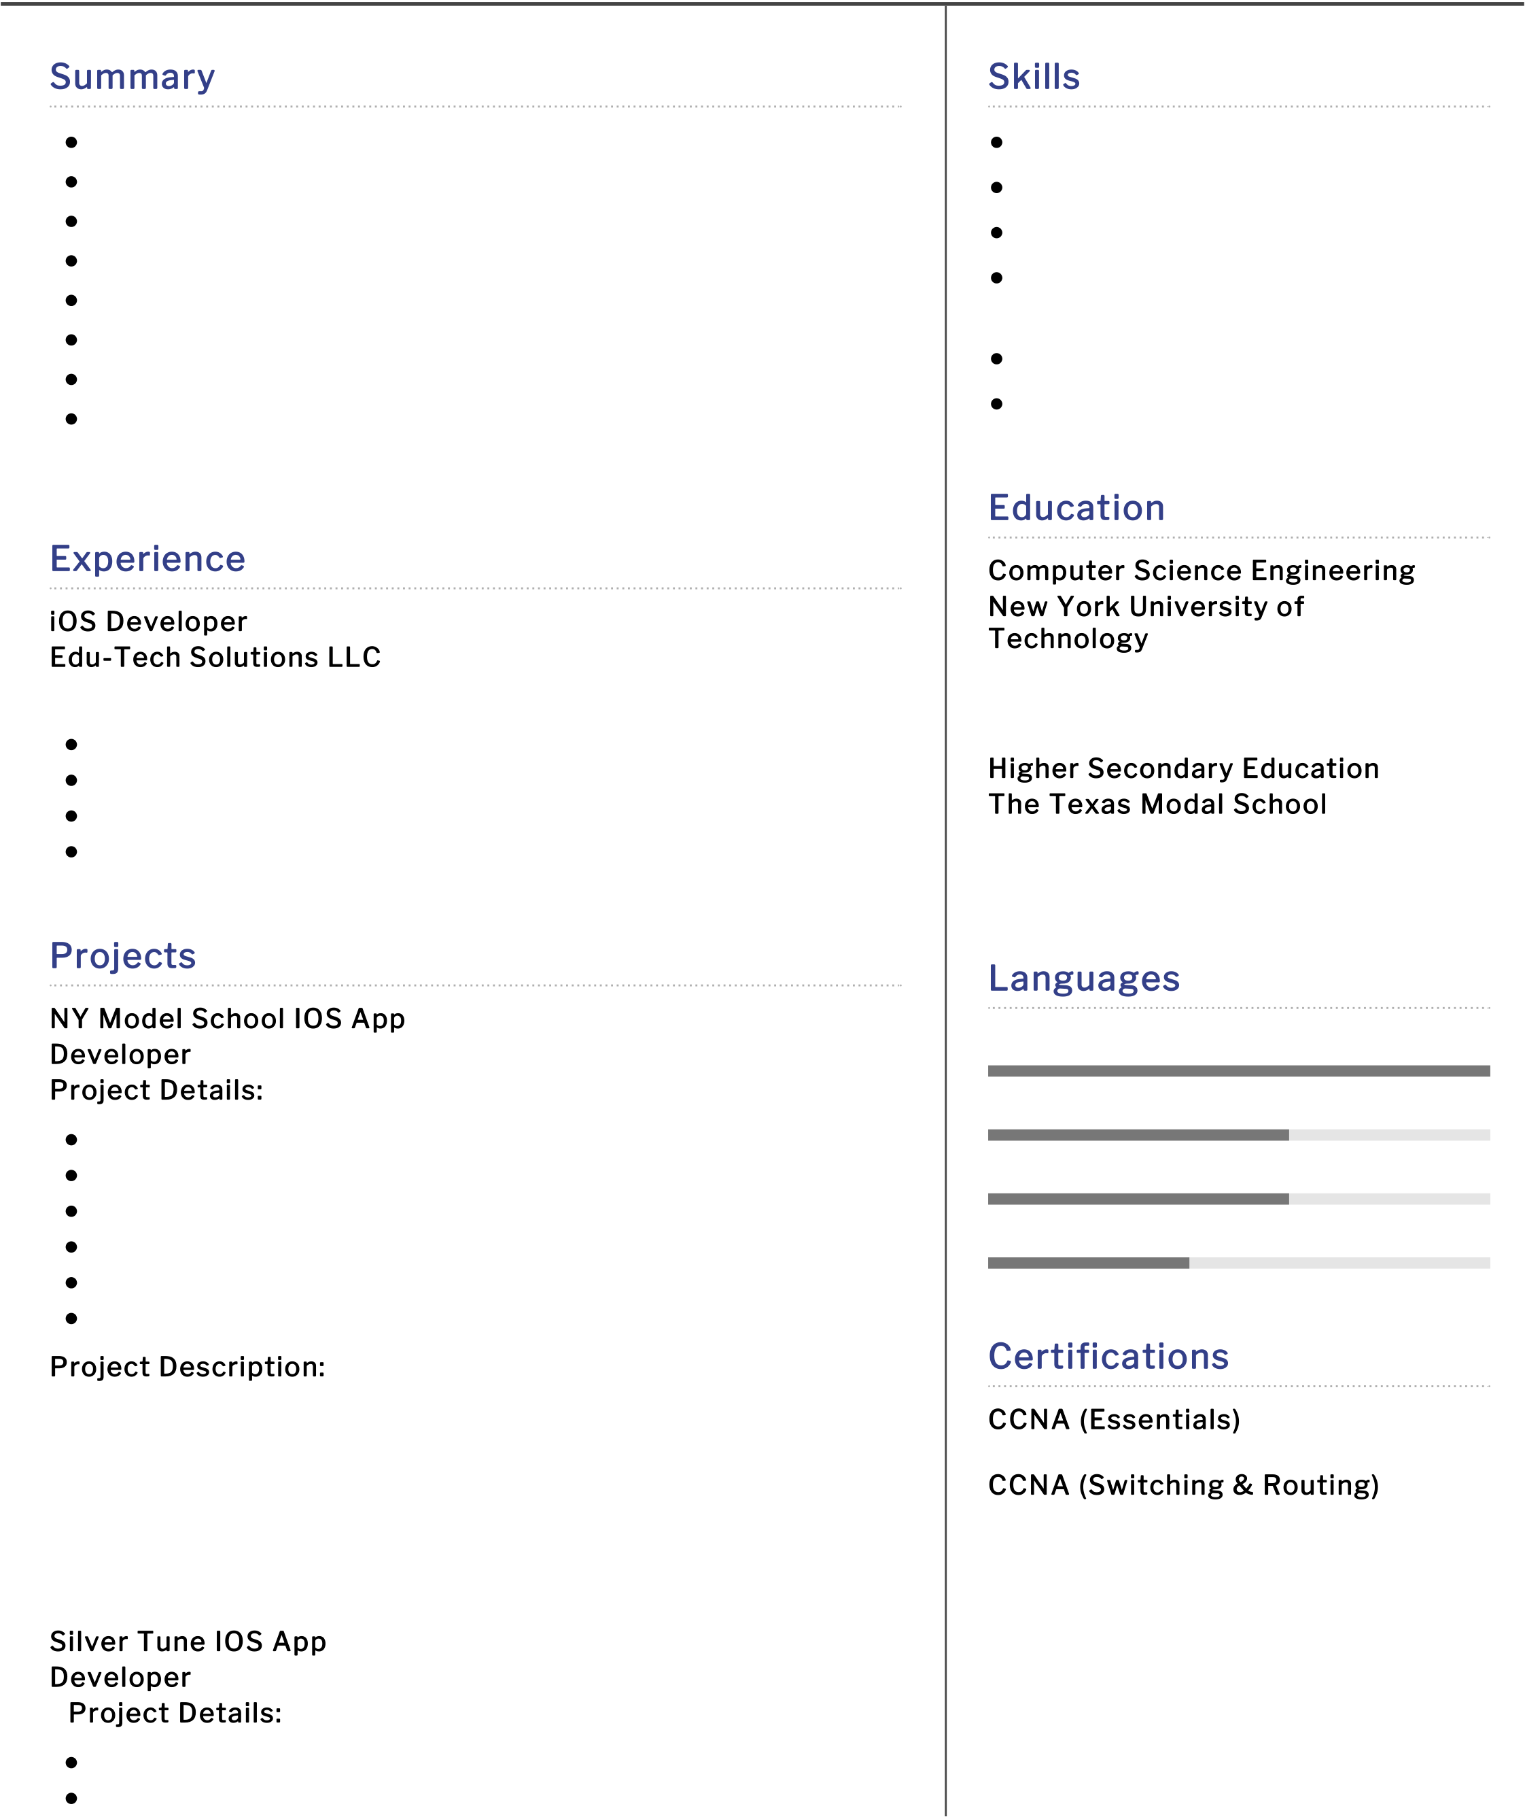

Samantha Ru   
I O S D E V E L O P E R

|  |  |  |  |
| --- | --- | --- | --- |
|  |  |  |  |
| info@resumekraft.com | +1-202-555-0135 | New York, US | linkedin.com/in/sam |
| Summary | | Skills |
| 4.7 years of experience in developing applications on IOS | | Swift,Objective -c |
| Work experience in swift programming | | Tools: XCode |
| Decent knowledge MVC Architecture | | FrameWorks: Cccoa Touch |
| Experience in using SOAP, REST-based Web Services | | Data Storage: |
| Good knowledge on push notification integration | |
| Sqlite,Plist,NSUserDefaults |
| Experience in App submission to the app store | |
| ParsingTechniques:XML,JSON |
| Excellent communication skills | |
| WebServices: REST, SOAP |
| Passionate to secure a challenging position in a reputable | |

organization to expand my learnings, knowledge, and skills.

Education

|  |  |
| --- | --- |
| Experience  iOS Developer  Edu-Tech Solutions LLC Jul 2017 - Present As a Developer i am responsible in  Gathering the requirments  Create UIDesigns screens  Total end-end development and  Uploading the app to AppStore  Projects  NY Model School IOS App  Developer  Project Details:  Project Name: NY Model School  Client: NY Model International Public School  Role: Developer  Organization: My Class Board Educational Solutions | Computer Science Engineering  New York University of  Technology  Aug 2013 - Nov 2017  with aggregate of 6.3%  Higher Secondary Education  The Texas Modal School Jun 2011 - May 2013  with an aggregate of 78%  Languages  English  German  French  Chines |

Tools: XCode   
Technologies: IOS -10,Swift

|  |  |
| --- | --- |
| Project Description:  This application is developed to constantly update parents about their child school activities also build a parent-teacher association. They can check grades, attendance status, assignments, and more. Parents will constantly receive alerts regarding the latest announcements, | Certifications  CCNA (Essentials)  CCNA (Switching & Routing) |

pictures, etc. parents will be kept updated with everything that is   
happening at NY Model International Public School

Silver Tune IOS App   
Developer  
 Project Details:

Project Name: Silver Tune   
Client: Silver Tune   
Role: Developer   
Organization: My Class Board Educational Solutions   
Tools: XCode   
Technologies: IOS -10, swift

Project Name: Silver Tune   
Client: Silver Tune

 Role: Developer

 Organization: My Class Board Educational Solutions

 Tools: XCode

 Technologies: IOS -10, swift

Project Description:   
This application is developed to constantly update parents about their child school activities also build a parent-teacher association. They can check grades, attendance status, assignments, and more. Parents will constantly receive alerts regarding the latest announcements,   
pictures, etc. parents will be kept updated with everything that is happening at Silver Tune

Bring-up International school   
Developer   
Project Details:

 Project Name: Bring-up International school

 Client: Bring-up International school

 Role: Developer

 Organization: My Class Board Educational Solutions

 Tools: XCode

 Technologies: IOS -10, swift

Project Description:

This application is developed to constantly update parents about their child school activities also build a parent-teacher association. They can check grades, attendance status, assignments, and more. Parents will constantly receive alerts regarding the latest announcements,   
pictures, etc. parents will be kept updated with everything that is happening at Bring-up