EMIPredict AI
Intelligent Financial Risk Assessment Platform
Exploratory Data Analysis Report — Findings and Business Insights
Scope
Fifteen visualisations across 404,800 loan applications and five lending products, examining target distributions, correlation structure, demographic patterns and product-level behaviour. Each figure states the question it answers and the business insight it produced.

Contents

1. Analysis Approach
This analysis was performed after the data quality pipeline had corrected the defects present in the raw extract — corrupted numeric strings, inconsistent categorical labels, out-of-range credit scores and missing values. Working on uncleaned data would have produced misleading distributions.
Charts are drawn from the full cleaned dataset except where noted; scatter plots and the pairplot use bounded random samples with a fixed seed, since rendering 400,000 points adds no information beyond a well-chosen sample.
Property | Value
Records analysed | 404,800
Input variables | 25 across six categories
Target variables | emi_eligibility (3 classes) · max_monthly_emi (continuous)
Lending products | 5, near-uniformly distributed at ~80,000 records each
Visualisations | 15

2. Target Variables

Figure 1. EMI Eligibility Class Distribution
How are outcomes distributed, and is the dataset balanced?
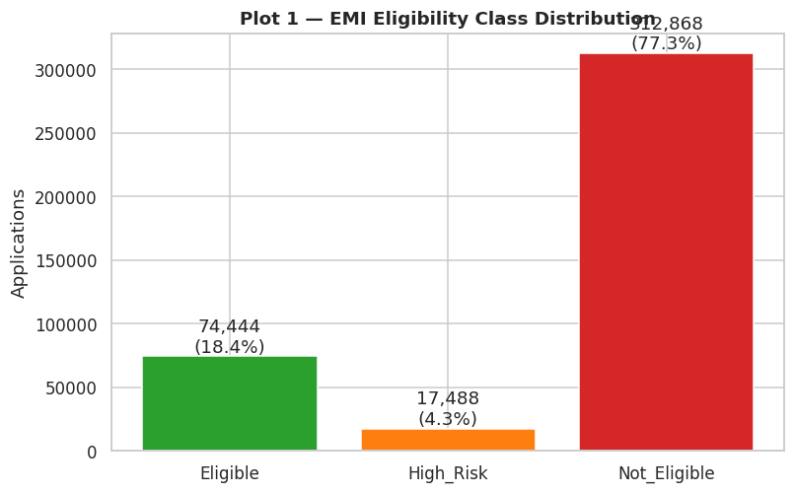
Distribution of the classification target across 404,800 applications.
The portfolio is severely imbalanced: 77.3% Not Eligible, 18.4% Eligible and only 4.3% High Risk. This is the single most consequential property of the dataset. A model that predicts 'reject' for every application would score 77% accuracy while being commercially useless, so accuracy alone cannot be used to select a model. All later evaluation uses macro-averaged metrics, which weight the three classes equally, and the classifiers are trained with balanced class weights.

Figure 2. Distribution of Maximum Safe Monthly EMI
What does affordable capacity look like across the customer base?
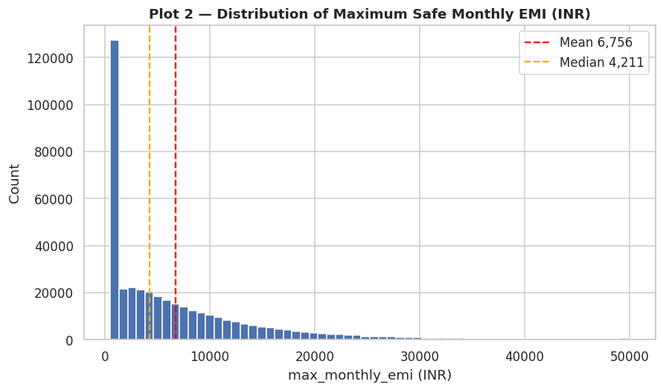
Distribution of the regression target with mean and median marked.
Capacity is strongly right-skewed. The median customer can service roughly ₹4,200 per month, while a small affluent segment supports ₹20,000 and above. Because the mean sits above the median, error metrics that square residuals — such as RMSE — will be dominated by the affluent tail, so mean absolute error is reported alongside RMSE to give a fair picture of typical error.

3. Product and Segment Behaviour

Figure 3. Eligibility Mix by Lending Product
Do approval rates differ across the five EMI products?
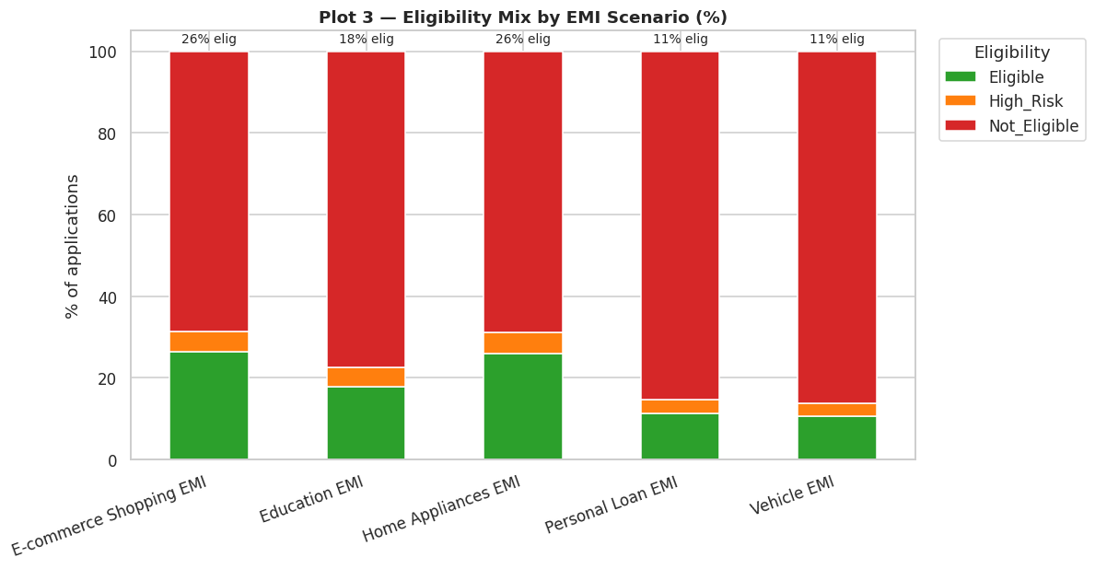
Percentage composition of eligibility outcomes within each lending product.
Approval rates vary by a factor of 2.5, from 26.3% for e-commerce shopping EMI down to 10.6% for vehicle finance. The driver is ticket size relative to income: e-commerce and home appliance loans are small and short, while vehicle and personal loans are five to ten times larger. This variation is a genuine property of the products, not inconsistent underwriting, and it justifies product-specific credit policy.

Figure 10. Eligibility by Employment Type
Does employment stability affect approval?
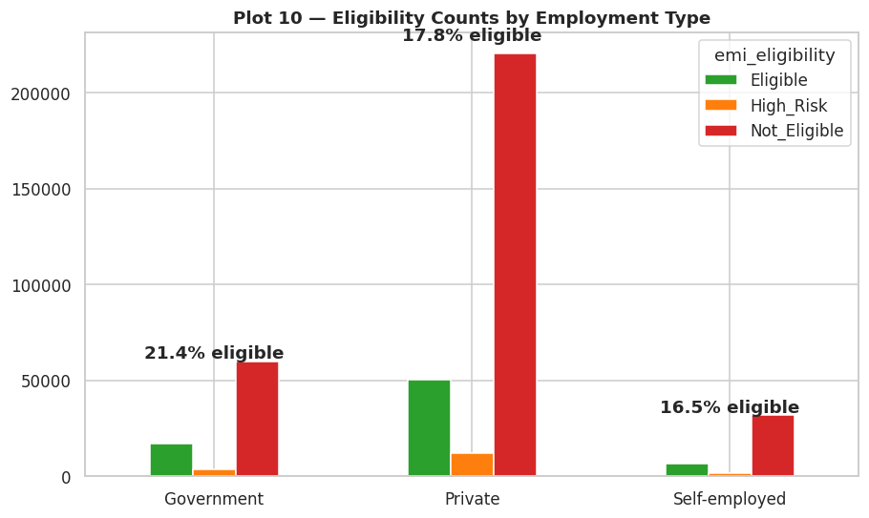
Eligibility counts and approval rate by employment category.
Government employees record the highest eligibility rate at 21.4%, private employees 17.8%, and self-employed applicants 16.5%. The ordering matches underwriting intuition — predictable income supports better terms — but the 4.3 percentage point spread is narrower than commonly assumed. Once affordability is measured properly, self-employed applicants are not disproportionately rejected, which argues against blanket policy restrictions on that segment.

Figure 13. Requested Tenure by Lending Product
How does repayment period vary by product?
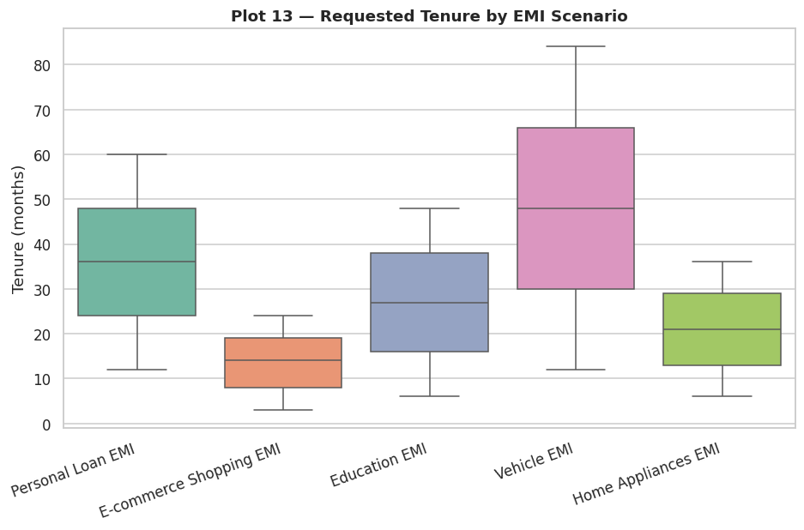
Distribution of requested tenure within each lending product.
Tenure is product-driven: vehicle loans extend to 84 months while e-commerce EMIs stay under 24. Since tenure and product encode overlapping information, tree-based models can exploit their interaction directly. Retaining the product as a model input allows a single model pair to serve all five products rather than maintaining five separate models.

4. Financial Drivers of Eligibility

Figure 4. Correlation Matrix of Numeric Variables
Which variables move together, and what drives the targets?
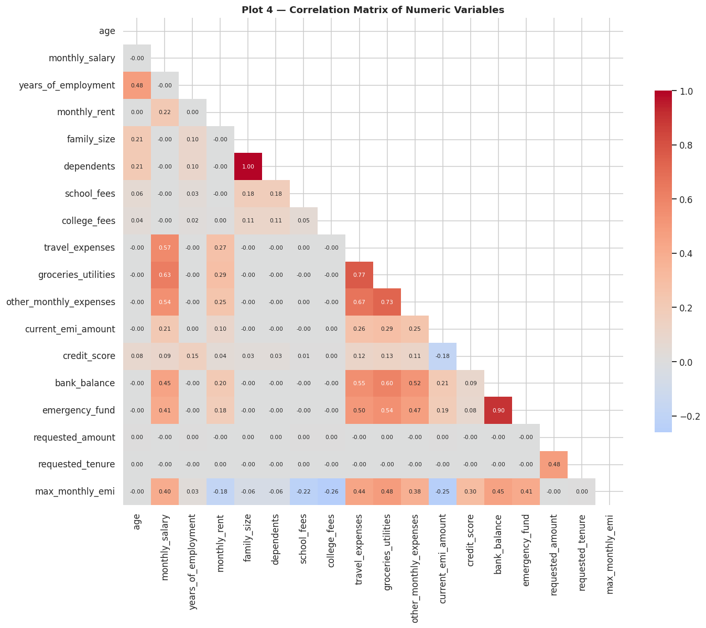
Pearson correlation across all numeric variables and both targets.
Monthly salary shows the strongest positive correlation with maximum safe EMI, while existing EMI commitments and household expenses pull it down. Requested amount and tenure correlate with each other — a consequence of product design — but only weakly with capacity, confirming that affordability is a property of the applicant rather than of the request.

Figure 5. Monthly Salary by Eligibility Class
How strongly does income separate the outcome classes?
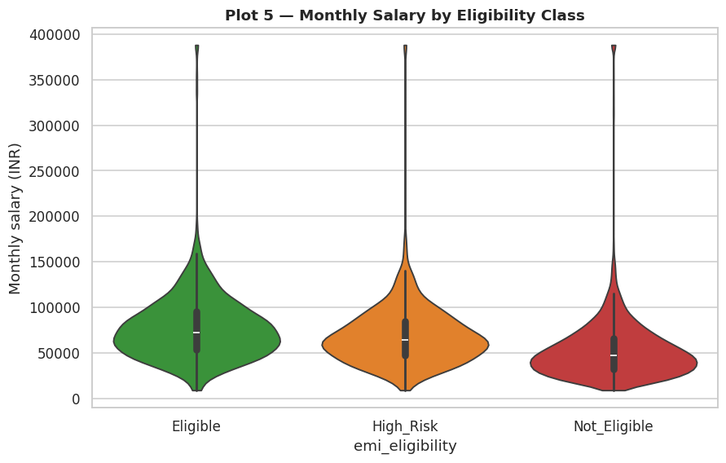
Distribution of monthly salary within each eligibility class.
Eligible applicants cluster well above ₹60,000 while ineligible applicants concentrate below ₹40,000, with High Risk sitting between them. Income separates the classes strongly but with meaningful overlap, which is precisely why a multi-factor model outperforms a simple salary threshold — two applicants on the same salary can have very different obligations.

Figure 6. Credit Score Density by Eligibility Class
Is credit score a reliable predictor of eligibility here?
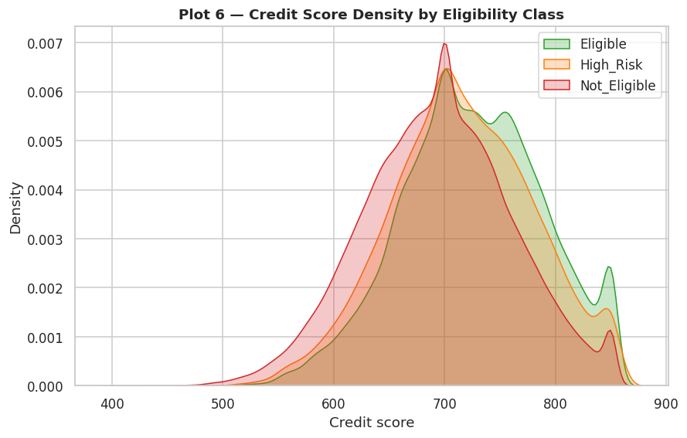
Kernel density of credit score within each eligibility class.
This is the most counter-intuitive finding in the analysis. The three distributions overlap heavily, with medians of 725 for eligible, 714 for high risk and 695 for ineligible applicants — a spread of just 32 points across the entire outcome range. Credit score is a weak separator in this portfolio. Eligibility is governed by capacity to pay rather than credit history, which is characteristic of affordability-based lending and has direct implications for credit policy design.

Figure 8. Existing Debt-to-Income Ratio by Class
Does prior debt burden distinguish rejected applicants?
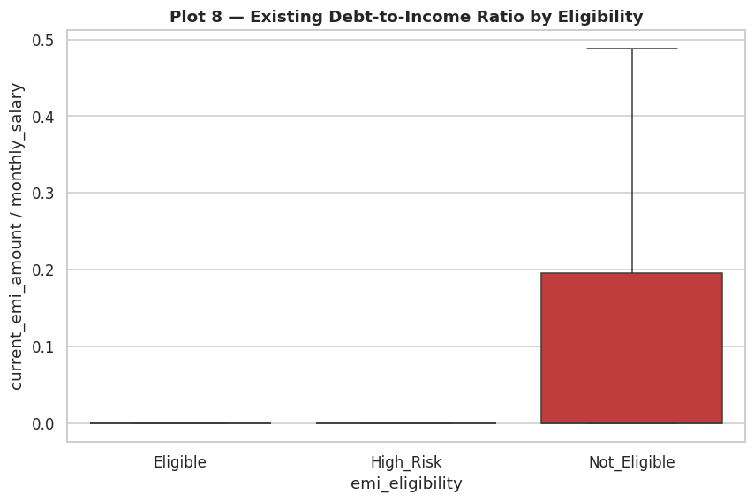
Ratio of existing EMI commitments to monthly salary, by eligibility class.
Ineligible applicants commit a visibly larger share of income to existing instalments. Debt-to-income is a standard underwriting metric and separates the classes considerably better than credit score does, so it was constructed as an explicit engineered feature. It subsequently ranked among the most important inputs to both production models.

Figure 12. Liquidity Buffers by Eligibility Class
Do savings and reserves relate to approval?
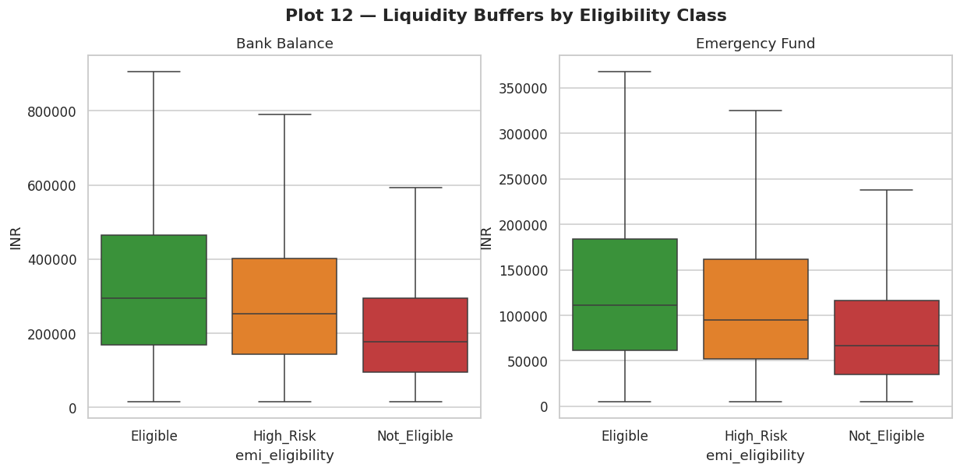
Bank balance and emergency fund distributions by eligibility class.
Eligible applicants hold materially larger bank balances and emergency funds. Liquidity signals resilience to income shocks — an applicant with six months of expenses in reserve can absorb a disruption that would cause another to default. This motivated a 'savings months' feature expressing reserves as months of outgoings covered, rather than as a raw rupee balance.

Figure 11. Monthly Expense Composition by Class
Do rejected applicants simply spend more?
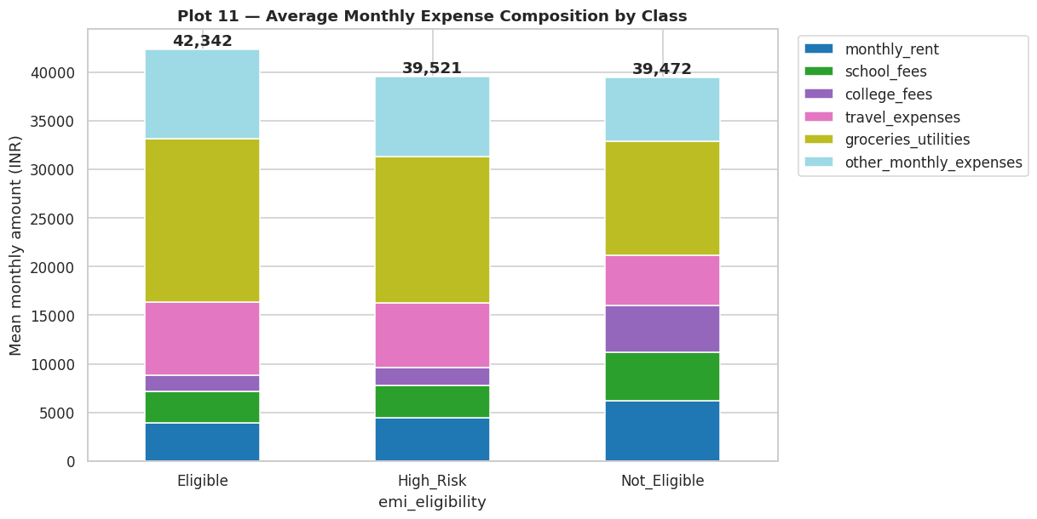
Average monthly expenditure by category within each eligibility class.
Total monthly expenses are broadly similar in rupee terms across all three classes; groceries and utilities dominate every household budget. What differs between classes is income, not spending. The consequence for modelling is important: the expense-to-income ratio is informative while raw expense values are not, and features were engineered accordingly.

Figure 9. Age Distribution by Eligibility Class
Is there any age bias in outcomes?
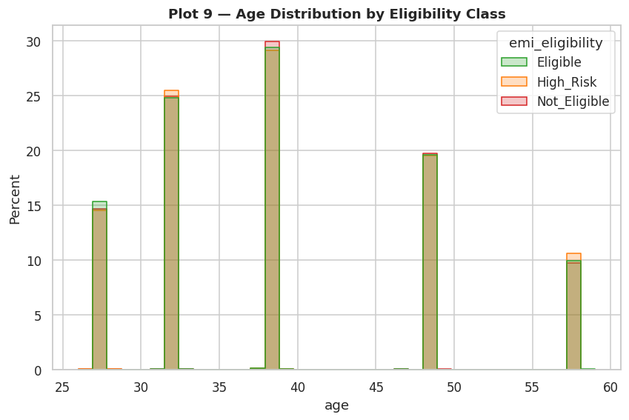
Age distribution within each eligibility class.
Age is close to uniform across the 21–65 range within every class, showing no age-related pattern in outcomes. This is a favourable indicator for fair-lending review, and it also predicts that age will carry little weight in the trained models — which the feature importance analysis later confirmed.

5. Relationships with Affordable Capacity

Figure 7. Requested Amount against Maximum Safe EMI
Are large requests simply rejected?
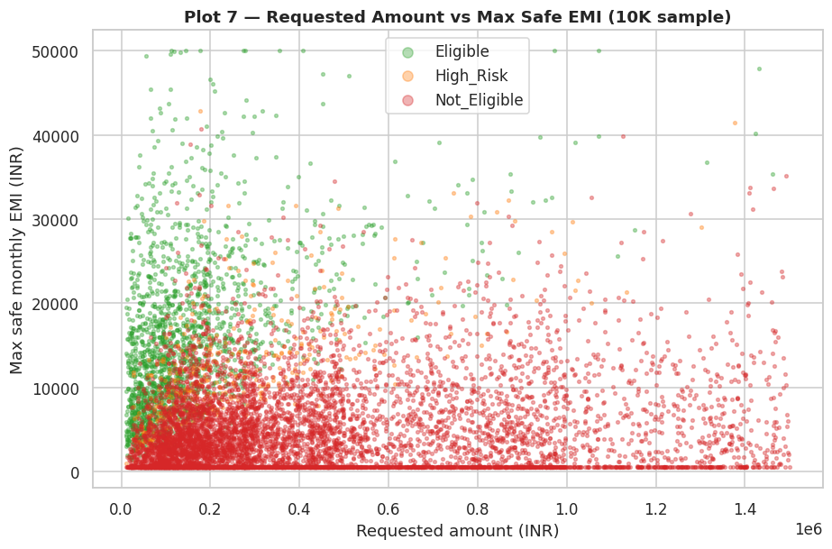
Requested loan amount against modelled safe capacity, coloured by eligibility (10,000-record sample).
Rejections appear across the entire range of requested amounts. Large requests are not automatically declined and small requests are not automatically approved — the decision boundary follows capacity rather than ticket size. This is the clearest evidence that the classification and regression tasks are complementary: knowing whether to lend is not the same as knowing how much.

Figure 14. Strongest Correlations with Maximum Safe EMI
Which variables most influence affordable capacity?
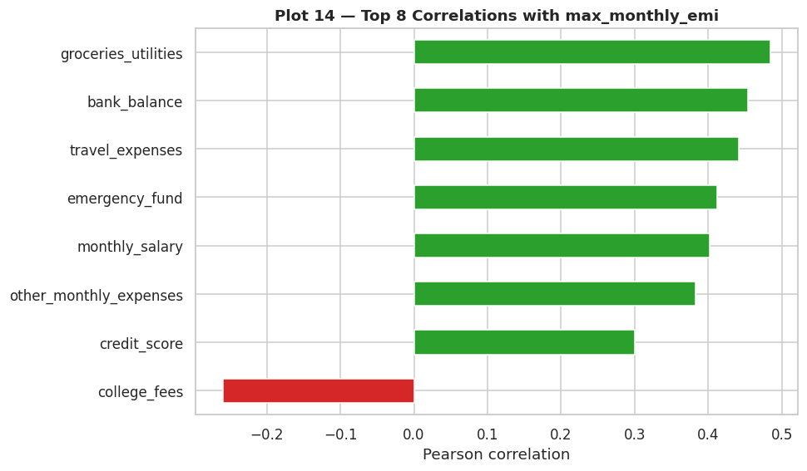
The eight variables most strongly correlated with the regression target.
Monthly salary dominates every other driver of capacity, followed by liquidity measures. Existing EMI burden and household expenses are the principal negative drivers. This ranking provided a useful check on the trained models: a model whose feature importances contradicted this ordering would warrant investigation, and in the event the fitted models agreed.

Figure 15. Pairwise Relationships of Key Financial Variables
How do the principal variables interact?
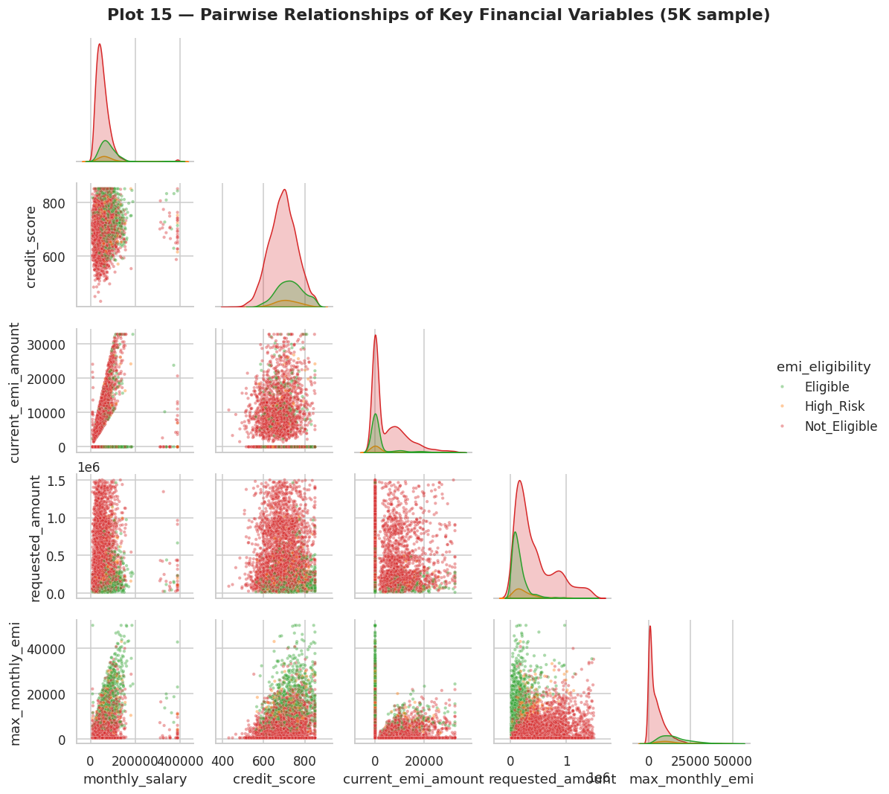
Pairwise relationships among five key financial variables (5,000-record sample).
The salary against maximum-EMI panel shows a clean positive band with visible class separation, while the credit score panels show substantial mixing — reinforcing that capacity variables dominate. Critically, no single two-dimensional view cleanly isolates the High Risk class, which sits between the other two on nearly every axis. That justifies non-linear ensemble models over simpler decision rules.

6. Consolidated Findings
Ten conclusions emerged from the analysis, ordered by their influence on the modelling strategy.
- Severe class imbalance at 77/18/4 makes accuracy an unsuitable selection metric; macro-averaged F1 was used instead.
- Income is the strongest single driver of both eligibility and affordable capacity.
- Credit score is a surprisingly weak separator, with only 30 points of median spread across all three classes.
- Approval rates differ by a factor of 2.5 across lending products, driven by ticket size relative to income.
- Existing debt-to-income clearly separates rejected applicants and became a key engineered feature.
- Liquidity buffers are markedly higher among eligible applicants, motivating a savings-months feature.
- Household expenses are similar in absolute terms across classes; only the expense-to-income ratio is informative.
- Neither age nor gender shows a material association with outcome — a positive fair-lending signal.
- Employment stability follows the expected ordering, but with a narrower spread than assumed.
- Affordable capacity is right-skewed, with a median near ₹4,200 and a long affluent tail.
The defining insight
In this portfolio, capacity to pay predicts eligibility far better than credit history does. The ratios that express capacity — debt-to-income, affordability, savings buffer — did not exist in the source data and had to be constructed. This finding directly shaped the feature engineering strategy, and the two features the final classifier relies on most are both engineered affordability ratios rather than raw inputs.

7. Implications for Modelling
Finding | Action taken
Severe class imbalance | Balanced class weights during training; macro-F1 used for model selection; per-class recall reported
Capacity outweighs credit history | Twelve affordability ratios engineered from raw financial variables
Expense ratios matter, absolute expenses do not | expense_to_income and affordability_ratio created; raw expenses retained but de-emphasised
Liquidity signals resilience | savings_months feature expressing reserves as months of outgoings
Product-specific approval behaviour | emi_scenario retained as a model input so one model pair serves all five products
High Risk not separable in 2-D | Non-linear ensemble models preferred over linear baselines
Right-skewed regression target | MAE and MAPE reported alongside RMSE to characterise typical error
Every figure in this report is generated by Section 3 of EMIPredict_AI.ipynb and saved to the eda_plots directory. All statistics quoted are computed from the cleaned dataset.

