Assignment : 01

Name :Machave Sahil

Roll No : 97 Div : B PRN No. : UCS22M1085

JDBC and Transaction Management -Add Database CRUD operations to MVC based web application using JDBC classes

**Step 1 : Create New Project in eclipse**

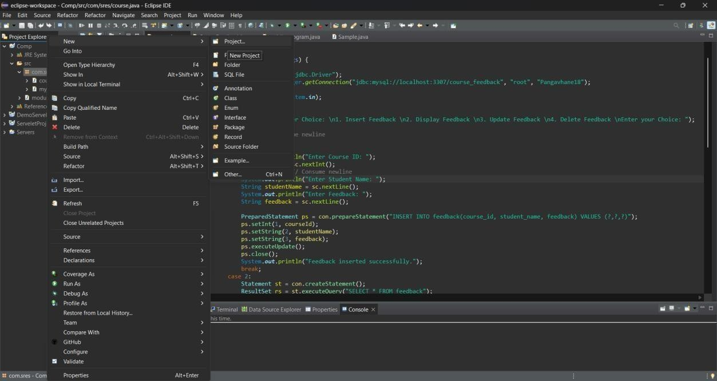

**Step 2: add external jar files like sql connector**

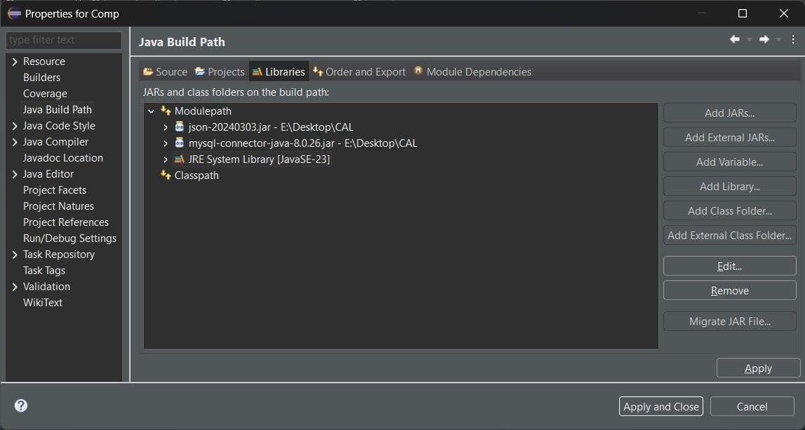

**Step 3 : Create servlet**

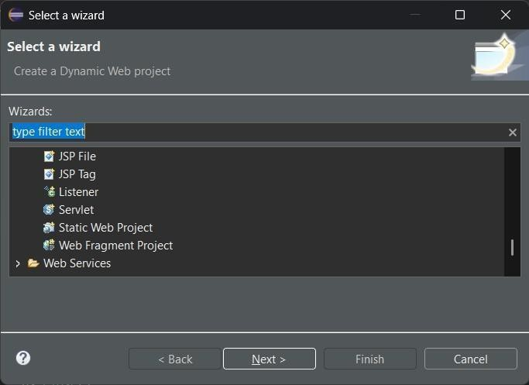

**Step 4 : Actual java Code**

package com.sres;

import java.sql.Connection; import java.sql.DriverManager;

import java.sql.PreparedStatement; import java.sql.ResultSet;

import java.sql.Statement; import java.util.Scanner;

public class course{

public static void main(String[] args) { try {

Class.forName("com.mysql.cj.jdbc.Driver"); Connection con =

DriverManager.getConnection("jdbc:mysql://localhost:3307/course_feedback", "root", "Pangavhane18");

Scanner sc = new Scanner(System.in); int chs;

do {

System.out.println("Enter Choice: \n1. Insert Feedback \n2. Display Feedback \n3.

Update Feedback \n4. Delete Feedback \nEnter your Choice: ");

int ch = sc.nextInt(); sc.nextLine(); // Consume newline switch (ch) {

case 1:

System.out.println("Enter Course ID: "); int courseId = sc.nextInt(); sc.nextLine(); // Consume newline

System.out.println("Enter Student Name: "); String studentName = sc.nextLine(); System.out.println("Enter Feedback: "); String feedback = sc.nextLine();

PreparedStatement ps = con.prepareStatement("INSERT INTO feedback(course_id, student_name, feedback) VALUES (?,?,?)");

ps.setInt(1, courseId); ps.setString(2, studentName); ps.setString(3, feedback); ps.executeUpdate(); ps.close();

System.out.println("Feedback inserted successfully."); break;

case 2:

Statement st = con.createStatement();

ResultSet rs = st.executeQuery("SELECT * FROM feedback"); System.out.println("Course ID\tStudent Name\tFeedback"); while (rs.next()) {

System.out.println(rs.getInt(1) + "\t" + rs.getString(2) + "\t" +

rs.getString(3));

}

rs.close();

st.close(); break;

case 3:

System.out.println("Enter Feedback ID to update: "); int feedbackId = sc.nextInt();

sc.nextLine(); // Consume newline System.out.println("Enter the new feedback: "); String newFeedback = sc.nextLine();

= ?");

ps = con.prepareStatement("UPDATE feedback SET feedback=? WHERE id

ps.setString(1, newFeedback); ps.setInt(2, feedbackId); ps.executeUpdate(); ps.close();

System.out.println("Update successful."); break;

case 4:

System.out.println("Enter Feedback ID to delete: "); int feedbackIdToDelete = sc.nextInt();

ps = con.prepareStatement("DELETE FROM feedback WHERE id = ?"); ps.setInt(1, feedbackIdToDelete);

ps.executeUpdate(); ps.close();

System.out.println("Feedback deleted successfully."); break;

default:

System.out.println("Invalid choice. Please enter a valid option."); break;

}

System.out.println("Press 0 to continue or any other key to exit: "); if (sc.hasNextInt()) {

chs = sc.nextInt();

} else {

chs = 1; // Exit safely

}

sc.nextLine(); // Consume newline

} while (chs == 0);

sc.close();

con.close();

} catch (Exception e) {

System.out.println("Error: " + e.getMessage()); e.printStackTrace();

}

}

}

**Step 5 : output**

