Assignment : 02

Name : Machave Sahil

Roll No : 97 Div : B

PRN No. : UCS22M1085

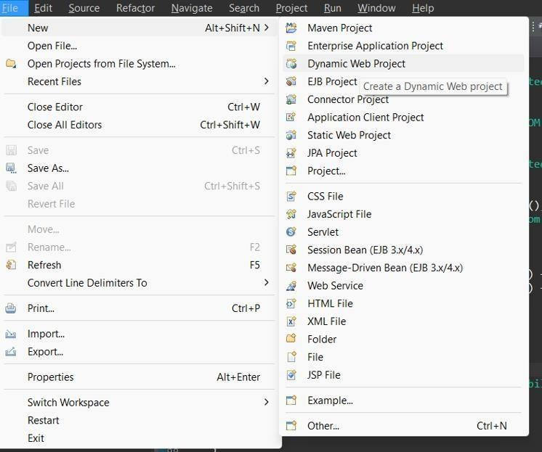**Problem :** Implement MVC based web application using Servlet Step 1 :

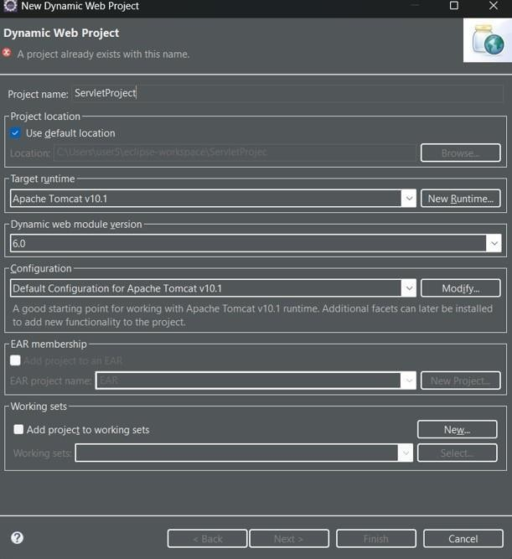

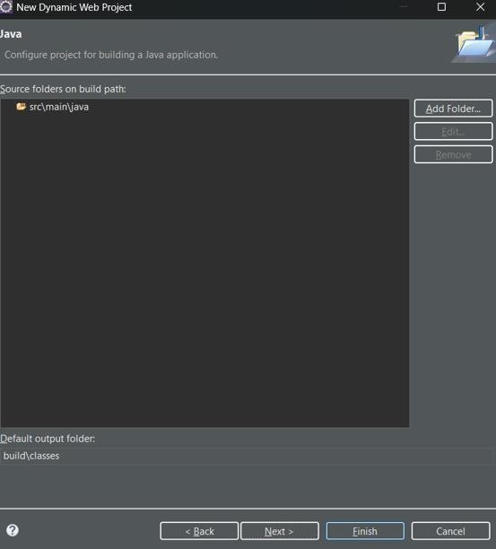

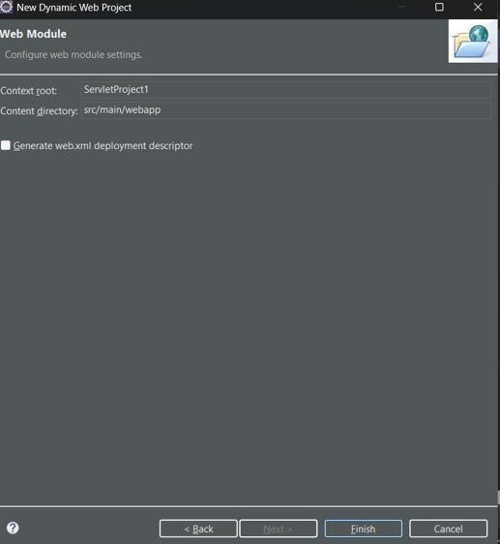

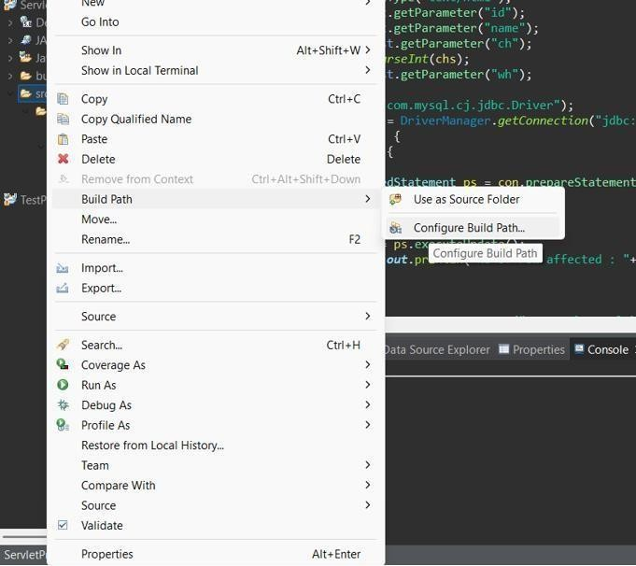

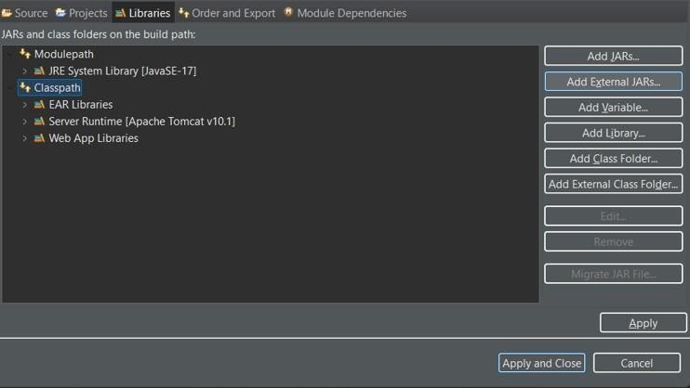

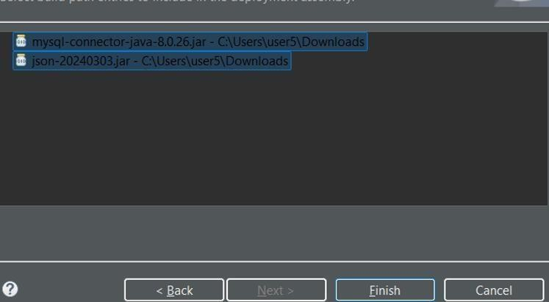

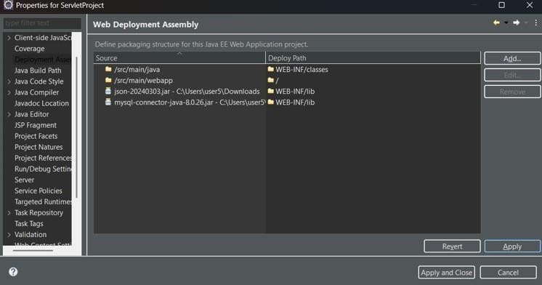

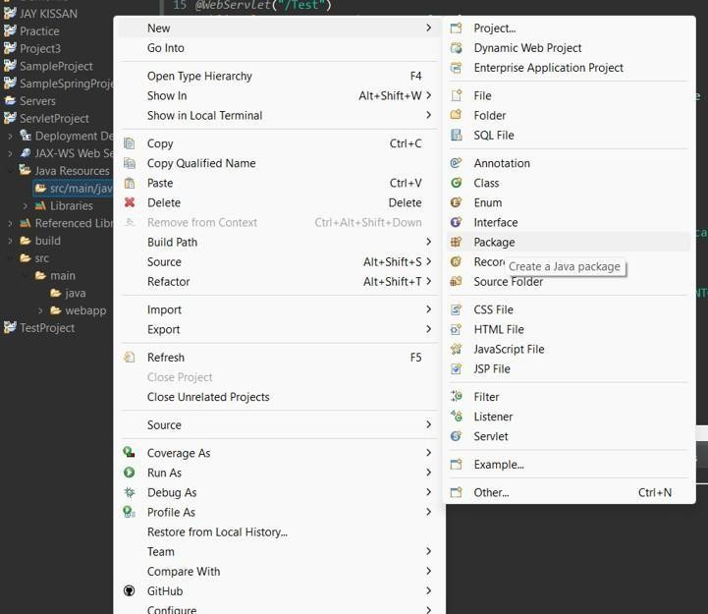

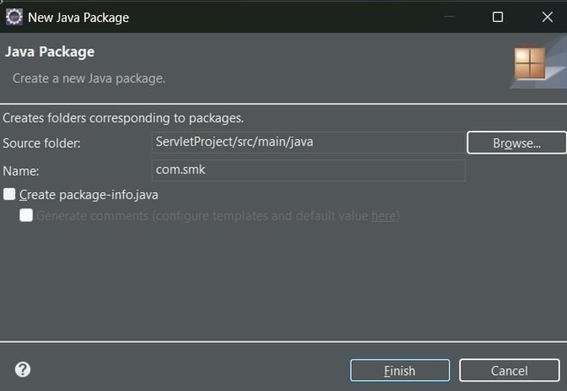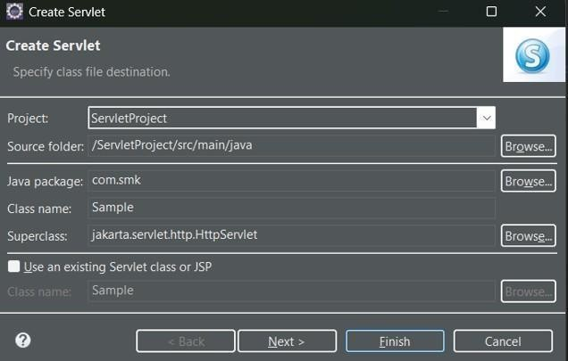

**Actual Code :**

package com.smk;

import jakarta.servlet.ServletException; import jakarta.servlet.annotation.WebServlet;

import jakarta.servlet.http.HttpServlet;

import jakarta.servlet.http.HttpServletRequest; import jakarta.servlet.http.HttpServletResponse; import java.io.IOException;

import java.io.PrintWriter; import java.sql.Connection; import java.sql.DriverManager;

import java.sql.PreparedStatement; import java.sql.ResultSet;

/**

* Servlet implementation class CourseFeedback

*/ @WebServlet("/CourseFeedback")

public class CourseFeedback extends HttpServlet { private static final long serialVersionUID = 1L;

/**

* @see HttpServlet#HttpServlet()

*/

public CourseFeedback() { super();

// TODO Auto-generated constructor stub

}

/**

* @see HttpServlet#service(HttpServletRequest request, HttpServletResponse response)

*/

protected void service(HttpServletRequest request, HttpServletResponse response) throws ServletException, IOException {

// TODO Auto-generated method stub response.setContentType("text/html"); String id = request.getParameter("id");

String courseId = request.getParameter("course_id");

String studentName = request.getParameter("student_name"); String feedback = request.getParameter("feedback");

String chs = request.getParameter("ch"); int ch = Integer.parseInt(chs);

String whs = request.getParameter("wh"); try {

Class.forName("com.mysql.cj.jdbc.Driver"); Connection con =

DriverManager.getConnection("jdbc:mysql://localhost:3307/course_feedback", "root", ""); if (con != null) {

switch (ch) { case 1:

PreparedStatement ps = con.prepareStatement("INSERT INTO

`feedback`(`course_id`, `student_name`, `feedback`) VALUES (?,?,?)");

ps.setString(1, courseId); ps.setString(2, studentName); ps.setString(3, feedback);

int i = ps.executeUpdate(); System.out.println("No of row affected : " + i); break;

case 2:

ps = con.prepareStatement("UPDATE `feedback` SET `course_id` = ?,

`student_name` = ?, `feedback` = ? WHERE `id` = ?"); ps.setString(1, courseId); ps.setString(2, studentName); ps.setString(3, feedback); ps.setString(4, whs);

i = ps.executeUpdate(); System.out.println("No of row affected : " + i); break;

case 3:

ps = con.prepareStatement("DELETE FROM `feedback` WHERE `id` = ?"); ps.setString(1, id);

i = ps.executeUpdate(); System.out.println("No of row affected :" + i); break;

case 4:

PrintWriter pw = response.getWriter();

ps = con.prepareStatement("SELECT * FROM feedback"); ResultSet rs = ps.executeQuery();

pw.println("<ul>");

while (rs.next()) {

pw.print("<li>" + rs.getString("id") + " - " + rs.getString("course_id") + " - " + rs.getString("student_name") + " - " + rs.getString("feedback") + "</li>");

}

pw.print("</ul>"); break;

}

} else {

System.out.println("Connection not established !!");

}

} catch (Exception e) { System.out.println(e);

}

}

}

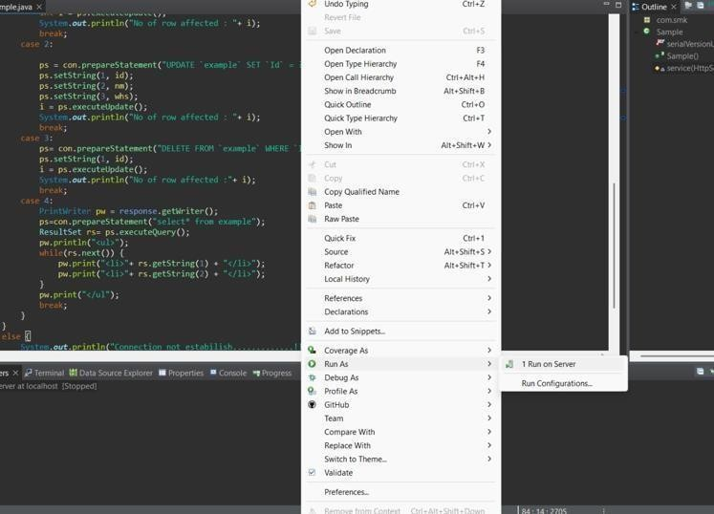

For Running the code… ( Run as-> Run on Server )

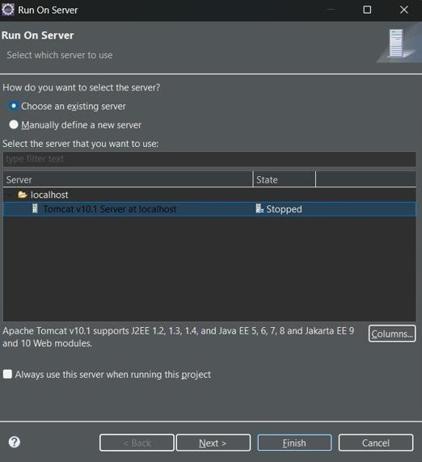

Select Tomcat Server 10.1

**Output :**