
Generative AI & LLMs
Lecture: AI Safety and Guardrails
Dr. Soharab Hossain Shaikh Professor, CSE, SoET
BML Munjal University
1

Agenda
- AI Safety and Guardrails
- Hallucination Guardrail
- Guardrails.AI
- How to implement?
- Gen-AI Tech Stack
2

AI Safety
3

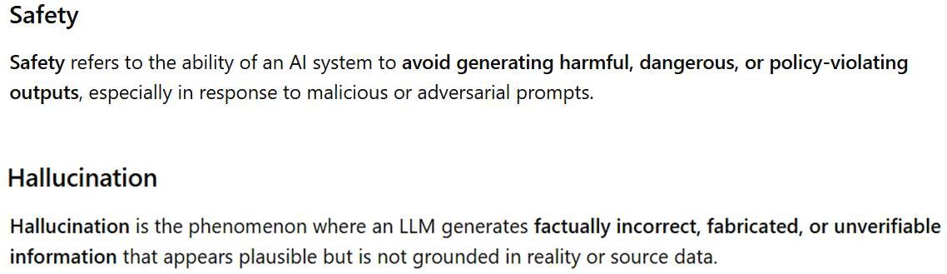
4

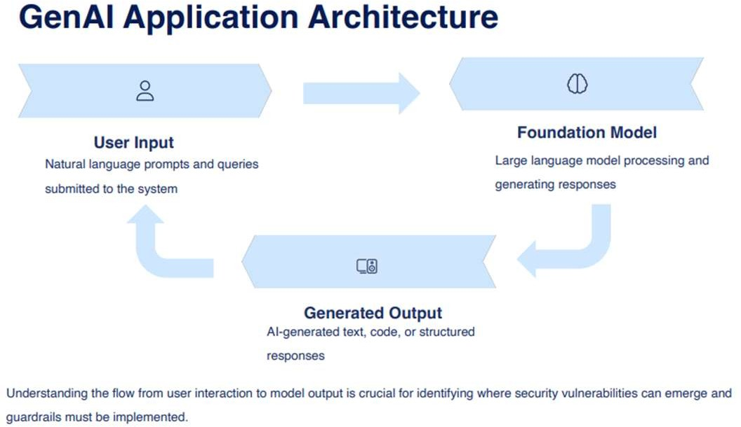
5

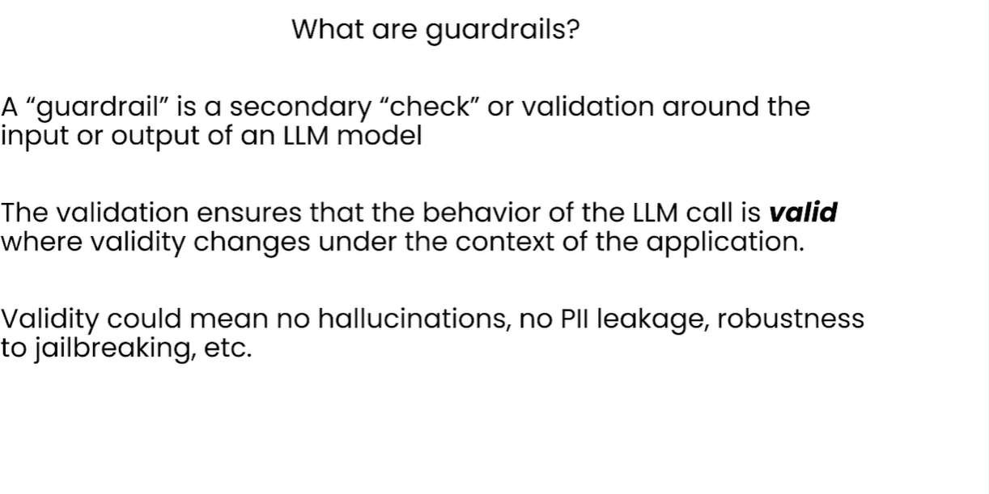
6

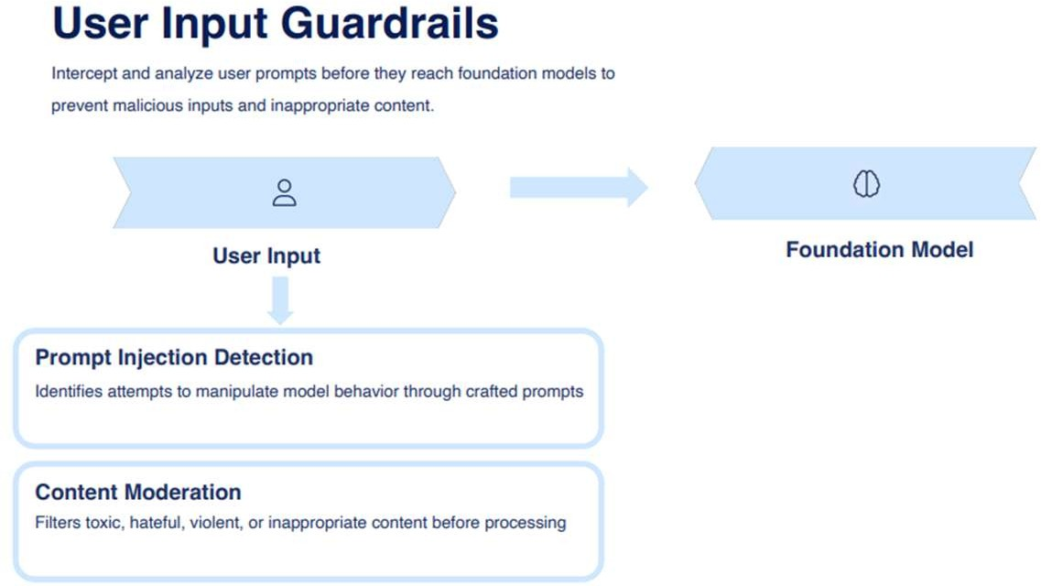
7

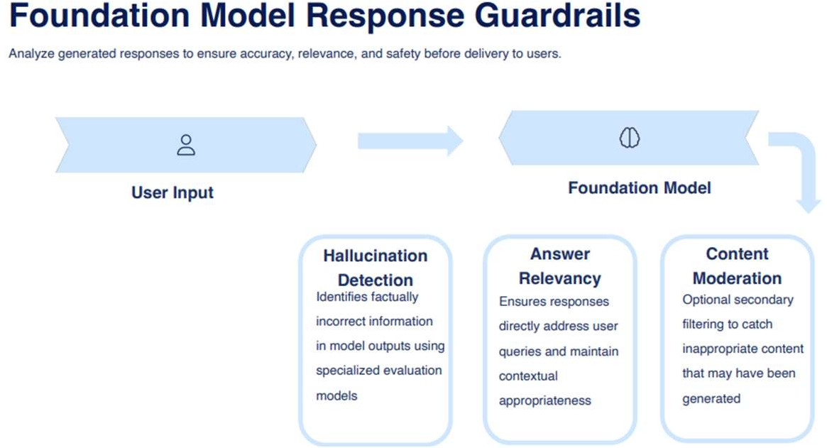
8

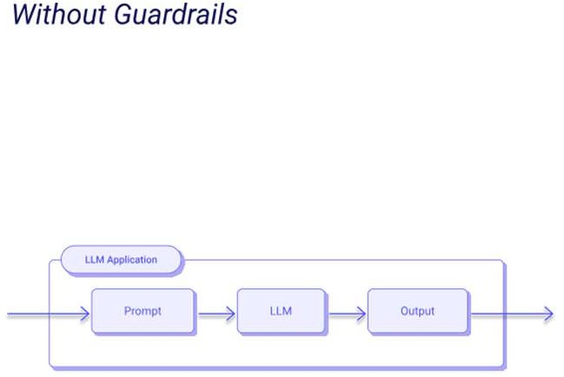
9

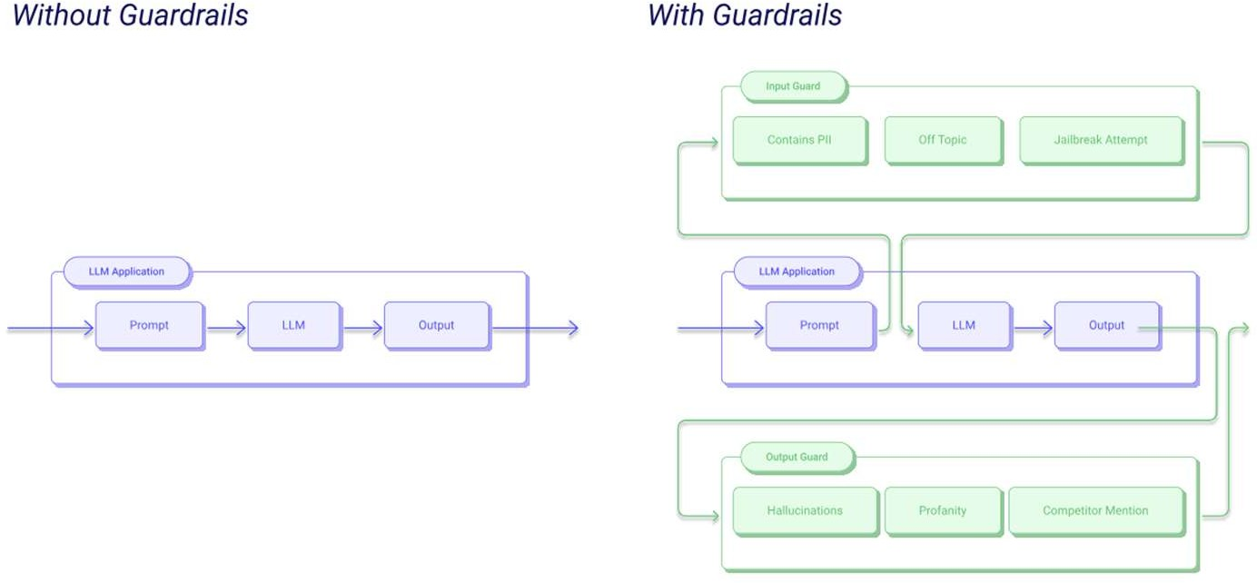
10

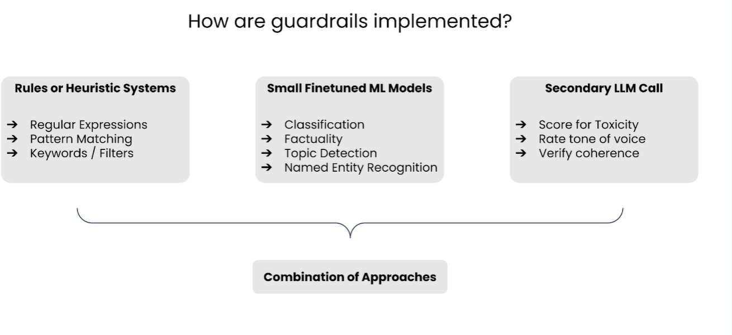
11

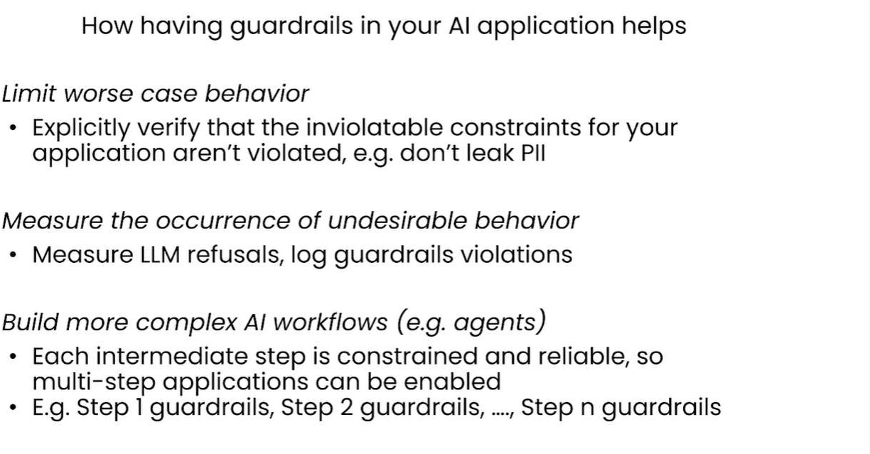
12

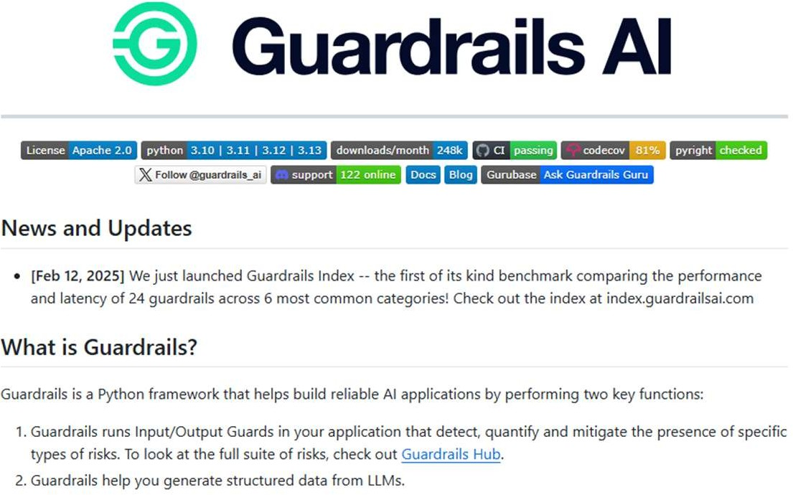

https://github.com/guardrails-ai/guardrails
13

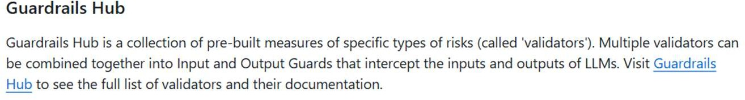
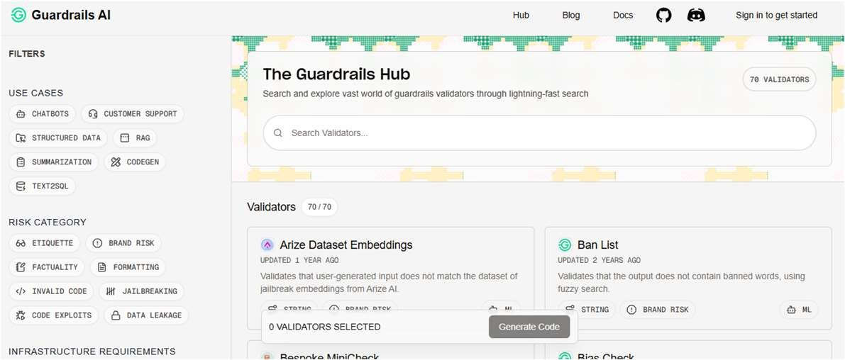

https://guardrailsai.com/hub
14

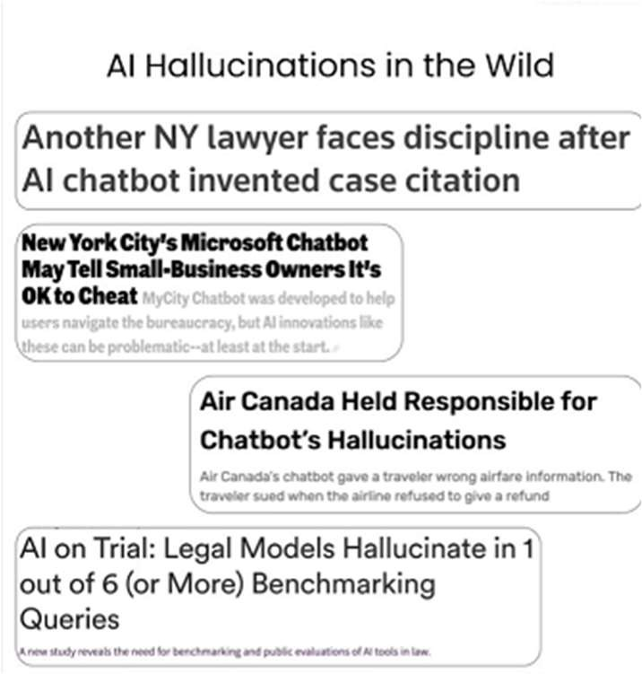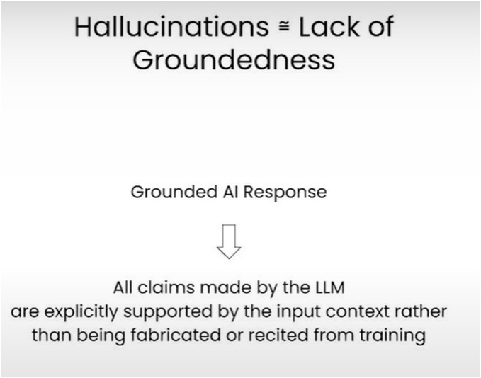
15

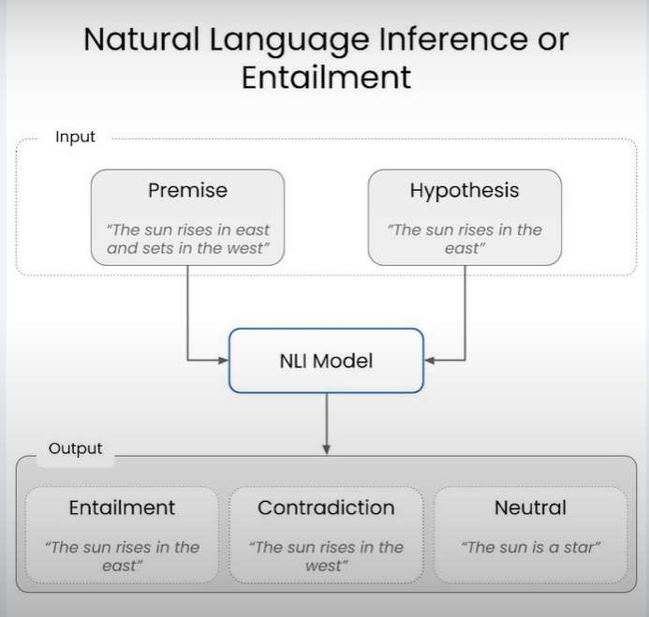
16

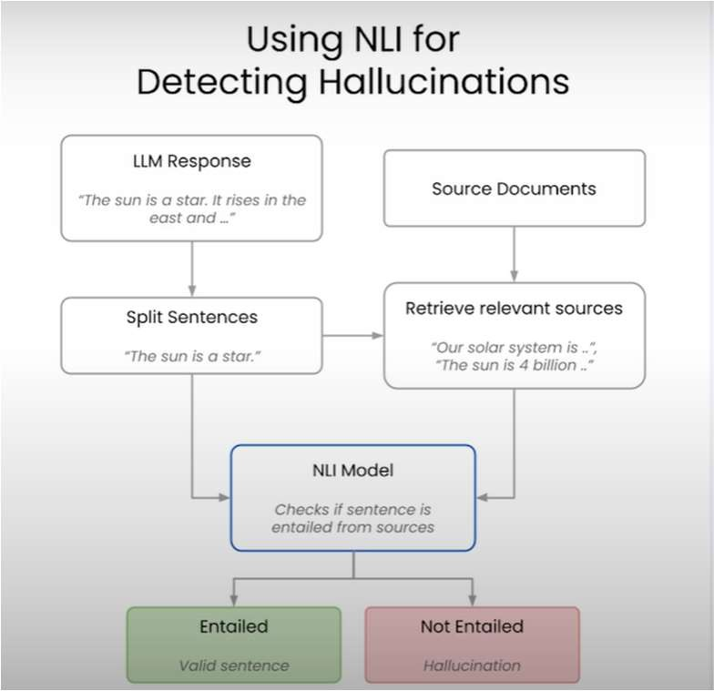
17

Gen-AI Tech Stack
18

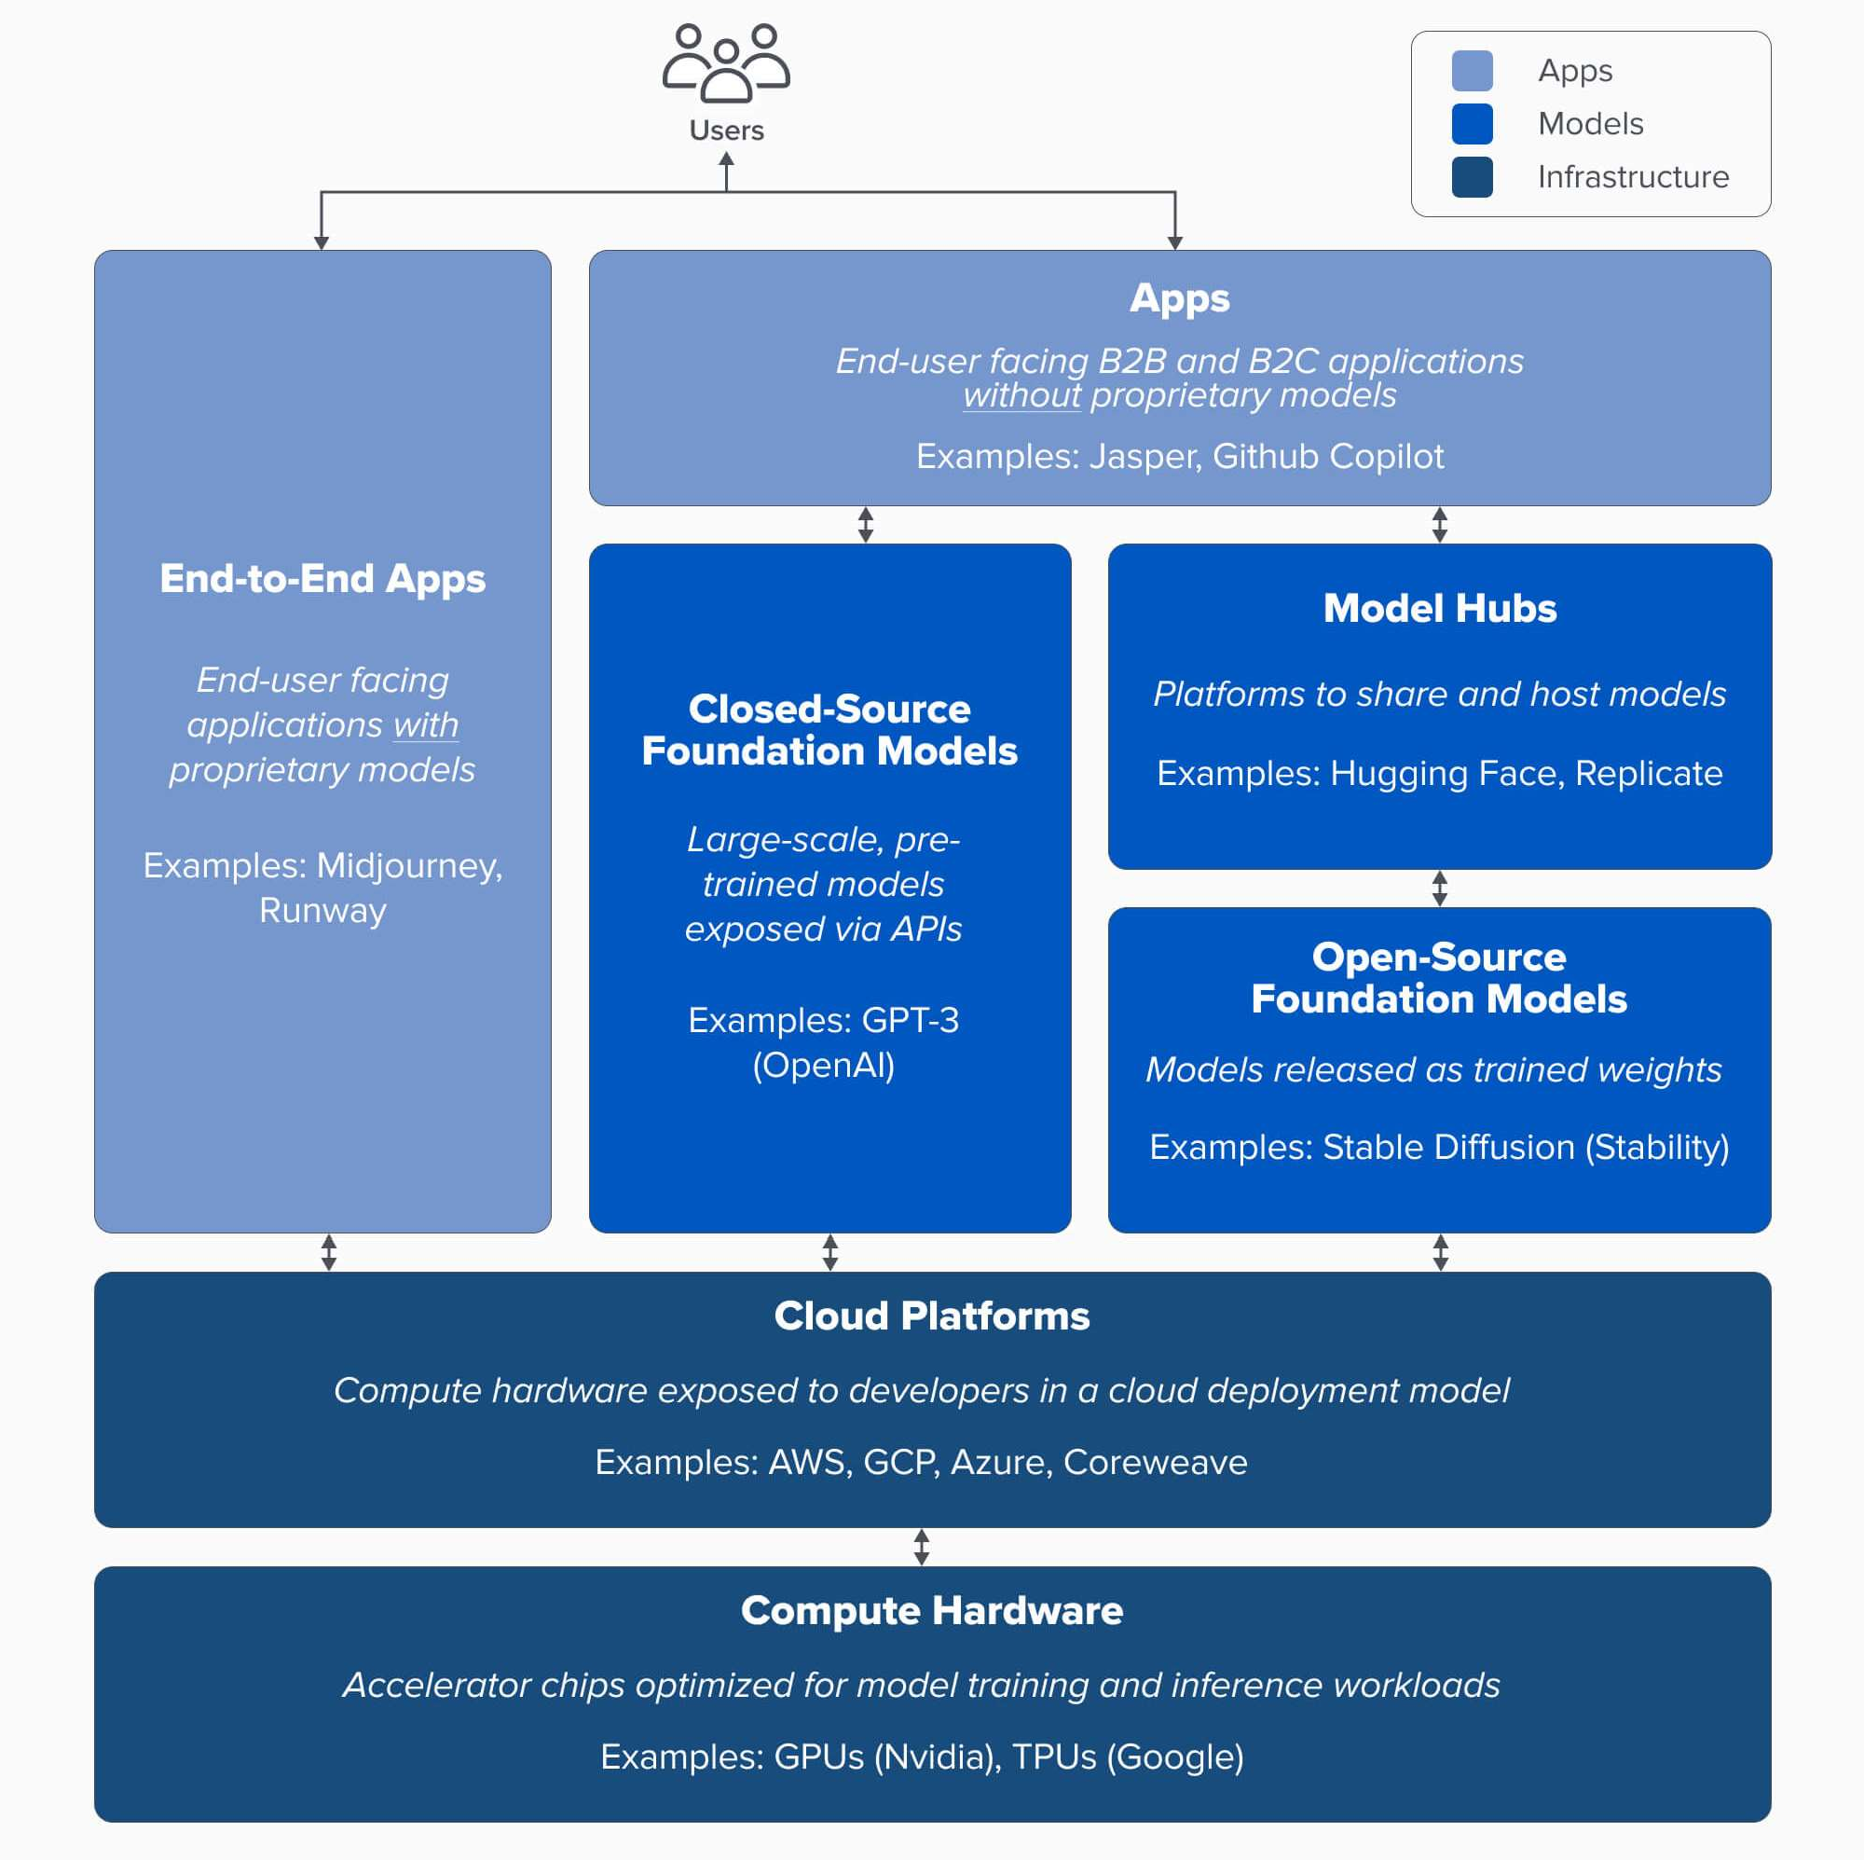
GenAI Tech Stack
The stack can be divided into three layers:
- Applications that integrate generative AI models into a user-facing product, either running their own model pipelines (“end-to-end apps”) or relying on a third-party API
- Models that power AI products, made available either as proprietary APIs or as open-source checkpoints (which, in turn, require a hosting solution)
- Infrastructure vendors (i.e. cloud platforms and hardware manufacturers) that run training and inference workloads for generative AI models

Source: https://a16z.com/who-owns-the-generative-ai-platform/
19

References
- Credits: DeepLearning.ai course: Safe and Reliable AI via Guardrails https://www.deeplearning.ai/short-courses/safe-and-reliable-ai-via-guardrails/
- Guardrails AI GitHub Repo
https://github.com/guardrails-ai/guardrails

- Guardrails Hub
https://guardrailsai.com/hub

- Examples from Guardrails AI
https://github.com/firstlink/guardrailsai

- Who owns the Generative AI platform?
https://a16z.com/who-owns-the-generative-ai-platform/
20


21



Thank You
Class material will be uploaded here:
https://github.com/soharabhossain/GenAI_n_LLMs
22

