WIDS

**SAHIL KALE -- IIT BOMBAY**

**Neural Networks**

* Neural Networks is the simple mathematical representation of a neuronal structure.
* A neural network analyses the input data set's characteristics and predicts the characteristics of the subsequent input data set using that information ( which is not in the input data set)
* Neural networks have an Input layer, various hidden layers and a output layer.
* Neural Networks can be helpful in developing tasks like Binary classification, object detection, facial recognition and verification etc.

**Forward propagation:**

**Input layer:**

* Input layer contains the vector of input features.

**Hidden layer:**

* Each hidden layer contains a specific number of neurons or units, and each layer may or may not be associated to an activation function.
* Each input feature is multiplied by a set of weights and added by biases in each neuron as the input is transferred through the layer.
* Generally, ‘Relu’ activation function is associated with the Hidden layers.

Ex:

* Suppose there are 4 inputs and 6 units in the layer, then there will be (4x6) i.e. 24 weight parameters and 6 biases for each layer.
* Let the inputs be x = [$x_{1}$, $x_{2}$, $x_{3}$, $x_{4}$] and weights for $i^{th}$ neuron be $w_{i}$ = [$w_{i1}$, $w_{i2}$, $w_{i3}$, $w_{i4}$] and biases be $b_{i}$,
* Then the linear output looks like,

$z_{i}$ = $w_{i}^{T}$ x + $b_{i}$

* Also, if there is a activation associated to a layer say ‘g’ then the activated output ‘ai’ looks like,

$a_{i}$ = g($z_{i}$)

**Output layer:**

* Based on the type of classification or operation we are performing the size of the output layer and its activation is decided.
* Say, if we are doing binary classification then we are expected to use ‘**sigmoid**’ activation function at the output layer with only one unit in the output layer.

Hence, the training data in the forward propagation follows the path,

Input layer 🡺 Hidden layers 🡺 Output layers

**Back Propagation:**

* Backpropagation is performed generally by gradient descent algorithm.

Before, that it is very important to understand the loss function,

**Loss:**

* Loss function as name suggest is the measure of deviation of the output to the estimated output,
* For different classification or regression models we have different loss functions.
* Some of them are,

Loss function corresponding to **Mean square error, absolute error, logistic** error etc.

**Cost function:**

* The cost function is the aggregate of the loss function over the whole training data.

**Gradient Descent:**

* Our, aim is to find the weights and biases such that we get the cost function minimized
* Therefore, in order to speed up the algorithm, we find the direction of the cost function's **steepest ascent** with respect to a parameter and add its opposite, that is, the direction of the cost function's **steepest descent**, to the parameter in order to update it. This allows us to quickly reach the cost function's minimum with respect to that parameter.

This is the gradient descent algorithm,

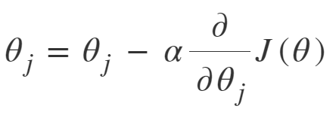

Here, the parameter **α** is the learning rate which is a **hyperparameter**.

**Convolutional Neural Networks**

* Convolutional neural networks are generally used in image recognition, detection, verification, speech verification, signal processing etc.
* ConvNet contains three layers:

1. **Convolutional layer**
2. **Pooling layers**
3. **Fully connected layers**

**Convolutional layer:**

* In convolutional layer, the convolutional filter is responsible for feature detection from the input data.
* Ex: Edge detection in Image

Each filter corresponds to detection of different features, say vertical or horizontal edge in the image.

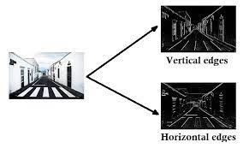

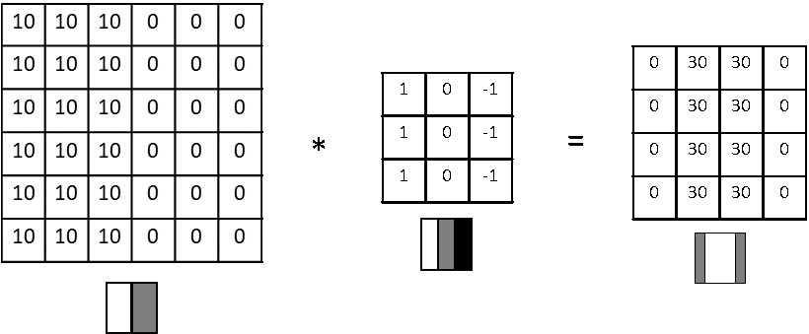

* The above filter is responsible for detecting the vertical edge in the image,
* Like this there are certain filters which detect specific features of the image, large number of filters together are used to detect all the edges of the image.
* Also, convolution reduces the size of the image which reduces the input features and hence number of parameters.
* Instead of guessing which filter to use we can define the whole filter as a parameter,

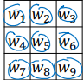

* Each convolutional layer like hidden layer may also be associated to an activation function.

**Pooling layers:**

Two types of pooling layers are generally used,

**1.Maxpooling:**

Used to enhance the features and reduce the size of the image.

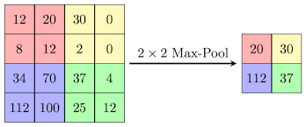

* Generally, Maxpooling layer is used between two convolutional layers.
* Pooling layers are generally done with stride = 2, filter size = 2.

1. **Average pooling:**

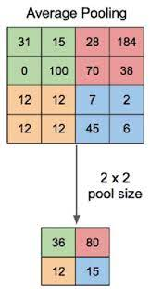

**Fully Connected layer:**

* Fully connected layer works as same as a artificial neural network which is discussed above.

Hence, the convolutional network looks like,

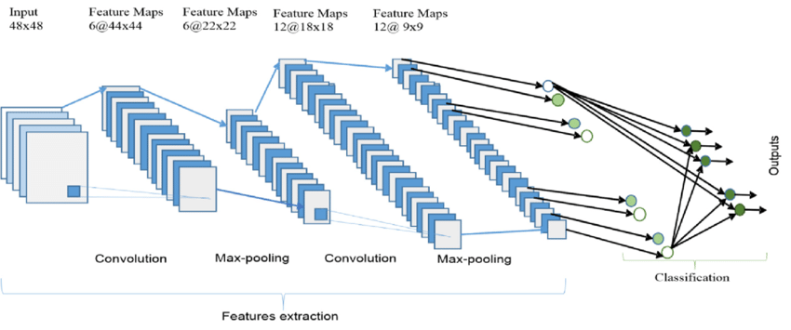

More generally networks like,

* **LeNet5, AlexNet** which are based on the concept of convolutional neural networks are used in practice which involve **normal/plain** convolutional neural network.
* Also, there are more efficient neural networks i.e. they **increase accuracy** more rapidly than the normal ones.

The schematic of a **residual neural network** looks like,

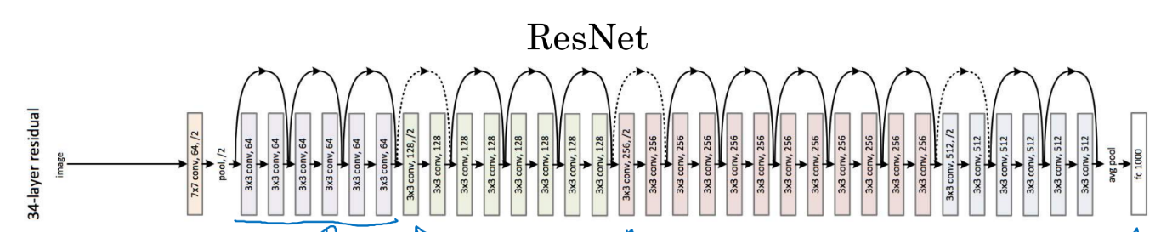

* Normal convolutional network for large dataset may turn out to be very heavy for even the descent computers.

Hence, there are ways to reduce the following issue,

**Depth wise convolution:**

* Here, convolutions are done in such a way that the computational cost is reduced compared to the plain convolutions.
* The convolution of each channel of the filter is done on each channel of the input, followed by pointwise convolutions.

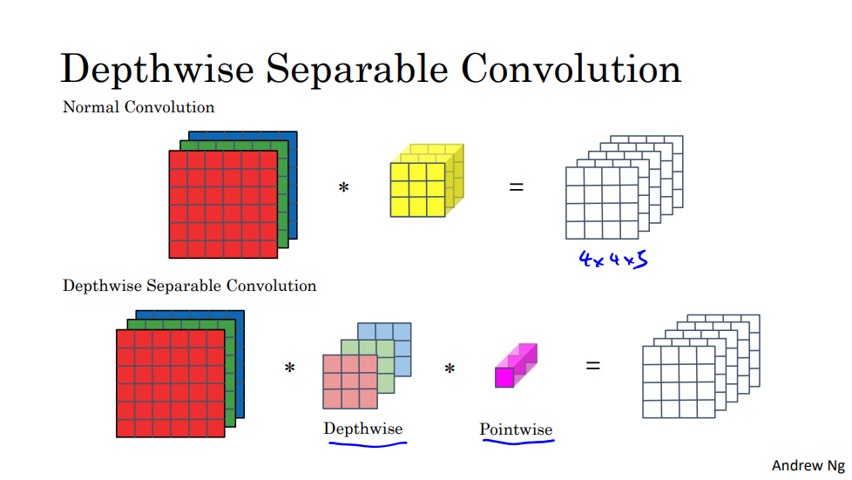

* **MobileNetV1** use these concepts, while **MobileNetV2** uses the concept of both residual NN as well as depth wise convolutions.

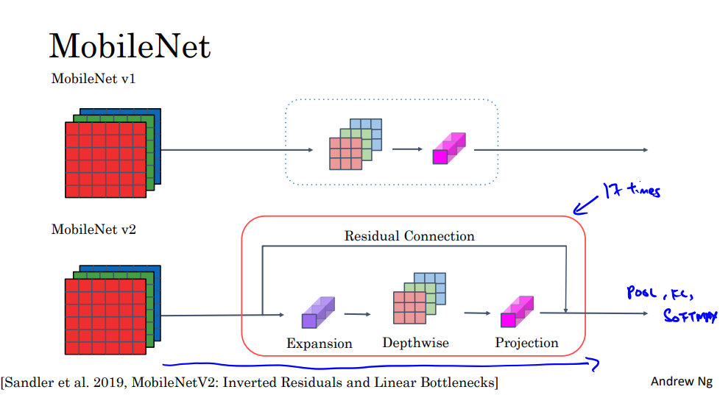

**Face Recognition:**

For face recognition we use Siamese network,

The architecture of the network looks like,

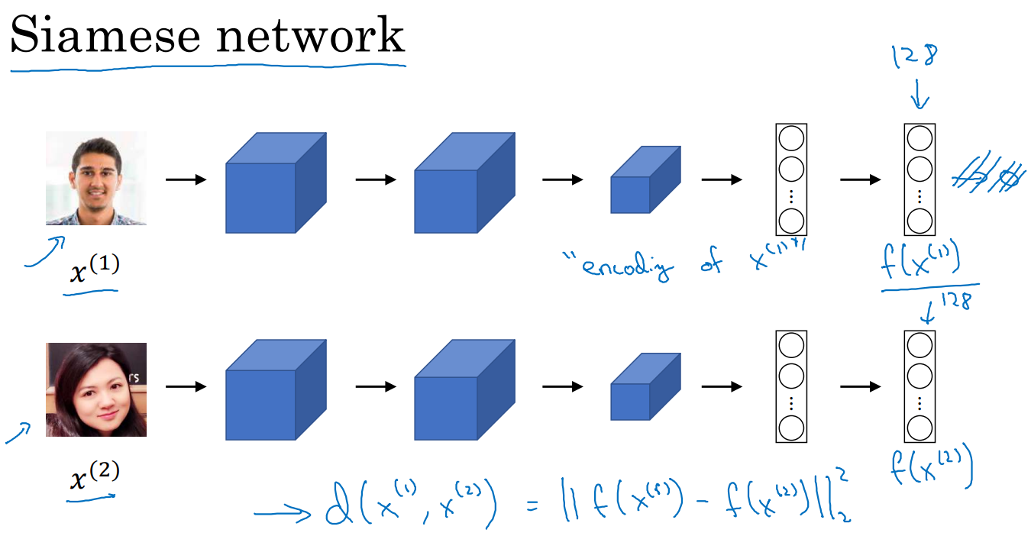

* The output from the hidden layers of both networks is passed into the distance layer, which then passes the distance layer's norm onto the output layer's sigmoid function to determine the similarity index.

Other concepts like **Object detection, Transfer learning, Neural transfer, inception network** is taught in the course, which I am not including in the document as they are not related to the project.