**Team B – Ekathra**

**SPECIFICATIONS**

**Introduction**

* 1. **Scope**

The traffic modeling system is a simulation system through which different types of road would be attached to simulate the behavior of traffic. There are several components like roundabout, 2-way road, 4-way, signals, and T-junction so that they would act as network of roads. To start the simulation, user need to input some parameters such as: number of cars per minute, reaction rate.

**1.2 Product Features**

Simulate the road traffic behavior

**1.3 User characteristics**

To use this product user should be:

Above 21 years

Should have computer knowledge

**1.4 Constraints**

This software is property of Team B(Ekathra) and should not be used illegally and should not be sold without developers permissions.

**1.5 Assumptions and dependencies**

Developers have assumed one way road

There would not be any lane for pedestrian lane

**2.0 Functional Requirements**

**Types of road components to be created:**

1. **2 - way stops:**

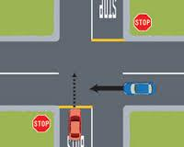

1. **4 - way stops:**

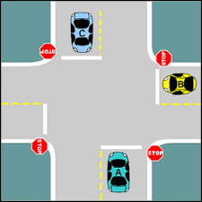

1. **Roundabout junctions:**

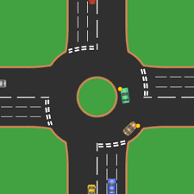

1. **Road with signals**

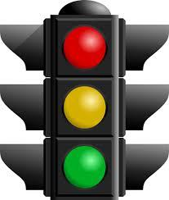

1. **T – Junction:**

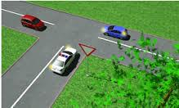

**User input:**

1. Drag and drop the above 5 road components on the simulator panel in any order to make the road path.
2. Load default values from file
3. User can change the % age of traffic going in any direction and the total %age would be 100%
4. If require user can change the values
5. User should input speed for the cars and every car would get random speed from the input value with +/- % mph.
6. Reaction time of cars: random value, because every car has different reaction rate.
7. Arrival rate: number of car per minute. e.g. 10 cars/min.
8. Distance of the road (distance one road component).
9. Distance between consecutive cars.
10. At end the cars would destroyed

**Facts about project:**

1. Roads should be of one way.
2. User can change the % age of traffic going in any direction and the total %age would be 100%
3. All the vehicles should be of four wheels and there should not be any vehicle of 2 wheels.
4. The simulator will only simulate the traffic flow of cars (4-vehicles) and not any pedestrians. So there would not be any pedestrian lanes.
5. Consecutive cars should maintain some gap (distance/time) so that not two cars would collide.
6. All cars must stop at “STOP” sign.
7. There would be three lights for the signals i.e. Red, Yellow, and Green, serving the following purpose:

a. Red: All cars should stop if signal turns to red except if any cars want to go right.

b. Yellow: If a car is at intersection then it should pass the intersection but if it is on the road then it should not across the intersection as it would not cross it and may leads to accidents.

* 1. Green:  First all cars should pass those wanted to go left and then remaining car should go.

1. Car slows down if it comes near to any other cars to avoid accidents.
2. There must not be any accident in any circumstances.
3. Signaling time for the signals should depend on flow of traffic i.e. if there is less traffic then the signal time should be less and vice-versa.
4. Reaction time of the car should be keep in mind while slowing down to give a smooth move.
5. If a high speed car comes near to low speed car (high speed car is coming from behind) then the high speed car should decelerate its speed and once the former car clears the road then the high speed car should come to it original speed.
6. Cars will come (generate) from all roads and in all direction.

**3.0 Quality Attributes (Nonfunctional Requirements)**

**Non – Functional Requirements**

1. Required 1 laptops or computers with 2 GB RAM 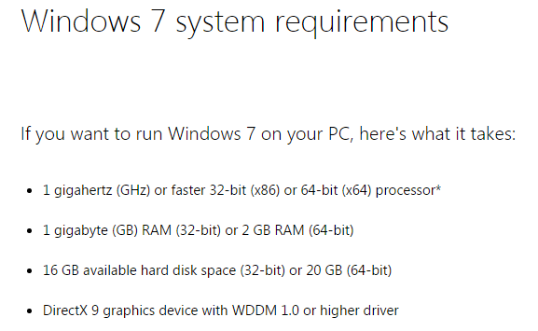
2. Laptop must be installed with the JAVA, Swing, Google Chrome
3. All the laptops must contain the Eclipse or Net Beans IDE.

**4.0 Behavioral Requirements**

To work with the software input all parameters

Drag and drop all road components to the simulation panel

Click on Run Simulation

**Optional Requirements**

When we run on the server then we need to check the speed i.e., when several users hits the system at the same time the arrival time of the output must be same for all.