**Team B - Ekathra**

**PROTOTYPE**

**Prototype 1:**

This is a page show user to select his choice of road, drag and drop in the box. As it is a prototype we are showing only three boxes. We have credibility to insert boxes to add more number of roads types and drag and drop them.

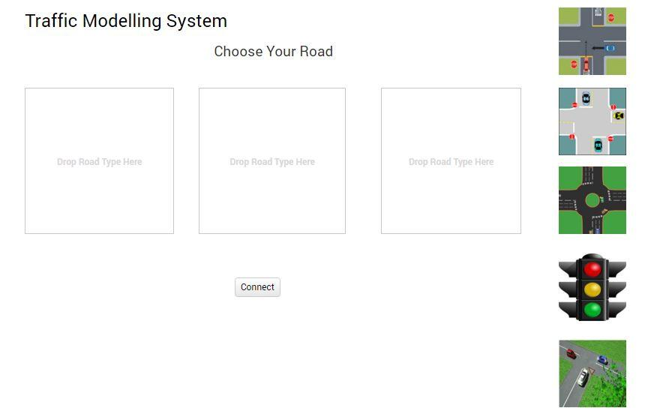

**Prototype 2:**

It was a prototype showing the combination of the roads and also car generators at every entry of the road system. There was an option to re customize the system if the user needs.

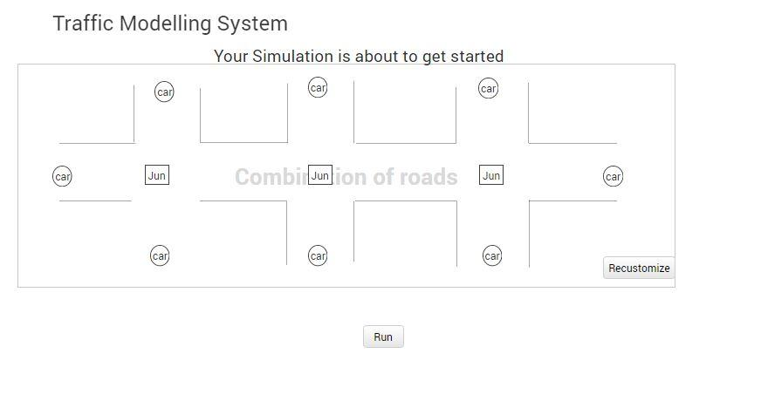

**Prototype 3:**

For every car generator there would be some input parameters that the user has to input or else system will take default values provided by the system. There were also speed limits for the roads for which we can assign values**.**

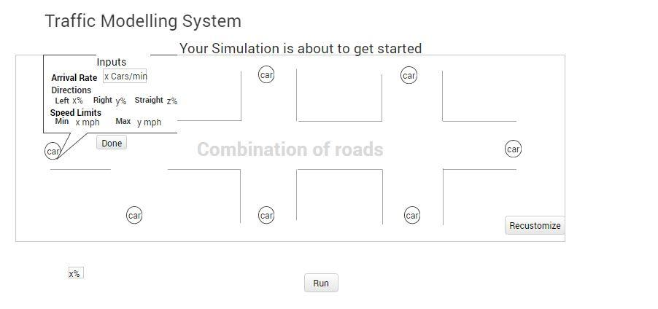

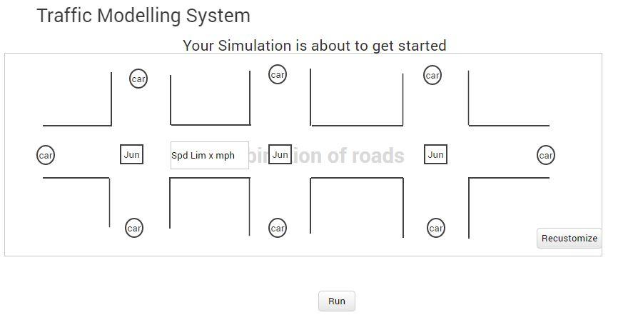

**Prototype 4:**

Once the user hits on the run button then there is a display of his simulation where he can look at the system. If the user wants to pause, he can be able to pause and play his simulation.

Once he stops the simulation there will be file displaying the information about the simulation.

