**Team B - Ekathra**

**USE CASES**

**Use Case 1:**

It was the total overview of the project in which user chooses the road type and sets the input parameters and then executes the project.

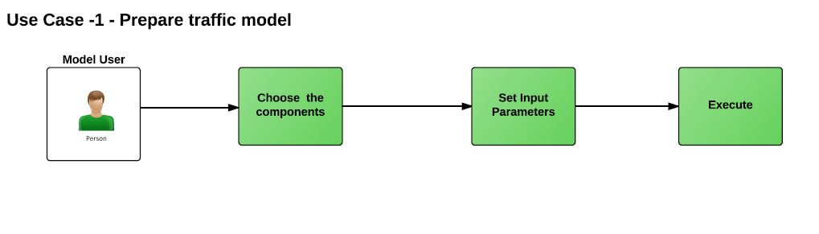

**Use Case 2:**

Here, it explains the clear view about the traffic signal where the car enters if the signal is red it waits for the signal to green and then proceeds.

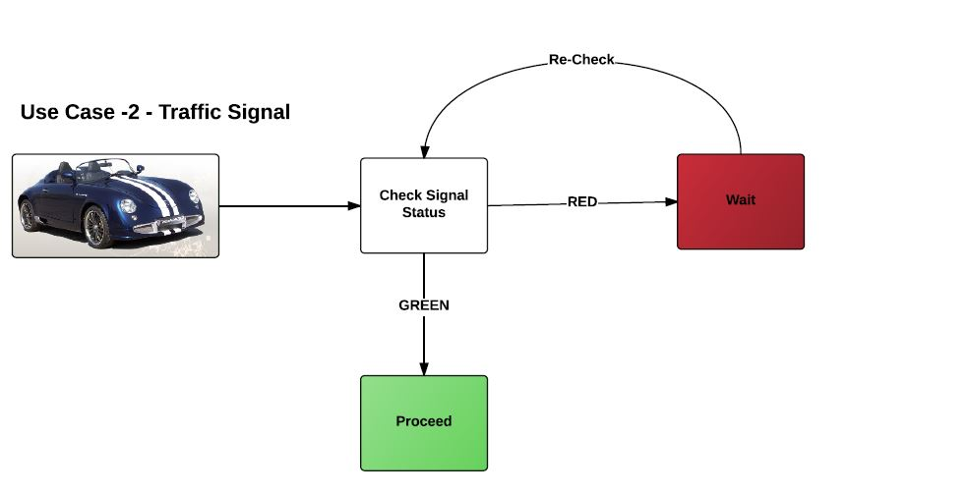

**Use Case 3:**

This use case was about roundabout roads where cars check for the incoming traffic and proceeds if there is no traffic.

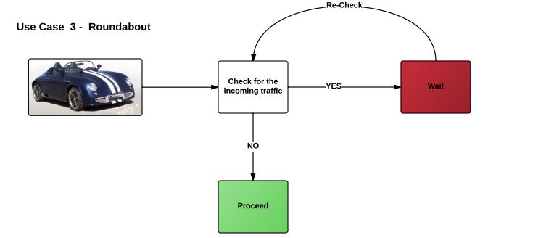

**Use Case 4:**

This use case describes about the 4-way stops 2-way stops and also T-junctions where the car has to check for the stop sign and oncoming traffic and then proceed in desired direction.

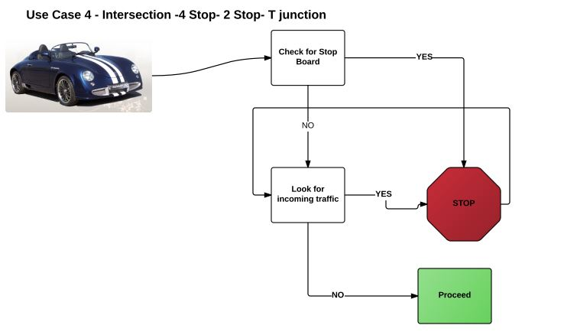

**Use Case 5:**

Here the acceleration and deceleration of the cars are based on the buffer time between the vehicles.

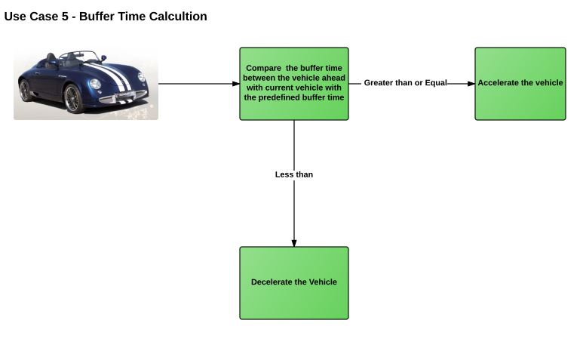

**Use Case 6:**

Here at every end of the road system cars are sent to garbage.

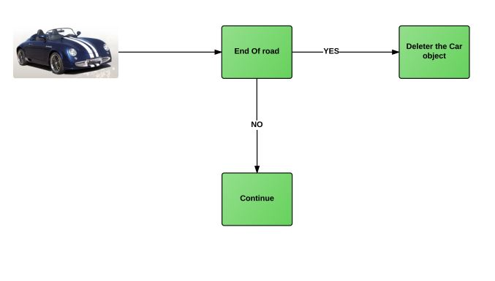

**Use Case 7:**

While giving input parameters to generate cars there will be input parameters by default, user has the credibility to change those inputs otherwise default values will be loaded.

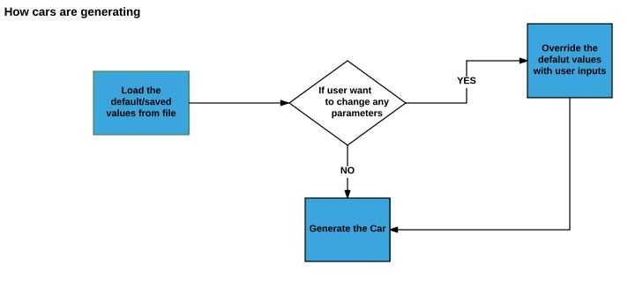

**Use Case 8:**

Cars will move depending on the speed limits on the roads and also the speed of the cars that were ahead of them.

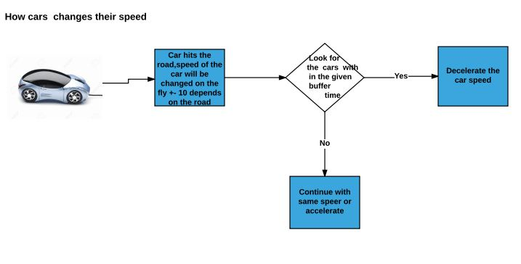

**Use case 9:**

Cars will change its direction based on the percentage of the cars to move in a direction that the user sets.

