**Team B - Ekathra**

**PROTOTYPE**

**Prototype 1:**

This is a page showing user to select his choice of road and drop on the box.

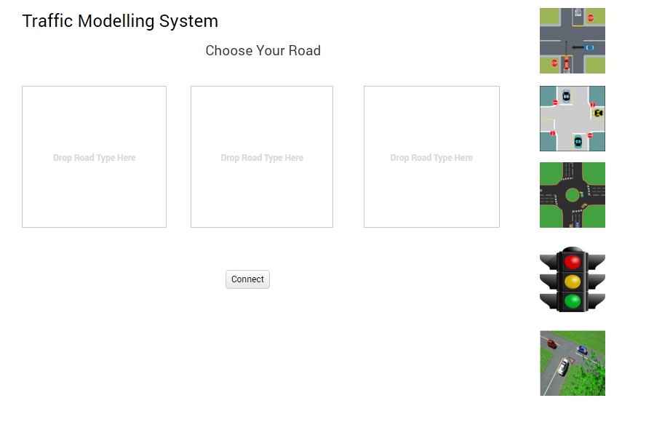

**Prototype 2:**

This is a prototype showing the combination of roads which the user has selected and then he will run the system after he looks at it.

