**Team B - Ekathra**

**REQUIREMENT DOCUMENT**

**Project overview:**

The traffic modeling system is a simulation system through which different types of road would be attached to simulate the behavior of traffic. There are several components like roundabout, 2-way road, 4-way, signals, and T-junction so that they would act as network of roads. To start the simulation, user need to input some parameters such as: number of cars per minute, reaction rate.

**Types of road components to be created:**

1. 2 - way stops:

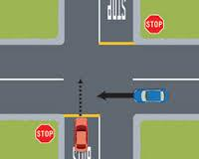

1. 4 - way stops:

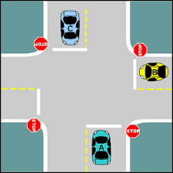

1. Roundabout junctions:

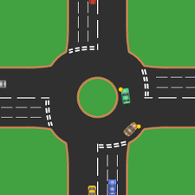

1. Road with signals

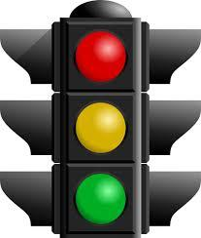

1. T – Junction:

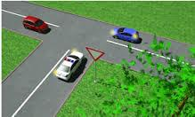

**User input:**

1. Drag and drop the above 5 road components on the simulator panel in any order to make the road path.
2. User should input speed for the cars and every car would get random speed from the input value with +/- 15 mph.
3. Reaction time of cars: random value, because every car has different reaction rate.
4. Arrival rate: number of car per minute. e.g. 10 cars/min.
5. Distance of the road (distance one road component).
6. Distance between consecutive cars.

**Facts about project:**

1. The road components should have facility to rotate them up to 360 degrees.
2. Roads should be of one way.
3. All the vehicles should be of four wheels and there should not be any vehicle of 2 wheels.
4. The simulator will only simulate the traffic flow of cars (4-vehicles) and not any pedestrians. So there would not be any pedestrian lanes.
5. Consecutive cars should maintain some gap (distance/time) so that not two cars would collide.
6. All cars must stop at “STOP” sign.
7. There would be three lights for the signals i.e. Red, Yellow, and Green, serving the following purpose:
   1. Red: All cars should stop if signal turns to red except if any cars want to go right.
   2. Yellow: If a car is at intersection then it should pass the intersection but if it is on the road then it should not across the intersection as it would not cross it and may leads to accidents.
   3. Green: First all cars should pass those wanted to go left and then remaining car should go.
8. Car slows down if it comes near to any other cars to avoid accidents.
9. There must not be any accident in any circumstances.
10. Signaling time for the signals should depend on flow of traffic i.e. if there is less traffic then the signal time should be less and vice-versa.
11. Reaction time of the car should be keep in mind while slowing down to give a smooth move.
12. If a high speed car comes near to low speed car (high speed car is coming from behind) then the high speed car should decelerate its speed and once the former car clears the road then the high speed car should come to it original speed.
13. Cars will come (generate) from all roads and in all direction.

**Optional requirements:**

1. Speed should be display on the car itself.
2. Roads should have multiple lanes.

**How system will work:**

1. Drag and drop all road components like roundabouts, 2-way etc. on the simulator panel.
2. All the dropped component should be connect to make a road network.
3. User/client should input all parameters and run simulator.
4. On simulator, the movement of cars should be either discrete or continuous.
5. Cars will generate based on the input parameters and will simulate on the road.